Instructions (translation from Italian)
You are participating in an economic experiment on decision-making. If you read the instructions carefully and make good decisions, you can earn a considerable amount of money. During the experiment, your earnings will be calculated in “tokens.” Your earnings depend on your decisions and the decisions of other people. At the end of the experiment, these tokens will be converted into Euros at the rate of
1 token = 2 euro cents
A participation fee of 3 Euros will be added to your total earnings. At the end of the experiment your earnings will be privately paid in cash.
During the experiment you will not be asked to reveal your identity and your name will not be associated with the decisions you are going to make. Moreover, during the experiment you are not allowed to talk or otherwise communicate with the other participants. Please turn off you cell phones.
This experiment is divided into three parts. We will now explain the procedures for the first part.

INSTRUCTIONS PART ONE
The first part is composed of 4 periods. In each period, you interact with two other persons. The experiment participants will be randomly re–matched after each period and therefore it is highly likely that in each period you will interact with different people. Nobody knows the identity of the people with whom she interacts.
At the beginning of each period, you receive 20 tokens. Your task concerns how to employ these tokens. The other participants will simultaneously face the same scenario. Out of the 20 tokens, you have to decide how many to deposit for a project and how many not to deposit.
Every token that you do not deposit for the project increases your earnings at face value. The tokens that you have deposited to the project and those deposited by the other two persons are increased by eighty percent. The resulting amount is then equally divided among the three persons. Therefore, you will receive one third of the tokens found in the project after the eighty percent increment. To sum up, your earnings consist of two parts:

Your period earnings = tokens not deposited + earnings from the project
= (20 – tokens deposited) + ¹/₃ x ((sum of yours’ and other two people’s deposit
to the project) x 1.8 )
Each of the other two people will receive from the project the same amount that you will. For example, consider a situation where the overall sum of the deposits of the three people is 5 tokens. In this case, each person receives from the project (5x1.8)/3=3 tokens. Instead, if the total deposit in the project is 45 tokens, each of the three people receives (45x1.8)/3=27 tokens. The following table gives you some examples of earnings from the project:

Sum of the tokens deposited | 0 | 10 | 20 | 30 | 40 | 50 | 60
Earnings from the project for each of the 3 persons | 0 | 6 | 12 | 18 | 24 | 30 | 36

For each token that you do not deposit, you earn 1 token. If you deposit this token to the project instead, then the total deposit in the project would increase by one token. Your earnings increase by 1x1.8/3=0.6 tokens. Your deposit in the project would also increase the earnings of other people. More precisely, the other two people will earn an additional 0.6 tokens each, so that the overall earnings increase for you and the others would be of 1.8 tokens.
After everybody has completed his or her decision, you will learn your period earnings. As you can see from the screen below, you will also learn the number of tokens deposited to the project by each one of the two people that could deposit with you as well as their period earnings. Your final earnings are the sum of the earnings from each period. The identity of the other people changes randomly from one period to the next.
This procedure will be repeated 4 periods.

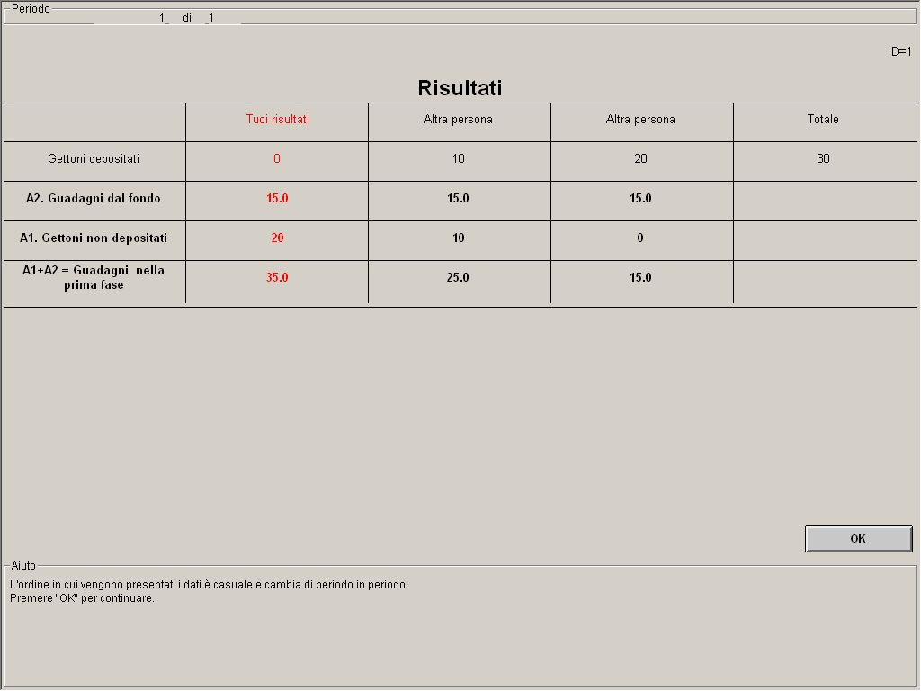

In the input screen you can press the “Show previous decisions” button to see a table with your choices and the choices of the others in previous periods.
Please record on paper, period by period, the decision you input into the computer.
Are there any questions?
If you have questions during the experiment, we kindly ask you to raise your hand and somebody will assist you in private.

QUIZ 1

- Every person has 20 tokens available. Neither you nor the other two people deposit any tokens in the project. How much do you earn?_____
What is the sum of the earnings of the other two people? ______
- Every person has 20 tokens available. Y. You deposit 20 tokens in the project. Each of the other two persons deposit 20 tokens in the project. How much do you earn?_____
What is the sum of the earnings of the other two people? ______
- Every person has 20 tokens available. Y. The other two persons deposit in total 30 tokens in the project.
How much do you earn if you deposit 0 tokens in the project? _____
How much do you earn if you deposit 15 tokens in the project? _______
- Every person has 20 tokens available. Y. You deposit 8 tokens in the project.
How much do you earn if the other two persons deposit in total 7 tokens in the project? _____
How much do you earn if the other two persons deposit in total 22 tokens in the project? _____

Date _______________ time_______________________ID _______
Part one
Period | Tokens you deposited | Total tokens in the project | Period earnings (A)

1 ______________ ______________ ______________
2 ______________ ______________ ______________
3 ______________ ______________ ______________
4 ______________ ______________ ______________

INSTRUCTIONS PART TWO
These are the instructions for the second part of the experiment. The second part consists of 10 periods and, as before, in each period you have to make a decision about the use of 20 tokens.
In this part of the experiment, each period is composed of two phases. Phase one is identical to the procedure already described, while in phase two you can choose whether and how much to reduce the earnings of other people that have benefited from the same project.
At the beginning of each period, you receive 20 tokens. Your task concerns how to employ these tokens. The other participants will simultaneously face the same scenario. Out of the 20 tokens, you have to decide how many to deposit for a project and how many not to deposit.
In phase one you have 20 tokens available. Your task concerns how to employ these tokens. The other participants will simultaneously face the same scenario. Out of the 20 tokens, you have to decide how many to deposit for a project and how many not to deposit.
Each token that you do not deposit in the project increases your earnings at its face value. The tokens that you deposit in the project plus the points that all the other two persons have deposited are increased by eighty percent. The resulting total amount is then divided into equal shares among the three people. Therefore, you will receive one third of the tokens in the project after the eighty percent increment. To sum up, your earnings consist of two parts:

Your period earnings = tokens not deposited + earnings from the project
= (20 – tokens deposited) + ¹/₃ x ((sum of yours’ and other two people’s deposit
to the project) x 1.8 )
For each token that you do not deposit, you earn 1 token. If you deposit this token to the project instead, then the total deposit in the project would increase by one token. Your earnings increase by 1x1.8/3=0.6 tokens. Your deposit in the project would also increase the earnings of other people. More precisely, the other two people will earn an additional 0.6 tokens each, so that the overall earnings increase for you and the others would be of 1.8 tokens.
After everybody has completed his or her decision, you will learn your phase one earnings. You will learn also the number of tokens deposited to the project by each one of the two people that could deposit with you as well as their period earnings.
In phase two of a period you can reduce the earnings of each of the two people that have benefited from the same project, or or leave them unchanged.

Your decision is about distributing points. Every point you distribute reduces the earnings of a person by 4 (four) tokens. For the person that distributes it, every point has a cost of 1 token. You can distribute points separately to each of the other two people. If you do not wish to change the earnings of a specific person, you can choose 0. If you wish to reduce the earnings of a specific person, you can distribute to her a number of points from 0 through 10. You know only the decision made in phase one by the other people. There is no way for you to know either the identity or previous choices of the others.
In the screen below you can see how the two point requests are submitted (last row of the table).
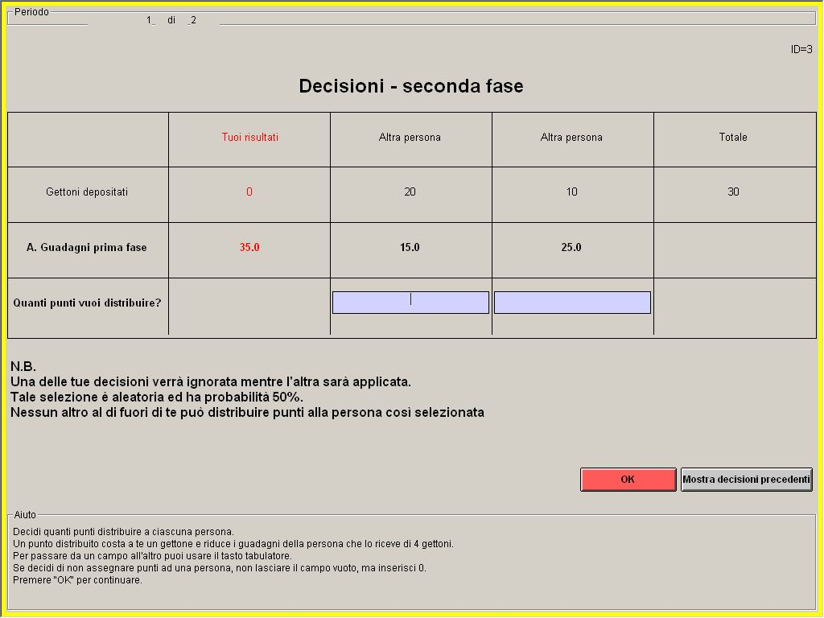
Of the two requests to distribute points, just one will be actually implemented while the other will be disregarded. This selection is made by the computer through a coin flip (random selection with probability 50%). When you make your choice you do not know which one of the two decisions will be selected.
Let us call the three persons ALPHA, BETA, and GAMMA. Suppose you are ALPHA and have distributed 2 points to BETA and 3 points to GAMMA. Just one of the following results will be carried out. With probability 50%, BETA’s earnings will be reduced by 8 tokens (2x4) and GAMMA’s earnings will not change. With probability 50% BETA’s earnings will not change while GAMMA’s earnings will be reduced by 12 tokens (3x4), (see figure below).

TWO DECISIONS
ALPHA BETA

GAMMA

ONE OF THE FOLLOWING RESULTS:
50% (random selection) 50% (random selection)
ALPHA BETA ALPHA BETA

GAMMA GAMMA

In phase two, everyone could receive points but from only one other person. If you have the opportunity to distribute points to BETA, nobody else will have that opportunity. If you have the opportunity to distribute points to GAMMA, nobody else will have that opportunity. In other words, if you do not distribute her points, nobody will have the opportunity to do it.
You will pay only the cost for the selected decision. Hence the overall cost for distributed points cannot be higher than 10 tokens. Your cost is always 0 if you do not distribute points to anybody.

Your overall period earnings are

Period earnings = phase one earnings – earning reduction – cost for points distributed
= phase one earnings – (received points)x4 – (actually distributed points)x4

Your final earnings are given by the sum of earnings in every period. Please notice that your period earnings can be negative. In that case they will be deducted from your cumulative earnings at the end of the experiment.
After everybody has completed his or her decision, you will learn phase two results. For each other person you will learn the earnings reduction due to point distributions. You will be informed about which one of your point distribution decisions was selected for implementation (asterisk in last row of the screen below). To protect anonymity, you will not know who distributed the points.

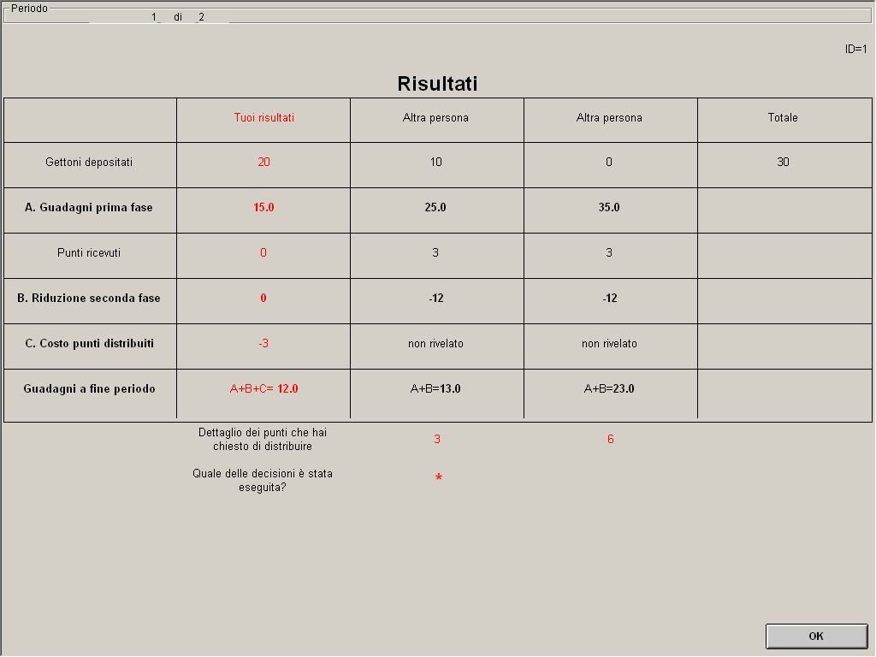

In the input screen you can press the “Show previous decisions” button to see a table with your choices and the choices of the others in previous periods.
Please record on paper, period by period, the decision you input into the computer.
Are there any questions?

QUIZ 2
- In phase two, you distribute points to the other two people as follow: 4, 1.
What is your total cost for distributing points? _____
- What is your cost if you distribute in total 0 points? _____
- Of how many tokens do your phase one earnings decrease if you receive in phase two in total 0 points from the other two people? _____
- Of how many tokens do your phase one earnings decrease if you receive in phase two in total 4 points from the other two people? _____

Date _______________ Time ____________ ID _______
Part two
Period | Tokens you deposited | Total tokens in the project | Phase one earnings (A) | Reduction for points received (B) | Cost for points distributed (C) | Period earnings  (A+B+C)

1 _________ _________ _________ - _________ - _________ _________
2 _________ _________ _________ - _________ - _________ _________
3 _________ _________ _________ - _________ - _________ _________
4 _________ _________ _________ - _________ - _________ _________
5 _________ _________ _________ - _________ - _________ _________
6 _________ _________ _________ - _________ - _________ _________
7 _________ _________ _________ - _________ - _________ _________
8 _________ _________ _________ - _________ - _________ _________
9 _________ _________ _________ - _________ - _________ _________
10 _________ _________ _________ - _________ - _________ _________

INSTRUCTIONS PART THREE

These are the instructions for the third and last part of the experiment. The third part consists of 10 periods and, as before, in each period you have to make a decision about the use of 20 tokens. As before, each period is composed of two phases. Phase one is identical to the procedure already described while phase two has different rules.
Phase one instructions do not change and hence you can refer back to the previous text. Only phase two instructions will now be read.

In phase two of a period you can reduce the earnings of each of the two persons that have benefited from the same project, or leave them unchanged.
Your decision is about distributing points. Every point you distribute reduces the earnings of a person by 4 (four) tokens. For the person who distributes it, every point has a cost of 1 token. You can distribute points separately to each of the other two people. If you do not wish to change the earnings of a specific person, you can choose 0. If you wish to reduce the earnings of a specific person, you can distribute to her a number of points from 0 through 10. You know only the decision made in phase one by the other people. There is no way for you to know either the identity or previous choices of the others.
For instance, if you distribute 2 points to a person and 3 points to another one, your overall cost is 5 tokens (2+3). Instead, if you choose 0 points for a person, you do not change her earnings. If you distribute 2 points to a person, you reduce her earnings by 8 tokens (2x4). The level of the earnings reduction depends on the sum of received points. If a person receives 2 points from somebody and 1 point from somebody else, her earnings are reduced by 12 tokens (((1+2)x4).

The distribution of points is carried out one person at a time in a sequence of two steps.
Each period can be described as follow:

Phase one Phase two

Step one Step two
(other person) (other person)

In step one, you decide how many points to distribute to a specific person. You are the first to decide if and how many points to distribute to this person. After you have chosen, somebody else will have the opportunity to distribute points to the same person.
After you have chosen how many points to assign to this specific person, you are asked to make a forecast about how many points the person who will decide after you will distribute in step two to the same person (see box in the screen below, outside the table). This forecast does not affect your earnings.

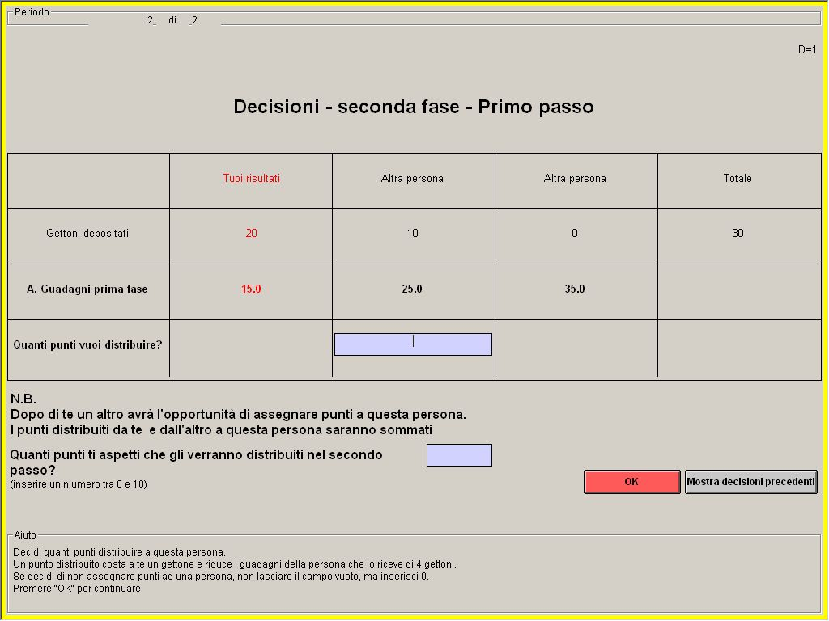

In step two you decide how many points to distribute to the other person in addition to those already received. You will learn the points already received in step one from the one-before-the-last line of the table reported below. After you, nobody else will have the possibility to distribute her points.

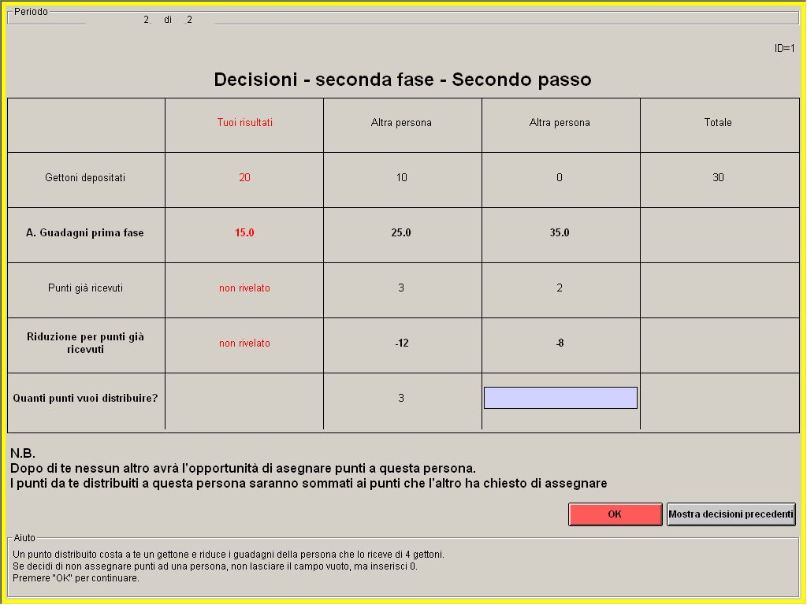

At the end of the two steps, every one of the persons that have benefited from the same project will have had the opportunity to distribute points to each one of the others.
Remember that the level of earning reduction depends on the sum of the points received in the first and the second step. Your overall cost in tokens is equal to the sum of the points that you have distributed to others. That cost cannot be higher than 20 tokens. (10 points times 2 people). Your cost is always 0 if you do not distribute points to anybody.

Your overall period earnings are
Period earnings = phase one earnings – earning reduction – cost for distributed points
= phase one earnings – (sum of received points)x4 – (total points distributed)x4

Please notice that your period earnings can be negative. In that case they will be deducted from your cumulative earnings at the end of the experiment.
After everybody has completed his or her decision, you will learn phase two results. For each other person you will learn the earning reduction due to point distributions.
After everybody has completed his or her decision, you will learn phase two results. For each other person you will learn the cumulative earning reduction due to point distributions. To protect anonymity, you will not know who distributed the points.
In the input screen you can press the “Show previous decisions” button to see a table with your choices and the choices of the others in previous periods.
Please record on paper, period by period, the decision you input into the computer.

Are there any questions?

QUIZ 3

- In phase two, you distribute points to the other two people as follow: 4, 1.
What is your total cost for distributing points? _____
- What is your cost if you distribute in total 0 points? _____
- Of how many tokens do your phase one earnings decrease if you receive in phase two in total 0 points from the other two people? _____
- Of how many tokens do your phase one earnings decrease if you receive in phase two in total 4 points from the other two people? _____

Date _______________ Time ____________ ID _______

Part three

Period | Tokens you deposited | Total tokens in the project | Phase one earnings (A) | Reduction for points received (B) | Cost for points distributed (C) | Period earnings  (A+B+C)

1 _________ _________ _________ - _________ - _________ _________
2 _________ _________ _________ - _________ - _________ _________
3 _________ _________ _________ - _________ - _________ _________
4 _________ _________ _________ - _________ - _________ _________
5 _________ _________ _________ - _________ - _________ _________
6 _________ _________ _________ - _________ - _________ _________
7 _________ _________ _________ - _________ - _________ _________
8 _________ _________ _________ - _________ - _________ _________
9 _________ _________ _________ - _________ - _________ _________
10 _________ _________ _________ - _________ - _________ _________

