Online material - Experimental instructions

You are about to take part in an experiment funded by several foundations for research purposes. During the experiment you will have the opportunity to make choices that will affect your earnings. The exact amount of your earnings will depend on your behavior and on the behavior of other participants. All the money you earn will be paid when the experiment is finished. The experiment is divided in two stages. At the beginning of each stage you will receive instructions that will explain the task to be performed.

STAGE 1

In the first stage you will have to perform a collective task. At the beginning of the experiment each subject has been assigned a colored bracelet. Subjects with the red bracelet belong to the Red group, while those with blue bracelet belong to the Blue group.
In the first stage of the experiment each group will have the opportunity to earn 30 euro by solving a simple problem. If the group is successful the amount earned will be distributed among all group members equally, otherwise nobody will gain anything.
To earn the prize, the group must be able to memorize at least 10 verses of a poem and to write them correctly on a sheet of paper that will be provided by the experimenters. You can keep the text of the poem for five minutes, during which you will try to memorize a sufficient number of verses. At the end of this period, the assistant will collect the text of the poem, and will give you a blank sheet of paper and a pen that you can keep for another five minutes, during which you will write the memorized verses. At the end of this period the assistant will collect the paper and check the correspondence with the text of the poem.
Note that:
• You can report on paper more than ten lines (to maximize the probability of success).
• Only verses that are reported correctly will count (for example verses with a wrong word are not valid, while minor misspelling do not count).
• If less than ten verses are correct the gain of the group is zero.
• If the correct verses are eleven or more, the gain of the group is still 30 euro.
The amount earned by the group will be divided among all members in equal shares and paid at the end of the experiment, along with the money earned in the other phases of the experiment.
Are there any questions?
STAGE 2

From this moment the second stage of the experiment begins. The instructions we have distributed are only for your personal use. Unlike in the first stage, it is forbidden to communicate with other participants. If you have any doubts or questions, please ask the assistants. If you do not stick to this rule, we will have to exclude you from the experiment and from additional money rewards.
During the second stage of the experiment you will have the opportunity to make choices that will affect your earnings. The exact amount of your earnings will depend on your decisions and the decisions of other participants. The choices made by each subject, however, will be completely anonymous. The anonymity will be maintained both during and after the experiment: all the money you earn will be paid privately at the end of the experiment.
Description of the task
We introduce now the situation you will face at this stage. Twenty subjects will participate in each experimental session. During the experiment each subject will play with other subjects randomly selected among the participants, and identified only by a role (auctioneer or competitor) and a color (Red or Blue, depending on the bracelet that you wear) that represents the group affiliation of each experimental subject.
Each subject will participate in a series of ten sealed bid auctions. Four competitors (two Red and two Blue) and an auctioneer (Red or Blue) participate in every auction. In each of the ten rounds the players will be grouped randomly, so each time you will play with potentially different opponents. The latter will be identified only by their role and their color, while their personal identity will remain strictly confidential. The role of each player and her color will remain fixed throughout this stage of the experiment.
At the beginning of each auction each competitor will have a budget of 60 cents to invest to win a prize worth 400 cents. The auctioneer will decide to assign the prize to one of the bidders.
In order to win the prize, each of the four bidders may offer a sum of money that does not exceed her budget (up to 60 cents). Bids will be made by typing a number from 0 to 60 in a screen like the one found on the next page.
Bids will be made “in a sealed envelope”, i.e. simultaneously, without communicating with other players, and without the ability to operate subsequent corrections. Bids will not be reimbursed: the amount of money offered will be subtracted from the budget of any bidder regardless of whether she has won the auction or not. In other words:
• Gain of the winner = 60 – bid + 400
• Gain of the other bidders = 60 – offer + 0

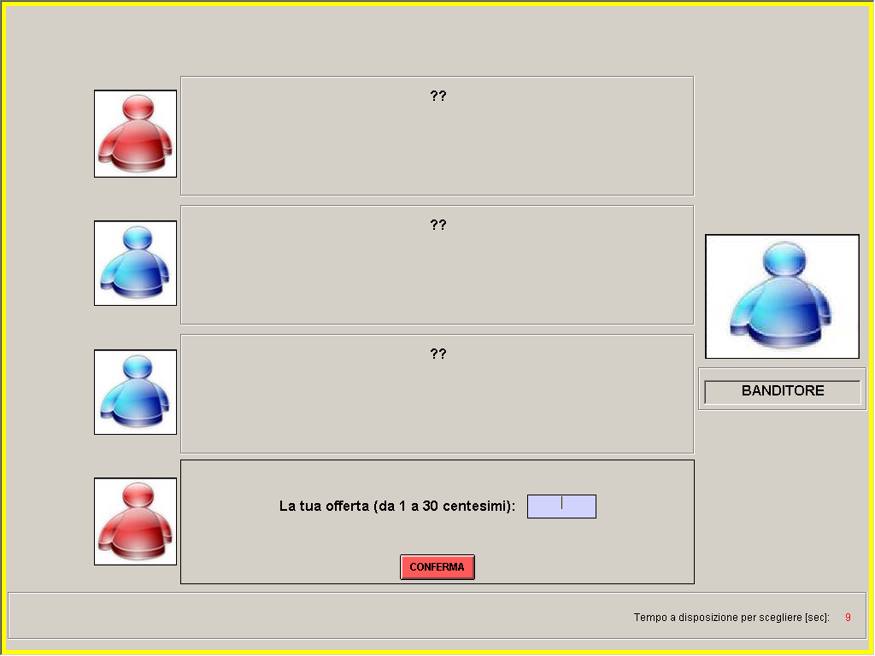

The auctioneer may award the prize to any bidder. Each bidder will be identified on her screen only by a number and by the color of her group (Red / Blue). (Note: Because the identity of competitors changes at every round, the subject identified as Player 1 in the first round will very likely not be the same person identified by the number 1 in the other rounds.)
The auctioneer will make his choice by typing the bidder’s number in a screen like this:

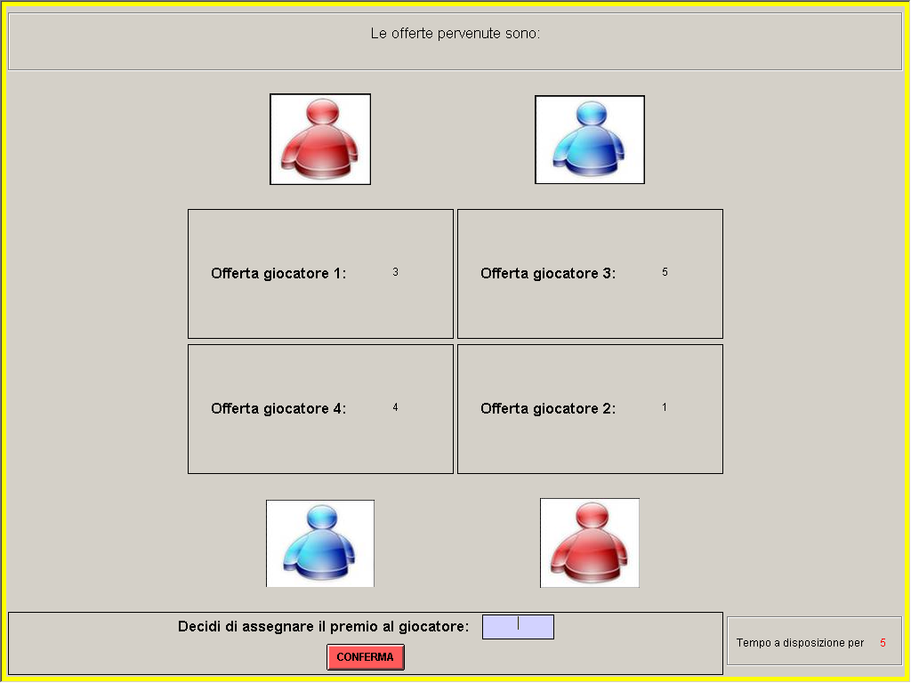

The auctioneer will earn a sum of money equal to the offer of the bidder who was awarded the prize (i.e. the winning bid) multiplied by three. In other words:
• Gain of the auctioneer = (winning bid × 3)
As mentioned, each subject will participate in ten subsequent auctions. At each round players will be grouped randomly, so that every subject might play with potentially different opponents in different rounds. At the end of each auction the color of the winner will be communicated. Each participant will also be notified the amount of money earned in that auction.
At the end of the experiment we will ask you to fill a short questionnaire. Then the experimenters will pay privately the money that you have earned during the experiment. You will be asked to sign a receipt, and then to leave the room quietly. We would be grateful if you will not discuss the experiment with other students after leaving the laboratory.

