Intermediaries in Corruption: An Experiment

Experimental Instructions
Intermediary Treatment

General instructions
Thank you all for coming today. You are here to participate in an experiment on individual decision-making. After playing the game you will be asked to complete a brief questionnaire. In addition to a $10 participation fee, you will be paid any money you accumulate from the game. You will be paid privately, by check, at the conclusion of the experiment. This study has been reviewed and approved by the FSU Human Subjects Committee. If you have any questions during the experiment, please raise your hand and wait for an experimenter to come to you. Please do not talk, exclaim, or try to communicate with other participants during the experiment. Participants intentionally violating the rules may be asked to leave the experiment and may not be paid.
Please read and sign the Consent form that you found on your desk. Please raise your hand if you have any question about any of the information on the Consent form. We will proceed with the experiment once we have collected all signed consent forms.
Detailed Instructions
You will be playing a simple game with the other participants in this room. The number that you have found on your desk is your identification number in the game. We won't ask you to write down your name at any time during this experimental session. At the end of the session, you will need to show your player number to the experimenter in order to receive the money that you collected while playing the game.
Earnings during the experiment will be denominated in Experimental Currency Units, or ECU. At the end of the game your earnings will be converted to dollars at the exchange rate of $1 for 4 ECU. The game you are going to play involves 4 players, each playing a different role. Your role will be either a Private Citizen, a Public Official, an Intermediary, or an Other Member of Society. You will be matched with three other participants, and roles will be anonymously and randomly assigned. At no point will you learn the identity of the other members from your group.
Each participant will have 35 ECU to start. The game proceeds as follows. First, the Private Citizen can pay a fee to the matched Intermediary to be given as a bribe to the Public Official with whom he or she is matched. While the Citizen makes his or her decision, the Public Official will decide, for each potential bribe amount, whether he would accept or reject the offer. If a fee is paid, the Intermediary will keep 1 ECU as a commission and must offer the remaining amount to the Public Official as a bribe on behalf of the Citizen. The Citizen can pay any amount between 2 and 21 ECU.
If the Private Citizen decides not to pay a fee to the Intermediary, all participants retain their initial endowment of 35 ECU.
If the Citizen decides to pay a fee to the Intermediary but the Public Official rejects the bribe offered by the Intermediary, the Public Official keeps the initial 35 ECU. The Private Citizen receives 34 ECU, which is the initial amount minus the commission to the Intermediary. That is, a rejected bribe is returned to the Citizen, but he or she loses the 1 ECU commission given to the Intermediary. The intermediary earns 36 ECU (initial 35 + 1 commission). The Other Member of Society keeps his or her initial 35 ECU.
If the private citizen decides to pay a fee to the Intermediary and the Public Official accepts the bribe offered by the Intermediary, the private Citizen receives 51 ECU -- 1 commission paid to the intermediary -- the bribe. The public official receives 30 ECU + the bribe. The Intermediary earns 36 ECU, as before. The Other Member of Society suffers a loss of 15 ECU, and therefore receives 20 ECU.
To summarize, in this game each Private Citizen decides whether or not to pay a fee to the Intermediary, knowing that the Intermediary will keep a commission equal to 1 and offer the remaining money as a bribe to the Public Official. The Public Official decides whether or not to accept the bribe offered by the Intermediary.
Note that if the Intermediary is paid a fee by the Citizen, he or she can only keep 1 ECU as commission and must offer the rest of the money to the Official as a bribe. In other words, the Intermediary cannot keep more than 1 ECU for him or herself and cannot refuse to offer the remaining money to the Official. The Other Member of Society does not make any decisions in this game. He or she suffers a loss of 15 ECU if the matched Citizen decides to pay a fee to the Intermediary and the Official accepts the bribe offered by the Intermediary. If no fee is paid or a bribe is rejected, the Other Member of Society retains the initial 35 ECU.
Now, we are going to work through some examples. Look at Table 1 that you have found on your desk. It is the same as the one here on the board. It is designed to help you to decide how to play the game. First, I am going to explain how to read the table. The first column on the left shows you all the possible amounts that the Intermediary could pay as a bribe to the Official if the Citizen pays him or her a few. Remember that the Intermediary will offer a bribe equal to the fee paid by the Citizen minus 1 ECU commission. So, in this top row the Intermediary is not offering a bribe to the Official. This happens when the Private Citizen decides not to pay a fee to the Intermediary. In the bottom row the Intermediary is offering a bribe equal to 20. This is because the Private Citizen has decided to pay a fee equal to 21ECU to the Intermediary. All the other possible bribes are listed in descending order. Note that the Citizen cannot pay a fee equal to 1 to the Intermediary, because such fee would leave the Intermediary no money to offer to the Official as a bribe.
To the right of this first column, you have two sets of three columns. The first set of three shows you what happens to the payoffs of the Private Citizen, the Public Official and the Other Member of Society if the Public Official accepts the bribe offered by the Intermediary. The second set of three shows you what happens to the payoffs of the Private Citizen, the Public Official and the Other Member of Society if the Public Official rejects the bribe offered by the Intermediary.

Payoff Table
 |  | The citizen pays a fee, the Intermediary offers the bribe and the Official decides to…
 |  | Accept |  |  | Reject
 |  | Private citizen | Public official | Other member of society | Private citizen | Public official | Other member of society
 | no bribe | 35 | 35 | 35 | 35 | 35 | 35
The Intermediary offers a bribe equal to…. | 1 | 49 | 31 | 20 | 34 | 35 | 35
The Intermediary offers a bribe equal to…. | 2 | 48 | 32 | 20 | 34 | 35 | 35
The Intermediary offers a bribe equal to…. | 3 | 47 | 33 | 20 | 34 | 35 | 35
The Intermediary offers a bribe equal to…. | 4 | 46 | 34 | 20 | 34 | 35 | 35
The Intermediary offers a bribe equal to…. | 5 | 45 | 35 | 20 | 34 | 35 | 35
The Intermediary offers a bribe equal to…. | 6 | 44 | 36 | 20 | 34 | 35 | 35
The Intermediary offers a bribe equal to…. | 7 | 43 | 37 | 20 | 34 | 35 | 35
The Intermediary offers a bribe equal to…. | 8 | 42 | 38 | 20 | 34 | 35 | 35
The Intermediary offers a bribe equal to…. | 9 | 41 | 39 | 20 | 34 | 35 | 35
The Intermediary offers a bribe equal to…. | 10 | 40 | 40 | 20 | 34 | 35 | 35
The Intermediary offers a bribe equal to…. | 11 | 39 | 41 | 20 | 34 | 35 | 35
The Intermediary offers a bribe equal to…. | 12 | 38 | 42 | 20 | 34 | 35 | 35
The Intermediary offers a bribe equal to…. | 13 | 37 | 43 | 20 | 34 | 35 | 35
The Intermediary offers a bribe equal to…. | 14 | 36 | 44 | 20 | 34 | 35 | 35
The Intermediary offers a bribe equal to…. | 15 | 35 | 45 | 20 | 34 | 35 | 35
The Intermediary offers a bribe equal to…. | 16 | 34 | 46 | 20 | 34 | 35 | 35
 | 17 | 33 | 47 | 20 | 34 | 35 | 35
 | 18 | 32 | 48 | 20 | 34 | 35 | 35
 | 19 | 31 | 49 | 20 | 34 | 35 | 35
 | 20 | 30 | 50 | 20 | 34 | 35 | 35

So, here are some examples [point to relevant cells as you go]:
1.1. Suppose that the Private Citizen decides to pay a fee equal to 3 ECU to the Intermediary. This means that the Intermediary will keep 1 ECU and will offer 2 ECU to the Public Official as a bribe. Then if the public official accepts the bribe, the Private Citizen receives 48 ECU (which is 51-1commission-the bribe equal to 2) from the experiment, the Public Official receives 32 ECU (which is 30+the bribe of 2), and the Other Member of Society receives 20 ECU (which is 35- the loss of 15). If, instead, the Public Official rejects the bribe offered by the Intermediary, the Citizen receives 34 ECU, which is the initial 35 minus the commission paid to the Intermediary, while the Public Official and the Other Member of Society each retain their initial 35 ECU.
1.2. Here is another example. Suppose that the Private Citizen decides to pay a fee equal to 13 ECU to the Intermediary. This means that the Intermediary will keep 1 ECU and will offer 12 ECU to the Public Official as a bribe. Then if the public official accepts the bribe, the Private Citizen receives 38 ECU (which is 51- 1 - 12) from the experiment, the intermediary receives 36 ECU (35+1 commission) the Public Official receives 42 ECU (which is 30 + the bribe of 12), and the Other Member of Society receives 20 ECU (which is 35-15). If, instead, the Public Official rejects the bribe offered by the Intermediary, the Citizen receives 34 ECU, which is the initial 35 minus the commission paid to the Intermediary; the Intermediary receives 36 ECU (35+1 commission), while the Public Official and the Other Member of Society retain their initial 35 ECU.
You will play this game only once.
Remember, none of you will know the identity of the participants with whom you are playing. You will now find out the role that you will play in this game on your computer screen. You will also receive additional information on how to play the game. Remember to use the payoff table to help you make your decisions in the game.
Are there any last questions before we begin? Just to remind you, if you have a question at any time during the experiment, please raise your hand and wait for the experimenter to come to you to answer your question in private. Please click Continue to see your role.

Private Citizen’s Screenshot

Public Official’s Screenshot
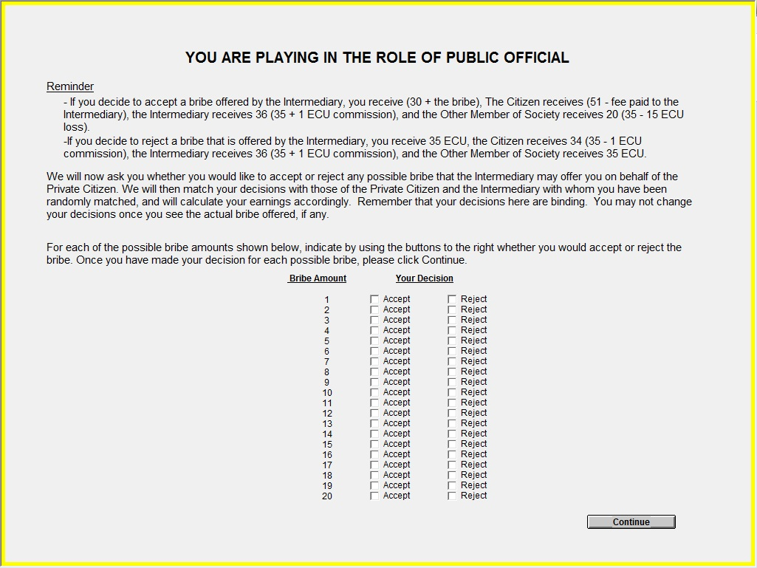
Note: By design, inconsistencies in the answers to the 20 questions above were not allowed.

