ELECTRONIC SUPPLEMENTARY MATERIAL – NOT FOR PUBLICATION
Supplementary Figures
Figure S1. Decision screen for the contribution table of the strategy method game without punishment.
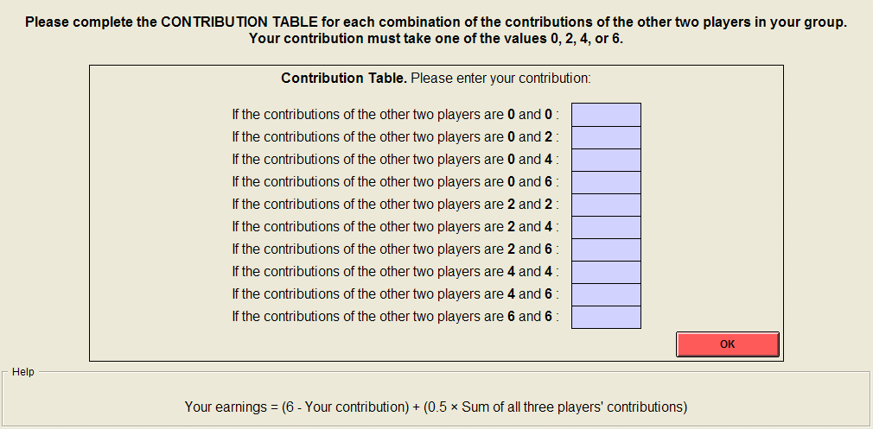
Figure S2. Sample decision screen showing one of the ten cases in the punishment stage of the strategy method game with punishment.
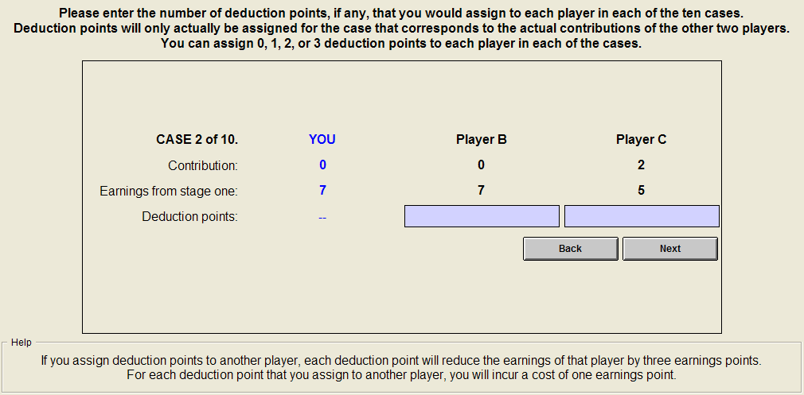
ELECTRONIC SUPPLEMENTARY MATERIAL – NOT FOR PUBLICATION
Instructions for the N-P Treatment Order
Horizontal rules denote the positions of page breaks in the original instructions.
Control questions were displayed on screen.
General information
Welcome to today’s session. In this session we will conduct two experiments on economic decision making. These experiments are simple, and if you read the instructions carefully and make good decisions, you may earn a considerable amount of money.
It is strictly prohibited to communicate with the other participants. If you violate this rule, you will be dismissed from the lab and forfeit all earnings. If you have any questions please raise your hand, and an experimenter will assist you.
In each of the two experiments, we will proceed through the following steps:
- Firstly, you will be given information about the decision situation for the experiment.
- You will then be asked to answer some questions at your computer to check that you fully understand the decision situation.
- Next, you will be given further instructions on how to use the computer screens to enter your decisions.
- Finally, you will enter your decisions into the computer.
At the end of the second experiment you will be given information about the results of your decisions in both experiments. After this, you will be asked to complete a questionnaire.
Throughout the session, your earnings will be calculated in “points”. At the end of the session, the total number of points you have earned will be converted into Australian Dollars and paid to you in cash. You will be paid for your decisions in both experiments.
The conversion rate will be 1 point = 1.5 Australian Dollars.
At the beginning of the session, you will have a starting balance of three points. This is in addition to the other points that you earn throughout the session.

First Experiment: decision situation
In this experiment, you will be in a group of three players, consisting of yourself and two others. All decisions will be made anonymously, and you will never learn the identity of the other two players in your group.
At the beginning of the experiment you will be given six points. (This is in addition to your starting balance of three points.) You have to decide how many of these six points you want to contribute to a project, and how many to retain for yourself.
You can choose to contribute 0, 2, 4, or 6 points to the project.
Each point that you do not contribute to the project will be automatically retained for yourself. The other two players will face the same decision situation.
Your earnings from this decision
Your earnings will depend on both your own decision, and the decisions of the other two players in your group. These earnings consist of two parts:
- Your earnings from the points you retain for yourself:
Your earnings from points you retain for yourself = 6 − Your contribution.
No-one other than you earns anything from the points you retain for yourself.
- Your earnings from the project. This is calculated as:
Your earnings from the project = 0.5 × Sum of all three players’ contributions.
All three players receive the same earnings from the project. For each point that anyone contributes to the project, the total earnings of the group therefore increase by 1.5 points.
Your contribution to the project thus increases the earnings of the other two players. At the same time, you also receive earnings as a result of the other players’ contributions.
Your total earnings are the sum of the points you retained and your earnings from the project:
Your earnings = (6 − Your contribution) + (0.5 × Sum of all three players’ contributions)
The earnings of the other two players are calculated in the same manner.

Please answer the following questions. These serve to check your understanding of the decision situation and earnings calculations. When everyone has completed all the questions correctly, we will explain how the experiment itself will take place.
If you have any questions, please raise your hand.
- Suppose that no-one contributes anything to the project.
- What are your earnings in points?
- What are the earnings of each of the other two players?
- Suppose that all three players each contribute 6 points to the project.
- What are your earnings in points?
- What are the earnings of each of the other two players?
- Suppose that you contribute 0 points, and the other two players each contribute 6 points.
- What are your earnings in points?
- What are the earnings of each of the other two players?
- Suppose that the other two players contribute a total of 8 points to the project.
- What are your earnings if you contribute 2 points?
- What are your earnings if you contribute 4 points?
- Suppose that you contribute 4 points to the project.
- What are your earnings if the other two players contribute a total of 4 points?
- What are your earnings if the other two players contribute a total of 8 points?

First experiment: Procedures
This experiment will take place only once. You will complete three tasks: an “unconditional” contribution, a “contribution table”, and your prediction of the contributions of the other participants in the laboratory.
Unconditional contribution
In the “unconditional” contribution decision, you simply indicate how many points you want to contribute to the project. You can contribute 0, 2, 4, or 6 points. You enter your decision by typing one of these numbers in the input field on your screen:
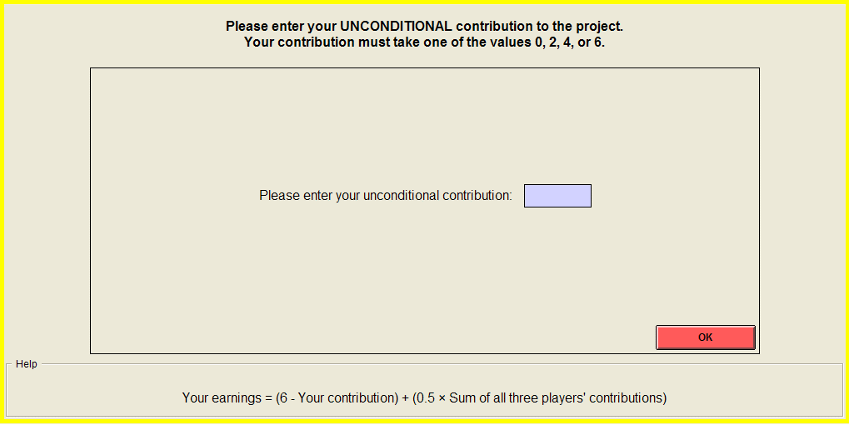
After you enter the amount you want to contribute, you must click the OK button. As long as you have not clicked OK, you can still change your decision. After you have clicked OK, your decision can no longer be revised.

Contribution table
In the “contribution table”, you indicate how many points you want to contribute to the project for every possible combination of the contributions of the other two players in your group. There are ten possible combinations, as you can see from the decision screen:
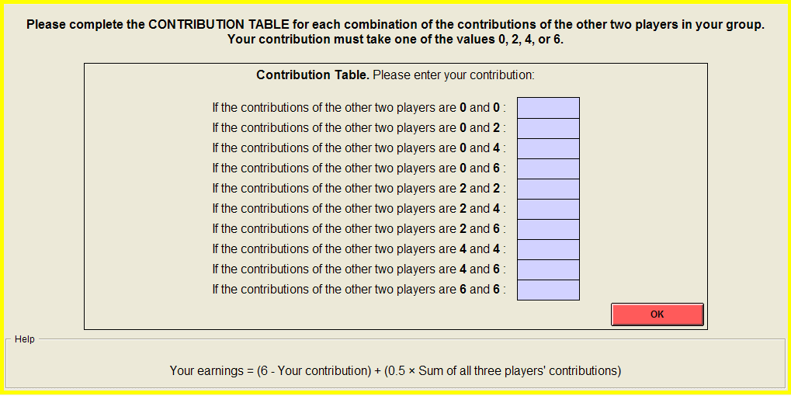
For each of the ten cases, you can choose to contribute 0, 2, 4, or 6 points to the project. You must make an entry in each of the ten input boxes. Once you have finished, please click OK.
Afterwards, the computer will randomly determine whether your unconditional contribution or your contribution table will be used to decide your earnings:
- For two of the three players in your group, the unconditional contribution will be used to decide that player’s contribution to the project.
- For the third player, the contribution table will be used. The computer will first look up the unconditional contributions of the first two players. It will then choose the appropriate contribution from the third player’s contribution table.
Your earnings will then be computed in the manner that was explained earlier:
Your earnings = (6 − Your contribution) + (0.5 × Sum of all three players’ contributions)
Since you do not know, at the time you make your decisions, whether your unconditional contribution or your contribution table will be used to decide your earnings, you should treat both sets of decisions as if they would count for your earnings.

Prediction of the other participants’ contributions
You can earn additional points by predicting the unconditional contributions of the other participants in the laboratory. In particular, you will be asked in how many cases out of 100 you think the other participants contributed 0, 2, 4, and 6 points:
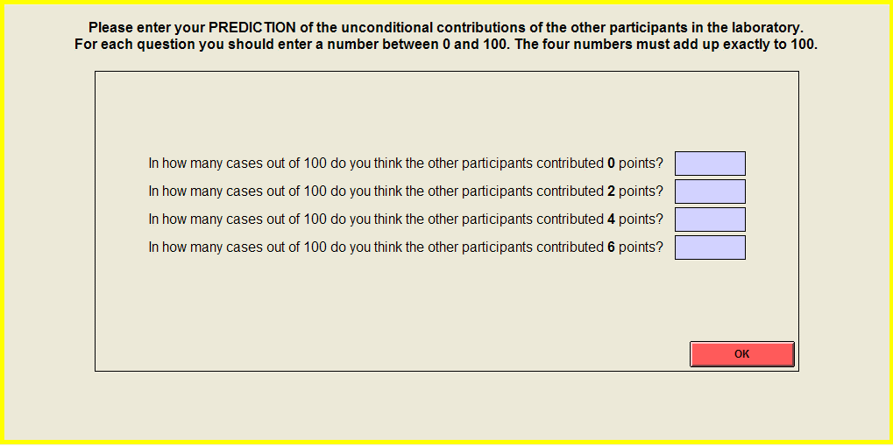
For each of the four contribution levels you should enter a number between zero and 100. These numbers must add up exactly to 100. Afterwards, the computer will compare your predictions to the actual unconditional contributions of the other participants in the laboratory.
You can earn up to two extra earnings points for your predictions. The closer your predictions are to the actual percentage of participants who chose each contribution level, the more you earn. You cannot lose points from making predictions; it is only possible to earn more points.
The formula that determines your earnings from your predictions is as follows:
where:
A = Percentage of the other participants who contribute 0, a = Your prediction of A,
B = Percentage of the other participants who contribute 2, b = Your prediction of B,
C = Percentage of the other participants who contribute 4, c = Your prediction of C,
D = Percentage of the other participants who contribute 6, d = Your prediction of D.

second experiment: Decision situation
We will now conduct a new experiment, in which there are some changes. You will complete this second experiment before you learn the results from the first experiment. After this, you will learn the results from both experiments and there will be no further experiments.
In this new experiment, you will be in a new group of three players, consisting of yourself and two others. Your new group will not include either of the players you were grouped with in the first experiment. Again, you will never learn the identity of the other two players.
The new experiment consists of two stages.
Stage one
Stage one is identical to the unconditional contribution in the first experiment. At the beginning of this stage you will again be given six points. You have to decide how many of these six points you want to contribute to a project, and how many to retain for yourself.
You can choose to contribute 0, 2, 4, or 6 points to the project.
Each point that you do not contribute to the project will be automatically retained for yourself. You will only make an unconditional contribution decision – there is no contribution table.
Your earnings from stage one will be computed in the same manner as in the first experiment:
Stage two
Stage two is new to this experiment. In this stage you can assign deduction points to reduce the earnings of one or both of the other players, or you can leave their earnings unchanged. The other players can also assign deduction points to reduce your earnings if they so wish.
You can assign 0, 1, 2, or 3 deduction points to each of the other two players.
If you assign deduction points to another player, each deduction point will reduce the earnings of that player by three earnings points. If you do not assign any deduction points to a player, then that player’s earnings will be unchanged.
For each deduction point that you assign to another player, you will incur a cost of one earnings point. If you do not assign any deduction points, you will not incur any costs.

Your earnings from these decisions
Your final earnings in this experiment will depend on your earnings from stage one, the number of deduction points you received from the other two players in your group, and the number of deduction points you assigned to them.
In particular, the computer will first take the number of deduction points (if any) you received from the other two players, and multiply this by three.
- If this amount (three times the number of deduction points you received) is no greater than your earnings from stage one, then your earnings will be reduced by this amount.
- Otherwise, if this amount is greater than your earnings from stage one, your earnings will be reduced to zero. Notice that this means that the deduction points you receive from the other players cannot cause you to suffer a loss.
After it has done this, the computer will then deduct the cost of any deduction points you assigned to the other two players. Notice that this means that you must always incur the cost of any deduction points you assign to the other players, even if this causes you to suffer a loss.
If your final earnings are negative, the loss will be taken out of the starting balance that you were given at the beginning of the session. Notice, however, that it is always possible to avoid such a loss for certain through your own decisions.
The earnings of the other two players will be calculated in the same manner.

Please answer the following questions. These serve to check your understanding of the decision situation and earnings calculations. When everyone has completed all the questions correctly, we will explain how the experiment itself will take place.
If you have any questions, please raise your hand.
- Suppose that you assign 3 deduction points to the second player and 0 deduction points to the third player.
- What cost do you incur to assign these deduction points?
- By how much will the earnings of the second player be reduced?
- By how much will the earnings of the third player be reduced?
- By how much will your earnings be reduced:
- If you receive a total of 1 deduction points from the other players?
- If you receive a total of 2 deduction points from the other players?

Second experiment: Procedures
This experiment takes place only once. You will complete four tasks: a contribution in stage one, a set of ten “cases” to assign deduction points in stage two, your prediction of the other participants’ contributions, and your prediction of the number of deduction points you receive.
Stage one contribution
In the contribution decision in stage one, you indicate how many points you want to contribute to the project. You can contribute 0, 2, 4, or 6 points.
In this experiment you only make an unconditional contribution decision – there is no contribution table. This means that the amount you enter in the contribution screen will for certain be your contribution to the project.
Stage two deduction cases
In the second task, you indicate how many deduction points, if any, you want to assign to each of the other two players.
When you assign deduction points, you will not know the actual contributions of the other two players. Instead, you will assign deduction points for ten cases, corresponding to all ten possible combinations of the other two players’ contributions.
Of the two other players in your group, we refer to the one who contributes less to the project as “Player B”, and the one who contributes more as “Player C”. Then the ten cases are:
 | Player B’s  contribution | Player C’s  contribution
Case 1 | 0 | 0
Case 2 | 0 | 2
Case 3 | 0 | 4
Case 4 | 0 | 6
Case 5 | 2 | 2
Case 6 | 2 | 4
Case 7 | 2 | 6
Case 8 | 4 | 4
Case 9 | 4 | 6
Case 10 | 6 | 6

You can assign up to three deduction points to each player in each of the ten cases. These deduction points will only actually be allocated for one of the ten cases. This is the case that corresponds to the actual contributions of the other two players.
For each case, you will complete a decision screen similar to the one shown for Case 1:
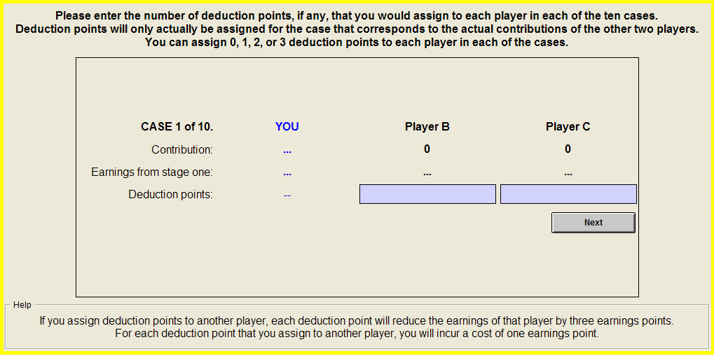
In each of the ten cases, your own contribution is always the amount you chose in stage one. In the actual experiment, each decision screen will show your own contribution in the first column, and you will also be able to see the earnings from stage one for each of the players.
For each of the cases, you must decide how many deduction points, if any, you want to assign to Player B and Player C. You must enter a number for each of the players. If you do not wish to reduce the earnings of a player, then you must enter “0”.
You can use the “Next” and “Back” buttons to move between the ten cases. The “OK” button appears after you have filled in all ten cases. As long as you have not clicked “OK”, you can change any of your decisions. After you click “OK”, your decisions can no longer be revised.
Afterwards, the computer will look up the stage one contributions of the other two players in your group. From this, it will determine which of the ten cases is the relevant one and use your decisions from that case to assign deduction points to the other two players.
The computer will also do the same for the two other players in your group. In this way it will determine how many deduction points, if any, you receive from each of the other players. Your earnings will then be computed in the manner that was explained previously.

Prediction of the other participants’ contributions
You can again earn additional points by predicting the contributions of the other participants in the laboratory. As before, you will be asked in how many cases out of 100 you think the other participants contributed 0, 2, 4, and 6 points in the second experiment.
For each of the four contribution levels you should enter a number between zero and 100. These numbers must add up exactly to 100. Afterwards, the computer will compare your predictions to the actual contributions of the other participants in the laboratory.
You can earn up to two extra earnings points for your predictions. The closer your predictions are to the actual percentage of participants who chose each contribution level, the more you earn. You cannot lose points from making predictions; it is only possible to earn more points.
The formula that determines your earnings from your predictions is the same as before:
where:
A = Percentage of the other participants who contribute 0, a = Your prediction of A,
B = Percentage of the other participants who contribute 2, b = Your prediction of B,
C = Percentage of the other participants who contribute 4, c = Your prediction of C,
D = Percentage of the other participants who contribute 6, d = Your prediction of D.
Prediction of deduction points received
Finally, you will be asked to predict the total number of deduction points assigned to you by the other two players in your group. This must be a number between zero and six. Afterwards, the computer will compare your prediction to the actual number of deduction points you received.
You can earn up to one extra earnings point for your prediction. The closer your prediction is to the total number of deduction points the other players assigned to you, the more you earn. You cannot lose points from making predictions; it is only possible to earn more points.
The formula that determines your earnings from your prediction is as follows:
where X is the actual number of deduction points you received, and x is your prediction of X.

