Instructions for the “Favor Trading in Public Good Provision” Experiment

There are four components to the instructions: the General Instructions, which are read at the start of the experiment; and then the specific instructions for each of three treatments. Each treatment’s instructions starts with the text, “Instructions for the [next] set of rounds.” In this Appendix, the name of the treatment is noted on the same line of text, although the treatment name was not included in the instructions the subjects saw. Otherwise, except for details of pagination, these instructions are identical to those provided to the subjects.

General Instructions
Welcome to the experiment! This is a study of decision-making behavior. It will last about two hours.
Complete Privacy
This experiment is structured so that no one, including the experimenters and the other participants, will ever know the decisions or earnings of anyone in the experiment. You will collect your earnings, in a sealed envelope, from a numbered mailbox that only you will have the key for. Your privacy is guaranteed because neither your name nor your student ID number will appear on any form that records your decisions or your earnings. The only identifying mark that will be used is the identification number on the mailbox key that you will select. Each key opens a mailbox in the hallway adjacent to this room. After the experiment, you will each collect your payment from your mailbox alone and privately. The key and mailbox are labeled with the same identification number. You are the only person who will know your identification number.
Random Group Assignments and Anonymity
Each person will be randomly matched with 4 other people to form a 5-person group. No one will learn the identity of the people in his/her group. The composition of your group will change after a number of rounds, and you will be randomly matched in a new group of 5 people (you and 4 others). You will be notified when the groups have been rearranged. Once you are matched with a group, you will learn how many rounds you will play with this group. In total, you will play in 3 different 5-person groups.
Your Payment
In each round of the experiment, you will make a decision. What you earn in each round will depend on decisions that you and the other 4 people in your group make. Your payment for this experiment will be the sum of your earnings in all rounds.
The Task
For each decision, you will choose how to divide 20 tokens between two funds: the Personal Fund and the Group Fund. You are free to contribute some of your tokens to the Personal Fund and some to the Group Fund. Alternatively, you can contribute all of them to the Personal Fund, or all of them to the Group Fund. You will earn money from the tokens you put in each fund (below we describe how). Your total earnings for each round is the sum of your earnings from the Personal Fund plus your earnings from the Group Fund.
- The Personal Fund: each token you contribute to the Personal Fund will earn you $0.02.
Example: Suppose you contribute 0 tokens to the Personal Fund. Then you would earn nothing from the Personal Fund.
Example: Suppose you contribute 10 tokens to the Personal Fund. Then you would earn $0.20 from the Personal Fund.
Example: Suppose you contribute 20 tokens to the Personal Fund. Then you would earn $0.40 from the Personal Fund.
- The Group Fund: What you earn from the Group Fund will depend on the total number of tokens that you and the other 4 members of your group contribute to the Group Fund. Every token any member of your group puts in the Group Fund earns money for each member of the group, but not everyone will earn the same amount of money.
Before we explain more about the earnings from the Group Fund, you must learn about the Stakeholder. In each round, one member of your group will be the Stakeholder. This person earns more money (relative to the rest of the group) from all of the tokens in the Group Fund. You will always know whether you are the Stakeholder. If you are not the Stakeholder, you earn $0.01 for each token any member of your group puts in the Group Fund. If you are the Stakeholder, you earn $0.03 for every token any member of your group puts in the Group Fund.
Example: Suppose you contribute 0 tokens to the Group Fund and no one else contributes any tokens to the Group Fund. Then you would earn nothing from the Group Fund. Everyone else in your group would also earn nothing from the Group Fund.
Example: Suppose you contribute 13 tokens to the Group Fund and no one else contributes any tokens to the Group Fund. Suppose that you are the Stakeholder. Then you would earn $0.39 from the Group Fund. Everyone else in your group would earn $0.13 each from the Group Fund.
Example: Suppose you contribute 20 tokens to the Group Fund and no one else contributes any tokens to the Group Fund. Suppose that you are not the Stakeholder. Then you would earn $0.20 from the Group Fund. The Stakeholder would earn $0.60 from the Group Fund. All of the other members of your group would earn $0.20 each from the Group Fund.
Everyone will earn money from every token contributed to the Group Fund, whether they contribute tokens to the Group Fund or not.
Decision Panel
For each decision, you will enter your Group Fund contribution in the Decision Panel. The Decision Panel is a box at the bottom of the screen that looks like the following:
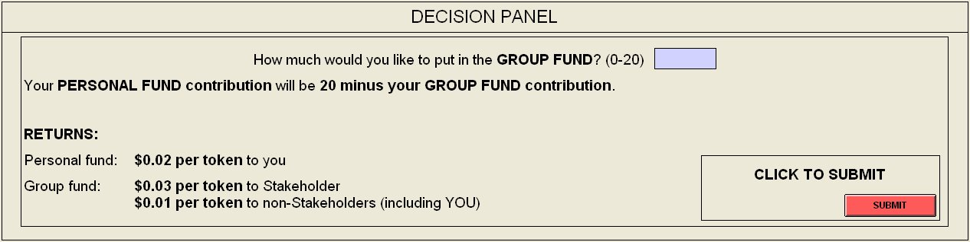
Type the amount you want to put in the Group Fund in the box. This must be a number between 0 and 20. The amount that will go into your Personal Fund is 20 minus the amount you type. For example, if you type the number 0, 0 tokens will go into the Group Fund and 20 into the Personal Fund. If you type 6, 6 tokens will go into the Group Fund and 14 into the Personal Fund. If you type 13, 13 tokens will go into the Group Fund and 7 into the Personal Fund.
When you are satisfied with the allocation of tokens you entered, you will click the “SUBMIT” button to submit your allocation.
Contributions Table
The Contributions Table gives you information about what has happened in past rounds and what will happen in future rounds. The table will show all of the rounds you will play with your current group, and will indicate when you will be the Stakeholder. Also, after everyone has made their decisions for a round, the table will tell you what the Group Fund contributions were in that round, and what your earnings were.
The table will change slightly in different parts of the experiment. Before each part starts, you will receive specific instructions and you will see what the table will look like.
Each Round Has Two Steps
In each Round, you will proceed through two screens, one after the other. The first screen is the decision screen. In the decision screen, you will make your decision and click the “SUBMIT” button when you are done. After everyone has clicked “SUBMIT”, everyone will proceed to the review screen.
The review screen will look very much like the decision screen, but you will have no decision to make. You will see information about the decisions that were made in that round and previous rounds, and you will learn how much money you earned in that round. In the Decision Panel of the review screen, you will see exactly how your earnings for that round were calculated. When you are done reviewing this information, you must click “DONE” to continue.
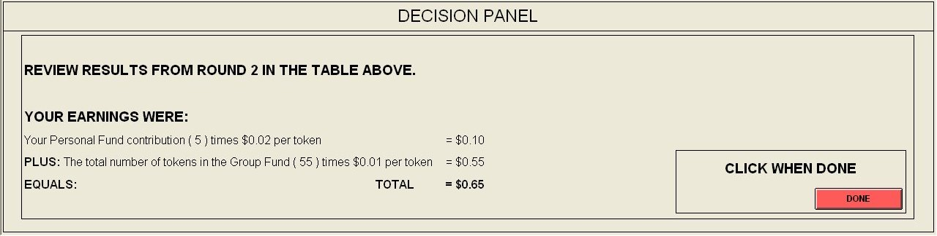
The information in the Contributions Table will stay in the table through all rounds you play with the group, in both the decision and review screens
Questionnaire and Payment
After you have finished all of your decisions, you will complete a brief questionnaire. Then you will receive payment anonymously and privately, and the session will be over. You will collect your payment with no one watching, and no one else will learn your earnings.

QUIZ
Case 1: Suppose out of your 20 tokens you contributed 5 tokens to the Personal Fund and 15 tokens to the Group Fund. Suppose that the other 4 members of your group together contribute a total of 60 tokens to the Group Fund. Returns for the two Funds are:
Personal Fund: $0.02 per token to you
Group Fund: $0.03 per token to Stakeholder
$0.01 per token to non-Stakeholders

- How much do you earn from the Personal Fund? _________
- How many tokens in total were contributed by your group to the Group Fund? _________
- If you ARE the Stakeholder, how much do you earn from the Group Fund? _________
- If you ARE the Stakeholder, how much do each of the other members of your group earn from the Group Fund? _________
- If you ARE the Stakeholder, how much do you earn altogether? _________
- If you ARE NOT the Stakeholder, how much do you earn from the Group Fund? _________
- If you ARE NOT the Stakeholder, how much does the group’s Stakeholder earn from the Group Fund? _________
- If you ARE NOT the Stakeholder, how much do each of the group’s other non-Stakeholders earn from the Group Fund? _________
- If you ARE NOT the Stakeholder, how much do you earn altogether? _________

Case 2: Suppose out of your 20 tokens you contributed 20 tokens to the Personal Fund and 0 tokens to the Group Fund. Suppose that the other 4 members of your group together contribute a total of 8 tokens to the Group Fund. Returns for the two Funds are:
Personal Fund: $0.02 per token to you
Group Fund: $0.03 per token to Stakeholder
$0.01 per token to non-Stakeholders

- How much do you earn from the Personal Fund? _________
- How many tokens in total were contributed by your group to the Group Fund? _________
- If you ARE the Stakeholder, how much do you earn from the Group Fund? _________
- If you ARE the Stakeholder, how much do each of the other members of your group earn from the Group Fund? _________
- If you ARE the Stakeholder, how much do you earn altogether? _________
- If you ARE NOT the Stakeholder, how much do you earn from the Group Fund? _________
- If you ARE NOT the Stakeholder, how much does the group’s Stakeholder earn from the Group Fund? _________
- If you ARE NOT the Stakeholder, how much do each of the group’s other non-Stakeholders earn from the Group Fund? _________
- If you ARE NOT the Stakeholder, how much do you earn altogether? _________

Instructions for the First Set of Rounds (PUBLIC TREATMENT)
- You will now be randomly assigned by the computer into groups of 5 people.
- You will be with the same group for 10 rounds.
- Each member of your group will be randomly assigned a new, different letter code that you will keep for these 10 rounds: A, B, C, D, or E.
- The Stakeholder position will rotate through all 5 members of the group, in alphabetical order (A, then B, then C, etc.). Each member of the group will be Stakeholder twice.
- You will always know who is currently Stakeholder, when you are going to be Stakeholder, and when each other member of your group (identified by their letter code) will be Stakeholder, because the Stakeholder position will be marked in the Contributions Table and in the status bar.
- In each round, you must decide how many of 20 tokens to put in the Personal Fund and how many in the Group Fund.
- When you have made your decision (by typing how many tokens (0 to 20) you want to put in the Group Fund), you must click “SUBMIT”.
- The Contributions Table will show, for each past round:
  - what each member (identified by letter code) has contributed to the Group Fund; that is, there will be a column in the table corresponding to each group member, and that member’s contributions for each round will be filled in after the round
  - the total number of tokens in the Group Fund
  - your earnings
- You will be able to tell what each group member contributed in each round; they will also be able to tell what you contributed in each round.
- The table will indicate in which rounds each person will be the Stakeholder by marking those rounds in each person’s column with red, underlined stars (*****).
- You will see which column corresponds to you because your column will say the word YOU above it. Each person has YOU marked at the top of their own column.
- Also at the top of each table, in each round, the word Stakeholder will appear in red above the column of the person who is the Stakeholder in this round.
- After everyone has made their decisions for each round, you may examine the Contributions Table and the calculation of your earnings in the review screen. Click “DONE” when you are ready to move on to the next round.
When you are entering your contribution, the screen will look like this:
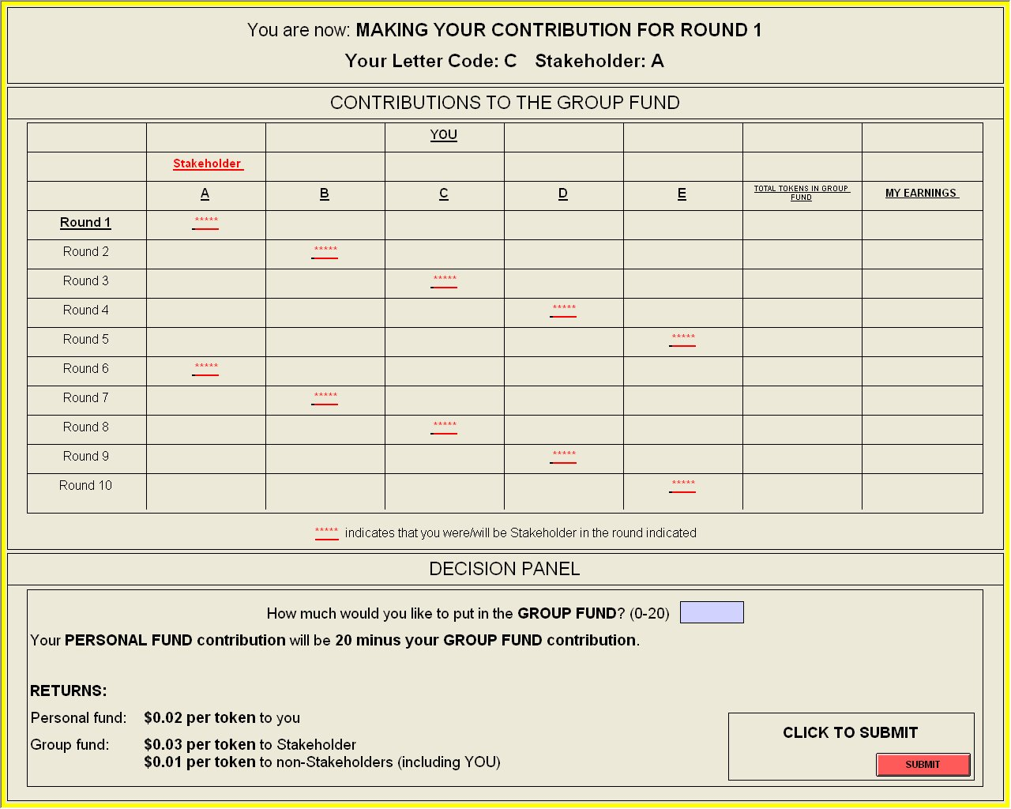
When you are reviewing your results, the screen will look like this:
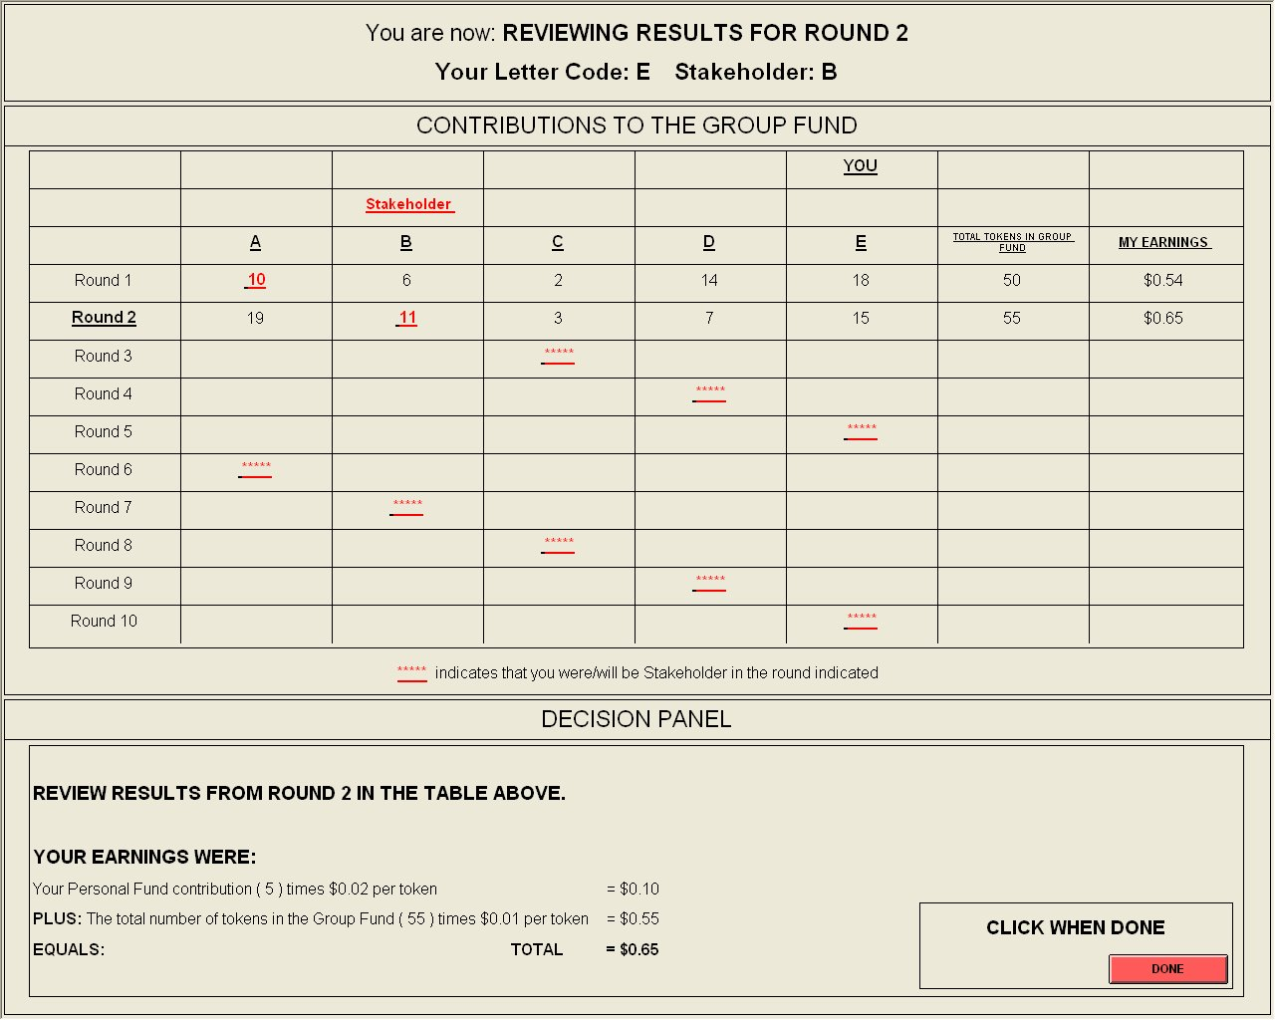

Instructions for the Second Set of Rounds (PRIVATE TREATMENT)
- You will now be randomly assigned by the computer into groups of 5 people.
- You will be with the same group for 10 rounds.
- All 5 members of the group will be Stakeholder twice.
- You will only know when YOU are the Stakeholder—you will not know which group member is the Stakeholder in any given round if it is not you.
- In each round, you must decide how many of 20 tokens to put in the Personal Fund and how many in the Group Fund.
- When you have made your decision (by typing how many tokens (0 to 20) you want to put in the Group Fund), you must click “SUBMIT”.
- The Contributions Table will show, for each past round:
  - what you have contributed to the Group Fund
  - a list of the Group Fund contributions of the other members of your group; these contributions will be listed in a random order that is reshuffled for each round
  - the total number of tokens in the Group Fund
  - your earnings
- No one will not be able to track any other individual group member’s contributions.
- The table will indicate in which rounds you will be the Stakeholder by marking those rounds in your column with red, underlined stars (*****).
- After everyone has made their decisions for each round, you may examine the Contributions Table and the calculation of your earnings in the review screen. Click “DONE” when you are ready to move on to the next round.
When you are entering your contribution, the screen will look like this:
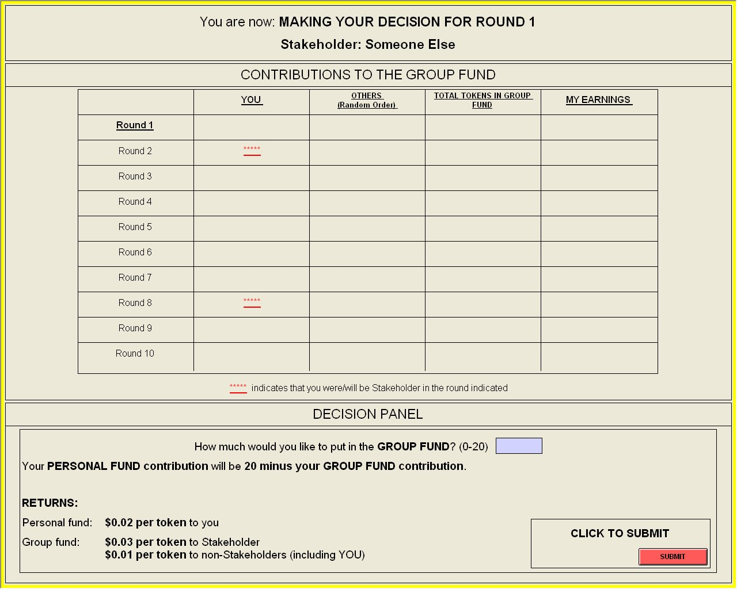
When you are reviewing your results, the screen will look like this:
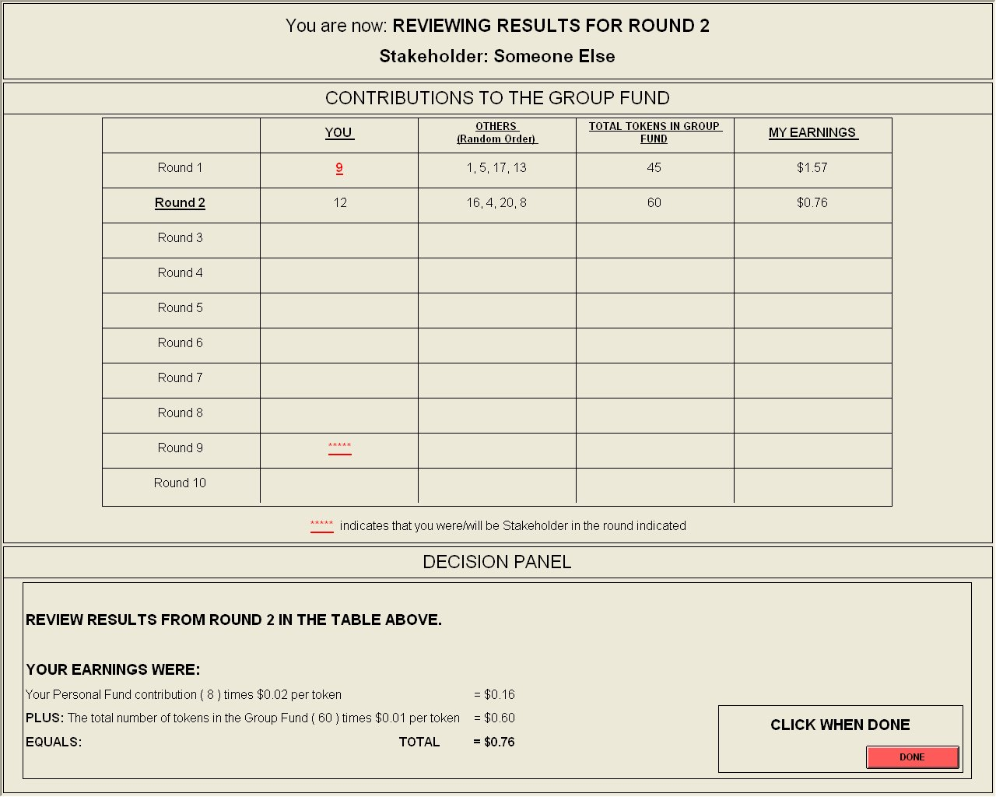

Instructions for the Third Set of Rounds (INELIGIBLE TREATMENT)
- You will now be randomly assigned by the computer into groups of 5 people.
- You will be with the same group for 8 rounds.
- Each member of your group will be randomly assigned a new, different letter code that you will keep for these 8 rounds: A, B, C, D, or E.
- The Stakeholder position will rotate through 4 of the 5 members of the group.
- The one person in your group who will never be the Stakeholder is the Ineligible Person. This person is randomly selected at the start of this set of rounds, and will be Ineligible (will never be the Stakeholder) for all 8 rounds. The Ineligible Person is identified to all group members in the Contributions Table and in the text in the status bar.
- The Stakeholder position rotates through the four eligible members of the group for all 8 rounds, in alphabetical order. For example, if person C is randomly chosen as Ineligible, the first Stakeholder will be person A, the second will be B, the third will be D, etc.
- Everyone who is not Ineligible will be Stakeholder twice.
- You will always know who is currently Stakeholder, when you are going to be Stakeholder, and when each other member of your group (identified by their letter code) will be Stakeholder, because the Stakeholder position will be marked in the Contributions Table and in the status bar.
- In each round, you must decide how many of 20 tokens to put in the Personal Fund and how many in the Group Fund.
- When you have made your decision (by typing how many tokens (0 to 20) you want to put in the Group Fund), you must click “SUBMIT”.
- The Contributions Table will show, for each past round:
  - what each member (identified by letter code) has contributed to the Group Fund; that is, there will be a column in the table corresponding to each group member, and that member’s contributions for each round will be filled in after the round
  - the total number of tokens in the Group Fund
  - your earnings
- You will be able to tell what each group member contributed in each round; they will also be able to tell what you contributed in each round.
- The table will indicate in which rounds each person will be the Stakeholder by marking those rounds in each person’s column with red, underlined stars (*****).
- You will see which column corresponds to you because your column will say the word YOU above it. Each person has YOU marked at the top of their own column.
- Also at the top of each table, in each round, the word Stakeholder will appear above the column of the person who is the Stakeholder in this round.
- The word Ineligible will appear above the column of the Ineligible person.
- After everyone has made their decisions for each round, you may examine the Contributions Table and the calculation of your earnings in the review screen. Click “DONE” when you are ready to move on to the next round.
When you are entering your contribution, the screen will look like this:
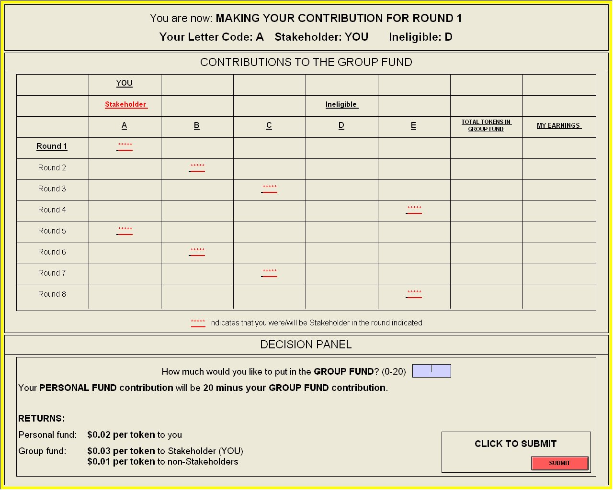
When you are reviewing your results, the screen will look like this:
