Appendix A: Experimental Instructions Game Order ACB

Instructions
This is an experiment on the economics of decision making. In addition to your participation fee, you will have the chance to earn money based on your decisions in this experiment. It is extremely important that you put away all materials including external reading material and turn off your cell phones and any other electronic devices. If you have a question, please raise your hand and I or one of my assistants will come by and answer your question privately.

You will be randomly and anonymously assigned to be in either group A or group B. You will remain in this group for the entire experiment. Each person in group A will be matched with another person from group B as his/her “other-group counterpart”. So, if you are in group A, you will have a counterpart in group B. Today’s experiment will last for 30 periods which are divided into 3 parts of 10 periods. The following instructions are for periods 1 – 10. Prior to the start of period 11, additional instructions will be given.
At the start of each decision period, you will face a decision and will be matched with two people from your group (so, if you are in group A, you are matched with two other group A individuals from the decision task, even though you will still have an assigned counterpart in group B). You will be randomly re-matched with a different pair of people for each decision. You will never be told who you are matched with in your group.
Today’s experiment will last for 30 periods which are divided into 3 parts of 10 periods. The following instructions are for periods 1 – 10. Prior to the start of period 11, additional instructions will be given.
At the start of each decision period, you will face a decision and will be matched with two people from your group (so, if you are in group A, you are matched with two other group A individuals from the decision task, even though you will still have an assigned counterpart in group B). You will be randomly re-matched with a different pair of people for each decision. You will never be told who you are matched with in your group.
In each period, you will be given 10 tokens. Your task is to decide how many tokens to allocate to a group account and how many to allocate to an individual account. You can allocate anywhere from 0 to 10 tokens to each account, but the total allocated to both must sum to 10. (Negative allocations or fractional allocations are not allowed). Each token allocated to the individual account will generate a $0.025 payoff to you and you alone. Each token allocated to the group account, however, will generate $.0125 to you and $.0125 to each of the other two members of your group. Similarly, when other members of your group allocate their tokens into their individual accounts, it generates a payoff to that person and no one else. But, for each token another member of your group allocates to the group account, this generates $.0125 for each member of the group, including you. So, your total earnings in each period are equal to $.025 times the number of tokens you allocate to your individual account plus $.0125 times the total number of tokens you and the other members of your group place in the group account.
Let’s go through some examples. Suppose you allocated 5 tokens to the individual account, 5 tokens to the group account and the total in the group account was 12 tokens (implying that the other two members of your group allocated a total of 7 tokens to the group account). In this example, your payoff would be $.025 times the 5 tokens you allocated to your individual account plus $.0125 times the 12 total tokens in the group account, for a total payoff of $.025*5 + $.0125*12 = $.28
If, on the other hand, you allocated 10 tokens to the individual account, 0 tokens to the group account and the total in the group account was 12 tokens, your payoff would be $.025 times the 10 tokens you allocated to your individual account plus $.0125 cents times the 12 tokens in the group account, for a total payoff of $.025*10 + $.0125*12 = $.40
As a final example, suppose you allocated 0 tokens to your individual account and the total tokens in the group account is 25. In this case, your earnings would be just the $.0125 times the 25 tokens in the group account (since you allocated no tokens to your individual account), for a payoff of $.0125*25 = $.32.
The members of group A will make their decisions first and then the members of group B will make their decisions. After all of the members of group B have made their decisions (i.e., allocations), a screen will be displayed showing the results of the period and your payoff for that period. No one else will see this results screen or how much your earnings are for the period.
Summary: You will need to decide how many of your 10 tokens to allocate to your group and individual accounts in each decision period. Your total payoffs in each period are equal to $.025 times the number of tokens you allocate to your individual account plus $.0125 times the total number of tokens you and the other group members allocate to the group account. The members of this group will be re-randomized after every decision period.

These instructions are for periods 11-20. Additional instructions will be given prior to the start of period 21.
The task is similar in this part except both members of group A and group B have a 50% chance of being punished $.125 if they do not allocate at least 5 tokens to the group account. For instance, if you allocated 6 tokens to the individual account and 4 tokens to the group account, there is a 50% chance you will lose $0.125. This chance can be thought of like flipping a coin. If you allocated less than 5 tokens and the computer flips a coin and it is heads, you lose $.125, if it is tails, then nothing is subtracted from your payoff. On the other hand, if you allocate 5 or more tokens to the group account, there is no possibility of being punished. (note: whether punished or not, you would still earn $.025 for each token in you individual account plus $.0125 times the total number of tokens in the group account. Punishment, if it occurs, would simply subtract $.125 from your payoff for that decision period).
Again, at the start of each period, you will be matched with two people from your group for the task. In addition to this, each person in group A will be matched with the same person from group B as his/her “other-group counterpart”. So, if you are in group A, you will have a counterpart in group B. You keep the same counterpart from the other group for decision periods 11-20. Each decision period will be the same in that group A subjects will make their allocations first. Following group A allocations, group B will be shown if their counterpart in group A was punished or not (but not what their counterpart’s exact allocation choice was) and how many times they have been punished. After all of the members of group B have made their decisions, a results screen will be displayed showing the results of the decision period. This is repeated for 10 periods. The only thing that is changed for this part is that members of both group A and group B face the possibility of getting punished if placing less than 5 tokens in the group account and subjects in group B will observe if their group A counterpart was punished or not and how many times they have been punished.

These instructions are for periods 21-30.
The task and payoffs in this set of decision periods is similar to before except that if you are in group A there is a 50% chance you will be punished $.125 if you do not allocate at least 5 tokens to the group account. As a reminder, if you are in group A and you allocated 6 tokens to the individual account and 4 tokens to the group account, there is a 50% chance you will lose $0.125. This chance can be thought of like flipping a coin. If you allocated less than 5 tokens and the computer flips a coin and it is heads, you lose $.125, if it is tails, then nothing is subtracted from your payoff. On the other hand, if you allocate 5 or more tokens to the group account, there is no possibility of being punished. (note: whether punished or not, you would still earn $.025 for each token in you individual account plus $.0125 times the total number of tokens in the group account. Punishment, if it occurs, would simply subtract $.125 from your payoff for that decision period). If you are in group B, you will not be punished, no matter what your allocation of tokens is.
Again, at the start of each period, you will be randomly matched with two people from your group for the decision task. In addition to this, each person in group A will be matched with someone from group B as his/her “other-group counterpart”. So, if you are in group A, you will have a counterpart in group B. You keep the same counterpart from the other group that you had previously for decision periods 21-30. Each decision period will be the same in that group A subjects will make their allocations first. Following group A allocations, group B will be shown if their counterpart in group A was punished or not (but not what their counterpart’s exact allocation choice was) and how many times they have been punished. After seeing this information, group B subjects will make their allocation decisions. After all of the members of group B have made their decisions, a results screen will be displayed showing the results of the decision period. This will be repeated for 10 periods. The only thing that is different in these periods compared to periods 11-20 is that members of group A face the possibility of getting punished if placing less than 5 tokens in the group account and their counterparts from group B will observe if their group A counterpart was punished or not and how many times they have been punished before they make their own allocation decisions (and group B subjects will not face any possibility of being punished, regardless of their allocation decision).

Appendix B: Screenshots

A decision screen of a subject in group 2 in Game B
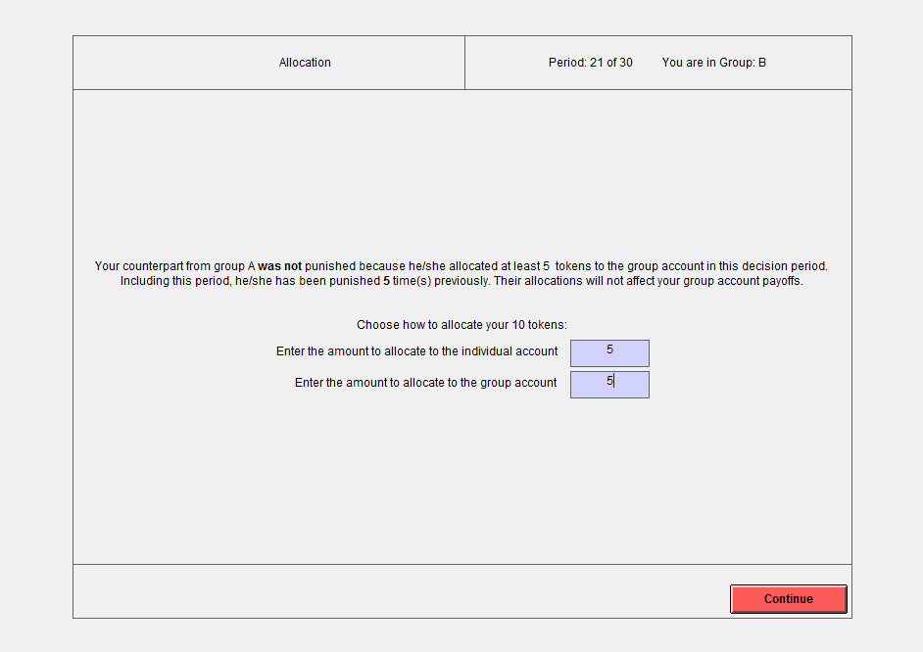

The results screen of a subject in group 2 for Game B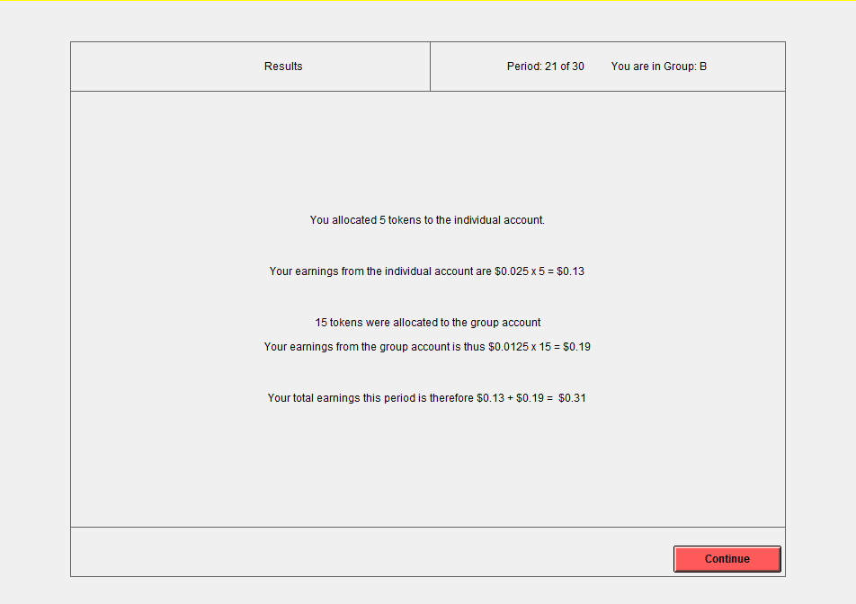

A decision screen of a subject in group 2 in Game C
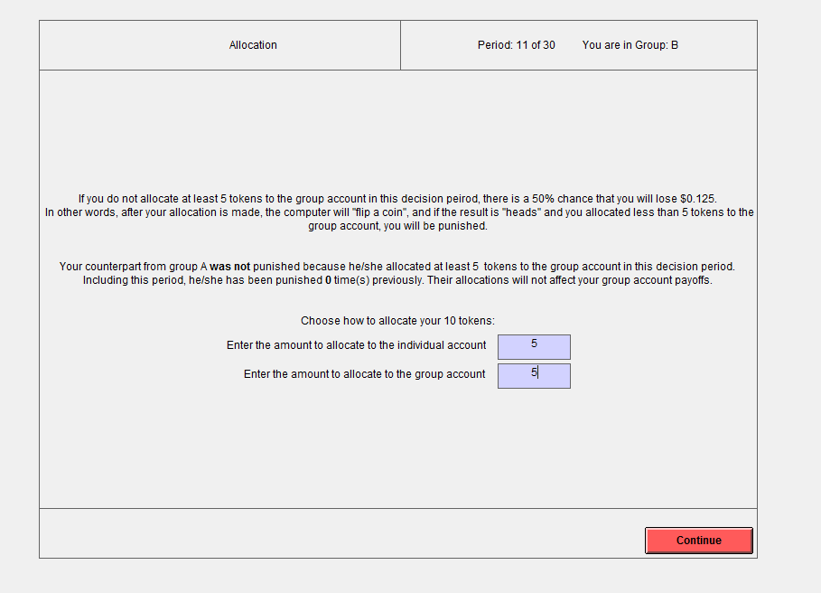

The results screen of a subject in group 2 for Game C
