Online Appendix A – Recruitment Messages
Money&Appeal recruitment message. The sentences deleted in the MoneyOnly treatment message are underlined and within square brackets. The sentences deleted in the AppealOnly treatment message are in italics and within parentheses.
Dear #name#,
We are a group of researchers based at the School of Economics, and we would like to invite you to participate in our studies. [Participation is fun and your collaboration will be of immense value to our scientific investigations.] (You will typically receive some reward (usually cash) in return for your participation.) To participate in our studies you need to register with us at: http://www.nottingham.ac.uk/economics/cedex/register/
Once you register you will be eligible to receive invitations for individual studies. The invitations will tell you the dates and times and any other necessary information. Note that registering with us does not commit you to anything. You are always free to accept or ignore a particular invitation. You can also deregister at any time.
[Our research investigates how people make decisions and for that we require the participation of volunteers: your participation is crucial to the success of our research, and we will highly appreciate your contribution and be really grateful for your collaboration.] If you have never taken part in our studies the best way to describe them is as a game in which you will act as a trader or other type of decision maker. Any interaction with other participants is typically via a computer network. There is no chance of your losing anything – at worst you will win nothing – and no special skills are required. Participating in a study usually does not take longer than an hour and normally takes place at the School of Economics (invitations for individual studies will give you more precise details about duration and location). (We pay you when you take part in our studies. We do not wish to create expectations about the payments, but we can tell you that most participants in previous experiments have been pleased with their cash rewards.) Your participation is strictly confidential: we never reveal your identity to other participants or anyone else.
We have been conducting these studies for nine years now. We had several thousands of students take part in many studies over the years. If you register, your registration will remain valid, and you will remain eligible to receive invitations, until the end of your studies (unless you choose to deregister in the meantime). Once again, if you wish to register, you can do it at: http://www.nottingham.ac.uk/economics/cedex/register/
Online Appendix B – Lab Experiment Invitation Letter & Instructions
Lab experiment invitation email
Dear #fname# #lname#,

You are registered with CeDEx to participate in experiments. We would like to invite you to take part in our upcoming experiment. The experiment will take place in the CeDEx computer lab, room C41, Sir Clive Granger Building. We are planning the following sessions (you can participate in one session only):

#sessionlist#

If you would like to participate, please click on the link below to sign up to the session of your choice. Please note: people that sign up to a session and do not turn up cause us problems; sign up to a session only if you are sure you can attend it, and if you sign up please do attend. We operate a policy of removing participants from our database who sign up but then fail to turn up (without good reason).

#link#

(If the link does not work, copy it and paste it into the address field of your internet browser.)

Please be on time and remember to bring your Student ID to the session.

This experiment is named JADN. Please include “JADN " in the subject field of any email you send CeDEx regarding this experiment.

Best regards,
Johannes Abeler and Daniele Nosenzo

Lab experiment instructions

PRELIMINARY INSTRUCTIONS

Welcome! You are about to take part in a decision-making experiment. This experiment is run by the “Centre for Decision Research and Experimental Economics” and has been financed by various research foundations.

There are other people in this room, who are also participating in this experiment. All participants are reading the same instructions and have been recruited in the same way. Likewise, everyone is participating in this experiment for the first time. It is important that you do not talk to any of the other participants during the experiment. If you have a question at any time, raise your hand and a monitor will come to your desk to answer it.

This experiment consists of six different parts.

In each part you will be asked to make one or more decisions. Decisions made in one part of the experiment will bear no consequences for the other parts of the experiment.

During the experiment you will have a chance to earn money. The total amount you will earn from the experiment will be the sum of the earnings you make in the different parts of the experiment. During the experiment your earnings will be calculated in points. These point earnings will be converted into cash at a rate of 10p per point. In addition to the money you will earn during the experiment, we will pay you £1.50 for showing up today. Your cash earnings will be paid to you in private at the end of the experiment.

You will be informed of any outcome (including your earnings) from the six parts of the experiment only at the end of the session. Therefore, in any given part of the experiment everyone will make their decisions without knowing any outcome from the previous parts.

You find on your desk instructions for PART 1 of the experiment. You will receive instructions for the other parts of the experiment gradually, as the experiment progresses.

If you have a question now, please raise your hand and a monitor will come to your desk.

PART 1
At the beginning of PART 1 the computer will randomly pair you with another person in this room. You will remain paired with this person for the whole duration of PART 1. At the end of PART 1 the pair will be dissolved, and you will not be matched with this other person again during today’s experiment. You will not learn the identity of the person you are paired with in PART 1, neither during, nor after, today’s session.
In PART 1 of the experiment you and the person you are paired with will be asked to make choices in a series of 24 situations. You and the other person will make choices independently and will not learn each other choices at any point during the experiment.
For each situation you will have to choose between two options: Option A or Option B. Each option specifies a number of points that you will receive or pay (“Points for you”), and a number of points that the other person will receive or pay (“Points for other”).
For example, a possible situation may look as follows:
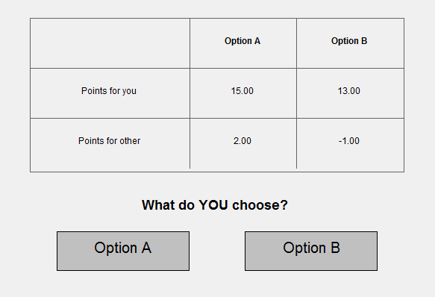
In this example situation, if you choose Option A you receive 15 points and the other person receives 2 points. If you choose Option B, you receive 13 points and the other person has to pay 1 point. Likewise, if the person you are paired with faces this situation and chooses Option A, he or she receives 15 points and you receive 2 points. If the person you are paired with chooses Option B, he or she receives 13 points and you have to pay 1 point.
Thus, in each situation your earnings depend on the number of points that you assign to yourself, and on the number of points that the other person assigns to you. For example, suppose that in the example situation above you choose Option A and the other person chooses Option B. Your total earnings for the situation will be 14 points: 15 points that you assign to yourself minus 1 point that the other person makes you pay. The earnings of the other person will be equal to 15 points: 13 points that he or she assigns to him or herself plus 2 points that you assign to him or her.
Your total earnings from PART 1 of the experiment will be the sum of the earnings you make in the 24 situations. You will learn your earnings from PART 1 at the end of today’s session. You will be paid in private and in cash at the end of the experiment.
Please raise your hand if you have any questions.
To make sure everyone understands the instructions, please complete the questions about PART 1 below. In a couple of minutes someone will come to your desk to check the answers. (The decisions and earnings used for the questions below are simply for illustrative purposes. In the experiment the decisions and earnings will depend on the actual choices of the participants.).

Questions about PART 1:
- How many choices will you make in total in PART 1? _______
- Suppose that in the example situation above you choose Option B and the person you are paired with also chooses Option B. How much would you earn? _______ How much would the other person earn? _______
- Is the following statement true: you will not learn the choices made by the other person, nor will he or she learn your choices during today’s experiment _______
- Is the following statement true: your total earnings from PART 1 will be determined by adding the earnings you make in each of the 24 situations _________

PART 2
At the beginning of PART 2 the computer will randomly match you with three other participants in this room to form a group of four people. You will remain in this group for the whole duration of PART 2. At the end of PART 2 the group will be dissolved, and you will not be matched with these three participants again during this experiment. You will not learn the identity of these participants neither during, nor after today’s session.
The Basic Decision Situation
The basic decision situation is simple. Each group member is given an endowment of 20 points, and has to decide how many of these points to place into a private account and how many to contribute to a group project.
- Each point a group member places into his or her private account earns 1 point to that person. For example, if you place 20 points into your private account (and therefore do not contribute to the group project) your earnings from your private account will be 20 points. If you place 6 points into your private account, your earnings from your private account will be 6 points. No one except you earns points from your private account.
- Each point contributed to the group project generates 1.6 points to be shared equally among the group members. For example, if the sum of all contributions to the project in your group is 60 points, then the project generates 60 × 1.6 = 96 points. These will be shared equally among you and the three other members of your group, so each of you will receive 96 ÷ 4 = 24 points. As another example, if you and the three other group members contribute a total of 10 points to the project, each of you will receive: (10 × 1.6) ÷ 4 = 4 points.
Your total earnings from the decision situation are given by the sum of your earnings from your private account and your earnings from the group project.

To make sure everyone understands the instructions so far, please complete the questions on the next page. If you want to, you can use an electronic calculator while you answer the questions. To use the electronic calculator, click the CALCULATOR icon on the bottom-right corner of your computer screen. In a couple of minutes someone will come to your desk to check your answers. (The decisions and earnings used for the questions below are simply for illustrative purposes. In the experiment decisions and earnings will depend on the actual choices of the participants.).

Questions about PART 2:
- Each group member has 20 points. Assume that none of the four group members (including you) contributes anything to the project.
What are your total earnings? __________
What are the earnings of each other member of your group? __________
- Each group member has 20 points. You contribute 20 points to the project. Each of the three other members of your group also contributes 20 points to the project.
What are your total earnings? __________
What are the earnings of each other member of your group? __________
- Each group member has 20 points. Suppose that the other three members of your group contribute a total of 30 points to the project.
  - What are your total earnings if – in addition to these 30 points - you contribute 0 points to the group project? __________
  - What are your total earnings if – in addition to these 30 points - you contribute 15 points to the group project? __________
- Each group member has 20 points. Suppose that you contribute 8 points to the project.
  - What are your total earnings if – in addition to your 8 points – the other group members contribute a total of 7 points to the group project? __________
  - What are your total earnings if – in addition to your 8 points - the other group members contribute a total of 22 points to the group project? __________
How You Make Decisions
PART 2 of the experiment is based on the decision situation just described above. As you know you will have an endowment of 20 points. You will have to decide how many of these points to contribute to the group project. Any point that you do not contribute to the project will be automatically placed into your private account.
In this experiment we ask you to make two types of decisions. We will refer to these two decision types as “the unconditional contribution decision” and “the contribution table”. You will make these decisions on the computer by completing two screens. Note that you will complete these screens only once, there is no repetition.
On the first screen, you have to make your unconditional contribution decision by typing in the number of points (between 0 and 20) you contribute to the group project. This is how the screen where you indicate your unconditional contribution will look like:
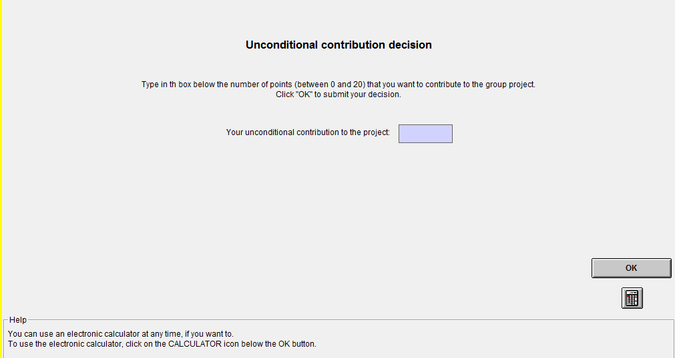
On the second screen, you have to fill out a contribution table where you indicate how many points you contribute to the project for each possible average contribution of the other group members (rounded to the closest whole number). Thus, with the contribution table you can condition your contribution decision on what the other group members contribute on average. This is how the screen containing the contribution table will look like:
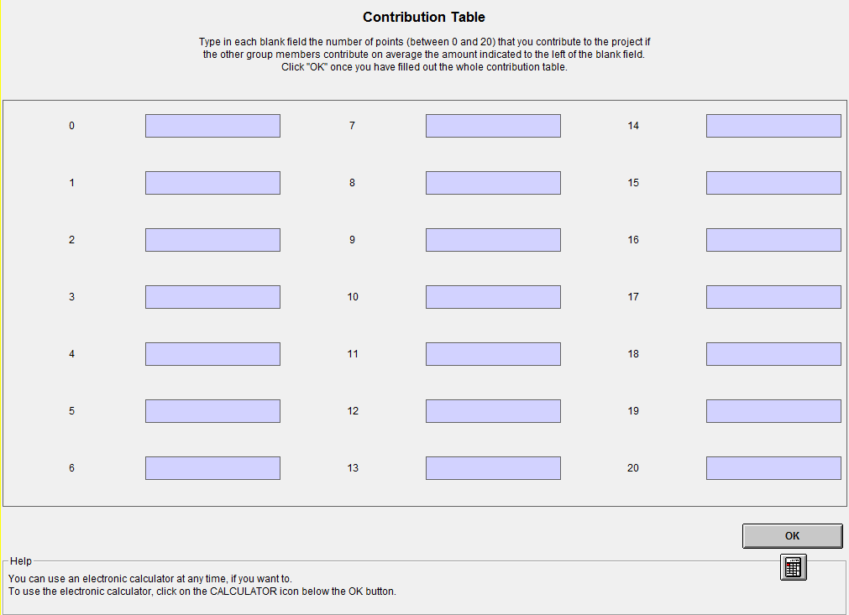
The numbers displayed to the left of each blank field are the possible (rounded) average contributions of the three other group members. We want to know how many points you contribute to the project for any possible average contribution of the other group members. Thus, you have to make a contribution decision for every possible average contribution of the other group members. In each blank field you must indicate the number of points (between 0 and 20) that you contribute to the project if the other group members contribute on average the amount indicated to the left of the blank field.
How Your Earnings Are Determined
In PART 2 of the experiment we ask you to make an unconditional contribution decision and to fill out a contribution table. However, only one type of decision will be used for determining your earnings in PART 2. Which type of decision will be used to compute earnings will be determined at random after you have made both types of decisions. Thus, at the time you make these decisions you do not know which one will be relevant for the computation of earnings. Therefore, you will have to think carefully about both types of decisions because both can become relevant for you.
After all group members have made their decisions, the computer will randomly select one group member. For the selected group member the contribution table will be used for the computation of earnings. For the other three group members who are not selected the unconditional contribution decision will be used. Thus,
If you are selected at random by the computer: then, we will compute earnings using your contribution table and the three unconditional contribution decisions of the other members of your group. We will average the unconditional contributions of the three other members of your group and round it to the closest whole number. We will then look at your contribution table to find out the number of points that you decided to contribute when the other group members make that average contribution.
If you are not selected at random by the computer: then, we will compute earnings using your unconditional contribution decision, the unconditional contribution decisions of the two other members of your group who have not been selected, and the contribution table of the member of your group who has been selected. We will compute the average of your unconditional contribution and the unconditional contributions of the two other non-selected members of your group, and round it to the closest whole number. We will then look at the contribution table of the selected group member to find out the number of points that he or she contributes when the other group members make that average contribution.
You will learn your earnings from PART 2 at end of today’s session. You will be paid in private and in cash at the end of the experiment.
Please raise your hand if you have any questions.
As before, to make sure everyone understands the instructions about PART 2, please complete the questions below. In a couple of minutes someone will come to your desk to check your answers. (The decisions and earnings used for the questions below are simply for illustrative purposes. In the experiment decisions and earnings will depend on the actual choices of the participants.).
Questions about PART 2:
1. How many types of decisions will you make in PART 2?
2. How many times will you make each type of decision?
3. Is the following statement true: in the contribution table you have to enter 21 contribution decisions, one for each possible (rounded) average contribution of the other group members.
4. Suppose that you are selected at random by the computer – so earnings are computed using your contribution table and the three unconditional contribution decisions of the other group members. Suppose that the three other members of your group contribute 0, 2 and 4 points. Their average contribution is therefore 2 points. Suppose that you decided to contribute 2 points when the other group members contribute on average 2 points. What are your total earnings?

PART 3 to PART 6
For the remaining four parts of the experiment you will not be matched with any of the other participants in this room. Thus, the decision situations in the next four parts of the experiment will not involve any interaction with the other participants in today’s experiment, and your earnings will be independent from their decisions.
You will receive the instructions for each of the four remaining parts of the experiment directly on your computer screen. Shortly, you will be shown instructions for PART 3. Once everyone in the room has completed PART 3, you will be shown the instructions for PART 4, and so on.
The instructions for each part of the experiment will explain whether and how you can earn points in that part. So, it is important that you read the instructions carefully.
If you have a question at any time during the rest of the experiment, raise your hand and a monitor will come to your desk to answer it.
Please raise your hand if you have any questions now.

Online Appendix C – Decision Problems in the Decomposed Game
Option A Option B
1. 0, 15 3.9, 14.5
2. 3.9, 14.5 7.5, 13
3. 7.5, 13 10.6, 10.6
4. 10.6, 10.6 13, 7.5
5. 13, 7.5 14.5, 3.9
6. 14.5, 3.9 15, 0
7. 15, 0 14.5, −3.9
8. 14.5, −3.9 13, −7.5
9. 13, −7.5 10.6, −10.6
10. 10.6, −10.6 7.5, −13
11. 7.5, −13 3.9, −14.5
12. 3.9, −14.5 0, −15
13. 0, −15 −3.9, −14.5
14. −3.9, −14.5 −7.5, −13
15. −7.5, −13 −10.6, −10.6
16. −10.6, −10.6 −13, −7.5
17. −13, −7.5 −14.5, −3.9
18. −14.5, −3.9 −15, 0
19. −15, 0 −14.5, 3.9
20. −14.5, 3.9 −13, 7.5
21. −13, 7.5 −10.6, 10.6
22. −10.6, 10.6 −7.5, 13
23. −7.5, 13 −3.9, 14.5
24. −3.9, 14.5 0, 15

(The first number is own payoff, the second number is the payoff for the matched subject.)
Online Appendix D – SDS-17 and GCS items
SDS-17 items
- I sometimes drop litter rather than carry it to a bin.
- I always admit my mistakes openly and face the potential negative consequences.
- In traffic I am always polite and considerate of others.
- I always accept others’ opinions, even when they don’t agree with my own.
- I take out my bad moods on others now and then.
- There has been an occasion when I took advantage of someone else.
- In conversations I always listen attentively and let others finish their sentences.
- I never hesitate to help someone in case of emergency.
- When I have made a promise, I keep it – no ifs, ands or buts.
- I occasionally speak badly of others behind their back.
- I would never live off other people.
- I always stay friendly and courteous with other people, even when I am stressed out.
- During arguments I always stay objective and matter-of-fact.
- There has been at least one occasion when I failed to return an item that I borrowed.
- I always eat a healthy diet.
- Sometimes I only help because I expect something in return.
GCS items
1. As a child, I always did as my parents told me.
2. I give in easily when I am pressured.
3. I am not too concerned what people think of me.
4. I tend to become easily alarmed and frightened when in the company of people in authority.
5. When I was a child I sometimes took the blame for things I had not done.
6. When I am uncertain about things I tend to accept what people tell me.
7. I tend to go along with what people tell me even when I know that they are wrong.
8. I would describe myself as a very obedient person.
9. I would never go along with what people tell me in order to please them.
10. I find it very difficult to tell people when I disagree with them.
11. I tend to give in to people who insist that they are right.
12. I try very hard not to offend people in authority.
13. I strongly resist being pressured to do things I don’t want to.
14. I generally tend to avoid confrontation with people.
15. I try to please others.
16. People in authority make me feel uncomfortable and uneasy.
17. I try hard to do what is expected of me.
18. Disagreeing with people often takes more time than it is worth.
19. I generally believe in doing as I am told.
20. I believe in avoiding rather than facing demanding situations.

Online Appendix E – CRT and Financial Literacy test questions
CRT Q.1 - A bat and a ball cost £1.10 in total. The bat costs £1.00 more than the ball. How much does the ball cost (in pence)?
CRT Q.2 - If it takes 5 machines 5 minutes to make 5 widgets, how long would it take 100 machines to make 100 widgets (in minutes)?
CRT Q.3 - In a lake, there is a patch of lily pads. Every day, the patch doubles in size. If it takes 48 days for the patch to cover the entire lake, how long would it take for the patch to cover half of the lake (in days)?
Financial Literacy Q.1- In a sale, a shop is selling all items at half price. Before the sale, a sofa costs £300. How much will it cost in the sale?
Financial Literacy Q.2 - If the chance of getting a disease is 10 per cent, how many people out of 1,000 would be expected to get the disease?
Financial Literacy Q.3 - A second hand car dealer is selling a car for £6,000. This is two-thirds of what it cost new. How much did the car cost new?
Financial Literacy Q.4 - If 5 people all have the winning numbers in the lottery and the prize is £2 million, how much will each of them get?
Financial Literacy Q.5 - Let’s say you have £200 in a savings account. The account earns ten per cent interest per year. How much will you have in the account at the end of two years?

