Appendix – Experimental Instructions
General Instructions for Participants

Welcome to the Experiment Laboratory!
You are now taking part in an economic experiment. You will be able to earn a considerable amount of money, depending on your decisions and the decisions of others. It is therefore important that you read these instructions carefully.
The instructions which we have distributed to you are solely for your private information. It is prohibited to communicate with other participants during the experiment. Should you have any questions please raise your hand and an experimenter will come to answer them. If you violate this rule, we will have to exclude you from the experiment and from all payments.
During the experiment you will make decisions anonymously. Only the experimenter knows your identity while your personal information is confidential and your decisions will not be traceable to your identity.
In any case you will earn 4 Euros for participation in this experiment. The additional earnings depend on your decisions. During the experiment your earnings will be calculated in tokens. At the end of the experiment your earned tokens will be converted into Euros at the following exchange rate:
1 Token = 0.30 €,
and they will be paid to you in cash.
The experiment consists of 10 periods in which you always play the same game. The participants are divided into groups of 4. Hence, you will interact with 3 other participants. The composition of the groups will remain the same for all 10 periods. Please mind that you and all other participants decide anonymously. Therefore group members will not be identifiable over the periods.
At the end of the experiments you will receive your earning from one out of the ten periods converted in Euros (according to the exchange rate above) in addition to the 4 Euros for your participation. The payout period will be determined randomly. You should therefore take the decision in each period seriously, as it may be determined as the payout period.
The following pages describe the course of the experiment in detail.
Rules of the Game

Each player faces the same assignment. Your task (as well as the task of all others) is to allocate tokens between your private account and a group account.
At the beginning of each period each participant receives 20 tokens in a private account. You have to decide how many of these 20 tokens you transfer to a group account, and how many you keep in your private account. Your transfer can be between 0 and 20 tokens (only whole numbers).
[TAKE: At the beginning of each period there are 80 tokens in the group account and no tokens in your private account. You have to decide how many of the 80 tokens you leave in the group account and how many tokens you transfer to your private account. Your transfer can be between 0 and 20 tokens (only whole numbers).]
[GITA: At the beginning of each period each participant receives 12 tokens in a private account. There are 32 tokens in a group account. You have to decide how many of these 32 tokens you leave in the group account and how many of the 12 tokens you transfer from your private account to the group account respectively. Your transfer input is related to the group account, so that a negative input means a transfer from the group account to your private account and positive inputs mean transfers from your private account to the group account. Your transfer can be between -8 and 12 tokens (only whole numbers).]
[GIVE*: At the beginning of each period each participant receives 12 tokens in a private account. There are 32 tokens in a group account. You have to decide how many tokens you transfer to the group account. Your transfer can be between 0 and 12 tokens (only whole numbers).]
Your total income consists of two parts:
(1) the tokens which you have kept in your private account,
(2) the income from the group account. This income is calculated as follows:
[TAKE: (1) the tokens which you have transferred to your private account]
Your income from the group account =
0.4 times the total amount of tokens in the group account
Your income in tokens in a period hence amounts to
(20 - your transfer) + 0.4 *(total amount of tokens in the group account).
[TAKE: (transfer to the private account) + 0.4*(total amount of tokens in the group account)]
[GITA, GIVE*: (12 – your transfer) + 0.4*(total amount of tokens in the group account)]
The income of each group member from the group account is calculated in the same way, this means that each group member receives the same income from the group account. Suppose the sum of transfers to the group account of all group members is 60 tokens. In this case each member of the group receives an income from the group account of 0.4*60 = 24 tokens. If you and your group members transfer a total amount of 9 tokens to the group account, then you and all other group members receive an income of 0.4*9 = 3.6 tokens from the group account. Every token that you keep in your private account yields 1 token of income to you.
[TAKE, GITA, GIVE*: similar or same examples.]

Information on the Course of the Experiment

At the beginning of each period the following input screen is displayed:
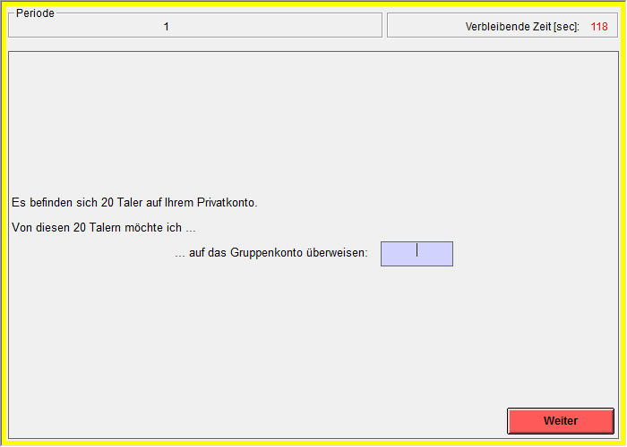
The Input Screen (in German):

The period number is displayed on the top left. The top right shows the time in seconds. This is how much time is left to make a decision.
At the beginning of each period your endowment contains 20 tokens (as described above). You decide about your transfer to the group account by typing a whole number between 0 and 20 into the input window. You can click on it by using the mouse.
[TAKE: At the beginning of each period the group account contains 80 tokens. You decide about your transfer to your private account by typing a whole number between 0 and 20 into the input window. You can click on it by using the mouse.]
[GITA: At the beginning of each period the group account contains 32 tokens. You decide about your transfer to your private account or your transfer to the group account by typing a whole number between -8 and 12 into the input window. You can click on it by using the mouse.]
[GIVE*: At the beginning of each period the group account contains 32 tokens. You decide about your transfer to the group account by typing a whole number between 0 and 12 into the input window. You can click on it by using the mouse.]
When you have decided about your transfer to the group account, you have also chosen how many tokens you keep to yourself, that is (20 - your transfer) tokens [differs by treatment]. When you have typed in your decision, you need to press the Enter Button (by use of the mouse). By pressing the Enter Button your decision for the period is final and you cannot go back.
After all group members have made their decisions, your income from the period will be displayed on the following income screen. You will see the sum of transfers to the group account and your income from your private account. You will also see your total income in that period.
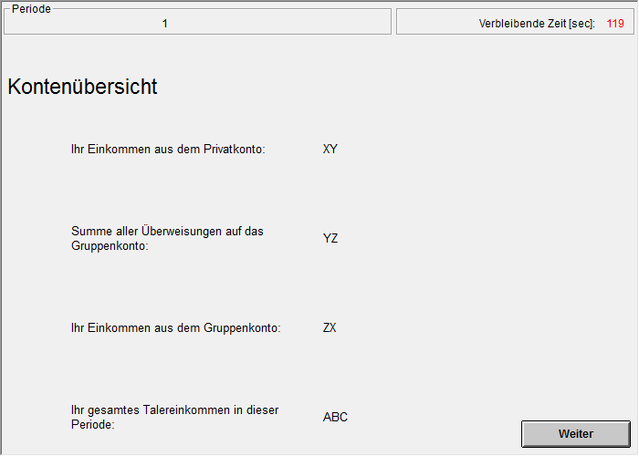
The Income Screen (in German):

As described above, your income is
(20 – your transfer) + 0.4*(total amount of tokens in the group account).
[TAKE: (transfer to the private account) + 0.4*(total amount of tokens in the group account)]
[GITA, GIVE*: (12 – your transfer) + 0.4*(total amount of tokens in the group account)]
Good luck in the experiment!

