Appendix 3
Oral instructions, which were read aloud before the experiment (English translation):
A very warm welcome to this experiment and thank you very much for your participation. I will read some general instructions for the experiment. Please listen carefully and just click on the button “Start Experiment” after you have listened to these instructions.
All participants taking part in this experiment are in this room and are participating in the same experiment. With the experiment, we want to get insights into human behavior. The game will last about 70-90 minutes and on average you will earn between 8 and 16 euro according to your decisions, but at least 3 euro.
In the experiment, the payoff will be calculated in the currency “Taler”. 5 Taler are equivalent to 20 eurocents. 200 Taler e.g. will be converted into 8 euros at the end of the experiment and paid out.
You will interact anonymously and cannot communicate with others. Also, the payoff will be paid out anonymously. No other participant will see how much you earn. The persons who conduct the experiment will not be informed about that either. After the experiment, you will be asked to leave the laboratory on your own. Outside of the laboratory you will get your payoff.
During the experiment you may have to wait for other participants. This may take some minutes. Please remain seated patiently. Use the waiting time in order to recalculate the examples and to think about your decision during the experiment.
You will find all instructions and explanations on the following screens. Please read all the information carefully before leaving a screen. You cannot go back to screens you have left.
If you want, you can take notes. Pen and paper are lying on your desk. During the experiment you may need to do calculations. Therefore, you find a pocket calculator on your desk as well as a pocket calculator button on the right corner of any screen. If you click on the button, the Windows calculator will open.
Please remain seated quietly at your desk. Please do not talk at all. If you have any questions please raise your hand. We will then come to your desk. Please click on the button „Start Experiment“ now.
Written instructions (English translation)
[During the whole instructions figure C.1 was displayed to the participants. It provides an overview and was displayed step-by-step in the instructions. Later it was used for showing the results of the previous round (see red numbers). Labels for consumption, total investment, etc. were used consistently throughout the whole experiment.]
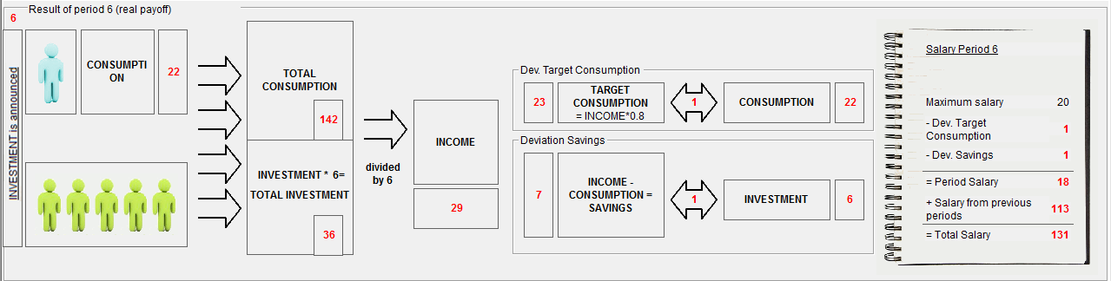
Figure C.1 – Graphical Overview
A very warm welcome! At the beginning of the experiment you will be instructed about the general procedures. These will be read aloud by the experimenter. Please only click on “Start experiment” if you are told to do so.

Participants [same for both treatments]
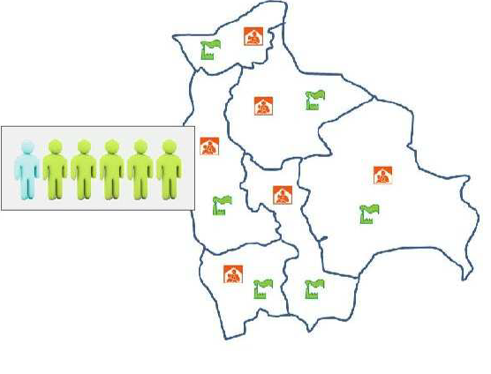
In this experiment, we simulate an economy consisting of 6 regions. An investor and a private household live in each region. The household generates its income from production and uses this income for consumption and savings. The savings of a private household are available to the investor as a loan.
Figure C.2 – Economy with 6 Regions
You are employed as an adviser and advise a household of one region on its level of consumption. The better you advise the higher your payoff, i.e. your salary as an adviser. In this economy, there are 5 other advisers who advise the other 5 households of the other regions on consumption. You interact with the same 5 other advisers during the whole experiment.
All regions are identical. Thus, each adviser has the same task. Each adviser may reach the same conclusion as you, but may just as well solve the task differently.
Decision
In each round you have to decide on the level of consumption for the household you advise. For your choice you can state values between 0 and 100. The values in the other regions are determined simultaneously. Levels of investment are identical across all 6 regions and reported upfront. While deciding on consumption you do not know the household’s income.

Production and Income
Total production in the economy is determined by the sum of consumption across all households (total consumption) and total investment across all 6 regions. Total investment is calculated as 6 times the investment, which is identical in every region. The value of investment and total investment is announced before you decide on consumption
PRODUCTION = TOTAL CONSUMPTION + TOTAL INVESTMENT
Every household gets 1/6 of the production of the economy as income. Thus, every household gets the same fraction of total income. As you do not know the consumption levels of all other households you can only estimate production and therefore your household’s income.

Targets [Keynes Treatment]
You aim at setting consumption for your household so as to achieve two targets at the same time.
Your first target is to align consumption to a consumption target. This consumption target is a share of your household’s income. Too little consumption lowers the standard of living while too much consumption hinders precaution. The target consumption is:
TARGET CONSUMPTION = 0.8*INCOME
Deviations from target consumption generate costs of equal magnitude. With consumption of 28 and a target consumption of 30, costs amount to 2 Taler.
The more you consume the less you save. The less you consume the more you save. This is due to SAVINGS = INCOME – CONSUMPTION
Your second target is to align the savings of your household with the investment in your region. The investor in your region can easily utilize the savings of your household. But if your household has savings exceeding the local investment level, he must pass them to the investors of other regions. Organizing this involves effort and is costly to you, the adviser.
Costs also arise if savings are too low. In this case you have to exert effort in order to gather savings from the others regions for the local investor. If local investment is 12 and savings of your household are 15, you incur costs of 3 Taler. The same costs occur with an investment of 12 and savings given by 9.
Payoff [Keynes Treatment]
At the beginning of the trial rounds and at the beginning of the real rounds you get 50 Taler as your initial salary. In every round, in which you advise the household, you can earn a maximum salary of 20 Taler. In every round, deductions from this amount are determined depending on the deviations of your choices from target values, i.e. the following two deviations:
Deviation of consumption from target consumption
Deviation of investment from savings
You should therefore try to keep both deviations small in order to avoid high deductions from your salary.

Rounds [same for both treatments]
Now you advise the household for 24 rounds. The first 4 rounds are trial rounds and the payoff expires after these, i.e. is not converted into euros. The following 20 rounds are then paid out in Taler and will be converted into euros at the end of the experiment.
[The following example screens are translated here only for the Keynes treatment but were done in the same way for the White treatment using the same example numbers and almost the same wording.]
Example Screen 1
Example Round | 1 | 2
INVESTMENT | 8
CONSUMPTION | 
TOTAL CONSUMPTION
TOTAL INVESTMENT | 48
INCOME
TARGET CONSUMPTION
SAVINGS
Salary per Round
Total Salary
[The following dynamic table is displayed.]
In each round you see this screen. On top the current round is displayed...
- At the beginning of each round you have to decide on the consumption for the household you advise. For this purpose you see a cell with a pencil symbol []. Please use this cell to fill in your integer value for consumption in the respective round. Please note that only values between 0 and 100 are allowed.
- While deciding on consumption, you see the value for investment in your region (INVESTMENT) and the sum of all investments across all regions (TOTAL INVESTMENT).
- In the lower part of the screen you see an overview [figure C.1, in the White treatment it was additionally stated that savings deviations were subtracted from the salary only if $i$] of the interdependencies in the economy. On the left you see how your decision and the decisions of the other advisers determine total consumption. In the middle you see the two target values at which you should aim with your decision. And on the right you see the calculation of your salary.
Please click on “Continue” once you have read and understood steps 1-3.
Example Screen 2
Example Round | 1 | 2
INVESTMENT | 8 | 12
CONSUMPTION | 35
TOTAL CONSUMPTION | 174
TOTAL INVESTMENT | 48 | 72
INCOME | 37
TARGET CONSUMPTION | 30
SAVINGS | 2
Salary per Round | 9
Total Salary | 59
[The following dynamic table is displayed.]
After having submitted your input for consumption, a new screen appears. The computer calculates all relevant results which are explained in steps 4-6. At the same time, the input field for the subsequent round appears.
- After you and all other advisers submitted the decisions, the computer calculates total consumption and your income. Please note that your income is determined only with integer numbers. Any rest will be distributed to the participants in turn.
- The computer also calculates your target consumption and savings for this round. Target consumption will be rounded up or down to integer numbers.
- Your salary as an adviser is calculated depending on the deviations from target values.
Please click on “Continue” once you have read and understood steps 4-6.

Example Screen 3
Example Round | 1 | 2
INVESTMENT | 8 | 12
CONSUMPTION | 35 | 52
TOTAL CONSUMPTION | 174 | 348
TOTAL INVESTMENT | 48 | 72
INCOME | 37
TARGET CONSUMPTION | 30
SAVINGS | 2
Salary per Round | 9
Total Salary | 59
[The following dynamic table is displayed.]
In this part of the instructions, you are required to do the calculations, which are normally done by the computer during the real and trial rounds. Assume that you chose a consumption level of 52. Investment is given by 12. Together with the input of all other advisers total consumptions amounts to 348. Total investment is 6*12=72.
For your own understanding, please determine the resulting income and click on the “Continue” button. You will get a notice if you calculated the income correctly. During the real and trial rounds this calculation will be done by the computer. You then only have to decide on the values for consumption.
Example Screen 4
Example Round | 1 | 2
INVESTMENT | 8 | 12
CONSUMPTION | 35 | 52
TOTAL CONSUMPTION | 174 | 348
TOTAL INVESTMENT | 48 | 72
INCOME | 37 | 70
TARGET CONSUMPTION | 30
SAVINGS | 2
Salary per Round | 9
Total Salary | 59
[The following dynamic table is displayed.]
Here you see if you calculated the income correctly. [It was shown whether the input was right. If not, an additional explanation was given regarding the income generating process.]
Please now calculate the values for target consumption and savings. These calculations will be done by the computer later and are only used here to test your understanding. When you have entered the values, please click on the “Continue” button.

Example Screen 5 (Treatment 1)
Example Round | 1 | 2
INVESTMENT | 8 | 12
CONSUMPTION | 35 | 52
TOTAL CONSUMPTION | 174 | 348
TOTAL INVESTMENT | 48 | 72
INCOME | 37 | 70
TARGET CONSUMPTION | 30 | 56
SAVINGS | 2 | 18
Salary per Round | 9 | 10
Total Salary | 59 | 69
[The following dynamic table is displayed.]
Here you see if you correctly calculated savings and target consumption. [It was shown whether the input was right. If not, an additional explanation was given regarding the calculation of target consumption and savings. Subjects had a possibility to correct their first entry once.]
Here you see all values of both example rounds again. From now on, the computer will calculate the values for income, savings and target consumption. You only have to choose the consumption level in every round. The experiment starts with 4 trial rounds, which are done for practice and which do not generate real payoffs. The amount you earn in the subsequent 20 rounds will be converted into euros and paid out at the end of the experiment. Please click on “Start trial rounds” now.

Throughout the instructions the term “region” was employed rather than “country” so as to facilitate understanding of the limited instruments available to the adviser. Figure C.2 was shown to visualize this.
For the White treatment the last two paragraphs of this subsection were changed to: (…) Your second target is that savings of your household are AT LEAST as high as investments in your region. If savings are lower than investments, costs arise. The investor in your region can easily gain access to the savings of your household. But costs arise if savings are insufficient. In this case, you in your role as the adviser must exert effort to gather savings from other regions for your region’s investor. If your savings are larger than investment, you can pass this excess of savings on to other regions for free, i.e. no costs arise. If local investment is 12 and savings of your household are 15, you incur no costs. With an investment of 12 and savings given by 9, costs of 3 Taler arise. (…)
For the White treatment this was changed to: In every round in which you advise the household, you can earn a maximum salary of 18 Taler. (…) from target values, i.e. the following two deviations: Deviation of investment from savings (if investments exceed savings) and deviation of consumption from target consumption. You should therefore (...)

