Instructions for Session 1

Welcome! This is an experiment in decision-making. Funding for this experiment has been provided by the National Science Foundation and Virginia Commonwealth University. The experiment consists of two sessions—one today and one next week. You are required to participate in both sessions. Each session is expected to last up to 2 hours.

For today’s session, you will receive a $6 show-up fee. In addition, you will have the opportunity to earn Experimental Currency Units (ECU). ECU will be converted into dollars at a rate of 500 ECU=$1. Thus, your earnings in today’s session will equal:
$6 + (ECU earned in today’s session)

You will receive only $10 in cash at the end of today’s session. The remainder of your earnings from today’s session will be paid to you at the end of next week’s session. Note that you need to show up punctually for next week’s session. If you fail to do so, any earnings from today’s session over and above $10 will be lost. If you do show up punctually for next week’s session, you will:
- be paid the remainder of your earnings from today’s session;
- receive a $6 show-up fee for attending next week’s session;
- have the opportunity to earn more money during next week’s session.

Note that your decisions are likely to considerably affect your earnings. If you follow the instructions carefully and make good decisions, you can earn a considerable amount of money.

Caution: This is a serious experiment and talking, looking at others’ screens, or exclaiming aloud are not allowed. Should you have any questions please raise your hand and an experimenter will come to you.

1. Session Structure
Today’s session is divided into a series of sequences. A sequence will consist of an indefinite number of rounds. At the beginning of each sequence, you will be matched with someone else in this room. You will remain matched with this same person for every round in the sequence. We will refer to the person you are matched with in a given sequence as OTHER.

2. Tasks in each round
In each round, you and OTHER will play the game shown below. In this game, each of you can make any one of three choices: X, Y or Z. You and OTHER will make your choices simultaneously without knowing each other’s choice.
In each round, you must also give your best forecast of what OTHER will choose.

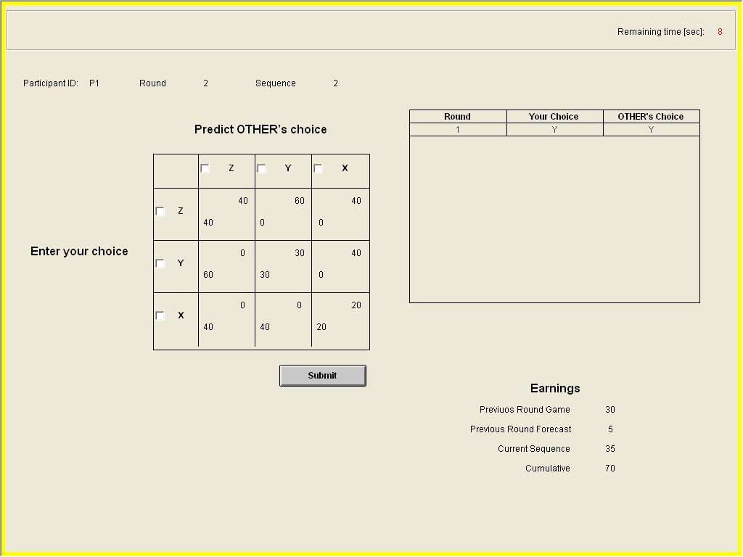

3. Earnings in each round
The ECU you earn in a round are determined based on the combination of your decision and OTHER’s decision. This combination determines a box in the table. Your earnings are listed in the lower left hand corner of the box. OTHER’s earnings are listed in the upper right corner.
In addition, remember that you will also need to give your best forecast of OTHER’s choice. We will pay you 5 ECU if this forecast is correct.

4. Earnings for each sequence and for the session
The earnings for a sequence will equal the sum of the earnings from all rounds within the sequence. Your earnings for the session will equal the sum of the earnings from all sequences (plus the show-up fee).

5. Information on the screen
In the upper-right corner of the screen, there will be a table showing the decisions you and OTHER made in previous rounds of the current sequence.
In the lower-right corner, you can see:
- your earnings from the combination of your decision and OTHER’s decision in the previous round;
- your earnings from your forecast of OTHER’s decision in the previous round;
- your earnings from all previous rounds of the current sequence;
- your cumulative earnings from the session so far (excluding your show-up fee).

6. Length of sequence
The number of rounds in a sequence will be determined randomly. In particular, after each round there is a 93% probability that the sequence continues and a 7% probability that the sequence ends. After a sequence ends, a new sequence is started.

One way to understand the above probabilities is to imagine that after each round the computer “spins a roulette wheel” like the one shown below. If the ball lands in the white area, the sequence continues; if it lands in the dark area, the sequence ends.

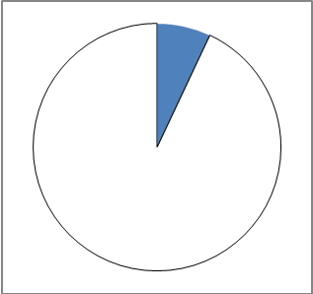

Note that after each round the probability of continuation is always 93%. In other words, regardless of whether the sequence just started or whether it has been going on for multiple rounds, the probability of continuation is always 93%.

7. Random re-matching
At the beginning of each new sequence, you are randomly re-matched with another person. This person will be different from the person you were matched with in the previous sequence.

8. Decision time
In each round, you will have 10 seconds to choose X, Y, or Z and to make your forecast of OTHER’s choice. Please do not take longer than that.

9. Another game
In later sequences, the game played will change to the one shown in the screenshot below. Everything else remains the same as with the previous game.

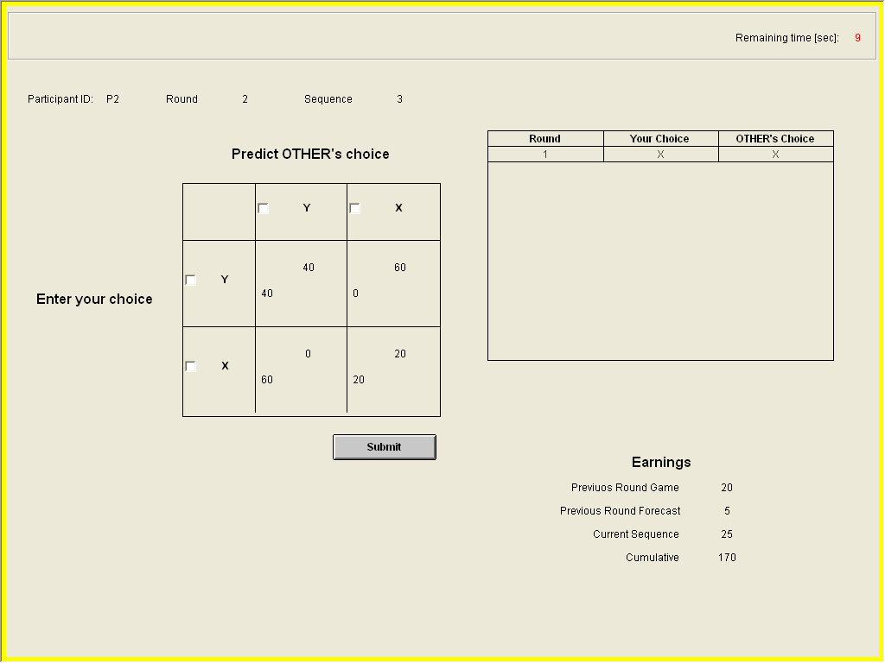

Any questions?

Questionnaire:
Prior to beginning please answer the following questions:

First, suppose you are playing the first game shown above.

- If you choose X and OTHER chooses X, you will earn ______ ECU and OTHER will earn ______ ECU.
- If you choose X and OTHER chooses Y, you will earn ______ ECU and OTHER will earn ______ ECU.
- If you choose X and OTHER chooses Z, you will earn ______ ECU and OTHER will earn ______ ECU.
- If you choose Y and OTHER chooses X, you will earn ______ ECU and OTHER will earn ______ ECU.
- If you choose Y and OTHER chooses Y, you will earn ______ ECU and OTHER will earn ______ ECU.
- If you choose Y and OTHER chooses Z, you will earn ______ ECU and OTHER will earn ______ ECU.
- If you choose Z and OTHER chooses X, you will earn ______ ECU and OTHER will earn ______ ECU.
- If you choose Z and OTHER chooses Y, you will earn ______ ECU and OTHER will earn ______ ECU.
- If you choose Z and OTHER chooses Z, you will earn ______ ECU and OTHER will earn ______ ECU.
- If your forecast is that OTHER will choose Z and OTHER actually chooses X, you will earn _____ ECU for your forecast.

Second, suppose you are playing the second game shown above.

- If you choose X and OTHER chooses X, you will earn ______ ECU and OTHER will earn ______ ECU.
- If you choose X and OTHER chooses Y, you will earn ______ ECU and OTHER will earn ______ ECU.
- If you choose Y and OTHER chooses X, you will earn ______ ECU and OTHER will earn ______ ECU.
- If you choose Y and OTHER chooses Y, you will earn ______ ECU and OTHER will earn ______ ECU.
- If your forecast is that OTHER will choose Y and OTHER actually chooses Y, you will earn _____ ECU for your forecast.

Any questions?

Let’s proceed with a practice sequence. In this practice sequence, you are not playing for real money. Also, you will be given longer to make your decisions in each round.

Instructions for Session 2

Welcome! Last week, you participated in the first session of the experiment. Today’s session is the second (and final) session of the experiment. Today’s session is expected to last up to 2 hours.

For today’s session, you will receive a $6 show-up fee. In addition, you will have the opportunity to earn money during the session.

At the end of today’s session, you will be paid the following: (i) your earnings from last week’s session over and above the $10 you received last week (ii) your $6 show-up fee for today’s session, and (iii) earnings from your decisions in today’s session. We note, however, that for one of the tasks in today’s session, you may choose to be paid at a later date.

Note that your decisions are likely to considerably affect your earnings. If you follow the instructions carefully and make good decisions, you can earn a considerable amount of money.

Caution: This is a serious experiment and talking, looking at others’ screens, or exclaiming aloud are not allowed. Should you have any questions please raise your hand and an experimenter will come to you.

Overview of today’s session:
Today´s session will consist of six different tasks. You will perform these tasks one after the other. For each task, we will read the appropriate instructions after which you will be given the opportunity to ask questions, complete a short understanding quiz, and then make decisions.

At the end of today’s session, one of the tasks will be used for payment. The task that will determine your payment will be selected randomly, and each task has an equal chance of being picked. Keep in mind that because you won’t know until the end of the session which task will be used for payment, it is in your best interest to make careful decisions in each task.

Task 1

In this task, participants are randomly divided into two groups—Row participants and Column participants. Each of you will be randomly matched with another participant whom we refer to as OTHER. This matching will be anonymous—no one will ever find out who they were matched with.

Each of you will be presented with 2 decision situations. Your earnings in a decision situation will depend not only on your decision but also on the decision OTHER made. You and OTHER will make your decisions simultaneously without being told each other’s decision.

Each decision situation will be presented in the form of a table like the following one (the numbers in the table and the size of the table will differ for each decision situation):

 | LEFT | CENTER | RIGHT
UP | 23 | 12 | 18
UP | 11 | 31 | 22
DOWN | 7 | 21 | 16
DOWN | 23 | 6 | 12

If you are a Row participant you will have to choose a row, i.e. in the case of the decision situation above UP or DOWN. If you are a Column participant you will have to choose a column, i.e. in the case of the decision situation above LEFT, CENTER, or RIGHT.

Your earnings for this task will be determined as follows. First, the computer will randomly select with 50-50 chance one of the two decision situations. Your earnings for this task will be determined based on the combination of your decision and OTHER’s decision in that decision situation as follows. The combination of your decision and OTHER’s decision determines a box in the table. If you are a Row participant and OTHER is a Column participant, your earnings are listed in the lower left corner of the box and OTHER’s earnings are listed in the upper right corner. If you are a Column participant and OTHER is a Row participant, your earnings are listed in the upper right corner of the box and OTHER’s earnings are listed in the lower left corner.

Note that only one of the two decision situations will be used for determining your earnings for this task. However, keep in mind that because you don’t know which decision situation will be used, it is in your best interest to make your decision carefully in both decision situations.

Of course, as explained in the beginning of today’s session, your earnings for this task will only be used for payment if this task is the one selected for payment.

Understanding Quiz

Suppose you are a Row participant. In the decision situation above:

- if you choose UP and OTHER chooses LEFT, you will earn $_____ and OTHER will earn $_____.

- if you choose UP and OTHER chooses CENTER, you will earn $_____ and OTHER will earn $_____.

- if you choose UP and OTHER chooses RIGHT, you will earn $_____ and OTHER will earn $_____.

- if you choose DOWN and OTHER chooses LEFT, you will earn $_____ and OTHER will earn $_____.

- if you choose DOWN and OTHER chooses CENTER, you will earn $_____ and OTHER will earn $_____.

- if you choose DOWN and OTHER chooses RIGHT, you will earn $_____ and OTHER will earn $_____.

Are there any questions? If not, we can start the task. You have 2 ½ minutes for making your decision in each decision situation in this task.

Task 2

In this task, you will make ten decisions. Each decision is a paired choice between “Option A” and “Option B”. All ten decisions are shown in the screenshot below.

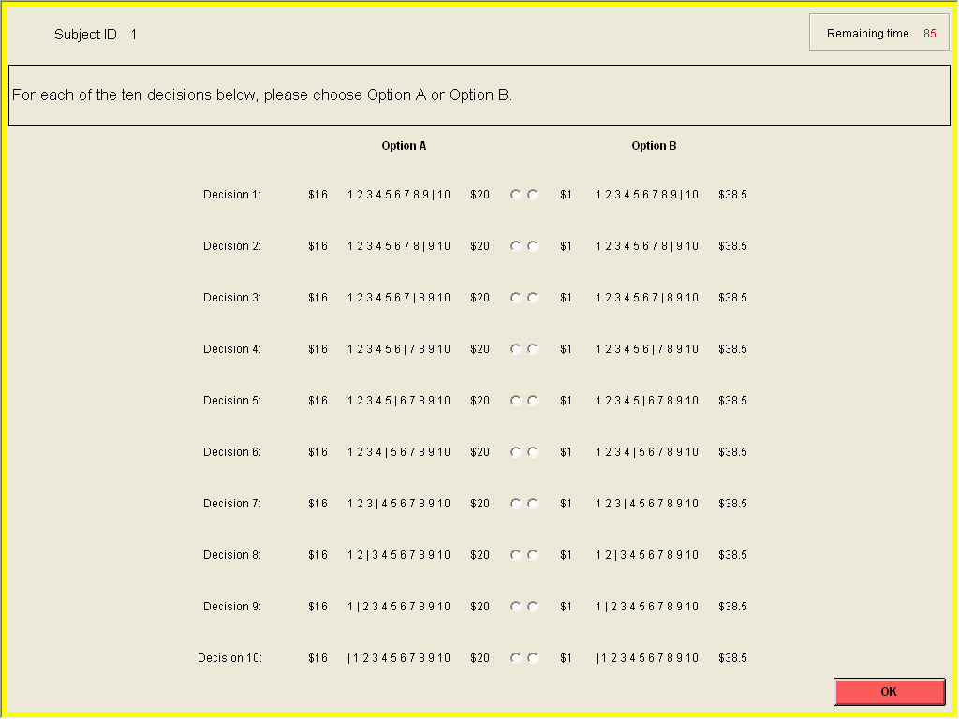

For example, let us focus on the first decision. Option A and Option B in this decision are to be understood as follows. Option A pays either $16 or $20; Option B pays either $1 or $38.5. The computer will randomly determine which amount each option pays. In particular, the computer will randomly select one of the numbers 1, 2, 3, 4, 5, 6, 7, 8, 9, or 10 where each number is equally likely to be selected. You can imagine that the computer selects a number by throwing a ten-sided die. If the number is to the left of the vertical line in the description of an option in the screenshot above, the option pays the smaller dollar amount; if the number is to the right of the vertical line, the option pays the larger dollar amount. That is, if the number is 1, 2, 3, 4, 5, 6, 7, 8, or 9, Option A pays $16 and Option B pays $1. On the other hand, if the number is 10, Option A pays $20 and Option B pays $38.5.

Now, consider all ten decisions. Notice that in each decision, Option A pays either $16 or $20 and Option B pays either $1 or $38.5. The only difference between decisions is that as you move down the rows, the chance that each option pays the high payoff increases. This is the case because the vertical line in each option shifts to the left as you move down the rows. In decision 10, the vertical line is all the way to the left which means that option A pays $20 for sure and Option B pays $38.5 for sure.

For each decision in this task, you have to choose either Option A or Option B. How you choose between Option A and Option B in each decision is entirely a question of personal preference—there is no right or wrong answer. The only restriction on your choices is the following.

Suppose that in some decision you choose Option B. Then, in all subsequent decisions you have to keep choosing Option B. The reason is that, in subsequent decisions, Option B becomes more attractive: the chance it pays $38.5 increases and the chance it pays $1 decreases.

Earnings:

Your earnings for this task will be determined as follows. First, the computer will randomly select one of the ten decisions. (Each decision has an equal chance of being selected.) Then, the computer will roll a ten-sided die to pick a number 1 to 10. This number, in combination with your option choice for the selected decision, will determine your earnings.

Note that only one of the decisions will be used for determining your earnings for this task. However, keep in mind that because you don’t know which decision will be used, it is in your best interest to make all ten decisions carefully.

Of course, as explained in the beginning of today’s session, your earnings for this task will only be used for payment if this task is the one selected for payment.

Understanding Quiz

Let’s say decision 5 is the randomly selected decision.

- Assume you chose Option A in decision 5. If, when the computer “rolls the ten-sided die”, the “die” comes up 2, your earnings for Task 1 will equal _________.

- Assume you chose Option A in decision 5. If, when the computer “rolls the ten-sided die”, the “die” comes up 7, your earnings for Task 1 will equal _________.

- Assume you chose Option B in decision 5. If, when the computer “rolls the ten-sided die”, the “die” comes up 2, your earnings for Task 1 will equal _________.

- Assume you chose Option B in decision 5. If, when the computer “rolls the ten-sided die”, the “die” comes up 7, your earnings for Task 1 will equal _________.

- Is it possible that someone chooses Option A in decision 3 and Option A in decision 5?

- Is it possible that someone chooses Option A in decision 3 and Option B in decision 5?

- Is it possible that someone chooses Option B in decision 3 and Option A in decision 5?

- Is it possible that someone chooses Option B in decision 3 and Option B in decision 5?

Are there any questions? If not, we can start the task. You have 3 minutes for making all ten decisions in this task.
Task 3

Overview:
In this task, you will be randomly matched with another subject whom we refer to as OTHER. This matching will be anonymous—no one will ever find out who they were matched with.

You and OTHER will play a game. The game consists of two players; a “first mover” who moves first, and a “second mover” who follows. At the outset, the first mover receives $16.00. The first mover then decides whether to keep this money, or to pass it along. If the money is passed it is multiplied by three and given to the second mover, who then must decide whether to split the total amount equally or keep it.

Specific Instructions:

The first mover has to decide whether to:

Keep $16 and pass $0 or

Keep $0 and pass $16

If the first mover chooses A, i.e. keeps $16 and passes $0, the game ends. If the first mover chooses B, i.e. keeps $0 and passes $16, the $16 passed by the first mover is tripled so that the second mover has to decide what to do with $48. In particular, the second mover has two options:

Keep $24 and pass $24 back to the first mover or

Keep $48 and pass $0 back to the first mover
B
($16,$0)
($24,$24)
A
a)
b)
First Mover
Second Mover
($0,$48)

You have to make two decisions. In particular, you have to decide:

What you would choose if you are the first mover: A or B;

What you would choose if you are the second mover and OTHER passed $16 to you so that you have $48 available. For this case, you must choose either a) or b).

Earnings:

Your earnings for this task will be determined as follows. The computer will determine with probability 50-50 whether you are the first mover or the second mover.

If you are the first mover, the computer will first check what you would do as the first mover. If you would keep $16 and pass $0, your earnings for this task will equal $16 and OTHER’s earnings will equal $0. On the other hand, if you would keep $0 and pass $16, the computer checks OTHER’s choice. If OTHER keeps $48 and passes $0 back, you will earn $0 and OTHER will earn $48. If OTHER keeps $24 and passes $24 back, you will earn $24 and OTHER will earn $24.

If you are the second mover and OTHER the first mover, things are analogous. Just switch the words you/your with OTHER/OTHER’s in the previous paragraph. That is, the computer will first check whether OTHER kept $16 or passed $16 to you (so that you have $48 available). In the latter case, the computer will also check whether you elected to keep $24 and pass back $24, or to keep the $48.

Of course, as explained in the beginning of today’s session, your earnings for this task will only be used for payment if this task is the one selected for payment.

Are there any questions? If not, we can start the task. You have 3 minutes for making both of your decisions in this task.

Task 4

Overview:
This task, concerns a Decision Tree. This decision tree is simply a short sequence of decisions to be taken by you, interlaced with moves taken by the computer. Each sequence of decisions by you and moves by the computer leads to a payoff.

The Decision Tree:
The Decision Tree, depicted below, is characterized by a sequence of decision and chance nodes. At each node, there are two subsequent paths to follow: Up and Down. At each decision node you will have to make a decision whether to go Up or Down. At each chance node, the computer will choose Up or Down randomly with 50-50 chance. Regardless of what happened previously in the decision tree, the computer always chooses Up or Down with equal probability. Thus, it is impossible to predict what the computer is going to do: Up and Down are equally likely.

A sequence of decision and chance nodes consists of a decision node, followed by a chance node, followed by a decision node, followed by a chance node. After the second and final chance node is played out you will arrive at a payoff node. Each payoff node has associated with it a monetary payoff which is written next to it.

How the task will proceed:
You should first study the decision tree carefully, and particularly the various possible payoff nodes. You will end up at one of these payoff nodes. After you have studied the tree you can enter your decision regarding whether you would like to move Up or Down at decision node 1 which is at the left end of the tree (see picture). Once you hit “OK”, your decision will lead to a particular chance node at which the computer will move. The computer’s move will then lead to your next decision node. You will be told whether the computer moved Up or Down and whether this led to decision node 2, 3, 4, or 5. Then, you will be asked to once again decide whether to move Up or Down. After your move, the computer moves again and this leads to one of the payoff nodes.

Earnings:
Your earnings in this task will equal the payoff at the payoff node that is reached. Of course, as explained in the beginning of today’s session, your earnings for this task will only be used for payment if this task is the one selected for payment.

Are there any questions? If not, we can start the task. You have 5 minutes to make your first decision (the one at decision node 1) and 2 minutes to make your second decision (the one at one of the decision nodes 2, 3, 4, or 5).

Computer
$15
$17
Computer
$2
$4
Computer
$20
$8
Computer
$8
$0
You
4
You
5
Computer
Computer
$8
$13
Computer
$16
$8
Computer
$6
$20
Computer
$6
$18
You
2
You
3
Computer
You
1

You
1
Task 5

In this task, you will make ten decisions. Each decision is a paired choice between “Option A” and “Option B”. All ten decisions are shown in the screenshot below.

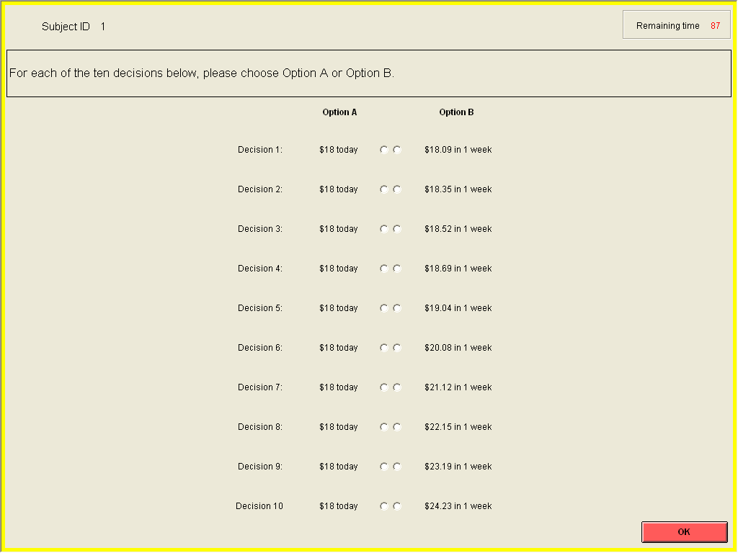

For example, let us focus on the first decision. Option A and Option B in this decision are to be understood as follows. Option A pays $18.00 today. Option B pays $18.09 in one week.

Now, consider all ten decisions. Notice that in all decisions, Option A pays $18 today and Option B pays an amount of money one week from today. The only difference between decisions is that as you move down, Option B pays progressively larger amounts.

For each decision in this task, you have to choose either Option A or Option B. How you choose between Option A and Option B in each decision is entirely a question of personal preference—there is no right or wrong answer. The only restriction on your choices is the following.

Suppose that in some decision you choose Option B. Then, in all subsequent decisions you have to keep choosing Option B. The reason is that, in subsequent decisions, Option B becomes more attractive because it pays a larger amount.

Earnings:

Your earnings for this task will be determined as follows. First, the computer will randomly select one of the ten decisions. Each decision has an equal chance of being selected. You will be paid for this task according to the option you chose in that decision.

In particular, if you chose Option A in the randomly selected decision, we will write you a check with today’s date on it which you can cash immediately. If you chose Option B in the randomly selected decision, we will write you a check with a date on it which will be one week from today. You will not be able to cash this check before the date written on it, i.e. before one week from today.

Note that only one of the decisions will be used for determining your earnings for this task. However, keep in mind that because you don’t know which decision will be used, it is in your best interest to make all ten decisions carefully.

Of course, as explained in the beginning of today’s session, your earnings for this task will only be used for payment if this task is the one selected for payment.

Understanding Quiz

Let’s say decision 7 is randomly selected for payment.

- Assume you chose Option A in decision 7. Then you will receive a check for the amount _________ which is payable on ________ (date).
- Assume you chose Option B in decision 7. Then you will receive a check for the amount _________ which is payable on ________ (date).
- Is it possible that someone chooses Option A in decision 4 and Option A in decision 7?
- Is it possible that someone chooses Option A in decision 4 and Option B in decision 7?
- Is it possible that someone chooses Option B in decision 4 and Option A in decision 7?
- Is it possible that someone chooses Option B in decision 4 and Option B in decision 7?

Are there any questions? If not, we can start the task. You have 2 minutes for making all ten decisions in this task.
Task 6

In this task, you are provided with $20. You have to decide how much of these $20 to keep for yourself and how much to contribute to the charitable organization “Feed the Children”. You are free to contribute to the charitable organization any integer amount between $0 and $20, including $0 and $20.

Note: “Feed the Children” provides food, clothing, medical care, education, and emergency relief to children in the United States and overseas. We selected this charity because of the importance of the work it does, and because of the organization’s efficiency (which is among the highest in the United Way).

You will make your decision by selecting one of the radio buttons shown on the screenshot below.

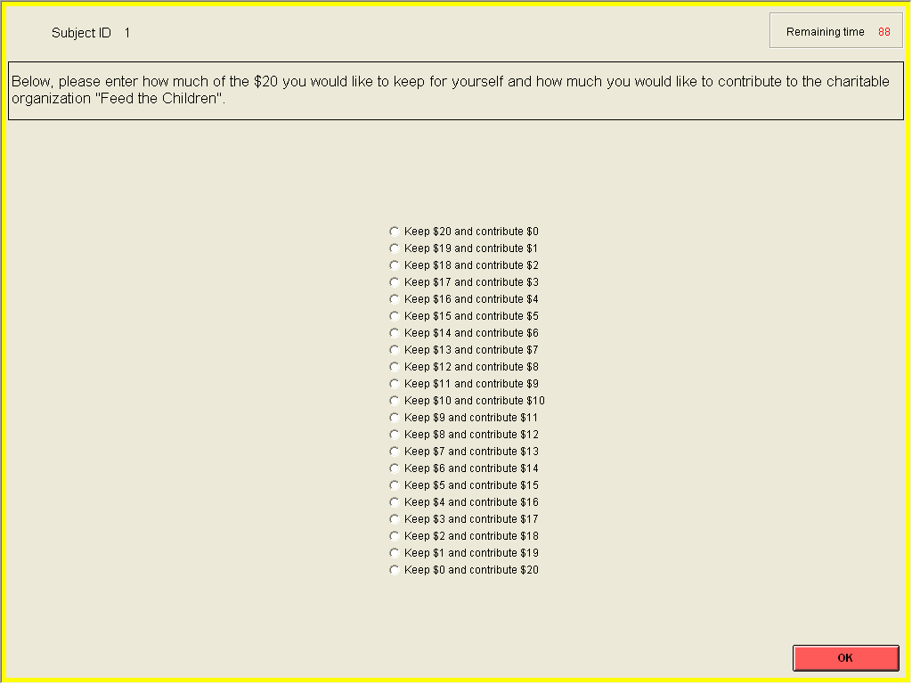

How much or little you decide to contribute is entirely a question of personal preference—there is no right or wrong answer.

Also note that your decision in this task will only be relevant if this task is the one selected for payment. If this is the case, your earnings for today’s session will equal the amount you chose to keep for yourself plus the $6 show-up fee. The amount you chose to contribute will go to the charity. We will add up the contributions all of you made and write a check for that amount for “Feed the Children”. We will place the check in a stamped envelope and mail the check to “Feed the Children” immediately after the experiment. If this task is selected for payments, we encourage any of you who are interested to stay just a few minutes after the session to go with us to a mail box and post this check.

Are there any questions? If not, we can start the task. You have 2 minutes to make your decision in this task.

