Appendix B – Experimental Instructions for Contextually Framed Condition
Experimental Instructions
Buyer
Part I: The Bargaining Task
You have been randomly assigned the role of Buyer, and you will remain in this role for the rest of the experiment. You will be randomly and anonymously paired with another participant who has been assigned the role of Seller. In this task, the seller has been endowed with a plot of land. As the buyer, you are trying to purchase the land from the seller. You and the seller will be given an opportunity to bargain over the price of the land (the specific bargaining process is described below). If you are unable to reach an agreement, then you and the seller will go to court, where the seller will be forced to sell the land to you. If you go to court, then you, as the buyer, will receive a fixed payment for acquiring the land. The price the seller receives for the land will be randomly determined by the court (the specific process of how the court amount is determined is described in more detail below).
Bargaining with the Seller:
In the experiment, we will be using a fictitious currency called: Thaler. Throughout the experiment your earnings will be in terms of Thalers, which will then be converted at the end of the experiment into dollars at a rate of: 10 Thaler to $1. As the buyer, your value for the plot of land is: 200 Thalers. Your earnings from acquiring the land from the seller will be your value of 200 Thaler minus the price you pay. You and the seller will have an opportunity to bargain over the price of the plot of land. The bargaining process will work as follows:
Buyer: You will first make an offer (in Thalers) to the seller for the land.
Seller: The seller will then decide whether or not to accept or reject your offer.
If the seller accepts offer then you acquire the land at the price you offered, and your earnings are: 200 - the accepted offer. The seller receives the accepted offer as payment for the land.
If the seller does not accept your offer, then you and the seller will go to court, where the seller is forced to sell the land to you. You will have to pay a fixed payment of 150 Thaler for the land. So your earning, if you have to go to court, will be: 200 – 150 = 50. The amount of money that the seller will receive for the land will depend on how much money the court awards the seller. The exact amount that the seller will receive will be determined randomly based on the possible court award amounts and the likelihood that these possible amounts are awarded, which is described below.
The Court Award:
In the event that an agreement is not reached in the bargaining stage, because the seller rejects your offer, the court will randomly determine how much the seller will receive. The possible amounts that the seller may be awarded, and the likelihood that each of these possible amounts is awarded to the seller will be displayed in a court award table. Below is an example of what one of these court award tables might look like:
Possible Court Awards | Chance of Court Award
40 Thaler | 10%
60 Thaler | 20%
100 Thaler | 40%
140 Thaler | 20%
160 Thaler | 10%
What this table conveys, is that if you and the seller go to court, then there would be a 10% chance the court would award the seller 40 Thaler, a 20% chance of 60 Thaler, a 40% chance of 100 Thaler, a 20% chance of 140 Thaler, and a 10% chance of 160 Thaler. Remember that you, as the buyer, will pay just a fixed amount of 150 as payment for acquiring the land, regardless of what the court decides, as described above.
Note: both you and seller will know what the possible court awards are and the likelihood that each occurs prior to making decisions in the bargaining stage. However, if you and the seller go to court, then you will not receive feedback about what the actual realized court award was.
Procedure and Computer Interface:
All of your decisions in the bargaining task will be made on the computer. The screen for entering your offer is split into two halves: on the right side of the screen, you will see the specific court award table (if an agreement is not reached), on the left side of the screen you will be asked to enter your offer (to the nearest Thaler). After you have entered in your offer, you will be asked to click the CONFIRM button. Below is a sample of what the scree will look like:
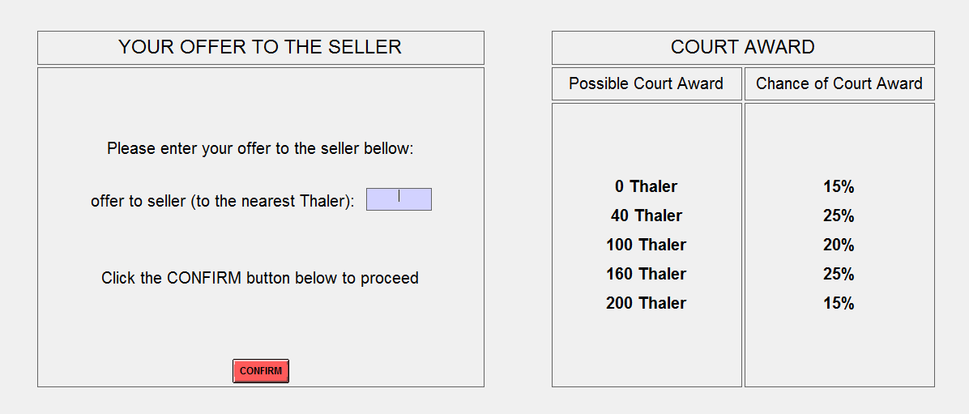

Multiple Times and Random Re-matching:
You will be participating in this bargaining task a total of 5 times. In each of the 5 rounds of the bargaining task, you will be randomly re-matched with a different participant seller. That is, you will be paired with a different seller in each of the 5 rounds. Additionally, in each of the 5 rounds, the possible court awards and/or the likelihood that each occurs will be different so be sure to look at the court award table before making your offer.
part ii: The Lottery Choice Task:
After you have finished the 5 rounds of the bargaining task, you will proceed to the lottery task part of the experiment. In this lottery task, you will make a decision in a series of 30 lottery choices problems. In each of the 30 lottery choice problems, there will be two possible lottery options, which will denote as: Option A and Option B. Each of these lottery options will involve possible amounts of Thaler that you could earn and the corresponding likelihood (expressed as a probability) that you would win that amount. For each of the 30 different lottery problems, you will be asked to select the option that you most prefer of the two options.
Procedure and Computer Interface:
For each of the 30 lottery choice problems, you will see a screen that displays Option A on the left and Option B on the right, with the corresponding possible amounts of Thaler and the % chance of winning that amount for each option. You will make your preferred choice between the two options by simply clicking the corresponding button below the option. You will proceed in this manner through all 30 lottery choice problems, and this will conclude the experiment. Below is a screen shot of a sample lottery choice problem:
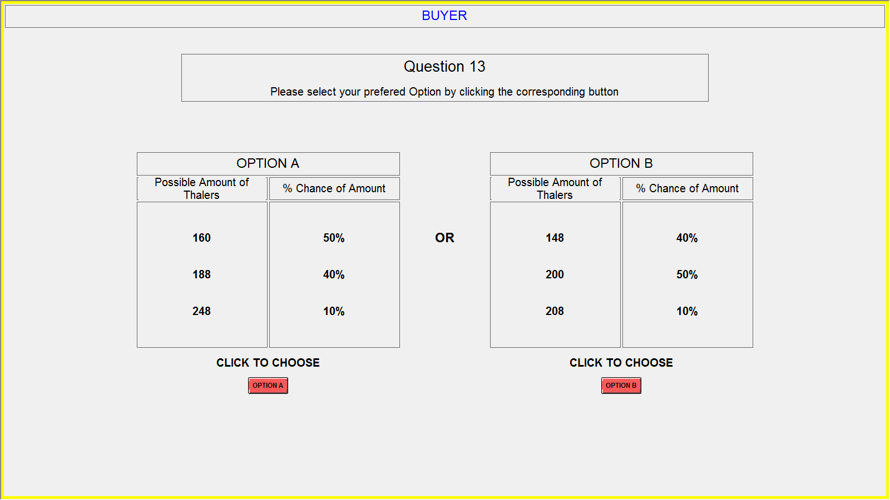

In the above sample lottery problem, if you choose OPTION A, then there is a 50% chance you would win 160 Thaler, a 40% chance you would win 188 Thaler, and a 10% chance you would win 248 Thaler. If you choose OPTION B, then there is a 40% chance you would win 148 Thaler, a 50% chance you would win 200 Thaler, and a 10% chance you would win 208 Thaler.
final Payment:
Your total earnings for this experiment will be determined as follows: First, you will receive $5 for showing up and participating in the experiment. In addition, you will be paid your earnings (converted from Thalers to dollar at a rate of 10 Thaler to $1) in either one randomly drawn round of the bargaining task or one randomly drawn lottery choice problem from the lottery choice task. This randomized payment will work as follows: First, after the experiment has ended, an experimenter will flip a coin to determine whether the bargaining task or the lottery task will be paid. Thus, each of the tasks is equally likely to be selected for payment. If it is heads then all participants will get paid for the bargaining task, and if it is tails then the lottery task will be paid.
If the bargaining task is selected, then an experimenter will come to your carrel where you will individually draw 1 ping pong ball from a bag that contains 5 balls, each one labeled for each of the 5 rounds. You will then be paid the earnings that correspond to the round that you selected.
If the lottery task is selected, then an experimenter will come to your carrel where you will individually draw 1 ping pong ball from a bag that contains 30 balls, each one labeled for each of the 30 lottery choice problems. You will then role two 10 sided dice to determine the amount that you will win, which will be based on the option that you actually choose for the lottery problem that you selected. The experimenter will have a sheet that displays which numbers of the die role correspond to which amount won (these die numbers are selected in a way to generate the same % chance of winning that is displayed in the option you selected).
After you have finished the experiment, please remain quietly seated until an experimenter comes to your carrel to determine your earnings. You will then be paid you total earnings in cash. After you have been paid you may quietly exit the lab.

Thank you for you participation and cooperation

Experimental Instructions
seller
Part I: The Bargaining Task
You have been randomly assigned the role of Seller, and you will remain in this role for the rest of the experiment. You will be randomly and anonymously paired with another participant who has been assigned the role of Buyer. In this task, you, as the seller, have been endowed with a plot of land. The buyer has been tasked with trying to purchase the land from you. You and the buyer will be given an opportunity to bargain over the price of the land (the specific bargaining process is described below). If you are unable to reach an agreement, then you and the buyer will go to court, where you will be forced to sell the land to the buyer. If you go to court, then the price you will receive for the land will be randomly determined by the court (the specific process of how the court amount is determined is described in more detail below). The buyer will simply pay a fixed payment for acquiring the land.
Bargaining with the Buyer:
In the experiment, we will be using a fictitious currency called: Thaler. Throughout the experiment your earnings will be in terms of Thalers, which will then be converted at the end of the experiment into dollars at a rate of: 10 Thaler to $1. As the buyer, your earnings from selling the land to the buyer will be the price you receive for the land (in Tahlers). You and the buyer will have an opportunity to bargain over the price of the plot of land. The bargaining process will work as follows:
Buyer: The buyer will first make you an offer (in Thalers) for the land.
Seller: You will be asked to state the minimum offer (in Thalers) that you would be willing to accept from the buyer to avoid going to court.
After you state your minimum acceptable offer, the buyer’s offer will be revealed to you. If the buyer’s offer is higher than your minimum acceptable offer, then you will sell the land at a price equal to the buyer’s offer. Your earnings will be: the accepted buyer offer.
If the buyer’s offer is lower than your minimum acceptable offer, then you and the buyer will go to court, where you will be forced to sell the land to the buyer. The amount of money that you will receive for the land will depend on how much money the court awards you. The exact amount that you will receive will be determined randomly based on the possible court award amounts and the likelihood that these possible amounts are awarded, which is described below. Your earnings in this case will be: the court award.
The Court Award:
In the event that an agreement is not reached in the bargaining stage, because the buyer’s offer is lower than your minimum acceptable offer, the court will randomly determine how much you will receive as payment for the land. The possible amounts that you may be awarded, and the likelihood that each of these possible amounts is awarded, will be displayed in a court award table. Below is an example of what one of these court award tables might look like:
Possible Court Awards | Chance of Court Award
40 Thaler | 10%
60 Thaler | 20%
100 Thaler | 40%
140 Thaler | 20%
160 Thaler | 10%
What this table conveys, is that if you and the buyer go to court, then there would be a 10% chance the court would award you 40 Thaler, a 20% chance of 60 Thaler, a 40% chance of 100 Thaler, a 20% chance of 140 Thaler, and a 10% chance of 160 Thaler.
Note: both you and buyer will know what the possible court awards are and the likelihood that each occurs prior to making decisions in the bargaining stage.
Procedure and Computer Interface:
All of your decisions in the bargaining task will be made on the computer. The screen for entering the minimum offer that you are willing to accept is split into two halves: on the right side of the screen, you will see the specific court award table (if an agreement is not reached), on the right side of the screen you will be asked to enter your minimum acceptable offer (to the nearest Thaler). After you have entered your minimum acceptable offer, you will be asked to click the CONFIRM button. Below is a sample of what the scree will look like:

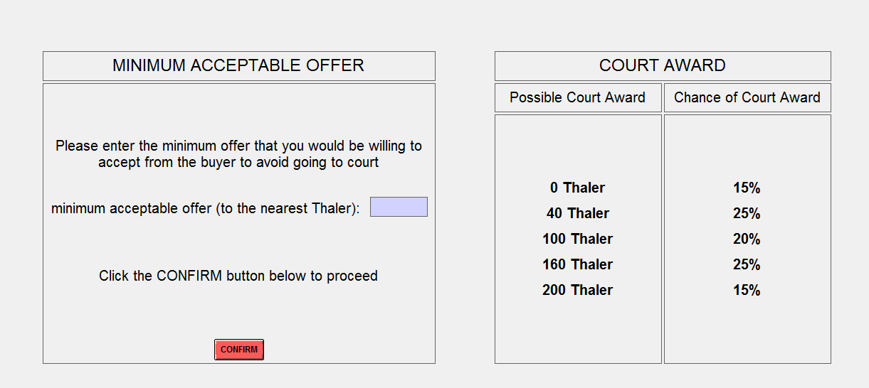

Multiple Times and Random Re-matching:
You will be participating in this bargaining task a total of 5 times. In each of the 5 rounds of the bargaining task, you will be randomly re-matched with a different participant buyer. That is, you will be paired with a different buyer in each of the 5 rounds. Additionally, in each of the 5 rounds, the possible court awards and/or the likelihood that each occurs will be different so be sure to look at the court award table before making your offer. If you do go to court in a particular round, you will not be informed about the actual realized court award until after the experiment has ended and payments are determined.
part ii: The Lottery Choice Task:
After you have finished the 5 rounds of the bargaining task, you will proceed to the lottery task part of the experiment. In this lottery task, you will make a decision in a series of 30 lottery choices problems. In each of the 30 lottery choice problems, there will be two possible lottery options, which will denote as: Option A and Option B. Each of these lottery options will involve possible amounts of Thaler that you could earn and the corresponding likelihood (expressed as a probability) that you would win that amount. For each of the 30 different lottery problems, you will be asked to select the option that you most prefer of the two options.
Procedure and Computer Interface:
For each of the 30 lottery choice problems, you will see a screen that displays Option A on the left and Option B on the right, with the corresponding possible amounts of Thaler and the % chance of winning that amount for each option. You will make your preferred choice between the two options by simply clicking the corresponding button below the option. You will proceed in this manner through all 30 lottery choice problems, and this will conclude the experiment. Below is a screen shot of a sample lottery choice problem:

In the above sample lottery problem, if you choose OPTION A, then there is a 50% chance you would win 160 Thaler, a 40% chance you would win 188 Thaler, and a 10% chance you would win 248 Thaler. If you choose OPTION B, then there is a 40% chance you would win 148 Thaler, a 50% chance you would win 200 Thaler, and a 10% chance you would win 208 Thaler.

final Payment:
Your total earnings for this experiment will be determined as follows: First, you will receive $5 for showing up and participating in the experiment. In addition, you will be paid your earnings (converted from Thalers to dollar at a rate of 10 Thaler to $1) in either one randomly drawn round of the bargaining task or one randomly drawn lottery choice problem from the lottery choice task. This randomized payment will work as follows: First, after the experiment has ended, an experimenter will flip a coin to determine whether the bargaining task or the lottery task will be paid. Thus, each of the tasks is equally likely to be selected for payment. If it is heads then all participants will get paid for the bargaining task, and if it is tails then the lottery task will be paid.
If the bargaining task is selected, then an experimenter will come to your carrel where you will individually draw 1 ping pong ball from a bag that contains 5 balls, each one labeled for each of the 5 rounds. You will then be paid the earnings that correspond to the round that you selected. If in the round that you selected you went to court, then you will then role two 10 sided dice to determine the amount you will be awarded, which will be based on the specific court award table from that round. The experimenter will have a sheet that displays which numbers of the die role correspond to which court awards (these die numbers are selected in a way to generate the same % chance of winning that is displayed in the specific court award table from that round).
If the lottery task is selected, then an experimenter will come to your carrel where you will individually draw 1 ping pong ball from a bag that contains 30 balls, each one labeled for each of the 30 lottery choice problems. Again, you will then role two 10 sided die to determine the amount that you will win, which will be based on the option that you actually choose for the lottery problem that you selected. The experimenter will have a sheet that displays which numbers of the die role correspond to which amount won (these die numbers are selected in a way to generate the same % chance of winning that is displayed in the option you selected).
After you have finished the experiment, please remain quietly seated until an experimenter comes to your carrel to determine your earnings. You will then be paid you total earnings in cash. After you have been paid you may quietly exit the lab.

Thank you for you participation and cooperation

