Appendix C – Experimental Instructions for Abstractly Framed Condition
Experimental Instructions
PLAYER A (Buyer analog)
Part I: The Bargaining Task
You have been randomly assigned the role of Player A, and you will remain in this role for the rest of the experiment. You will be randomly and anonymously paired with another participant who has been assigned the role of Player B. In this task, Player B has been endowed with one fictitious token. As Player A, you are trying to purchase this token from Player B. You and Player B will be given an opportunity to bargain over the price of the token (the specific bargaining process is described below). If you are unable to reach an agreement, then you will be given the token, and you will pay a predetermined fixed amount for acquiring the token. The price the seller will receive as compensation for the token will be randomly determined by a draw from a lottery (the process of how the lottery amount is determined is described in detail below).
Bargaining with Player B:
In the experiment, we will be using an experimental currency called: Thaler. Throughout the experiment your earnings will be in terms of Thalers, which will then be converted at the end of the experiment into dollars at a rate of: 10 Thaler to $1. As Player A, your value for the token is: 200 Thalers. Your earnings from acquiring the token from Player B will be your value of 200 Thaler minus the price you pay. You and Player B will have an opportunity to bargain over the price of the token. The bargaining process will work as follows:
Player A: You will first make a price offer (in Thalers) to Player B for the token.
Player B: Player B will then decide whether or not to accept or reject your price offer.
If Player B accepts your offer, then you acquire the token at the price you offered, and your earnings are: 200 - the accepted price offer. Player B receives the accepted offer as payment for the token.
If Player B does not accept your offer, then you will be given the token. You will have to pay a fixed payment of 150 Thaler for the token. So your earning, if you and Player B do not reach an agreement, will be: 200 – 150 = 50. The amount of money that Player B will receive for the token will depend on the draw of the lottery that Player B faces as compensation for the token. The exact amount that Player B will receive will be determined randomly based on the possible outcomes of the lottery and the likelihood (expressed as a % chance) that these outcomes occur, which is described below.
The Lottery:
In the event that an agreement is not reached in the bargaining stage, because Player B rejects your offer, a random draw from a lottery determines how much Player B receives for the token. The possible amounts that Player B may receive, and the likelihood that Player B receives each of these possible amounts, will be displayed in a lottery table. Below is an example of what one of these lottery tables might look like:
Possible Amounts | Chance of Receiving the Amount
40 Thaler | 10%
60 Thaler | 20%
100 Thaler | 40%
140 Thaler | 20%
160 Thaler | 10%
What this table conveys is that if you and Player B do not reach an agreement, then there would be a 10% that Player B would receive 40 Thaler for the token, a 20% chance of receiving 60 Thaler, a 40% chance of receiving 100 Thaler, a 20% chance of receiving 140 Thaler, and a 10% chance of receiving 160 Thaler. Remember that you, as Player A, will pay just a fixed amount of 150 as payment for acquiring the token, regardless of the outcome of the lottery, as described above.
Note: both you and Player B will know what the possible amounts of the lottery are, and the likelihood that each occurs, prior to making your decisions in the bargaining stage.
Procedure and Computer Interface:
All of your decisions in the bargaining task will be made on the computer. The screen for entering your offer is split into two halves: on the right side of the screen, you will see the specific lottery table (if an agreement is not reached); on the left side of the screen you will be asked to enter your price offer (to the nearest Thaler). After you have entered your offer, you will be asked to click the CONFIRM button. Below is a sample of what the scree will look like:
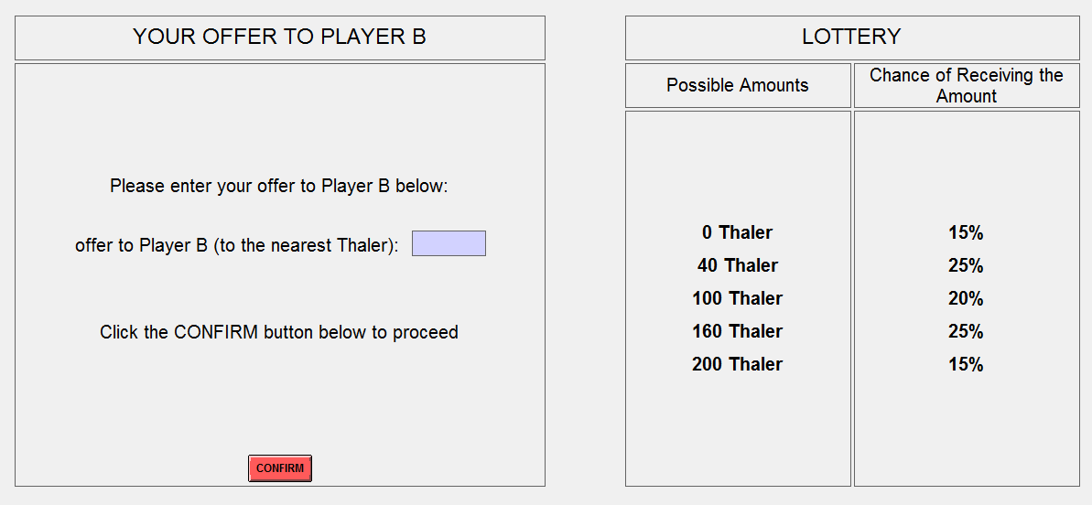
Multiple Rounds and Random Re-matching:
You will be participating in this bargaining task a total of 5 times. In each of the 5 rounds of the bargaining task, you will be randomly re-matched with a different Player B. That is, you will be paired with a different Player B in each of the 5 rounds. Additionally, in each of the 5 rounds, the possible lottery amounts and/or the chance of receiving the amount will be different, so be sure to look at the lottery table before making your offer. In the event that you and Player B don’t reach an agreement and Player B’s payment is determined by the lottery, you will not receive feedback about the actual realized outcome of the lottery.
part ii: The Lottery Choice Task:
After you have finished the 5 rounds of the bargaining task, you will proceed to the lottery task part of the experiment. In this lottery task, you will make a decision in a series of 30 lottery choices problems. In each of the 30 lottery choice problems, there will be two possible lottery options, which will be denoted as: Option A and Option B. Each of these lottery options will involve possible amounts of Thaler that you could earn and the corresponding likelihood (expressed as a % chance) that you would win that amount. For each of the 30 different lottery problems, you will be asked to select which of the two options that you most prefer.
Procedure and Computer Interface:
For each of the 30 lottery choice problems, you will see a screen that displays Option A on the left and Option B on the right, with the corresponding possible amounts of Thaler and the % chance of winning that amount for each option. You will make your preferred choice between the two options by simply clicking the corresponding button below the option. You will proceed in this manner through all 30 lottery choice problems, and this will conclude the experiment. Below is a screen shot of a sample lottery choice problem:
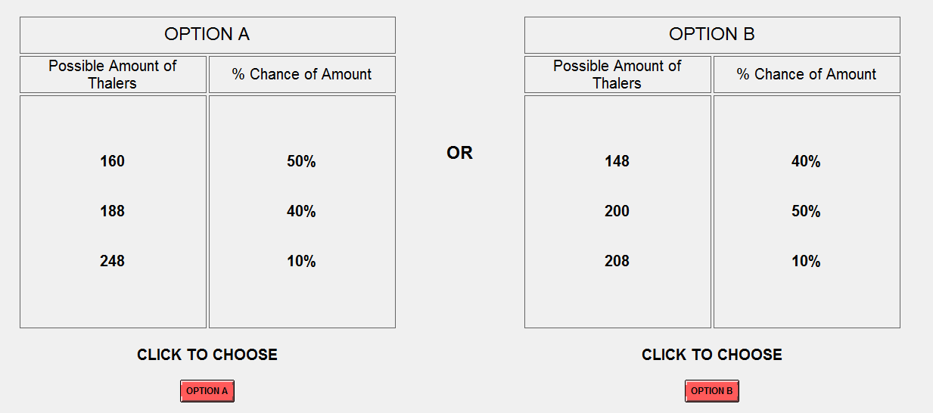
In the above sample lottery problem, if you choose OPTION A, then there is a 50% chance you would win 160 Thaler, a 40% chance you would win 188 Thaler, and a 10% chance you would win 248 Thaler. If you choose OPTION B, then there is a 40% chance you would win 148 Thaler, a 50% chance you would win 200 Thaler, and a 10% chance you would win 208 Thaler.

final Payment:
Your total earnings for this experiment will be determined as follows: First, you will receive $5 for showing up and participating in the experiment. In addition, you will be paid your earnings (converted from Thalers to dollar at a rate of: 10 Thaler to $1) in either one randomly drawn round of the bargaining task or one randomly drawn lottery choice problem from the lottery choice task. This randomized payment will work as follows: First, after the experiment has ended, an experimenter will flip a coin to determine whether the bargaining task or the lottery task will be paid. Thus, each of the two tasks is equally likely to be selected for payment. If it is heads, then all participants will get paid for the bargaining task; if it is tails, then all participants will get paid for the lottery task.
If the bargaining task is selected, then an experimenter will come to your carrel where you will individually draw 1 ping pong ball from a bag that contains 5 balls, each one labeled for each of the 5 rounds. You will then be paid the earnings that correspond to the round that you selected.
If the lottery task is selected, then an experimenter will come to your carrel where you will individually draw 1 ping pong ball from a bag that contains 30 balls, each one labeled for each of the 30 lottery choice problems. You will then role two 10-sided die to determine the amount that you will win, which will be based on the option that you actually choose from the lottery problem that you selected. The experimenter will have a sheet that displays which numbers of the die role correspond to which amount won (these die numbers are selected in a way to generate the same % chance of winning that is displayed in the option you selected).
After you have finished the experiment, please remain quietly seated until an experimenter comes to your carrel to determine your earnings. You will then be paid you total earnings either by cash or check. After you have been paid you may quietly exit the lab.

Thank you for you participation and cooperation

Experimental Instructions
Player B (Seller anolog)
Part I: The Bargaining Task
You have been randomly assigned the role of Player B, and you will remain in this role for the rest of the experiment. You will be randomly and anonymously paired with another participant who has been assigned the role of Player A. In this task, you, as Player B, have been endowed with one fictitious token. Player A has been tasked with trying to purchase the token from you. You and Player A will be given an opportunity to bargain over the price of the token (the specific bargaining process is described below). If you are unable to reach an agreement, then Player A will be given the token. In return, the price you will receive as compensation for the token will be randomly determined by a draw from a lottery (the process of how the lottery amount is determined is described in detail below). Player A will pay a fixed payment for acquiring the token.
Bargaining with Player A:
In the experiment, we will be using a fictitious currency called: Thaler. Throughout the experiment your earnings will be in terms of Thalers, which will then be converted at the end of the experiment into dollars at a rate of: 10 Thaler to $1. As Player B, your earnings from selling the token will be the price you receive for the token (in Thalers). You and Player A will have an opportunity to bargain over the price of the token. The bargaining process will work as follows:
Player A: Player A will first make you a price offer (in Thalers) for the token.
Player B: You will be asked to state the minimum price offer (in Thalers) that you would be willing to accept from Player A for the token to avoid having the price be determined by the lottery
After you state your minimum acceptable offer, Player A’s offer will be revealed to you. If Player A’s offer is higher than your minimum acceptable offer, then you will sell the token at a price equal to Player A’s offer. Your earnings will be: the accepted offer made by Player A.
If Player A’s offer is lower than your minimum acceptable offer, then Player A will be given the token. The amount of money that you will receive as compensation for the token will be randomly determined by a draw from a lottery. The exact amount that you will receive will be determined randomly based on the possible outcomes of the lottery and the likelihood (expressed as a % chance) that these outcomes occur, which is described below. Your earnings in this case will be: the random draw of the lottery.
The Lottery:
In the event that an agreement is not reached in the bargaining stage, because Player A’s offer is lower than your minimum acceptable offer, the price you will receive for the token will be randomly determined by a draw from a lottery. The possible amounts that you may receive, and the likelihood that you receive each of these possible amounts, will be displayed in a lottery table. Below is an example of what one of these lottery tables might look like:

Possible Amounts | Chance of Receiving the Amount
40 Thaler | 10%
60 Thaler | 20%
100 Thaler | 40%
140 Thaler | 20%
160 Thaler | 10%
What this table conveys is that if you and Player A do not reach an agreement, then there would be a 10% that you would receive 40 Thaler for the token, a 20% chance you would receive 60 Thaler, a 40% chance you would receive 100 Thaler, a 20% chance you would receive 140 Thaler, and a 10% chance you would receive 160 Thaler.
Note: both you and Player A will know what the possible amounts of the lottery are, and the likelihood that each occurs, prior to making your decisions in the bargaining stage.
Procedure and Computer Interface:
All of your decisions in the bargaining task will be made on the computer. The screen for entering the minimum offer that you are willing to accept is split into two halves: on the right side of the screen, you will see the specific lottery table (if an agreement is not reached), on the left side of the screen you will be asked to enter your minimum acceptable offer (to the nearest Thaler). After you have entered your minimum acceptable offer, you will be asked to click the CONFIRM button. Below is a sample of what the scree will look like:
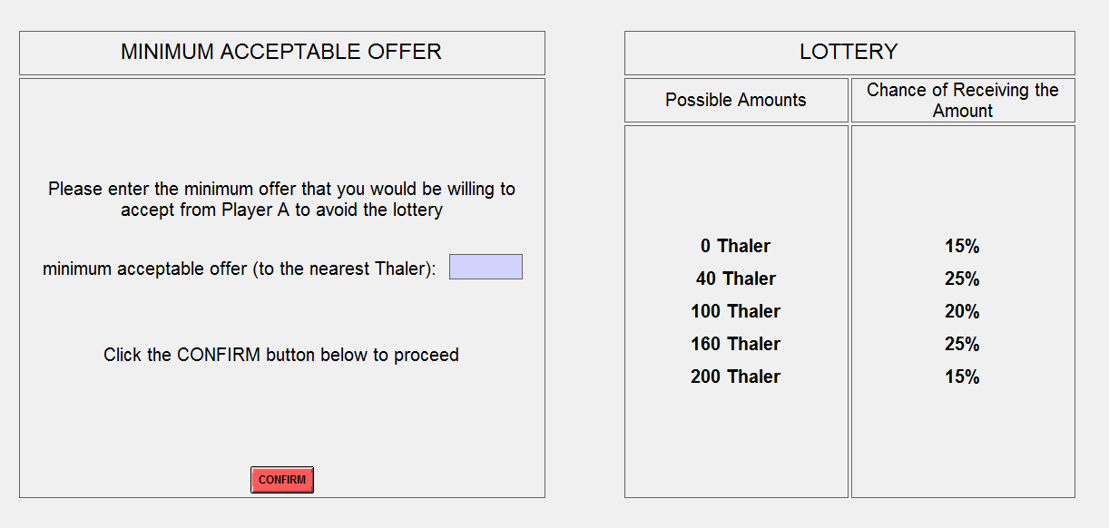

Multiple Times and Random Re-matching:
You will be participating in this bargaining task a total of 5 times. In each of the 5 rounds of the bargaining task, you will be randomly re-matched with a different participant assigned to the role of Player A. That is, you will be paired with a different Player A in each of the 5 rounds. Additionally, in each of the 5 rounds, the lottery will be different, so be sure to look at the lottery table before making your minimum acceptable offer. In the event that you and Player A don’t reach an agreement and your payment is determined by the lottery, you will not be informed about the actual realized outcome of the lottery draw until after the experiment has ended and payments are determined.
part ii: The Lottery Choice Task:
After you have finished the 5 rounds of the bargaining task, you will proceed to the lottery task part of the experiment. In this lottery task, you will make a decision in a series of 30 lottery choices problems. In each of the 30 lottery choice problems, there will be two possible lottery options, which will be denoted as: Option A and Option B. Each of these lottery options will involve possible amounts of Thaler that you could earn and the corresponding likelihood (expressed as a probability) that you would win that amount. For each of the 30 different lottery problems, you will be asked to select the option that you most prefer of the two options.
Procedure and Computer Interface:
For each of the 30 lottery choice problems, you will see a screen that displays Option A on the left and Option B on the right, with the corresponding possible amounts of Thaler and the % chance of winning that amount for each option. You will make your preferred choice between the two options by simply clicking the corresponding button below the option. You will proceed in this manner through all 30 lottery choice problems, and this will conclude the experiment. Below is a screen shot of a sample lottery choice problem:
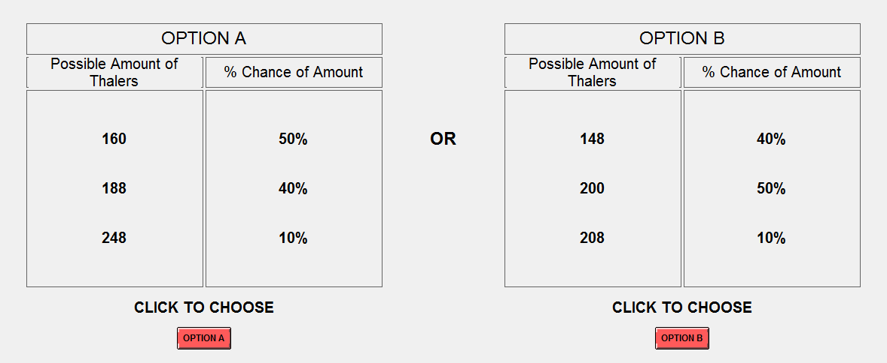
In the above sample lottery problem, if you choose OPTION A, then there is a 50% chance you would win 160 Thaler, a 40% chance you would win 188 Thaler, and a 10% chance you would win 248 Thaler. If you choose OPTION B, then there is a 40% chance you would win 148 Thaler, a 50% chance you would win 200 Thaler, and a 10% chance you would win 208 Thaler.
final Payment:
Your total earnings for this experiment will be determined as follows: First, you will receive $5 for showing up and participating in the experiment. In addition, you will be paid your earnings (converted from Thalers to dollar at a rate of 10 Thaler to $1) in either one randomly drawn round of the bargaining task or one randomly drawn lottery choice problem from the lottery choice task. This randomized payment will work as follows: First, after the experiment has ended, an experimenter will flip a coin to determine whether the bargaining task or the lottery task will be paid. Thus, each of the tasks is equally likely to be selected for payment. If it is heads then all participants will get paid for the bargaining task, and if it is tails then the lottery task will be paid.
If the bargaining task is selected, then an experimenter will come to your carrel where you will individually draw 1 ping pong ball from a bag that contains 5 balls, each one labeled for each of the 5 rounds. You will then be paid the earnings that correspond to the round that you selected. If in the round that you selected an agreement was not reached and your payment is determined by the lottery, then you will role two 10 sided dice to determine the amount you will receive based on the corresponding lottery table from that round. The experimenter will have a sheet that displays which numbers of the die role correspond to which possible outcomes of the lottery (these die numbers are selected in a way to generate the same % chance of winning that is displayed in the specific lottery table from that round).
If the lottery task is selected, then an experimenter will come to your carrel where you will individually draw 1 ping pong ball from a bag that contains 30 balls, each one labeled for each of the 30 lottery choice problems. Again, you will then role two 10 sided die to determine the amount that you will win, which will be based on the option that you actually choose for the lottery problem that you selected. The experimenter will have a sheet that displays which numbers of the die role correspond to which amount won (these die numbers are selected in a way to generate the same % chance of winning that is displayed in the option you selected).
After you have finished the experiment, please remain quietly seated until an experimenter comes to your carrel to determine your earnings. You will then be paid you total earnings either by cash or check. After you have been paid you may quietly exit the lab.

Thank you for you participation and cooperation

