Appendix (Not for Publication) – Experiment Instructions
GENERAL INSTRUCTIONS
This is an experiment in the economics of strategic decision making. Various research agencies have provided funds for this research. The instructions are simple. If you follow them closely and make appropriate decisions, you can earn an appreciable amount of money.
The experiment will proceed in two parts. Each part contains decision problems that require you to make a series of economic choices which determine your total earnings. The currency used in Part 1 of the experiment is U.S. Dollars. The currency used in Part 2 of the experiment is francs. Francs will be converted to U.S. Dollars at a rate of _25_ francs to _1_ dollar. At the end of today’s experiment, you will be paid in private and in cash. 12 participants are in today’s experiment.
It is very important that you remain silent and do not look at other people’s work. If you have any questions, or need assistance of any kind, please raise your hand and an experimenter will come to you. If you talk, laugh, exclaim out loud, etc., you will be asked to leave and you will not be paid. We expect and appreciate your cooperation.
At this time we proceed to Part 1 of the experiment.

INSTRUCTIONS FOR PART 1
YOUR DECISION
In this part of the experiment you will be asked to make a series of choices in decision problems. How much you receive will depend partly on chance and partly on the choices you make. The decision problems are not designed to test you. What we want to know is what choices you would make in them. The only right answer is what you really would choose.
For each line in the table in the next page, please state whether you prefer option A or option B. Notice that there are a total of 15 lines in the table but just one line will be randomly selected for payment. You ignore which line will be paid when you make your choices. Hence you should pay attention to the choice you make in every line. After you have completed all your choices a token will be randomly drawn out of a bingo cage containing tokens numbered from 1 to 15. The token number determines which line is going to be paid.
Your earnings for the selected line depend on which option you chose: If you chose option A in that line, you will receive $1. If you chose option B in that line, you will receive either $3 or $0. To determine your earnings in the case you chose option B there will be second random draw. A token will be randomly drawn out of the bingo cage now containing twenty tokens numbered from 1 to 20. The token number is then compared with the numbers in the line selected (see the table). If the token number shows up in the left column you earn $3. If the token number shows up in the right column you earn $0.
Decision no. | Option A | Option  B |  | Please  choose  A or B
1 | $1 | $3 never | $0 if 1,2,3,4,5,6,7,8,9,10,11,12,13,14,15,16,17,18,19,20
2 | $1 | $3 if 1 comes out of the bingo cage | $0 if 2,3,4,5,6,7,8,9,10,11,12,13,14,15,16,17,18,19,20
3 | $1 | $3 if 1 or 2 | $0 if 3,4,5,6,7,8,9,10,11,12,13,14,15,16,17,18,19,20
4 | $1 | $3 if 1,2,3 | $0 if 4,5,6,7,8,9,10,11,12,13,14,15,16,17,18,19,20
5 | $1 | $3 if 1,2,3,4, | $0 if 5,6,7,8,9,10,11,12,13,14,15,16,17,18,19,20
6 | $1 | $3 if 1,2,3,4,5 | $0 if 6,7,8,9,10,11,12,13,14,15,16,17,18,19,20
7 | $1 | $3 if 1,2,3,4,5,6 | $0 if 7,8,9,10,11,12,13,14,15,16,17,18,19,20
8 | $1 | $3 if 1,2,3,4,5,6,7 | $0 if 8,9,10,11,12,13,14,15,16,17,18,19,20
9 | $1 | $3 if 1,2,3,4,5,6,7,8 | $0 if 9,10,11,12,13,14,15,16,17,18,19,20
10 | $1 | $3 if 1,2,3,4,5,6,7,8,9 | $0 if 10,11,12,13,14,15,16,17,18,19,20
11 | $1 | $3 if 1,2, 3,4,5,6,7,8,9,10 | $0 if 11,12,13,14,15,16,17,18,19,20
12 | $1 | $3 if 1,2, 3,4,5,6,7,8,9,10,11 | $0 if 12,13,14,15,16,17,18,19,20
13 | $1 | $3 if 1,2, 3,4,5,6,7,8,9,10,11,12 | $0 if 13,14,15,16,17,18,19,20
14 | $1 | $3 if 1,2, 3,4,5,6,7,8,9,10,11,12,13 | $0 if 14,15,16,17,18,19,20
15 | $1 | $3 if 1,2, 3,4,5,6,7,8,9,10,11,12,13,14 | $0 if 15,16,17,18,19,20
INSTRUCTIONS FOR PART 2
YOUR DECISION
The second part of the experiment consists of 30 decision-making periods. At the beginning of the first period, you will be randomly and anonymously placed into a group of 3 people: group A or group B. You will remain in the same group for all 30 periods of the experiment. At the beginning of the first period, your group will be paired with another group. This pairing remains the same for all 30 periods of the experiment. Either group A or group B will receive a reward. The reward is 60 francs to each group member.
Each period you will be given an endowment of 60 francs and asked to decide how much to allocate to the group account or the individual account. You may allocate any integer number of francs between 0 and 60. An example of your decision screen is shown below.

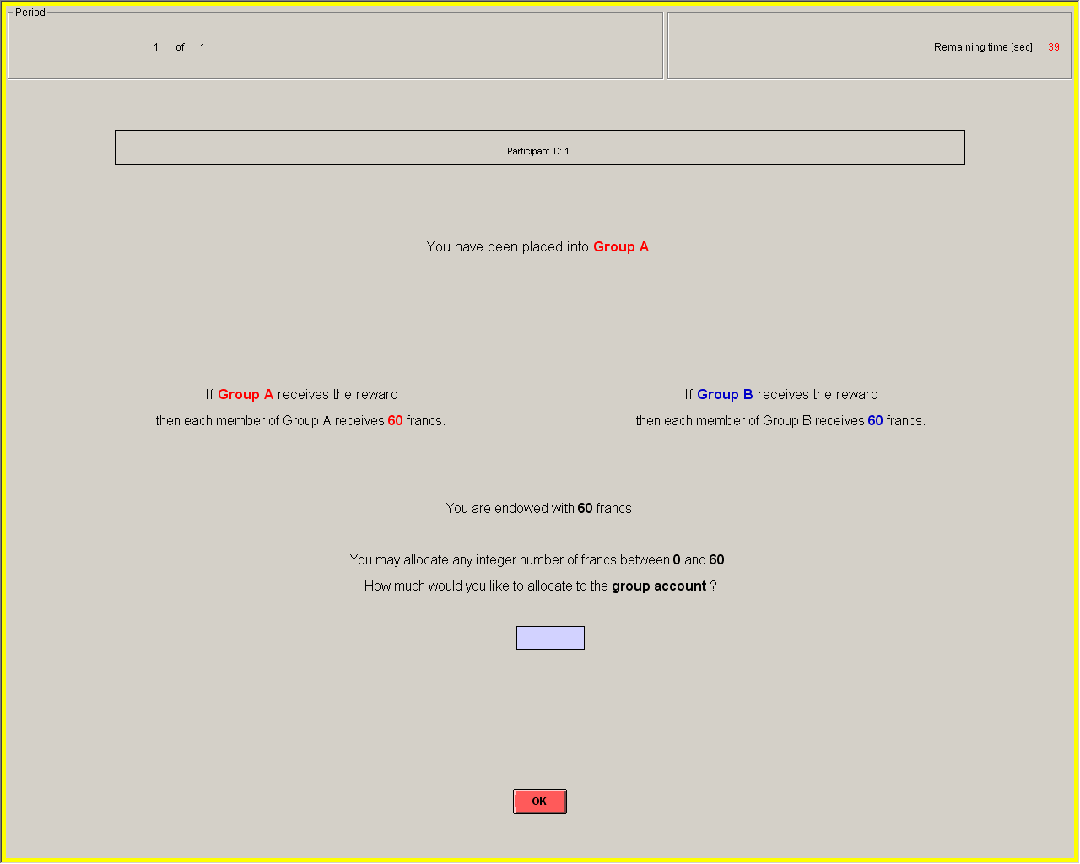
Your Group

COMMUNICATION
In some periods before they are asked to make the allocation decision, participants may have an opportunity to communicate with the other two participants in their own group. This communication will consist of messages exchanged in a “chat area” shown on their computer screen. Any messages sent in this chat will only be viewed by you and the other two members in your group. The chat time will be active for 60 seconds each period that this communication opportunity is available. In periods that the communication opportunity is not available, there will be a 60 second break each period before the allocation decision.
Although we will record the messages you send to each other, your chat id remains anonymous. The first person to send a message in a period will always be referred to as “member 1”, the second as “member 2” and so on. In sending messages, you should follow two basic rules: (1) be civil to one another and do not use profanities, and (2) do not identify yourself in any manner. The communication channel is intended to discuss your allocation choices and should be used that way.
After the chat period is over, all group members then make their actual decisions simultaneously; you do not learn the actual allocation decisions of your group members until after you make your decision.
In decision-making periods 1-10 there will be no opportunity for communication. Before period 11 you and the other two participants in your group will vote to determine whether to communicate each period before making an allocation in periods 11-20. Only if all three participants unanimously vote to communicate will the chat room be created for communication. Before period 21 another vote will determine whether you and your group communicate each period before making an allocation in periods 21-30. Again, communication will occur only if all three participants unanimously vote to communicate.
Both groups will vote before periods 11 and 21, so in some cases both groups A and B might communicate, in other cases neither group A nor B communicate, and in other cases only one of the two groups will communicate. Your decision screen where you make your allocation will always indicate which (if any) of the two groups communicated that period.

YOUR EARNINGS
After all participants have made their decisions, your earnings for the period are calculated. These earnings will be converted to cash and paid at the end of the experiment if the current period is one of the five periods that is randomly chosen for payment.
- Your period earnings are the sum of the earnings from your individual account and the earnings from your group account.
- For each franc in your individual account, you will earn 1 franc in return. So, if you keep all 60 francs that you are endowed with to your individual account you will earn 60 francs. But you can also earn some francs from your group account.
- By contributing to the group account you may increase the chance of receiving the reward for your group. In determining which group receives the reward, the computer will consider only the lowest contribution in group A’s account and the lowest contribution in group B’s account. If the lowest contribution in group A’s account exceeds the lowest contribution in group B’s account, group A has higher chance of receiving the reward and vise-versa. In particular, your group’s chance of receiving the reward is
(Your Group’s Minimum Bid)/(Minimum Bid in group A + Minimum Bid in group B)
If both group’s minimum bids are 0, the reward is randomly assigned to one of the two groups.
- If your group receives the reward then in addition to the earnings from your individual account you receive the reward of 60 francs from your group account. A group can never guarantee itself the reward. However, by increasing your contribution, you can increase your group’s chance of receiving the reward.
- The computer will assign the reward either to your group or to the other group, via a random draw. So, in each period, only one of the two groups can obtain the reward.

Example: Random Draw and Earnings
This is a hypothetical example used to illustrate how the computer is making a random draw. Let’s say the members of groups A and B allocate their francs in the following way.

Table 1 – Allocation of francs by all members in group A and B
Group A | If Group A receives reward | Allocation  to individual  account | Allocation  to group  account |  | Group B | If Group B receives reward | Allocation  to individual account | Allocation  to group  account
Member 1  Member 2  Member 3 | 60  60  60 | 40  45  50 | 20  15  10 |  | Member 1  Member 2  Member 3 | 60  60  60 | 59  50  55 | 1  10  5

In group A, member 1 contributes 20 francs, member 2 contributes 15 francs, and member 3 contributes 10 francs to group A’s account. In group B, member 1 contributes 1 franc, member 2 contributes 10 francs, and member 3 contributes 5 francs to group B’ account.
Then the computer chooses the lowest contribution in group A’s account and the lowest contribution in group B’s account. The two highest contributions in group A and the two highest contributions in group B will not be considered by the computer. In this example, member 3 has the lowest contribution of 10 francs in group A and member 1 has the lowest contribution of 1 franc in group B. For each franc of member 3 in group A the computer puts 1 red token into a bingo cage and for each franc of member 1 in group B the computer puts 1 blue token. Thus, the computer places 10 red tokens and 1 blue token into the bingo cage (11 tokens total). Then the computer randomly draws one token out of the bingo cage. If the drawn token is red group A receives the reward, if the token is blue group B receives the reward. You can see that since group A has more tokens it has a higher chance of receiving the reward (10 out of 11 times group A will receive the reward). Group B has a lower chance of receiving the reward (1 out of 11 times group B will receive the reward).
Let’s say the computer made a random draw and group A receives the reward. Thus, all the members of group A receive the reward of 60 francs from the group account plus they also receive earnings from the individual account. All members of group B receive earnings only from the individual account, since group B does not receive the reward. The calculation of the total earnings is shown in Table 2 below.

Table 2 – Calculation of earning for all members in group A and B
Group A | Earnings  from  group  account | Earnings  from  individual  account | Total  earnings |  | Group B | Earnings  from  group  account | Earnings  from  individual  account | Total  earnings
Member 1  Member 2  Member 3 | 60  60  60 | 40  45  50 | 60+40 = 100  60+45 = 105  60+50 = 110 |  | Member 1  Member 2  Member 3 | 0  0  0 | 59  50  55 | 59  50  55

At the end of each period, the total number of francs in the two groups’ accounts, group which receives the reward, earnings from individual and group accounts, and total earnings for the period are reported on the outcome screen as shown on the next page. Please record your results for the period on your record sheet under the appropriate heading.
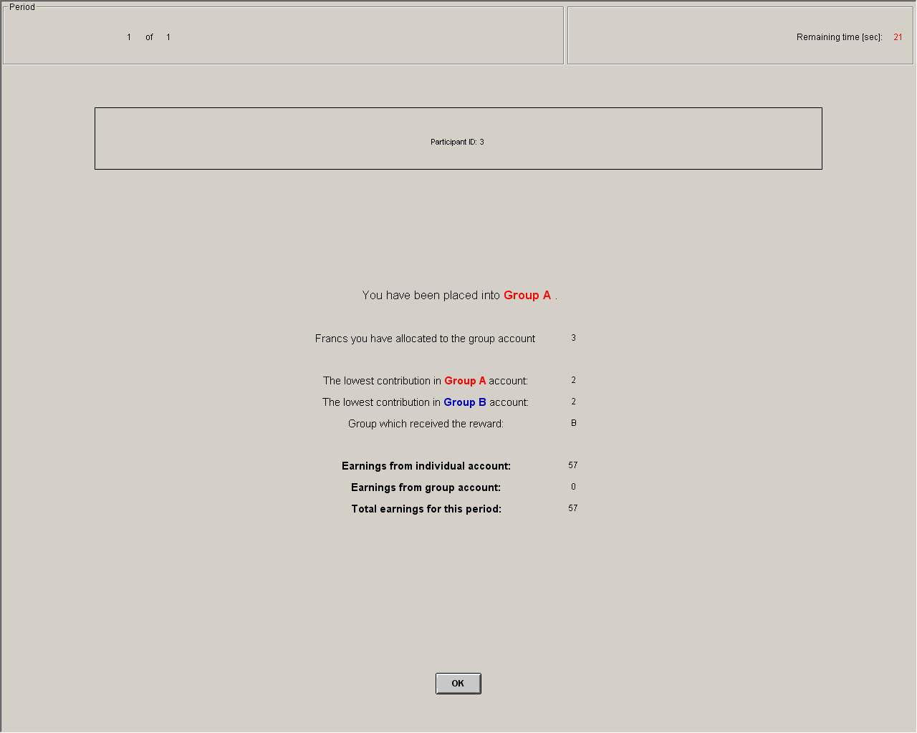
Outcome Screen

IMPORTANT NOTES
You will not be told which of the participants in this room are assigned to which group. At the beginning of the first period, you will be randomly and anonymously placed into a group of 3 people: group A or group B. You will remain in the same group for all 30 periods of the experiment. At the beginning of the first period, your group will be paired with another group. This pairing remains the same for all 30 periods of the experiment. Either group A or group B will receive a reward. The reward is 60 francs to each group member. A group can never guarantee itself the reward. However, by increasing your contribution, you can increase your group’s chance of receiving the reward.
At the end of the experiment we will randomly choose 5 of the 30 periods for actual payment in Part 2 using a bingo cage. You will sum the total earnings for these 5 periods and convert them to a U.S. dollar payment.

