INSTRUCTIONS FOR FIRST-PRICE SEALED-BID AUCTIONS
Thank you for being part of our research. Various research foundations have provided funds for this research. This is an experiment in the economics of market decision making. The instructions are simple and, if you follow them carefully and make good decisions, you may earn a considerable amount of money which will be paid to you in cash at the end of the experiment.
All values in the experiment will be in terms of Experimental Currency Unit (ECU). At the end of the experiment, we will convert your total earnings in the session to US$.
- In this experiment, you will participate in a sequence of auctions. There will be 5 practice periods and 25 real periods. You will be paid only for the real periods.
- At the beginning of the session, you will be assigned to one of the two types: A and B.
- Your type is fixed throughout the experiment.
- A single good will be auctioned off in each period.

Matching in Each Period
In each period, each type A subject will be randomly matched with a type B subject and form a team of two. Then each team will be randomly matched with another team of two subjects and then two teams will participate in an auction. You will never know whom you are matched. You will not be matched with the same group of subjects in any two consecutive periods.
- Each team consists of a type A and a type B subjects.
- Each team participates in an auction to obtain an auctioned good.
- Two teams participate in an auction.

Values
For Type A subjects:
At the beginning of each period, each type A subject privately observes her maximum possible value (MAX VALUE) for the auctioned good. MAX VALUE is a number randomly selected from the interval [0,100] and rounded to the nearest cent. Each number is equally likely. The MAX VALUEs of the two type A subjects in two teams that are participating in the same auction are independently determined and most likely different.
Type A subject does not know her exact VALUE for the good at the time of decision making. All she knows is that her VALUE is a number contained in the interval [0, MAX VALUE]. Therefore, her VALUE is at minimum zero and cannot exceed her MAX VALUE. Again, any number between 0 and her MAX VALUE is equally likely. For example, let’s say a type A subject receives a MAX VALUE of 45.32. Then her VALUE is uniformly distributed on interval [0, 45.32] and it can be any number less than or equal to 45.32. Let’s say her VALUE is 21.00. This means that if her team obtains the good at the end of the period, she will receive 21.00 ECU from us.
For Type B Subjects:
Each Type B subject knows the true value of her Type A teammate. Each Type B subject’s value for obtaining the good is 2.5 times her Type A teammate’s value.
Type B’s Value = 2.5 x Type A’s Value

Auction

Each auction occurs in two stages. In the first stage only the Type A subjects will be active. In the second stage, only the Type B subjects are active. Specifically,

Stage 1:
- Each Type A only observes her MAX VALUE. Her true value is something less than this MAX VALUE.
- Each Type A subject decides on a CAP which is the maximum amount she allows her type B teammate to bid.
Stage 2:
- Each Type B observes the exact value of the good for herself.
- Each Type B also observes the CAP decided on by her Type A teammate.
- Each Type B subject decides on how much she wants to bid in behalf of her team in the auction. Type B subjects are not allowed to bid above the CAP. The bid decided on is simply labeled BID.
- After both teams participating in the auction submit their BIDs, the one who has the highest BID obtains the good and pays her BID. In case of a tie, each of the two participants in the auction will receive the good with equal probabilities.
- This is the end of the period.
The following table summarizes the progression of stages
 | Team 1 |  | Team 2
 | Type A | Type B | Type A | Type B
Stage 1 | Sees: MAX VALUE  Chooses: CAP |  | Sees: MAX VALUE  Chooses: CAP
Stage 2 |  | Sees: CAP,VALUE  Chooses: BID ($≤$ CAP) |  | Sees: CAP,VALUE  Chooses: BID ($≤$ CAP)

Earnings in a Period
When your team obtains the good at the end of a period (if your BID is the highest), then you will receive your VALUE for the good and will pay the team’s BID. If your team does not obtain the good, you do not receive or pay any amount. In other words, your earnings in the current period are:
Earnings = Your VALUE – Your BID (If you obtained the auctioned good);

Earnings = 0 (If you did not obtain the auctioned good).

Recall that a Type B subject’s value is 2.5 times more than her Type A teammate. Moreover, at the time of decision making, each Type B subject knows her value. However, Type A subjects only know their maximum possible value but not their actual value.
Sequence of Auctions:
When the current period is over, the next period will start. Each period, you will be randomly matched with a new teammate and participate in a new auction with a different opponent team. Your VALUE of the good in each period is independent of your VALUE in the previous periods.

Screens
Below, there is an example of how Type A’s and Type B’s screens may look.
If you are a Type A subject, you see your MAX VALUE. Remember that this is the highest amount your actual value can be. You DON’T know your actual value before the auction is over. You need to enter a CAP for your Type B teammate in the text box on your screen and click on SUBMIT.
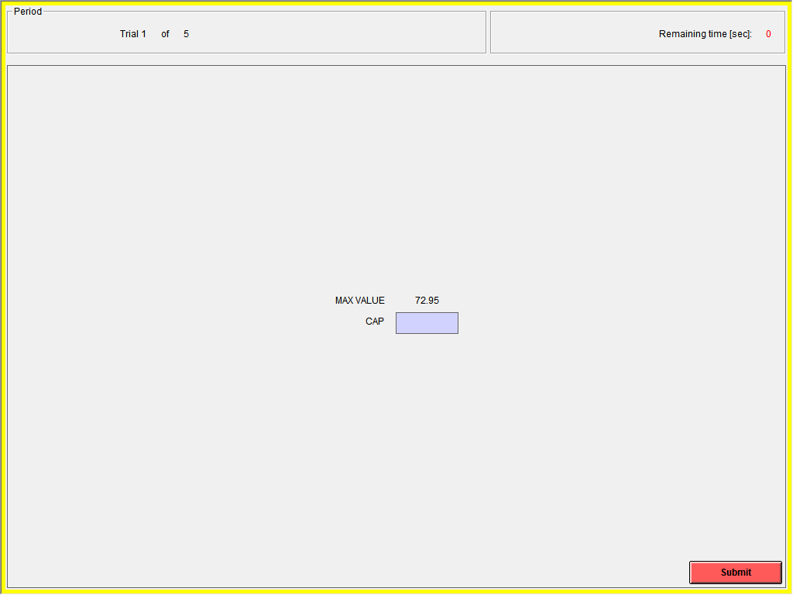

If you are a Type B subject, you see your value for the good and the CAP that your Type A teammate decided on. After observing your value, you will enter your BID in the text box on your screen and click on SUBMIT. Your bid has to be less than or equal to your CAP.
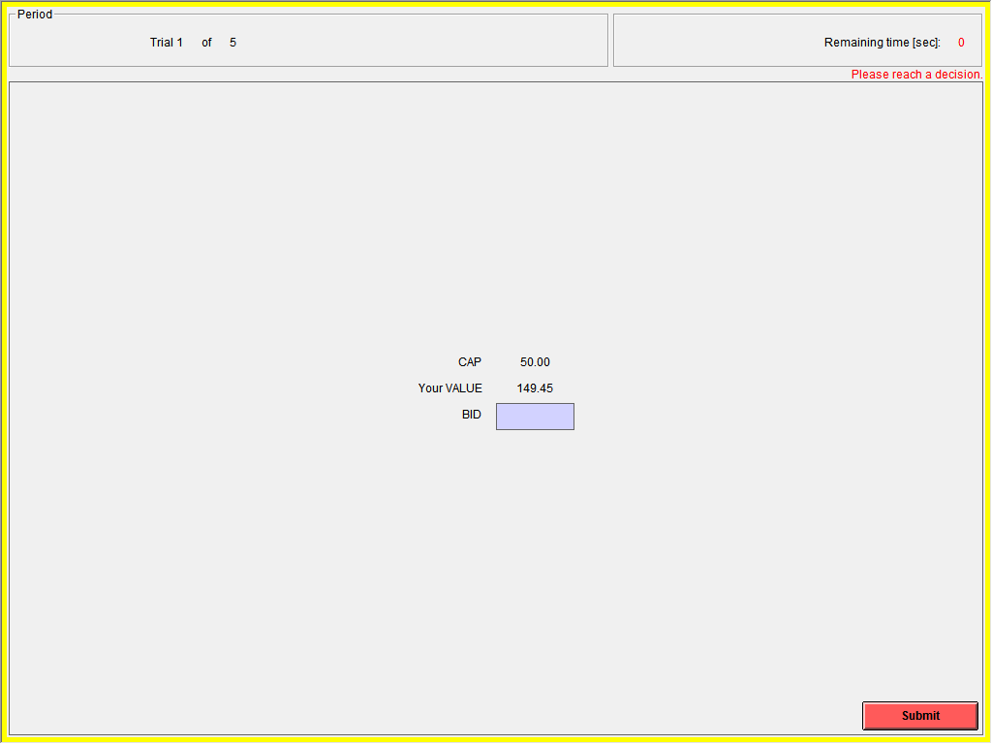

The screen below shows the information that a Type A person will see at the conclusion of a period. It displays Type A’s MAX VALUE, VALUE and CAP. Then it shows the BID that the Type B teammate decided on. It will also give you the BID of your opponent team and calculates the winner, the price of the good and your payoff for the round. Note that much of the information about your opponent is hidden.
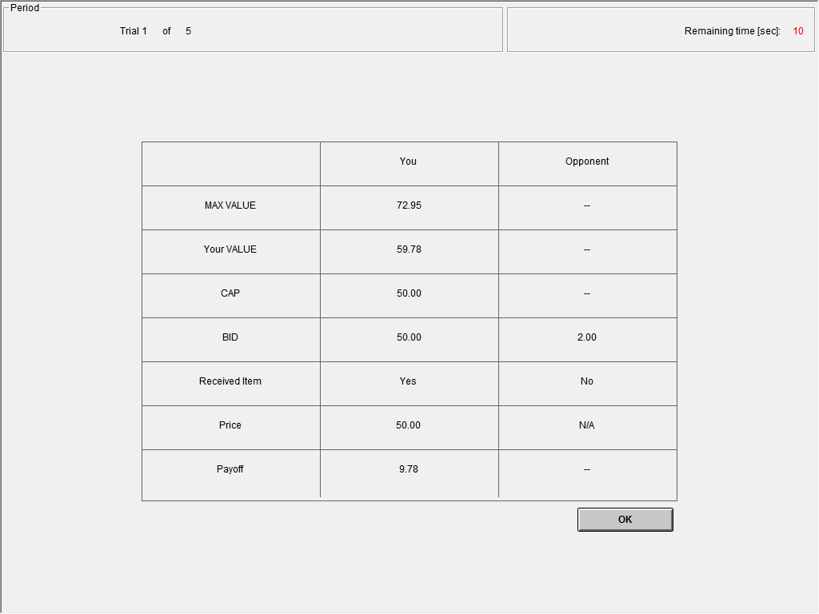

The next screen shows the information that a Type B person will see at the conclusion of a period. It displays Type B’s VALUE, CAP and BID. It will also give you the BID of your opponent team and calculates the winner, the price of the good and your payoff for the round. Again, much of the information about your opponent is hidden.
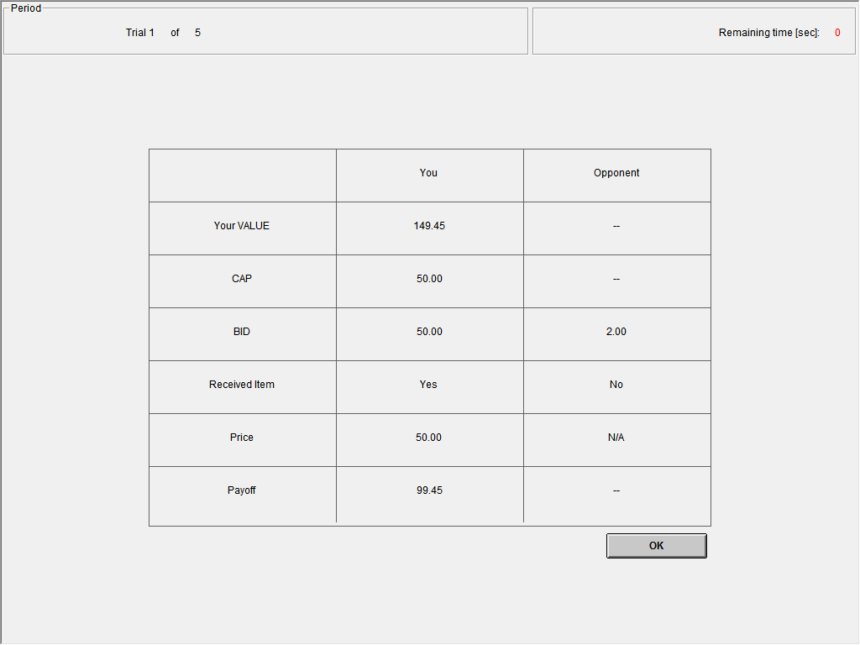

Example
The tables below indicate all the MAX VALUEs, VALUEs and BIDs in an auction, and show the results for three different choices of a CAP. Recall that in the experiment Type A subjects will observe only their own MAX VALUEs and Type B subjects will observe their own VALUES. No subject will know the values received by the opponent team.
1.
 | Team 1  (YOU) | Team 2
Type A’s MAX VALUE (observed by Type A) | 84.62 | 37.40
Type A’s VALUE | 56.40 | 8.08
Type A’s CAP | 5.00 | 20.50
Type B’s VALUE | 141.00 | 20.20
Type B’s BID | 5.00 | 9.03
Received Item | No | Yes
Price | N/A | 9.03
Type A’s Payoff | 0 | -0.95
Type B’s Payoff | 0 | 11.17
2.
 | Team 1  (YOU) | Team 2
Type A’s MAX VALUE (observed by Type A) | 84.62 | 37.40
Type A’s VALUE | 56.40 | 8.08
Type A’s CAP | 36.00 | 20.50
Type B’s VALUE | 141.00 | 20.20
Type B’s BID | 36.00 | 9.03
Received Item | Yes | No
Price | 36.00 | N/A
Type A’s Payoff | 20.40 | 0
Type B’s Payoff | 105.00 | 0
3.
 | Team 1  (YOU) | Team 2
Type A’s MAX VALUE (observed by Type A) | 84.62 | 37.40
Type A’s VALUE | 56.40 | 8.08
Type A’s CAP | 70.00 | 20.50
Type B’s VALUE | 141.00 | 20.20
Type B’s BID | 59.44 | 9.03
Received Item | Yes | No
Price | 59.44 | N/A
Type A’s Payoff | -2.96 | 0
Type B’s Payoff | 81.56 | 0

In all of the examples above, Type A of Team 2 (your opponent) observes a MAX VALUE of 37.40 and she decides on a CAP of 20.50. Team 2’s BID is 9.03.
Type A of Team 1 observes a MAX VALUE of 84.62. Her true value (which she does not know at the time of decision making), is 56.40. Therefore, the value of the Type B subject of Team 1 is 141 (2.5x56.40=141).
Each of the three tables corresponds to different choices of CAP and BID for Team 1. In the first table, Type A chose a cap of 5.00 and Type B chose a BID of 5.00.
In the first example the BIDs of two teams are 5.00 and 9.03. Since the highest bid (9.03) is submitted by Team 2, Team 2 obtains the good and pays its BID (9.03). In this period, the subjects in Team 1 earn zero, Type A of Team 2 earns 8.08 – 9.03 = -0.95 ECU, and Type B of Team 2 earns 20.20-9.03=11.17. Note that Type A of Team 2 loses money in this period because her Type B teammate is allowed to submit a bid that is higher than the Type A’s true value.
In the second example, everything is the same except Type A of Team 1 choses a higher CAP (36.00) and Type B chooses a higher BID (36.00). Now Team 1 receives the item. The price is equal to the BID (36.00), so Type A of Team 1’s payoff is 56.40 – 36.00 = 20.40 ECU and Type B of Team 1’s payoff is 141.00-36.00=105.00 ECU.
In the third example, Type A of Team 1’s CAP is now 70.00, and Type B’s BID is now 59.44. The BIDs are 59.03 and 9.03. Team 1 receives the item for a price of 59.03, Type A’s payoff is 56.40 – 59.03 = -2.96 ECU, and Type B’s payoff is 141.00-59.03=81.97 ECU.

Total Payoffs
At the beginning of today’s session both Type A and Type B subjects will receive an endowment of $8. The endowment is provided in order to cover any losses that you may make. Every period your earnings from that period are added to your initial endowment. At the end of today’s session you will receive your cumulative earnings —your earnings from 25 auctions plus your initial endowment. The conversion rate is $1 = 20 ECU for Type A and $1 = 80 ECU for Type B. In addition to this sum, you will be paid a $7 participation fee.
Are there any questions?
Practice Questions

Please answer the questions below. The experiment will start after everybody answers all the questions correctly. Please feel free to ask questions.
1. Suppose a Type A subject observes a MAX VALUE of 76.00ECU. What is her possible VALUE?
a) any value from 0 to 100.00
b) any value from 0 to 76.00
c) any value from 0 to 76.00 but not 76.00
d) any value from 0 to 100.00 but not 76.00

2. Suppose a Type A subject entered 21.00 as the CAP. What are the possible BIDs that the Type B subject in her team can select?
a) Any BID is possible.
b) Any BID that is between 0 and Type B’s VALUE is possible.
c) Any BID that is between 0 and Type A’s VALUE is possible.
d) Any BID that is between 0 and the CAP is possible.

3. Fill the table below
 | Team 1 | Team 2
MAX VALUE (observed by Type A) | 43.00 | 37.40
Type A’s VALUE | 4.00 | 10
Type A’s CAP | 38.00 | 21.00
Type B’s VALUE
Type B’s BID | 6.00 | 8.00
Received Item
Price
Type A’s Payoff
Type B’s Payoff

INSTRUCTIONS FOR FIRST-PRICE SEALED BID AUCTIONS (computerized bidders)
Thank you for being part of our research. Various research foundations have provided funds for this research. This is an experiment in the economics of market decision making. The instructions are simple and, if you follow them carefully and make good decisions, you may earn a considerable amount of money which will be paid to you in cash at the end of the experiment.
All values in the experiment will be in terms of Experimental Currency Unit (ECU). At the end of the experiment, we will convert your total earnings in the session to US$.
- In this experiment, we will run a sequence of auctions in which you will act as the buyer of a fictitious good. There will be 5 practice periods and 25 real periods. You will be paid only for the real periods.
- A single good will be auctioned off in each period.
- In each period, a computerized bidder will bid on behalf of you in the auction. We will tell you the bidding rule of the computerized bidder later in these instructions
- If you do not limit your computerized bidder, it will place an UNCONSTRAINED BID which may be higher than the amount you would like it to bid.
- Your task will be to determine a CAP, which is the maximum amount that you allow your computerized bidder to bid.
- The computerized bidder’s ACTUAL BID is the lesser of its UNCONSTRAINED BID and the CAP.
Matching in Each Period
In each period, you will be randomly matched with another person in this room. You and that person will participate in the auction. You will never know who the other person is in your auction. You will not be matched with the same person in any two consecutive periods.
Values
At the beginning of each period, each person participating in the auction privately observes her maximum possible value (MAX VALUE) for the auctioned good. Your MAX VALUE is a number randomly selected from the interval [0,100] and rounded to the nearest cent. Each number is equally likely. Your MAX VALUE and the MAX VALUE of the other person who participates in the same auction with you are independently determined.
Your VALUE for the good is the amount of ECU the experimenter will give you if you receive the item at the end of the period. You do not know your exact VALUE for the good at the time of decision making. All you know is that your VALUE is a number contained in the interval [0, MAX VALUE]. Therefore, your VALUE is at minimum zero and cannot exceed your MAX VALUE. Again, any number between 0 and your MAX VALUE is equally likely. For example, let’s say you receive a MAX VALUE of 45.32. Then your VALUE is uniformly distributed on interval [0, 45.32] and it can be any number less than or equal to 45.32. Let’s say your VALUE is 21.00. This means that if you get the good at the end of the period, you will receive 21.00 ECU from us.
To reiterate, MAX VALUE is never higher than 100 and a VALUE is never higher than the corresponding MAX VALUE. Each person in an auction receives independent MAX VALUEs and independent VALUEs. Hence, your VALUE and MAX VALUE are most likely different from your opponent’s VALUE and MAX VALUE.
Auction
- Two persons participate in each auction. Each person is represented by a computerized bidder.

- You observe your MAX VALUE for the current period. Your computerized bidder observes your true VALUE for the good.
- After observing your MAX VALUE for the period, you need to decide the maximum amount that you will allow the computerized bidder to bid on your behalf. We call this amount your “CAP”.
- You have been given two sheets explaining the bidding rule of your computerized bidder for each possible VALUE (unless you restrict it by a CAP). These two sheets provide you with the same information in two formats: one is a table, and one is a graph. The bids on the sheets are referred to as the computerized bidder’s UNCONSTRAINED BID. Please take a look at these sheets and confirm that when your VALUE is, for example, 22.00 ECU, the UNCONSTRAINED BID will be 44.00.
- The computerized bidder’s ACTUAL BID is the lesser of its UNCONSTRAINED BID and the CAP:

ACTUAL BID = minimum {UNCONSTRAINED BID , CAP}

- After both your and the other player’s ACTUAL BIDs are submitted, the one who has the highest ACTUAL BID obtains the good and pays her ACTUAL BID. In case of a tie, each of the two participants in the auction will receive the good with equal probabilities.
- This is the end of the period.

Earnings in a Period
If you obtain the good at the end of the period (if your ACTUAL BID is the highest), then you will receive your VALUE for the good and you will pay your ACTUAL BID. If you did not obtain the good, you do not receive or pay any amount. In other words, your earnings in the current period are:
Earnings = Your VALUE – Your ACTUAL BID (If you obtained the auctioned good);

Earnings = 0 (If you did not obtain the auctioned good).

When the current period is over, the next period will start. Each period, you will be randomly matched with a new player and receive a new MAX VALUE. Therefore, your VALUE of the good in each period is independent of your VALUE in the previous periods.

Screens
Below, there is an example of how your screen may look. On top of your screen there is an interactive tool. The tool shows your MAX VALUE for the current period. Remember that your VALUE can be any number between zero and your MAX VALUE, but you do not know what it is. However, your computerized bidder knows your VALUE and bases its UNCONSTRAINED BID on your VALUE. By sliding the little black square between zero and your MAX VALUE, you may see the UNCONSTRAINED BID of your computerized bidder for the corresponding VALUE. This tool provides you with the exact same information as you may learn from the UNCONSTRAINED BID table or graph that we have provided to you. Please use whichever tool that you prefer in order to understand how the computerized bidder bids unless it is restricted by a CAP.
You need to enter your bidder’s CAP for this period in the text box on your screen and click on SUBMIT. Remember that your ACTUAL BID will be what your computerized bidder’s UNCONSTRAINED BID is unless you restrict it by a CAP, in which case it will be the lesser of the two numbers.
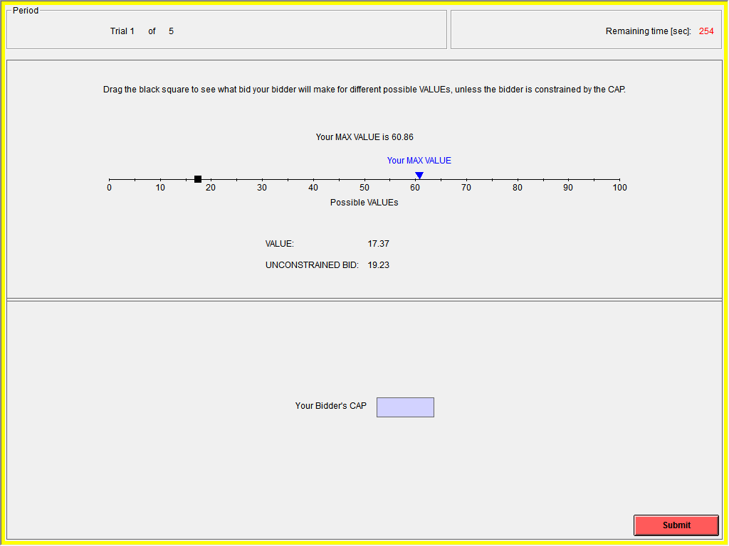
The screen below is an example of the results screen after the conclusion of one auction. It displays your true VALUE, the UNCONSTRAINED BID that corresponds to that value, and the ACTUAL BID. It will also give you the ACTUAL BID of your opponent and calculate the winner, the price of the item and your payoff for the round. Note that much of the information about your opponent is hidden.
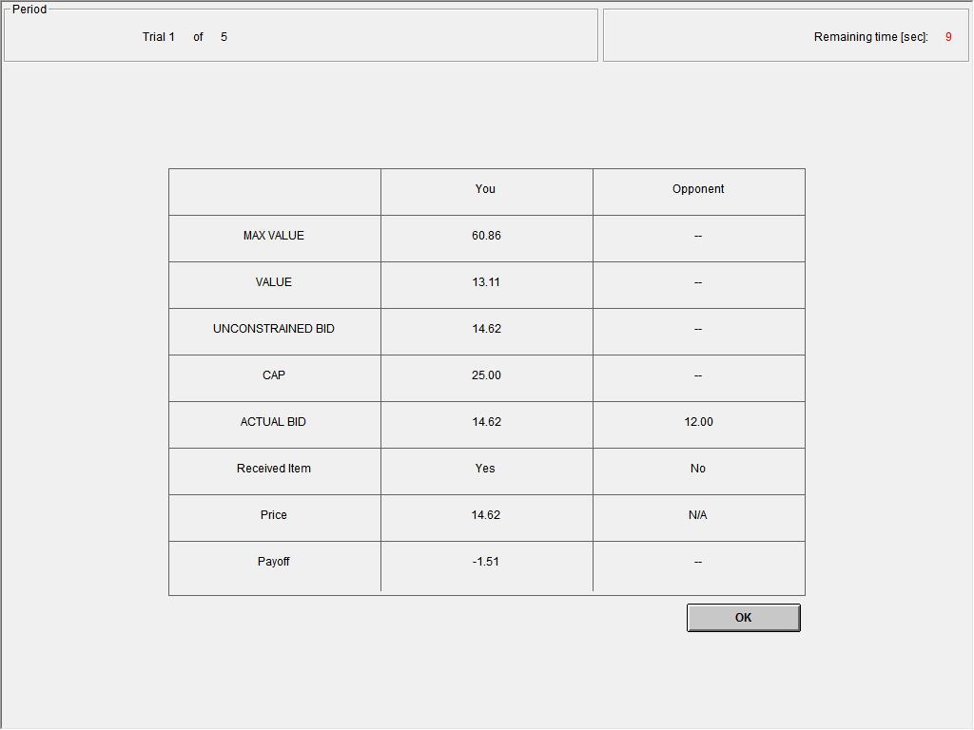

Example
The tables below indicate all the MAX VALUEs, VALUEs and UNCONSTRAINED BIDs in an auction, and show the results for three different choices of a CAP. Recall that in the experiment you will only observe your own MAX VALUE and will only know that your VALUE is not higher than your MAX VALUE. You will not know the MAX VALUE or VALUE of the other player.
 | Player 1  (YOU) | Player 2
MAX VALUE | 84.62 | 37.40
VALUE | 56.40 | 8.08
UNCONSTRAINED BID | 59.44 | 9.03
CAP | 5.00 | 20.50
ACTUAL BID | 5.00 | 9.03
Received Item | No | Yes
Price | N/A | 9.03
Payoff | 0 | -0.95

 | Player 1  (YOU) | Player 2
MAX VALUE | 84.62 | 37.40
VALUE | 56.40 | 8.08
UNCONSTRAINED BID | 59.44 | 9.03
CAP | 36.00 | 20.50
ACTUAL BID | 36.00 | 9.03
Received Item | Yes | No
Price | 36.00 | N/A
Payoff | 20.40 | 0

 | Player 1  (YOU) | Player 2
MAX VALUE | 84.62 | 37.40
VALUE | 56.40 | 8.08
UNCONSTRAINED BID | 59.44 | 9.03
CAP | 70.00 | 20.50
ACTUAL BID | 59.44 | 9.03
Received Item | Yes | No
Price | 59.44 | N/A
Payoff | -2.96 | 0

In all of the examples above, Player 2 (your opponent) observes a MAX VALUE of 37.40 and she decides on a CAP of 20.50. Player 2’s VALUE is 8.08 and therefore, her computerized bidder’s UNCONSTRAINED BID is 9.03. However, since 20.50 > 9.03, the ACTUAL BID of Player 2 is her UNCONSTRAINED BID.
Player 1 observes a MAX VALUE of 84.62. Each of the three tables corresponds to a different choice of CAP that Player 1 might have chosen. Player 1’s private VALUE is 56.40 (she does not observe this at the time of deciding on the CAP but her computerized bidder knows the VALUE). In the first table, Player 1 chose a cap of 5.00. If you check the provided bidding sheet, you will see that Player 1’s computerized bidder’s UNCONSTRAINED BID is 59.44. Since 5.00 < 59.44, the ACTUAL BID is 5.00.
In the first example the ACTUAL BIDs are 5.00 and 9.03. Since the highest bid (9.03) is submitted by Player 2, Player 2 obtains the good and pays her ACTUAL BID (9.03). In this period, Player 1 earns zero and Player 2 earns 8.08 – 9.03 = -0.95 ECU. Note that Player 2 loses money in this period because the bidder is unconstrained and allowed to submit a bid that is higher than the true value.
In the second example, everything is the same except Player 1 chose a higher CAP (36.00). Now the ACTUAL BIDs are 36.00 and 9.03 and Player 1 receives the item. The price is equal to her ACTUAL BID (36.00), so Player 1’s payoff is 56.40 – 36.00 = 20.40 ECU.
In the third example, Player 1’s CAP is now 70.00. The ACTUAL BIDs are now 59.03 and 9.03. Player 1 receives the item for a price of 59.03, so her payoff is 56.40 – 59.03 = -2.96 ECU.

Total Payoffs
At the beginning of today’s session you will receive an endowment of 160 ECU which is provided in order to cover any losses that you may make. Every period your earnings from that period are added to your initial endowment. At the end of today’s session you will receive your cumulative earnings —your earnings from 25 auctions plus your initial endowment. The conversion rate from ECU to dollars is $1 = 20 ECU. In addition to this sum, you will be paid a $7 participation fee.
Are there any questions?
Practice Questions
Please answer the questions below. The experiment will start after everybody answers all the questions correctly. Please feel free to ask questions.

1. Suppose your MAX VALUE is 76.00ECU. What is your possible VALUE?
a) any value from 0 to 100.00
b) any value from 0 to 76.00
c) any value from 0 to 76.00 but not 76.00
d) any value from 0 to 100.00 but not 76.00

2. Suppose your MAX VALUE is 76.00 and you entered 21.00 as your CAP. Your computerized bidder observed your private VALUE of 69.00. What will your ACTUAL BID be?
a) 69.00
b) 21.00
c) 54.00
d) 76.00

3. Suppose your MAX VALUE is 43.00 and you entered 38.00 as your CAP. Your computerized bidder observed your VALUE of 4.00. What will your ACTUAL BID be?
a) 4.00
b) 4.57
c) 38.00
d) 43.00

4. Suppose Player 1’s ACTUAL BID is 26.15 and Player 2’s ACTUAL BID is 63.00. Who will obtain the good and what price the winner will pay?
a) Player 1 wins and pays 26.15
b) Player 1 wins and pays 63.00
c) Player 2 wins and pays 63.00
d) Player 2 wins and pays 26.15

5. Suppose Player 1’s ACTUAL BID is 31.00 and Player 2’s ACTUAL BID is 24.00. Player 1’s VALUE for the good was 38, and Player 2’s VALUE was 46. What will be the earnings of each player from this period.
a) Player 1 earns 7, Player 2 earns zero.
b) Player 1 earns 7, Player 2 earns 22.
c) Player 1 earns 14, Player 2 earns zero.
d) Player 1 earns zero, Player 2 earns 22.
INSTRUCTIONS FOR FIRST-PRICE SEALED BID AUCTIONS (passive principals)
Thank you for being part of our research. Various research foundations have provided funds for this research. This is an experiment in the economics of market decision making. The instructions are simple and, if you follow them carefully and make good decisions, you may earn a considerable amount of money which will be paid to you in cash at the end of the experiment.
All values in the experiment will be in terms of Experimental Currency Unit (ECU). At the end of the experiment, we will convert your total earnings in the session to US$.
- In this experiment, you will participate in a sequence of auctions. There will be 5 practice periods and 25 real periods. You will be paid only for the real periods.
- At the beginning of the session, you will be assigned to one of the two types: A and B.
- There are two type A subjects in this session, all other subjects are type B.
- Only type B bidders will submit bids in auctions.
- Your type is fixed throughout the experiment.
- A single good will be auctioned off in each auction.

The Role of Type B Subjects

Matching in Each Period
In each period, each type B subject will be randomly matched with another type B subject and they will participate in an auction to obtain a fictitious good that is auctioned off. A type B subject will never know the identity of her opponent in an auction. There will be random re-matching between type B subjects in each period.

Values
For Type B subjects:
At the beginning of each period, each type B subject privately observes her value for the auctioned good. A type B subject will know her own value but not her opponent’s. The value of each type B subject is a number randomly selected from the interval [0,250] and rounded to the nearest cent.
The table on the next page shows the probability that the value of a type B subject falls in one of 5 ranges. The table shows that more than half of the time the value will be between 0 and 50 (the range [0,50]), and that there is a 25% chance of receiving a value between 50 and 100 (the range [50,100]).
The histogram that follows the table breaks this same probability into finer bins. For example, the probability of a type B subject having a value in the range of [50,60] is 6% . Similarly, the probability of a type B subject having a value in the range of [0,10] is 16.9%. As it can be seen in the distribution it is more likely to get a smaller value rather than a higher value for the good, even though all values from the interval [0,250] are possible.
The values of the two type B subjects bidding in an auction are independently determined and most probably different.
Probability of Bidder Values
Value Range | [0,50] | [50,100] | [100,150] | [150,200] | [200,250]
Probability | 0.52 | 0.25 | 0.14 | 0.07 | 0.02

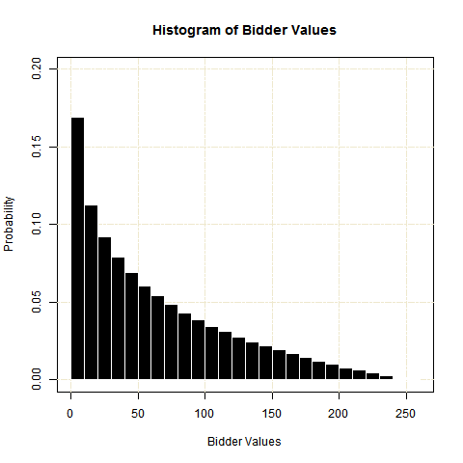

Auction

In each auction only the type B subjects are playing active roles. Specifically,
- Each type B observes the exact value of the good for herself.
- Each type B subject decides on how much she wants to bid in the auction, enters the bid on her computer screen, and submits it.
- After both type B subjects participating in the auction submit their BIDs, the one who has the highest BID obtains the good and pays her BID. In case of a tie, each of the two participants in the auction will receive the good with equal probabilities.
- This is the end of the period.
- A new period will start with a new matching between type B subjects and new private values for the good.

Earnings of a Type B in a Period
When a type B subject obtains the good at the end of a period (if her BID is the highest), then she will receive her VALUE for the good and will pay her BID. If she does not obtain the good, she does not receive or pay any amount. In other words, the earnings of a type B in the current period are:
Earnings = Her VALUE – Her BID (If she obtained the auctioned good);

Earnings = 0 (If she did not obtain the auctioned good).

The Role of Type A Subjects
Remember that there are two type A subjects participating in this session. In each round, half of the type B subjects will be matched to one of these type As, and the other half of the type Bs will be matched with the other type A in the room. This matching is anonymous and there will be new matching between type As and type Bs each round.
Each type B matched with a type A will form a team and jointly participate in an auction. The type B will be the active bidder in the auction as explained above, and type A will earn a payoff if the team wins the auction. Since there are multiple type B subjects assigned to a type A subject, a type A subject will earn payoffs from each auction her type B teammates win.
The value of each type A subject for the good auctioned in an auction determined by her type B teammate’s value. If the value of the type B subject in an auction is $X$, then the value of the type A assigned to her is $\frac{X}{2.5}$. In other words a type B subject’s value for a good is 2.5 times more than her type A teammate. For example if the value of a type B subject in an auction is 50, the value of her type A teammate is 20 (i.e. 20=$\frac{50}{2.5}$ ).
Type A’s Value =$\frac{TypeB’sValue}{2.5}$

Earnings of a Type A in a Period
Recall that a type A subject will earn payoffs from each auction her type B teammates win. A type A subject’s earnings from an auction is
Earnings = Type A’s VALUE – Her Type B teammate’s BID (If she obtained the auctioned good);

Earnings = 0 (If she did not obtain the auctioned good).

Since a type A’s value is a fraction of her assigned type B’s value, an auction price that is below the value of a winning type B bidder might be higher than her type A teammate’s value. In such a case, the type A may lose money in that auction.
A type A’s overall earnings from a period will be the sum of her earnings from each auction that her type B teammates participate.

Sequence of Auctions:
When the current period is over, the next period will start. Each period, type As and type Bs will be randomly matched and participate in a new auction with a different opponent. Two type B subjects participating in the same auction will never be teammates of the same type A. A subject’s VALUE of the good in each period is independent of her VALUE in the previous periods.
Example
The tables below indicate all the VALUEs and BIDs in an auction, and show the results for three different submitted bids. Recall that in the experiment no subject will know the values received by the opponent.
1.
 | Team 1  (YOU) | Team 2
Type A’s VALUE | 56.40 | 8.08
Type B’s VALUE | 141.00 | 20.20
Type B’s BID | 5.00 | 9.03
Received Item | No | Yes
Price | N/A | 9.03
Type A’s Payoff | 0 | -0.95
Type B’s Payoff | 0 | 11.17

2.
 | Team 1  (YOU) | Team 2
Type A’s VALUE | 56.40 | 8.08
Type B’s VALUE | 141.00 | 20.20
Type B’s BID | 36.00 | 9.03
Received Item | Yes | No
Price | 36.00 | N/A
Type A’s Payoff | 20.40 | 0
Type B’s Payoff | 105.00 | 0

3.
 | Team 1  (YOU) | Team 2
Type A’s VALUE | 56.40 | 8.08
Type B’s VALUE | 141.00 | 20.20
Type B’s BID | 59.44 | 9.03
Received Item | Yes | No
Price | 59.44 | N/A
Type A’s Payoff | -2.96 | 0
Type B’s Payoff | 81.56 | 0
Each of the three examples above corresponds to different BIDs for Team 1.
In the first example the BIDs of two teams are 5.00 and 9.03. Since the highest bid (9.03) is submitted by Team 2, Team 2 obtains the good and pays its BID (9.03). In this period, the subjects in Team 1 earn zero, type A of Team 2 earns 8.08 – 9.03 = -0.95 ECU, and type B of Team 2 earns 20.20-9.03=11.17. Note that type A of Team 2 loses money in this period because her type B teammate is allowed to submit a bid that is higher than the type A’s true value.
In the second example, everything is the same except type B of Team 1 chooses a higher BID (36.00). Now Team 1 receives the item. The price is equal to the BID (36.00), so type A of Team 1’s payoff is 56.40 – 36.00 = 20.40 ECU and type B of Team 1’s payoff is 141.00-36.00=105.00 ECU.
In the third example, the BIDs are 59.03 and 9.03. Team 1 receives the item for a price of 59.03, type A’s payoff is 56.40 – 59.03 = -2.96 ECU, and type B’s payoff is 141.00-59.03=81.97 ECU.

Total Payoffs
At the beginning of today’s session type A subjects will receive an endowment of $10 and type B subjects will receive an endowment of $5. The endowment is provided in order to cover any losses that you may make. Every period your earnings from that period are added to your initial endowment. At the end of today’s session you will receive your cumulative earnings —your earnings from 25 auctions plus your initial endowment. The conversion rate is $1 = 300 ECU for type A and $1 = 50 ECU for type B. In addition to this sum, you will be paid a $7 participation fee.
Are there any questions?

Practice Questions: Please answer the questions below. The experiment will start after everybody answers all the questions correctly. Please feel free to ask questions.

1. Fill the table below
 | Team 1 | Team 2
Type A’s VALUE | 4 | 10
Type B’s VALUE
Type B’s BID | 6 | 8
Received Item
Price
Type A’s Payoff
Type B’s Payoff

2. Fill the table below
 | Team 1 | Team 2
Type A’s VALUE
Type B’s VALUE | 50 | 150
Type B’s BID | 38 | 100
Received Item
Price
Type A’s Payoff
Type B’s Payoff

