Online Appendix to What if women earned more than their spouses?
An experimental investigation of work-division in couples
François Cochard, Hélène Couprie and Astrid Hopfensitz

APPENDIX A: Instructions (translated from French)

Welcome

The study in which you are going to participate aims at studying economic behavior. More precisely, we are interested in economic decisions in couples.
During this study, we will ask you to respond to questions or to do simple tasks. Little by little, we will give you over the course of the study instructions about these. These instructions are simple. If you pay close attention, you can earn a significant amount of money. Your earnings will be paid out to you in cash at the end of the study.
This study is financed through public research funding. Please note that there are no right or wrong answers for the questions we will pose you. We just wish to observe how you and your partner behave.
This study consists of multiple parts that have differing “rules”. In each part you will be exposed to multiple situations. Each of them will be explained to you in detail. You will then be asked to either take a decision, answer a question or do a task. All of your actions will allow you to earn Francs Toulousains (FT). Your earnings in Francs Toulousain depend also on the decisions of your partner, boy-friend, girl-friend, husband, wife,... From now on we will simply refer to him or her as your ‘partner’.

At the end of the study, the computer will randomly select one situation from each part, for final payout. You will then be privately informed about your total earnings in FT for the whole study.

Your total earnings in FT will be converted to euros and paid out to you. The exchange rate between FT and euros is:

1 euro for 20 FT

We inform you that in this study the earning possibilities in the different situations will be either the same for the man and the woman, or there will be an advantage for the [treatment “women advantaged”: woman] [treatment “ men advantaged”: man].
Please note that your decisions and thus your earnings are individual, private and anonymous. Your earnings will be paid out to you individually and seperately, at the end of this study. Specifically your partner will have no possibility to find out about your decisions and your earnings. The same holds for any other participant in this study.
Your decisions and your earnings will be perfectly anonymous. To preserve your anonymity, a personal identification number has been assigned to you: you find this number on the small piece of paper on your table. The link between this number and your name will be used only once, in your presence, at the moment of payout. In fact, you will have to present this number at the end of the study to receive your payment. We will thus have no means to later link the information collected during this study with a name, since we will only keep your personal identification number in our files. You should thus feel free to take any decision you want, without fear that it will be revealed to whoever, not even your partner.
Furthermore, we placed on your tables a sheet of paper. You can use it at any moment for notes. We remind you that you are not allowed to speak with other participants at any moment during the study . If you have a question or if something is not clear to you, please raise your hand.
We will now start with the first part of the study. We ask you to click on the button “next” if you have not already done so.

Part 1

We will start the first part that will consist of two situations. Lets start with situation 1.

Situation 1
In this first situation, we will allocate to each of you 20 tokens, thus 40 tokens for each couple. These tokens can be used to earn some FT. For this you will have to take a simple and abstract investment decision. You have the choice of investing your tokens, or part of them in an option A and/or in an option B. Your earnings in FT will depend on your own investment decision but also on the decision of your partner.
The earnings generated by each option will be shown on your computer screen in a few minutes.
You will have to take your decision, which means the number of tokens to invest in the option A and/or in the option B, without communicating with your partner. Thus, without knowing what he or she will choose. We will later ask you what you believe that your partner did.
For the previously mentioned privacy reasons, you will not be able to find our about the decisions of your partner, not even at the end of the study. Equally, your partner will have no way to know your decision, even at the end of the study.
We remind you that we are here in the first situation of the first part, and that at the end of the study one situation from each part will be randomly selected for your payment (that means that your earnings in FT from that situation will be converted to euros). Each of your decisions is thus important since it can be selected for payment.
You will now see a summary of the instructions and of the earnings of each option on your screen. We will now distribute a form with a short question. Please answer this question with respect to this first situation. Take your time to respond. Do not hesitate to ask questions. Please wait for us to pass at your table before clicking on the button ‘”next”.

Summary on screen:
You and your partner have 20 tokens each.

You and your partner can invest the number of tokens you want in an option A and/or an option B.

Each token invested by yourself in the option A generates for you 10 FT.
Each token invested by your partner in the option A generates for him/her 10 FT.

Each token invested in the option B generates for you 6 FT and generates 6 FT for your partner.
Each token invested by your partner in the option B generates for you 6 FT and generates 6 FT for your partner.

Decision screen (for detailed layout see Appendix B):
option A: ___
option B: ___

Questionnaire screen after decision:
What do you think: how much has your partner put in:

option A: ___
option B: ___

(10 FT for each correct answer, plus/minus 2 tokens)

Situation 2

We will now start the second situation of the first part. This situation is similar to the preceding one. You will have again 20 tokens each, that means 40 tokens per couple. But the earnings associated with the investment decision A are now more advantageous for the [treatment “women advantaged” : women] [treatment “ men advantaged”: men]. Those associated with the investment decision B did not change. The details of the earnings from each option will be shown on your screen in a moment.
We remind you that we are here in the second situation of the first part, and that at the end of the study one situation from this part will be randomly selected for final payment.
We also remind you that you will not be able to find out about the decision of your partner, not even at the end of the study.
The details concerning the earnings from each option appear now on your screen. Please respond to the questions concerning the second situation on the form that we distributed to you previously. Please wait that we pass by your place before clicking on “next”.

Summary on screen:
You and your partner have each 20 tokens.

You and your partner can invest the number of tokens you want in an option A and/or an option B.

If you are a man (dependent on treatment: woman):
Each token invested in the option A generates for you 13 FT.
If you are a woman (dependent on treatment: man):
Each token invested in the option A generates for you 10 FT.

Whether you are man or woman, each token invested in the option B generates for you 6 FT and generates 6 FT for your partner.

Decision screen (for detailed layout see Appendix B):
option A: ___
option B: ___

Questionnaire screen after decision:
What do you think: how much has your partner put in:

option A: ___
option B: ___

(10 FT for each correct answer, plus/minus 2 tokens)

Part 2

We start the second part that will also consist of two situations. However, there will be no more tokens. From now on, we will give you the opportunity to work to earn FT. This “work” is simple and abstract.
We start with the first situation.
Situation 1

You and your partner will have the possibility to work on two identical tasks that, however, generate different types of earnings: task A and task B. You will each have 5 minutes time and will be paid in proportion to the time that you will spend on either task.
Concretely the work will consist in typing phone numbers that will be shown on your screen. The gains from each task are the following:
If you work on task A, you earn 40 FT per minute.
If you work on task B, you earn 24 FT per minute and your partner will also earn 24 FT per minute.

We remind you that you will be paid based on the total amount of time that you will spend on each task during these 5 minutes and not based on the number of phone numbers that you type.
You also have the possibility to distract yourself, which does not lead to any earnings in FT. On your screen you have several entertainment activities at your disposition. For example games, journals and a web browser. We inform you that you cannot use the web browser for communication.
Your partner is in exactly the same situation as you and can work on the tasks A, B or distract him or herself.
We will now distribute a short summary of these instructions, with a short question. Please take your time to read these and to respond to the question.
--
To summarize, you and your partner will have the possibility to work to earn money or to use a distraction. Note that you will be paid by rounded intervals of 15 seconds. If you work for example for 8 seconds or more on a task, we will consider that you worked for 15 seconds. If you work for 7 seconds or less on a task we will consider that you did not work on this task.
You will have to act without communicating with your partner, and thus without knowing what he or she will choose. We will afterwards ask you what you think that your partner did in this situation.
For the previously mentioned privacy reasons, you will not be able to find our about the decisions of your partner, not even at the end of the study. Similarly, your partner will have no way to know your decision, even at the end of the study.
You will now have a few minutes to familiarize yourself with the different tasks: task A, task B and the distraction task. This test period will not be paid. Click on the different buttons on the left to explore each of the options: try to type some numbers, look at the different distraction options. Notice that you can switch at any moment between the different options and that you can come back to the same option multiple times.
Before this test period a screen with a summary of these instructions will appear on your screen. Look at these instructions by clicking on “next” to start the test period.

Summary on screen:
You have 5 minutes. You can work on task A, on task B or use the distraction task. You will be paid proportionally to the time that you will spend on each of the two tasks. Your partner is in the same situation as you.

Working on task A generates for you 40 FT per minute.
Working on task B generates for you 24 FT per minute and generates 24 FT per minute for your partner.

Decision screen (for detailed layout see Appendix B):
task A:
task B:
distraction task:

Questionnaire screen after decision:
What do you think: how much time did your partner spend on:

task A: ___
task B: ___
distraction task: ___

(10 FT for each correct answer, plus/minus 20 seconds)

Situation 2

The second situation is similar to the previous situation. You have again 5 minutes time to work on task A, B or to use the distraction. However note: the earnings in FT generated by task A are now more advantageous for the [treatment “women advantaged” : women] [treatment “ men advantaged”: men]. Those associated with task B have not changed. The details of the earnings from each option will be shown on your screen in a moment.
The distraction task does not generate any earnings.

We remind you that we are here in the second situation of the second part, and that at the end of the study one situation from this part will be randomly selected for final payment.
We also remind you that you will not be able to find out about the decision of your partner, not even at the end of the study.
The details concerning the earnings from each option appear now on your screen. When you are ready click on “next” to start.

Summary on screen:
The situation is the same as previously. You have 5 minutes but the earnings changed.

If you are a man (dependent on treatment: woman):
Working on task A generates for you 52 FT per minute.
If you are a woman (dependent on treatment: man):
Working on task A generates for you 40 FT per minute.

Whether you are man or woman, working on task B generates for you 24 FT per minute and generates 24 FT per minute for your partner.

Decision screen (for detailed layout see Appendix B):
task A:
task B:
distraction task:

Questionnaire screen after decision:
What do you think: how much time did your partner spend on:

task A: ___
task B: ___
distraction task: ___

(10 FT for each correct answer, plus/minus 20 seconds)

Part 3

We start the third part that will also consist of two situations. This part will be very similar to the previous, however you will no longer have the possibility to use the distraction task. You and your partner have each 5 minutes and you will be paid proportional to the total time you spend on either task.
We start with the first situation.

Situation 1

The gains from each task are the following:
If you work on task A, you earn 40 FT per minute.
If you work on task B, you earn 24 FT per minute and your partner will also earn 24 FT per minute.
We remind you that we are here in the first situation of the third part, and that at the end of the study one situation from this part will be randomly selected for final payment.
We also remind you that you will not be able to find out about the decision of your partner, not even at the end of the study.
The details concerning the earnings from each option appear now on your screen. When you are ready click on “next” to start.

Summary on screen:
You have 5 minutes. You can work on task A or on task B. You will be paid proportionally to the time that you will spend on each of the two tasks. Your partner is in the same situation as you.

Working on task A generates for you 40 FT per minute.
Working on task B generates for you 24 FT per minute and generates 24 FT per minute for your partner.

Decision screen (for detailed layout see Appendix B):
task A:
task B:

Questionnaire screen after decision:
What do you think: how much time did your partner spend on:

task A: ___
task B: ___

(10 FT for each correct answer, plus/minus 20 seconds)

Situation 2

The second situation is similar to the previous. The earnings in FT generated by task A are now more advantageous for the [treatment “women advantaged” : women] [treatment “ men advantaged”: men]. Those associated with task B have not changed.
The details concerning the earnings from each option appear now on your screen. When you are ready click on “next” to start.

Summary on screen:
The situation is the same as previously. You have 5 minutes but the earnings changed.

If you are a man (dependent on treatment: woman):
Working on task A generates for you 52 FT per minute.

If you are a woman (dependent on treatment: man):
Working on task A generates for you 40 FT per minute.

Whether you are man or woman, working on task B generates for you 24 FT per minute and generates 24 FT per minute for your partner.

Decision screen (for detailed layout see Appendix B):
task A:
task B:

Questionnaire screen after decision:
What do you think: how much time did your partner spend on:

task A: ___
task B: ___

(10 FT for each correct answer, plus/minus 20 seconds)

Part 4

We now start the 4th part in which you will no longer have to work. You will simply have to take a series of decisions.
The instructions will appear on the screen. I will read them out loud. Please read them at the same time and do not click on “next” immediately.

You will take a series of decisions.
Each numbered line, proposes two possible divisions of FT between you and your partner.
For each line, you have to choose one of the two divisions: the option A or the option B.
Take for example the first line. In option A, both partners earns 100 FT. In option B, you earn 300 FT for yourself and your partner earns 0 FT.
For each line, you will thus have to check one of the boxes. At the end of the study, we will randomly select on of the line for final payment. We will then randomly select which of the two decisions in a couple (the division chosen by the man or by the woman) will be applied.
Please take your decisions now and please do not hesitate to ask us questions.

Part 5

The computer will now make the random draws concerning each part of the study to calculate your individual earnings.
Your individual earnings will appear on the screen.

---
You now know your individual earnings. Your partner will not be informed about them.

Your earnings are individual: you will receive your earnings separately in individual envelops. However, you have the possibility to decide to transfer your individual earnings or part of them to a joint envelope that is given to the couple. We call this the “joint account”.
You can now discuss with your partner the contributions of each of you to this joint account.
To do so you have access to a “chat” tool. Concretely you can write messages for your partner in a window on your screen. He or she can then respond to you with the same tool. Each of you can, whenever he wants, fill in the amount that he or she wishes to transfer to the joint account.

Whenever you want, you fill in the amount that you want to transfer to the joint account and your partner will do the same. We will then ask you if you agree with the proposal by your partner. The chat phase will continue until you agree on the amount to transfer to the joint account.
All of this is summarized on the following screen. Click on “next” to access the chat.

End

The study is now finished.
We now ask you fill out this final questionnaire that will allow us to have more information about you. This information is very important for the scientific quality of the study. If certain questions seem too indiscreet, we prefer that you do not respond to them than to respond falsely. However, rest assured that your responses stay completely anonymous and private. Even your partner will not be informed of them. You will receive 100 FT for taking the time to respond to this questionnaire.
When you are finished with the questionnaire, you can return to the reception room to wait for final payout. Make sure to keep your personal identification number with you.
We will call you one by one to give you your payment and to ask you to sign a receipt. If you wish you can stay after payout to lean more about this research project and the questions we want to investigate in this study.
Thank you very much for your participation.

APPENDIX B: Decision screens
Specialization task: Abstract treatment

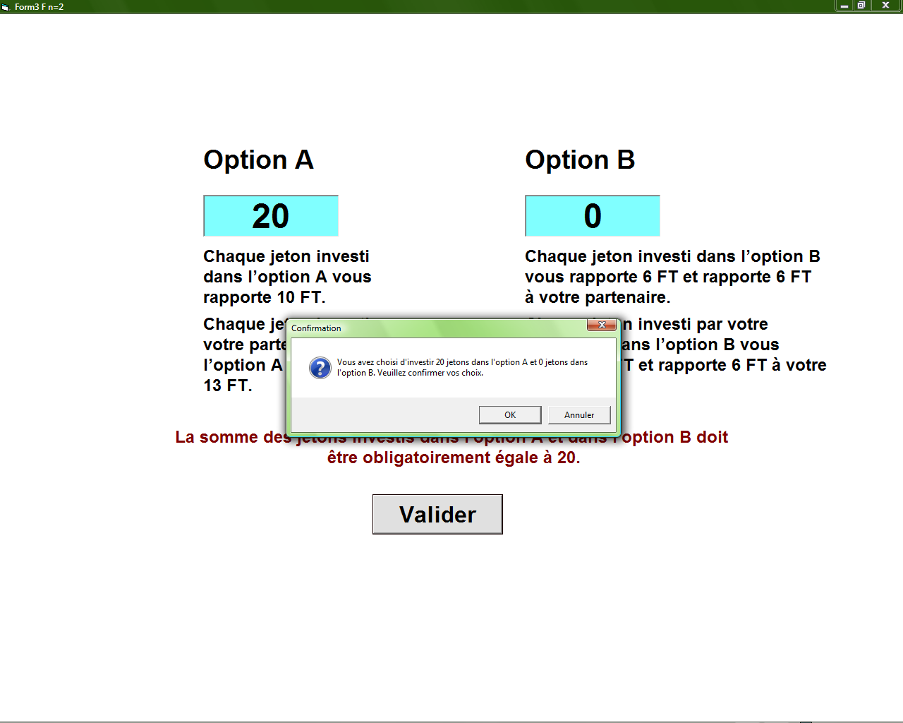

Specialization task: Effort treatment
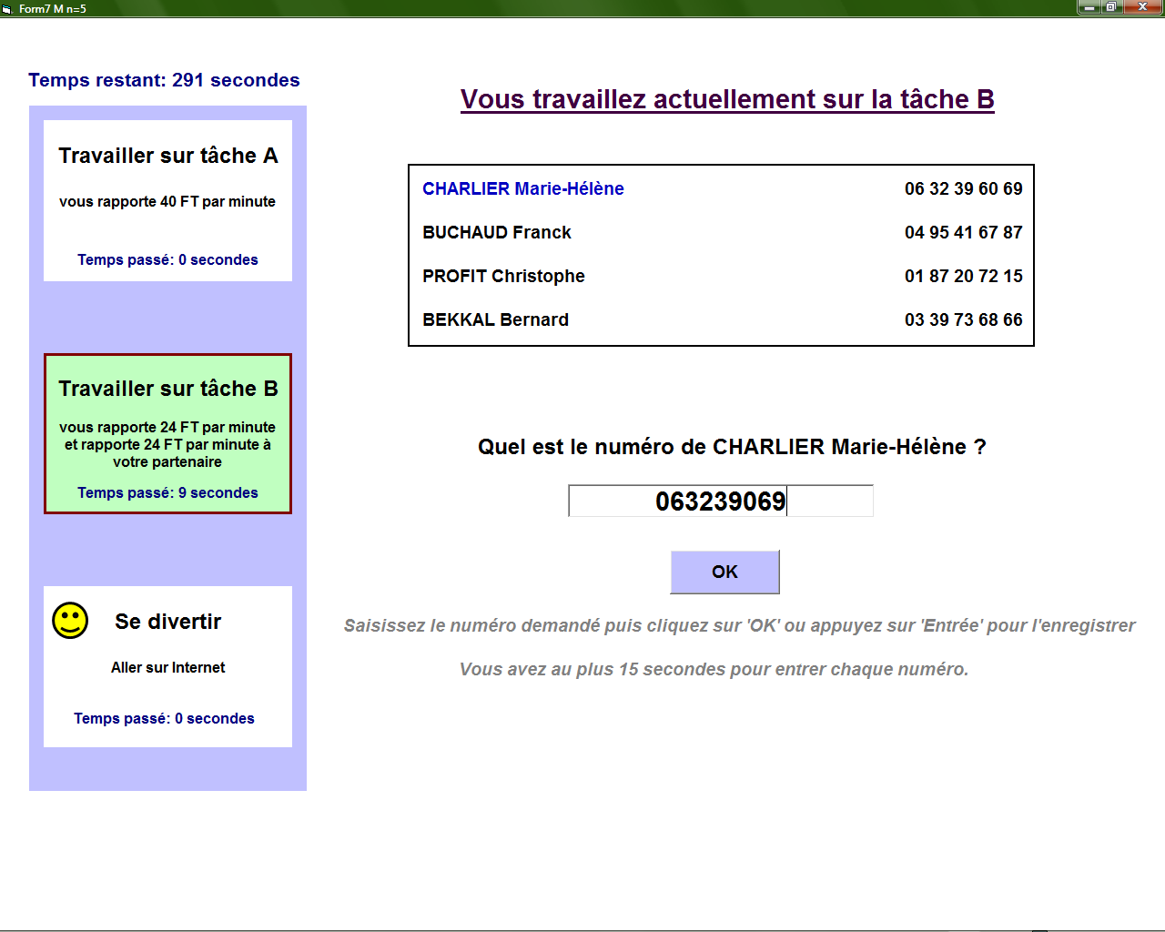

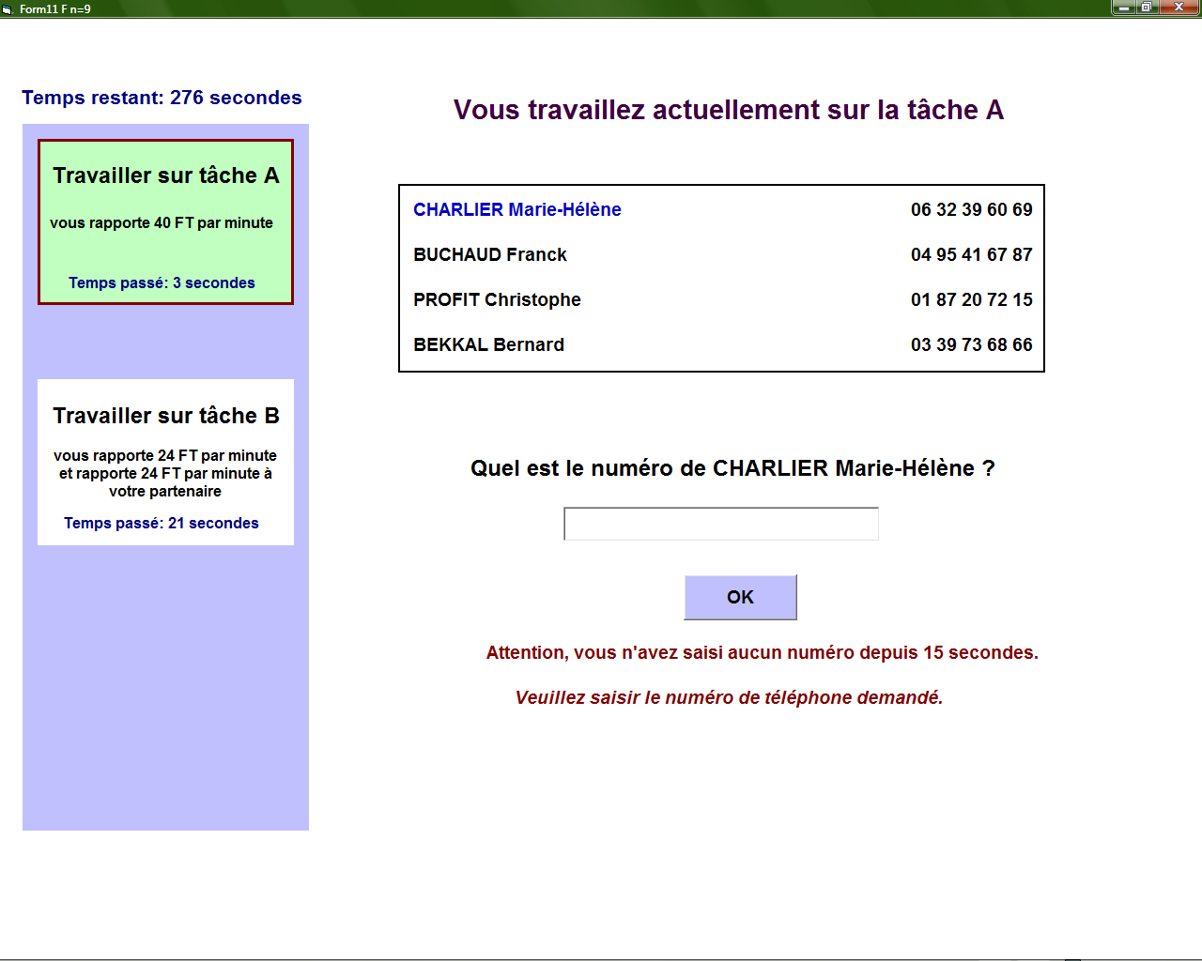
Specialization task: Time treatment
Payout screen in treatment: public
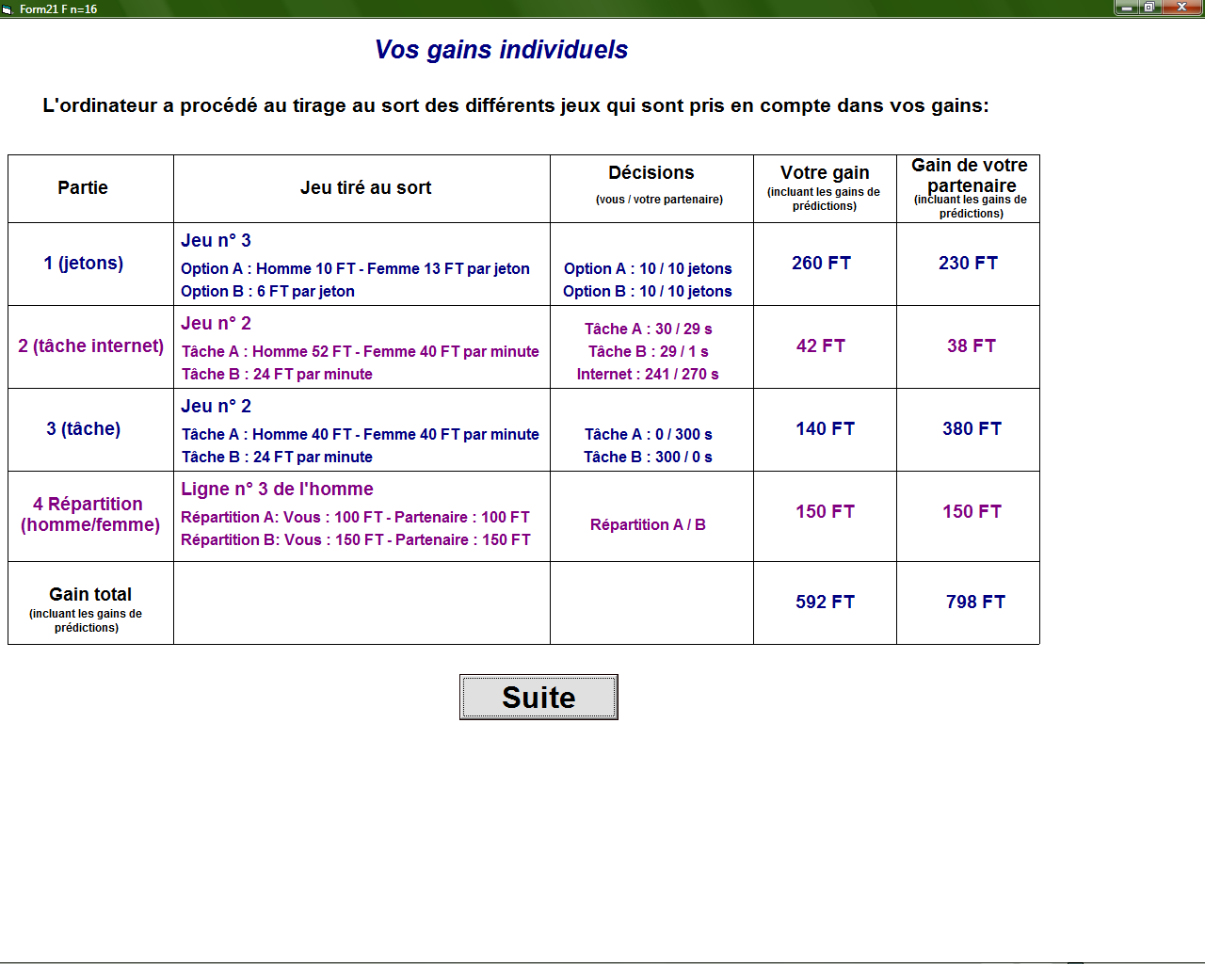
Chat screen in treatment public (male version)
