Online Appendix: Instructions
Part 1 Description
This part of the experiment consists of seventy-five separate decision making periods. You will participate in a group of eight people. At the beginning of period one, each of the participants in this room will be randomly assigned to a group of size eight and will remain in the same group for the entire seventy-five decision making periods. Hence, you will remain grouped with the same seven other participants for the next seventy-five periods.

At the beginning of each decision making period you will be randomly re-paired with another participant in your group. The repairings use a random round robin procedure, that is, you play each of the other seven participants once in every seven period cycle. A new random round robin match is generated for each seven period cycle.

At the beginning of each period, you and all other participants will choose an action. An earnings table is provided which tells you the earnings you receive given the action you and your currently paired participant chose. The actions you may choose are row A or row B. During a period everyone will have the same earnings table. Seventy-five earnings tables, one for each of the seventy-five periods, have been generated by a computer. Many sequences of seventy-five earnings tables were generated. One of these sequences will be used in today's session. However, in each period, all participants in the experiment will have the same earnings table.

The outcome each period will be found in the cell determined by your action and the action of the other participant you are paired with for the current decision making period. Your action determines the row and the other participant's action determines the column of the earnings table. The values in the cell determined by the intersection of the row and column chosen is the outcome for the current period.

Your earnings are displayed in green and are located in the lower left corner of each cell. The other participant's earnings are displayed in blue and are located in the upper right corner. The conversion rate from points to dollars is 4 points = 1 cent. For example, if you chose A and the other participant chose A, then the outcome is (A,A) and your earnings will be 40 points = 10 cents and the other participant's earnings will be 30 points = 7.5 cents, see the following example earnings table:

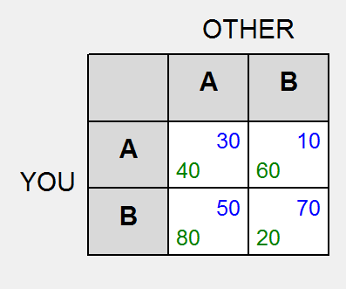
Making a choice consists of clicking on the row of your choice, which highlights it in blue and activates a confirmation button below the earnings table. You may either confirm your choice or change it by clicking on the other row. Your choice is not final until you have clicked on the confirm button.

After you and the participant you are matched with have made decisions, the outcome for this period will be reported. The cell resulting from your choice and the other participant's choice will be highlighted in yellow. You will have 15 seconds to review the results for each round.

Questionnaire

We will now post a questionnaire on the computer screen to make sure that all participants understand how their earnings depend on the choices made by the participants. Please turn to your monitor and complete the questionnaire now.

Summary

*** This part of the experiment consists of seventy-five separate decision making periods.

*** You have been randomly assigned to a group of size eight and will remain in the same group for the entire seventy-five decision making periods.

*** Each period you will be re-paired with one of the seven other participants in your group. Most of the time you have a zero percent chance of being repaired with the same participant next period. However, at the start of each round robin rematch, which happens every 7 periods, you have a one in seven chance of playing the same participant twice in a row.

*** You make a choice by clicking on a row, which highlights the row in blue. You must also confirm your choice of the highlighted row.

*** Your balance at the end of the session will be paid to you in private and by check.

We have completed the instructions. Again, it is important that you remain silent and do not look at other people's work. Please make certain your cell phone is turned off and put away.

If you have a question, please raise your hand, and an experimenter will come to privately assist you. If there are no questions, period one will begin.

Part 2 Description
The experiment will continue for fourteen more periods. You will participate in the same group of eight people as in Part 1 of the experiment.

At the beginning of each period, you and all other participants will choose an action. The actions you may choose are row 1, 2, 3, 4, 5, 6, or 7. To make a choice highlight a row by clicking on it and then confirm your choice by clicking the confirm button that appears under the table after you have highlighted a row. Your choice is not final until you confirm it.

To understand how your payoffs are calculated, you need to understand how to calculate the order statistic of the other seven participants choices. The order statistic j given the other participants’ seven choices is found by ordering the seven choices from smallest to largest and then selecting the jth largest choice.

For example, suppose you choose 6, and the other seven participants choose 6, 2, 1, 6, 2, 5, and 7. To find the order statistics write out the seven choices as follows:

1, 2, 2, 5, 6, 6, 7

Suppose you want to find the second order statistic (order statistic 2). Counting over two from the left gives the second order statistic, which is 2 in this example. Suppose you want to find the fourth order statistic (order statistic 4). Counting over four from the left gives the fourth order statistic, which is 5 in this example. Suppose you want to find the sixth order statistic (order statistic 6). Counting over six from the left gives the sixth order statistic, which is 6 in this example.

Notice that the order statistics do not depend on your choice. If your choice had been 2 instead of 6, for example, none of the preceding examples would have changed!

A payoff table is provided which tells you the points you receive given your choice and the order statistic computed from the other participants’ choices. Everyone will have the same earnings table. In the following example, your choice determines the row and the 2nd order statistic of the
other seven choices determines the column used in the table:

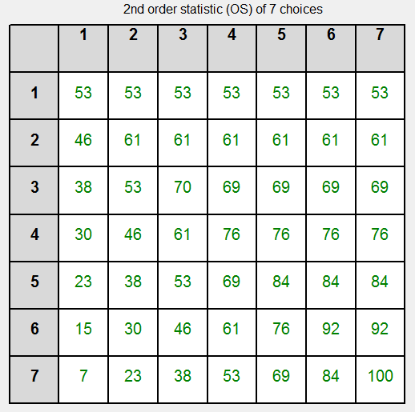

After everyone has confirmed their choice, an outcome screen will display the results for the period. An outcome screen consists of three parts: the original table with the chosen row and column highlighted, a table reporting the frequency of the various choices, and a summary table. In the example screen shot you chose 3. The second order statistic of the other 7 choices was 3.
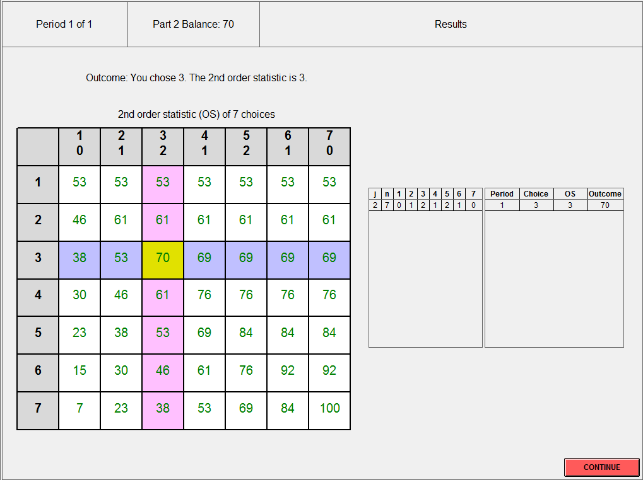

The outcome screen reports a frequency table of the other seven participants' choices and an outcome summary table. The frequency table is reproduced below:

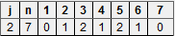

In the example frequency table, the other participants made the following choices: 1 participant chose 2, 2 participants chose 3, 1 participant chose 4, 2 participants chose 5, and 1 participant chose 6. No participant chose 1 or 7. The order statistic j given n choices is found by ordering the n choices from smallest to largest and then selecting the jth largest choice. To compute the second order statistic write out the seven choices as follows:

2, 3, 3, 4, 5, 5, 6

Counting over two from the left gives the second order statistic (order statistic 2), which is 3 in this example.

The frequency table will keep a record of all of the outcomes. You may also find the outcome for the current period summarized in the column headers of the payoff table:

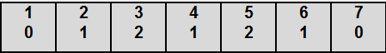

This is the same information collected in the frequency table. The top number is the choice and the bottom number is the number of other participants who made that choice in that period. This information will only be available during the outcome phase of each period.

The outcome summary table can be found on the right side of the main screen. It is reproduced below:

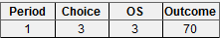

The outcome each period will be found in the cell determined by your action and the current order statistic of the other seven choices. Your action determines the row and the other participants’ actions and the current order statistic determine the column of the payoff table. The value in the cell determined by the intersection of the row and column chosen is your payoff for the current period. In the example, the outcome resulting from a choice of 3 and the 2nd order statistic of (2,3,3,4,5,5,6) or 3 gives a payoff to the player of 70. The outcome for the first period is summarized on the far right side of the outcome screen.

The payoff table will remain constant during the session. The order statistic will change from period to period. So even if everyone made the same choice in two different periods the column used to determine your payoff may change because the order statistic changed. For example, the 6th order statistic of (2,3,3,4,5,5,6) is 5.

Payoff Tables

The outcome for your choice and an order statistic is displayed in each cell. The conversion rate from points to dollars is 4 points = 1 cent. So, for example, 70 points = 17.5 cents. After you have made a choice, a "please wait" message will be displayed and then the outcome will be reported. The cell resulting from your choice and the other participant's choice will be highlighted in yellow.

Questionnaire

We will now post a questionnaire on the screen to make sure that all participants understand how their earnings depend on the choices made by the participants. Please turn to your monitor and complete the questionnaire now.

Summary

*** Part 2 of the experiment consists of fourteen separate decision making periods.

*** You will continue in the same group of size eight that you participated in from Part 1 of the experiment.

*** You make a choice by clicking on a row, which highlights the row in blue. You must also confirm your choice of the highlighted row.

*** Your payoff will be determined by your choice, the choice of the other seven participants, and the current order statistic.

*** The order statistic, "j", will change from period to period, but the other seven participants will remain the same for all fourteen separate decision making periods.

*** Your balance at the end of the session will be paid to you in private and by check.

We have completed the instructions. Again, it is important that you remain silent and do not look at other people's work.
If you have a question, please raise your hand, and an experimenter will come to assist you. If there are no questions, period one of the experiment will begin.

