B. Instructions

General
Thank you for agreeing to take part in this study. Please read the instructions we give you today carefully. A clear understanding of the instructions will help you make better decisions and increase your earnings. After reading the instructions, there will be 10 questions to test your understanding. To guarantee everyone understands the experiment, you can not move on to the next question if you do not enter the correct answer. All the money you earn is yours to keep and will be paid to you in private and in cash immediately after the experiment. If you decide to leave early, you will forgo all your earnings.

If you have any questions during the experiment, please raise your hand. Please do not consult with other participants in this room or look at the computer screens of other participants. Please turn your phone off or to silent mode now and place it on the floor, along with any other materials you have brought into the room.

At the beginning of the experiment, you will be randomly assigned into a group consisting of six people, you and five others. The other people in your group are sitting in this room. You and the other five group members will remain in the same group throughout today’s experiment. You and any group members will remain anonymous. Please do not attempt to communicate with other participants in the room during the experiment.

Payoff
The amount of money each participant gets paid is different. It depends on your choice and the other five group members’ choices. Details are as following.

This experiment has 10 periods altogether. At the beginning of each period, you will be asked to pick a value of X. The values of X you may choose are 1, 2, 3, 4, 5, 6 or 7. The value you pick for X and the minimum value picked for X by any participant in your group, including your choice of X, will determine the payoff you receive. You are provided with a table which tells you the potential payoffs you may receive. Please look at Figure 1 on the next page now.

The earnings in each period may be found by looking across from the value you choose on the left hand side of the table and down from the minimum value chosen within group from the top of the table. For example if you choose a 4 and values chosen by five other members are 5, 5, 4, 3, and 3. Then the smallest value chosen in your group is 3, your current payoff is 80 points. In Figure 1, the payoff can be found at the cell in the fourth row and fifth column. The points will be converted into cash at the end of the experiment. 40 points equal to 1 AUD. Thus the more points you earn, the more you will get paid.

Figure 1
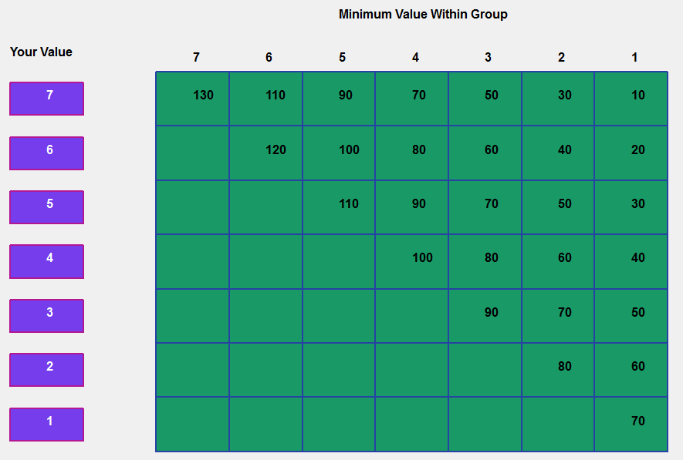

You can change your value every 0.3 seconds. In other words, you or other participants can change the choice three or four times in one second. Periods will each last 60 seconds. During the 60 seconds, you can switch your chosen value as many times as you wish. The numbers in the payoﬀ matrix are the period payoﬀs you would earn if you maintained the same action throughout the period. For instance if you chose value 6 for the entire period and the minimum value chosen in your group stays at 2, you would earn 40 points.

Apart from your own value and the smallest value chosen within your group, your payoff in a period also depends on how much time is spent in each cell of the payoﬀ table. For example, if you choose value 7 for the first 20 seconds and value 4 for the later 40 seconds while the minimum group value stays at value 2 for the whole period. The period accumulated earnings are calculated as following. In the first 20 seconds you stayed at the 1st row and 6th column cell of the payoﬀ matrix getting payoff 30, you accumulated (20/60)30=10 points. In the later 40 seconds, you stayed in the 4th row and 6th column cell getting payoff of 60, you accumulated (40/60)60=40 points. Your period accumulated payoff would be 10points + 40points=50points.

In summary, the final payoff is accumulated by the time spent in each cell. The more time you spend in any one cell, the closer ﬁnal payoﬀ will be to the payoﬀ in that cell. As in the above example, 50 points is closer to 60 than to 30. This is because you spent longer staying at the cell with payoff 60 than staying at the cell with payoff 30.

Details on How to Use the Software
At the beginning of each period, each participant has to choose a starting value for X. After the starting values are picked by all participants in the room, the 60 seconds for the period begins and payoffs start to accumulate.
Figure 2
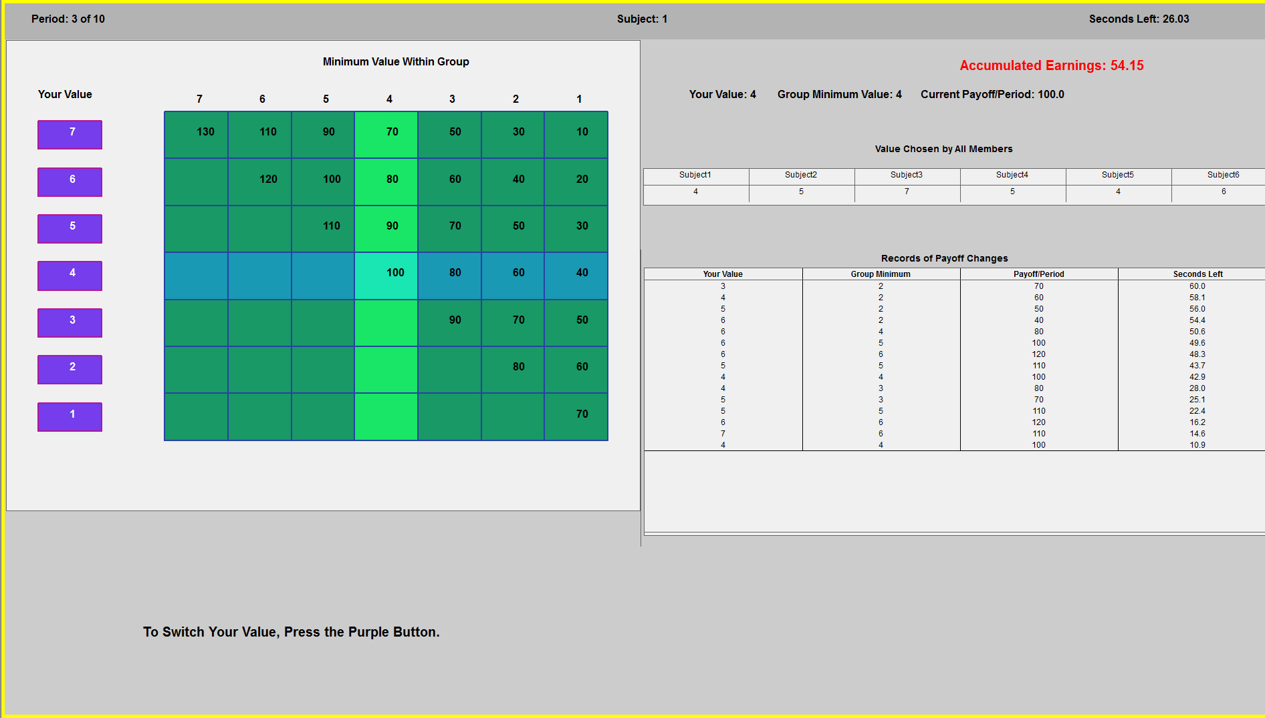

Figure 2 shows a screenshot from the experiment. The clock at the right top corner of the screen shows how much time is left in the period. The left side of the screen shows same payoff table as Figure 1. At any moment during the period, you will be able to change your action by clicking the purple buttons at the left side of screen. The row corresponding to your chosen action and the column corresponding to the group minimum will both be highlighted in different colors. For example, Figure 2 currently shows that you have chosen a value of 4, while the group minimum is also 4.

The right hand side of the screen displays your earnings during the period. A closer look at the right side of the screen is shown in Figure 3 on the next page. Your current accumulated earnings are displayed in red at the top. The accumulated earnings are updated every 0.3 seconds. The next line displays your current chosen value, group minimum value, and current payoff per minute. The table below displays the value chosen by each participant. You can easily find your subject number at the top middle of the screen.

The table in the middle displays records of changed payoff and the time that change is made. For example, the first row shows that your starting value is 3 (or you chose 3 when 60 seconds are left) and the starting group minimum is 2 giving a current payoff of 70. You changed your value from 3 to 4 when 58.1 seconds are left in the period. In other words, you spent 60.0-58.1=1.9 seconds playing the starting value 3 with the group minimum equal 2. The second row shows that you spent 58.1-56.0=2.1 seconds playing value 4 with the minimum equal 2, and so on.

Figure 3
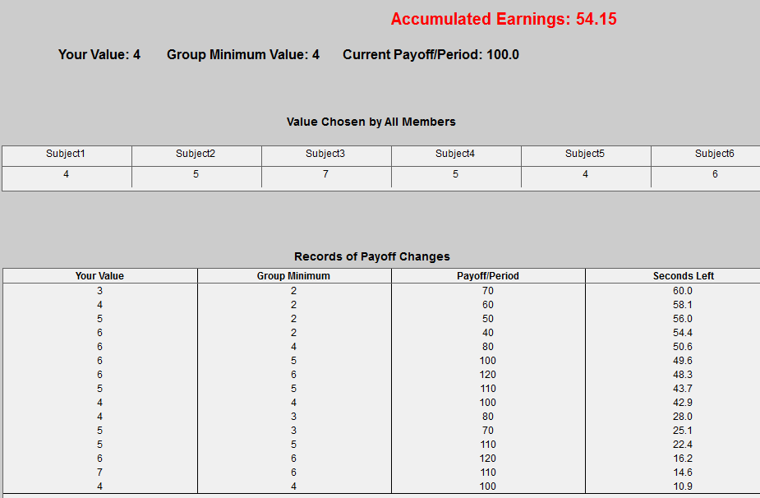

At the end of each period, you are provided with another two tables. The first table lists your average value and group average minimum value, along with your period payoff and its converted money amount. Please see Figure 4. The second table records the average chosen value for all group members. Please see Figure 5. After you have finished reviewing the table, the next period will start.
Figure 4
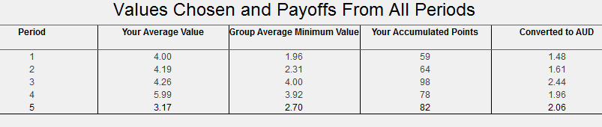
Figure 5
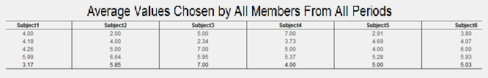

Earnings
You will be paid at the end of the experiment in cash based on the sum of point earnings throughout the experiment. The conversion rate from points to AUD is 40. That is
40 points = 1 AUD
Apart from the converted point earnings, you are paid another $5 participation fee.

Now you have 5 minutes to read the instructions and ask questions. A quiz consisting of 10 questions will start before the experiment. Feel free to ask experiment administrator questions during the quiz, if you have any confusion. A full understanding of the experiment is important.

