Appendix A (For Online Publication): Instructions
GENERAL INSTRUCTIONS
This is an experiment in the economics of strategic decision making. Various research agencies have provided funds for this research. The instructions are simple. If you follow them closely and make appropriate decisions, you can earn an appreciable amount of money.
The experiment will proceed in two parts. Each part contains decision problems that require you to make a series of economic choices which determine your total earnings. The currency used in part 1 of the experiment is U.S. Dollars. The currency used in part 2 of the experiment is francs. These francs will be converted to U.S. Dollars at a rate of _25_ francs to _1_ dollar. You have already received a $20.00 participation fee (this includes your show-up fee of $7.00). Your earnings from both part 1 and part 2 of the experiment will be incorporated into your participation fee. At the end of today’s experiment, you will be paid in private and in cash. There are 12 participants in today’s experiment.
It is very important that you remain silent and do not look at other people’s work. If you have any questions, or need assistance of any kind, please raise your hand and an experimenter will come to you. If you talk, laugh, exclaim out loud, etc., you will be asked to leave and you will not be paid. We expect and appreciate your cooperation.

INSTRUCTIONS FOR PART 1
In this part of the experiment you will be asked to make a series of choices in decision problems. How much you receive will depend partly on chance and partly on the choices you make. The decision problems are not designed to test you. What we want to know is what choices you would make in them. The only right answer is what you really would choose.
For each line in the table in the next page, please state whether you prefer option A or option B. Notice that there are a total of 15 lines in the table but only one line will be randomly selected for payment. Each line is equally likely to be selected, and you do not know which line will be selected when you make your choices. Hence you should pay attention to the choice you make in every line. After you have completed all your choices a token will be randomly drawn out of a bingo cage containing tokens numbered from 1 to 15. The token number determines which line is going to be selected for payment.
Your earnings for the selected line depend on which option you chose: If you chose option A in that line, you will receive $1. If you chose option B in that line, you will receive either $3 or $0. To determine your earnings in the case you chose option B there will be second random draw. A token will be randomly drawn out of the bingo cage now containing twenty tokens numbered from 1 to 20. The token number is then compared with the numbers in the line selected (see the table). If the token number shows up in the left column you earn $3. If the token number shows up in the right column you earn $0.
While you have all the information in the table, we ask you that you input all your 15 decisions into the computer. The actual earnings for this part will be determined at the end of part 2, and will be independent of part 2 earnings.

Decision no. | Option A | Option  B |  | Please choose  A or B
1 | $1 | $3 never | $0 if 1,2,3,4,5,6,7,8,9,10,11,12,13,14,15,16,17,18,19,20
2 | $1 | $3 if 1 comes out of the bingo cage | $0 if 2,3,4,5,6,7,8,9,10,11,12,13,14,15,16,17,18,19,20
3 | $1 | $3 if 1 or 2 | $0 if 3,4,5,6,7,8,9,10,11,12,13,14,15,16,17,18,19,20
4 | $1 | $3 if 1,2,3 | $0 if 4,5,6,7,8,9,10,11,12,13,14,15,16,17,18,19,20
5 | $1 | $3 if 1,2,3,4, | $0 if 5,6,7,8,9,10,11,12,13,14,15,16,17,18,19,20
6 | $1 | $3 if 1,2,3,4,5 | $0 if 6,7,8,9,10,11,12,13,14,15,16,17,18,19,20
7 | $1 | $3 if 1,2,3,4,5,6 | $0 if 7,8,9,10,11,12,13,14,15,16,17,18,19,20
8 | $1 | $3 if 1,2,3,4,5,6,7 | $0 if 8,9,10,11,12,13,14,15,16,17,18,19,20
9 | $1 | $3 if 1,2,3,4,5,6,7,8 | $0 if 9,10,11,12,13,14,15,16,17,18,19,20
10 | $1 | $3 if 1,2,3,4,5,6,7,8,9 | $0 if 10,11,12,13,14,15,16,17,18,19,20
11 | $1 | $3 if 1,2, 3,4,5,6,7,8,9,10 | $0 if 11,12,13,14,15,16,17,18,19,20
12 | $1 | $3 if 1,2, 3,4,5,6,7,8,9,10,11 | $0 if 12,13,14,15,16,17,18,19,20
13 | $1 | $3 if 1,2, 3,4,5,6,7,8,9,10,11,12 | $0 if 13,14,15,16,17,18,19,20
14 | $1 | $3 if 1,2, 3,4,5,6,7,8,9,10,11,12,13 | $0 if 14,15,16,17,18,19,20
15 | $1 | $3 if 1,2, 3,4,5,6,7,8,9,10,11,12,13,14 | $0 if 15,16,17,18,19,20

Instructions for the Simultaneous Treatment
INSTRUCTIONS FOR PART 2
YOUR DECISION
The second part of the experiment consists of 20 decision-making periods. The 12 participants in today’s experiment will be randomly re-matched every period into 6 groups with 2 participants in each group. Therefore, the specific person who is the other participant in your group will change randomly after each period. The group assignment is anonymous, so you will not be told which of the participants in this room are assigned to your group
Each period you and the other participant in your group will simultaneously make bids (any number, including 0.1 decimal points) in three boxes. Your bid in each box cannot exceed 100 francs. The more you bid, the more likely you are to win a particular box. This will be explained in more detail later. The participant who wins at least two boxes receives the reward of 100 francs. Your total earnings depend on whether you receive the reward or not and how many francs you spent on bidding. An example of your decision screen is shown below:
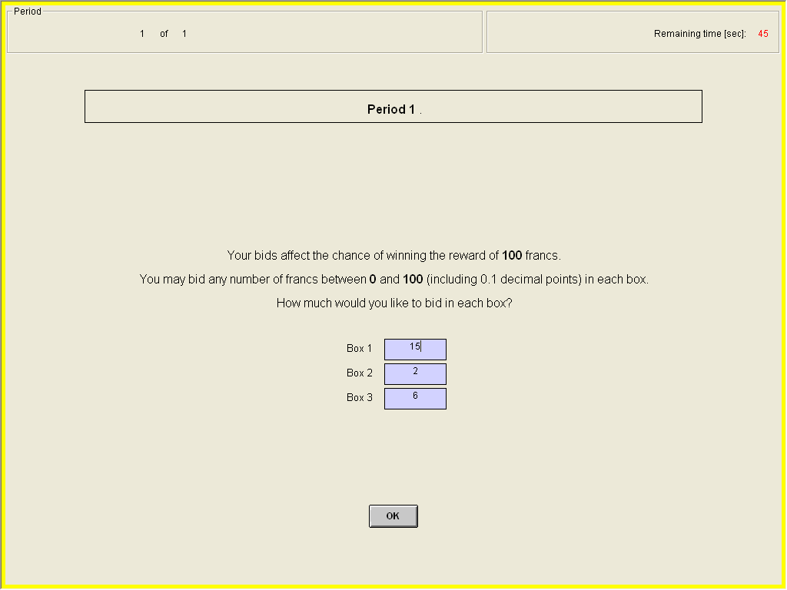

CHANCE OF WINNING A BOX
The more you bid in a particular box, the more likely you are to win that box. The more the other participant bids in the same box, the less likely you are to win that box. Specifically, for each franc you bid in a particular box you will receive one lottery ticket. At the end of each period the computer draws randomly one ticket among all the tickets purchased by you and the other participant in the group. The owner of the drawn ticket wins. Thus, your chance of winning a particular box is given by the number of francs you bid in that box divided by the number of francs you and the other participant bid in that box.
Your chance of winning a box | = | Your Bid in That Box
Your chance of winning a box | = | Your Bid in That Box + The Other Participant’s Bid in That Box
In case both participants bid zero in the same box, the computer determines randomly who wins that box.
Example: This is an example to illustrate how the computer makes a random draw of lottery tickets. Suppose, participant 1 bids 10 francs in box 1 and participant 2 bids 20 francs in box 1. Therefore, the computer assigns 10 lottery tickets to participant 1 and 20 lottery tickets to participant 2. Then the computer randomly draws one lottery ticket out of 30 tickets (10 + 20 = 30). As you can see, participant 2 has higher chance, 0.67 = 20/30, while participant 1 has lower chance, 0.33 = 10/30, of winning box 1.
In the sheet attached to these instructions, you will find a probability table. This table will give you some idea of how your bid and the other participant’s bid affect your chance of winning. For instance, suppose you bid 50 francs and the other participant bid 30 francs then your chance of winning the box is 0.63. Note that as stated before, your chance of winning increases as your bid increases relative to the other participant’s bid. So if you bid 70 francs and the other participant is still bidding 30 francs, your chance of winning increases to 0.70. To assist you with calculation of more precise numbers, we will provide you with the Excel calculator. You may use the calculator to find the chance of winning for any combination of your bid and the other participant’s bid. We will have a few practice rounds with the Excel calculator before the start of the experiment.

YOUR EARNINGS
Your earnings depend on whether you receive the reward or not and how many francs you spent on bidding. The participant who wins at least two boxes receives the reward of 100 francs. Regardless of who receives the reward, both participants will have to pay their bids in each box. Thus, the period earnings will be calculated in the following way:
Earnings of the participant who won at least two boxes= 100 - (bid in box 1) - (bid in box 2) - (bid in box 3)
Earnings of the participant who won less than two boxes = 0 - (bid in box 1) - (bid in box 2) - (bid in box 3)

END OF THE PERIOD
After both participants make their box bids, the computer will make a random draw for each box separately and independently. The random draws made by the computer will decide which boxes you win. The computer will calculate your period earnings based on whether you received the reward or not and how many francs you spent on bidding in each box. Both participants will observe the outcome of the period – your bid in each box, other participant’s bids in each box, winner of each box, and your earnings from that period, as shown below. Once the outcome screen is displayed you should record your results for the period on your Personal Record Sheet under the appropriate heading. You will be randomly re-matched with a different participant at the start of the next period.
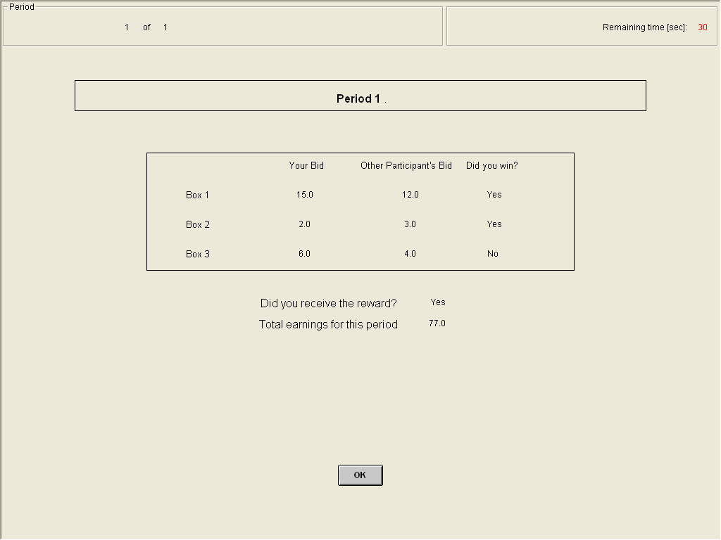

END OF THE EXPERIMENT
At the end of the experiment we will use the bingo cage to randomly select 2 out of 20 periods for actual payment. Depending on the outcome in a given period, you may receive either positive or negative earnings. You will sum the total earnings for these 2 periods and convert them to a U.S. dollar payment, as shown on the last page of your personal record sheet. Remember you have already received a $20.00 participation fee (equivalent to 500 francs). If your earnings from this part of the experiment are positive, we will add them to your participation fee. If your earnings are negative, we will subtract them from your participation fee.

Instructions for the Sequential Treatment
INSTRUCTIONS FOR PART 2
YOUR DECISION
The second part of the experiment consists of 20 decision-making periods. The 12 participants in today’s experiment will be randomly re-matched every period into 6 groups with 2 participants in each group. Therefore, the specific person who is the other participant in your group will change randomly after each period. The group assignment is anonymous, so you will not be told which of the participants in this room are assigned to your group
Each period consists of a maximum of three rounds. The period ends when one of the participants wins two of the three rounds ("best of three"). Thus, each period will consist of either two or three rounds. In each round, you and the other participant in your group will simultaneously make a bid (any number, including 0.1 decimal points). Your bid in each round cannot exceed 100 francs. The more you bid, the more likely you are to win a particular round. This will be explained in more detail later. The participant who is first to win two rounds receives the reward of 100 francs. Your earnings depend on whether you receive the reward or not and how many francs you spent on bidding. An example of your decision screen is shown below:
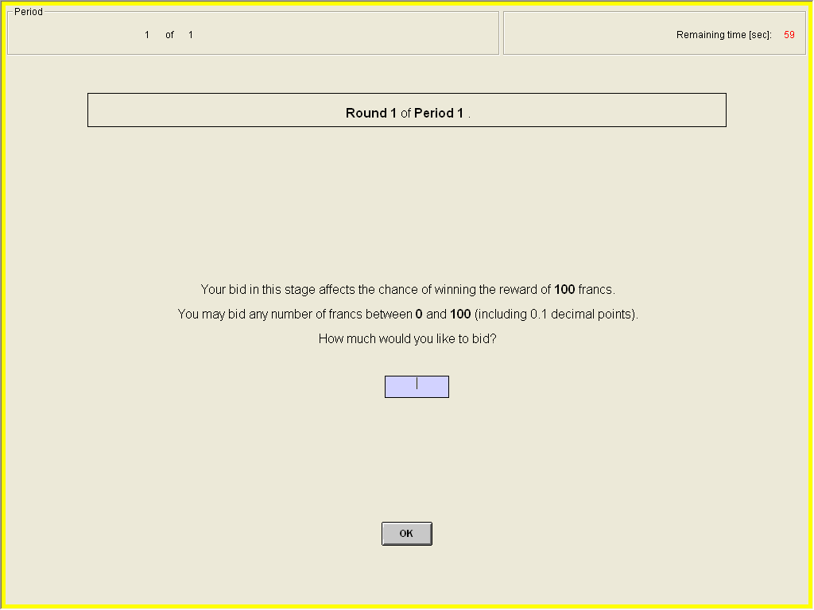

CHANCE OF WINNING A ROUND
The more you bid in a particular round, the more likely you are to win that round. The more the other participant bids in the same round, the less likely you are to win that round. Specifically, for each franc you bid you will receive one lottery ticket. At the end of each round the computer draws randomly one ticket among all the tickets purchased by you and the other participant in the group. The owner of the drawn ticket wins. Thus, your chance of winning a round is given by the number of francs you bid in that round divided by the number of francs you and the other participant bid in that round.
Your chance of winning a round | = | Your Bid in That Round
Your chance of winning a round | = | Your Bid in That Round + The Other Participant’s Bid in That Round
In case both participants bid zero, the computer determines randomly who wins that round.
Example: This is an example to illustrate how the computer makes a random draw of lottery tickets. Suppose, in a given round participant 1 bids 10 francs and participant 2 bids 20 francs. Therefore, the computer assigns 10 lottery tickets to participant 1 and 20 lottery tickets to participant 2. Then the computer randomly draws one lottery ticket out of 30 tickets (10 + 20 = 30). As you can see, participant 2 has higher chance, 0.67 = 20/30, while participant 1 has lower chance, 0.33 = 10/30, of winning the round.
In the sheet attached to these instructions, you will find a probability table. This table will give you some idea of how your bid and the other participant’s bid affect your chance of winning. For instance, suppose you bid 50 francs and the other participant bid 30 francs then your chance of winning the round is 0.63. Note that as stated before, your chance of winning increases as your bid increases relative to the other participant’s bid. So if you bid 70 francs and the other participant is still bidding 30 francs, your chance of winning increases to 0.70. To assist you with calculation of more precise numbers, we will provide you with the Excel calculator. You may use the calculator to find the chance of winning for any combination of your bid and the other participant’s bid. We will have a few practice rounds with the Excel calculator before the start of the experiment.

YOUR EARNINGS
Your earnings depend on whether you receive the reward or not and how many francs you spent on bidding in each round. The participant who is first to win two rounds receives the reward of 100 francs. Regardless of who receives the reward, both participants will have to pay their bids in each round. One of the four payment scenarios is possible:
(1) If the period lasted for only two rounds
(1a) Earnings of the participant who won both rounds are = 100 – (bid in round 1) – (bid in round 2)
(1b) Earnings of the participant who won neither rounds are = 0 – (bid in round 1) – (bid in round 2)
(2) If the period lasted for three rounds
(2a) Earnings of the participant who won two rounds are = 100 – (bid in round 1) – (bid in round 2) - (bid in round)
(2b) Earnings of the participant who won one round are = 0 – (bid in round 1) – (bid in round 2) - (bid in round 3)
END OF THE ROUND
After both participants make their round bids, the computer will make a random draw which will determine the winner of the round. Both participants will observe the outcome of the round – your bid, other participant’s bid and winner, as shown below. Then they make bids in another round. This continues until one of the participants in the group wins two rounds.
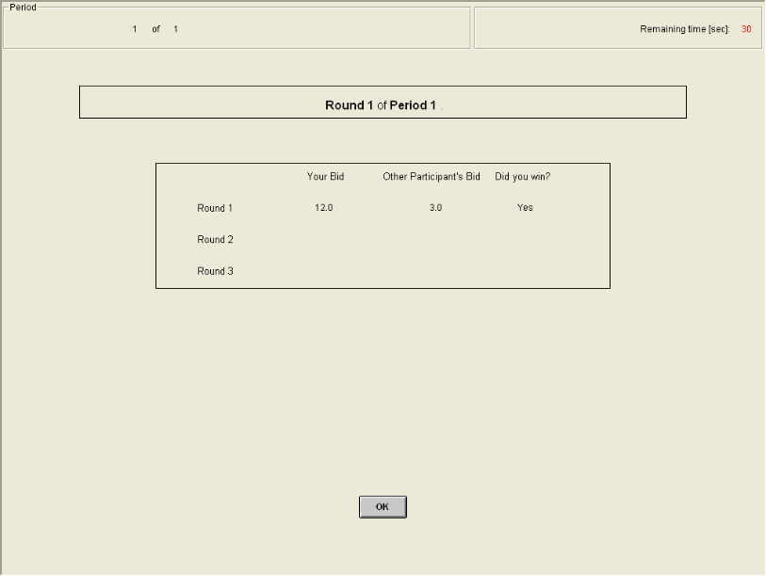

END OF THE PERIOD
The period ends when one of the participants in the group wins two rounds. At the end of the period, the computer will calculate your period earnings based on the number of rounds you won and how many francs you spent on bidding in each round. Your earnings from that period will be reported on the outcome screen as shown below. Once the outcome screen is displayed you should record your results for the period on your Personal Record Sheet under the appropriate heading. You will be randomly re-matched with a different participant at the start of the next period.
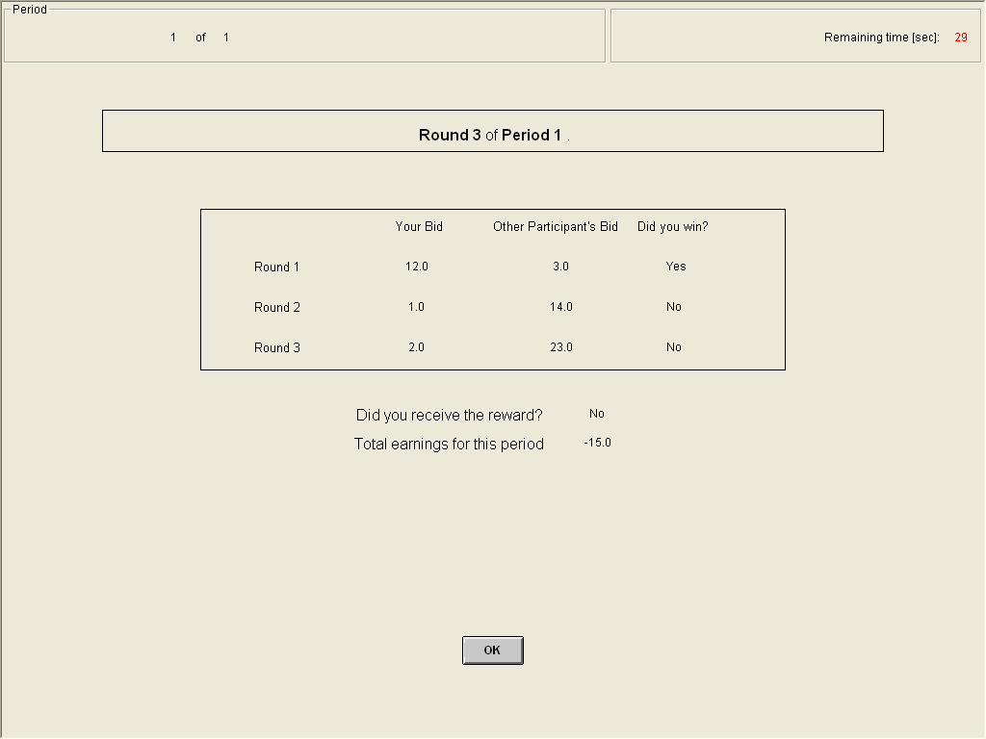

END OF THE EXPERIMENT
At the end of the experiment we will use the bingo cage to randomly select 2 out of 20 periods for actual payment. Depending on the outcome in a given period, you may receive either positive or negative earnings. You will sum the total earnings for these 2 periods and convert them to a U.S. dollar payment, as shown on the last page of your personal record sheet. Remember you have already received a $20.00 participation fee (equivalent to 500 francs). If your earnings from this part of the experiment are positive, we will add them to your participation fee. If your earnings are negative, we will subtract them from your participation fee.

Appendix B (For Online Publication): Additional Tables

Table B1: Mixed-Effects Panel Models (Theory)
Treatment | Sequential | Simultaneous
Dependent variable | Total expenditure | Total expenditure
Period | 32.33*** | 8.34***
[inverse period trend] | (3.09) | (2.32)
Constant | 50.21*** | 38.88***
 | (3.35) | (2.70)
Observations | 1,440 | 1,440
Hypothesis | Constant = 32.0 | Constant = 37.5
p-value | < 0.01 | = 0.60
* significant at 10%, ** significant at 5%, *** significant at 1%. The standard errors are in parentheses. All models include a mixed-effects error structure to account for session and individual subject effects.

Table B2: Mixed-Effects Panel Models (Finding 1)
Treatment | Sequential and  Simultaneous | Sequential and  Simultaneous
Period | 1-20 | 11-20
Dependent variable | Total expenditure | Total expenditure
Sequential | 15.64*** | 11.22**
[1 if sequential contest] | (4.25) | (4.54)
Period | 20.33*** | 19.97
[inverse period trend] | (1.94) | (31.52)
Constant | 36.72*** | 36.52***
 | (3.03) | (3.84)
Observations | 2,880 | 1,440
Hypothesis | Sequential = 0 | Sequential = 0
p-value | < 0.01 | = 0.02
* significant at 10%, ** significant at 5%, *** significant at 1%. The standard errors are in parentheses. All models include a mixed-effects error structure to account for session and individual subject effects.

Table B3: Mixed-Effects Panel Models (Finding 2)
Treatment | Sequential
Dependent variable | Expenditure in battle 2
Win | 5.16***
[1 if the winner of battle 1] | (0.70)
Period | 13.37***
[inverse period trend] | (1.52)
Constant | 18.39***
 | (1.66)
Observations | 2,880
Hypothesis | Win = 0
p-value | < 0.01
* significant at 10%, ** significant at 5%, *** significant at 1%. The standard errors are in parentheses. All models include a mixed-effects error structure to account for session and individual subject effects.

Table B4: Mixed-Effects Panel Models (Finding 3)
Treatment | Sequential | Sequential | Sequential | Sequential | Sequential
Dependent variable | Expenditure  in battle 1 | Expenditure  in battle 2  (battle 1 winner) | Expenditure  in battle 2  (battle 1 loser) | Expenditure  in battle 3 | End in battle 2
Period | 10.30*** | 10.33*** | 15.44*** | 7.32*** | -0.16***
[inverse period trend] | (1.09) | (1.98) | (1.98) | (2.40) | (0.06)
Constant | 20.29*** | 24.46*** | 18.22*** | 28.51*** | 0.67***
 | (1.18) | (1.70) | (2.12) | (1.99) | (0.03)
Observations | 1440 | 720 | 720 | 510
Hypothesis | Constant = 16.4 | Constant = 14.1 | Constant = 4.7 | Constant = 25.0 | Constant = 0.75
p-value | < 0.01 | < 0.01 | < 0.01 | = 0.07 | = 0.02
* significant at 10%, ** significant at 5%, *** significant at 1%. The standard errors are in parentheses. All models include a mixed-effects error structure to account for session and individual subject effects.

Table B5: Mixed-Effects Panel Models (Sunk Cost)
Treatment | Sequential | Sequential | Sequential | Sequential
Dependent variable | Expenditure  in battle 1 | Expenditure  in battle 2  (battle 1 winner) | Expenditure  in battle 2  (battle 1 loser) | Expenditure  in battle 3
Sunk | -4.66** | -3.85* | -6.01** | -8.02***
[1 if sunk treatment] | (1.92) | (2.32) | (2.38) | (2.65)
Period | 8.54*** | 5.94*** | 10.83*** | 5.33***
[inverse period trend] | (1.05) | (1.29) | (1.33) | (1.60)
Constant | 21.84*** | 25.24*** | 19.06*** | 28.92***
 | (1.31) | (1.58) | (1.62) | (1.82)
Observations | 2640 | 1320 | 1320 | 960
Hypothesis | Sunk = 0 | Sunk = 0 | Sunk = 0 | Sunk = 0
p-value | = 0.02 | = 0.09 | = 0.02 | < 0.01
* significant at 10%, ** significant at 5%, *** significant at 1%. The standard errors are in parentheses. All models include a mixed-effects error structure to account for session and individual subject effects.

