Appendix A.
Table A1. Sixty-Four Games in the Experiment
Type | Game  ID |  | Option A |  |  |  | Option B |  |  |  | Signs
Type | Game  ID |  | A1 | A2 | A3 |  | B1 | B2 | B3 |  | Selfishness | Efficiency | Maximin | Envy | FS-α | FS-β
TP | 1 |  | 6 | 14 | 7 |  | 6 | 14 | 19 |  | 0 | -1 | 0 | 1 | 1 | -1
TP | 2 |  | 7 | 18 | 9 |  | 7 | 18 | 20 |  | 0 | -1 | 0 | 1 | 1 | -1
TP | 3 |  | 11 | 16 | 14 |  | 13 | 16 | 18 |  | 0 | -1 | -1 | 1 | 1 | -1
TP | 4 |  | 10 | 14 | 13 |  | 12 | 14 | 18 |  | 0 | -1 | -1 | 1 | 1 | -1
TP | 5 |  | 5 | 11 | 20 |  | 15 | 11 | 16 |  | 0 | -1 | -1 | -1 | 0 | -1
TP | 6 |  | 6 | 13 | 19 |  | 16 | 13 | 16 |  | 0 | -1 | -1 | -1 | 0 | -1
TP | 7 |  | 9 | 14 | 19 |  | 12 | 14 | 18 |  | 0 | -1 | -1 | -1 | -1 | -1
TP | 8 |  | 5 | 9 | 18 |  | 10 | 9 | 16 |  | 0 | -1 | -1 | -1 | -1 | -1
TP | 9 |  | 6 | 12 | 19 |  | 16 | 12 | 19 |  | 0 | -1 | -1 | 0 | 1 | -1
TP | 10 |  | 5 | 14 | 19 |  | 15 | 14 | 19 |  | 0 | -1 | -1 | 0 | 1 | -1
TP | 11 |  | 11 | 13 | 18 |  | 15 | 13 | 17 |  | 0 | -1 | -1 | -1 | 1 | -1
TP | 12 |  | 8 | 9 | 19 |  | 15 | 9 | 17 |  | 0 | -1 | -1 | -1 | 1 | -1
TP | 13 |  | 5 | 16 | 20 |  | 19 | 16 | 19 |  | 0 | -1 | -1 | -1 | 1 | -1
TP | 14 |  | 5 | 15 | 18 |  | 17 | 15 | 17 |  | 0 | -1 | -1 | -1 | 1 | -1
TP | 15 |  | 13 | 16 | 17 |  | 17 | 16 | 17 |  | 0 | -1 | -1 | 0 | 1 | -1
TP | 16 |  | 9 | 14 | 16 |  | 15 | 14 | 16 |  | 0 | -1 | -1 | 0 | 1 | -1
TP | 17 |  | 7 | 10 | 20 |  | 8 | 10 | 8 |  | 0 | 1 | -1 | -1 | -1 | 1
TP | 18 |  | 8 | 11 | 20 |  | 9 | 11 | 9 |  | 0 | 1 | -1 | -1 | -1 | 1
TP | 19 |  | 7 | 9 | 8 |  | 7 | 9 | 20 |  | 0 | -1 | 0 | 1 | 1 | -1
TP | 20 |  | 14 | 15 | 14 |  | 14 | 15 | 19 |  | 0 | -1 | 0 | 1 | 1 | -1
TP | 21 |  | 6 | 20 | 19 |  | 8 | 20 | 8 |  | 0 | 1 | -1 | 0 | 0 | 1
TP | 22 |  | 8 | 19 | 18 |  | 9 | 19 | 9 |  | 0 | 1 | -1 | 0 | 0 | 1
TP | 23 |  | 12 | 18 | 19 |  | 13 | 18 | 14 |  | 0 | 1 | -1 | -1 | -1 | 1
TP | 24 |  | 7 | 15 | 19 |  | 10 | 15 | 11 |  | 0 | 1 | -1 | -1 | -1 | 1
TP | 25 |  | 5 | 11 | 20 |  | 11 | 11 | 11 |  | 0 | 1 | -1 | -1 | -1 | -1
TP | 26 |  | 6 | 11 | 19 |  | 7 | 11 | 14 |  | 0 | 1 | -1 | -1 | -1 | -1
TP | 27 |  | 11 | 15 | 19 |  | 12 | 15 | 17 |  | 0 | 1 | -1 | -1 | -1 | -1
TP | 28 |  | 6 | 13 | 20 |  | 12 | 13 | 12 |  | 0 | 1 | -1 | -1 | -1 | -1
TP | 29 |  | 11 | 16 | 15 |  | 20 | 16 | 20 |  | 0 | -1 | -1 | 1 | 1 | -1
TP | 30 |  | 8 | 16 | 18 |  | 20 | 16 | 20 |  | 0 | -1 | -1 | 1 | 1 | -1
TP | 31 |  | 12 | 15 | 17 |  | 16 | 15 | 18 |  | 0 | -1 | -1 | 1 | 1 | -1
TP | 32 |  | 8 | 9 | 15 |  | 12 | 9 | 19 |  | 0 | -1 | -1 | 1 | 1 | -1
SP | 33 |  | 7 | 11 | 9 |  | 7 | 13 | 19 |  | -1 | -1 | 0 | 1 | 1 | 0
SP | 34 |  | 10 | 15 | 11 |  | 10 | 17 | 19 |  | -1 | -1 | 0 | 1 | 1 | -1
SP | 35 |  | 9 | 16 | 14 |  | 11 | 17 | 19 |  | -1 | -1 | -1 | 1 | 1 | -1
SP | 36 |  | 8 | 12 | 11 |  | 10 | 13 | 19 |  | -1 | -1 | -1 | 1 | 1 | -1
SP | 37 |  | 3 | 14 | 20 |  | 15 | 12 | 15 |  | 1 | -1 | -1 | -1 | 0 | -1
SP | 38 |  | 5 | 14 | 20 |  | 16 | 13 | 16 |  | 1 | -1 | -1 | -1 | 0 | -1
SP | 39 |  | 7 | 13 | 18 |  | 13 | 12 | 15 |  | 1 | -1 | -1 | -1 | -1 | -1
SP | 40 |  | 2 | 13 | 20 |  | 13 | 11 | 15 |  | 1 | -1 | -1 | -1 | -1 | -1
SP | 41 |  | 7 | 8 | 16 |  | 17 | 10 | 18 |  | -1 | -1 | -1 | 0 | 1 | -1
SP | 42 |  | 6 | 8 | 12 |  | 11 | 10 | 14 |  | -1 | -1 | -1 | 0 | 1 | -1
SP | 43 |  | 12 | 13 | 19 |  | 17 | 14 | 18 |  | -1 | -1 | -1 | -1 | 1 | -1
SP | 44 |  | 6 | 7 | 15 |  | 15 | 8 | 15 |  | -1 | -1 | -1 | -1 | 1 | -1
SP | 45 |  | 5 | 17 | 20 |  | 17 | 15 | 17 |  | 1 | -1 | -1 | -1 | 1 | -1
SP | 46 |  | 5 | 17 | 20 |  | 18 | 16 | 18 |  | 1 | -1 | -1 | -1 | 1 | -1
SP | 47 |  | 6 | 13 | 16 |  | 13 | 12 | 15 |  | 1 | -1 | -1 | 0 | 1 | -1
SP | 48 |  | 5 | 16 | 20 |  | 15 | 14 | 18 |  | 1 | -1 | -1 | 0 | 1 | -1
SP | 49 |  | 12 | 19 | 20 |  | 13 | 16 | 14 |  | 1 | 1 | -1 | -1 | -1 | -1
SP | 50 |  | 8 | 17 | 18 |  | 9 | 13 | 11 |  | 1 | 1 | -1 | -1 | -1 | -1
SP | 51 |  | 10 | 12 | 11 |  | 10 | 16 | 17 |  | -1 | -1 | 0 | 1 | 1 | 1
SP | 52 |  | 8 | 9 | 8 |  | 8 | 10 | 19 |  | -1 | -1 | 0 | 1 | 1 | 0
SP | 53 |  | 5 | 18 | 17 |  | 6 | 20 | 6 |  | -1 | 1 | -1 | 0 | 0 | 1
SP | 54 |  | 7 | 19 | 18 |  | 8 | 20 | 8 |  | -1 | 1 | -1 | 0 | 0 | 1
SP | 55 |  | 10 | 17 | 18 |  | 11 | 18 | 12 |  | -1 | 1 | -1 | -1 | -1 | 1
SP | 56 |  | 8 | 18 | 19 |  | 9 | 20 | 10 |  | -1 | 1 | -1 | -1 | -1 | 1
SP | 57 |  | 3 | 14 | 20 |  | 12 | 12 | 12 |  | 1 | 1 | -1 | -1 | -1 | -1
SP | 58 |  | 5 | 12 | 17 |  | 10 | 11 | 12 |  | 1 | 1 | -1 | -1 | -1 | -1
SP | 59 |  | 6 | 13 | 20 |  | 11 | 12 | 14 |  | 1 | 1 | -1 | -1 | -1 | -1
SP | 60 |  | 5 | 12 | 20 |  | 11 | 11 | 13 |  | 1 | 1 | -1 | -1 | -1 | -1
SP | 61 |  | 10 | 13 | 10 |  | 16 | 12 | 16 |  | 1 | -1 | -1 | 1 | 1 | -1
SP | 62 |  | 7 | 14 | 13 |  | 18 | 13 | 20 |  | 1 | -1 | -1 | 1 | 1 | -1
SP | 63 |  | 5 | 16 | 19 |  | 19 | 14 | 20 |  | 1 | -1 | -1 | 1 | 1 | -1
SP | 64 |  | 5 | 16 | 20 |  | 18 | 14 | 19 |  | 1 | -1 | -1 | 1 | 1 | -1
Notes. In the columns of signs, 1 indicates that the motive favors Option A, -1 indicates the motives favors Option B, and 0 means the two options are indifferent for that motive. For example, in the fourth game, the dictator could choose between allocations of Option A (10, 15, 11) and Option B (10, 17, 19), where the parameters in each option refers to the payoffs for the first player, the dictator and the third player. The efficiency motive favors Option B, the envy motive favors Option A, and the two options are indifferent for the maximin motive.

Table A2. Logistic regression results of the finite mixture model I, II, and III
 | Model I |  |  | Model II |  |  | Model III
Num. subjects | 10 | 16 | 79 | 10 | 16 | 79 | 10 | 16 | 79
Norm type (NT) | NT I | NT II | NT III | NT I | NT II | NT III | NT I | NT II | NT III
SignEfficiency | 0.588* | -4.960 | 1.581*** | 0.542** | -3.018 | 2.585*** | 0.639*** | -5.185 | 2.627***
 | (0.312) | (47.541) | (0.302) | (0.270) | (11.103) | (0.319) | (0.235) | (55.662) | (0.220)
DiffEfficiency | 0.091 | 0.014 | 0.084
 | (0.112) | (0.107) | (0.246)
SignEnvy | -0.658** | -0.213 | 0.379 | -0.327 | 0.972*** | 0.435
 | (0.291) | (0.335) | (0.636) | (0.214) | (0.246) | (0.502)
DiffEnvy | 0.152 | 0.342** | -0.077 |  |  |  | -0.020 | 0.293*** | -0.039
 | (0.118) | (0.134) | (0.248) |  |  |  | (0.040) | (0.053) | (0.032)
SignMaximin | 0.193 | 0.396 | 0.829*** | 0.486*** | 1.330*** | 1.435*** | 0.273 | 0.454* | 0.442**
 | (0.291) | (0.301) | (0.314) | (0.186) | (0.173) | (0.211) | (0.231) | (0.252) | (0.218)
DiffMaximin | 0.065 | 0.287*** | 0.345*** |  |  |  | 0.032 | 0.266*** | 0.493***
 | (0.077) | (0.091) | (0.070) |  |  |  | (0.053) | (0.079) | (0.056)
SignFS-α | 0.113 | 0.114 | -0.897 | -0.013 | 0.070 | -0.353
 | (0.302) | (0.352) | 0.658 | (0.270) | (0.377) | (0.555)
SignFS-β | -0.044 | 5.547 | -0.178 | -0.057 | 3.532 | 0.940*** | -0.117 | 5.620 | 0.521***
 | (0.294) | (47.540) | (0.193) | (0.218) | (11.088) | (0.108) | (0.221) | (55.661) | (0.115)
DiffFS-β | -0.225 | -0.083 | 0.414
 | (0.246) | (0.239) | (0.513)
Constant | 0.195 | -0.258* | -0.093 | 0.205 | -0.136 | -0.034 | 0.163 | -0.269** | -0.032
 | (0.133) | (0.139) | (0.110) | (0.129) | (0.127) | (0.103) | (0.129) | (0.137) | (0.108)
Num. obs | 320 | 512 | 2528 | 320 | 512 | 2528 | 320 | 512 | 2528
AIC | 1793.316 |  |  | 1942.759 |  |  | 1798.439
BIC | 1989.146 |  |  | 2065.153 |  |  | 1920.833
Log Likelihood | -864.658 |  |  | -951.380 |  |  | -879.219
Notes. The dependent variable is Decision. ***p < 0.01, **p < 0.05, *p < 0.1.

Table A3. The identified social motives for each norm type in the four models
 | Norm type I | Norm type II | Norm type III
Model I | Efficiency | Envy, Maximin | Efficiency, Maximin
Model II | Efficiency, Maximin | Envy, Maximin | Efficiency, Maximin, FS-β
Model III | Efficiency | Envy, Maximin | Efficiency, Maximin, FS-β
Model IV | Efficiency, Maximin | Envy, Maximin | Efficiency, Maximin, FS-β
Notes. Apart from some minor differences, the four models identify almost identical norm types.

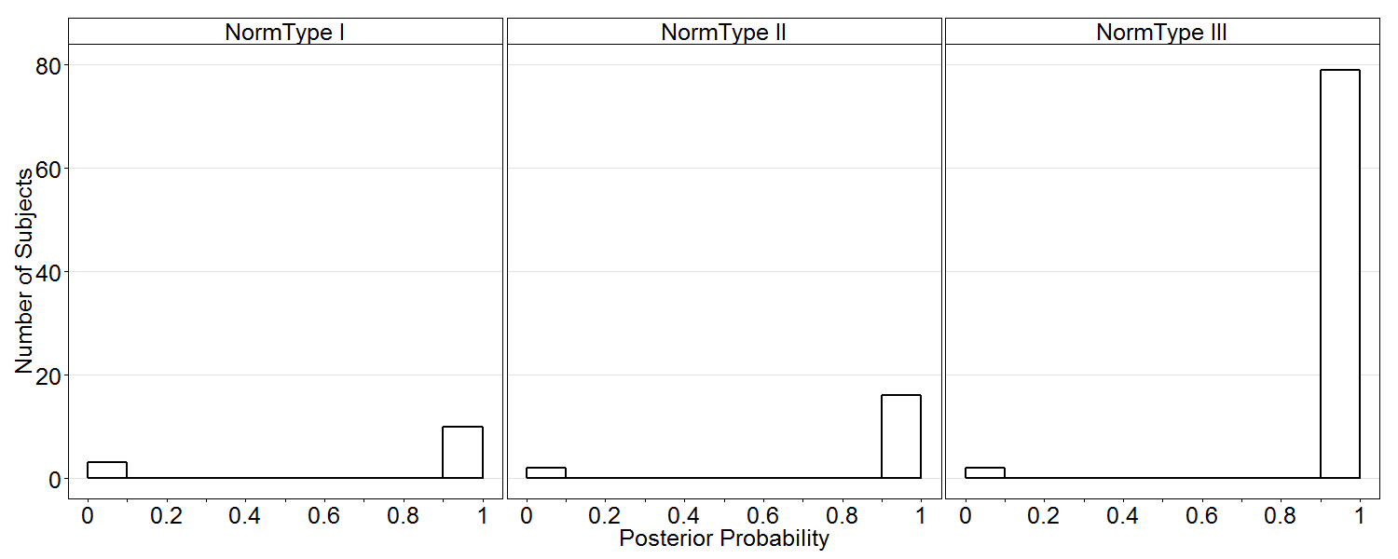
Model I
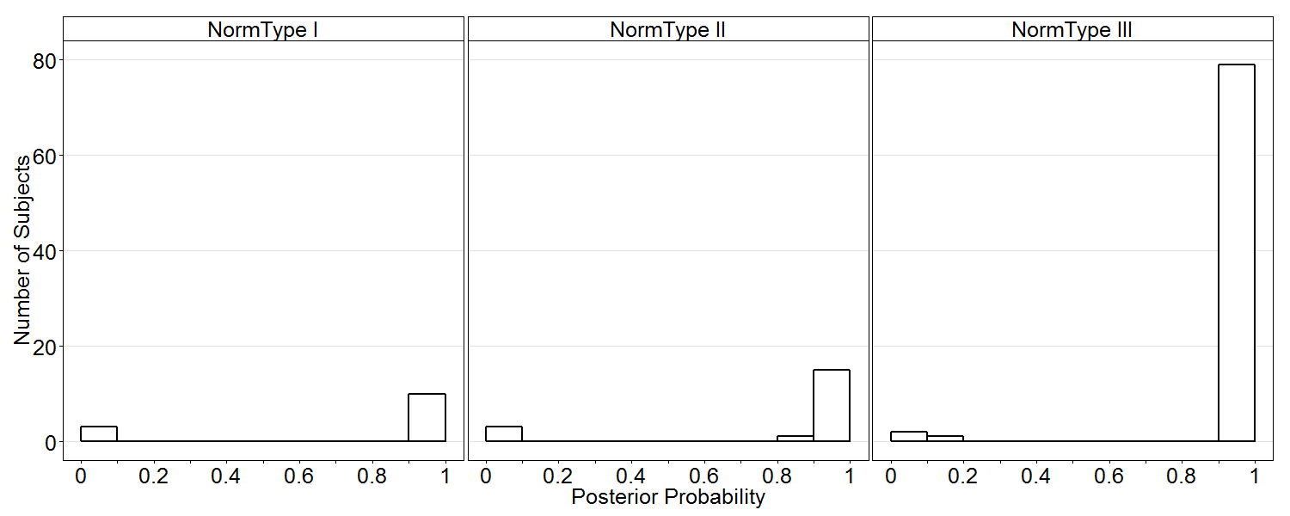
Model II
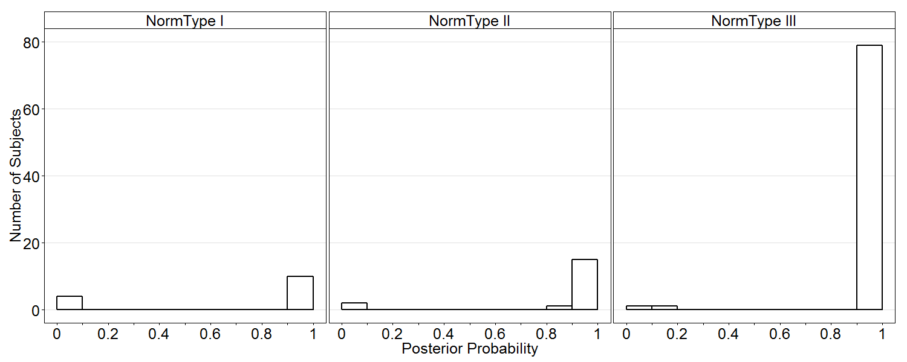
Model III
Fig. A1. The posterior probabilities that the number of subjects can be assigned to a norm type in Model I, Model II, and Model III separately. This figure displays the posterior probabilities which are larger than 0.01. A peak at probability 1 indicates that a norm type is well separated from the other types, and no signiﬁcant mass in the middle of the unit interval indicates clean classification.

Appendix B
B.1 The Evolution of Mean Response Time
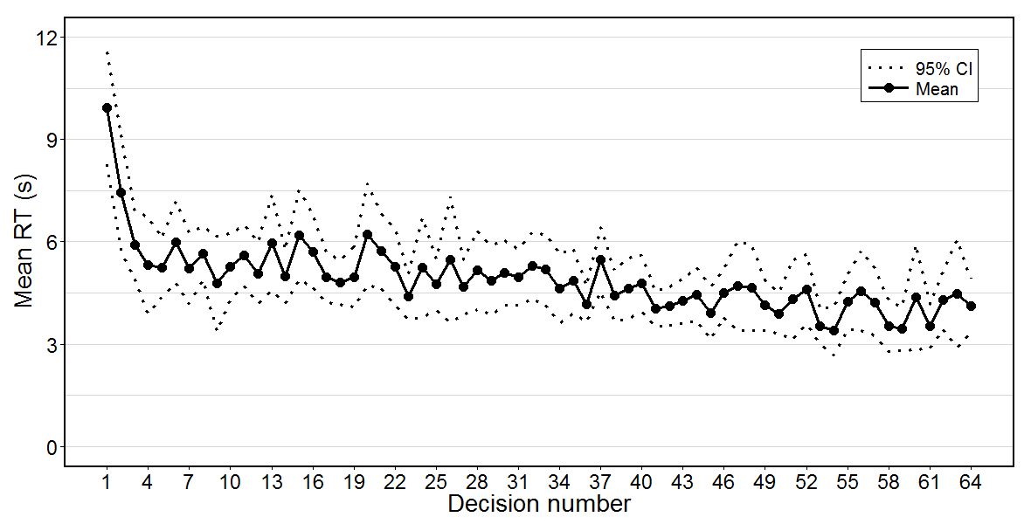
Fig. B.1. The evolution of the mean RT of all subjects
B.2 The Distribution of Response Times in the Second-Party decisions
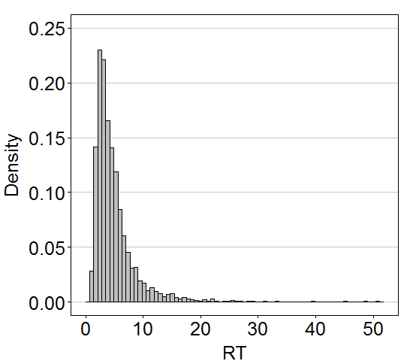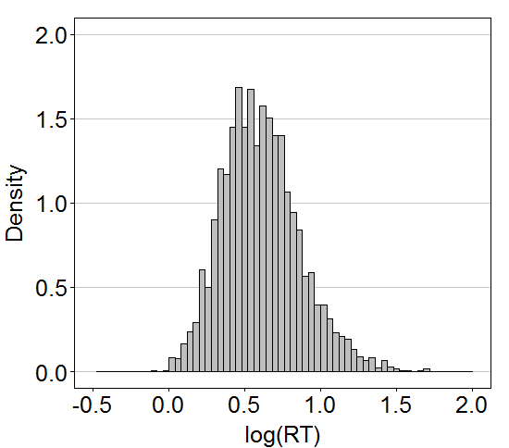
Fig. B.2. The distributions of RTs (left panel) and log(RT) (right panel) in the second-party decisions

Appendix C (Using Data of Odd Trials to Predict the RTs of Even Trials)
C.1 Regressions for Calculating the Utility Difference based on FMM
Table C1. Logit regression for the odd trials of the second-party decisions
 | Norm type I | Norm type II | Norm type III
Constant | -0.037 | 0.065 | 0.254***
 | (0.172) | (0.149) | (0.077)
Latent FMM based on TP decisions | 0.272 | 0.147*** | 0.397***
 | (0.278) | (0.041) | (0.033)
DiffSelfish | 0.205 | 0.509*** | 1.039***
 | (0.223) | (0.179) | (0.107)
SignSelfish | 1.191* | -0.462 | -0.502**
 | (0.672) | (0.393) | (0.204)
AIC | 155.546 | 324.700 | 1038.934
BIC | 167.720 | 338.754 | 1059.552
Log Likelihood | -73.773 | -158.350 | -515.467
Pseudo R² | 0.310 | 0.079 | 0.419
Num. obs. | 155 | 248 | 1280
Notes. The dependent variable is Decision. The robust standard errors are clustered on subjects and reported in parentheses. ***p < 0.01, **p < 0.05, *p < 0.1.

C.2 The RT and the Utility Difference
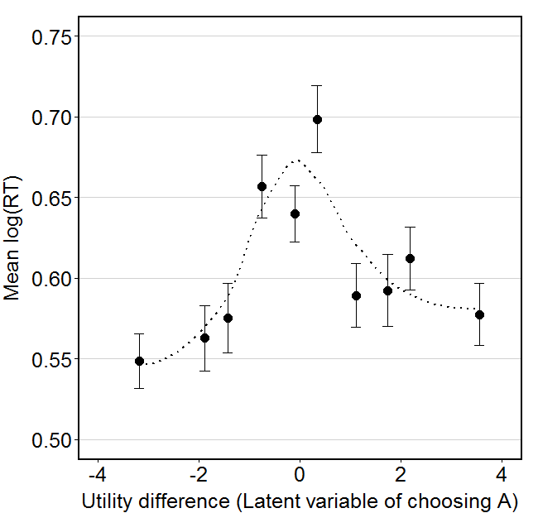
Fig. C1. The mean log(RT) and the utility difference in the even trials of the second-party decisions. All the data are divided into 10 bins of equal size according to the utility difference. Each dot represents one bin, and the solid line is the standard error of that bin. The dotted line is the smoothing line using method “loess”. The log(RT) is negatively related to the absolute value of the utility difference (Pearson correlation test, r = -0.146. p < 10⁻⁸). At the individual level, the log(RT) has negative relationship with the absolute value of the utility difference for 79 of 105 subjects, which is significantly different from the chance level of 50% (two-sided binomial test, p < 10⁻⁶).

C.3 The Mixed-Effects Regressions of Response Times on the Conflict and the Utility Difference
Table C2. Mixed-effects regressions of response times on conflicts and utility difference
 | All SP decisions |  | The even trials of SP decisions
 | All subjects | Norm type III | All subjects | Norm type III
 | (1) | (2) | (3) | (4)
Constant | 0.659*** | 0.504*** | 0.730*** | 0.608***
 | (0.017) | (0.038) | (0.022) | (0.065)
Conflict decision | 0.076*** |  | 0.035***
 | (0.008) |  | (0.012)
Decision number | -0.003*** | -0.004*** | -0.003*** | -0.003***
 | (0.000) | (0.000) | (0.000) | (0.000)
Number of conflicts |  | 0.076*** |  | 0.053***
 |  | (0.010) |  | (0.016)
abs(Utility difference) |  |  | -0.036*** | -0.022***
 |  |  | (0.005) | (0.007)
AIC | -976.750 | -427.512 | -424.249 | -112.853
BIC | -946.198 | -399.982 | -391.772 | -83.972
Log Likelihood | 493.375 | 218.756 | 218.124 | 62.427
Num. obs. | 3332 | 1822 | 1661 | 914
Num. groups | 105 | 79 | 105 | 79
Notes. The dependent variable is log(RT). ***p < 0.01, **p < 0.05, *p < 0.1. The coefficients of the absolute value of the utility difference are significantly negative in regressions (3) and (4).

C.4 The Strength of Selfishness
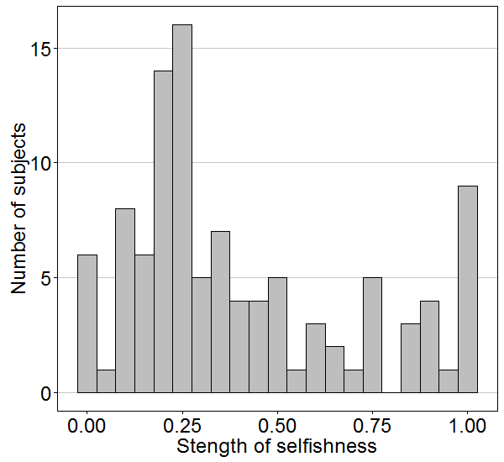
Fig. C2. The distribution of the strength of selfishness in the odd trials of conflict decisions

C.5 The Response Time of Selfish and Social Decisions
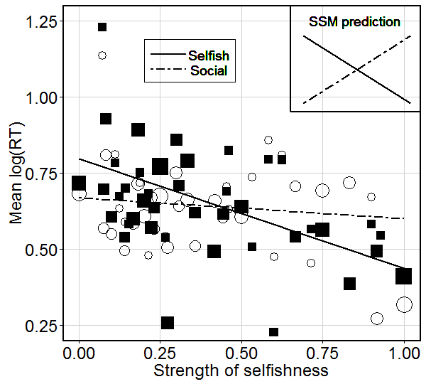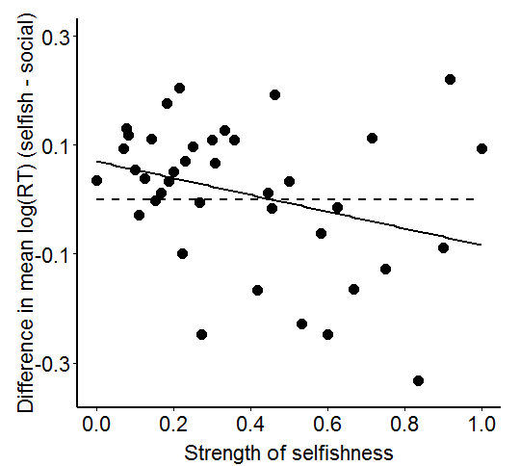
Fig. C3. The RT of selfish and social decisions in the even trials of conflict decisions. The left panel plots the relationship between the strength of selfishness and the RTs of selfish or social decisions. The circle represents social decisions, and the square represents selfish decisions. The size of the circle or the square indicates the number of subjects in that circle or square. The dashed line is the regression line for social decisions, and the solid line is the regression line for selfish decisions. The “SSM prediction” in the upper right corner represents the correlation between the strength of selfishness and the RTs of selfish decisions (solid line) / social decisions (dashed line) predicted by the standard sequential sampling models (SSM), which should be symmetric. Subjects who are more selfish are quicker in making selfish decisions (Pearson’s correlation test, r = -0.441, p < 10⁻¹⁵). But subjects who are more selfish are not significantly slower in making social decisions (Pearson’s correlation test, r = -0.048, p = 0.195). The right panel plots the relationship between the strength of selfishness and the RT difference of selfish and social decisions. The RT difference between selfish and social decisions is negatively related with the strength of selfishness (Pearson’s correlation test, r = -0.285, p < 0.007).

C.6 Regressions of Response Times on the Decision Type and the Strength of Selfishness
Table C3. Regressions of response times on decision type and the strength of selfishness (the even trials of conflict decisions)
 | Mixed-effects regression | OLS regressions
 | (1) | (2) | (3)
Constant | 0.737*** | 0.826*** | 0.790***
 | (0.022) | (0.036) | (0.037)
Selfish decision | 0.011 | 0.023 | 0.122***
 | (0.016) | (0.028) | (0.043)
Strength of selfishness |  | -0.287*** | -0.090
 |  | (0.048) | (0.079)
abs(Utility difference) | -0.028*** | -0.023*** | -0.029***
 | (0.006) | (0.008) | (0.008)
Conflict within norms | 0.049*** | 0.053*** | 0.042***
 | (0.013) | (0.014) | (0.015)
Male |  | 0.044 | 0.025
 |  | (0.035) | (0.034)
Decision number | -0.003*** | -0.003*** | -0.003***
 | (0.000) | (0.000) | (0.000)
Selfish decision × Male |  | -0.013 | 0.025
 |  | (0.038) | (0.036)
Selfish decision × Strength of selfishness |  |  | -0.297***
 |  |  | (0.085)
Num. obs. | 1239 | 1239 | 1239
Num. groups | 105 | 105 | 105
Notes. The dependent variable is log(RT). Selfish Decision is a dummy variable which indicate whether the decision is a selfish decision or social decision. Conflict within norms is a dummy which indicates whether there is a conflict within the social motives or not. Male is a dummy variable which indicates the gender. The robust standard errors for regressions (2) and (3) are clustered on subjects and reported in parentheses. Regression (1) and (2) show that the RTs of selfish decisions are not significantly different from the RTs of social decisions when controlling for the utility difference between choice options and the conflicts between norms. Regression (3) shows that the RTs of selfish decisions decrease with the strength of selfishness, but the strength of selfishness has no significant effect on the RTs of social decisions. Both regressions (2) and (3) show that there is no significant gender difference on the RTs of selfish and social decisions.
***p < 0.01, **p < 0.05, *p < 0.1.

Appendix D (Analysis of Eye-Tracking Data from Fiedler et al, 2013)
In the paper of Fiedler et al. (2013), subjects make decision for both Social Value Orientation (SVO) Ring Measure Task and SVO Slider Task. To do an out-of-sample analysis, we access subjects’ pro-sociality using their decisions for SVO Slider Task, and analyze their fixation behavior in the SVO Ring Measure Task.
Using decisions for SVO Slider Task, all subjects can be classified into three types: selfish, pro-social and competitive types. There is only one subject who is competitive type. In the following, we focus our analysis on selfish and pro-social subjects. Fig. D1 displays the proportion of the fixation on own payoffs and how it changes with time. We divide each decision (process) into five bins with equal time period, and then calculate the proportion of the fixation time on own payoffs in each time bin. It shows that the selfish subjects put more attention (80.117%) on their own payoffs at the beginning of the decision process compare to pro-social subjects (60.078%). The proportion of the fixation on own payoffs decreases with time for both selfish and pro-social subjects, and becomes stable at the end of the decision process.
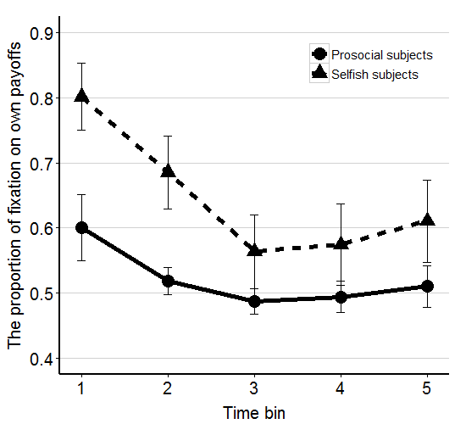
Fig. D1. The proportion of the fixation on own payoffs. We divided all decisions into 5 time bins equally, and we calculate the proportion of the fixation time on own payoffs in each time bin. The dot represents the proportion of pro-social subjects, and the triangle represents the proportion of selfish subjects. The vertical social line on each dot or triangle is the standard error of that proportion.
To look at each fixation individually, we also plot the proportion of subjects who fixate on their own payoffs in each fixation, as shown in Fig. D2. It shows that 78.571% of selfish subjects fixate on their own payoffs in the first fixation, while 58.523% of pro-social subjects fixate on their own payoffs in the first fixation. The proportion of subjects who fixate on own payoffs becomes stable and around 50% from the fifth fixation for both selfish and pro-social types.

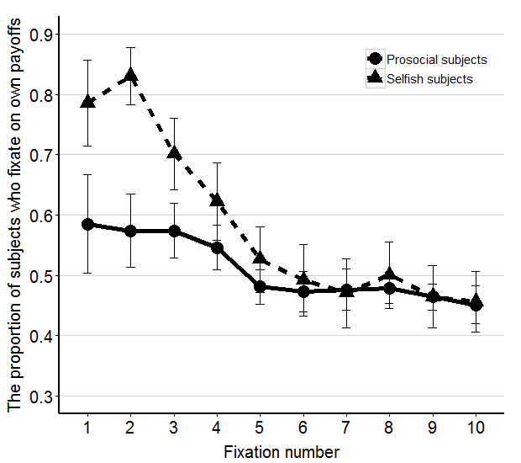
Fig. D2. The proportion of subjects who fixate on own payoffs in each fixation. The dot represents the proportion of selfish subjects, and the triangle represents the proportion of pro-social subjects. The vertical solid line on each dot or triangle is the standard error of that proportion.

Appendix E.

General Instructions

Today you are participating in an economic experiment. If you read the following instructions carefully, you can – depending on your decisions – earn money in addition to the show-up fee of 3 Euros. Therefore, it is important that you read these instructions carefully.
During the whole experiment, it is not allowed to communicate with other participants. We, therefore, ask you to turn off the cell phone and not to speak with each other. If you do not understand something, please consult the instructions again. If you still have questions, please raise your hand. We will come to you and answer your questions individually.
In this experiment, you will need to decide for different situations. At the end, one of the situations will be randomly drawn and paid out. You will receive your payment in accordance with the decisions in this relevant situation.
In the instructions we do not speak of Euro, but points. The points you earn during the experiment will be converted into Euros in the following rate:
1 Point = 50 Cents
That is, you get 50 cents per point in the relevant situation. Of course, you will also receive a show up fee of 3 Euros.
On the following pages we will explain the exact course of the experiment. First, we will familiarize you with the decision situation. When you finish reading the instructions, on your screen you will find control questions which will help you to understand the situations. The experiment only begins when all participants are completely familiar with the course of the experiment.

The Experiment

All the participants in the laboratory are randomly divided into groups of three. Each group consists of Participant I, Participant II and Participant III. In each situation, two point distributions which relate to the three members of the group are available. Participant II can decide which of the two distributions is selected. Since only Participant II makes decisions, in the following we explain the experiment from the perspective of Participant II (Important: Each participant can be Participant II). In the experiment, each participant makes decisions as Participant II. Which person is Participant I, II or III in the group will be randomly drawn at the end of the experiment. In addition, one of the decisions of Participant II will be randomly drawn to be implemented at the end of the experiment.
Display on the Screen
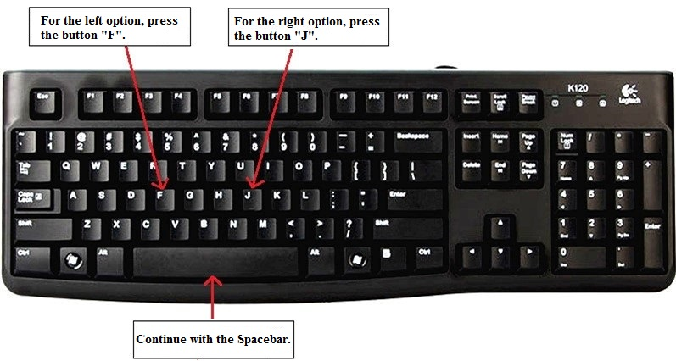
Fig. E1. Keys, with which you make decisions
This experiment consists of a series of 64 decision situations in which you can choose one of two point distributions as Participant II. The following screen shot shows an example (Fig. E2). In the left option, Participant I receives 9 points, you, as Participant II, receive 12 points and Participant III receives 16 points. The height of bars on the left corresponds to the corresponding amounts. “Your” bar is always shown in the middle and in white color. In the right option, Participant I receives 10 points, you, as Participant II, receive 17 points and Participant III receives 19 points. The height of the bars on the right also corresponds to these amounts. You make your decisions with the help of the keyboard. For the left option, you press the key “F” and for the right option you press the key “J” (see Fig. E1). Which key to press is also displayed at the bottom of the screen. Therefore, in this example, if you press “F”, you receive 12 points, Participant I receives 9 points and Participant III received 16 points. If you press “J”, you receives 17 points, Participant I receives 10 points and Participant III receives 19 points. After each decision you have to press the ‘Spacebar’ to continue.
Fig. E2. Screen layout
Payment
At the end of the experiment, it will be randomly drawn which one of the 64 situations will be paid and who is Participant I, II and III. The draw will be made with a die by the participant at the 13th place. Then it takes about one minute to display all your decision situations and your income in the experiment.
If you have understood the instructions, please answer the control questions on the screen.

