Online Appendix of

“Cortisol Meets GARP: The Effect of Stress on Economic Rationality”

Appendix A: Power analysis
The sample size was calculated at a two-sided alpha level of 0.05 and a power (1-β) = 0.80 using software G*Power 3.1. The analysis requires specification of the response distribution. As we had no prior prediction about the response distribution, we selected the most conservative “minimum asymptotic relative efficiency (min ARE)” option which results in a theoretical minimum of the power regardless of the response distribution.

Table A: Sample size estimation under different effect sizes

 | d = 0.5 | d = 0.6 | d = 0.7 | d = 0.8
Sample size 1 | 74 | 52 | 39 | 30
Sample size 2 | 74 | 52 | 39 | 30
Total sample size | 148 | 104 | 78 | 60

Appendix B: Alternatives measures of rationality
In this section we analyze consistency with GARP using two alternatives indexes to the CCEI: the Money Pump Index (MPI) and Varian’s Index (VI). Results are summarized in Table B.1: we find no treatment difference in economic rationality, regardless of which index is employed to analyze the choice data.

The Money Pump Index
Echenique et al. (2011) propose to measure the severity of GARP violations by computing the amount of money that could be extracted from a consumer as a “money pump”. Figure B.1 provides an example in which lines A, B, C, and D represents the portfolios of two goods that consumers can buy at prices pª and p^{b} respectively. Suppose a consumer chooses to buy a bundle xª on line B at prices pª and a bundle x^{b} on line D at prices p^{b}. An “arbitrager” can make profit by following the opposite purchasing strategy, that is buying a bundle xª on line C at prices p^{b} and a bundle x^{b} on line A at prices pª, and reselling xª to the consumer at prices pª and x^{b} at prices p^{b}. The total profit the arbitrager would make equals to the money pump index, MPI = pª (xª – x^{b}) + p^{b} (xª – x^{b}). In other words, the MPI is the budget wasted by adopting the inferior purchasing strategy. The individual can use less budget to buy the same goods xª and x^{b} by choosing to buy xª at prices p^{b} and bundle x^{b} at prices p^{a .} The saved budget is (pª xª + p^{b} x^{b}) – (pª x^{b} + p^{b} xª) = MPI = (D+B) – (C+A).
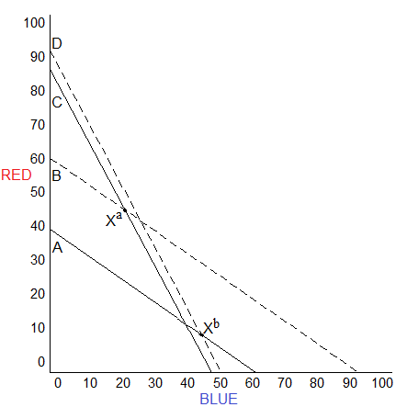
Figure B.1 An illustration of the Money Pump Index

Calculating the MPI index is computationally very demanding, so we calculate an approximation of it using Warshall’s algorithm (Varian,1982) .

Varian’s Index
Varian’s (1990, 1991) Index is a lower bound of the CCEI. The index indicates the largest perturbation of budget lines required to remove all violations of GARP, whereas the CCEI represents the minimum adjustment.

Table B1: Treatment comparisons of two indexes of economic rationality

 | Stress  Mean  (SD) | No Stress  Mean  (SD) | Wilcoxon  Rank-Sum test p-value | Kolmogorov  Smirnov test  p-value
MPI | 5.821  (8.855) | 6.705  (9.773) | 0.66 | 0.88
VI | 0.873  (0.159) | 0.832  (0.195) | 0.32 | 0.75

Appendix C: Gender

In this section we test whether our results still hold when controlling for gender. In order to obtain more power, we pool the samples from both experiments and run two OLS regressions specifications where the dependent variables are the six different measures of consistency with GARP. The odd columns of Table C.1 report coefficients of regressing each of the consistency measures on a treatment dummy, gender and a dummy for the second experiment. The even columns of Table C.1 report coefficients of regressions adding an interaction term between treatment and gender, to test for gender-specific treatment effects. We find that the coefficient of Female is statistically significant in most specifications, and its direction always indicates that men are more consistent with GARP than women (a similar result is also reported by Choi et al., 2014). We do not observe gender-specific treatment effects though.

Table C.1: Analysis of Gender Effects
 | (1) | (2) | (3) | (4) | (5) | (6) | (7) | (8) | (9) | (10) | (11) | (12)
VARIABLES | Violations | Violations | HMI | HMI | CCEI | CCEI | UCCEI | UCCEI | VI | VI | MPI | MPI
Stress | -10.09 | -11.91 | 0.10 | 0.15 | 0.01 | 0.02 | 0.02 | 0.03 | 0.03 | 0.04 | -0.67 | 0.13
 | (26.63) | (31.76) | (0.43) | (0.52) | (0.01) | (0.02) | (0.02) | (0.03) | (0.02) | (0.03) | (1.25) | (1.36)
Female | 63.49*** | 61.82* | -1.59*** | -1.55*** | -0.03*** | -0.02 | -0.04** | -0.04 | -0.09*** | -0.08** | 4.50*** | 5.23***
 | (24.14) | (34.53) | (0.40) | (0.58) | (0.01) | (0.02) | (0.02) | (0.03) | (0.02) | (0.04) | (1.12) | (1.67)
Female×Stress |  | 3.04 |  | -0.07 |  | -0.01 |  | -0.00 |  | -0.02 |  | -1.33
 |  | (50.10) |  | (0.82) |  | (0.02) |  | (0.04) |  | (0.05) |  | (2.31)
2nd Experiment | -8.51 | -8.55 | 0.63 | 0.63 | 0.01 | 0.01 | 0.02 | 0.02 | 0.03 | 0.03 | -1.42 | -1.41
 | (25.64) | (25.58) | (0.43) | (0.43) | (0.01) | (0.01) | (0.02) | (0.02) | (0.02) | (0.02) | (1.22) | (1.22)
Constant | 50.97* | 52.04** | 47.80*** | 47.78*** | 0.96*** | 0.95*** | 0.90*** | 0.90*** | 0.89*** | 0.88*** | 4.15*** | 3.69***
 | (27.71) | (25.60) | (0.44) | (0.44) | (0.01) | (0.02) | (0.02) | (0.03) | (0.03) | (0.03) | (1.23) | (1.14)
Observations | 204 | 204 | 204 | 204 | 204 | 204 | 204 | 204 | 204 | 204 | 204 | 204
R-squared | 0.03 | 0.03 | 0.07 | 0.07 | 0.05 | 0.05 | 0.03 | 0.03 | 0.07 | 0.08 | 0.06 | 0.06
Note: Robust standard errors in parentheses. *** p<0.01, ** p<0.05, * p<0.1

Appendix D: Experiment instructions

Screen 1
Thanks for agreeing to participate in this experiment!
Please type in your cubicle number: [ ]

Screen 2
Introduction
Please read the instructions carefully. You will receive 5 Euros for showing up on time today, and you can earn an additional sum of money which depends on your decisions and on chance. Your total earnings will be paid to you via bank transfer, at the end of the experiment.
From now on you are not allowed to communicate with the other participants. Anyone who violates this rule will lose his or her right to participate in this experiment. If you have any questions, please raise your hand, and the experimenter will come to you. The experiment will take about one and half hour.

Screen 3
During the whole experiment, you will be videotaped. You are advised not to lean forward towards the screen or lean on your elbows.
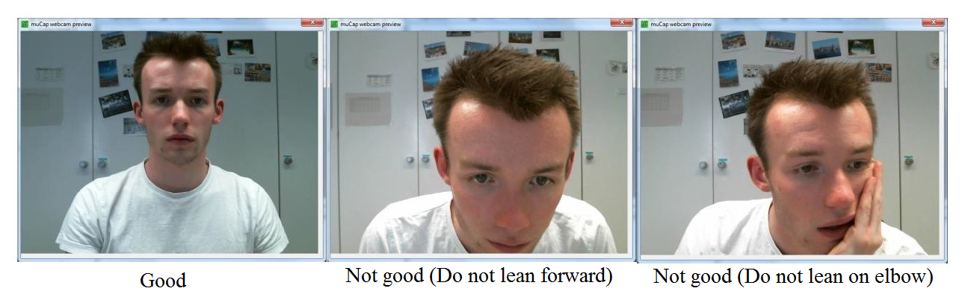

Screen 4
Please describe your feelings and emotions. Indicate to what extent you feel stressed, pain, unhappy and attentive respectively right now, that is, at the present moment.

The value 0 means “not at all” and the value 10 means “very much”.

Stressed: [ ]
Pain: [ ]
Unhappy: [ ]
Attentive: [ ]

Screen 5
We now ask you to provide the first saliva sample.
1. Please pick the tube beside you (labeled No.1).
2. Remove the top cap of the tube.
3. Pass saliva by spitting or drooling directly into the tube for 180 seconds.
4. In order to know when the 180 seconds have passed, please refer to the clock (counting down, in seconds) on your screen.
5. Replace the cap. Make sure cap is on tightly.
6. Press the OK button after one of our experimenters has collected the tube.
If you have any questions, please raise your hand.

Screen 6
The questions that follow ask you about your feelings and thoughts during the last month. In each case, please indicate with a check how often you felt or thought a certain way.
1. In the last month, how often have you been upset because of something that happened unexpectedly?
___ 0 = Never ____ 1 = Rarely ___ 2 = Sometimes ____ 3 = Fairly often ___ 4 = Very often
2. In the last month, how often have you felt that you were unable to control the important things in your life?
___ 0 = Never ____ 1 = Rarely ___ 2 = Sometimes ____ 3 = Fairly often ___ 4 = Very often
3. In the last month, how often have you felt nervous and "stressed"?
___ 0 = Never ____ 1 = Rarely ___ 2 = Sometimes ____ 3 = Fairly often ___ 4 = Very often
4. In the last month, how often have you felt confident about your ability to handle your personal problems?
___ 0 = Never ____ 1 = Rarely ___ 2 = Sometimes ____ 3 = Fairly often ___ 4 = Very often
5. In the last month, how often have you felt that things were going your way?
___ 0 = Never ____ 1 = Rarely ___ 2 = Sometimes ____ 3 = Fairly often ___ 4 = Very often
6. In the last month, how often have you found that you could not cope with all the things that you had to do?
___ 0 = Never ____ 1 = Rarely ___ 2 = Sometimes ____ 3 = Fairly often ___ 4 = Very often
7. In the last month, how often have you been able to control irritations in your life?
___ 0 = Never ____ 1 = Rarely ___ 2 = Sometimes ____ 3 = Fairly often ___ 4 = Very often
8. In the last month, how often have you felt that you were on top of things?
___ 0 = Never ____ 1 = Rarely ___ 2 = Sometimes ____ 3 = Fairly often ___ 4 = Very often
9. In the last month, how often have you been angered because of things that were outside of your control?
___ 0 = Never ____ 1 = Rarely ___ 2 = Sometimes ____ 3 = Fairly often ___ 4 = Very often
10. In the last month, how often have you felt difficulties were piling up so high that you could not overcome them?
___ 0 = Never ____ 1 = Rarely ___ 2 = Sometimes ____ 3 = Fairly often ___ 4 = Very often

Screen 7
There is a bucket of water on your right hand side. You will put your right hand into the water. Please make sure that your hand including the wrists completely immersed in the water. Keep your hand in the water for 90 seconds. Some people experience some discomfort from having the hand in the water. If this happens to you, please remember that it is perfectly safe to have the hand in the water for 90 seconds (and for longer than that as well). Please try as hard as you can to keep the hand in the water for 90 seconds.
In order to know when the 90 seconds have passed, please refer to the clock (counting down, in seconds) on your screen. After the 90 seconds have passed, please remove your hand and dry it off on the tissue on your desk. Thereafter press the OK button.
When you are ready to do this task, please press the START button.

Screen 8
Please stand up and look straight. Please do not communicate with other participants.
After the 90 seconds have passed, please remove your hand and dry it off on the tissue on your desk. Thereafter press the OK button.

Screen 9
We now ask you to provide the second saliva sample. The instructions are the same as before.
1. Please pick the tube beside you (labeled No.2).
2. Remove the top cap of the tube.
3. Pass saliva by spitting or drooling directly into the tube for 180 seconds.
4. In order to know when the 180 seconds have passed, please refer to the clock (counting down, in seconds) on your screen.
5. Replace the cap. Make sure cap is on tightly.
6. Press the OK button after one of our experimenters has collected the tube.
If you have any questions, please raise your hand.

Screen 10
Please describe your feelings and emotions. Indicate to what extent you have felt stressed, pain, unhappy and attentive respectively while you held your hand in the water.
The value 0 means “not at all” and the value 10 means “very much”.

Stressed: [ ]
Pain: [ ]
Unhappy: [ ]
Attentive: [ ]

Screen 11
How do you see yourself? Are you generally a person who is fully prepared to take risks or do you try to avoid taking risks?
The value 0 means “not at all willing to take risks” and the value 10 means “very willing to take risks”.
0 1 2 3 4 5 6 7 8 9 10
I set higher goals than most people
1 = Disagree strongly
2 = Disagree moderately
3 = Disagree a little
4 = Neither agree nor disagree
5 = Agree a little
6 = Agree moderately
7 = Agree strongly
Other people say that I am perfectionistic
1 = Disagree strongly
2 = Disagree moderately
3 = Disagree a little
4 = Neither agree nor disagree
5 = Agree a little
6 = Agree moderately
7 = Agree strongly

Please fill in the questionnaire below:
Gender
Age
Height (in centimeters, e.g., 163)
Weight (in kilograms, e.g., 64)
Your program of study
Do you smoke cigarettes?

Screen 12
(The two questions are only shown for female participants.)
Have you taken oral contraceptives (birth control pills) during the last week? Yes No
Are you on period (‎menstruation) now? Yes No
If no, how many days has it been since the beginning of your last period (‎menstruation)?

What was the highest degree that your father achieved? (or other caretaker)
1=elementary school
2=professional school (Dutch LTS/LEA)
3=high school
4=college/university
5=master
6=PhD

What was the highest degree that your mother achieved? (or other caretaker)
1=elementary school
2=professional school (Dutch LTS/LEA)
3=high school
4=college/university
5=master
6=PhD

On a scale from 0 to 10, how much financial difficulties do you have (over the past month)
0 means “not at all”; 10 means “the worst possible, close to being bankrupt”.
0 1 2 3 4 5 6 7 8 9 10

On a scale from 0 to 10, how much academic difficulties do you have (over the past month)
0 means “not at all”; 10 means “the worst possible, close to being asked to leave the university”.
0 1 2 3 4 5 6 7 8 9 10

Screen 13
This scale consists of a number of words that describe different feelings and emotions. Read each item and then list the number from the scale below next to each word. Indicate to what extent you feel this way right now, that is, at the present moment.
Scale:
1 = Very Slightly
2 = A little
3 = Moderately
4 = Quite a bit
5 = Extremely
- Interested: 1 2 3 4 5
- Distressed: 1 2 3 4 5
- Excited: 1 2 3 4 5
- Upset: 1 2 3 4 5
- Strong: 1 2 3 4 5
- Guilty: 1 2 3 4 5
- Scared: 1 2 3 4 5
- Hostile: 1 2 3 4 5
- Enthusiastic: 1 2 3 4 5
- Proud: 1 2 3 4 5
- Irritable: 1 2 3 4 5
- Alert: 1 2 3 4 5
- Ashamed: 1 2 3 4 5
- Inspired: 1 2 3 4 5
- Nervous: 1 2 3 4 5
- Determined: 1 2 3 4 5
- Attentive: 1 2 3 4 5
- Jittery: 1 2 3 4 5
- Active: 1 2 3 4 5
- Afraid: 1 2 3 4 5

Screen 14
Below are a number of personality traits that may or may not apply to you. Please write a number next to each statement to indicate the extent to which you agree or disagree with that statement. You should rate the extent to which the pair of traits applies to you, even if one characteristic applies more strongly than the other.
Scale:
1 = Disagree strongly
2 = Disagree moderately
3 = Disagree a little
4 = Neither agree nor disagree
5 = Agree a little
6 = Agree moderately
7 = Agree strongly
I see myself as:
- Extraverted, enthusiastic.
- Critical, quarrelsome.
- Dependable, self-disciplined.
- Anxious, easily upset.
- Open to new experiences, complex.
- Reserved, quiet.
- Sympathetic, warm.
- Disorganized, careless.
- Calm, emotionally stable.
- Conventional, uncreative.

Screen 15
Please describe your feelings and emotions. Indicate to what extent you feel stressed, pain, unhappy and attentive respectively right now, that is, at the present moment.
The value 0 means “not at all” and the value 10 means “very much”.

Stressed: [ ]
Pain: [ ]
Unhappy: [ ]
Attentive: [ ]

Screen 16
We now ask you to provide the third saliva sample. The instructions are the same as before.
1. Please pick the tube beside you (labeled No.3).
2. Remove the top cap of the tube.
3. Pass saliva by spitting or drooling directly into the tube for 180 seconds.
4. In order to know when the 180 seconds have passed, please refer to the clock (counting down, in seconds) on your screen.
5. Replace the cap. Make sure cap is on tightly.
6. Press the OK button after one of our experimenters has collected the tube.
If you have any questions, please raise your hand.

Screen 17
Economic choices
In this part of the experiment you can earn real money, the amount you earn depends partly on your decisions and partly on chance. Please read the instructions carefully. During the experiment, we will refer to points instead of Euros. Your earnings will be calculated in points and later be converted into Euro at the exchange rate:
8 points = 1 Euro.

Screen 18
This experiment consists of 50 rounds. Every round is independent, but your task will be the same in every round. In each round, your task is to distribute points between two accounts, called BLUE and RED. At the start of each round, you will receive a set of possible distributions of points, out of which you are allowed to choose one.
After you have made your decision, the computer will randomly select one of the accounts; both of the accounts BLUE and RED have the same probability of being selected.
Your earnings in a particular round are the points that you allocated to the account that has been selected by the computer, the points that you distributed to the other account do not count.

Screen 19
To make your decision in each of the rounds, you will use a chart. Below you can see what this looks like.
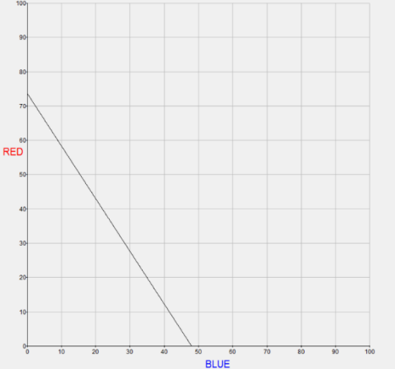
The BLUE account corresponds to the horizontal axis, and the RED account corresponds to the vertical axis. Every point on the chart resembles a distribution between the BLUE and RED. At the start of each decision round, you will see a line which shows the possible distributions of points between the BLUE and RED account. In each decision round you can only choose a point, which lies on the line.
In each round the computer selects one line which crosses both axes between 10 and 100 points, and at least one of the axes at 50 or more points. The lines that will be selected for you in the other decision rounds are independent of each other.

Screen 20
In every round the computer will provide you with a new line. With every choice, you are allowed to choose any allocation of points between the BLUE and RED account that is located on the line. You are allowed to choose one point.

An example of one of those lines is shown below. A possible choice is A, where you allocate 28.8 points to the BLUE account and 13.7 points to the RED account. Another possible choice is B, where you allocate 11.9 points to the BLUE account and 44.2 points to the RED account.

There are many more points on this line that you can choose, other than point A and B alone. You are allowed to choose any point on the line. The only condition is that you can only choose one point in each round.
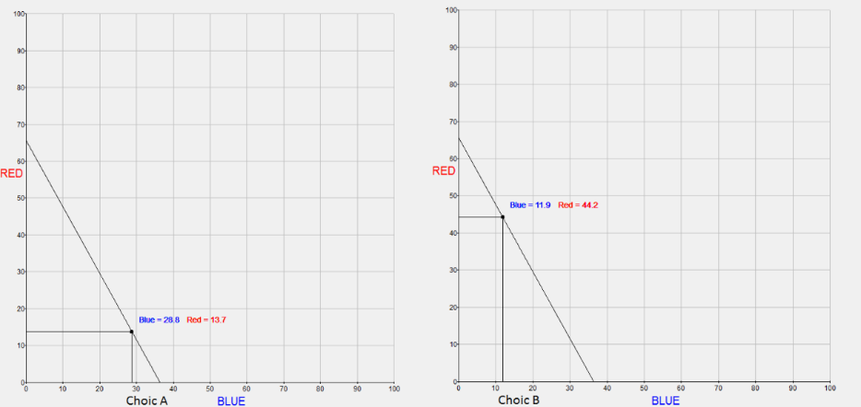

Screen 21
Now you can practice two rounds. Click the START button to begin. Then, you will see a line with the possible distributions in this practice round. To choose a distribution, use the mouse to drag the cursor on the screen along the line towards the distribution of your choice. (To do this, first move the cursor in the neighborhood of the point on the line.) You can see that you can only choose distributions that are located on the line.

When you know which decision you would like to make, click on the left button on your mouse, to select your choice. To confirm your decision, click the Yes button. You will then be automatically transferred to the next round. To choose another point on this line, click the No button. After you have practiced two rounds, click continue to proceed to the next information page. This is a practice screen. The decision you make, will not be recorded.

Screen 22
After confirming your decision, the computer will randomly select one account; each of the two accounts, BLUE and RED, have the same probability of being selected.

If the BLUE account is selected, then your earnings in this round equal the amount of points on the BLUE account. The points on the other account are not used. If the RED account is selected, then your earnings in this round equal the amount of points on the RED account. The points on the other account are not used.

Next, a new decision round starts. You will receive a graph with a new line from the computer. You will then make a new decision about the number of points to allocate to the BLUE and the RED account. The computer will again choose between the BLUE and RED account. This process repeats itself, until 50 rounds have passed. After the last round, you will see a screen showing a message that the experiment has ended.

Screen 23
This is the method that is used to determine how much you earn in this experiment. At the end of the experiment (after round number 50), the computer randomly chooses one round from the 50 rounds. To do that, the computer draws a number between 1 and 50. So the selected round only depends on chance: all rounds have the same probability of being chosen.

Because only one round (out of the 50 rounds in total) is randomly selected and paid out, there is no feedback after each round about the result (which round has been selected by the computer and the earnings in that round). The selected round, your own choice in that round and the amount that will be paid, are shown on the screen. The points will be exchanged to money. Eight points are worth 1 Euro.

Screen 24
The experiment starts now. From now, you will see 50 screens with the chart and 50 different lines. The computer chooses the lines based on chance.

As explained earlier in the instructions, your task is to select a point from the possible point distributions. To move a point along the line, first drag the cursor in the neighborhood of the point on the line. It could take a moment before the next screen shows up. To begin, you will have to click the START button.

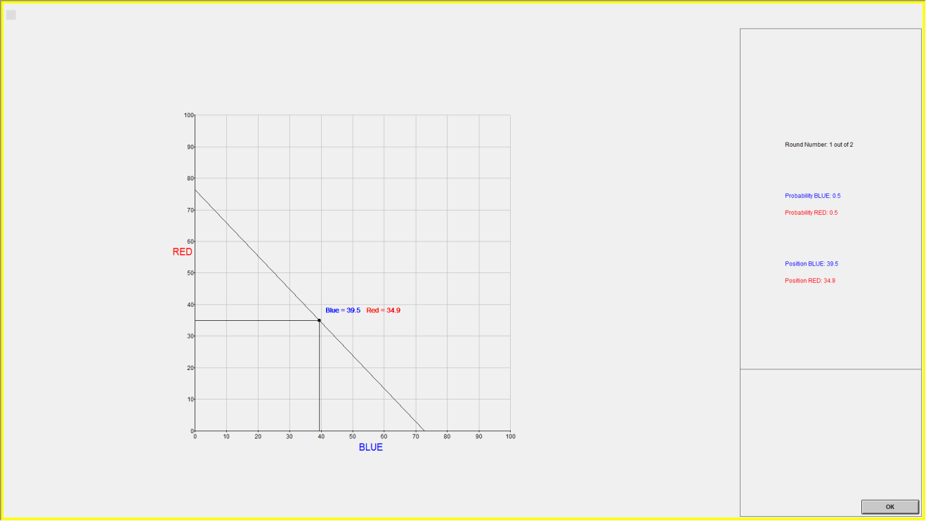

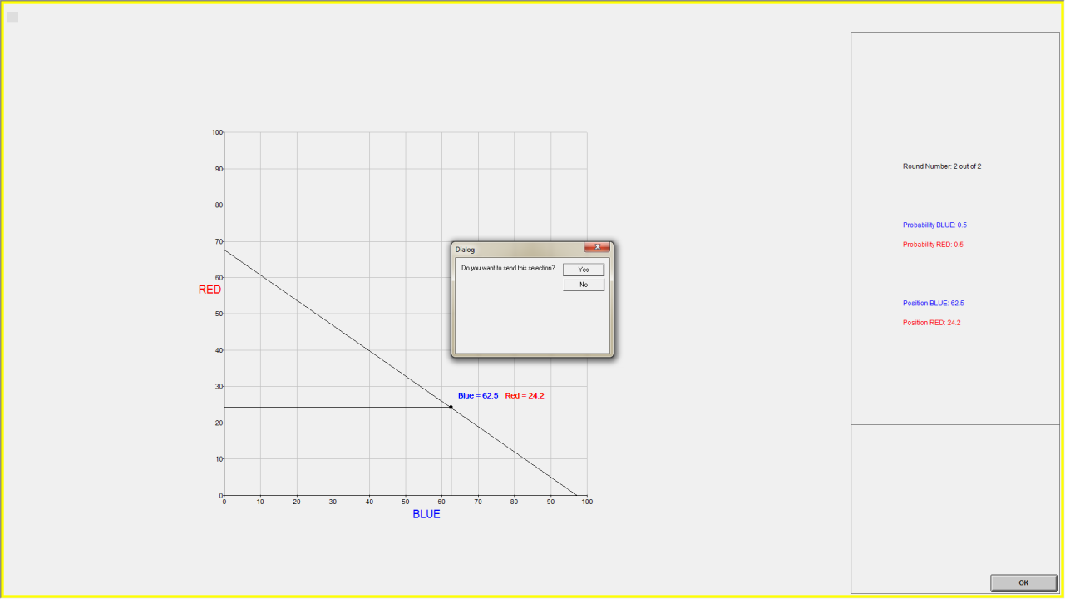

Figure: Example of two practice rounds

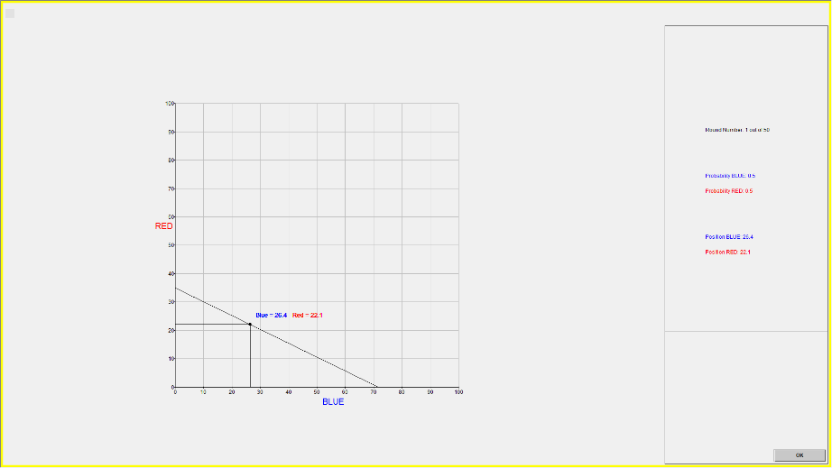

Figure: Example of one round of real economic choices

(After the participants finish all 50 rounds of economic choices, the screen will show the results of this part and the points the participants get.)

Screen 25
We now ask you to provide the fourth saliva sample. The instructions are the same as before.
1. Please pick the tube beside you (labeled No.4).
2. Remove the top cap of the tube.
3. Pass saliva by spitting or drooling directly into the tube for 180 seconds.
4. In order to know when the 180 seconds have passed, please refer to the clock (counting down, in seconds) on your screen.
5. Replace the cap. Make sure cap is on tightly.
6. Press the OK button after one of our experimenters has collected the tube.
If you have any questions, please raise your hand.

Screen 26
Please describe your feelings and emotions. Indicate to what extent you have felt stressed, pain, unhappy and attentive respectively while you were doing the decision choices.
The value 0 means “not at all” and the value 10 means “very much”.

Stressed: [ ]
Pain: [ ]
Unhappy: [ ]
Attentive: [ ]

Screen 27
When you took the economic decisions, how did you choose the amount of points you allocated to each account?
Did you use the same strategy throughout 50 rounds of economic decision problems? Yes or No
If the previous answer is No, please describe how did your strategy change over time? Why?

Screen 28
You have 5 Euro of show-up fee and your total earnings in this experiment are [ ], which will be paid to you via bank transfer at the end of the experiment.
To end this experiment, press the END button.
Please wait until the experimenter call your number. Thank you very much for your participation!

For 50 choices there are $\sum_{k=2}^{50}{\left(\begin{aligned}50 \\ 2\end{aligned}\right){\left(k−1\right)!}^{}}=1.6879×{10}^{63}$computations for each potential violation of GARP.
These pictures are retrieved from the FaceReader user documentation on the official website of Noldus – FaceReader.

