Appendix A: Instructions (Team – Cost, Low Pay, No Time Bonus)

Experiment Instructions

Welcome

This is an experiment in the economics of decision-making. Several research institutions have provided funds for this research. You will be paid for your participation in the experiment. The exact amount you will be paid will depend on your and/or others' decisions. Your payment will consist of the amount you accumulate plus a $10 show-up fee. You will be paid privately via check at the conclusion of the experiment.

If you have a question during the experiment, raise your hand and an experimenter will assist you. Please do not talk, exclaim, or try to communicate with other participants during the experiment. Please put away all outside materials (such as books, bags, notebooks, cellphones) before starting the experiment. Participants violating the rules will be asked to leave the experiment and will not be paid.

Basic Structure

Today you will solve a series of puzzles called nonograms. First you will learn the basic rules of the puzzle and then you will try your hand at solving some nonograms individually. You will be paid $0.50 for each nonogram you solve within the time limit in the individual stage.

After that, we will form groups of four participants and you will solve more difficult nonograms with your group. You will paid $3 for each nonogram your group solves within the time limit in the group stage. You will be able to consult with other members of your group using a chat box, but you will be charged a small fee for each chat message.

What is a Nonogram?

A nonogram is logic puzzle. The rules are simple. You have a grid of squares, each of which must either be marked with an X or left blank. Beside each row of the grid are listed the lengths of each “run” of continuous X’s in that row, in order. Above each column are listed the lengths of each “run” of continuous X’s in that column, in order.

Your aim is to find and mark all the X’s. Click on a square to mark it with an X and click on it again to unmark it. If you would like to clear all the X’s from the grid, click “Retry (clear board)”. If you have finished, click “Check Answer”.

Below is an example screenshot of a 5x5 nonogram (5 rows, 5 columns). For reference, we have labeled the rows with roman numerals I – V and the columns with letters A – E.

Note that row II is labeled with a “2”. This means that there are two X’s in a row, with no spaces between them, somewhere in that row.

Row IV is labeled with a “1” and a “3”. This means that in that row, there is one X and then three X’s in a row, separated by one or more blank spaces.

Finally, look at column C, which is labeled with a “1” above a “2”. This means that there is one X and then two X’s in a row, separated by one or more blank spaces.

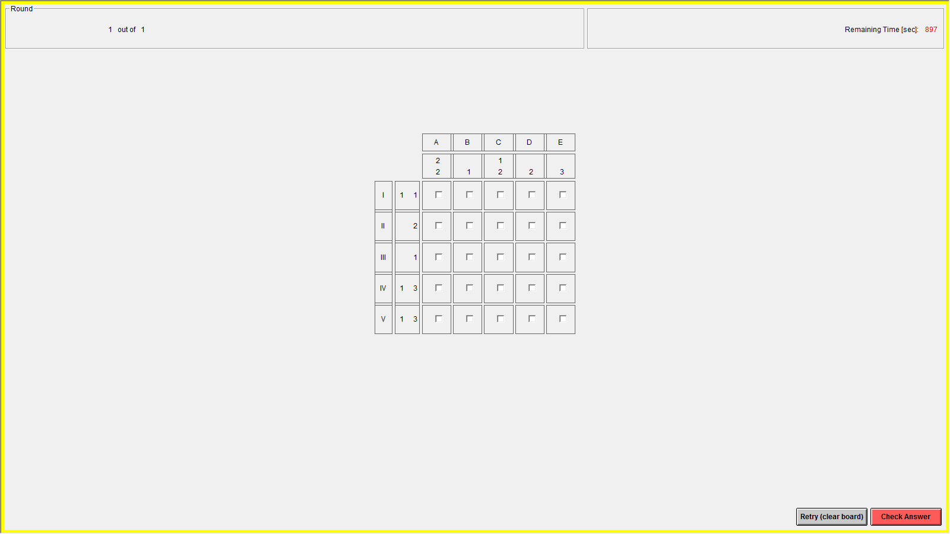

Below is a screenshot of what this puzzle looks like when it is correctly completed.

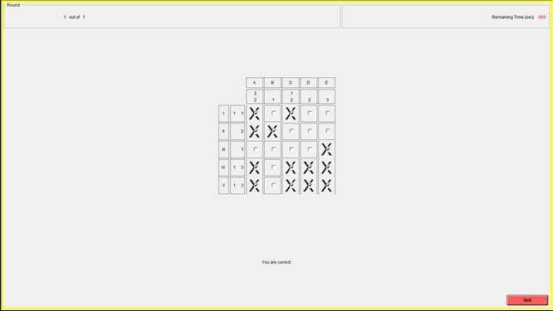

Before learning more details, we will pause for questions.
Individual Stage
You will have 95 seconds to complete each of the five nonograms in the individual stage. Each puzzle has 5 rows and 5 columns (5x5), and if you complete it before the time is up, you will earn 50 cents.

Group Stage
There are five rounds in the group stage. In each round, everyone will be randomly assigned into groups of four. You are not with the same group for all five rounds; in each round you will be assigned to a different group of people. The groups are anonymous—you will not know which of the other people in the room are in your group. In each round, your group will work together to solve a 10x10 nonogram with a time limit of 540 seconds (9 minutes).

Although everyone in the same group can see the puzzle, only one person, called the Leader, will be able to mark or unmark the squares on the board. Other than this, there is no distinction between the group’s Leader and the rest of the people, who are called Followers. You will be in the same role (Leader or Follower) for all five rounds.

Players in the same group may communicate with and advise each other using a chat box. This will be available until you have solved the problem or the time limit is reached. Chat messages will be displayed to all other members of the same group. Only people in your group will be able to see your messages. Each person in the group has a chat id (1 – 4) so you can identify who is sending messages. The chat ids are randomly generated in each round, so your chat id will change from round to round.

The chat box works much like an IM program. You have a box to type messages. When you hit the enter key, all four members of the group see your message. When using the chat box, we ask that you follow two simple rules: (1) Do not send any messages that would allow another group member to identify you and (2) please avoid offensive language.

If your group completes a puzzle within the time limit, each person in the group will earn $3. If you do not solve the puzzle, each person will earn $0. Every chat message that you send will cost you $0.01, regardless of whether or not your group completes the nonogram.

Example 1: If your group completes the nonogram and you sent 10 chat messages, you will earn $2.90 = $3.00 - $0.10 for the round.

Example 2: If your group does not complete the nonogram in the 9 minutes and you sent 20 chat messages, you will lose $0.20 for the round.

Your earnings for the session are calculated by adding your earnings from the five individual rounds to your earnings from the five group rounds, as well as your $10 show-up fee.

Appendix B: CRT Instructions

Experiment Instructions

Welcome instructions (first screen) [All treatments]

This is an experiment in the economics of decision-making. Several research institutions have provided funds for this research. You will be paid for your participation in the experiment. The exact amount you will be paid will depend on your and/or others' decisions. Your payment will consist of the amount you accumulate plus a $5 show-up fee. You will be paid privately via check at the conclusion of the experiment.

If you have a question during the experiment, raise your hand and an experimenter will assist you. Please do not talk, exclaim, or try to communicate with other participants during the experiment. Please put away all outside materials (such as books, bags, notebooks, cellphones) before starting the experiment. Participants violating the rules will be asked to leave the experiment and will not be paid.

Part 1 Instructions [Individual (treatment 1)]

Today you will answer a series of questions. First you will try your hand at answering some questions individually. You will be paid $1 for each puzzle you solve within the time limit in the initial stage.

After that, you will answer more questions. You will be paid $1 for each question your group answers correctly within the time limit in this second stage.

Try your best to answer each of the following 5 questions. You have 30 seconds for each question.

If the answer is a number please type the number, for example, "7" instead of "seven".

Part 1 Instructions [Team (treatment 2)]

Today you will answer a series of questions. First you will try your hand at answering some questions individually. You will be paid $1 for each puzzle you solve within the time limit in the individual stage.

After that, we will form groups of four participants and you will answer more questions with your group. You will be paid $1 for each question your group answers correctly within the time limit in the group stage. You will be able to consult with other members of your group using a chat box.

Try your best to answer each of the following 5 questions. You have 30 seconds for each question.

If the answer is a number please type the number, for example, "7" instead of "seven".

Part 1 Instructions [Team-Cost (treatment 3)]

Today you will answer a series of questions. First you will try your hand at answering some questions individually. You will be paid $1 for each puzzle you solve within the time limit in the individual stage.

After that, we will form groups of four participants and you will answer more questions with your group. You will be paid $1 for each question your group answers correctly within the time limit in the group stage. You will be able to consult with other members of your group using a chat box, but you will be charged a small fee for each chat message.

Try your best to answer each of the following 5 questions. You have 30 seconds for each question.

If the answer is a number please type the number, for example, "7" instead of "seven".

Part 2 Instructions [Individual (treatment 1)]

Try your best to answer each of the following 5 questions. You have 60 seconds for each question and you will earn $1 for every correct answer.

If the answer is a number please type the number, for example, "7" instead of "seven".

Your earnings for the session are calculated by adding your earnings from the five initial questions to your earnings from the five questions in the second stage, as well as your $5 show-up fee.

Part 2 Instructions [Team (treatment 2)]

There are five rounds in the group stage. In each round, everyone will be randomly assigned into groups of four. You are not with the same group for all five rounds; in each round you will be assigned to a different group of people. The groups are anonymous- you will not know which of the other people in the room are in your group. In each round, your group will work together to answer a question with a time limit of one minute.

Although everyone in the same group can see the question, only one person, called the Leader, will be able to answer the question. Note to submit the answer, the Leader must enter the answer and click the "OK" button. Other than this, there is no distinction between the group's Leader and the rest of the people, who are called Followers. You will be in the same role (Leader or Follower) for all five rounds.

Players in the same group may communicate with and advise each other using a chat box. This will be available until you have answered the question or the time limit is reached. Chat messages will be displayed to all other members of the same group. Only people in your group will be able to see your messages. Each person in the group has a chat ID (1 - 4) so you can identify who is sending messages. The Leader is always player 1. The chat IDs are randomly generated in each round, so your chat id will change from round to round.

The chat box works much like an IM program. You have a box to type messages. When you hit the enter key, all four members of the group see your message. When using the chat box, we ask that you follow two simple rules: (1) Do not send any messages that would allow another group member to identify you and (2) please avoid offensive language.

If your group answers a question correctly within the time limit, each person in the group will earn $1. If you do not answer the question correctly, each person in the group will earn $0.

Your earnings for the session are calculated by adding your earnings from the five individual questions to your earnings from the five group questions, as well as your $5 show-up fee.

Part 2 Instructions [Team-Cost (treatment 3)]

There are five rounds in the group stage. In each round, everyone will be randomly assigned into groups of four. You are not with the same group for all five rounds; in each round you will be assigned to a different group of people. The groups are anonymous- you will not know which of the other people in the room are in your group. In each round, your group will work together to answer a question with a time limit of one minute.

Although everyone in the same group can see the question, only one person, called the Leader, will be able to answer the question. Note to submit the answer, the Leader must enter the answer and click the "OK" button. Other than this, there is no distinction between the group's Leader and the rest of the people, who are called Followers. You will be in the same role (Leader or Follower) for all five rounds.

Players in the same group may communicate with and advise each other using a chat box. This will be available until you have answered the question or the time limit is reached. Chat messages will be displayed to all other members of the same group. Only people in your group will be able to see your messages. Each person in the group has a chat ID (1 - 4) so you can identify who is sending messages. The leader is always player 1. The chat IDs are randomly generated in each round, so your chat ID will change from round to round.

The chat box works much like an IM program. You have a box to type messages. When you hit the enter key, all four members of the group see your message. When using the chat box, we ask that you follow two simple rules: (1) Do not send any messages that would allow another group member to identify you and (2) please avoid offensive language.

If your group answers a question with the time limit, each person in the group will earn $1. If you do not answer the question correctly, each person in the group will earn $0. Every chat message that you send will cost you $0.01, regardless of whether or not your group answers the question correctly.

Example 1: If your group correctly answers a question and you send 10 messages, you will earn $0.90=$1-$0.10 for the round.
Example 2: If your group correctly answers a question and you send 15 chat messages, you will earn $0.85=$1-$0.15 for the round.

Example 3: If your group fails to correctly answer a question in 1 minute and you sent 20 chat messages, you will lose $0.20 for the round.

Your earnings for the session are calculated by adding your earnings from the five individual questions to your earnings from the five group questions, as well as your $5 show-up fee.

Appendix C: CRT Questions

Questions 1-5 were used for Stage 1. They appeared in the same order for all participants. Time limit = 30 seconds and reward = $1.

Questions 6-10 were used for Stage 2. They appeared in the same order for all participants and groups. Time limit = 60 seconds and reward = $1.

- If you’re running a race and you pass the person in second place, what place are you in? (Please enter 1, 2, 3, or 4) Intuitive/Incorrect Answer: 1/ Correct answer: 2

- A farmer had 15 sheep and all but 8 died. How many are left? Intuitive/Incorrect Answer:7/ Correct answer: 8

- Emily's father has three daughters. The first two are named April and May. What is the third daughter's name? Intuitive/Incorrect answer: June / Correct answer: Emily

- In an athletics team, tall members won three times as many medals as short members. This year the team has won 60 medals so far. How many have been won by short athletes? Intuitive/Incorrect answer: 20 / Correct answer: 15

- A farmer makes 4 piles of hay in one corner of a field and 5 other piles in another corner. If he merges them, how many piles will he have? Intuitive/Incorrect answer: 9 piles / Correct answer: 1 pile

- How many cubic feet of dirt are there in a hole that is 3' deep x 3' wide x 3' long? Intuitive/incorrect answer: 27 / correct: 0

- Jerry received both the 15th highest and the 15th lowest mark in the class. How many students are in the class? Intuitive/Incorrect answer: 30 / correct answer: 29

- A man buys a pig for $60, sells it for $70, buys it back for $80, and sells it finally for $90. How much money has he made? Intuitive/Incorrect answer: $10 / correct answer: $20.

- Sally is making sun tea. Every hour, the concentration of the tea doubles. If it takes 6 hours for the tea to be ready, how long would it take for the tea to reach half of the final concentration? Intuitive/Incorrect answer: 3 hours / correct answer: 5 hours.

- The ages of Mark and Adam add up to 28 years total. Mark is 20 years older than Adam. How many years old is Adam? Intuitive/Incorrect answer: 8 years / correct answer: 4 years.

