“Belief Adjustment: A Double Hurdle Model and Experimental Evidence”

Timo Henckel, Gordon D. Menzies, Peter Moffatt and Daniel J. Zizzo

Online Appendix

Index

Interpretation of Figure 3: p.1

Sequence and dates/times of experimental sessions: p. 4

Tables of payoffs (as provided in print to subjects at the beginning of each part): p. 5

Computer screenshots: p. 7

Mean Square Deviation (MSD) analysis: p. 37

1. Interpretation of Figure 3
One apparent anomaly of Figure 3 in the main paper is that a sizeable minority of adjustments are in the ‘wrong direction’, lowering the probability guess g on receipt of a white ball, and raising it on receipt of an orange ball. The figure needs to be interpreted carefully for three reasons:
(i) The nonparametric analysis uses raw data before the risk adjustment;
(ii) Figure 3 combines complex histories, and
(iii) Once proper modelling is done, the fraction of agents moving in the wrong direction is much lower.

We consider these points in turn.
- Raw data
At the point in the paper where Figure 3 appears we are dealing with the raw data, before any risk adjustment, as befits nonparametric analysis. So, while it is true that a white ball ought to make a rational player lift their true belief about the probability urn 1 was chosen, g*, it does not necessarily follow that an increase in g* translates into an increase in g. It turns out that for risk loving agents the derivative dg/dg* can be negative.
We begin with the solution for g*, from (1), take the derivative with respect to g, and invert it.
$$g∗{\left(1+UV^{θ}\right)}^{−1}whereU=\frac{1}{g}−1∧V=\frac{1−g^{2}}{2g−g^{2}}$$
$\frac{dg∗}{dg}=\frac{−1}{}$

$$\frac{dg}{dg∗=}$$

In the last line the numerator is negative, so the sign hinges on the denominator. Noting g-g²-1 is negative, the denominator is negative for positive θ, making the derivative dg/dg* positive.
However, for a negative enough θ (i.e. for risk lovers) the denominator can be positive, making the whole derivative negative.
Thus, under rational expected utility maximization, every white ball should make g* rise and every orange ball should make g* fall, the opposite can be true of chosen g for agents with a large love of risk. Thus it is possible that some agents might move in the ‘wrong direction’ when they receive a ball draw.
What we have established above is that there is no necessary connection for risk-loving agents between the movements in g* and the movements in g. The latter cannot be inferred from the former with complete confidence. Instead, the proportion of surprising movements of g in Figure 3 form an upper bound on the proportion of contrary movements of g*.
- A range of histories
The choices summarized in Figure 3 are made by subjects with different information sets. The reader may wonder whether subjects appearing to go in the wrong direction had previously over-reacted in previous rounds, but this does not appear to be the case in the following transition matrix in Table A1.1:

Table A1.1 Cross-tabulation of reaction against lagged reaction
-1: going the wrong direction
0: not changing
1: under-adjusting or fully adjusting: 0 < β ≤ 1
2: over-reacting

reaction | lagged reaction
reaction | -1 | 0 | 1 | 2 | Total
-1 | 503 | 582 | 873 | 269 | 2,227
-1 | (21.53) | (11.76) | (28.92) | (15.81) | (18.55)
0 | 654 | 3,597 | 895 | 445 | 5,591
0 | (28.00) | (72.68) | (29.65) | (26.16) | (46.57)
1 | 1,011 | 486 | 823 | 392 | 2,712
1 | (43.28) | (9.82) | (27.26) | (23.05) | (22.59)
2 | 168 | 284 | 428 | 595 | 1,475
2 | (7.19) | (5.74) | (14.18) | (34.98) | (12.29)
Total | 2,336 | 4,949 | 3,019 | 1,701 | 12,005
Total | (100.00) | (100.00) | (100.00) | (100.00) | (100.00)

Note: The cross-tabulation shows, as columns, the number (and percentage) of contrarian reactions (-1), no change (0), under-reaction or full adjustment (1) and over-adjustment (2) in the previous period. This is plotted against, as rows, the number and percentage of contrarian reactions (-1), no change (0), under-reaction or full adjustment (1) and over-adjustment (2) in the current period. The data is from all stages. Percentages are out of all observations in each column.
That said, the underlying model of such a matrix is that agents have a rule of thumb with respect to their past that they invariably apply. If instead they are responding to a history as cumulative evidence within a given stage, it is not clear that this will be well-modelled by such an approach.
A more rigorous approach is to examine the first round, where by definition there is no within-stage history. Table A1.2 shows the data (245 subjects x 7 first rounds) for the first round.
Table A1.2. First round guesses g
interval of guesses | color of ball
interval of guesses | orange | white | Total
below 50 | 375 | 69 | 444
below 50 | (49.54) | (7.20) | (25.89)
exactly 50 | 299 | 290 | 589
exactly 50 | (39.50) | (30.27) | (34.34)
50-60 | 17 | 63 | 80
50-60 | (2.25) | (6.58) | (4.66)
exactly 60 | 36 | 168 | 204
exactly 60 | (4.76) | (17.54) | (11.90)
above 60 | 30 | 368 | 398
above 60 | (3.96) | (38.41) | (23.21)
Total | 757 | 958 | 1,715
Total | (100.00) | (100.00) | (100.00)

Note: The table shows the number (and percentage) of guesses g for each interval in round 1, on receipt of either an orange or a white ball. The data is from all stages. Percentages are out of all observations in each column.

Since this is the raw data, it is possible that risk averse agents will, on a white ball, fall to 0.5. However it is impossible that they would fall below 50%, so 69/958 = 7% are inexplicable for risk averse agents. Similarly, since raising the guess after an orange ball is irrational for risk averse agents, 30/757 = 4% are inexplicable. These are small percentages consistent with some random error, and so help us develop a more nuanced understanding of Figure 3.
- Proper modelling reduces the scope of the problem
Figure 3 is a nonparametric result on raw data, before adjusting for risk, and proper modelling includes an error term which makes allowance for the part of subjects’ play that is inexplicable or driven by noise.
When we properly model this data, the fraction of agents moving systematically in the wrong direction (β<0) after adjusting for risk is much smaller, at around 5%. Having adjusted for risk, there is indeed evidence g* is moving in the wrong direction, but the scope of this is smaller than Figure 3 would appear to suggest. The around 5% error rate is consistent with the analysis of round 1 data noted above as well as with the kind of noise factors commonly found in economic experiments.

2. – Sequence and dates/times of experimental sessions

Treatment | Session Date & Time
B | 2013-07-25, 16:10
C | 2013-08-01, 13:10
I | 2013-08-01, 16:10
B | 2013-12-04, 14:10
B | 2013-12-09, 12:00
B | 2013-12-09, 14:10
B | 2013-12-09, 16:10
C | 2013-12-10, 16:10
C | 2013-12-10, 9:00
I | 2013-12-11, 12:00
I | 2013-12-11, 16:10
I | 2013-12-11, 9:00
C | 2013-12-12, 09:00
B | 2013-12-12, 12:00
I | 2013-12-13, 12:00
C | 2013-12-13, 16:10
I | 2013-12-16, 10:00
B | 2013-12-16, 13:10
C | 2013-12-16, 16:10
B | 2013-12-17, 14:10

3. – Tables of payoffs (as provided in print to subjects at the beginning of each part)

Earnings for Each Round – Practice Part

Earnings = 300 – 300 × (guess – correct probability)²

Earnings for Each Round – Main Part

Earnings = 1,800 – 1,800 × (guess – correct probability)²

4. - Computer screenshots

Instructions Risk Attitude Task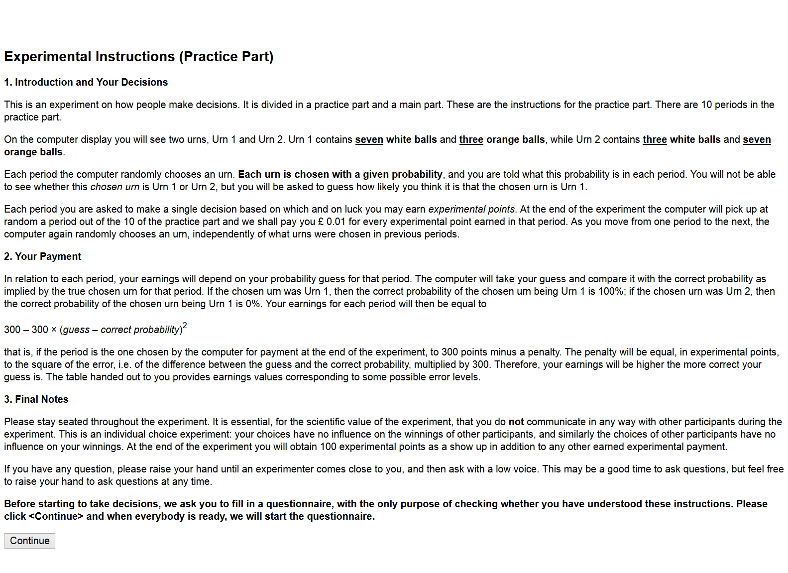
After participants have clicked <Continue> and before the experimenter has released the next phase, participants see the screen below.


Questionnaire Risk Attitude Task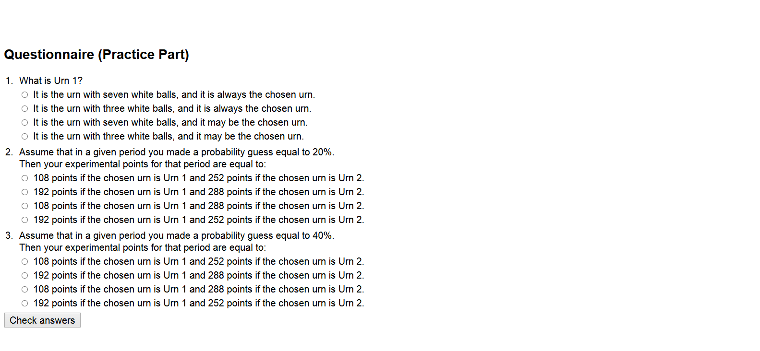

Questionnaire Risk Attitude Task with corrections
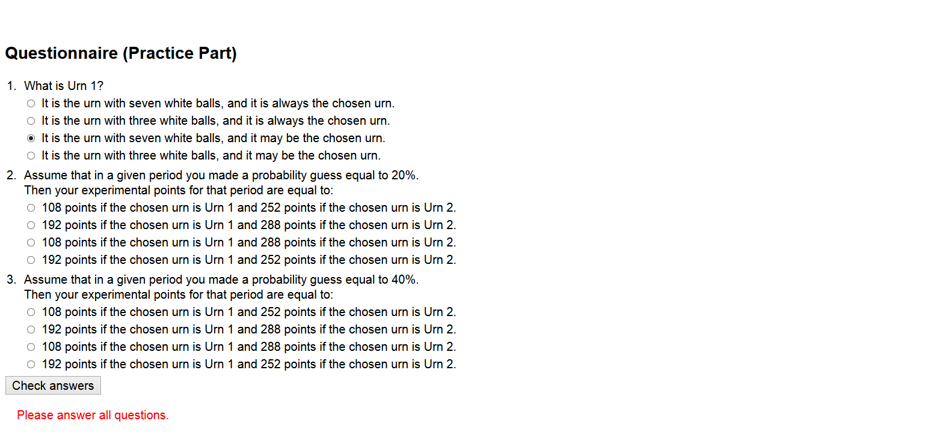

Questionnaire Risk Attitude Task with corrections

If participants click <Continue> the screen will not disappear. Only after the experimenter releases the next phase the risk attitude task will start and there will be no [Wait until] screen (see below for [Wait until] screen). 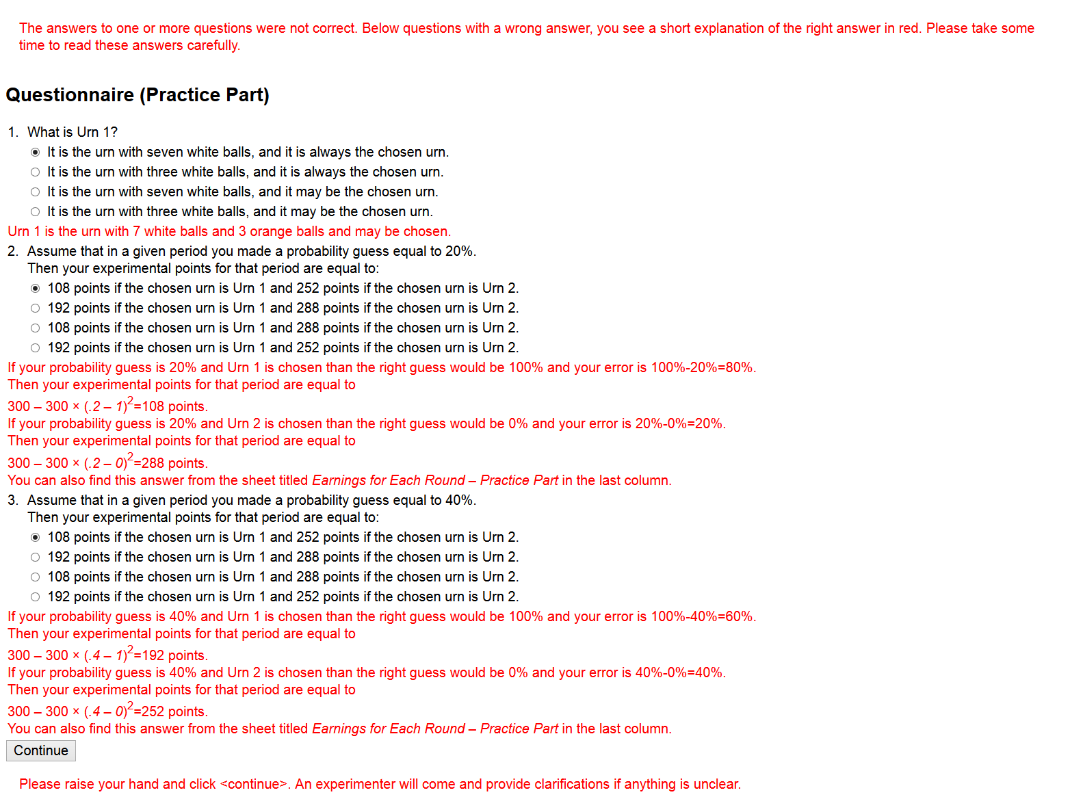

Risk Attitude Task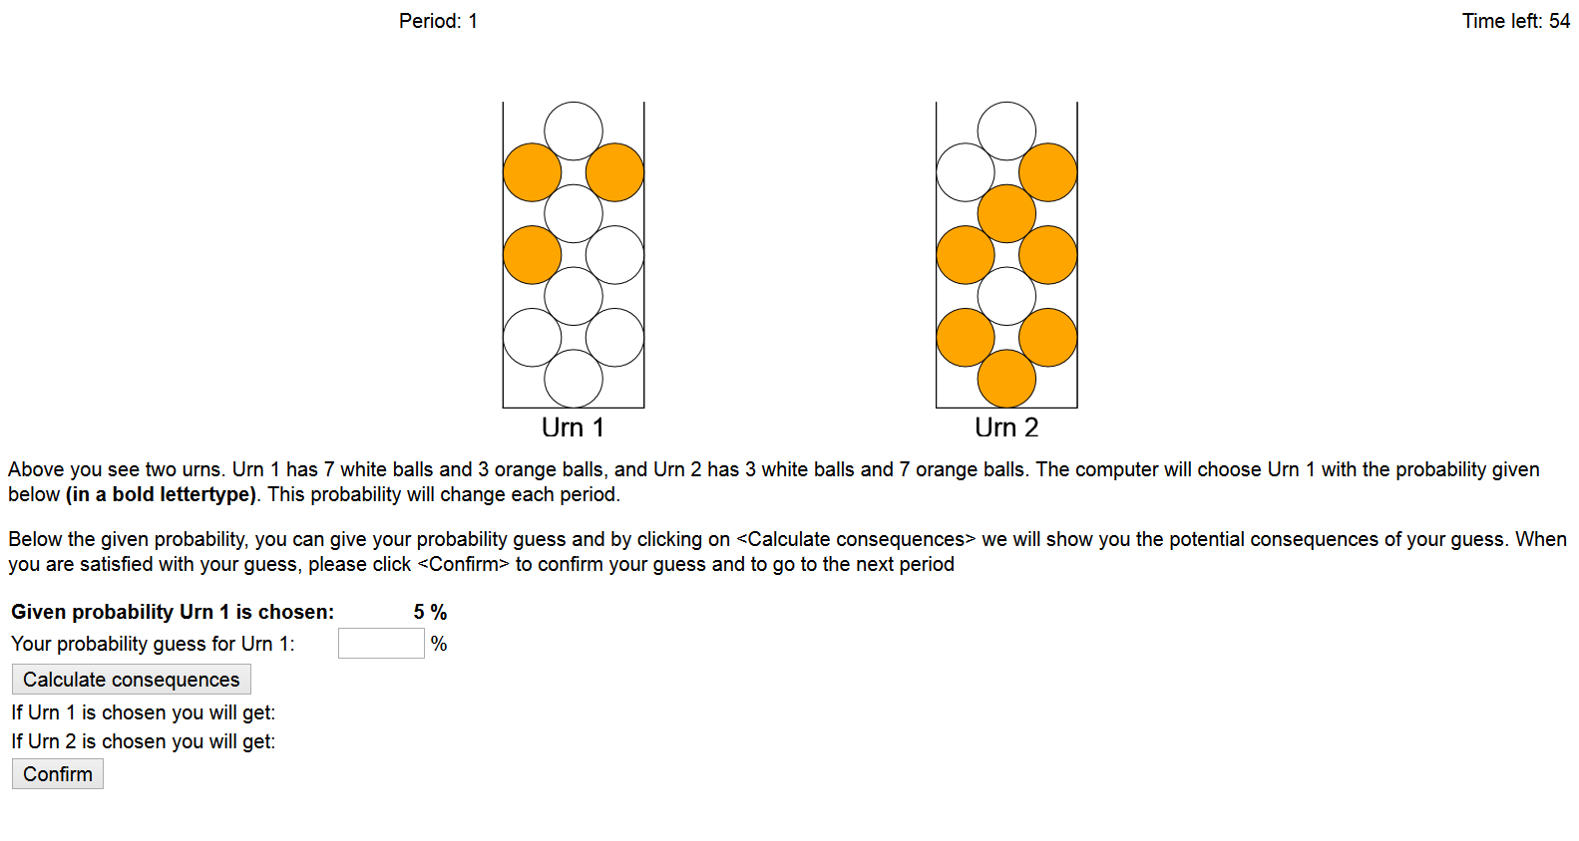

Risk Attitude Task with correction

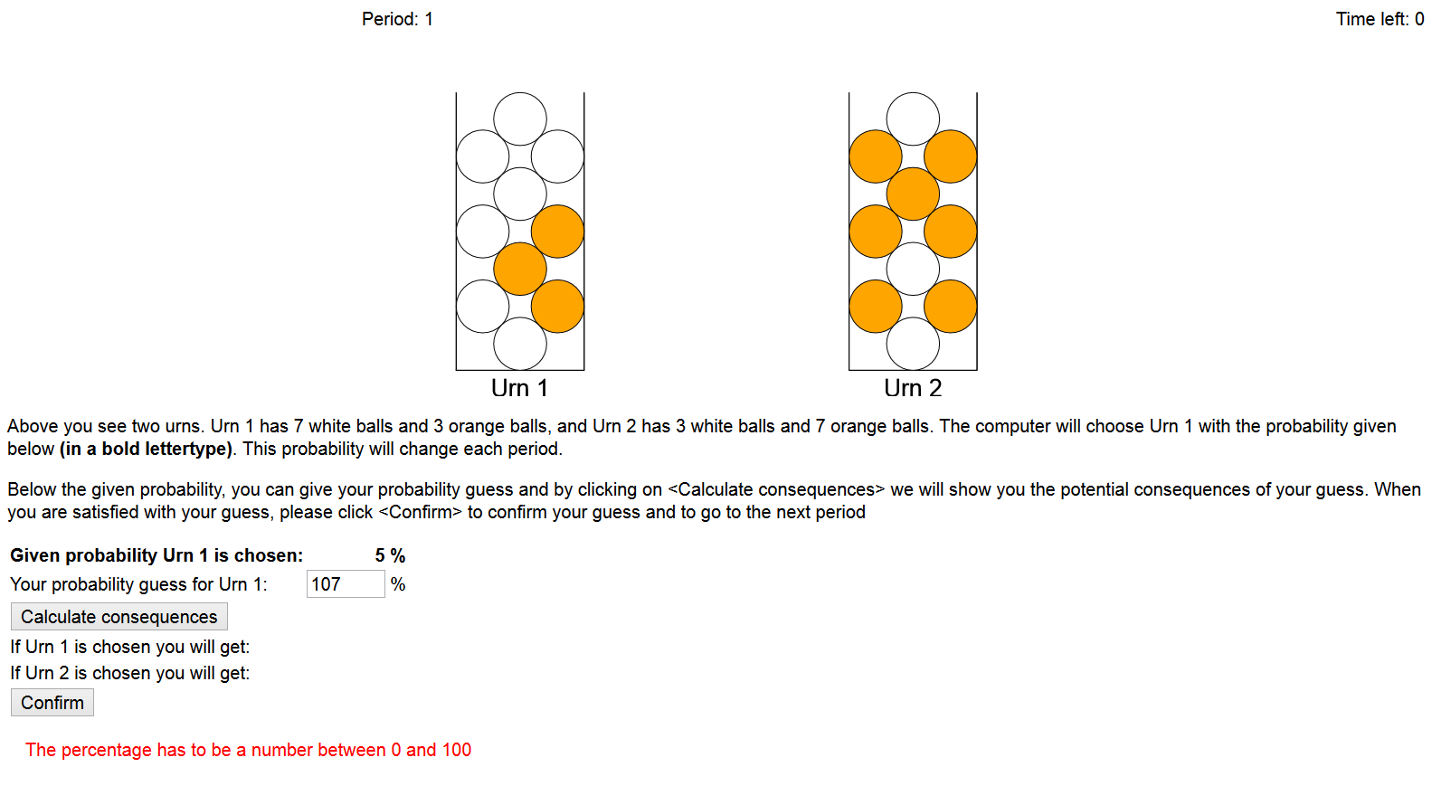

Risk Attitude Task where participant has potential consequences calculated
During the Risk Attitude Task and the Main part every 1.5 seconds both urns will show a new random arrangement of the balls.

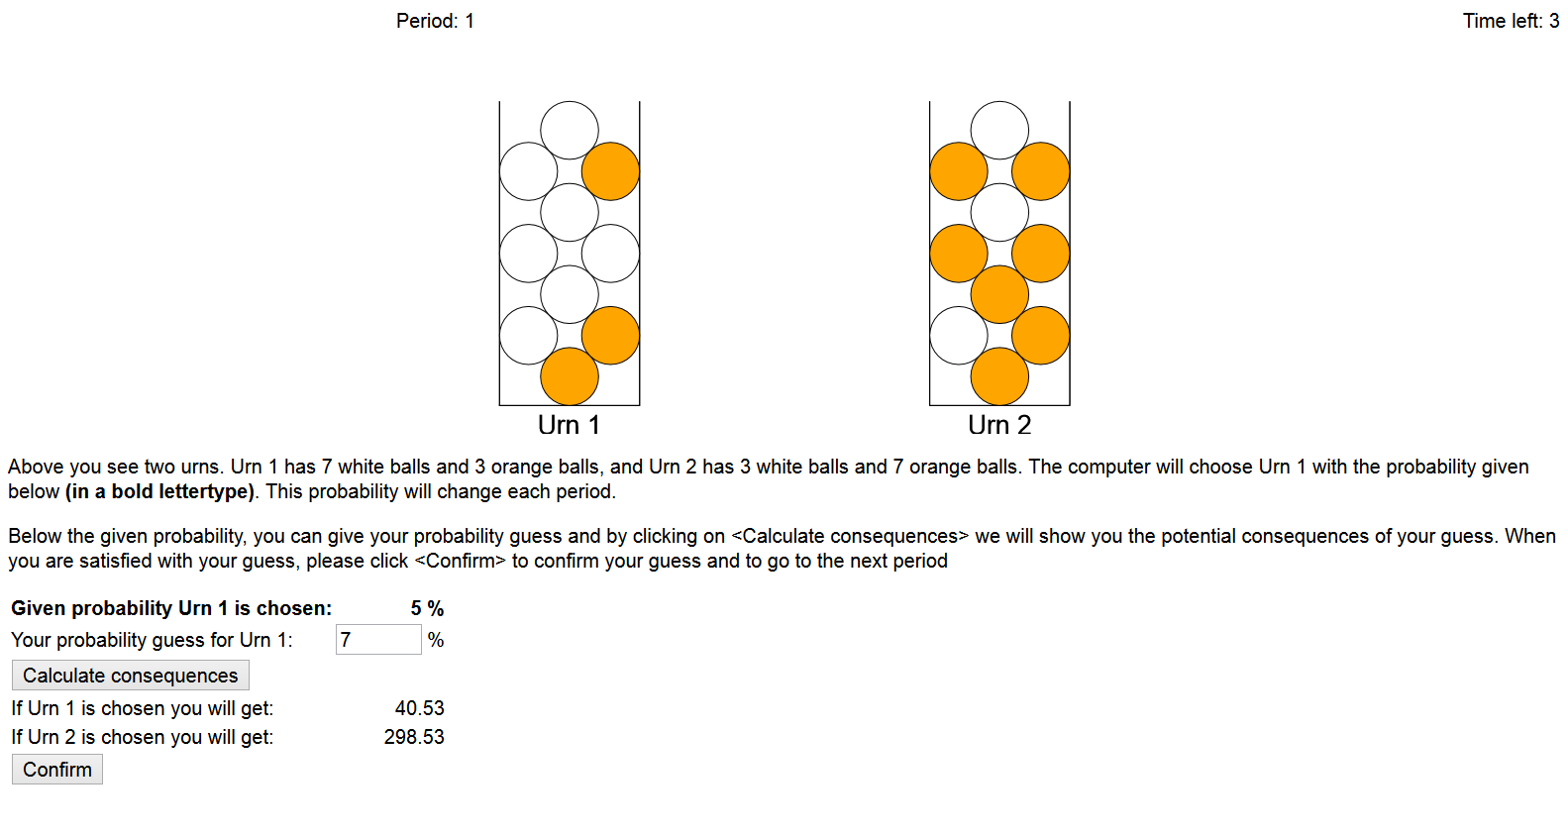

[Wait until] Screen

Instructions Main Part Baseline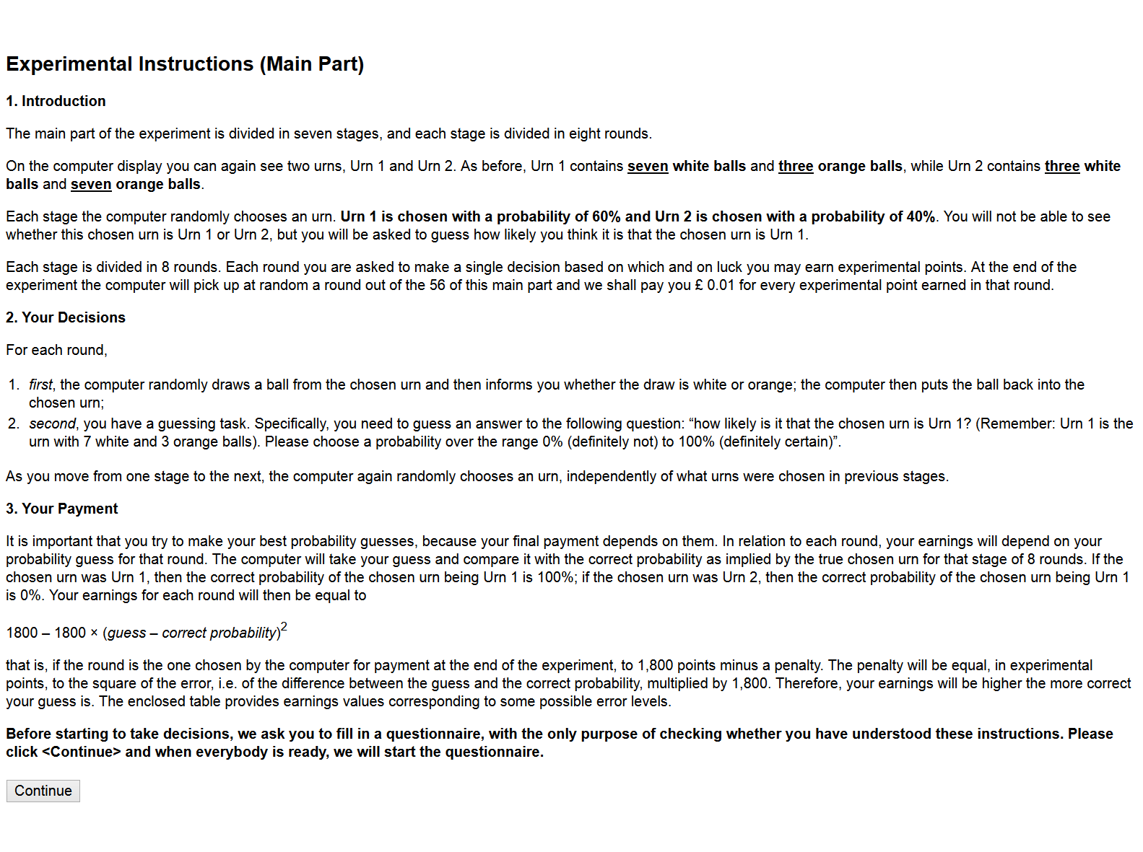

Instructions Main Part Complex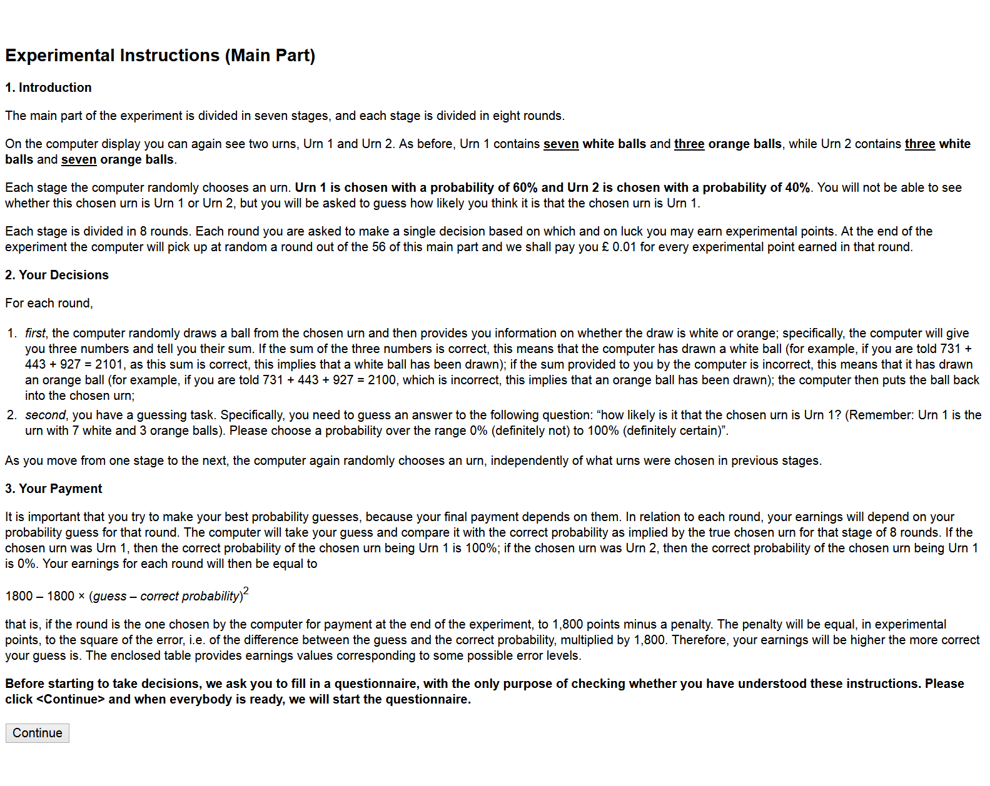

Instructions Main Part Inattention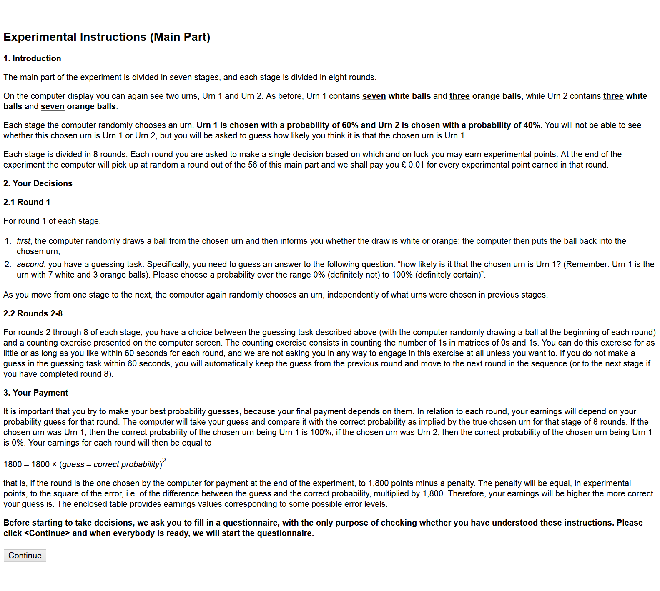

[Wait Until] Screen


Questionnaire Main Part Baseline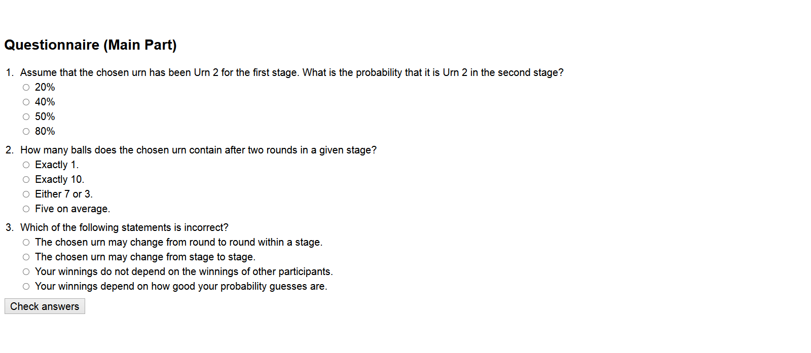

Questionnaire Main Part Complex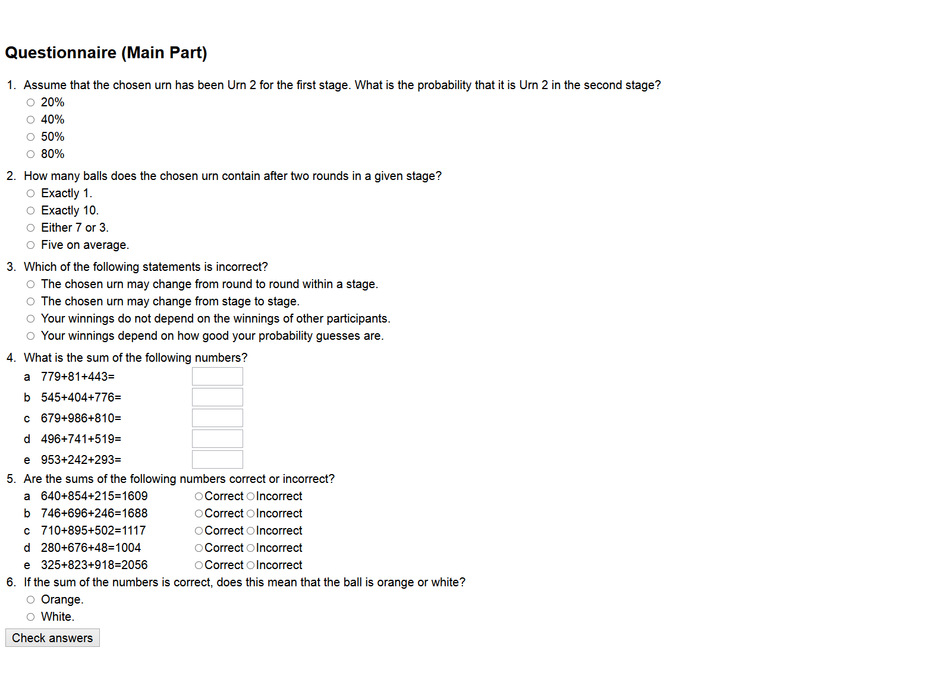

Questionnaire Main Part Inattention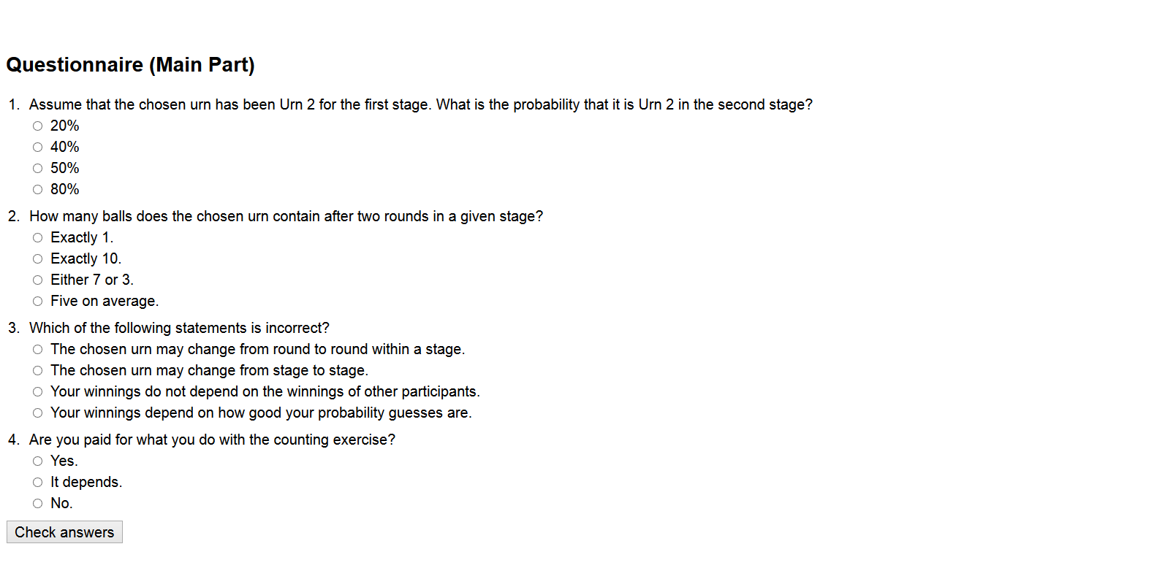

Questionnaire Main Part Baseline with corrections

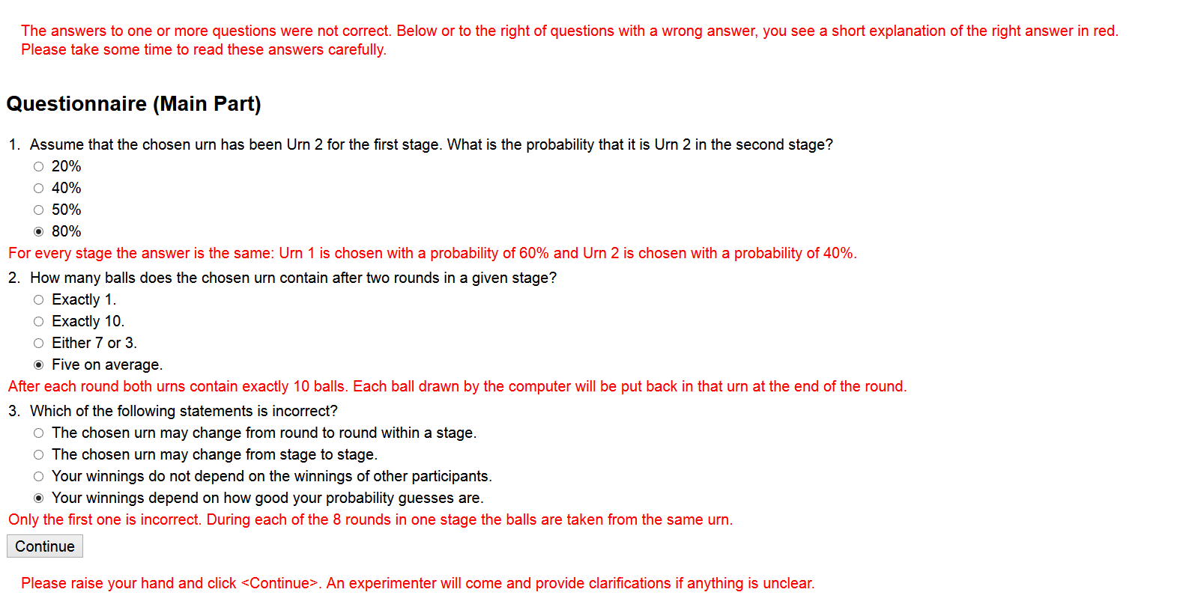

Questionnaire Main Part Complex with input correction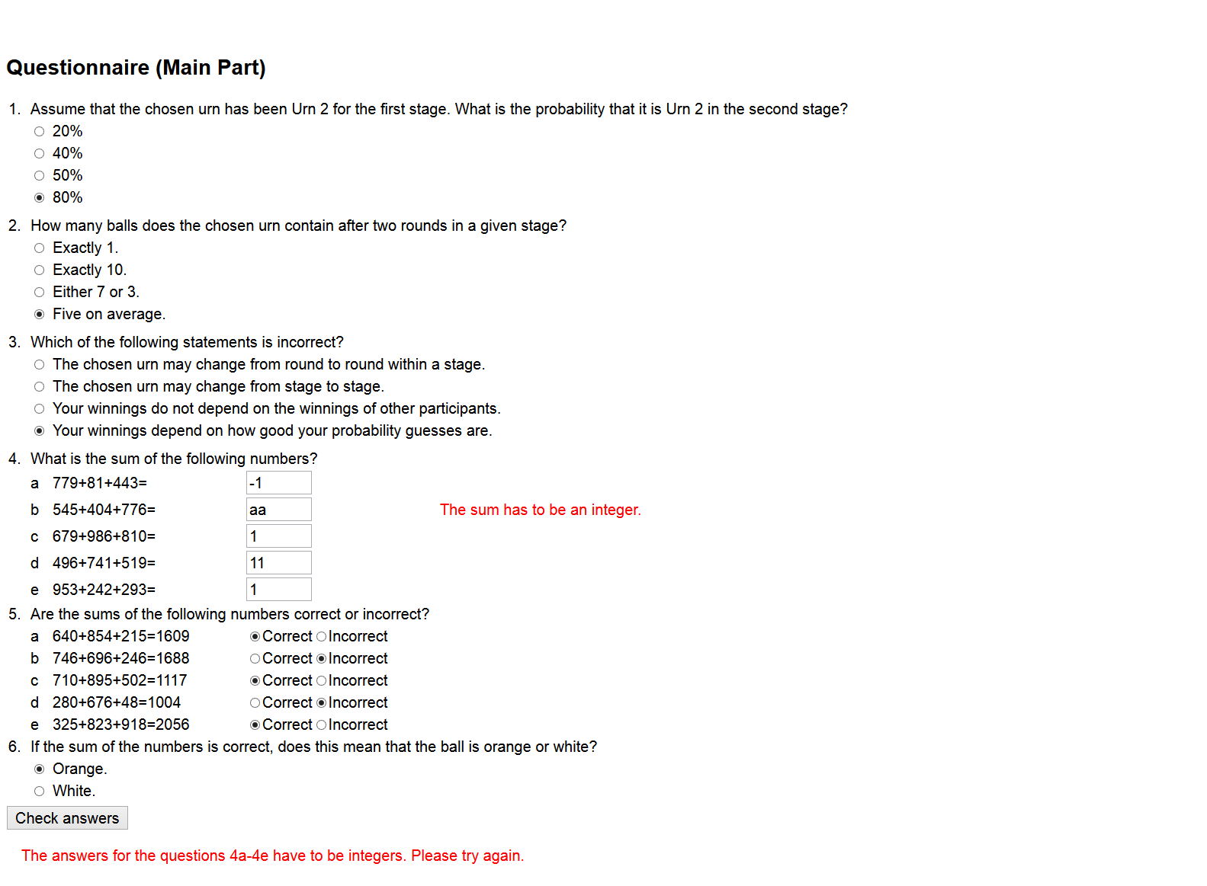

Questionnaire Main Part Complex with corrections

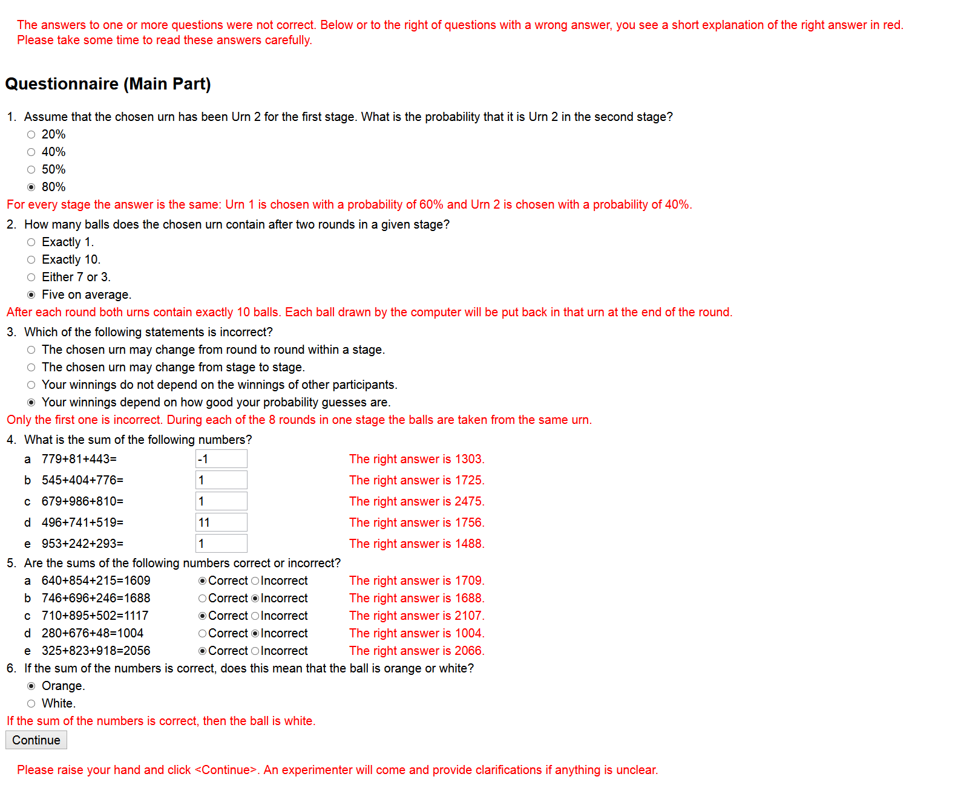

Questionnaire Main Part Inattention with corrections

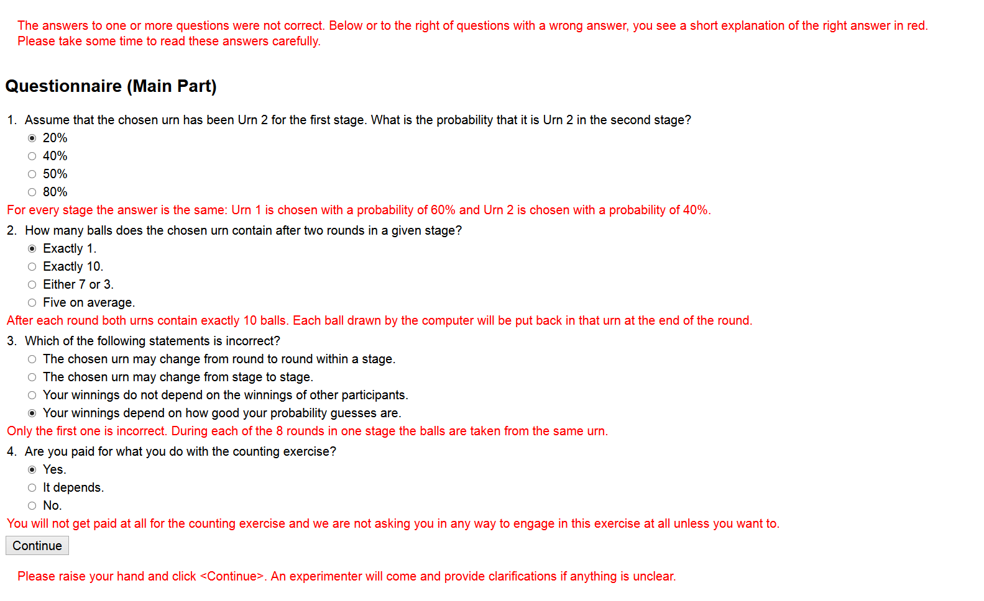

Main Part Baseline

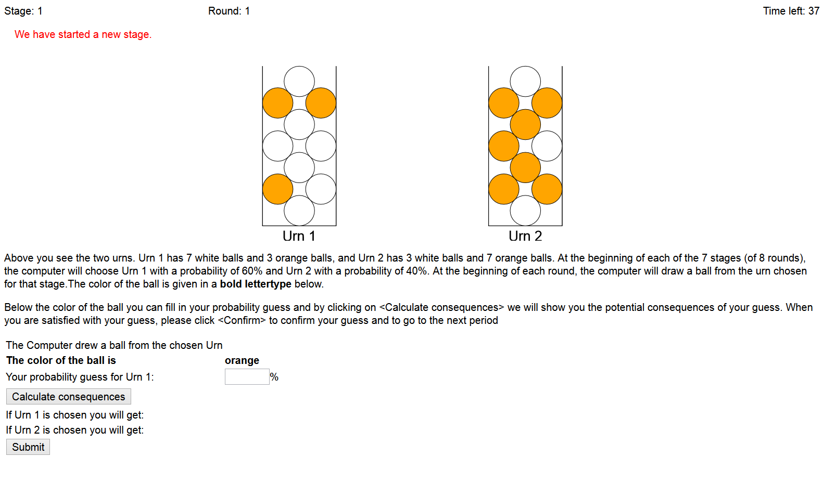

Main Part Complex

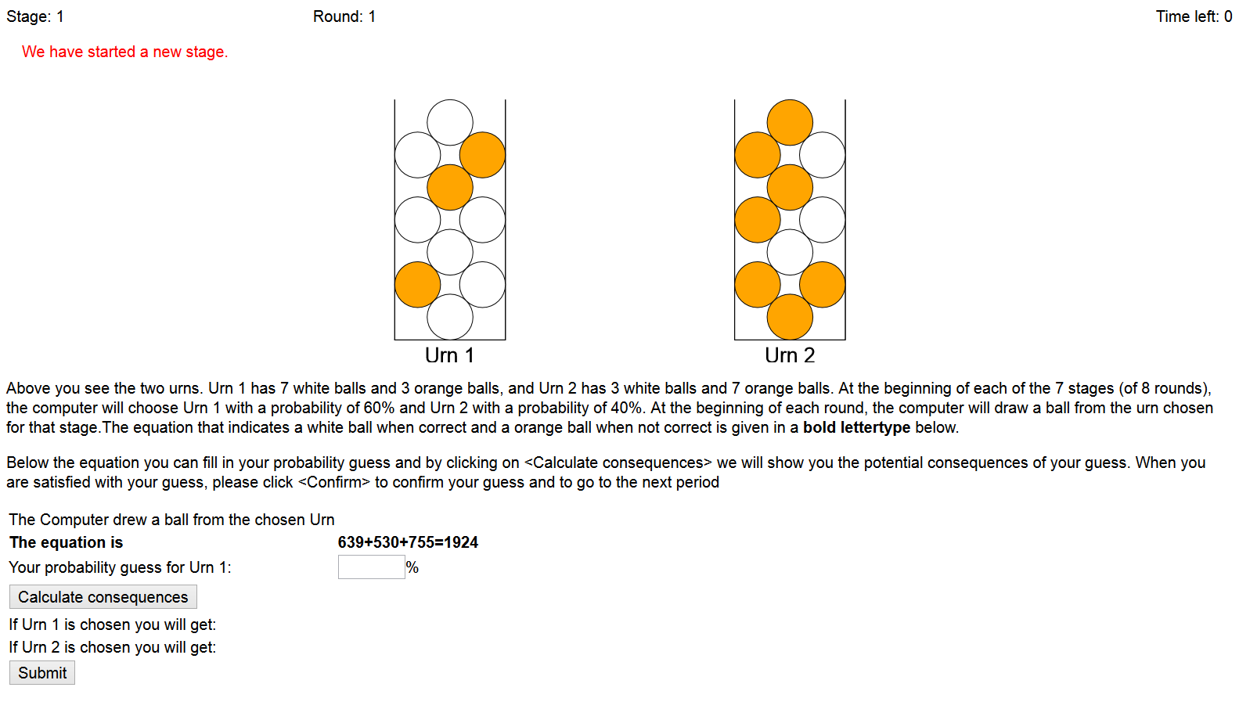
Main Part Inattention round 1
During the first round of every stage the button <Go to the counting exercise> is disabled.

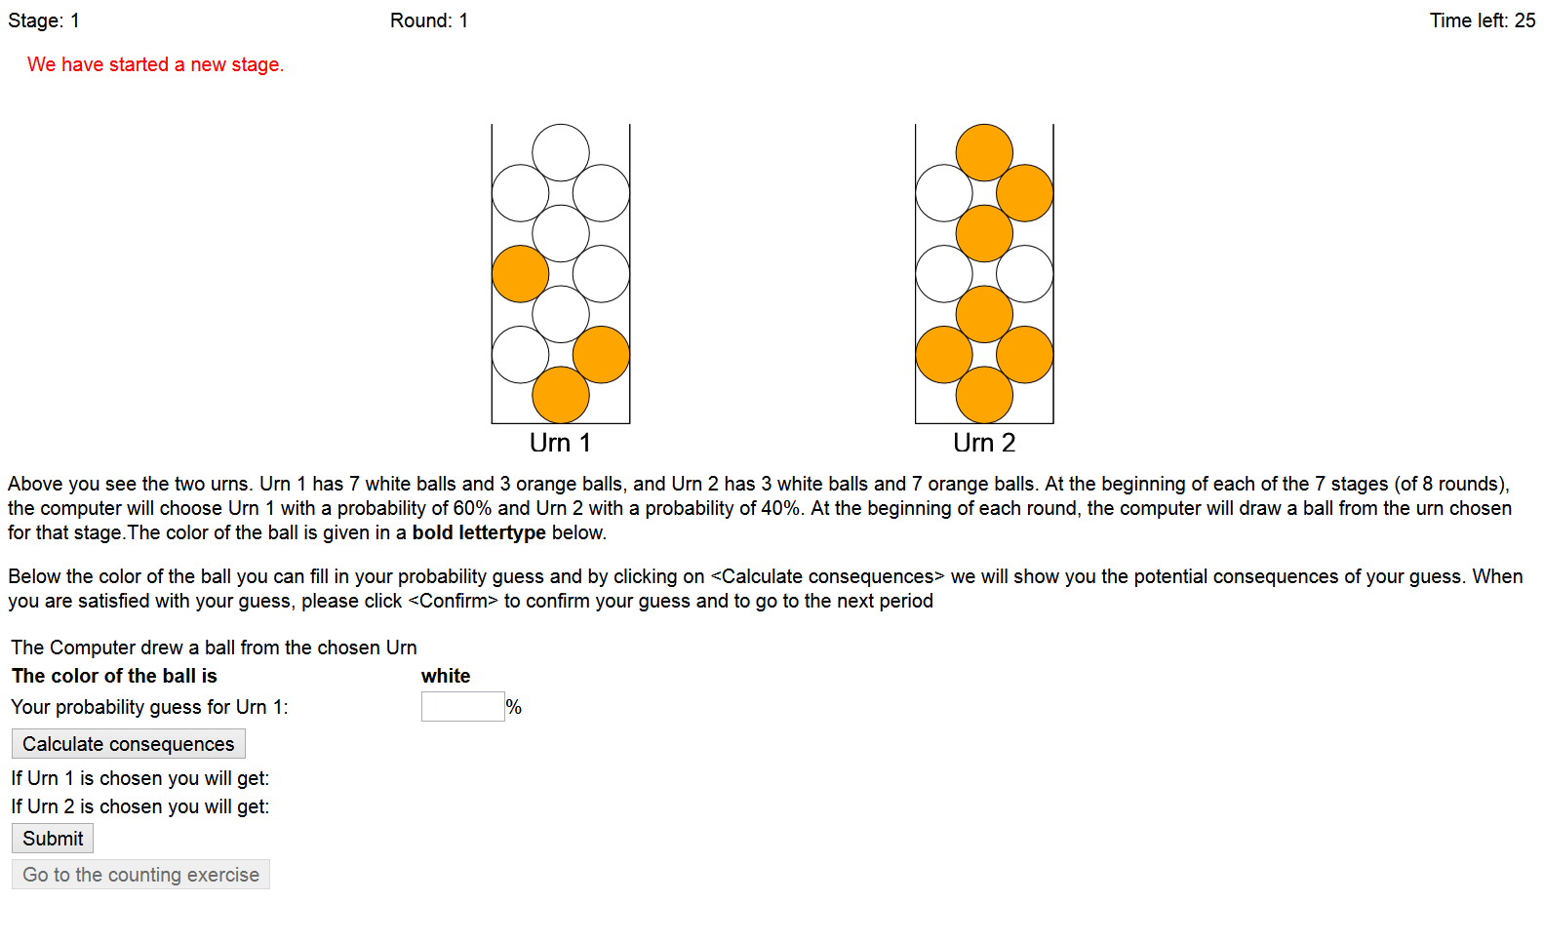

Main Part Inattention counting exercise (rounds 2-8)

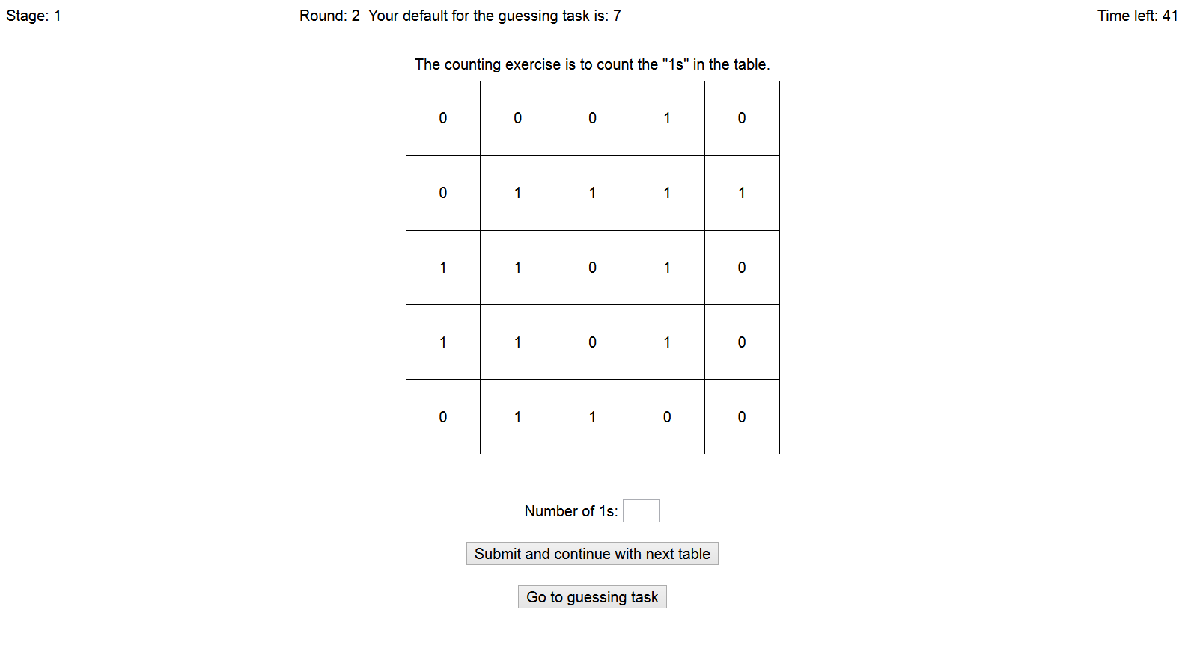

Main Part Inattention counting exercise with correction (rounds 2-8)

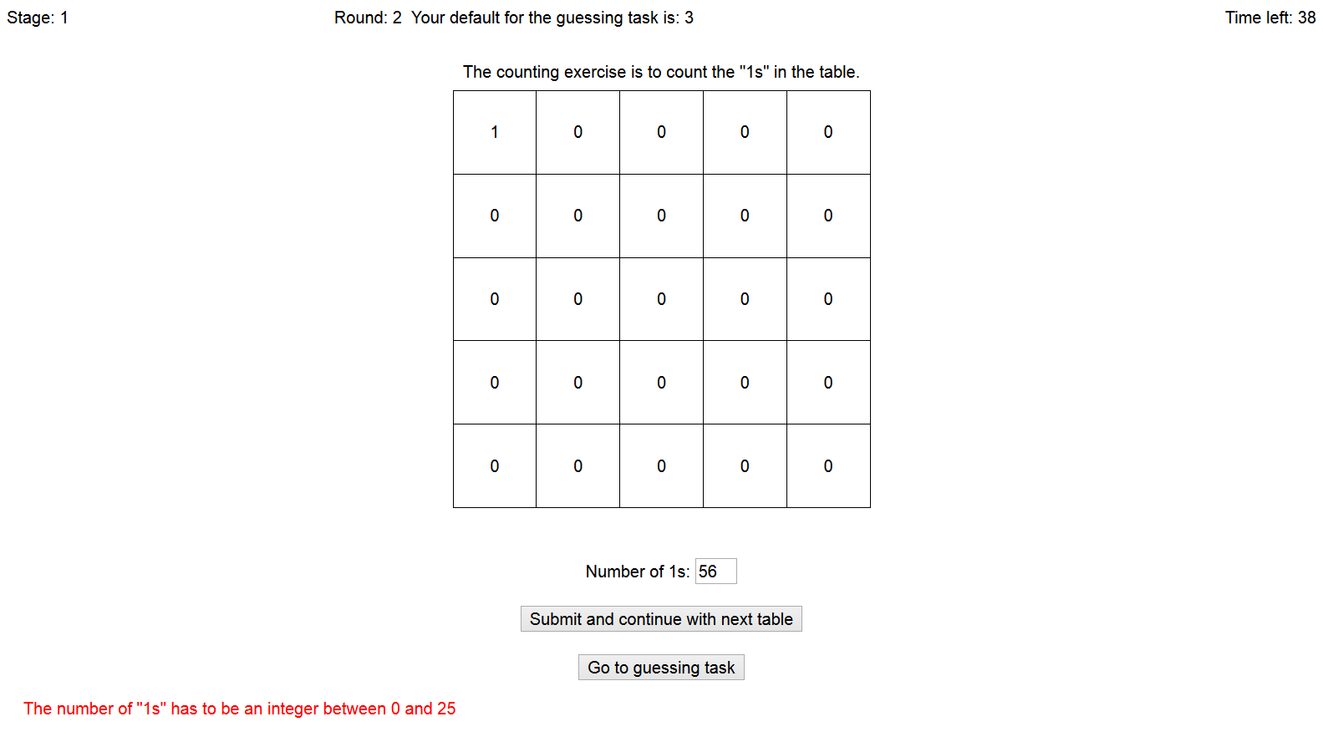

Main Part Inattention guessing task (rounds 2-8)

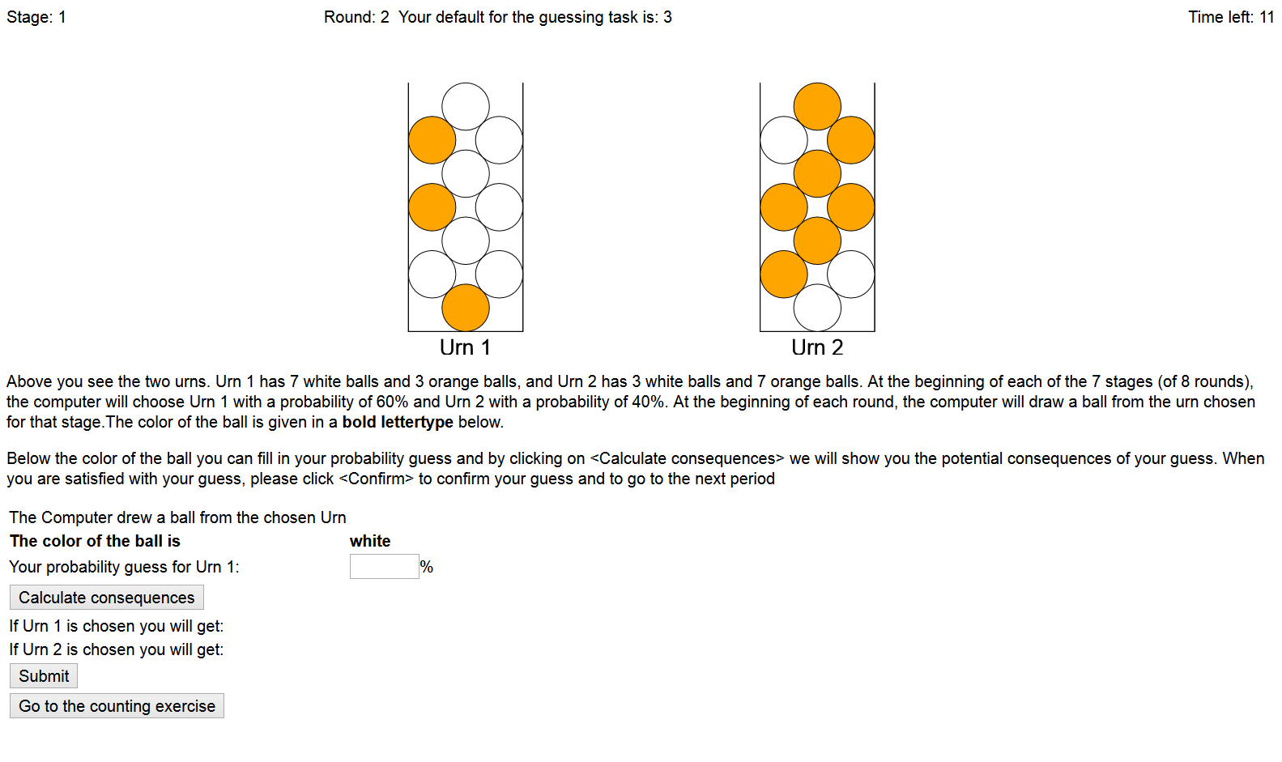

[Wait until] Screen.

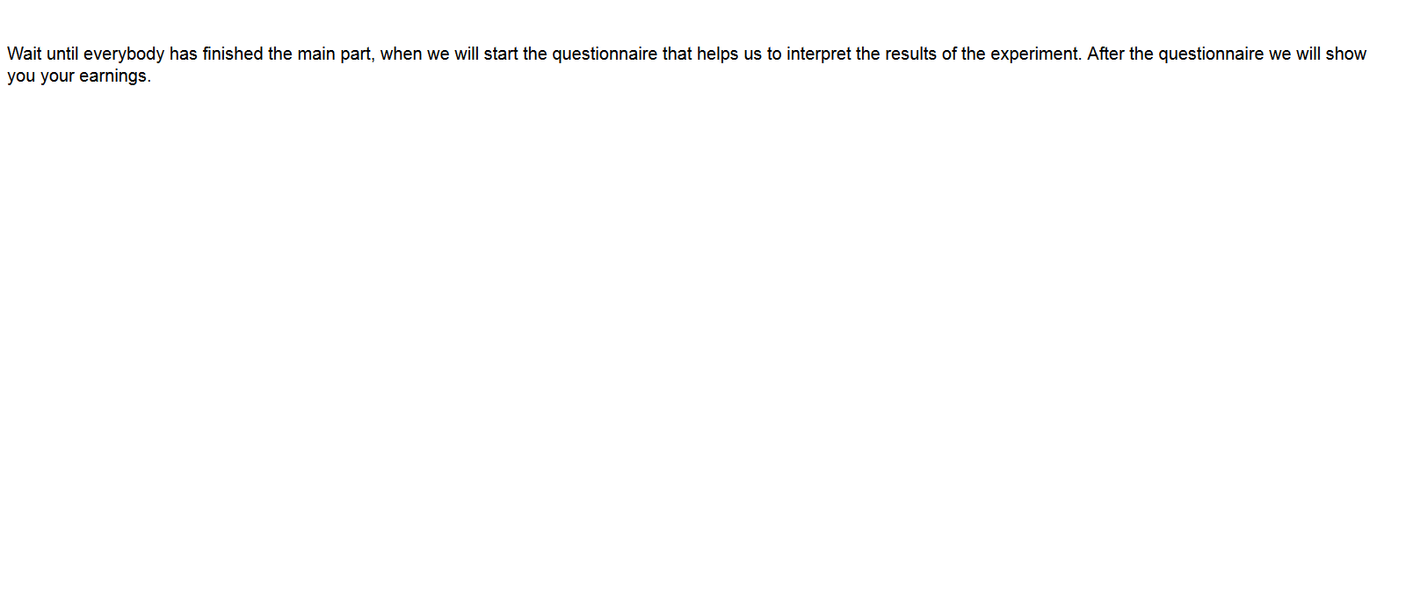

Social Desirability Scale (SDS-16)

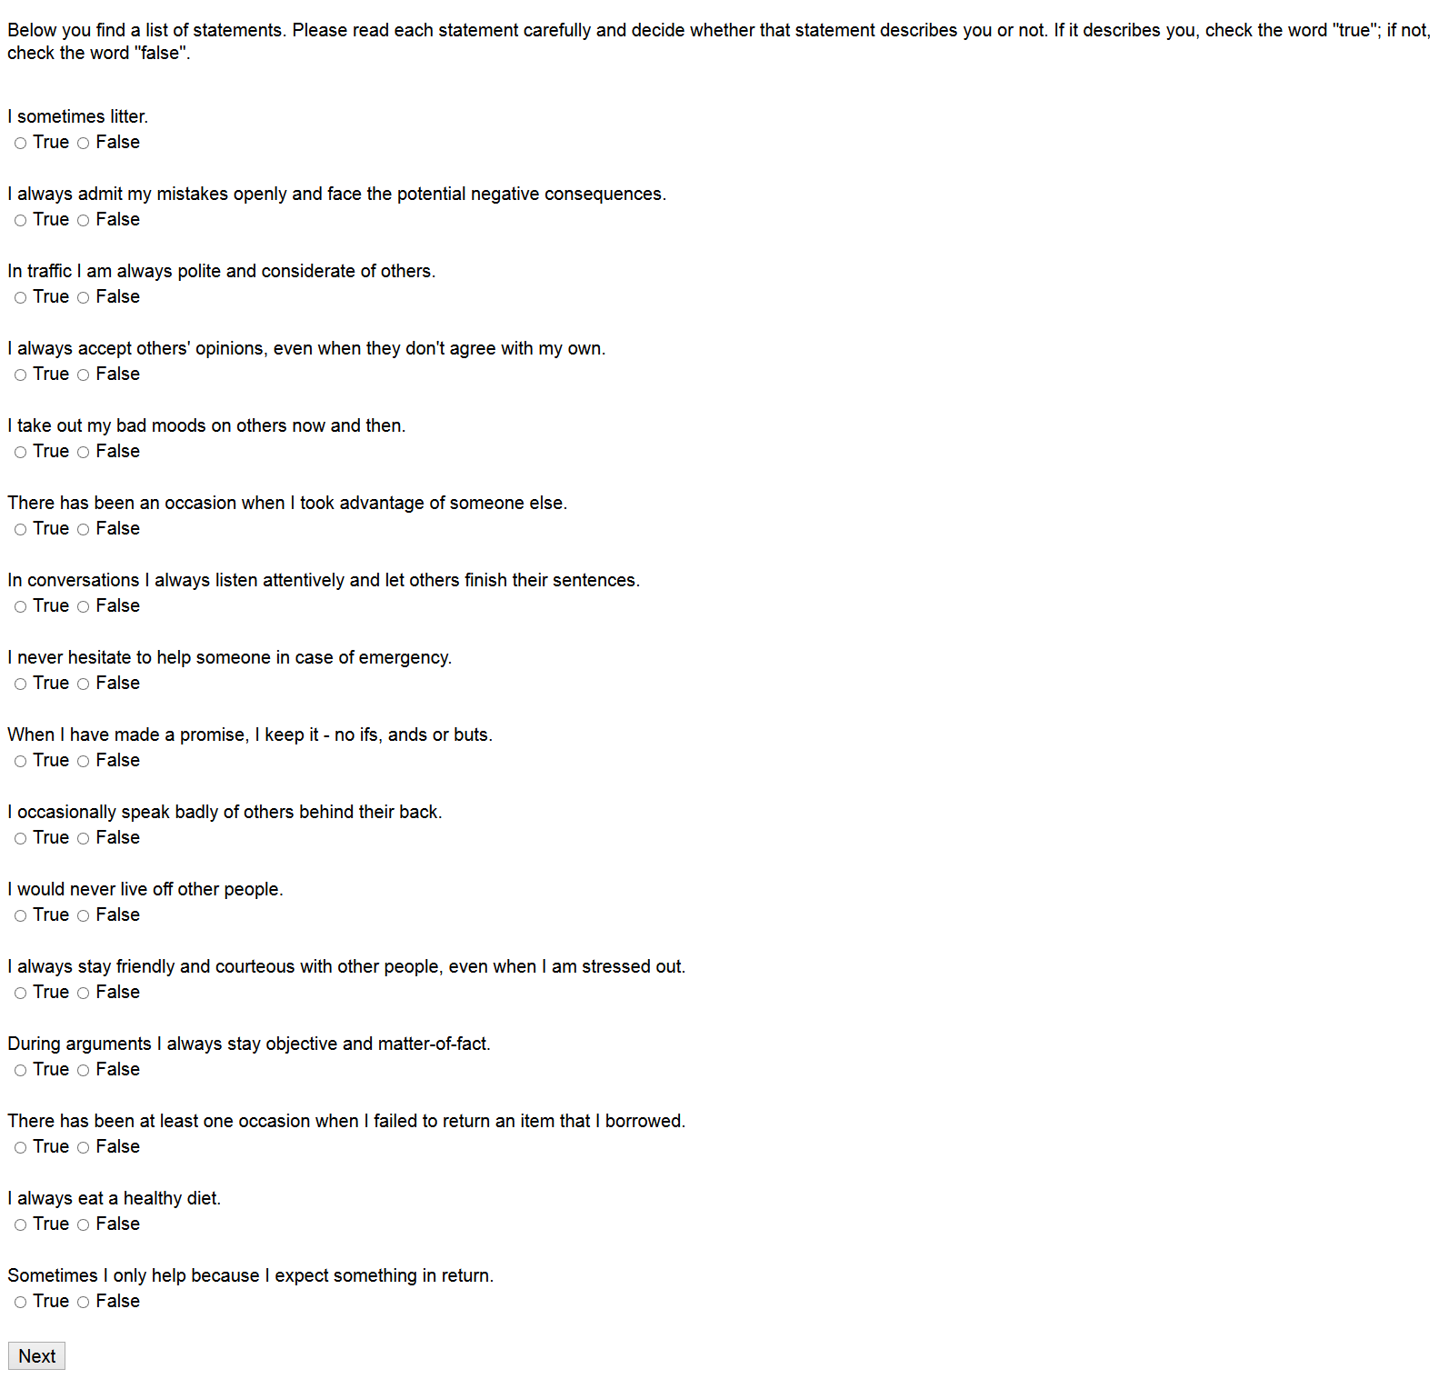

SDS-16 with corrections
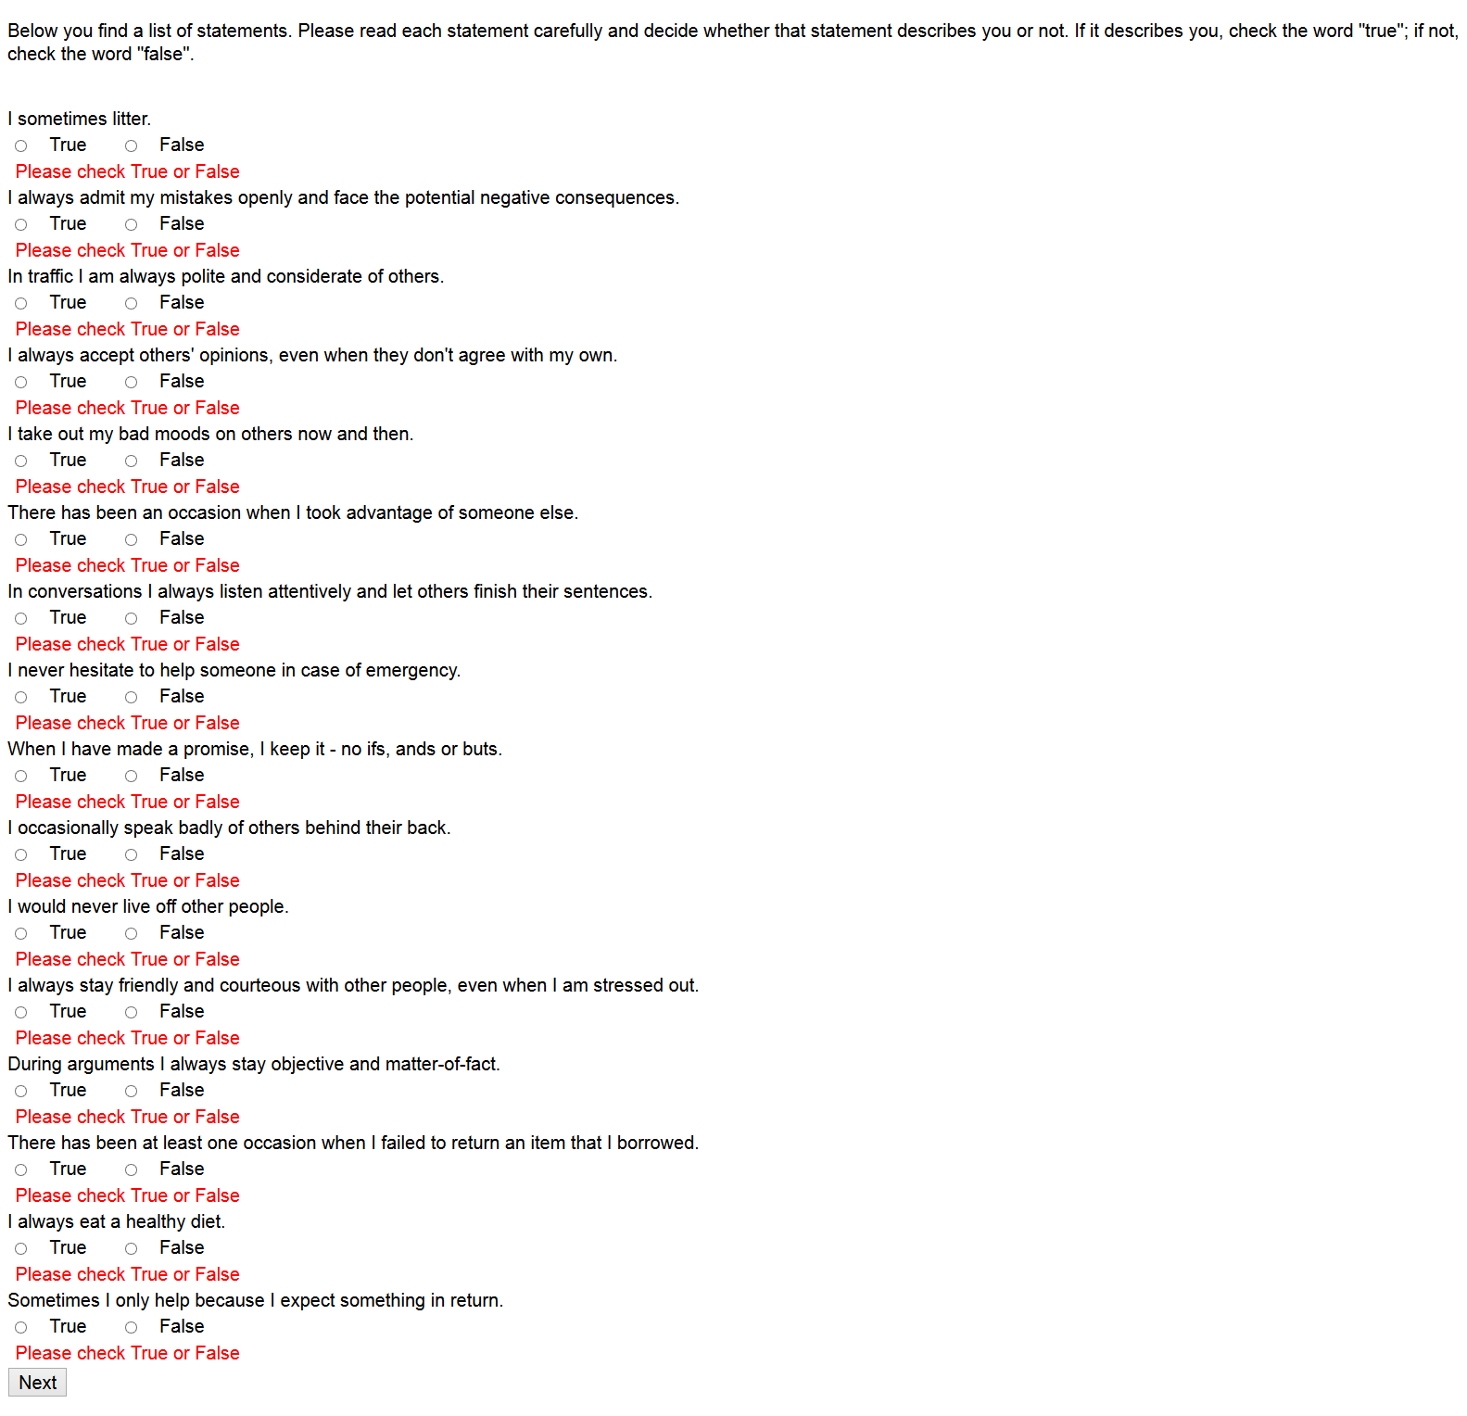

Demographics Screen

Demographics Screen with corrections



Earnings Screen

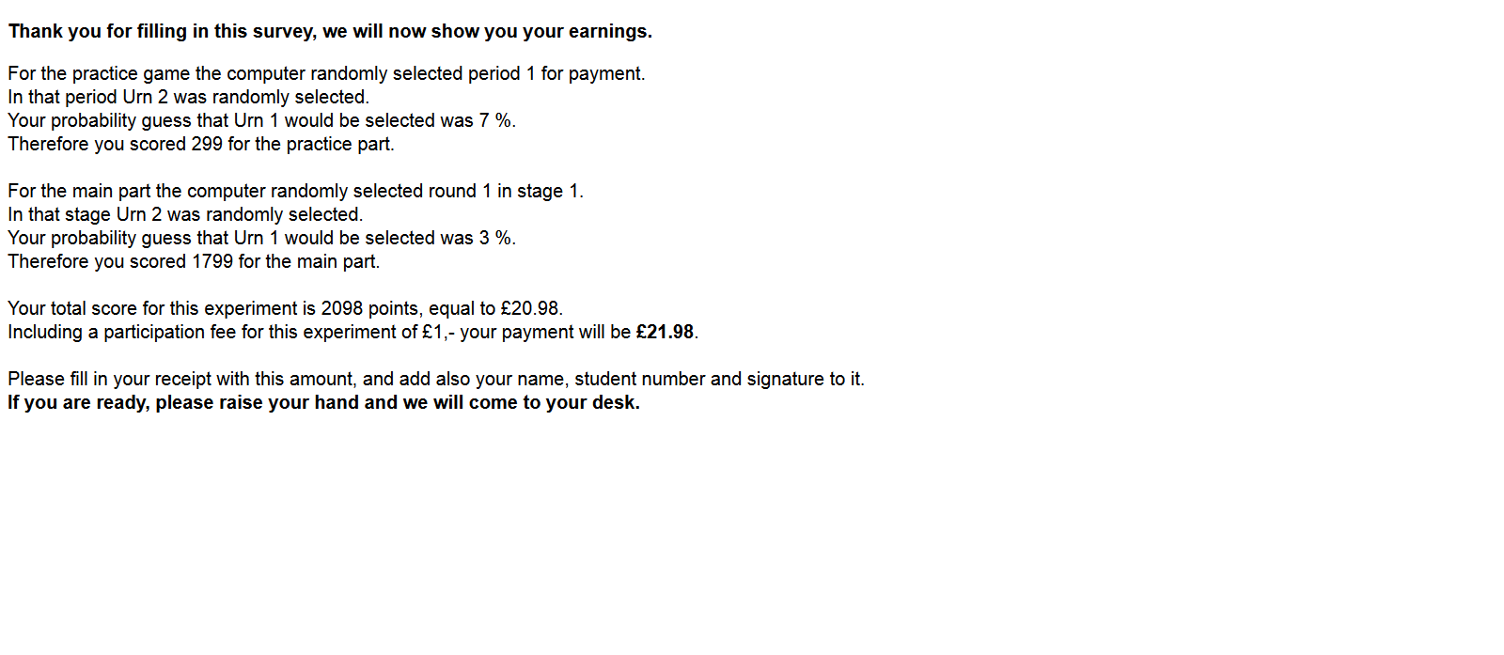

5. - Mean Square Deviation (MSD) analysis

We define SQD as the squared deviation of the observed guess from the corresponding Bayesian prediction. Let the mean square deviation (MSD) be the mean, taken over all decisions, of SQD.

This appendix complements the main paper by presenting a figure plotting SQD by stage and a regression model with SQD as the dependent variable.

The plot of SQD against stage includes a Lowess smoother, which essentially indicates how the MSD varies with stage. This shows that the deviations appear very stable across stages.

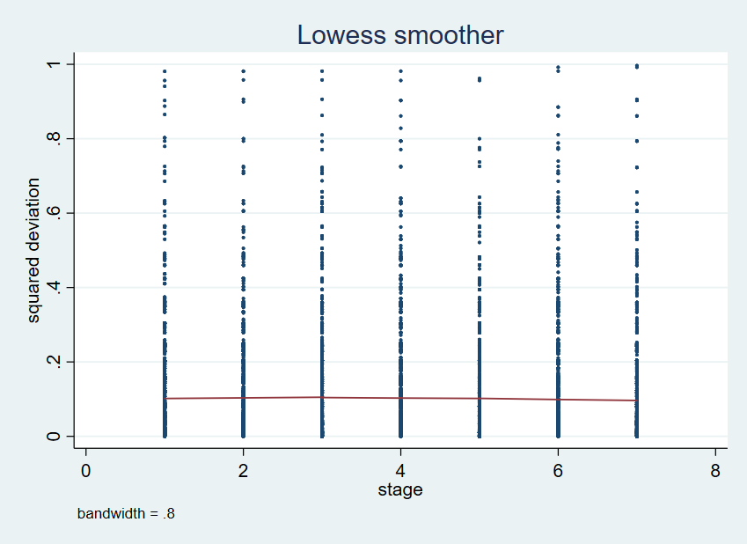

Note: The dots represents SQD for each guess and corresponding Bayesian prediction. The data is shown by stage. The lines are Lowess smoothers, obtained using a tricube weighting function and bandwidth 0.8 (both STATA defaults).

A regression model for SQD infers the stability of MSD in the figure above from the joint insignificance of stage dummies S, and characterizes subject play as the round number (t) progresses. In the following regression, the subscripts for the other non-stage dummies D are: inf for infrequent adjusters (α_{med} ≤ 0.2), fr for frequent adjusters (α_{med} ≥ 0.8), C for complexity treatment, I for inattention treatment. The benchmark constant term when all dummy variables are zero is the first stage in the baseline treatment with middling adjustment (0.2 < α_{med} < 0.8).

$${SQD}_{i}=β_{1}+\sum_{r=2}^{7}{{β_{r}S}_{ri}}+β_{8}.t+β_{9}.D_{infr}+β_{10}.D_{fr}+β_{11}.D_{C}+β_{12}.D_{I}{+β}_{13}.D_{infr}.t+β_{14}.D_{fr}.t+β_{15}.D_{C}.t+β_{16}.D_{I.t}\left(A1\right)$$

Table A5.1 Regression with SQD as dependent variable

Observations | 13,720
R² | 0.0925
F for the regression | F_{15, 244} = 44.6, p=0.0000 **
Coefficient | Estimate (s.e)
Constant | 0.2125** (0.0055)
Stage 2 | 0.0041 (0.0058)
Stage 3 | 0.0021 (0.0061)
Stage 4 | 0.0069 (0.0060)
Stage 5 | -0.0037 (0.0055)
Stage 6 | 0.0020 (0.0060)
Stage 7 | -0.0063 (0.0057)
Round (t) ^{1.} | 0.0143** (0.0013)
Infrequent (α_{med} ≤ 0.2) ^{2.} | 0.0212** (0.0049)
Frequent (α_{med} ≥ 0.8) ^{3.} | 0.0109 (0.0068)
Complexity ^{4.} | 0.0132** (0.0053)
Inattention | 0.0011 (0.0051)
Infrequent × t ^{2.} | -0.0011 (0.0015)
Frequent × t ^{3.} | 0.0053* (0.0025)
Complexity × t ^{5.} | -0.0013 (0.0017)
Inattention × t ^{5.} | 0.0023 (0.0016)
F test on all stages ^{6.} | F (6, 244) = 1.3, p=0.2561

Note: Coefficient estimates for equation (A1) of SQD on rounds and Dummy variables. Robust standard errors adjusted for 245 subjects in clusters. Significance at 5% and 1% denoted * and **.

As marked on the table, tests of significance indicate:

1. MSD increases with round number. This is because the Bayesian prediction starts off near the centre and moves towards the extremes by the end, while the reported probabilities tend to stay nearer the centre.
2. Infrequent changers are responsible for larger deviations (than middling changers), irrespective of round number.
3. Frequent changers are not responsible for larger deviations (than middling changers), but their deviations tend to become larger over rounds.
4. The complexity treatment C is responsible for larger deviations than B and I.
5. There is no interaction between treatment and round.
6. There is no evidence of a difference in deviations of any stage compared with the first stage (p = 0.26), in line with the visual inspection of the figure above.

