Online Appendix Ranehill Weber 2021
Table OA1: Relationships between preferences and performance beliefs on first-period votes
Dependent variable: | Vote in Period 1
 | All |  |  |  |  |  |  |  | Male | Female
 | (1) | (2) | (3) | (4) | (5) | (6) | (7) | (8) | (9) | (10)
Female | 0.190***  (0.049) | 0.177***  (0.048) | 0.189***  (0.047) | 0.166***  (0.047) | 0.183***  (0.047) | 0.161***  (0.050) | 0.122**  (0.049) | 0.186***  (0.049)
Risk condition | 0.136***  (0.049) | 0.142***  (0.049) | 0.123**  (0.049) | 0.136***  (0.048) | 0.133***  (0.048) | 0.135***  (0.048) | 0.105**  (0.047) | 0.132***  (0.048) | 0.116*  (0.069) | 0.072  (0.067)
Risk preferences  (Investment task, standardized) | -0.011  (0.023) |  |  |  |  |  |  |  | 0.007  (0.038) | 0.013  (0.036)
Risk preferences  (Survey question, standardized) |  | -0.040  (0.026) |  |  |  |  |  |  | -0.056  (0.038) | -0.021  (0.037)
Social Value Orientation - Primary  (competitive-altruistic, standardized) |  |  | 0.083***  (0.025) |  |  |  |  |  | 0.024  (0.044) | 0.107***  (0.032)
Social Value Orientation - Secondary  (egalitarian-efficiency, standardized) |  |  |  | -0.075***  (0.019) |  |  |  |  | -0.018  (0.033) | -0.060  (0.037)
Giving  (Survey question, standardized) |  |  |  |  | 0.033  (0.022) |  |  |  | 0.037  (0.030) | -0.008  (0.037)
Competition  (1 = competitive) |  |  |  |  |  | -0.129***  (0.050) |  |  | -0.022  (0.067) | -0.067  (0.090)
Relative performance beliefs  (standardized) |  |  |  |  |  |  | -0.144***  (0.024) |  | -0.135***  (0.036) | -0.112***  (0.034)
Part 2 task performance (standardized) |  |  |  |  |  |  |  | -0.058**  (0.023) | -0.045  (0.028) | 0.019  (0.031)
Constant | -0.049  (0.035) | -0.044  (0.035) | -0.040  (0.035) | -0.036  (0.035) | -0.042  (0.035) | 0.006  (0.040) | 0.001  (0.035) | -0.043  (0.035) | 0.028  (0.046) | 0.144***  (0.051)
Observations | 415 | 415 | 415 | 415 | 415 | 415 | 415 | 415 | 218 | 197
R-squared | 0.063 | 0.069 | 0.091 | 0.085 | 0.067 | 0.076 | 0.144 | 0.077 | 0.158 | 0.185
Estimates from linear regressions. Standard errors (clustered at the group level) in parentheses, *** p<0.01, ** p<0.05, * p<0.1.

Table OA2: Correlations between vote in Period 1 and individual characteristics
 | No Risk |  |  | Risk
 | All | Male | Female | All | Male | Female
Risk (Investment task)  (incentivized 0-100, 100 = risky) | -0.143  (0.043) | -0.147  (0.130) | -0.020  (0.852) | -0.011  (0.877) | 0.057  (0.556) | 0.018  (0.860)
Risk (Survey question)  (non-incentivized 0-10, 10 = risk taking) | -0.215  (0.002) | -0.297  (0.002) | 0.006  (0.956) | -0.051  (0.461) | 0.050  (0.603) | -0.092  (0.353)
Social Value Orientation (Primary)  (Incentivized, -45 = competitive; 90 = altruistic) | 0.181  (0.011) | 0.062  (0.524) | 0.293  (0.004) | 0.181  (0.008) | 0.048  (0.614) | 0.347  (<0.001)
Social Value Orientation (Secondary)  (Incentivized, 0 = egalitarian; 1 = efficiency) | -0.243  (0.001) | -0.169  (0.082) | -0.239  (0.021) | -0.161  (0.018) | -0.024  (0.803) | -0.264  (0.007)
Giving (Survey question)  (non-incentivized, 0-1000, 1000 = generous) | 0.104  (0.142) | 0.038  (0.701) | 0.015  (0.886) | 0.108  (0.115) | 0.115  (0.231) | 0.066  (0.504)
Competitiveness  (0 or 1, 1 = competitive) | -0.232  (0.001) | -0.239  (0.013) | -0.033  (0.757) | -0.124  (0.070) | -0.068  (0.478) | -0.111  (0.263)
Relative performance beliefs  (guessed rank: 0 = worst; 100 = best) | -0.394  (<0.001) | -0.480  (<0.001) | -0.161  (0.122) | -0.283  (<0.001) | -0.194  (0.041) | -0.337  (0.001)
Average performance  (Initial piece rate in Part 2) | -0.171  (0.015) | -0.178  (0.067) | -0.060  (0.567) | -0.108  (0.114) | -0.159  (0.095) | -0.050  (0.618)
Observations | 200 | 107 | 93 | 215 | 111 | 104
Each cell reports the correlation between the corresponding individual-level measure and Period 1 vote. Italics: p<0.05; bold: p<0.01.
Table OA3: The impact of preferences and performance beliefs on votes in Periods 2-10
Dependent variable: | Vote
 | Periods |  |  | Periods 2-10
 | 2-4 | 5-7 | 8-10 | No Risk | Risk
 | (1) | (2) | (3) | (4) | (5)
Female | 0.052  (0.048) | 0.055  (0.055) | 0.092  (0.057) | 0.060  (0.061) | 0.096  (0.072)
Risk condition | 0.187***  (0.044) | 0.171***  (0.048) | 0.117***  (0.048)
Risk preferences  (Investment task, standardized) | 0.005  (0.025) | 0.042  (0.034) | 0.010  (0.031) | -0.014  (0.037) | 0.059  (0.037)
Risk preferences  (Survey question, standardized) | -0.012  (0.022) | -0.021  (0.029) | -0.020  (0.027) | -0.003  (0.031) | -0.033  (0.037)
Social Value Orientation - Primary  (competitive-altruistic, standardized) | 0.014  (0.023) | 0.027  (0.033) | 0.060*  (0.033) | 0.049  (0.045) | 0.028  (0.034)
Social Value Orientation - Secondary  (egalitarian-efficiency, standardized) | -0.026  (0.024) | -0.011  (0.028) | -0.022  (0.024) | 0.006  (0.034) | -0.026  (0.028)
Giving  (Survey question, standardized) | 0.002  (0.021) | 0.013  (0.028) | -0.048*  (0.028) | -0.056*  (0.023) | 0.021  (0.030)
Competition  (1 = competitive) | -0.091*  (0.050) | -0.059  (0.064) | -0.041  (0.062) | -0.072  (0.075) | -0.069  (0.075)
Relative Part 2 performance beliefs  (standardized) | -0.074***  (0.022) | -0.121***  (0.027) | -0.108***  (0.028) | -0.123***  (0.035) | -0.099***  (0.030)
Lagged relative performance  (standardized) | -0.228***  (0.021) | -0.178***  (0.022) | -0.219***  (0.023) | -0.231***  (0.024) | -0.120***  (0.018)
Constant | 0.014  (0.041) | -0.005  (0.045) | 0.000  (0.043) | 0.008  (0.048) | 0.145**  (0.058)
Observations | 1,245 | 1,245 | 1,245 | 1,800 | 1,935
R-squared | 0.384 | 0.331 | 0.378 | 0.526 | 0.267
Estimates from linear regressions with random effects at the subject level. Robust standard errors in parentheses, *** p<0.01, ** p<0.05, * p<0.1.

Figure OA1: An example of policy gaps as a function of individual preference gaps
In the simulation analysis presented above, we assume that men’s preferences are distributed according to a normal distribution, $v^{m} N\left(0,1\right)$, and that women’s preferences are distributed similarly but with a different mean, $v^{f} N\left(θ,1\right)$. Our simulations construct five-person groups at random, classify them as majority male or majority female, and then identify the group’s median preference. This simple stylized example of a group making a collective choice parallels our experiment’s design. In the graph, the horizontal axis shows the mean gender preference gap, $θ$, while the vertical axis presents the mean difference in implemented policies between majority-male and majority-female groups

Figure OA2: Cumulative distributions of first-period votes by gender and condition
Figure OA3. Performance in task over time
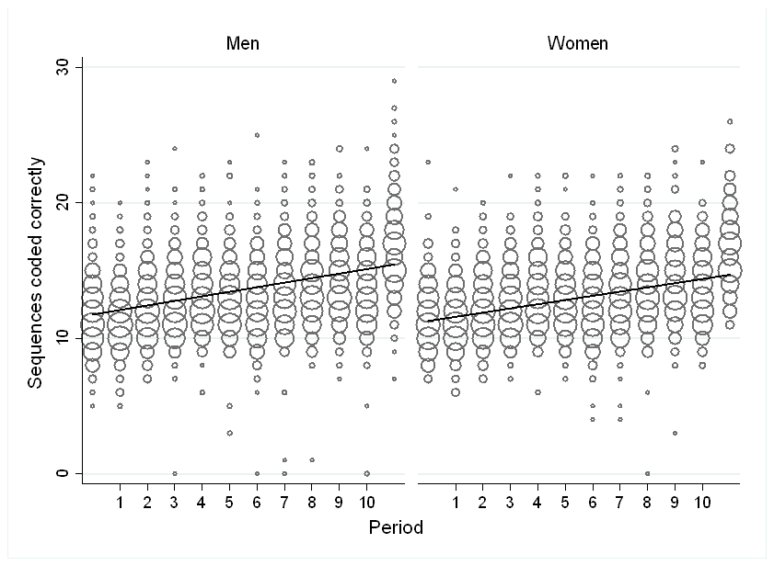

Figure A4. Comparison of votes (first vs. second half of Stage 3)

