Relaxing the symmetry assumption in participation games:
A specification test for cluster-heterogeneity ‡

Alan Kirman François Laisney Paul Pezanis-Christou

APPENDIX

Contents

Appendix I: | Probability of going conditional on $p_{−i}$ | 1
Appendix II: | Derivation of Quantal Response Equilibrium | 2
Appendix III: | Technical details
 | - Estimation of ${\hat{V}}_{T}$ | 3
 | - Determination of derivatives | 3-4
 | - Clustering of probabilities | 4
 | - Regularized minimum distance | 5-10
Appendix IV: | Experimental instructions and exact payoff figures | 11-14
Appendix V: | Observed probabilities of entry (session data) | 15
Appendix VI: | Bar-plots of individual entry probabilities | 16
Appendix VII: | Cluster-estimation outcomes
 | Summary tables (by payoff level) | 17-18
 | - OLS (All rounds) | 19-22
 | - OLS (Last 75 rounds) | 23-26
 | - With(out) regularisation (All rounds) | 27-30

Appendix I: Probability of going conditional on $p_{−i}$.

To provide an expression for $P\left[kgo∨p_{−i}\right]$, we consider the set $I$ individual other than $i$ and a subset $E$ of $I$ of $k$ individuals who enter, and the corresponding set $I∖E$of individuals other than $i$ who do not enter. The probability for this event is $P_{E}=\prod_{j∈E}{p_{j}}\prod_{l∈I}{\left(1−p_{l}\right)},$ and $P\left[kgo∨p_{−i}\right]$ is the sum of these probabilities over the set of such events:

$$P\left[kgo | p_{−i}\right]=\sum_{E}{P_{E}}=\sum_{E}{\prod_{j∊E}{p_{j}}\prod_{l∊I}{\left(1−p_{l}\right)}}.$$

Now consider the derivative of $P\left[kgo∨p_{−i}\right]$ with respect to a component $p_{m}$ of $p_{−i}$. Since each component of $p_{−i}$ appears only once in the product $P_{E}$, we have:

$$\frac{∂P_{E}}{∂p_{m}}$$ | $$\prod_{j∊E}{p_{j}}\prod_{l∊I}{\left(1−p_{l}\right)}$$ | if $m$ is in $E$, and
$$\frac{∂P_{E}}{∂p_{m}}$$ | $$−\prod_{j∊E}{p_{j}}\prod_{l∊\left(I\right)}{\left(1−p_{l}\right)}$$ | if $m$ is not in $E$.

Thus

$$\frac{∂P\left[kgo | p_{−i}\right]}{∂p_{m}}=\sum_{E∍m}{\prod_{j∊E}{p_{j}}\prod_{l∊I}{\left(1−p_{l}\right)}}−\sum_{E∌m}{\prod_{j∊E}{p_{j}}\prod_{l∊\left(I\right)}{\left(1−p_{l}\right)}},$$

and of course
$$\frac{∂P\left[kgo | p_{−i}\right]}{∂p_{i}}=0.$$

Since the probabilistic structure of market-entry games is similar to that of the volunteer’s dilemma and the binary step-level public games, the re-writing of individual probabilities as being conditional on $p_{−i}$ is straightforward for these games.
As for the symmetric voter participation game, the equilibrium participation rate depends on the probability that one’s participation is pivotal (see e.g., Goeree and Holt, 2005), so the re-writing of individual probabilities follows the same logic but requires additional notation to account for two distinct populations of voters.

Appendix II: Derivation of the Quantal Response Equilibrium.

In this appendix we provide the usual arguments for the derivation of a Quantal Response Equilibrium for the congestion game we study. According to QRE, agents make mistakes in their best replies and the latter take account of rivals' mistakes. QRE postulates in particular that each agent has a random utility of his decision which is the payoff plus a "standard error" parameter times a random term. The two random terms corresponding to entering and not entering are assumed to take i.i.d. extreme values, and the payoff is computed as expected payoff given the vector $p_{−i}$ of the probabilities of entering of the other agents. Formally, for agent $i$, we have:

$$U_{i}\left(d=1,p_{−i}\right)$$ | $$π^{E}\left(p_{−i}\right)+σε_{1}$$
and
$$U_{i}\left(d=0,p_{−i}\right)$$ | $$H+σε_{0}$$

Thus, if we denote $p_{i}$ the probability of entering for agent $i$, we have:

$$p_{i}$$ | $$P\left[U_{i}\left(d=1,p_{−i}\right)−U_{i}\left(d=0,p_{−i}\right)≥0\right]$$
 | $$P$$
 | $$\frac{1}{1+exp⁡\{−\frac{1}{σ}\left[π^{E}\left(p_{−i}\right)−H\right]\}}$$

since $\left(ε₁−ε₀\right)$ is logistic. Note that the last expression is identical to (4) up to the reparametrization $1/σ=λ$.

Appendix III: Technical details.

Here we provide the technical details for the implementation of our specification test; namely the estimation of ${\hat{V}}_{T}$,the derivatives ${∂g_{i}\left(p,θ\right)}/{∂p_{i}}$ and ${∂g_{i}\left(p,θ\right)}/{∂p_{j}}$ with $j≠i$, the clustering of agents and the regularization of the minimum distance estimation.

- Estimation of ${\hat{V}}_{T}$

The vector of estimated entry probabilities is ${\hat{p}}_{T}=\sum_{t=1}^{n−1}{{d_{t}}/T}={\hat{d}}_{T}$, with $d_{t}$ the entry vector at $t$, with dimension $n$. We assume independence between agents in each round, thus the variance matrix is diagonal. We estimate each diagonal term using the heteroskedasticity and autocorrelation robust estimator of Newey and West (1987, 1994) with automatic lag selection, using the R program of Zeileis (2004). To illustrate the desirable properties of this procedure, consider a sequence of 75 ones followed by 75 zeroes. Assuming independence yields a variance estimate of 0.5²/149 = 0.00168, whereas the Newey-West procedure yields 0.2483. If instead we consider an alternated sequence of ones and zeroes, we would still have the same variance estimate if assuming independence, whereas the exact variance is 0: the Newey-West procedure yields 1.3e-33.

A problem arises for participants in a session that choose a constant response (entry or non-entry). For them the frequency estimate of entry probability is 0 or 1 and the corresponding variance estimate is 0. In those cases we depart from the frequency estimator and replace it with the mean obtained by replacing one of the $T$ values with ½ (see, e.g., He and Wu, 2009). In order to estimate the variance of the mean we average the Newey-West estimates obtained when moving the ½ value across the $T$ possible positions. With $T=150$ this yields a variance estimate of 1.09e-05.

- Determination of derivatives

For EvE, we have:

$$\frac{{∂g}_{i}\left(p,λ\right)}{∂p_{i}}$$ | $$\frac{1}{p_{i}\left(1−p_{i}\right)}$$
$$\frac{{∂g}_{i}\left(p,λ\right)}{∂p_{j}}$$ | $$−λ\frac{∂π_{i}^{E}\left(p_{−i}\right)}{∂p_{j}}$$

and it is fairly easy to compute ${∂π_{i}^{E}\left(p_{−i}\right)}/{∂p_{j}}$ analytically: for $i≠j$,
$\frac{∂π_{i}^{E}\left(p_{−i}\right)}{∂p_{j}}=\sum_{k=0}^{n−1}{G\left(k+1\right)}\frac{∂P\left[kgo∨p_{−i}\right]}{∂p_{j}}$

For IBE, we have:
$$\frac{{∂g}_{i}\left(p,κ\right)}{∂p_{i}}$$ | $${IMP}^{E}\left(p_{−i}\right)+κ{IMP}^{NE}\left(p_{−i}\right)$$
$$\frac{{∂g}_{i}\left(p,κ\right)}{∂p_{j}}$$ | $$p_{i}\frac{∂{IMP}^{E}\left(p_{−i}\right)}{∂p_{j}}−κ\left(1−p_{i}\right)\frac{∂{IMP}^{NE}\left(p_{−i}\right)}{∂p_{j}}$$

where:
$$\frac{∂{IMP}^{E}\left(p_{−i}\right)}{∂p_{j}}$$ | $$\sum_{k=0}^{n−1}{\frac{∂P\left[kgo | p_{−i}\right]}{∂p_{j}}}G\left(k+1\right)I_{\left\{G\left(k+1\right)>H\right\}},$$
and
$$\frac{∂{IMP}^{NE}\left(p_{−i}\right)}{∂p_{j}}$$ | $$−H\sum_{k=0}^{n−1}{\frac{∂P\left[kgo | p_{−i}\right]}{∂p_{j}}}I_{\left\{G\left(k+1\right)>H\right\}}.$$

The computation of $∂P{\left[kgo | p_{−i}\right]}/∂p_{j}$, was discussed in Appendix 2.

- Clustering the probabilities

When allowing for heterogeneous $θ$ parameters we need to determine groups of agents that will share a common value of $θ$ (allowing all values to differ would amount to a simple reparamerization from p to $θ$ as in the aggregate case). One possibility to do this would be to cluster the $\left(x,y\right)$ vectors defined below equation (10), but this would lead to different groupings for IBE and QRE. Therefore we cluster the entry probabilities p using the kmeans procedure with 20 random initial values. We do not a priori exclude the possibility that a group contains only one value. In such a case we have exact identification for the parameter of the singleton, and over-identification for the parameters for the other groups (assuming only one singleton). The results of Kodde, Palm and Pfann (1985) show that the minimum distance estimate for the $θ$ values for the other groups will be the same if we estimate all parameters simultaneously or only the overidentified parameters, whereas simultaneous estimation will lead to efficiency gains for the exactly identified parameter. (This applies to the optimal estimator, i.e. the GLS estimator: for the OLS estimator, which corresponds to $S=I$ in equation (11), there is no difference between separate estimation for each cluster and simultaneous estimation).

- Regularized minimum distance estimation.

We first document the need for regularization. Table A shows OLS and GLS results for one treatment (NOM1 high) and one group (2) and also a regularized estimator.
The column headed “condition number” gives the quotient of the largest to the smallest eigenvalue of the weighting matrix S in equation (11). For the GLS estimate for QRE, it is extremely large and it translates in an exaggerated (estimated) relative efficiency gain with respect to OLS. For IBE, none of these values is especially alarming, but the estimate is negative, and makes no economic sense. Thus in both cases we need some kind of regularization.
One possibility to regularize matrix $S$, termed "naïve" in the sequel, consists in loading the diagonal with a positive number $α$. We thus replace $S$ with
$S_{N}\left(α\right)=S+αI$,
with $I$ the identity matrix. If $λ$ is an eigenvalue of $S$ the corresponding eigenvalue of $S_{N}\left(α\right)$ is $λ+α$. By letting $α$ grow we thus move gradually from the GLS estimator to the OLS estimator (note that in equation (11) $S$ appears in two places, so that if $S_{N}\left(α\right)$ tends to $αI$, (11) with $S_{N}\left(α\right)$ in place of $S$ yields the OLS estimator).
Note also that the eigenvalues of $S_{N}\left(α\right)$ are in the same order as the eigenvalues of $S$, and that the condition number of $S_{N}\left(α\right)$ declines monotonically with $α$.
Moreover, all estimators in the sequence are consistent, since (11) yields a consistent estimator regardless of the choice of the weighting matrix.
Table III.D.1: Estimates for Session 2 of NOM1 (High)
Model | Estimator | Coefficient |  | Confidence  interval |  | Condition  number ª | Relative efficiency % OLS b |  | α c |  | Spec. test  p-value
QRE
 | OLS | 3.453 |  | [1.772, 5.134] |  |  |  |  |  |  | .010
 | GLS | 1.995 |  | [1.923, 2.067] |  | 9235 | 540 |  | 0 |  | 1.6e-5
 | Tikhonov | 2.495 |  | [2.165, 2.825] |  | 206.8 | 25.9 |  | 12.6 |  | 6.2e-4
IBE
 | OLS | 0.841 |  | [0.620, 1.062] |  |  |  |  |  |  | 4.0e-60
 | GLS | -0.244 |  | [-.288, -.199] |  | 384 | 24.7 |  | 0 |  | 1.7e-108
 | Tikhonov | 2.636 |  | [2.371, 2.968] |  | 13.05 | 1.51 |  | 0.2 |  | 0
Note: ª: quotient of the largest to the smallest eigenvalue of the weighting matrix S in equation (11), after regularization if α > 0 ; ^{b}: this can be interpreted as the multiple of the number of observations needed to reach the same precision with OLS; ^{c}: amount of regularization yielding the estimator.
Another possibility with better theoretical grounding, advocated by Sokullu (2020) for minimum distance estimation, is to use the Tikhonov regularization of $S^{−1}$
$$S_{T}\left(α\right)={\left(S^{'}S+αI\right)}^{−1}S.$$
With $S=PLP'$ the spectral decomposition of $S$ ($P$ is the orthonormal matrix of eigenvectors of $S$, so that $P'P=I$, and $L$ is the diagonal matrix with the eigenvalues on the diagonal)
$$S_{T}\left(α\right)={\left({PLP}^{'}PLP'+αI\right)}^{−1}PLP^{'}=P{\left(L^{2}+αI\right)}^{−1}P^{'}PLP^{'}=PDP'$$
with $D$ diagonal with diagonal elements $λ/{\left(λ^{2}+α\right)}$. Note that if $λ=0$ and $α>0$ tends to $0$, then the corresponding diagonal element of $D$ tends to 0, while it tends to $+∞$ if $α=0$ and $λ$ tends to 0. Actually, with $α>0$ tending to 0 the Tikhonov regularization tends to the Moore-Penrose generalized inverse obtained by inverting the non-zero eigenvalues and keeping zeroes on the diagonal where $S$ has zeroes.
Note that, contrary to the naïve regularization, the eigenvalues of $S_{T}\left(α\right)$ are not in the same order as the eigenvalues of $S^{−1}$ (it is easy to check that if $λ_{i}>λ_{j}$ then $D_{ii}<D_{jj}$ iff $α<λ_{i}λ_{j}$) and the condition number of $S_{T}\left(α\right)$ does not decline monotonically with $α$.
In Table A we see that quite a large amount of regularization was used in producing the reported estimate for QRE. In many cases however, a small amount of Tikhonov regularization suffices to obtain a well-behaved regularized inverse, as here for IBE.
The next topic we discuss is the choice of $α$ but before turning to it we give the form of the test statistic applying to any choice of the weighting matrix $W$:
${Tg}^{'}\left({\hat{p}}_{T},{\hat{θ}}_{T}\right){\left[V_{asy}\left(\sqrt{T}g\left({\hat{p}}_{T},{\hat{θ}}_{T}\right)\right)\right]}^{−}$ $g\left({\hat{p}}_{T},{\hat{θ}}_{T}\right)≈χ^{2}$,
with
$${\hat{θ}}_{T}=$$ | $${\left[x^{'}\left(p\right)Wx\left(p\right)\right]}^{−1}x^{'}\left(p\right)Wy\left(p\right).$$
$$V_{asy}\left(\sqrt{T}g\left({\hat{p}}_{T},{\hat{θ}}_{T}\right)\right)=$$ | $$\left(I−M\right)\frac{∂g\left({\hat{p}}_{T},{\hat{θ}}_{T}\right)}{∂p^{'}}V\frac{∂g^{'}\left({\hat{p}}_{T},{\hat{θ}}_{T}\right)}{∂p}{\left(I−M\right)}^{'},$$
where M is the orthogonal projector on $x\left(p\right)$ for the scalar product with matrix W:
$$M={x\left(p\right)\left[x^{'}\left(p\right)Wx\left(p\right)\right]}^{−1}x^{'}\left(p\right)W.$$
The value of the test statistic does not depend of the choice of the generalized inverse of $V_{asy}\left(\sqrt{T}g\left({\hat{p}}_{T},{\hat{θ}}_{T}\right)\right)$ and for the GLS estimator both expression (12) and the one given here yield the same result. This one is more general, though, because it also applies to the clustered case (with an abuse of notation, because $x\left(p\right)$ now denotes an $n×K$ matrix with each column being the Hadamard product of the original $x\left(p\right)$with the indicator of the corresponding cluster).
All these claims may be checked in Chapter 18 of Gouriéroux and Monfort (1995), and their property 18.11 shows that all these test statistics depending on the choice of $W$ are asymptotically equivalent. It turns out that if we compute the test statistic using all functions of $θ$ (except $g$ of course) at the OLS estimate ${\tilde{θ}}_{T}$rather than at ${\hat{θ}}_{T}$, which is asymptotically valid by Slutsky’s theorem, the test statistic coincides with the one for the choice $W=I$, and thus all test statistics are equal. Thus, in order to obtain the gain in power associated with a more precise estimator, we must evaluate all functions of $θ$ in the test statistic (except $g$) at ${\hat{θ}}_{T}.$ This search for gains in power is also the reason why we cannot simply rely on the more simple OLS estimator. Note that in Table A the p-value (last column) decreases when the efficiency of the estimator increases, which is associated with a gain in the power of the test.
The variance of the estimator also needs adjustment when we use weighting matrix $W$ rather than the optimal weighting matrix $S^{−1}$ corresponding to GLS:
$\hat{V_{asy}\left({\hat{θ}}_{T}\right)}={\left[x^{'}\left({\hat{p}}_{T}\right)Wx\left({\hat{p}}_{T}\right)\right]}^{−1}x^{'}\left({\hat{p}}_{T}\right)\frac{∂g\left({\hat{p}}_{T}{\tilde{θ}}_{T}\right)}{∂p'}V\frac{∂g'\left({\hat{p}}_{T},{\tilde{θ}}_{T}\right)}{∂p}x\left({\hat{p}}_{T}\right){\left[x^{'}\left({\hat{p}}_{T}\right)Wx\left({\hat{p}}_{T}\right)\right]}^{−1}$.
Again, for the GLS estimator both this expression and the one given above equation (12) yield the same result, since then
$W=\frac{∂g\left({\hat{p}}_{T}{\tilde{θ}}_{T}\right)}{∂p'}V\frac{∂g'\left({\hat{p}}_{T},{\tilde{θ}}_{T}\right)}{∂p}$.
Choice of $α$ and more generally, choice of the preferred estimate

Considering both types of regularization and also the possibility to write the restriction $y\left(p\right)−θx\left(p\right)=g\left(p,θ\right)=0$ in terms of $ψ=1/θ$ as $x\left(p\right)−ψy\left(p\right)=g\left(p,ψ\right)=0,$ we have a host of estimates to choose from – and all of them are statistically valid, in the sense that they are consistent.
A first choice we made was to define a grid of values for the regularization parameter $α$. We chose the same initial grid for both types of regularization and for all treatments, sessions and models (QRE, IBE and the inverse models described above). The grid is obtained from the digits 1 to 9 multiplied by powers of 10 ranging from 10⁻³ to 10³. We thus consider 63 values ranging from .001 to 9000, plus the value 0, which corresponds to GLS.
We then performed cross-validation in the following way, described for the full set of observations ($T=150$ periods). We first created 11 “training” subsets of 100 consecutive periods, the first one starting at period 1, the second one at period 6, and the last one at period 51. The remaining observations constitute the corresponding “test” subset. (When looking at results obtained for only the first or last 100 observations, we used six training subsets of 75 observations.)
For each of the training sets we conduct the estimation for the 64 separate values of $α$ in the initial grid. For each $α$ we compute the $n=10$ prediction errors on the test subset, as well as the root mean square error (RMSE) and the mean absolute error (MAE). For each of these two measures we then compute the mean and the standard deviation over the 11 training sets and record two values of $α$: the value yielding the minimum of the mean measure and the first value yielding a measure within a standard deviation of that minimum. The idea here is that the minimum might yield a too drastic regularization. This yields four remarkable values of $α$ labelled $α_{rmse1}$, $α_{rmse2}$, $α_{mae1}$ and $α_{mae2}$ — the index 1 referring to the smaller one. For the Tikhonov regularization, a fifth remarkable value is the one yielding the minimum of the median (across the training samples) of the condition number of matrix $S_{T}\left(α\right)$, and we call this $α_{CNmin}$.
We then narrow the grid in the following way: we extend the range of vector $\left(α_{rmse1},α_{rmse2},α_{mae1},α_{mae2},α_{CNmin}\right)$ by considering up to five values from the initial grid on each side (obviously no such extension is possible if some of the remarkable values are at or near the bounds of the grid) and take as new grid 256 equally spaced values in this interval, taking care to include also the values $α_{rmse1}$, $α_{rmse2}$, $α_{mae1}$, $α_{mae2}$ and $α_{CNmin}$. We thus now examine at most 261 different values of α and repeat the procedure above, which yields a new vector $\left(α_{rmse1},α_{rmse2},α_{mae1},α_{mae2},α_{CNmin}\right)$.
Figure I shows the details for the estimation of model QRE for Session 2 of treatment NOM1 High with Tikhonov regularization. The first two panels pertain to the original grid of 64 values of $α$ ranging from 0 to 9000, the next two to the narrowed grid, here 258 values ranging from 0.6 to 800 (0.003 to 9 for the inverse model). The horizontal axis shows the index of each value of $α$ rather than the value itself (this is necessary for legibility of the graphs). The first panel shows how the median value of CN evolves with $α$ (solid line). The dashed lines correspond to the 20% and 80% quantiles. The horizontal line is at the value 1000, the maximum value we chose to accept for CN. For a square matrix of order 10, this shows a very large discrepancy between the maximum and minimum eigenvalue. The second panel shows the mean RMSE plus/minus one standard deviation as functions of $α$ (three solid lines), and the analogue for MAE (three dashed lines). The horizontal lines show the minimum of the mean measure and the first value within a standard deviation of that minimum (both may coincide for the original grid, where values of $α$ with high indices are far apart). These explanations apply also to panels 3 and 4. In panel 3, note that CN takes smaller values for the narrowed grid than for the original grid.
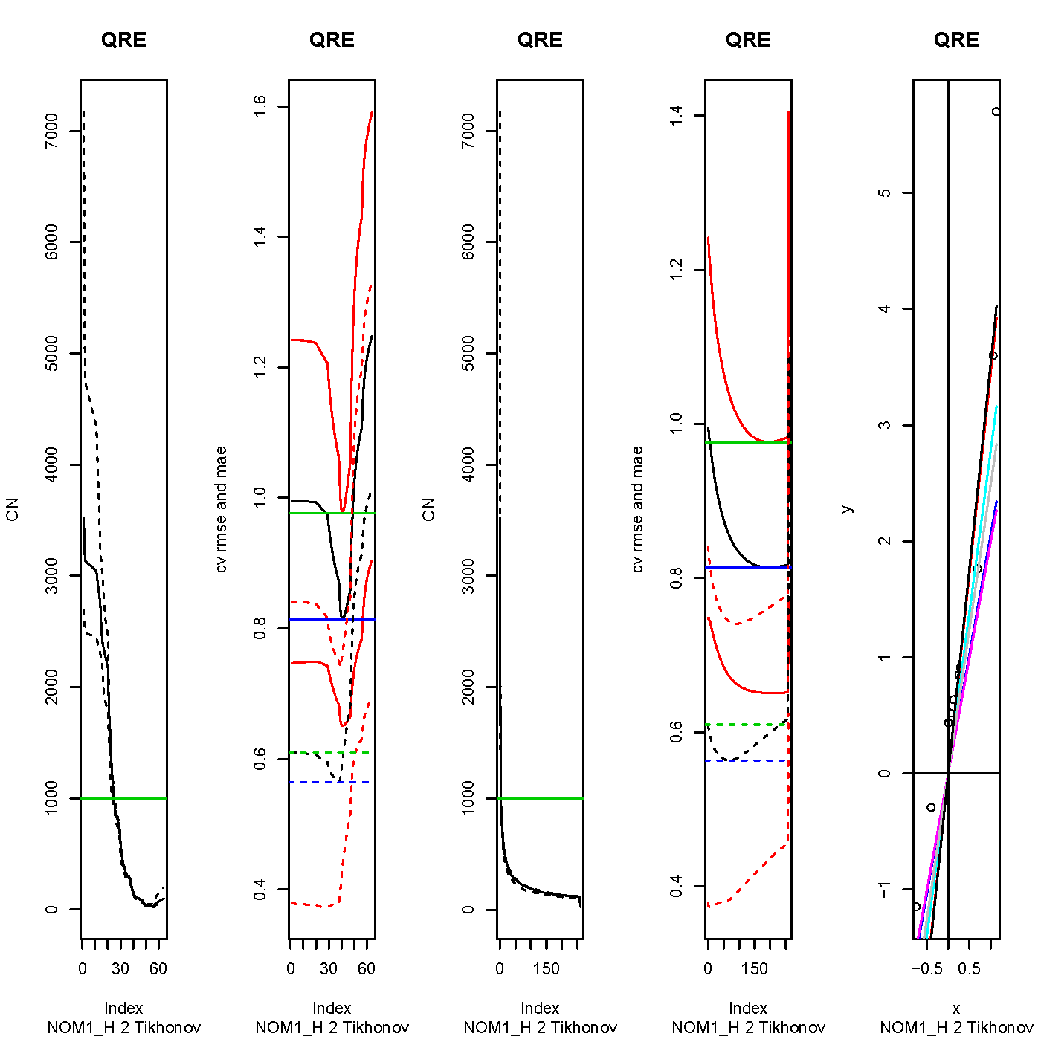
Figure III.D.1: Tikhonov Regularization of QRE estimates
for Session 2 of Treatment NOM1 High.

Panel 5 shows the ten points $\left(x\left(p\right),y\left(p\right)\right)$ and the seven estimates of $λ$ (OLS, GLS and the five regularized estimates corresponding to $α_{rmse1}$, $α_{rmse2}$, $α_{mae1}$, $α_{mae2}$ and $α_{CNmin}$, which are the slopes of the seven lines going through the origin). The values are given in Table B. The constellation NOM1 High Session 2 is the only one (for $T=150$) for which an individual always enters, and for which we had to depart from the frequency estimator, as explained in the subsection Estimation of ${\hat{V}}_{T}$ above. Still, the scatter plot $\left(x\left(p\right),y\left(p\right)\right)$ exhibits no pathological feature.
A comparison with Figure II for IBE and the same data shows (panel 5) that we can expect a line through the origin to fit QRE more easily than IBE, because in the latter case the scatter $\left(x\left(p\right),y\left(p\right)\right)$ has a decreasing shape.
In panels 1 and 3, we see that CN takes lower values for IBE than for QRE. While this is not the case for all treatments and groups, it is for most of them. For IBE the narrowed grid for this instance ranges from 0 to 800 (0 to 200 for the inverse model, the model for which we report the regularized estimate in Table A).
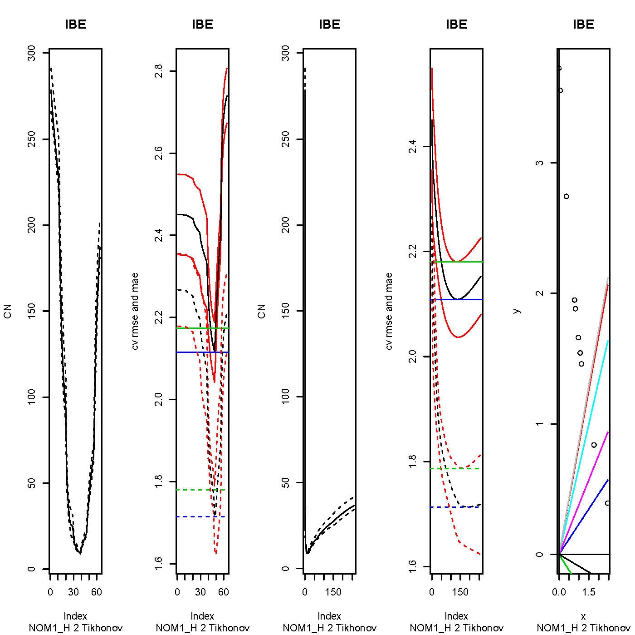
Figure III.D.2: Tikhonov Regularization of IBE estimates
for Session 2 of Treatment NOM1 High.

As an afterthought, we also looked at the Tikhonov estimate corresponding to the minimum of CN on the full sample, and denote by $α_{CNMIN}$ the corresponding value of $α$ (whereas $α_{CNmin}$ corresponds to the minimum of the median of CN across the training samples). Had we have this idea earlier, we would have used this as the upper value in the grid, since there is no point in considering higher values. In some cases $α_{CNMIN}$ yields the preferred estimate.
In Table B we show the regularized direct estimates for QRE. As $α_{mae1}$ is zero, the corresponding estimate is the GLS estimate. The other estimates are clearly preferable to both the OLS and GLS estimates reported in Table A. Our preferred estimate corresponds to $α_{mae2}$: while $α_{rmse1}$ yields a higher efficiency w.r.t. OLS (98.2 vs. 25.9) we do not really trust such a large value and fall back on the most precise one in the remaining list. Note that the $α_{CNmin}$ estimate ought to be discarded, because $α_{CNmin}$ (800) exceeds $α_{CNMIN}$ (235).
In practice we do not look at all estimates as we did here, but discard those that are negative, or correspond to $α>α_{CNMIN}$, or present a CN above 1000, or a relative efficiency w.r.t. OLS above 100 – the relative efficiency can be read as the multiple of the number of observations needed to reach the same precision with OLS as with the estimator under review – or lower efficiency than OLS. For QRE here this only reduces the number of estimates to consider from eight to five, but there are still the naïve regularization and the indirect estimates to consider. Unfortunately, we have not come up with a simple way to automatize the final choice.
For indirect estimates – using the restriction $x\left(p\right)−ψy\left(p\right)=0$ – we still report the results in terms of$θ=1/ψ.$ If the bounds of the (symmetric) confidence interval for $ψ$ are both positive we obtain a valid (asymmetric) confidence interval for $θ$ – in the sense that it has the correct asymptotic covering probability – by inverting and permuting those. Otherwise we report (symmetric) confidence intervals based on the delta method.
In our inferences we ignore the uncertainty associated with the choice of the estimate. Bootstrapping the whole procedure would not be feasible and we do not expect that it would lead to qualitatively different results.
Table III.D.2: Tikhonov Regularized QRE Estimates For Session 2 of NOM1 (High)
Estimator | Coefficient |  | Confidence  interval |  |  | Condition  number ª |  | Relative efficiency % OLS b | α c |  | Spec. test  p-value
α_{rmse1} | 2.063 |  | [1.894, 2.233] |  |  | 774.5 |  | 98.2 | 0.9 |  | 9.5e-6
α_{rmse2} | 2.786 |  | [2.349, 3.223] |  |  | 119.4 |  | 14.8 | 38.0 |  | .0026
α_{mae1} | 1.995 |  | [1.923, 2.067] |  |  | 9235 |  | 540 | 0 |  | 1.6e-5
α_{mae2} | 2.495 |  | [2.165, 2.825] |  |  | 206.8 |  | 25.9 | 12.6 |  | 6.2e-4
α_{CNmin} | 3.543 |  | [2.816, 4.270] |  |  | 71.0 |  | 5.3 | 800 |  | .010
α_{CNMIN} | 3.187 |  | [2.624, 3.750] |  |  | 47.9 |  | 8.9 | 235 |  | .009
Note: ª: quotient of the largest to the smallest eigenvalue of the weighting matrix S in equation (11), after regularization if α > 0 ; ^{b}: this can be interpreted as the multiple of the number of observations needed to reach the same precision with OLS; ^{c}: amount of regularization yielding the estimator.

Appendix IV: Experimental Instructions
A. Treatment DISC (Low)
You are about to participate in an experiment on decision-making. In this experiment, there are 2 groups of 10 people. You are in one of those 2 groups and you do not know who else is in the same group as you. You will be in the same group of people for the whole experiment.
Please do not communicate in any way with other participants during the experiment.
The experiment is made of 150 rounds of a game that proceeds as follows:
1. In each round, you are asked to choose action A or action B. Once all participants have chosen their actions, the computer will calculate the total number of participants in your group who chose B.
2. The payoff you receive from choosing A or B is determined the following way:
• If you chose A, you will earn 400 points, whatever the other participants in your group have chosen.
• If you chose B and the total number of participants in your group who chose B is less than or equal to 6, then all participants in your group who chose B earn 800 points.
• If you chose B and the total number of participants in your group who chose B is more than 6, then all participants in your group who chose B will earn 0 points.
3. At the end of each round, you will be given the following information/feedback about the round you just played (the round number, the choice you made, how many times action B was chosen in your group, the profit you made in that round and the total profits you made so far),
4. At any time during the experiment, the outcomes of all previous rounds in which you played are displayed on the lower part of your terminal screen.
5. You are allowed to use the calculator we provide you with at the outset of the experiment.
6. The payoffs you earn in each round are quoted in terms of "points". Your reward from participating in this experiment is determined by the sum of your payoffs in points. Your total payoff in points will be exchanged for Euros (€) and paid in cash to you at the end of the experiment at the rate of 0.02 € per 100 points.
7. All other participants in this room received the same instruction sheet.

Please raise your hand if something is unclear or if you have a question to ask.

B. Treatment NOM1 (Low)
You are about to participate in an experiment on decision-making. In this experiment, there are 2 groups of 10 people. You are in one of those 2 groups and you do not know who else is in the same group as you. You will be in the same group of people for the whole experiment.
Please do not communicate in any way with other participants during the experiment.
The experiment is made of 150 rounds of a game that proceeds as follows:
1. In each round, you are asked to choose action A or action B. Once all participants have chosen their actions, the computer will calculate the total number of participants in your group who chose B.
2. The payoff you receive from choosing A or B is determined the following way:
- If you chose A, you will earn 400 points, whatever the other participants in your group have chosen.
- If you chose B and the total number of participants in your group who chose B is equal to:
  - Then all participants in your group who chose B will earn 467 points,
  - Then all participants in your group who chose B will earn 733 points,
  - Then all participants in your group who chose B will earn 867 points,
  - Then all participants in your group who chose B will earn 1067 points,
  - Then all participants in your group who chose B will earn 800 points,
  - Then all participants in your group who chose B will earn 467 points,
  - Then all participants in your group who chose B will earn 200 points,
  - Then all participants in your group who chose B will earn 132 points,
  - Then all participants in your group who chose B will earn 67 points,
  - Then all participants in your group who chose B will earn 0 points,

3. At the end of each round, you will be given the following information/feedback about the round you just played (the round number, the choice you made, how many times action B was chosen in your group, the profit you made in that round and the total profits you made so far),
4. At any time during the experiment, the outcomes of all previous rounds in which you played are displayed on the lower part of your terminal screen.
5. You are allowed to use the calculator we provide you with at the outset of the experiment.
6. The payoffs you earn in each round are quoted in terms of "points". Your reward from participating in this experiment is determined by the sum of your payoffs in points. Your total payoff in points will be exchanged for Euros (€) and paid in cash to you at the end of the experiment at the rate of 0.02 € per 100 points.
7. All other participants in this room received the same instruction sheet.
Please raise your hand if something is unclear or if you have a question to ask.

C. Treatment NOM2 (Low)
You are about to participate in an experiment on decision-making. In this experiment, there are 2 groups of 10 people. You are in one of those 2 groups and you do not know who else is in the same group as you. You will be in the same group of people for the whole experiment.
Please do not communicate in any way with other participants during the experiment.
The experiment is made of 150 rounds of a game that proceeds as follows:
1. In each round, you are asked to choose action A or action B. Once all participants have chosen their actions, the computer will calculate the total number of participants in your group who chose B.
2. The payoff you receive from choosing A or B is determined the following way:
- If you chose A, you will earn 400 points, whatever the other participants in your group have chosen.
- If you chose B and the total number of participants in your group who chose B is equal to:
- Then all participants in your group who chose B will earn 133 points,
- Then all participants in your group who chose B will earn 667 points,
- Then all participants in your group who chose B will earn 1000 points,
- Then all participants in your group who chose B will earn 1267 points,
- Then all participants in your group who chose B will earn 867 points,
- Then all participants in your group who chose B will earn 467 points,
- Then all participants in your group who chose B will earn 200 points,
- Then all participants in your group who chose B will earn 132 points,
- Then all participants in your group who chose B will earn 67 points,
- Then all participants in your group who chose B will earn 0 points.

3. At the end of each round, you will be given the following information/feedback about the round you just played (the round number, the choice you made, how many times action B was chosen in your group, the profit you made in that round and the total profits you made so far),
4. At any time during the experiment, the outcomes of all previous rounds in which you played are displayed on the lower part of your terminal screen.
5. You are allowed to use the calculator we provide you with at the outset of the experiment.
6. The payoffs you earn in each round are quoted in terms of "points". Your reward from participating in this experiment is determined by the sum of your payoffs in points. Your total payoff in points will be exchanged for Euros (€) and paid in cash to you at the end of the experiment at the rate of 0.02 € per 100 points.
7. All other participants in this room received the same instruction sheet.

Please raise your hand if something is unclear or if you have a question to ask.
D. Exact payoff figures.
The instructions for the High payoff treatments were identical to those used for the Low payoff treatments but used the payoff figures listed below.

 |  |  | Payoff Data
No entry | Attendance | DISC High | DISC Low | NOM1 High | NOM1 Low | NOM2 High | NOM2 Low
400 | 1 | 1200 | 800 | 700 | 467 | 200 | 133
400 | 2 | 1200 | 800 | 1100 | 733 | 1000 | 667
400 | 3 | 1200 | 800 | 1300 | 867 | 1500 | 1000
400 | 4 | 1200 | 800 | 1600 | 1067 | 1900 | 1267
400 | 5 | 1200 | 800 | 1200 | 800 | 1300 | 867
400 | 6 | 1200 | 800 | 700 | 467 | 700 | 467
400 | 7 | 0 | 0 | 300 | 200 | 300 | 200
400 | 8 | 0 | 0 | 200 | 132 | 200 | 132
400 | 9 | 0 | 0 | 100 | 67 | 100 | 67
400 | 10 | 0 | 0 | 0 | 0 | 0 | 0

Appendix V: Observed probabilities of entry (session data).

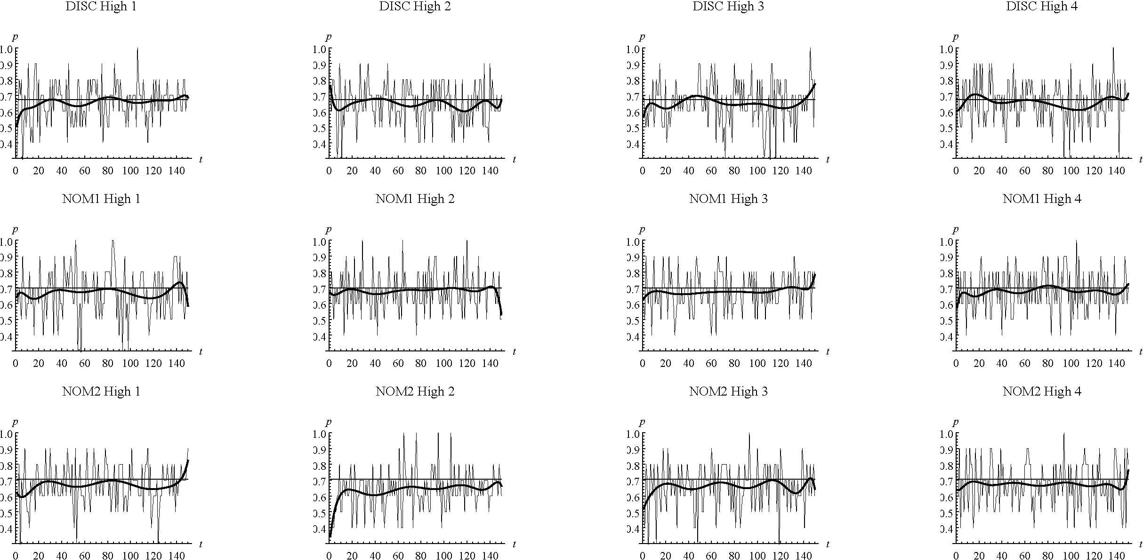

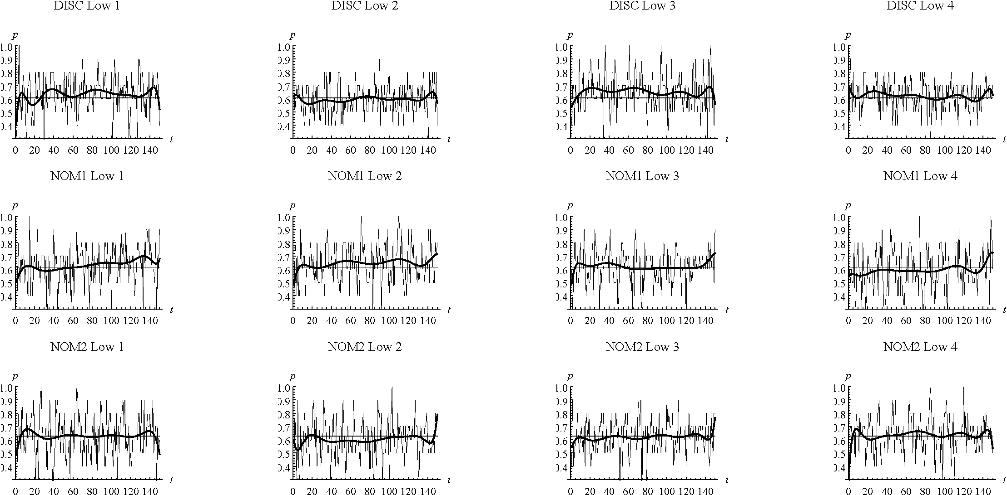
Note: Thin Black line: Nash mixed-equilibrium prediction; Thick red line: Polynomial fit of degree 10.
Average Probabilities of Entry per Round (Session Data)
and Nash Equilibrium Predictions.

Appendix VI: Bar-plots of individual entry probabilities in last 75 rounds.
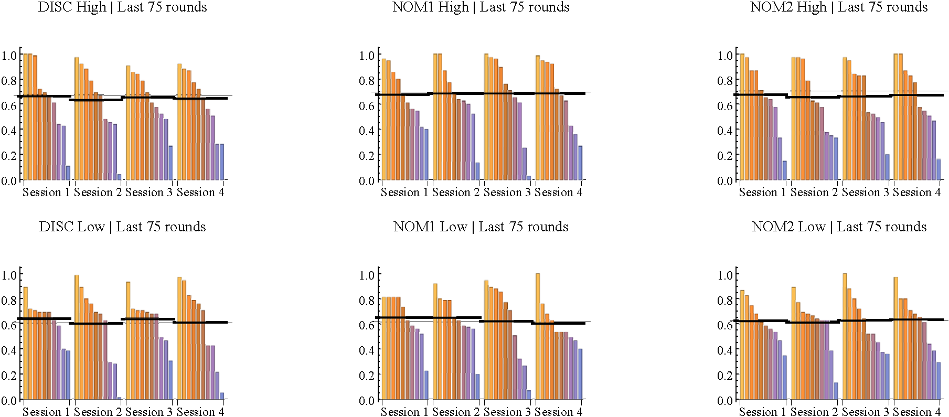
Note: Each vertical bar represents an individual. Horizontal thin (thick) lines characterise the symmetric mixed-equilibrium prediction (average probability of entry).
Bar-Charts of Individual Probabilities of Entry in Last 75 rounds.

Appendix VII: Cluster-Estimation Results
The following tables tally sessions (and their identities) which data rejects the null of the $Σ$-test for both EvE and IBE (cf. Panel I), for EvE only (cf. Panel II), for IBE only (Panel III) and for neither model (Panel IV).
Table VII.1: Summary of rejections of EvE and/or IBE – OLS procedures
 |  |  | I: EvE & IBE |  | II: EvE only |  | III: IBE only |  | IV: Neither model
 |  |  | #(Ses.) | Session  IDs | #(Ses.) | Session  IDs | # Ses. | Session  IDs | # Ses. | Session  IDs
All  data | DISC | High | 2 | 3, 4 | 1 | 1 | 0 | -- | 1 | 2
All  data | DISC | Low | 2 | 1, 3 |  | 4 | 0 | -- | 1 | 2
All  data | NOM1 | High | 2 | 1, 3 | 1 | 4 | 0 | -- | 1 | 2
All  data | NOM1 | Low | 4 | 1 to 4 | 0 | -- | 0 | -- | 0 | --
All  data | NOM2 | High | 1 | 2 | 2 | 1, 3 | 0 | -- | 1 | 4
All  data | NOM2 | Low | 3 | 1, 2, 4 | 1 | 3 | 0 | -- | 0 | --
All  data | Total | High | 5 |  | 4 |  | 0 |  | 3
All  data | Total | Low | 9 |  | 2 |  | 0 |  | 1
Last 75 rounds | DISC | High | 3 | 1, 3, 4 | 1 | 2 | 0 | -- | 0 | --
Last 75 rounds | DISC | Low | 3 | 1, 3, 4 | 1 | 2 | 0 | -- | 0 | --
Last 75 rounds | NOM1 | High | 2 | 1, 4 | 2 | 2, 3 | 0 | -- | 0 | --
Last 75 rounds | NOM1 | Low | 4 | 1 to 4 | 0 | -- | 0 | -- | 0 | -
Last 75 rounds | NOM2 | High | 3 | 2, 3, 4 | 1 | 1 | 0 | -- | 0 | --
Last 75 rounds | NOM2 | Low | 3 | 1, 2, 4 | 1 | 3 | 0 | -- | 0 | --
Last 75 rounds | Total | High | 8 |  | 4 |  | 0 |  | 0
Last 75 rounds | Total | Low | 10 |  | 2 |  | 0 |  | 0

Table VII.2: Summary of rejections of EvE and/or IBE
– with(out) Regularisation – All Data
 |  | I: EvE & IBE |  | II: EvE only |  | III: IBE only |  | IV: Neither
 |  | #(Ses.) | Session  IDs | #(Ses.) | Session  IDs | # Ses. | Session  IDs | # Ses. | Session  IDs
DISC | High | 1 | 3 | 2 | 1, 4 | 0 | -- | 1 | 2
DISC | Low | 2 | 1, 3 | 1 | 4 | 0 | -- | 1 | 2
NOM1 | High | 2 | 1, 3 | 1 | 4 | 0 | -- | 1 | 2
NOM1 | Low | 4 | 1 to 4 | 0 | -- | 0 | -- | 0 | --
NOM2 | High | 1 | 2 | 0 | -- | 1 | 1 | 2 | 3, 4
NOM2 | Low | 3 | 1, 2, 4 | 1 | 3 | 0 | -- | 0 | --
Total | High | 4 |  | 4 |  | 1 |  | 4
Total | Low | 9 |  | 2 |  | 0 |  | 1
The following table provides the count data used in Tables 3 and 4 of text.
Table VII.3: Summary of non-rejected specifications

 |  |  | OLS/ All data |  |  |  | OLS / Last 75 rounds |  |  |  | With(out) reg./ All data
 |  |  | High | Low | Total |  | High | Low | Total |  | High | Low | Total
 | #(Non-rejected specifications with $K=1$) |  | 3 | 5 | 8 |  | 6 | 6 | 12 |  | 1 | 1 | 0
 | #(Non-rejected specifications with $K>1$) |  | 6 | 6 | 12 |  | 6 | 6 | 12 |  | 6 | 10 | 16
EvE | #(Over-parametrised specifications) |  | 6 | 2 | 8 |  | 6 | 5 | 11 |  | 3 | 8 | 11
EvE | #(Estimates of non-rejected specifications) |  | 20 | 21 | 41 |  | 22 | 25 | 47 |  | 19 | 28 | 47
EvE | #(Insignificant estimates) |  | 9 | 9 | 18 |  | 12 | 14 | 26 |  | 2 | 3 | 5
EvE | #(Inconsistent estimates) |  | 0 | 2 | 2 |  | 0 | 0 | 0 |  | 0 | 2 | 2
EvE | #(Participants in non-rejected specifications.) |  | 90 | 110 | 200 |  | 120 | 120 | 240 |  | 70 | 110 | 180
EvE | #(Participants with ins./inc. estimates) |  | 33 | 42 | 75 |  | 52 | 65 | 117 |  | 9 | 21 | 30
 | #(Non-rejected specifications with $K=1$) |  | 0 | 0 | 0 |  | 0 | 0 | 0 |  | 0 | 0 | 0
 | #(Non-rejected specifications with $K>1$) |  | 5 | 9 | 14 |  | 8 | 10 | 18 |  | 5 | 9 | 14
IBE | #(Over-parametrised specifications) |  | 1 | 1 | 2 |  | 4 | 5 | 9 |  | 1 | 0 | 1
IBE | #(Estimates of non-rejected specifications) |  | 18 | 29 | 47 |  | 30 | 33 | 63 |  | 18 | 30 | 48
IBE | #(Insignificant estimates) |  | 4 | 3 | 7 |  | 8 | 9 | 17 |  | 3 | 3 | 6
IBE | #(Inconsistent estimates) |  | 0 | 0 | 0 |  | 0 | 0 | 0 |  | 0 | 0 | 0
IBE | #(Participants in non-rejected spec.) |  | 50 | 90 | 140 |  | 80 | 100 | 180 |  | 50 | 90 | 140
IBE | #(Participants with ins./inc. estimates) |  | 6 | 5 | 11 |  | 14 | 17 | 31 |  | 5 | 5 | 10

- OLS (All data)

Table VII.A.1: EvE Cluster OLS Estimates when Relaxing Symmetry:
High Payoff Treatments.
 | Session | Inverse Estimator ª | Cluster 1  # (ind.) | Cluster 2  # (ind.) | Cluster 3  # (ind.) | Cluster 4  # (ind.) | Σ-test  $p$-value | $χ^{2}$-tests of equality ^{b}
DISC | 1 | No | 1.263  [.35, 2.17]  1 | 1.221  [.45, 2.00]  6 | 2.371  [1.39, 3.35]  3 | -- | .457 | $$3≠2$$
DISC | 2 | No | 2.322  [1.46, 3.19]  1 | 1.086  [-1.12, 3.29]  2 | 1.083  [-.62, 2.79]  3 | 1.325  [.52, 2.13]  4 | .002 | No Rejection
DISC | 3 | No | 1.338  [-.07, 2.75]  10 | -- | -- | -- | .228 | n.a.
DISC | 4 | No | 1.055  [-.54, 2.65]  3 | 1.504  [-.45, 3.46]  3 | 1.533  [.46, 2.60]  4 | -- | .466 | No Rejection
NOM1 | 1 | No | 1.134  [-1.77, 4.04]  5 | 1.741  [.58, 2.90]  5 | -- | -- | .088 | No Rejection
NOM1 | 2 | No | 1.541  [-.59, 3.67]  1 | .748  [-3.57, 5.07]  1 | 3.502  [-3.95, 10.9]  5 | 3.962  [1.71, 6.22]  3 | .006 | No Rejection
NOM1 | 3 | No | 1.691  [-.26, 3.65]  2 | 3.507  [.45, 6.56]  8 | -- | -- | .068 | No Rejection
NOM1 | 4 | No | 1.080  [-1.68, 3.84]  3 | 4.405  [-5.10, 13.9]  3 | 2.717  [-.38, 5.81]  1 | 3.661  [1.14, 6.18]  3 | .687 | $$4≠3$$
NOM2 | 1 | No | 1.779  [.61, 2.95]  10 | -- | -- | -- | .074 | n.a.
NOM2 | 2 | Yes | .885  [.63, 1.50]  10 | -- | -- | -- | .316 | n.a.
NOM2 | 3 | No | 3.807  [1.34, 6.27]  2 | .624  [-1.28, 2.52]  3 | 1.299  [.40, 2.20]  5 | -- | .116 | No Rejection
NOM2 | 4 | No | 1.955  [.34, 3.57]  2 | 1.999  [-2.89, 6.89]  3 | 1.730  [.34, 3.12]  3 | 3.334  [2.24, 4.43]  2 | .001 | $$4≠3$$
Note: ª: The 95% confidence interval of the inverse estimator is obtained by inverting the bounds for the inverse if they have the same sign, and by the delta method otherwise; ^{b}: observed rejections of parameter equality at $α=5\text{\%}$ (according to pairwise $χ^{2}$-tests), e.g., $3≠\left(1,2\right)$ means that the 3rd parameter is significantly different from the 1st and 2nd and all other estimates are not significantly different from each other. Similarly, $3=\left(1,2\right)$ means that 3rd parameter is not significantly different from the 1st and 2nd and all other estimates are significantly different from each other; shaded cells characterize instances where the symmetric mixed-equilibrium strategy cannot be rejected at $α$ = 5%, cf. Table 1; boldfaced $p$-values indicate rejection of the specification at $α=5\text{\%}$; italicized figures characterise instances with maximal exploration, i.e., $λ$ not significant at $α=5\text{\%}$.

Table VII.A.2: EvE Cluster OLS Estimates when Relaxing Symmetry:
Low Payoff Treatments.
 | Session | Inverse Estimator ª | Cluster 1  # (ind.) | Cluster 2  # (ind.) | Cluster 3  # (ind.) | Cluster 4  # (ind.) | Σ-test  $p$-value | $χ^{2}$-test(s) of equality ^{b}
DISC | 1 | Yes | 1.615  [1.49, 1.76]  4 | -4.650  [-16.8, 7.48]  6 | -- | -- | .671 | Reject
DISC | 2 | No | 2.608  [1.52, 3.70]  1 | 1.612  [-.02, 3.24]  3 | 1.480  [.25, 2.71]  4 | 2.507  [1.66, 3.35]  2 | .031 | $$2≠1$$  $$4≠3$$
DISC | 3 | No | -.151  [-1.15, .84]  5 | -.121  [-2.59, .17]  4 | -8.474  [-11.4, -5.58]  1 | -- | .469 | Reject all
DISC | 4 | No | 2.074  [.53, 3.61]  1 | .037  [-2.35, 3.10]  3 | 5.324  [1.32, 9.33]  6 | -- | .675 | $$2≠1$$
NOM1 | 1 | Yes | 1.199  [.79, 2.53]  1 | -2.728  [-7.25, 1.79]  7 | 74.863  [<-10³, >10³]  2 | -- | .525 | Reject all
NOM1 | 2 | No | 1.027  [-.23, 2.29]  1 | -.522  [-2.81, 1.76]  5 | -4.609  [-7.85, -1.37]  4 | -- | .366 | Reject all
NOM1 | 3 | No | 1.603  [1.08, 2.12]  10 | -- | -- | -- | .245 | n.a.
NOM1 | 4 | No | 2.983  [.07, 5.90]  10 | -- | -- | -- | .374 | n.a.
NOM2 | 1 | No | .333  [-3.22, 3.88]  4 | 3.922  [.66, 7.18]  6 | -- | -- | . 898 | No Rejection
NOM2 | 2 | No | 1.481  [.49, 2.47]  10 | -- | -- | -- | .478 | n.a.
NOM2 | 3 | No | 3.520  [1.99, 5.04]  10 | -- | -- | -- | .354 | n.a.
NOM2 | 4 | No | .980  [.15, 1.81]  10 | -- | -- | -- | .381 | n.a.
Note: ª: The 95% confidence interval of the inverse estimator is obtained by inverting the bounds for the inverse if they have the same sign, and by the delta method otherwise; ^{b}: observed rejections of parameter equality at $α=5\text{\%}$ (according to pairwise $χ^{2}$-tests), e.g., $3≠\left(1,2\right)$ means that the 3rd parameter is significantly different from the 1st and 2nd and all other estimates are not significantly different from each other. Similarly, $3=\left(1,2\right)$ means that 3rd parameter is not significantly different from the 1st and 2nd and all other estimates are significantly different from each other; shaded cells characterize instances where the symmetric mixed-equilibrium strategy cannot be rejected at $α$ = 5%, cf. Table 1; framed cells highlight inconsistent (i.e., significantly negative) estimates; boldfaced $p$-values indicate rejection of the specification at $α=5\text{\%}$; italicized figures characterise instances with maximal exploration, i.e., $λ$ not significant at $α=5\text{\%}$.

Table VII.A.3: IBE Cluster OLS Estimates when Relaxing Symmetry:
High Payoff Treatments.
 | Session | Inverse Estimator ª | Cluster 1  # (ind.) | Cluster 2  # (ind.) | Cluster 3  # (ind.) | Cluster 4  # (ind.) | Σ-test  $p$-value | $χ^{2}$-tests of equality ^{b}
DISC | 1 | No | .200  [-.12, .52]  1 | 1.105  [.49, 1.72]  2 | 2.937  [2.39, 3.48]  4 | 45.514  [15.7, 75.3]  3 | .000 | Reject all
DISC | 2 | No | .051  [-.22, .31]  1 | 1.423  [.72, 2.13]  2 | 3.463  [2.51, 4.42]  3 | 13.610  [10.7, 16.6]  4 | .025 | Reject all
DISC | 3 | No | .195  [-.26, .65]  1 | 3.134  [2.24, 4.03]  6 | 10.828  [7.23, 14.4]  3 | -- | .630 | Reject all
DISC | 4 | No | .370  [-.02, .76]  1 | 1.020  [.45, 1.58]  2 | 3.494  [2.54, 4.45]  3 | 11.509  [9.34, 13.67]  4 | .051 | Reject all
NOM1 | 1 | No | .634  [.18, 1.09]  2 | 1.294  [.67, 1.92]  3 | 4.048  [3.01, 5.09]  3 | 19.046  [10.2, 27.9]  2 | .365 | Reject all
NOM1 | 2 | No | .160  [-.03, .35]  1 | .474  [.16, .79]  1 | 1.706  [1.37, 2.04]  5 | 8.818  [4.94, 12.7]  3 | .000 | Reject all
NOM1 | 3 | No | .105  [-.10, .31]  2 | 1.786  [1.15, 2.42]  4 | 6.601  [3.82, 9.38]  2 | 41.357  [-.80, 83.5]  2 | .248 | $$4=\left(2,3\right)$$
NOM1 | 4 | No | .256  [.02, .49]  3 | 1.678  [1.24, 2.11]  3 | 10.13  [4.91, 15.35]  1 | 28.91  [12.5, 45.4]  3 | .000 | Reject all
NOM2 | 1 | No | .205  [-.09, .50]  2 | 1.453  [.69, 2.21]  2 | 2.511  [1.46, 3.56]  2 | 10.690  [7.56, 13.8]  4 | .047 | Reject all
NOM2 | 2 | No | 1.039  [.40, 1.67]  5 | 5.820  [3.77, 7.87]  2 | 21.282  [13.6, 29.0]  3 | -- | .125 | Reject all
NOM2 | 3 | No | .185  [.03, 1.17]  1 | .530  [4.05, 7.95]  1 | 1.431  [18.5, 32.5]  3 | 8.092  [6.85, 9.33]  5 | .000 | Reject all
NOM2 | 4 | Yes | .330  [.27, .44]  2 | 1.224  [.96, 1.73]  3 | 5.407  [2.74, 196]  3 | 263.5  [<-10³, >10³]  2 | .000 | Reject all
Note: ª: The 95% confidence interval of the inverse estimator is obtained by inverting the bounds for the inverse if they have the same sign, and by the delta method otherwise; ^{b}: observed rejections of parameter equality at $α=5\text{\%}$ (according to pairwise $χ^{2}$-tests), e.g., $3≠\left(1,2\right)$ means that the 3rd parameter is significantly different from the 1st and 2nd and all other estimates are not significantly different from each other. Similarly, $3=\left(1,2\right)$ means that 3rd parameter is not significantly different from the 1st and 2nd and all other estimates are significantly different from each other; boldfaced $p$-values indicate rejection of the specification at $α=5\text{\%}$; italicized figures characterise instances with maximal exploration, i.e., $λ$ not significant at $α=5\text{\%}.$

Table VII.A.4: IBE Cluster OLS Estimates when Relaxing Symmetry:
Low Payoff Treatments.
 | Session | Inverse Estimator ª | Cluster 1  # (ind.) | Cluster 2  # (ind.) | Cluster 3  # (ind.) | Cluster 4  # (ind.) | Σ-test  $p$-value | $χ^{2}$-tests of equality ^{b}
DISC | 1 | No | .911  [.41, 1.41]  2 | 2.178  [1.50, 2.86]  3 | 4.505  [3.70, 5.31]  5 | -- | .074 | Reject all
DISC | 2 | No | .074  [-.23, .38]  1 | .946  [.41, 1.48]  3 | 7.226  [6.43, 8.02]  4 | 27.479  [18.5, 36.5]  2 | .000 | Reject all
DISC | 3 | No | 1.316  [.89, 1.74]  5 | 3.324  [2.61, 4.04]  4 | 18.339  [5.76, 30.9]  1 | -- | .157 | Reject all
DISC | 4 | No | .022  [-.21, .26]  1 | .922  [.41, 1.43]  3 | 5.507  [4.67, 6.34]  4 | 42.761  [21.8, 63.7]  2 | .004 | Reject all
NOM1 | 1 | No | .247  [.18, .39]  1 | 2.360  [1.87, 3.20]  7 | .648 | 5.645  [3.32, 18.83]  2 | .786 | -- | .087 | Reject all
NOM1 | 2 | No | .164  [-.12, .44]  1 | 1.240  [.74, 1.74]  4 | 3.628  [2.78, 4.48]  4 | 14.702  [4.19, 25.2]  1 | .338 | Reject all
NOM1 | 3 | No | .255  [-.14, .65]  3 | 1.589  [.57, 2.60]  1 | 7.545  [6.86, 8.23]  6 | -- | .536 | Reject all
NOM1 | 4 | No | 1.746  [1.24, 2.25]  6 | 3.644  [2.74, 4.55]  3 | 476.22  [-460, 1412]  1 | -- | .724 | $$2≠1$$
NOM2 | 1 | No | 1.048  [.66, 1.44]  4 | 2.832  [2.23, 3.44]  4 | 9.347  [6.56, 12.1]  2 | -- | .126 | Reject all
NOM2 | 2 | No | .420  [.04, .80]  2 | 3.441  [2.71, 4.18]  5 | 5.622  [4.08, 7.16]  2 | 14.362  [6.98, 21.7]  1 | .119 | Reject all
NOM2 | 3 | No | .901  [.51, 1.30]  3 | 1.563  [1.06, 2.06]  3 | 4.493  [3.27, 5.72]  2 | 13.095  [7.29, 18.9]  2 | .000 | Reject all
NOM2 | 4 | No | .690  [.25, 1.13]  3 | 2.816  [2.16, 3.47]  5 | 7.226  [4.38, 10.1]  2 | -- | .145 | Reject all
Note: ª: The 95% confidence interval of the inverse estimator is obtained by inverting the bounds for the inverse if they have the same sign, and by the delta method otherwise; ^{b}: observed rejections of parameter equality at $α=5\text{\%}$ (according to pairwise $χ^{2}$-tests), e.g., $3≠\left(1,2\right)$ means that the 3rd parameter is significantly different from the 1st and 2nd and all other estimates are not significantly different from each other. Similarly, $3=\left(1,2\right)$ means that 3rd parameter is not significantly different from the 1st and 2nd and all other estimates are significantly different from each other; boldfaced $p$-values indicate rejection of the specification at $α=5\text{\%}$; italicized figures characterise instances with maximal exploration, i.e., $λ$ not significant at $α=5\text{\%}.$

- For the last 75 rounds of play.
Table VII.B.1: EvE’s Cluster OLS Estimates when Relaxing Symmetry:
Last 75 Rounds of High Payoff Treatments.

 | Session | Inverse Estimator ª | Cluster 1  # (subjects) | Cluster 2  # (subjects) | Cluster 3  # (subjects) | Cluster 4  # (subjects) | Spec. test  $p$-value | $χ^{2}$-tests of equality ^{b}
DISC | 1 | No | .925  [-2.37, 4.22]  3 | 3.42  [-.24, 7.07]  7 | -- | -- | .204 | No Rejection
DISC | 2 | No | 2.395  [1.72, 3.07]  4 | 1.058  [-.46, 2.58]  6 | -- | -- | .071 | No Rejection
DISC | 3 | No | 1.428  [-.31, 3.17]  10 | -- | -- | -- | .773 | n.a.
DISC | 4 | No | 1.156  [.23, 2.09]  10 | -- | -- | -- | .112 | n.a.
NOM1 | 1 | No | 2.422  [-.24, 5.09]  10 | -- | -- | -- | .226 | n.a.
NOM1 | 2 | No | 3.667  [2.05, 5.28]  10 | -- | -- | -- | .063 | n.a.
NOM1 | 3 | No | 2.047  [-.16, 4.26]  2 | 4.759  [.32, 9.19]  8 | -- | -- | .055 | No Rejection
NOM1 | 4 | No | 2.631  [1.87, 3.39]  10 | -- | -- | -- | .068 | n.a.
NOM2 | 1 | No | 2.714  [.64, 4.79]  10 | -- | -- | -- | .168 | n.a.
NOM2 | 2 | No | -6.754  [-43.1, 29.6]  3 | .816  [-3.50, 5.13]  4 | 1.736  [-.70, 4.17]  3 | -- | .999 | No Rejection
NOM2 | 3 | No | 3.398  [-1.71, 8.51]  1 | .133  [-3.06, 3.33]  4 | 1.571  [.78, 2.36]  5 | -- | .144 | No Rejection
NOM2 | 4 | No | 2.273  [.49, 4.06]  1 | 1.728  [-1.84, 5.30]  4 | 1.684  [-.15, 3.52]  3 | 3.247  [1.74, 4.75]  2 | .743 | $$4≠3$$
Note: ª: The 95% confidence interval of the inverse estimator is obtained by inverting the bounds for the inverse if they have the same sign, and by the delta method otherwise, cf. Appendix 3 for details; ^{b}: observed rejections of parameter equality at $α=5\text{\%}$ (according to pairwise $χ^{2}$-tests), e.g., $3≠\left(1,2\right)$ means that the 3rd parameter is significantly different from the 1st and 2nd and all other estimates are not significantly different from each other. Similarly, $3=\left(1,2\right)$ means that 3rd parameter is not significantly different from the 1st and 2nd and all other estimates are significantly different from each other; shaded cells characterize instances where the symmetric mixed-equilibrium strategy cannot be rejected at $α$ = 5%, cf. Table 1; italicized figures characterise instances with maximal exploration, i.e., $λ$ not significant at $α=5\text{\%}$.

Table VII.B.2: EvE’s Cluster OLS Estimates when Relaxing Symmetry:
Last 75 Rounds of Low Payoff Treatments.

 | Session | Inverse Estimator ª | Cluster 1  # (subjects) | Cluster 2  # (subjects) | Cluster 3  # (subjects) | Cluster 4  # (subjects) | Spec. test  $p$-value | $χ^{2}$-tests of equality ^{b}
DISC | 1 | No | -4.254  [-15.9, 7.34]  10 | -- | -- | -- | .268 | n.a.
DISC | 2 | No | 3.127  [1.38, 4.87]  1 | 1.136  [-.85, 3.12]  2 | 2.12  [-.89, 5.13]  5 | 3.309  [1.51, 5.11]  2 | .423 | $$2≠1$$
DISC | 3 | No | .316  [-13.9, 14.5]  3 | -1.580  [-33.7, 30.6]  6 | 107.234  [40.9, 173]  1 | -- | .999 | $$3≠\left(1,2\right)$$
DISC | 4 | No | 1.562  [-.14, 3.26]  2 | .435  [-3.18, 4.05]  2 | 3.624  [.44, 6.81]  6 | -- | .111 | No Rejection
NOM1 | 1 | Yes | .898  [.52, 3.19]  1 | -.340  [-1.90, 1.21]  4 | -3.288  [-8.93, 1.76]  5 | -- | .468 | Reject all
NOM1 | 2 | Yes | .998  [-.52, 2.52]  1 | -.620  [-1.24, .005]  5 | -5.996  [-24, 12.01]  4 | -- | .883 | $$1=\left(2,3\right)$$
NOM1 | 3 | Yes | 2.046  [1.33, 4.46]  1 | .937  [.52, 4.14]  3 | 8.896  [-18.7, 36.5]  6 | -- | .108 | No Rejection
NOM1 | 4 | No | 3.923  [-.76, 8.61]  10 | -- | -- | -- | .463 | n.a.
NOM2 | 1 | No | 2.353  [1.14, 3.57]  10 | -- | -- | -- | .736 | n.a.
NOM2 | 2 | No | 2.314  [.25, 4.38]  10 | -- | -- | -- | .123 | n.a.
NOM2 | 3 | No | 2.828  [2.16, 3.50]  10 | -- | -- | -- | 162 | n.a.
NOM2 | 4 | No | 1.368  [.23, 2.50]  10 | -- | -- | -- | .558 | n.a.
Note: ª: The 95% confidence interval of the inverse estimator is obtained by inverting the bounds for the inverse if they have the same sign, and by the delta method otherwise, cf. Appendix 3 for details; ^{b}: observed rejections of parameter equality at $α=5\text{\%}$ (according to pairwise $χ^{2}$-tests), e.g., $3≠\left(1,2\right)$ means that the 3rd parameter is significantly different from the 1st and 2nd and all other estimates are not significantly different from each other. Similarly, $3=\left(1,2\right)$ means that 3rd parameter is not significantly different from the 1st and 2nd and all other estimates are significantly different from each other; shaded cells characterize instances where the symmetric mixed-equilibrium strategy cannot be rejected at $α$ = 5%, cf. Table 1; italicized figures characterise instances with maximal exploration, i.e., $λ$ not significant at $α=5\text{\%}$.

Table VII.B.3: IBE’s Cluster OLS Estimates when Relaxing Symmetry:
Last 75 Rounds of High Payoff Treatments.

 | Session | Inverse Estimator ª | Cluster 1  # (subjects) | Cluster 2  # (subjects) | Cluster 3  # (subjects) | Cluster 4  # (subjects) | Spec. test  $p$-value | $χ^{2}$-tests of equality ^{b}
DISC | 1 | No | .085  [-.31, .48]  1 | .80  [.49, 1.72]  2 | 3.003  [2.43, 3.57]  4 | 241.082  [87.8, 394.3]  3 | .811 | Reject all
DISC | 2 | No | .043  [-.38, .47]  1 | 1.416  [.46, 2.37]  3 | 5.770  [3.91, 7.63]  3 | 29.846  [18.2, 41.5]  3 | .015 | Reject all
DISC | 3 | No | .403  [-.37, 1.18]  1 | 2.033  [.86, 3.21]  5 | 11.350  [7.17, 15.53]  4 | -- | .364 | Reject all
DISC | 4 | No | .478  [.35, .74]  2 | 1.915  [.80, 3.03]  2 | 5.145  [3.45, 6.85]  3 | 20.614  [12.2, 28.98]  3 | .632 | Reject all
NOM1 | 1 | No | .472  [-.03, .98]  2 | 1.292  [.60, 1.99]  4 | 5.941  [2.66, 9.22]  2 | 31.26  [1.74, 60.8]  2 | .888 | $$4=3$$
NOM1 | 2 | No | .062  [-.12, .24]  1 | 1.147  [.73, 1.56]  5 | 4.393  [2.39, 6.40]  2 | 213.19  [-79.9, 506.3]  2 | .049 | $$4≠\left(2,3\right)$$
NOM1 | 3 | No | .007  [-.14, .15]  1 | .113  [-.13, .36]  1 | 1.350  [.79, 1.91]  4 | 12.983  [3.81, 22.2]  4 | .000 | $$1=2$$
NOM1 | 4 | No | .243  [-.07, .55]  3 | 1.527  [.92, 2.14]  3 | 17.793  [8.13, 27.45]  4 | -- | .076 | Reject all
NOM2 | 1 | No | .076  [-.23, .38]  1 | .274  [-.20, .75]  1 | 1.533  [.59, 2.48]  4 | 9.747  [3.50, 16.0]  4 | .000 | $$1=2$$
NOM2 | 2 | No | .447  [-.10, .99]  3 | 1.846  [.92, 2.78]  3 | 6.112  [3.02, 9.20]  1 | 65.926  [-30.1, 161.9]  3 | .993 | $$4=\left(2,3\right)$$
NOM2 | 3 | No | .158  [-.16, .47]  1 | .927  [.31, 1.54]  4 | 7.966  [5.82, 10.1]  3 | 42.392  [4.91, 79.9]  2 | .892 | $$4=3$$
NOM2 | 4 | No | .095  [-.17, .36]  1 | .870  [.30, 1.44]  4 | 5.807  [3.78, 7.83]  3 | 268.9  [-101.7, 640]  2 | .674 | $$4=\left(2,3\right)$$
Note: ª: The 95% confidence interval of the inverse estimator is obtained by inverting the bounds for the inverse if they have the same sign, and by the delta method otherwise, cf. Appendix 3 for details; ^{b}: observed rejections of parameter equality at $α=5\text{\%}$ (according to pairwise $χ^{2}$-tests), e.g., $3≠\left(1,2\right)$ means that the 3rd parameter is significantly different from the 1st and 2nd and all other estimates are not significantly different from each other. Similarly, $3=\left(1,2\right)$ means that 3rd parameter is not significantly different from the 1st and 2nd and all other estimates are significantly different from each other; boldfaced $p$-values indicate rejection of the specification at $α=5\text{\%}$; italicized figures characterise instances with maximal exploration, i.e., $λ$ not significant at $α=5\text{\%}.$

Table VII.B.4: IBE’s Cluster OLS Estimates when Relaxing Symmetry:
Last 75 Rounds of Low Payoff Treatments.

 | Session | Inverse Estimator ª | Cluster 1  # (subjects) | Cluster 2  # (subjects) | Cluster 3  # (subjects) | Cluster 4  # (subjects) | Spec. test  $p$-value | $χ^{2}$-tests of equality ^{b}
DISC | 1 | No | .679  [.03, 1.33]  2 | 2.916  [2.20, 3.63]  7 | 15.944  [1.66, 30.23]  1 | -- | .811 | $$3=2$$
DISC | 2 | No | .013  [-.36, .39]  1 | .535  [-.12, 1.19]  2 | 5.519  [4.68, 6.36]  5 | 29.537  [9.27, 49.8]  2 | .000 | Reject all
DISC | 3 | No | .747  [.09, 1.40]  3 | 3.529  [2.83, 4.23]  6 | 28.347  [-3.38, 60.1]  1 | -- | .553 | $$3=\left(1,2\right)$$
DISC | 4 | No | .141  [-.29, .57]  2 | 1.057  [.23, 1.89]  2 | 7.525  [6.38, 8.67]  4 | 65.424  [15, 115.8]  2 | .127 | Reject all
NOM1 | 1 | No | .163  [-.14, .46]  1 | 1.123  [.59, 1.65]  4 | 4.430  [3.43, 5.43]  5 | -- | .419 | Reject all
NOM1 | 2 | No | .136  [-.31, .58]  1 | 1.321  [.50, 2.14]  5 | 4.961  [3.17, 6.75]  4 | -- | .381 | Reject all
NOM1 | 3 | Yes | .041  [.02, .31]  1 | .315  [.24, .48]  2 | 2.203  [1.24, 9.69]  2 | 13.310  [-25.2, 51.8]  5 | .189 | $$1=2$$
NOM1 | 4 | No | 1.460  [.78, 2.15]  6 | 4.145  [2.70, 5.59]  3 | 433.550  [-<10³, >10³]  1 | -- | .762 | $$3=\left(1,2\right)$$
NOM2 | 1 | No | .735  [.08, 1.39]  2 | 2.008  [1.23, 2.78]  5 | 7.428  [4.83, 10.03]  3 | -- | .299 | Reject all
NOM2 | 2 | No | .313  [-.20, .83]  2 | 3.253  [2.48, 4.07]  6 | 9.107  [5.01, 13.2]  2 | -- | .144 | Reject all
NOM2 | 3 | No | .560  [.06, 1.06]  2 | 1.134  [.50, 1.77]  3 | 3.686  [2.57, 4.80]  3 | 15.708  [3.07, 28.3]  2 | .000 | $$4=3$$
NOM2 | 4 | No | .496  [-.05, 1.04]  3 | 2.487  [1.53, 3.45]  4 | 6.332  [3.09, 9.57]  2 | 73.314  [-29.6, 176.2]  1 | .824 | $$3=2$$  $$4=\left(2,3\right)$$
Note: ª: The 95% confidence interval of the inverse estimator is obtained by inverting the bounds for the inverse if they have the same sign, and by the delta method otherwise, cf. Appendix 3 for details; ^{b}: observed rejections of parameter equality at $α=5\text{\%}$ (according to pairwise $χ^{2}$-tests), e.g., $3≠\left(1,2\right)$ means that the 3rd parameter is significantly different from the 1st and 2nd and all other estimates are not significantly different from each other. Similarly, $3=\left(1,2\right)$ means that 3rd parameter is not significantly different from the 1st and 2nd and all other estimates are significantly different from each other; boldfaced $p$-values indicate rejection of the specification at $α=5\text{\%}$; italicized figures characterise instances with maximal exploration, i.e., $λ$ not significant at $α=5\text{\%}.$

- With(out) regularisation
Table VII.C.1: EvE Cluster Estimates ($λ$) when Relaxing Symmetry:
High Payoff Treatments.

Structure | Session | Regularisation  α | Preferred  estimator | Cluster 1  # (subjects) | Cluster 2  # (subjects) | Cluster 3  # (subjects) | Cluster 4  # (subjects) | Spec. test  $p$-value | $χ^{2}$-tests of equality ^{b}
DISC | 1 | Tikhonov  4.53 | CNMIN | 1.454  [1.30, 1.61]  1 | 1.188  [1.01, 1.36]  6 | 1.798  [1.64, 1.96]  3 | -- | .492 | Reject all
DISC | 2 | Tikhonov  .7 | CNmin | 2.248  [1.80, 2.70]  1 | 1.886  [.22, 3.55]  2 | 1.292  [.67, 1.91]  3 | 1.457  [1.23, 1.68]  4 | .002 | $$3≠\left(1,2\right)$$
DISC | 3 | Tikhonov  5 | CNmin * | 1.545  [1.33, 1.84]  10 | -- | -- | -- | .890 | n.a.
DISC | 4 | Tikhonov  2.15 | $$rmse2$$ | 1.393  [1.10, 1.69]  3 | .936  [.39, 1.49]  3 | 1.508  [1.25, 1.76]  4 | -- | .145 | No Rejection
NOM1 | 1 | Tikhonov  10 | CNmin | 1.661  [.80, 2.52]  4 | 1.689  [1.41, 1.97]  4 | 2.093  [1.85, 2.34]  2 | -- | .382 | $$3≠2$$
NOM1 | 2 | naive  5.44 | $$rmse2$$ | 1.877  [1.49, 2.26]  1 | 1.439  [.75, 2.13]  1 | 2.175  [.65, 3.70]  5 | 2.676  [2.20, 3.16]  3 | .004 | $$3≠2$$
NOM1 | 3 | Tikhonov  295.4 | CNMIN | 2.177  [1.50, 2.85]  2 | 2.011  [-1.57, 5.59]  4 | 2.103  [.88, 3.33]  2 | 3.107  [2.17, 4.04]  2 | .346 | No Rejection
NOM1 | 4 | naive  42.8 | $$mae2$$ | 1.556  [1.13, 1.99]  3 | 2.727  [2.23, 3.22]  7 | -- | -- | .078 | Reject
NOM2 | 1 | Tikhonov  2 | CNmin | 1.991  [1.03, 28.2]  2 | 1.712  [-2.88, 6.30]  2 | 1.885  [-.61, 4.38]  2 | 2.144  [1.34, 5.39]  4 | .002 | No Rejection
NOM2 | 2 | none  0 | GLS | -.038  [-.40, .33]  5 | .697  [.44, .95]  2 | .984  [.73, 1.24]  3 | -- | .064 | Reject all
NOM2 | 3 | Tikhonov  .0013 | $rmse2$ * | 2.061  [1.74, 2.53]  1 | 2.437  [-.98, 5.86]  1 | 2.961  [-1.10, 7.02]  3 | 1.847  [1.54, 2.31]  5 | .008 | No Rejection
NOM2 | 4 | naive  1.05 | mae2 * | 2.189  [1.87, 2.64]  2 | 1.512  [1.17, 2.13]  3 | 1.585  [1.47, 1.73]  3 | 3.162  [2.89, 3.50]  2 | .009 | $$3≠\left(2,1\right)$$  $$4≠\left(2,3\right)$$
Note: ª: The 95% confidence interval of the inverse estimator is obtained by inverting the bounds for the inverse if they have the same sign, and by the delta method otherwise, cf. Appendix 3 for details; ^{b}: observed rejections of parameter equality at $α=5\text{\%}$ (according to pairwise $χ^{2}$-tests), e.g., $3≠\left(1,2\right)$ means that the 3rd parameter is significantly different from the 1st and 2nd and all other estimates are not significantly different from each other. Similarly, $3=\left(1,2\right)$ means that 3rd parameter is not significantly different from the 1st and 2nd and all other estimates are significantly different from each other; shaded cells characterize instances where the symmetric mixed-equilibrium strategy cannot be rejected at $α$ = 5%, cf. Table 1; boldfaced $p$-values indicate rejection of the specification at $α=5\text{\%}$; italicized figures characterise instances with maximal exploration, i.e., $λ$ not significant at $α=5\text{\%}$.

Table VII.C.2: EvE Cluster Estimates ($λ$) when Relaxing Symmetry:
Low Payoff Treatments.

Structure | Session | Regularization  α | Preferred  estimator | Cluster 1  # (subjects) | Cluster 2  # (subjects) | Cluster 3  # (subjects) | Cluster 4  # (subjects) | Spec. test  $p$-value | $χ^{2}$-tests of equality ^{b}
DISC | 1 | naive  24.5 | $rmse2$ * | 1.679  [1.56, 1.82]  4 | 3.628  [2.26, 9.17]  6 | -- | -- | .218 | Reject all
DISC | 2 | Tikhonov  1 | CNmin | 2.631  [1.97, 3.29]  1 | 2.268  [.88, 3.66]  3 | 1.643  [1.27, 2.01]  4 | 2.110  [1.86, 2.36]  2 | .035 | $$3≠1$$
DISC | 3 | none  0 | GLS | .657  [-.11, 1.42]  5 | -.117  [-1.21, .98]  4 | -9.773  [-12.4, -7.11]  1 | -- | .238 | Reject all
DISC | 4 | naive  156.5 | $$rmse2$$ | 2.489  [1.62, 3.35]  1 | 1.112  [.50, 1.72]  3 | 2.066  [1.81, 2.32]  4 | 4.416  [3.40, 5.43]  2 | .414 | $$2=\left(1,3\right)$$
NOM1 | 1 | none  0 | GLS * | 2.220  [1.36, 5.95]  1 | 6.631  [-10.6, 23.9]  7 | 3.330  [1.92, 12.4]  2 | -- | .417 | No Rejection
NOM1 | 2 | none  0 | GLS | 2.157  [1.39, 2.93]  1 | 1.594  [.369, 2.82]  5 | -2.330  [-4.41, -.249]  4 | -- | .092 | $$2=1$$
NOM1 | 3 | naive  423.5 | $$rmse2$$ | 1.950  [1.29, 2.61]  3 | 2.928  [1.37, 4.48]  7 | -- | -- | .145 | No Rejection
NOM1 | 4 | Tikhonov  5.13 | $$rmse2$$ | 2.522  [2.02, 3.02]  10 | -- | -- | -- | .362 | n.a.
NOM2 | 1 | Tikhonov  3.99 | CNMIN | 2.070  [1.55, 2.59]  4 | 2.233  [1.69, 2.77]  6 | -- | -- | . 312 | Not Rejected
NOM2 | 2 | Tikhonov  .325 | $$rmse2$$ | 2.835  [2.18, 3.49]  2 | 1.845  [1.48, 2.21]  7 | 2.066  [1.78, 2.35]  1 | -- | .667 | No Rejection
NOM2 | 3 | Tikhonov  8.31 | mae2 | 1.710  [.97, 2.45]  6 | 3.223  [1.94, 4.51]  2 | 3.162  [2.37, 3.95]  2 | -- | .361 | $$3≠1$$
NOM2 | 4 | Tikhonov  27.84 | mae2 | 2.034  [1.71, 2.36]  3 | 2.176  [1.68, 2.67]  7 | -- | -- | .267 | Not Rejected
Note: ª: The 95% confidence interval of the inverse estimator is obtained by inverting the bounds for the inverse if they have the same sign, and by the delta method otherwise, cf. Appendix 3 for details; ^{b}: observed rejections of parameter equality at $α=5\text{\%}$ (according to pairwise $χ^{2}$-tests), e.g., $3≠\left(1,2\right)$ means that the 3rd parameter is significantly different from the 1st and 2nd and all other estimates are not significantly different from each other. Similarly, $3=\left(1,2\right)$ means that 3rd parameter is not significantly different from the 1st and 2nd and all other estimates are significantly different from each other; shaded cells characterize instances where the symmetric mixed-equilibrium strategy cannot be rejected at $α$ = 5%, cf. Table 1; framed cells highlight inconsistent (i.e., significantly negative) estimates; boldfaced $p$-values indicate rejection of the specification at $α=5\text{\%}$; italicized figures characterise instances with maximal exploration, i.e., $λ$ not significant at $α=5\text{\%}.$

Table VII.C.3: IBE Cluster Estimates ($κ$) when Relaxing Symmetry:
High Payoff Treatments.

Structure | Session | Regularization  α | Preferred  estimator | Cluster 1  # (subjects) | Cluster 2  # (subjects) | Cluster 3  # (subjects) | Cluster 4  # (subjects) | Spec. test  $p$-value | $χ^{2}$-tests of equality ^{b}
DISC | 1 | none  0 | OLS | .200  [-.12, .52]  1 | 1.105  [.49, 1.72]  2 | 2.937  [2.39, 3.48]  4 | 45.514  [15.7, 75.3]  3 | .000 | Reject all
DISC | 2 | none  0 | OLS | .051  [-.22, .31]  1 | 1.423  [.72, 2.13]  2 | 3.463  [2.51, 4.42]  3 | 13.610  [10.7, 16.6]  4 | .025 | Reject all
DISC | 3 | none  0 | GLS | .151  [-.23, .53]  1 | 3.102  [2.30, 3.90]  6 | 11.340  [8.36, 14.3]  3 | -- | .625 | Reject all
DISC | 4 | none  0 | GLS | .192  [-.17, .56]  1 | .870  [.33, 1.41]  2 | 3.151  [2.26, 4.04]  3 | 12.304  [10.3, 14.3]  4 | .040 | Reject all
NOM1 | 1 | none  0 | GLS | .424  [.01, .83]  2 | 1.083  [.50, 1.67]  3 | 3.931  [2.95, 4.92]  3 | 18.291  [9.51, 27.1]  2 | .272 | Reject all
NOM1 | 2 | none  0 | OLS | .160  [-.03, .35]  1 | .474  [.16, .79]  1 | 1.706  [1.37, 2.04]  5 | 8.818  [4.94, 12.7]  3 | .000 | Reject all
NOM1 | 3 | none  0 | OLS | .105  [-.10, .31]  2 | 1.786  [1.15, 2.42]  4 | 6.601  [3.82, 9.38]  2 | 41.357  [-.80, 83.5]  2 | .248 | $$3=2$$  $$4=\left(2,3\right)$$
NOM1 | 4 | none  0 | OLS | .256  [.02, .49]  3 | 1.678  [1.25, 2.11]  3 | 10.129  [4.91, 15.4]  3 | 28.907  [12.5, 45.4]  1 | .000 | $$4≠3$$
NOM2 | 1 | none  0 | GLS | .013  [.03, 1.17]  2 | 1.079  [.38, 1.78]  2 | 2.264  [1.28, 3.25]  2 | 12.769  [9.88, 15.7]  4 | .108 | Reject all
NOM2 | 2 | none  0 | OLS | .599  [.03, 1.17]  5 | 5.999  [4.05, 7.95]  2 | 25.496  [18.5, 32.5]  3 | -- | .082 | Reject all
NOM2 | 3 | none  0 | OLS | .185  [.03, 1.17]  1 | .530  [4.05, 7.95]  1 | 1.431  [18.5, 32.5]  3 | 8.092  [6.85,9.33]  5 | .000 | Reject all
NOM2 | 4 | none  0 | OLS | .330  [.27, .44]  2 | 1.224  [.96, 1.73]  3 | 5.407  [2.74, 196.4]  3 | 263.5  [<-10³, >10³]  2 | .000 | Reject all
Note: ª: The 95% confidence interval of the inverse estimator is obtained by inverting the bounds for the inverse if they have the same sign, and by the delta method otherwise, cf. Appendix 3 for details; ^{b}: observed rejections of parameter equality at $α=5\text{\%}$ (according to pairwise $χ^{2}$-tests), e.g., $3≠\left(1,2\right)$ means that the 3rd parameter is significantly different from the 1st and 2nd and all other estimates are not significantly different from each other. Similarly, $3=\left(1,2\right)$ means that 3rd parameter is not significantly different from the 1st and 2nd and all other estimates are significantly different from each other; boldfaced $p$-values indicate rejection of the specification at $α=5\text{\%}$; italicized figures characterise instances with maximal exploration, i.e., $λ$ not significant at $α=5\text{\%}.$

Table VII.C.4: IBE Cluster Estimates ($κ$) when Relaxing Symmetry:
Low Payoff Treatments.

Structure | Session | Regularisation  α | Preferred  estimator | Cluster 1  # (subjects) | Cluster 2  # (subjects) | Cluster 3  # (subjects) | Cluster 4  # (subjects) | Spec. test  $p$-value | $χ^{2}$-tests of equality ^{b}
DISC | 1 | none  0 | GLS | .853  [.38, 1.33]  2 | 1.988  [1.26, 2.72]  2 | 3.639  [2.89, 4.39]  4 | 7.038  [4.91, 9.17]  2 | .824 | Reject all
DISC | 2 | none  0 | OLS | .074  [-.23, .38]  1 | .946  [.41, 1.48]  3 | 7.226  [6.43, 8.02]  4 | 27.479  [18.5, 36.5]  2 | .000 | Reject all
DISC | 3 | none  0 | GLS | 1.174  [.78, 1.57]  5 | 3.337  [2.72, 3.95]  4 | 19.128  [6.66, 31.6]  1 | -- | .126 | Reject all
DISC | 4 | none  0 | OLS | .021  [-.21, .26]  1 | .922  [.41, 1.43]  3 | 5.507  [4.67, 6.34]  4 | 42.761  [21.8, 63.7]  2 | .000 | Reject all
NOM1 | 1 | none  0 | GLS * | .226  [.17, .34]  6 | 2.388  [1.89, 3.23]  3 | 5.699  [3.43, 16.9]  1 | -- | .085 | Reject all
NOM1 | 2 | none  0 | GLS | .149  [-.12, .42]  1 | 1.237  [.77, 1.70]  4 | 3.670  [2.83, 4.51]  4 | 15.77  [5.35, 26.2]  1 | .347 | Reject all
NOM1 | 3 | none  0 | GLS | .043  [-.28, .36]  3 | 1.185  [.29, 2.08]  1 | 7.628  [6.98, 8.28]  6 | -- | .424 | Reject all
NOM1 | 4 | Tikhonov  .142 | $rmse2$ * | 1.770  [1.55, 2.07]  6 | 3.976  [2.75, 7.16]  3 | 126.265  [-835, 1089]  1 | -- | .712 | Reject all
NOM2 | 1 | none  0 | GLS | 1.005  [.63, 1.38]  4 | 2.739  [2.15, 3.33]  4 | 9.639  [6.89, 12.39]  2 | -- | .124 | Reject all
NOM2 | 2 | none  0 | OLS | .420  [.04, .80]  2 | 3.441  [2.71, 4.18]  5 | 5.622  [4.08, 7.16]  2 | 14.362  [6.98, 21.7]  1 | .119 | Reject all
NOM2 | 3 | Tikhonov  150.6 | $$rmse2$$ | .527  [.18, .87]  3 | 1.212  [.75, 1.67]  3 | 4.815  [3.65, 5.98]  2 | 15.726  [10.0, 21.4]  2 | .000 | Reject all
NOM2 | 4 | none  0 | GLS | .467  [.09, .84]  3 | 2.622  [2.01, 3.24]  5 | 8.290  [5.70, 10.9]  2 | -- | .178 | Reject all
Note: ª: The 95% confidence interval of the inverse estimator is obtained by inverting the bounds for the inverse if they have the same sign, and by the delta method otherwise, cf. Appendix 3 for details; ^{b}: observed rejections of parameter equality at $α=5\text{\%}$ (according to pairwise $χ^{2}$-tests), e.g., $3!=\left(1,2\right)$ means that the 3rd parameter is significantly different from the 1st and 2nd and all other estimates are not significantly different from each other. Similarly, $3=\left(1,2\right)$ means that 3rd parameter is not significantly different from the 1st and 2nd and all other estimates are significantly different from each other; boldfaced $p$-values indicate rejection of the specification at $α=5\text{\%}$; italicized figures characterise instances with maximal exploration, i.e., $λ$ not significant at $α=5\text{\%}.$

References

He, X., & Wu, S. J. (2009). Confidence intervals for the binomial proportion with zero frequency. Paper SP10-2009, SESUG.

Kodde, D., Palm, F., & Pfann, G. (1990). Asymptotic least-squares estimation efficiency considerations and applications. Journal of Applied Econometrics, 5(3), 229–243.

Newey, W., & West, K. (1987). A simple, positive semi-definite, heteroskedasticity and autocorrelation consistent covariance matrix. Econometrica, 55, 703–708.

Newey, W., & West, K. (1994). Automatic lag selection in covariance matrix estimation. Review of Economic Studies, 61, 631–653.

Sokullu, S. (2020). A regularization approach to minimum distance estimation: Application to structural macroeconomic estimation using IRFs. Oxford Economic Papers, 72(2), 546–565.

Zeileis, A. (2004). Econometric computing with HC and HAC covariance matrix estimators. Journal of Statistical Software, 11(10), 1–17.

We thank an anonymous referee for suggesting this type of exposition.
So if the minimum value in the vector is .002, then the extended grid would start at 0; but if the minimum were .03, the five values in the initial grid below that would be .02, .01, .009, .008, and .007 and the extended grid would start at .007. We proceed similarly for the upper bound.

