APPENDIX A

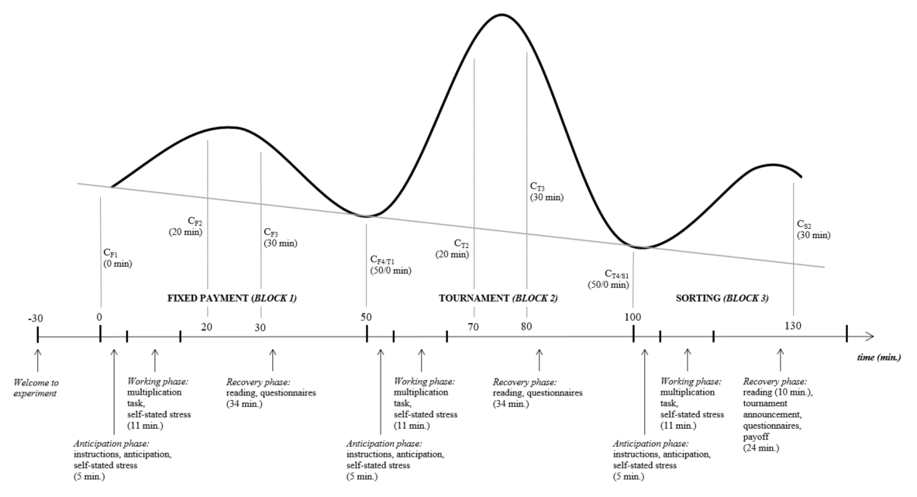FIGURE A1 depicts the setup of the experiment. 30 minutes before the start of the experiment, subjects enter the lab, hand in their home saliva samples and are welcomed. The subsequent time line is divided into three blocks. In each block subjects perform the multiplication task. During the first block subjects are rewarded by a fixed payment, during the second block subjects are rewarded by a tournament scheme, and during the third block subjects may select either of the aforementioned payment schemes. The first two blocks are randomized to assess order effects. Each block consists of three phases: the anticipation phase, the working phase, and the recovery phase. The curves in the upper part of the figure denote an exemplary cortisol response. The solid curve depicts the observed cortisol response that is extracted from saliva. Cortisol levels that are extracted from saliva are lagged values of cortisol levels that are secreted in the bloodstream. To measure cortisol responses to the different incentive schemes, saliva is collected during the 0th, 20th, 30th, and 50th minute of the first two blocks. During the third block, saliva is samples during the 0th minute and the 30th minute. We assume cortisol levels are at their baseline level during the 0th and 50th minute. The downward sloping grey line indicates the diurnal cycle: a gradual decrease in cortisol levels during the afternoon.

TABLE A1 - Experimental procedures
Place | Date (S1, S2) | Treatment | Order | N (S1, S2)
 | 14, 20 June 2016 | Private | FT | 11, 8
MAASTRICHT | 15, 21 June 2016 | Public | FT | 15, 15
 | 16, 22 June 2016 | Public | TF | 13, 11
 | 18, 24 August 2016 | Private | FT | 22, 21
BONN | 18, 25 August 2016 | Private | TF | 23, 23
 | 18, 26 August 2016 | Public | FT | 21, 21
TABLE A1 describes the experimental procedures. S1 and S2 denote session 1 and session 2, respectively. FT indicates that subjects were rewarded by a fixed payment in the first block, and played the tournament in the second block. TF denotes the opposite.

FIGURE A2 – The distribution of cortisol responses to financial incentives in different periods
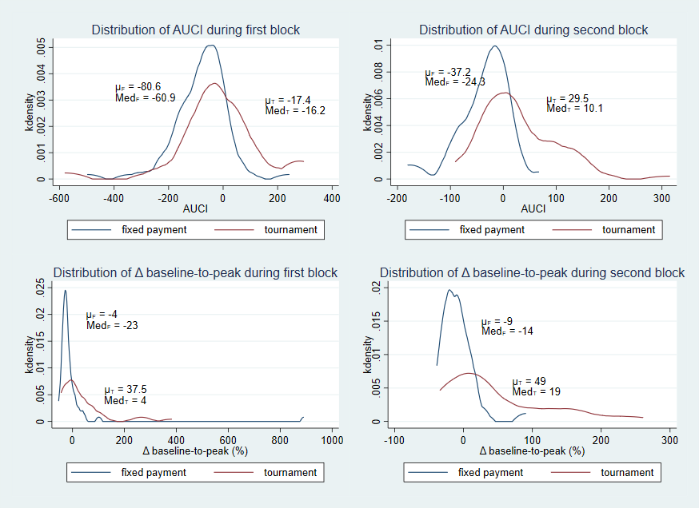
TABLE A2 - Cortisol responses by incentive order (within-subject)
 |  |  | mean T | mean F |  | median T | median F
A. Subjects in FT (n=64)
 | AUCI |  | 29.5*** | -80.6 |  | 10.1*** | -60.9
 | baseline-to-peak (%) |  | 49% *** | -4% |  | 10%*** | -28%
B. Subjects in TF (n=32)
 | AUCI |  | -17.4 | -37.2 |  | -16.2 | -24.3
 | baseline-to-peak (%) |  | 37.5%** | -9% |  | 1% | -19%
TABLE A2 depicts the mean and median of cortisol responses that occurred in the first (A.) and second (B.) block. With respect to the means, statistical significance is tested with a paired two-sided t-test of the difference of the means. For the median a two-sided Mann-Whitney U test of the difference of the distributions is implemented. *** p<0.01, ** p<0.05, * p<0.1.
Panel A of Table 2B denotes the effects of incentives on cortisol responses in a within-subjects comparison for subjects who begin with the fixed payment scheme and end with the tournament scheme. Both the AUCI and baseline-to-peak increase from the tournament are significantly greater than that of the fixed payment. Panel B indicates the within-subject metrics for the tournament-fixed payment randomization. The AUCI and baseline-to-peak increase of the tournament treatment are greater than the fixed payment response indicators. However, we only find a significant effect for the baseline-to-peak increase. The novelty effect increases pre-experiment cortisol levels and induces a recovery response during the first block. Consequently, both the tournament and fixed payment AUCI and baseline-to-peak increase are deflated (i.e. greater decrease) during the first block. This is seen by comparing treatment effects during the first and second block.

TABLE A3 - Primary appraisals
 | mean T | mean F |  | median T | median F
A. SUBJECTS IN FT (n = 64)
Threat | 2.75*** | 1.67 |  | 2.38*** | 1.5
Challenge | 4.59*** | 3.27 |  | 4.75*** | 3.5
B. SUBJECTS IN TF (n = 32)
Threat | 2.70*** | 1.71 |  | 2.25*** | 1.5
Challenge | 4.38*** | 3.01 |  | 4.38*** | 3.13
TABLE A3 denotes the mean and median of primary appraisals before the task in incentive orders FT (A.) and TF (B.) With respect to the means, statistical significance is tested with a paired two-sided t-test of the difference of the means. For the median a two-sided Mann-Whitney U test of the difference of the distributions is implemented. *** p<0.01, ** p<0.05, * p<0.1.
TABLE A4 – Primary appraisals of private and public disclosure
 |  |  | mean PR | mean PU |  | median PR | median PU
Appraisals (n_{PR}=50, n_{PU}=46)
 | Threat |  | 2.71 | 2.75 |  | 2.38 | 2.25
 | Challenge |  | 4.69 | 4.34 |  | 4.75 | 4.5
TABLE A4 denotes the mean and median of primary appraisals by the private (Pri) and public (Pub) treatment. With respect to the means, statistical significance is tested with a paired two-sided t-test of the difference of the means. For the median a two-sided Mann-Whitney U test of the difference of the distributions is implemented. *** p<0.01, ** p<0.05, * p<0.1.
TABLE A5 – Random-effects regression of baseline-to-peak increase on multiple self-stated stress measures
DEPENDENT: ln($\frac{c_{max}}{c_{start}}$) | Baseline | model1 | model2 | model3 | model4
Stress before task (std) |  | 0.09**
Stress during task (std) |  |  | 0.15***
Challenge appraisal (std) |  |  |  | 0.06*
Threat appraisal (std) |  |  |  |  | 0.03
Treatment (1 if tournament) | 0.35*** | 0.26*** | 0.19* | 0.28*** | 0.32***
Period (1 if block 2) | 0.08 | 0.09 | 0.13 | 0.02 | 0.08
Treatment X Period | 0.06 | 0.03 | 0.00 | 0.11 | 0.06
Constant | -0.2*** | -0.15** | -0.12** | -0.15** | -0.18***
N | 192 | 192 | 192 | 192 | 192
R² (overall) | 0.20 | 0.23 | 0.27 | 0.22 | 0.21
Table A5 denotes coefficients of a random-effects regression model in which the log-transformed baseline-to-peak is regressed on self-stated stress measures and treatment and period indicators. Stress measures are standardized. *** p<0.01, ** p<0.05, * p<0.1.
Table A5 shows the regression results for the baseline-to-peak increase of cortisol. Notice the measure of cortisol increase is log-transformed due to its skewness. The first column represents the baseline model and shows a positive and significant tournament effect – akin to Table 2 and A2. The second and third column show that, within each treatment and period, the self-stated stress measures are able to explain cortisol increases. Self-stated stress during the task (retrospectively) yields greater explanatory power than self-reported stress beforehand. The partial correlations are 0.16 (p = 0.03) and 0.28 (p = 0.00), respectively. Both self-stated stress perceptions explain variation in cortisol that is caused by the treatment effect. Circa 30% of the treatment effect on cortisol runs through ex ante perceived stress. Perceived stress during the task explains approximately 45% of the total treatment effect. Again, we show that a large fraction of the treatment effects on cortisol responses are explained by effects on perceived stress. Almost half of the cortisol response to the treatment can be predicted by the ex-post perceptions of stress of the participant. This shows that perceptions of stress that are generated by a situation can quite accurately provide information about cortisol responses that such a situation evokes.
The primary appraisals show smaller dependence to baseline-to-peak increase of cortisol. Table A5 shows that both challenge and threat appraisals are associated with cortisol increases. Only for the challenge appraisal do we find a significant effect at a 10% significance level. It follows that these self-reported appraisals do not pick up any variation in cortisol responses that is caused by the tournament.
TABLE A6 – Linear probability models of tournament choice on AUCI
Compensation choice | 1 if Tourn | 1 if Tourn | 1 if Tourn | 1 if Tourn
AUCI (Tournament) |  | 0.245
 |  | (0.524)
AUCI (Fixed payment) |  |  | 0.244
 |  |  | (1.699)
AUCI (Tournament - Fixed) |  |  |  | 0.237
 |  |  |  | (0.542)
Order effect (1 if FT) |  | 0.021 | 0.013 | 0.036
 |  | (0.199) | (0.215) | (0.208)
AUCI X Order effect |  | -0.367 | -0.211 | -0.310
 |  | (0.963) | (1.783) | (0.746)
Performance tournament | 0.003 | 0.003 | 0.003 | 0.003
 | (0.002) | (0.003) | (0.003) | (0.003)
Self-assessment | 0.641*** | 0.630*** | 0.638*** | 0.628***
 | (0.226) | (0.230) | (0.231) | (0.231)
Risk attitude | 0.552 | 0.528 | 0.565 | 0.525
 | (0.382) | (0.389) | (0.397) | (0.395)
Session effects (baseline is 1):
Session 2 | -0.009 | -0.012 | -0.010 | -0.014
 | (0.201) | (0.204) | (0.205) | (0.205)
Session 3 | 0.0211 | 0.032 | 0.038 | 0.0343
 | (0.218) | (0.181) | (0.181) | (0.180)
Session 4 | -0.032 | -0.038 | -0.031 | -0.038
 | (0.194) | (0.196) | (0.196) | (0.196)
Session 5 | -0.020 | - | - | -
 | (0.193)
Session 6 | -0.164 | -0.170 | -0.165 | -0.170
 | (0.197) | (0.200) | (0.200) | (0.201)
Observations | 93 | 93 | 93 | 93
R-squared | 0.242 | 0.244 | 0.242 | 0.244
Standard errors in parentheses
*** p<0.01, ** p<0.05, * p<0.1
TABLE A7 – Coefficients of correlations between performance and stress
 | # Solved multiplications
 | Tournament | Fixed payment
AUCI | 0.10 | 0.14
Baseline-to-peak (%) | 0.11 | -0.02
Self-stated stress (before) | 0.004 | -0.04
Self-stated stress (during) | 0.15 | 0.18*
*** p<0.01, ** p<0.05, * p<0.1
APPENDIX B
We have demonstrated that the observed cortisol effects in Figure 2 and Tables 2A and 2B are composed of different latent effects: treatment (i.e. fixed payment and tournament), novelty and diurnal effects. Since several effects occur simultaneously, isolated treatment effects cannot be immediately observed. Moreover, it seems that the duration of the stress response to the tournament is greater than 50 minutes. Since we measure the two treatment responses for each subject, and have information about baseline cortisol levels taken at home, we can decompose the observed AUCIs to identify the AUCIs that results from the different effects: fixed payment, tournament, novelty and diurnal cycle. Thus, we estimate the net accumulated changes in cortisol concentration that are caused by the different effects at play. Next we show how, and under which assumptions, the true AUCIs are identified.
The true cortisol effects are identified by making the following assumptions. First, the average of the home cortisol samples represents the baseline value at the beginning of the experiment – net of novelty effects. Second, the novelty effect is depleted 50 minutes after the experiment starts. Third, the decrease in cortisol due to the diurnal cycle is linear over the course of the experiment. Fourth, the tournament effect lasts 80 minutes. Fifth, different sources of accumulated cortisol change affect observed cortisol change additively.
Now, the observed mean AUCIs (given by $∆$) for both blocks (1,2) and treatments (T,F) can be written as:
$∆_{1F}=∆_{d}^{}+∆_{n}^{}+∆_{f}^{}$
$∆_{1T}=∆_{d}^{}+∆_{n}^{}+∆_{t1}^{}$
$∆_{2F}=∆_{d}^{}+∆_{f}^{}+∆_{t2}^{}$
$∆_{2T}=∆_{d}^{}+∆_{t1}^{}$
where $∆_{d}^{}$ indicates the diurnal effect, $∆_{n}^{}$ states the novelty effect, $∆_{f}^{}$ is the effect of the fixed payment, and $∆_{t1}^{}$ represents the tournament effect in the first 50 minutes. These latent changes in cortisol volume occur over a period of 50 minutes. $∆_{t2}^{}$ represents the prolonged tournament effect that lasts 30 minutes.
Moreover, the difference between the average home samples and the fourth cortisol measure for subjects who start with the fixed payment, $∆_{H}$, (at the end of the first block and the beginning of the second block), can be written as:
$∆_{H}=∆_{d}^{}$
This gives 5 equations and 5 unknowns which can be solved. For $∆_{t2}^{}$ we must account for the fact that its duration is only 30 minutes. Moreover, as $∆_{t2}^{}$ represents a decrease in cortisol concentration following the initial tournament peak, its negative must be added to $∆_{t1}^{}$ to gain the total tournament AUCI:
$∆_{t}^{}=∆_{t1}^{}−∆_{t2}^{}$ .
All estimates are bootstrapped to generate standard errors (M=999).
Table 2C reports the estimated mean AUCIs that are caused by the tournament and fixed payment treatment, novelty and the diurnal cycle. The tournament AUCI is estimated for a period of 80 minutes. The results show that the net change in cortisol due to the tournament is positive and significant. Over the course of 80 minutes we estimate that on average a total of 57 mnol/L cortisol is secreted due to tournament incentives. The fixed payment scheme seems to have no significant effect on cortisol secretion. If anything, a fixed payment causes a minor decrease in cortisol levels. The estimated mean change in cortisol concentration due to novelty is negative and significant. This again shows that individuals are initially coming down from a stress response due to anticipation or novelty stress. Finally, the diurnal cycle leads to a total drop of approximately 23 mnol/L of cortisol over a period of 50 minutes.

Effect | AUCI (mean)
Tournament | 56.7***
Fixed payment | -10.6
Novelty | -46.9
Diurnal cycle | -23.1***
TABLE B1 – True AUCI estimates for different simultaneous effects
Table B1 depicts true AUCI estimates for different cortisol responses that occur simultaneously. For example, in the first block the treatment, novelty and diurnal effects generate the observed cortisol response. *** p<0.01, ** p<0.05, * p<0.1 where standard errors are bootstrapped.
APPENDIX C
As mentioned in the main paper, we assume the novelty effect does not influence subjects’ preferences for the tournament or the fixed payment. If the novelty effect is independent of choice, then an estimate of the association between cortisol responses and incentive choice is unbiased. Alternatively, if cortisol responses to novelty covary with incentive choice, any estimate of dependence will be biased. To deal with this issue we aim to isolate the effect of the fixed payment and the tournament on cortisol responses in the first block. We assume that the novelty effect is depleted from the 30th minute onwards. Consequently, cortisol levels from the 30th minute onwards are solely influenced by the incentives in the first period. Moreover, we assume that the average of the two home samples represents an accurate baseline value. Under these assumptions the AUCI and baseline-to-peak measures are adjusted. The first cortisol measure (C₁) is replaced by each subject’s average home sample (C_{h}). Furthermore, the second cortisol measure (c₂) that is elicited in the 20th minute is omitted from the AUCI measures as it is potentially affected by the novelty effect.
Table C1 reveals the results for the adjusted measures $AUCI_{T}^{A}$ and $AUCI_{F}^{A}$ and its difference $∆AUCI^{A}$. The effect of the adjusted AUCI during the tournament in the in the first period – net of novelty effects – does not affect compensation choice. Alternatively, the third and fourth columns show that adjusted AUCI during the first period fixed payment negatively impacts tournament entry. A greater increase in cortisol concentration during the fixed payment in the first block causes people to shy away from the tournament. The result is statistically significant. In turn, this alters the effect of the difference of adjusted AUCI measures for subjects who start with the fixed payment. For these subjects, a greater difference between the tournament and adjusted fixed payment AUCI decreases the probability that they will select the tournament. After controlling for baseline variables, the effect is no longer statistically significant, however. The results are qualitatively similar if we use baseline-to-peak increase as a regressor of tournament entry.
Tables 7 (in the main paper) and C1 provide little evidence that cortisol responses influence compensation choice. First, unadjusted cortisol measures show near to zero dependence with tournament entry. This result is especially powerful for the second period responses since these are not affected by the novelty effect. Second, if we adjust the first period cortisol responses and filter out the potential novelty effect, then we find significant results for the fixed payment in the first block. Here, subjects who have a greater cortisol response to the fixed payment scheme in the first block are more likely to choose the fixed payment towards the end. As the estimated effect is driven by one period-treatment cluster (n = 32), is opposite in direction in comparison to the effect in the second period fixed payment scheme, and is prone to potentially large measurement error, we interpret these results as not being meaningful.
Table C1 – Linear probability models of tournament entry on adjusted AUCI
Comp. choice. | 1 if Tournament |  | 1 if Tournament |  | 1 if Tournament
$AUCI_{T}^{A}$ (TF) | 0.71(0.69) | 0.35(0.69)
$AUCI_{T}^{A}$ (FT) | 0.50(0.86) | -0.12(0.81)
$AUCI_{F}^{A}$ (TF) |  |  | 0.36(1.73) | 0.21(1.67)
$AUCI_{F}^{A}$ (FT) |  |  | -1.28(0.55)** | -1.00(0.55)*
$∆AUCI^{A}$ (TF) |  |  |  |  | 0.38(0.52) | 0.19(0.52)
$∆AUCI^{A}$ (FT) |  |  |  |  | 1.15(0.48)** | 0.69(0.47)
Controls | No | Yes | No | Yes | No | Yes
N | 96 | 93 | 96 | 93 | 96 | 93
TABLE C1 denotes coefficients of a linear probability model in which tournament entry is regressed on adjusted cortisol response measures AUCI_{T} and AUCI_{F} and its difference $∆$AUCI = AUCI_{T} – AUCI_{F}. Estimates for subjects in incentive order TF and FT are shown by adding an interaction effect for incentive order (TF or FT) and depicting the resulting regression coefficients for both. All regressions include session effects. Control variables include Risk attitude, Productivity, and Self-assessment. Standard errors are depicted in parenthesis. *** p<0.01, ** p<0.05, * p<0.1.

In Table 2b we do not control for session effects. Nevertheless, if we consider the average effects of incentives on cortisol – i.e. mean F and mean T – and control for session effects in an OLS specification, then the results are the same.
This follows from two observations. First, subjects who participate in the tournament phase in the second block have equal cortisol level at the beginning and end of the treatment. Cortisol levels at the end of the treatment block, however, should be lower due to the diurnal cycle. Second, cortisol levels of subjects with tournament incentives are higher than for subjects with a fixed payment at the end of the first block (fourth measurement). This seems to be caused by a prolonged tournament effect as it is likely that the novelty effect has worn out.

