Appendix A: Instructions (Translated)
1 Experimental structure
There are a total of one trial period and eight official trading periods in this part of the experiment. The trading rules and experimental structure for each trading period are the same. There is a short break between each trading period, so trading is not continuous. Each trading period is independent and does not affect other trading periods. In the experiment, each official transaction period is divided into three phases: the “Preview phase” at the beginning of each period and the “Trading Phase”, and “Review phase”, respectively, lasting for 15, 150, and 15 seconds. To allow participants to become familiar with the trading interface, the “Trading Phase” of the trial period will last 300 seconds.
During each trading period, you will anonymously trade with other experiment participants. We will never disclose your or other participants’ identities. All the other traders are reading the same experimental instructions.
In each trading period, you will trade a virtual good in one of the markets. There are several buyers and sellers in each trading period of every market. You will know whether you are assigned the role of either a buyer or a seller before the trial period of the market starts (Figures A.1 and A.2), and you will maintain your role for all markets. If your assigned role is a buyer, your task is to buy units of the item in the market to make a profit; if your assigned role is a seller, your task is to sell units of the item in the market to make a profit.
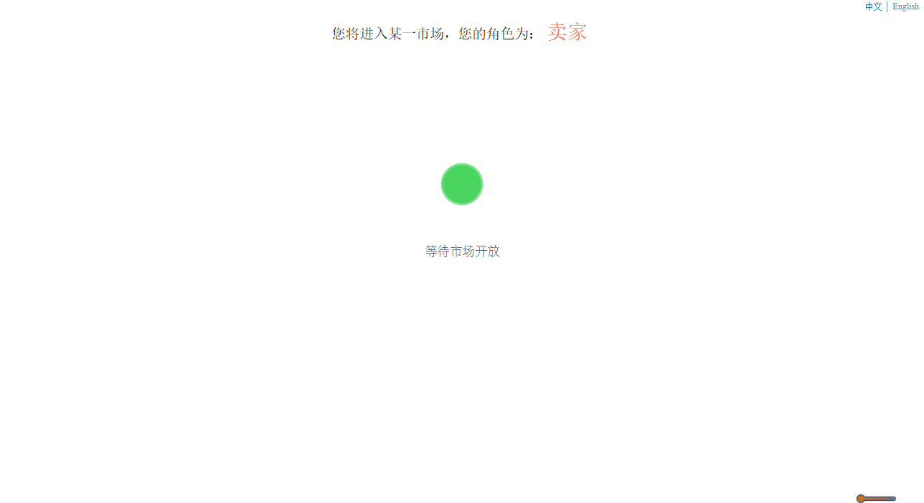
You will enter one of the markets, and your role is Seller.
Please wait for the opening of the market.
Figure A.1 Sellers’ role assignment page
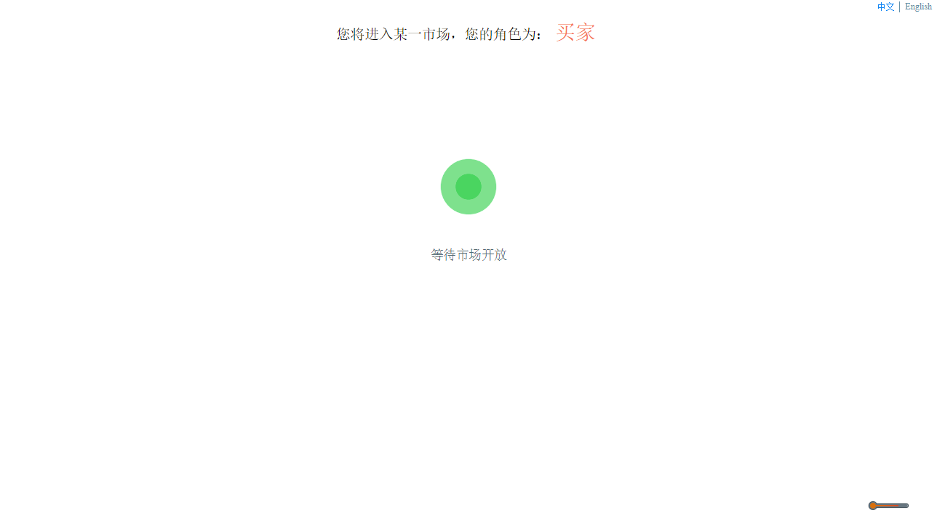
You will enter one of the markets, and your role is Buyer.
Please wait for the opening of the market.
Figure A.2 Buyers’ role assignment page
Note: there may or may not be robot traders participating in the markets, where robot traders refer to buyers or sellers whose actions follow a computer algorithm. The presence or absence of such traders will not be announced.
In this part of the experiment, the currency is called the experimental currency units (ECU). The income (CNY) you earn in this part is determined by the ECU you earn in 8 official trading periods. ECU’s exchange rate to Chinese Yuan (CNY) will be displayed on your computer page after the market starts.
- For all buyers: 1 CNY=35 ECU;
- For sellers in competitive markets: 1 CNY=35 ECU;
- For sellers in duopoly markets: 1 CNY=105 ECU;
- For sellers in monopoly markets: 1 CNY=210 ECU.
[The exchange rate is private information, and it will only be displayed to the corresponding type of participants.]

2 Instructions for buyers
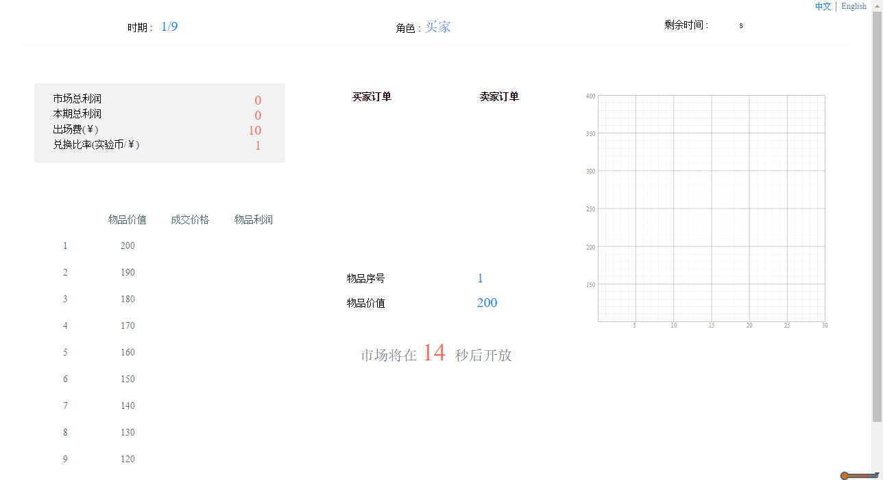
Period: 1/9 Your Role: Buyer Remaining Time: 14 s

Total profit: 0
Profit in the current period: 0
Show up Fee (CNY): 20
Exchange Rate (ECU/￥): 1
Bid Ask
No. Valuation Price Profit
Item’s No.: 1
Item’s valuation: 200
The trading phase of the current period will start after 14 seconds.
Figure A.3 “Preview phase” page of buyers
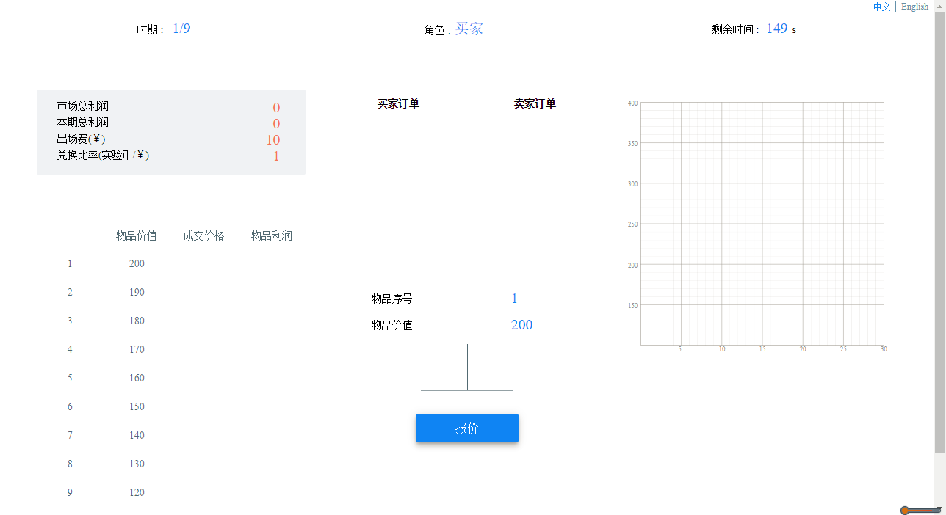
Period: 1/9 Your Role: Buyer Remaining Time: 14 s
Total profit: 0
Profit in the current period: 0
Show up Fee (CNY): 20
Exchange Rate (ECU/￥): 1
No. Valuation Price Profit
Bid Ask
Item’s No. 1
Item’s valuation: 200
Submit the Bid
Panel A
Panel B
Panel C
Figure A.4 “Trading phase” page of buyers
2.1 Valuation of the items for buyers
During the “Preview phase” and “Trading phase”, you can check the “Valuation” and “Price” of each unit of the item. (→Panel A in Figure A.4)
For example, the valuation of the first unit you bought is v1, the valuation of the second is v2, and so on, the valuation of the Nth is vN. In the trading phase, if you successfully buy a unit, the valuation of this unit of the item can be redeemed. If you do not have a transaction, you will not receive its valuation.
You must first buy the first unit, and only after the first unit is successfully purchased, can you make a bid for the second unit, where bid means the highest price you are willing to pay for buying a certain unit. By analogy, you can purchase up to N units shown in panel A of your computer interface during each trading period.
If you have not bought any units at the end of the current trading period, the units’ valuation will become invalid and will not be retained for the next trading period. At the beginning of each new trading period, the units you can purchase will be numbered sequentially starting from 1.
2.2 Calculation of buyers’ profits
In case of a transaction, you realise a profit in the amount of the difference between your private valuation and the transaction price. The units’ valuation appears on your screen at the beginning of each period, and the transaction price and units’ profit will appear on your screen after the unit of the item has been bought by you (Panel A in Figure A.4).
The item’s profit (ECU)= valuation- price
2.3 How to submit a bid and how the transaction price is determined
The only way for you to buy items in the market is to submit a bid. The serial number and the valuation of the unit you are currently trading will be displayed in panel C of Figure A.4. To prevent you from losing money when trading, the bid you submit must be at most as large as the current unit’s valuation. Moreover, the bid you submit must exceed the current highest bid in the market.
All bids submitted by buyers but not yet concluded transactions will be displayed in descending order from highest to lowest in panel B of Figure A.4.
In panel C, after entering the bid that meets the requirements ($≤$ valuation of the current item and the current highest bid), and clicking the “Submit the bid” button, you can submit your bid to the trading system. Only one of your bids can exist at any time in the order book, which means that if your order is shown in panel B at the point of submission of a new order, the newly submitted order will automatically overwrite the original order. In addition, if your order is not the highest bid in the current market, you can withdraw your bid.
As shown below (Figure A.5), your bid will be displayed in blue font. If your bid is not the highest bid in the current market, there will be a “Cancel” button on the right side of your bid. You can cancel your order by clicking on “Cancel” next to your order.
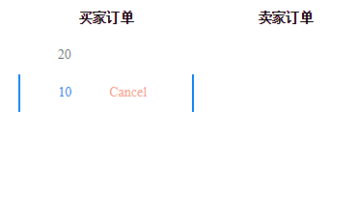
Bid Ask
Figure A.5 An example of bid sequences
If the bid you successfully submitted is greater than or equal to the lowest ask displayed in the current panel B, you immediately buy this unit, and the transaction price will be the displayed lowest ask. The relevant transaction information will appear in panel A of the page for you and the seller with whom you have concluded the transaction.
If the bid you successfully submitted is less than the lowest ask, your bid does not trigger a transaction immediately, and it will be displayed in panel B alongside other orders, sorted by limit price.

3 Instructions for sellers
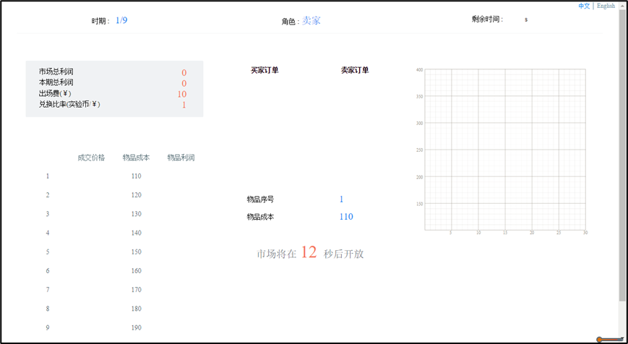
Period: 1/9 Your Role: Seller Remaining Time: 14 s

Total profit: 0
Profit in the current period: 0
Show up Fee (CNY): 20
Exchange Rate (ECU/￥): 1
Bid Ask
No. Price Cost Profit
Item’s No.: 1
Item’s cost: 110
The trading phase of the current period will start after 14 seconds.
Figure A.6 “Preview phase” page of sellers
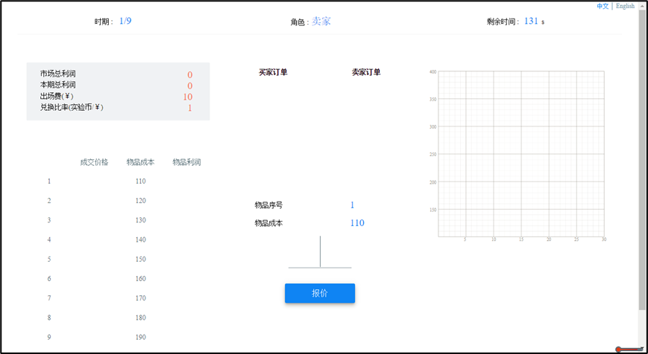
Period: 1/9 Your Role: Seller Remaining Time: 14 s
Total profit: 0
Profit in the current period: 0
Show up Fee (CNY): 20
Exchange Rate (ECU/￥): 1
No. Price Cost Profit

Bid Ask
Item’s No.: 1
Item’s cost: 110

Submit the Ask
Panel A
Panel B
Panel C
Figure A.7 “Trading phase” page of sellers
3.1 Cost of the items for sellers
During the “Preview phase” and “Trading phase”, you can check the “Price” and “Cost” of each unit of the item. (Panel A in Figure A.7)
For example, the cost of the first unit you sold is c1, the cost of the second is c2, and so on, the cost of the Nth is cN. If you successfully sell a unit in the trading phase, you pay the cost of this unit of the item to the trading system. If you do not partake in a transaction, you do not need to pay the cost.
You must first sell the first unit. Only after the first unit is successfully sold, you can ask for the second item, where ask means the lowest price you are willing to pay for selling a certain item. You can sell up to N items shown in panel A of your computer interface during each trading period.
If you have not sold some items at the end of the current trading period, the items’ cost will become invalid and will not be retained until the next trading period. At the beginning of each new trading period, the items you can sell will be numbered sequentially starting from 1.
3.2 Calculation of sellers’ profits
In the case of a transaction, you realize a profit in the amount of the difference between the transaction price and your private cost. The units’ costs appear on your screen at the beginning of each period, and the transaction prices and units’ profits will appear on your screen after the units of the item have been sold (→Panel A in Figure A.7).
The unit’s profit (ECU)= price- cost
3.3 How to submit an ask and how the transaction price is determined
The only way for you to sell items in the market is to submit an ask. The serial number and the cost of the unit you are currently trading will be displayed in panel C of Figure A.7. To prevent you from losing money while trading, the ask you submit must be at least as large as the current unit’s cost. Moreover, the ask you submit must be less than the current lowest ask in the market.
All asks submitted by sellers but not yet concluded transactions will be displayed in increasing order from up to down in Panel B of Figure A.7.
In panel C, after entering the ask that meets the requirements ($≥$ cost of the current item, and the current lowest ask), and clicking the “Submit the Ask" button, you can submit your ask to the trading system. At the same time, only one of your asks can exist in the order book, which means, that if you already submitted an order in panel B at this time, the newly submitted order will automatically overwrite the original order. In addition, if your order is not the lowest ask in the current market, you can withdraw your ask.
As shown below (Figure A.8), your ask will be displayed in blue font. If your ask is not the lowest ask in the current market, there will be a “Cancel” button on the right side of your ask. You can cancel your order by clicking on “Cancel” next to your order.
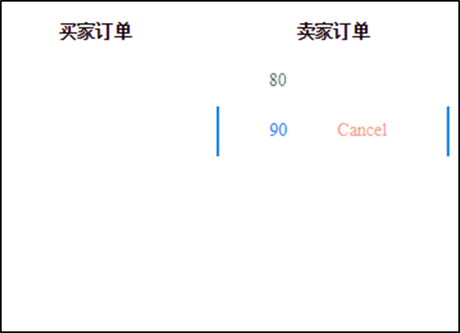
Bid Ask
Figure A.8 An example of ask sequences
If the ask you successfully submitted is less than or equal to the highest bid displayed in the current panel B, you sell this unit immediately, and the transaction price will be the current highest bid. The relevant transaction information will appear in panel A of your page and the page of the buyer with whom you have concluded the transaction.
If the ask you successfully submitted is higher than the highest bid, your ask does not trigger a transaction immediately, and it will be displayed in panel B by order of limit price.
4 Other instructions on the personal page for all traders
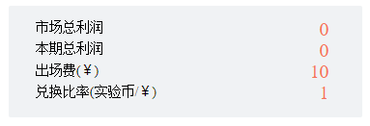
Total profit: 0
Profit in the current period: 0
Show up Fee (CNY): 20
Exchange Rate (ECU/￥): 1
Figure A.9 Trading profit
In the section shown in Figure A.9, you can find your profits earned in the current market scenario, in the current period, show-up fee, and exchange rate. At the end of this trading part, the total profit will be converted into CNY according to the exchange rate and added to your experimental payoff.
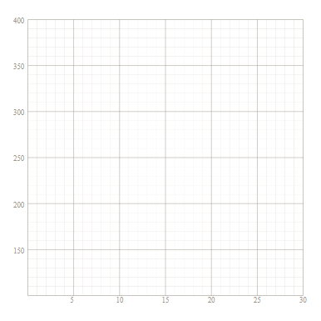
Figure A.10 Transaction price path
The figure shown above will appear on the right side of your computer interface, which shows the transaction price corresponding to each transaction unit in the current trading period of your market. The horizontal axis of the figure represents the order number that was traded in the market, and the vertical axis represents the transaction price corresponding to the transaction.
Notes: The numbers shown on all screenshots in the experiment instructions are for illustrative purposes only and are independent of the official experiment.

Appendix B: ZIP agent description (Cliff and Bruten, 1997)
- Notation
i: buyer or seller agent i
j: the unit the agent buyer (seller) i is attempting to buy(sell). $j$=1, 2, 3, …, N
k: sequence number for accepted market actions (transactions and accepted limit prices)
s: number of sleep cycles of agent i followed by order submissions or updates upon waking of agent i
t: market time t
${t_{i}}^{k}$: real time when trader i submits its order value $p_{i,j}$ to the market
$∆{t_{i}}^{k}=timeinterval×\left(1+{α_{i}}^{k}\right)$ for $∀i,k$, where the fixed time interval for fast-ZIP is 1 second, and for slow-ZIP is 5 seconds. ${α_{i}}^{k}$ is drawn at random from a uniform distribution over the interval [-0.25, 0.25] for $∀i,k$.
$p_{i,j}\left(t\right)$: The current limit price of trader i for unit j.
$q_{s}\left(t\right)$: last limit price accepted by the market
$μ_{i}\left(t\right)$: latent surplus demand (profit margin) of agent i
$λ_{i,j}\left(t\right)$: agent i’s value or cost of unit j

- Overview
At a given time t, a ZIP agent $i$ calculates the shout-price $p_{i}\left(t\right)$ for unit $i$ with value/cost $λ_{i,j}$ using the latent surplus demand $μ_{i}\left(t\right)$ according to the equation:
$$p_{i,j}\left(t\right)=λ_{i,j}\left(1+μ_{i}\left(t\right)\right)$$

At market opening $t=0$, $μ_{i}\left(0\right)$ is drawn randomly from a uniform distribution over the interval $\left[0.05,0.35\right]$ for sellers and $\left[−0.35,−0.05\right]$ for buyers. Every agent i will calculate an initial latent order $p_{i,1}\left(t\right)$ and its 1st sleep time $∆{t_{i}}^{1}$ which determines the time ${t_{i}}^{1}$ when it should submit its first order of $p_{i,1}$ to the market.

A market action triggers a response from agent i. We distinguish between 4 types of market actions. Depending on the relationship between its current latent order price $p_{i,j}\left(t\right)$ and last shout-price $q\left(t\right)$, the ZIP agents will take action depending on their role and latent order price.
Market action 1: A new limit buy order ($q_{s}\left(t\right)=newBIDprice$) is added to the order book.
- Agent buyer i’s latent order $p_{i,j}\left(t\right)>q_{s}\left(t\right)$: Agent i does not respond to market action.
- Agent buyer i’s latent order $p_{i,j}\left(t\right)≤q_{s}\left(t\right)$: Agent i should lower its profit margin, i.e., increase its latent order price.
- Agent sellers do not respond to market action
Market action 2: A new limit sell order ($q_{s}\left(t\right)=newASKprice$) is added to the order book.
- Agent seller i’s latent order $p_{i,j}\left(t\right)≥q_{s}\left(t\right)$: Agent i should lower its profit margin, i.e., decrease its latent order price.
- Agent seller i’s latent order $p_{i,j}\left(t\right)<q_{s}\left(t\right)$: Agent i does not respond to market action.
- Agent buyers do not respond to market action
Market action 3: A new buy order triggers a transaction with a latent sell order at price $q_{s}\left(t\right)$
- Agent buyer i’s latent order $p_{i,j}\left(t\right)≥q_{s}\left(t\right)$: Agent i should raise its profit margin, i.e., decrease its latent order price.
- Agent buyer i’s latent order $p_{i,j}\left(t\right)<q_{s}\left(t\right)$: Agent i does not respond to market action.
- Agent seller i’s latent order $p_{i,j}\left(t\right)≤q_{s}\left(t\right)$: Agent i should increase its profit margin, i.e., increase its latent order price.
- Agent seller i’s latent order $p_{i,j}\left(t\right)>q_{s}\left(t\right)$: Agent i should lower its profit margin, i.e., decrease its latent order price.
Market action 4: A new sell order triggers a transaction with a latent buy order at price $q_{s}\left(t\right)$
- Agent buyer i’s latent order $p_{i,j}\left(t\right)≥q_{s}\left(t\right)$: Agent i should raise its profit margin, i.e., decrease its latent order price.
- Agent buyer i’s latent order $p_{i,j}\left(t\right)<q_{s}\left(t\right)$: Agent i should lower its profit margin, i.e., increase its latent order price.
- Agent seller i’s latent order $p_{i,j}\left(t\right)≤q_{s}\left(t\right)$: Agent i should raise its profit margin, i.e., increase its latent order price.
- Agent seller i’s latent order $p_{i,j}\left(t\right)>q_{s}\left(t\right)$: Agent i does not respond to market action.
NOTE: Following the implementation by Das et al. (2007), fast-ZIP agents will respond to all 4 kinds of market actions $q_{s}\left(t\right)$, while slow-ZIP agents will only respond to Market action 3 & Market action 4.

- Different agent actions are reflected through different formulas
For every ZIP agent, there are 3 types of actions: not respond (the agent’s latent order $p_{i,j}$ will remain the same.), increase latent order, and decrease latent order. The update rule of increasing or decreasing a latent order is described below (we suppress subscript t below for the sake of readability and use the sequence variables k and s).
The target price is set based on a relative price change and an absolute price change:
$$\left(1\right)τ_{i}^{k}=R_{i}^{k}∗q_{s}+A_{i}^{k}$$
$τ_{i}^{k}$: target price determined by $R_{i}^{k}$, $A_{i}^{k}$ and price $q_{s}$
$R_{i}^{k}$: randomly generated relative price change, uniformly distributed over [1.0, 1.05] for price increases, and [0.95, 1.0] for price decreases
$A_{i}^{k}$: randomly generated absolute price change, uniformly distributed over [0.0, 0.05] for price increases and [-0.05, 0.0] for price decreases
Based on the new target price, the change in price is calculated using the Widrow-Hoff rule and the learning characteristic of the individual agent.
(2) $∆_{i}^{k}=β_{i}\left(τ_{i}^{k}−p_{i,j}\right)$
$∆_{i}^{k}$: Widrow-Hoff delta rule based on target price $τ_{i}^{k}$ and latent order $p_{i,j}$
$β_{i}$: learning characteristic of agent i. For every agent i in a period, $β_{i}$ is randomly generated from the uniform distribution [0.1, 0.5] at the beginning of this period and remains fixed for the whole period.
The learning system requires a dampening factor $\left(1−γ_{i}\right)$ to prevent price oscillations:
$\left(3\right)Γ_{i}^{k}=γ_{i}∗Γ_{i}^{k−1}+\left(1−γ_{i}\right)∗∆_{i}^{k}$ , where $Γ_{i}^{0}=0$
$Γ_{i}^{k}$: new price change based on Widrow-Hoff delta and previous price change $Γ_{i}^{k−1}$
$γ_{i}$: momentum coefficient. For every agent i, $γ_{i}$ is randomly generated from the uniform distribution over [0, 0.1] at the beginning of the period and remains fixed for the whole period.
(4) $μ_{i}^{k+1}=\frac{p_{i,j}^{k}+Γ_{i}^{k}}{λ_{i,j}^{k}}−1$
$μ_{i}^{k+1}$: new latent surplus demand of trader i based on previous latent order $p_{i,j}^{k}$, new price change $Γ_{i}^{k}$, and private value/cost $λ_{i,j}^{k}$
(5) $p_{i,j}^{k+1}$=$λ_{i,j}^{k+1}\left(1+μ_{i}^{k+1}\right)$
$p_{i,j}^{k+1}$: new latent order price

Appendix C: Pre- and post-experiment surveys
At the beginning of the experiment, participants completed three tasks: the eye gaze test (ET), the extended cognitive response test (CRT), and the reaction test (RT). All three tasks are rewarded on a piece-rate basis. At the end of the experiment, the participants completed a general survey and a market assessment survey.

C.1 Pre-experiment eye gaze test
We administered the eye gaze test to measure ToM skills, developed by Baron-Cohen et al. (1997) and applied by Bruguier et al. (2010) and Corgnet et al. (2018), among others. 36 photographs of eye gazes are shown, and subjects are asked to pick the mental state from a list of four adjectives that best describe the mental state of the person. We reward subjects for correct answers, as is common in the literature (see for example, Bruguier et al. 2010). The average rate of correct answers is 25.69 (N=745, SD=2.92, Min=14, Max=34).
Adult Eyes Instructions: For each set of eyes, choose which word best describes what the person in the picture is thinking or feeling. You may feel that more than one word is applicable but please choose just one word, the word that you consider to be most suitable. Before making your choice, make sure that you have read all 4 words. If you do not know what a word means, you can look it up in the definition handout.
Figure C.1 Practice eye test question

C.2 Pre-experiment extended CRT
The second task is the CRT, a common test to measure skills of cognitive reflection and thus their ability to avoid common behavioral biases. We use the test version by Frederick (2005) which consists of 7 questions that have an intuitive but incorrect answer (e.g., “A bat and a ball cost $1.10 in total. The bat costs a dollar more than the ball. How much does the ball cost?”, Frederick 2005). While the intuitive answer (“10¢”) is incorrect, reflection will often lead to the correct response (“5¢”). We again reward subjects for correct answers in this task. The average number of correct answers is 5.70 (N=746, SD=1.52, Min=1, Max=7). We administered the extended (seven-question) version of the CRT, which includes the original three questions (Frederick (2005)) and four additional questions developed by Toplak, West, and Stanovich (2014).
- A bat and a ball cost $1.10 in total. The bat costs a dollar more than the ball. How much does the ball cost? ____ cents [Correct answer: 5 cents; intuitive answer: 10 cents]
- If it takes 5 machines 5 minutes to make 5 widgets, how long would it take 100 machines to make 100 widgets? ____ minutes [Correct answer: 5 minutes; intuitive answer: 100 minutes]
- In a lake, there is a patch of lily pads. Every day, the patch doubles in size. If it takes 48 days for the patch to cover the entire lake, how long would it take for the patch to cover half of the lake? ____ days [Correct answer: 47 days; intuitive answer: 24 days]
- If John can drink one barrel of water in 6 days, and Mary can drink one barrel of water in 12 days, how long would it take them to drink one barrel of water together? _____ days [Correct answer: 4 days; intuitive answer: 9]
- Jerry received both the 15th highest and the 15th lowest mark in the class. How many students are in the class? ______ students [Correct answer: 29 students; intuitive answer: 30]
- A man buys a pig for $60, sells it for $70, buys it back for $80, and sells it finally for $90. How much has he made? _____ dollars [Correct answer: $20; intuitive answer: $10]
- Simon decided to invest $8,000 in the stock market one day early in 2008. Six months after he invested, on July 17, the stocks he had purchased were down 50%. Fortunately for Simon, from July 17 to October 17, the stocks he had purchased went up 75%. At this point, Simon has: a. broken even in the stock market, b. is ahead of where he began, c. has lost money [Correct answer: c; intuitive answer: b]

C.3 Pre-experiment reaction test
The third task is the RT, a test in which subjects are repeatedly asked to choose the highest of three listed numbers during a fixed time period of 2 minutes. We measure the number of correct answers for this task and offer a reward proportional to the performance in the task. The average number of correct answers is 31.08 (N=746, SD=5.98, Min=16, Max=54).

C.4 Post-experiment general survey
1. How old are you? _______ years
2. Are you [male/female]
3. Are you enroled in an economics-related study programme? [yes/no]
4. Have you ever participated in a double auction experiment (in a laboratory or classroom)? [yes/no]
5. How would you rate your knowledge about double auctions? [expert/basic knowledge/none]

C.5 Post-experiment market assessment survey
1. Do you think that computer traders were active in the market? [yes/no]
If you answer yes, then go to 2, otherwise, go to 3.
2.
a. If yes, how many buyers and sellers do you think were participating in the market?
_______ buyers, _______ of which were computer traders
_______ sellers, _______ of which were computer traders
b. how would you describe the computer traders’ strategies? [max 350 characters]
3.
a. If no, how many buyers and sellers do you think were active?
_______ buyers
_______ sellers
b. How would you describe the other traders’ strategies? [max 350 characters]

Appendix D: Assessing the robustness to differences in demand and supply price sensitivity
To rule out any confounding effects due to the configuration of the market supply and demand schedules, the specific trader role, or the distribution of market power, we conduct simulations for two scenarios. In Scenario (1), we horizontally flip the market supply and demand schedules around the competitive equilibrium price whilst retaining relative market power between buyers and sellers. In Scenario (2), we flip the supply-demand curves and reallocate market power to the demand rather than supply side by keeping the number of sellers constant at six and restricting the number of buyers to two (in an effective duopsony setting) and one (in a monopsony setting), respectively. The simulations are run with the same market software as the actual experiments and with agents on both the supply and demand side.
In each scenario and market structure, we conduct three different simulation treatments: a treatment with fast-ZIP agents only, a treatment with fast-ZIP sellers and slow-ZIP buyers, and a treatment with slow-ZIP sellers and fast-ZIP buyers. Each treatment consists of eight trading periods, repeated eight times, to reflect the eight sessions per treatment in the actual experiment. We compare the performance differences between fast-ZIP and slow-ZIP sellers and buyers between two treatments with the same market structure but vary the ZIP agent type populating the opposite side of the market. For Scenario (1), the simulation results confirm our results for unbalanced markets under alternative market supply and demand schedules.
In contrast, our results are reversed in Scenario (2), when the market power switches from sellers to buyers. We find that slow-ZIP agents generally outperform fast-ZIP agents under unbalanced market structures in Scenarios (1) and (2) for competitive/duopoly/monopoly and competitive/duopsony/monopsony structures.

D.1 Flipping process
We use the competitive equilibrium of 262.5 as the symmetry axis to flip the supply and demand curves. Buyer i’s Value_{i,F} (seller i’s Cost_{i,F}) in the flipped supply and demand situation is derived from seller i’s Cost_{i,O} (buyer i’s Value_{i,O}) in the original supply and demand situation (Figure 1):
${Value}_{i,F}=262.5∗2−{Cost}_{i,O}$ and ${Cost}_{i,F}=262.5∗2−{Value}_{i,O}$,
where $F$ indicates a flipped schedule and $O$ is an original schedule.
Figure D.1 Flipped Supply and Demand Curves (Top: Scenario 1; Bottom: Scenario 2)

D.2 Trade Price Dynamics in Scenario 1 (Flipped Supply and Demand Schedule and Duopoly/Monopoly Structure)
We first show the simulation results by the trade price dynamics figures (Figure D.2) first, then the trade price statistics and the surplus distribution (Table D.1), and finally the Wilcoxon rank sum test results for performance comparison between fast-ZIP and slow-ZIP agents (Table D.2).

Figure D.2 Trade Price Dynamics (Scenario 1: Monopolist and Duopolist Sellers)
This figure presents the average trade prices for simulation scenario 1. The time series in the figures plot the average price of the n^{th} transaction of a period, averaged across all periods, markets, and sessions. The dots (●) in the plots represent the average prices for transactions that occur in at least 95% of all periods across markets and simulations, while the crosses (×) represent average prices for the transactions that occur in 80%-95% of all periods across markets and simulations.

Table D.1 Trade price statistics and surplus distribution of simulation treatments in Scenario 1
This table presents the surplus shares of buyers and sellers by treatment for Scenario 1.
Treatment | Average  Price | Std. Dev. Price | Average Volume | Market  Efficiency | Surplus  (Seller) | Surplus  (Buyer)
Panel A: Competitive Market Structure
6FZ-6FZ | 260 | 13.07 | 19.55 | 98.49% | 44.83% | 53.65%
6FZ-6SZ | 222 | 10.02 | 20.00 | 97.85% | 9.18% | 88.66%
6SZ-6FZ | 288 | 16.63 | 18.70 | 99.02% | 69.77% | 29.25%
Panel B: Duopoly Market Structure
2FZ-6FZ | 291 | 13.10 | 18.66 | 99.84% | 72.59% | 27.25%
2FZ-6SZ | 239 | 10.41 | 19.83 | 98.70% | 24.84% | 73.86%
2SZ-6FZ | 335 | 4.84 | 14.39 | 90.40% | 88.78% | 1.62%
Panel C: Monopoly Market Structure
1FZ-6FZ | 307 | 11.19 | 18.00 | 100.00% | 85.33% | 14.67%
1FZ-6SZ | 265 | 12.50 | 18.73 | 99.71% | 49.73% | 49.97%
1SZ-6FZ | 345 | 1.71 | 11.98 | 83.31% | 82.45% | 0.86%

Table D.2 Performance comparison between fast-ZIP and slow-ZIP agents in Scenario 1
This table presents the average surplus across traders for different types of traders (fast-ZIP vs. slow-ZIP) at the period level. Buyer and seller surplus of different types are compared between treatments with the same market structure, where the opposite side of the market is composed of fast-ZIP agents. Two-sided p-values based on Wilcoxon rank sum test results are recorded in parentheses. ***, **, and * denote statistical significance at the 0.01, 0.05, and 0.1 levels.
Market Structure | Seller Surplus | Buyer Surplus
Competitive | 6FZ-6FZ vs. 6SZ-6FZ | 6FZ-6FZ vs. 6FZ-6SZ
Competitive | z = -7.899***  (0.000) | z = -9.402***  (0.000)
Duopoly | 2FZ-6FZ vs. 2SZ-6FZ | 2FZ-6FZ vs. 2FZ-6SZ
Duopoly | z = -8.352***  (0.000) | z = -9.750***  (0.000)
Monopoly | 1FZ-6FZ vs. 1SZ-6FZ | 1FZ-6FZ vs. 1FZ-6SZ
Monopoly | z = 2.429**  (0.015) | z = -9.588***  (0.000)

Our simulation results for Scenario 1 are consistent with our main results from Table 7, slow-ZIP agents consistently outperform fast-ZIP agents in different market structures as both buyers and sellers, with one exception being the fast-ZIP and slow-ZIP monopolist. When comparing the surplus of the fast-ZIP and slow-ZIP monopolists (1FZ-6FZ vs. 1SZ-6FZ), we find that the fast-ZIP monopolist seller captures more surplus than the slow-ZIP monopolist seller. When comparing the price of the two treatments, the slow-ZIP monopolist sellers achieve higher prices on average than their fast-ZIP counterparts, the 1SZ-6FZ mean is 345 while the 1FZ-6FZ mean is 307. From the 1SZ-6FZ subgraph in Figure D.2, we can also see that the slow-ZIP monopolist effectively uses market power. However, the volume is lower in the 1SZ-6FZ simulations compared to the 1FZ-6SZ simulations. Therefore, the relatively inferior performance of slow-ZIP monopolists compared to fast-ZIP monopolists is due to their average failure to trade all tradable units.

D.3 Trade Price Dynamics in Scenario 2 (Flipped Supply and Demand Schedule and Duopsony/Monopsony Structure)
We follow the same organisation as in Scenario 1 to report the simulation results of Scenario 2.
Figure D.3 Trade Price Dynamics (Scenario 2: Monopsonist and Duopsonist Buyers)
This figure presents the average trade prices for simulation Scenario 2. The time series in the figures plot the average price of the n^{th} transaction of a period, averaged across all periods, markets, and sessions. The dots (●) in the plots represent the average prices for transactions that occur in at least 95% of all periods across markets and simulations, while the crosses (×) represent the average prices for the transactions that occur in 80%-95% of all periods across markets and simulations.

Table D.3 Trade price statistics and surplus distribution of simulation treatments in Scenario 2
This table presents the surplus shares of buyer and seller types and by treatment for Simulation Scenario 2.
Treatment | Average  Price | Std. Dev. Price | Average Volume | Market  Efficiency | Seller Surplus | Buyer Surplus
Panel A: Competitive Market Structure
6FZ-6FZ | 260 | 13.07 | 19.55 | 98.49% | 44.83% | 53.65%
6FZ-6SZ | 222 | 10.02 | 20.00 | 97.85% | 9.18% | 88.66%
6SZ-6FZ | 288 | 16.63 | 18.70 | 99.02% | 69.77% | 29.25%
Panel B: Duopsony Market Structure
6FZ-2FZ | 227 | 7.72 | 18.95 | 99.64% | 15.89% | 83.75%
6FZ-2SZ | 209 | 3.30 | 18.02 | 99.16% | 1.84% | 97.32%
6SZ-2FZ | 280 | 18.83 | 19.25 | 99.53% | 63.82% | 35.71%
Panel C: Monopsony Market Structure
6FZ-1FZ | 215 | 4.87 | 18.00 | 100.00% | 6.98% | 93.02%
6FZ-1SZ | 203 | 4.38 | 12.98 | 85.89% | 0.60% | 85.29%
6SZ-1FZ | 256 | 18.32 | 18.41 | 99.87% | 42.11% | 57.76%

Table D.4 Performance comparison between fast-ZIP and slow-ZIP agents in Scenario 2
This table presents the average surplus across traders for different types of traders (fast-ZIP vs. slow-ZIP) at the period level. Buyer and seller surplus of different types are compared between treatments with the same market structure, where the opposite side of the market is composed of fast-ZIP agents. Two-sided p-values based on Wilcoxon rank sum test results are recorded in parentheses. ***, **, and * denote statistical significance at the 0.01, 0.05, and 0.1 levels.
Market Structure | Seller Surplus | Buyer Surplus
Competitive | 6FZ-6FZ vs. 6SZ-6FZ | 6FZ-6FZ vs. 6FZ-6SZ
Competitive | z = -7.899***  (0.000) | z = -9.403***  (0.000)
Duopsony | 6FZ-2FZ vs. 6SZ-2FZ | 6FZ-2FZ vs. 6FZ-2SZ
Duopsony | z = -9.727***  (0.000) | z = -9.195***  (0.000)
Monopsony | 6FZ-1FZ vs. 6SZ-1FZ | 6FZ-1FZ vs. 6FZ-1SZ
Monopsony | z = -9.684***  (0.000) | z = 6.664***  (0.000)

In the simulations of Scenario 2 simulations, slow-ZIPs consistently outperform fast-ZIPs, evident from the lower average prices achieved by slow-ZIP buyers and the higher average prices achieved by slow-ZIP sellers in Figure D.3. Our previous price and surplus results are thus reversed due to the shift in market power from sellers to buyers. As shown in Table D.3 and D.4, one exception is the 6FZ-1SZ simulation treatment due to the low trading volume in this treatment, similar to the exception in Scenario 1 (1SZ-6FZ treatment).
Simulations in Scenario 2 suggest that our results are robust to flipping market supply and demand schedules and switching from duopolists/monopolists to duopsonists/monopsonists market structures. In other words, the inferior performance of fast-ZIP agents to slow-ZIP agents observed on the seller side holds for the buyer side when market power is concentrated on the demand side of the market.

References of Appendices
- Baron-Cohen, S., Jolliffe, T., Mortimore, C. & Robertson, M. (1997) Another advanced test of theory of mind: Evidence from very high functioning adults with autism or Asperger syndrome. Journal of Child Psychology and Psychiatry and Allied Disciplines, 38, 813–822.
- Bruguier, A. J., Quartz, S. R. & Bossaerts, P. (2010) Exploring the nature of ‘trader intuition’. Journal of Finance, 65, 1703–1723.
- Cliff, D. & Bruten, J. (1997) Zero is not enough: on the lower limit of agent intelligence for continuous double auction markets. HP Laboratories Technical Report HPL vol. 28.
- Corgnet, B., Desantis, M., & Porter, D. (2018) What makes a good trader? On the role of intuition and reflection on trader performance. The Journal of Finance, 73(3): 1113-1137.
- Frederick, S. (2005) Cognitive reflection and decision making. Journal of Economic Perspectives, 19, 25–42.
- Toplak, M. E., West, R. F., & Stanovich, K. E. (2014) Assessing miserly information processing: An expansion of the Cognitive Reflection Test. Thinking & Reasoning, 20(2), 147-168.

In contrast to the experiments, the simulations exclusively include ZIP agents whose behavioural rules do not adjust across periods. Thus, we proceed by treating the market period as the unit of independent observation rather than the session level. This allows us to conduct more powerful hypothesis tests as the number of independent observations in the simulations is larger.

