**Iron Age Connectivity Revealed by an Assemblage of Egyptian Faience in Central Iberia**

**Linda Chapon, Juan Jesús Padilla-Fernández, Alberto Dorado-Alejos and Antonio Blanco-González**

Supplementary Material: S1–S5

**S1: Macrophotography**

Macrophotographs were taken with a Leica binocular loupe, model M80 with an 8:1 zoom range of 7.5× to 60×. The camera was an EC3 model (3.1 megapixels), which allows progressive scanning and image acquisition (up to 15 frames per second) using the Leica Application Suite software in which the images are calibrated to add scale automatically.

When making faience, sodium oxide is added to the mixture as a flux for better cohesion and glazing of the piece at lower temperatures in the kiln. Sodium oxide could be obtained in various ways: by adding natron—a sodium carbonate (Na2CO3-10H2O) extracted from Wadi El-Natrun (northern Egypt)—or by adding carbonized plant ash mixed with water in different proportions.

**S2: Microphotography**

Microphotographs were taken with a Coxem EM-30AXP desktop Scanning Electron Microscope, with Low Vacuum system and Secondary electron detector (SE), Backscattered electron detector (BSE) and X-ray detector (EDS), not used in this study. This equipment captures images at a wide range of magnification (from ×15 to ×150,000), having been taken at a magnification of ×500 and ×1000, and at a voltage of 10-11 kV.

The microphotographs examined the heterogeneity of the mineral samples and their surface microstructure, the chemical composition of the minerals, the organic components of the samples (inclusions), and the microstructural changes of the clay matrix (e.g. vitrification) to identify production traces or to characterize pigments and other elements applied to the artefacts (Gibson & Woods, 1997; Nicholson & Peltenburg, 2000; Ionescu et al., 2015).

Regarding the temperatures reached in the production process (which show obvious differences between faience and glass composition through microstructural observation), in the case of faience, a temperature of 100º C is maintained for the first hour to eliminate water that may still be inside the objects. Subsequently, the temperature is gradually increased, as the crystalline structure of the silica must be modified without sudden changes. The most critical moments occur first at 573º, when the quartz and pigments begin to melt, and then between 800º and 900º C, when the carbonaceous and sodium material in the paste is reduced and there is a risk that the piece becomes deformed. The temperature is then increased to 960º–1000º C, which is necessary for the varnish and paste to vitrify.

**S3: Infrared spectra**

Infrared spectra were recorded and analysed using a Jasco 4700 instrument, obtained at 4 cm−1 resolution for 30 scans in the 4000–400 cm−1 spectral range. The equipment incorporates an Attenuated Total Reflectance (ATR) module to improve the results. This method provides useful information on the mineral phases present, while only using a very small sample (*c.* 0.2 mg) (Ostrooumov, 2009; Akyuz et al., 2008), and is widely used in the characterization of materials such as ceramics or pigments (Shoval, 2016).

**S4: Chemical characterization**

Chemical characterization used a portable X-Ray Fluorescence Thermo Scientific Niton XL3t, model GOLDD. The faience and glass were placed on the 3 mm diameter spot, applying Cu/Zn Mining mode and always centred on the core of the objects, when possible, in order to eliminate compositional variations that could derive from the surface decorations (e.g. Egyptian blue). In samples where it was not possible to analyse the matrix, the measurement was carried out on the surface. Where it was possible, several analyses were carried out. The instrument was adjusted to detect the low, high and lightweight elemental ranges for a total of 120 seconds. This mode measures the concentration of elements heavier than magnesium (Mg) and reports the data as a percentage by weight of the element, while the concentration of undetected elements is calculated to give a total balance of 100 wt%, expressed as Bal.

The elements Al, Ca, Mg, and K were used to compare all series, as other studies have done (Koleini et al., 2017; García-González et al., 2021), the aim being to establish relationships between all the samples in the statistical analysis by eliminating the sodium factor, which cannot be identified by this technique. The result is expressed as a percentage of the absolute weight of the element and not as an oxide, as this requires the concentrations of all the main elements, which have not been detected with this method (Brand & Brand, 2014).

**References**

Akyuz, S., Akyuz, T., Basaran, S., Bolcal, C. & Gulec, A. 2008. Analysis of Ancient Pottery Using FT-IR, Micro-Raman and EDXFR Spectrometry. *Vibrational Spectroscopy*, 48: 276–80. <https://doi.org/10.1016/j.vibspec.2008.02.011>

Brand, N.W. & Brand, C.J. 2014. Performance Comparison of Portable XRF Instruments. *Geochemistry: Exploration, Environment, Analysis*, 14: 125. https://doi.org/10.1144/geochem2012-172

García-González, J., Dorado-Alejos, A., Cobos-Rodríguez, L.M. & López-López, V. 2021. Cuentas de pasta vítrea y fayenza en contextos postalayóticos (s. VII- II a.n.e): El conjunto de So na Caçana (Alaior, Menorca). *Cuadernos de Prehistoria y Arqueología de la Universidad Autónoma de Madrid*, 47: 123–49. https://doi.org/10.15366/cupauam2021.47.2.004

Gibson, A. & Woods, A. 1997. *Prehistoric Pottery for the Archaeologist*. London: Leicester University Press.

Ionescu, C., Hoeck, V., Crandell, O.N. & Šaric´, K. 2015. Burnishing versus Smoothing in Ceramic Surface Finishing: A SEM study. *Archaeometry*, 57: 18–26. https://doi.org/10.1111/arcm.12089

Koleini, F., Colomban, F., Antonites, A. & Pikirayi, I. 2017. Raman and XRF Classification of Asian and European Glass Beads Recovered at Mutamba, a Southern African Middle Iron Age Site. *Journal of Archaeological Science: Reports*, 13: 333–40. https://doi.org/10.1016/j.jasrep.2017.04.004

Nicholson, P.T. & Peltenburg, E. 2000. Egyptian Faience. In: P.T. Nicholson & I. Shaw, eds. *Ancient Egyptian Materials and Technology*. Cambridge: Cambridge University Press, pp. 177–94.

Ostrooumov, M. 2009. *Mineralogía analítica*. Michoacán: Sociedad Mexicana de Mineralogía.

Shoval, S. 2016. Fourier Transform Infrared Spectroscopy (FT-IR) in Archaeological Ceramic Analysis. In: A. Hunt, ed. *The Oxford Handbook of Archaeological Ceramic Analysis*. Oxford: Oxford University Press, pp. 509–30. <https://doi.org/10.1093/oxfordhb/9780199681532.013.28>

**S5: Supplementary Figures and Tables**



*Figure S1. Overlay of two FTIR spectra obtained from Item 1.*



*Figure S2. Overlay of two FTIR spectra obtained from Item 2.*

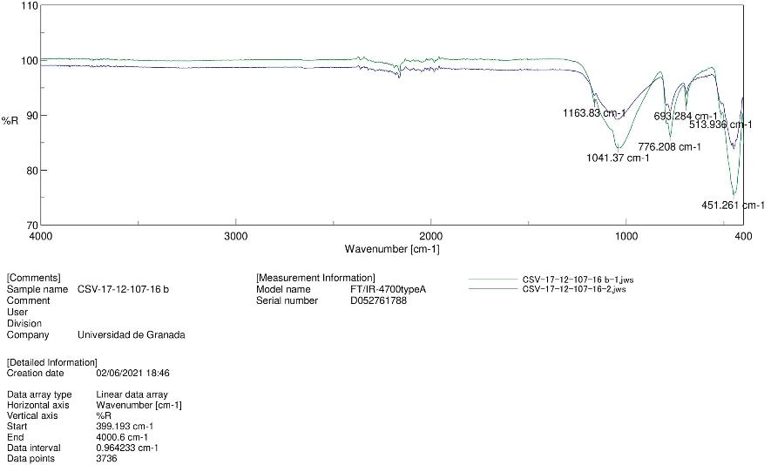

*Figure S3. Overlay of two FTIR spectra obtained from Item 3.*



*Figure S4. Overlay of two FTIR spectra obtained from Item 4.*



*Figure S5. Overlay of two FTIR spectra obtained from Item 5.*

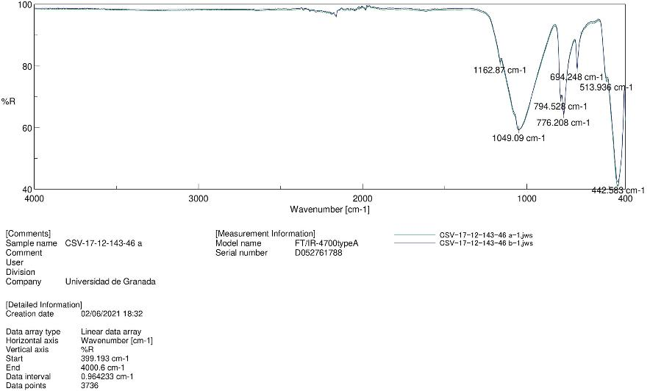

*Figure S6. Overlay of two FTIR spectra obtained from Item 6.*

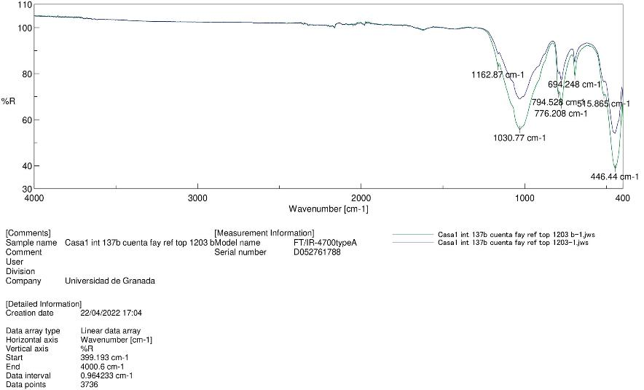

*Figure S7. Overlay of two FTIR spectra obtained from Item 7.*



*Figure S8. Overlay of two FTIR spectra obtained from Item 8.*

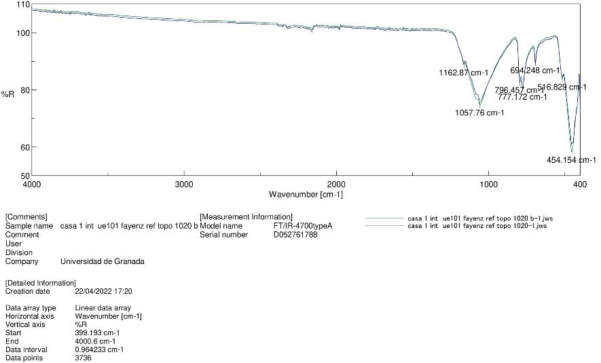

*Figure S9. Overlay of two FTIR spectra obtained from Item 9.*

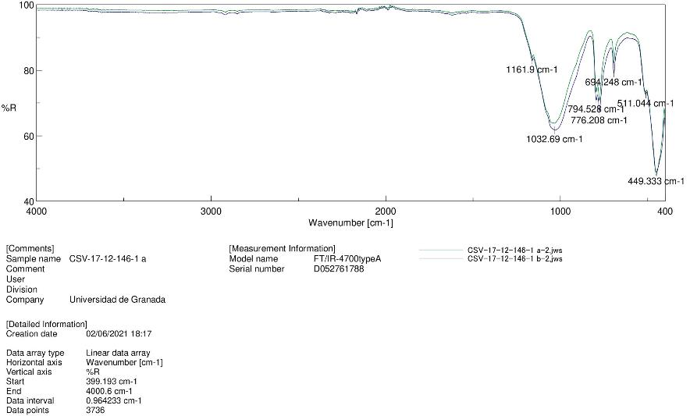

*Figure S10. Overlay of two FTIR spectra obtained from Item 10.*

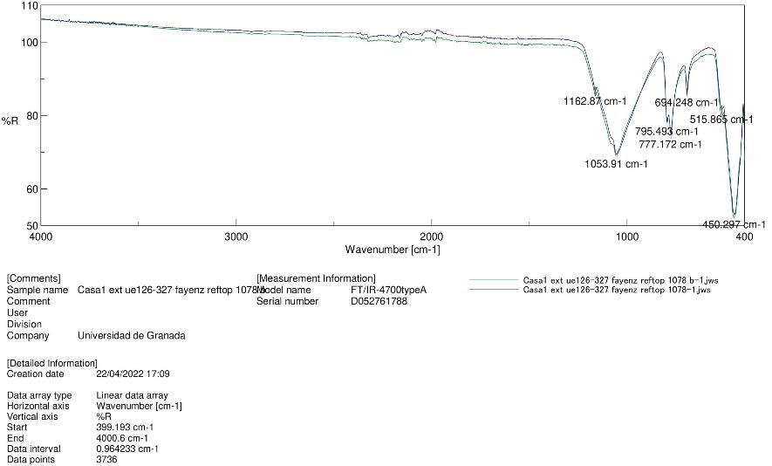

*Figure S11. Overlay of two FTIR spectra obtained from Item 11.*



*Figure S12. Overlay of two FTIR spectra obtained from Item 12.*



*Figure S13. Overlay of two FTIR spectra obtained from Item 13.*

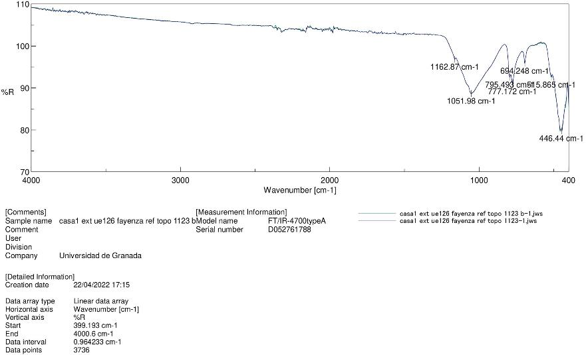

*Figure S14. Overlay of two FTIR spectra obtained from Item 14.*

*Table S1. Chemical results of X-Ray fluorescence (pXRF). Values expressed in %; <LOD = Limit of detection).*

|  |  |  |  |  |  |  |  |  |  |  |  |  |  |  |  |  |  |  |  |  |  |  |  |  |  |  |  |
| --- | --- | --- | --- | --- | --- | --- | --- | --- | --- | --- | --- | --- | --- | --- | --- | --- | --- | --- | --- | --- | --- | --- | --- | --- | --- | --- | --- |
| Sample Id | Ba | Sb | Sn | Cd | Pd | Ag | Zr | Sr | As | Se | Pb | W | Zn | Cu | Fe | Mn | V | Ti | Ca | K | Al | P | Si | Cl | S | Mg | Bal |
| Item 1 | < LOD | 0.002 | 0.05 | < LOD | < LOD | < LOD | < LOD | 0.003 | < LOD | < LOD | 0.003 | < LOD | 0.006 | 1.2 | 0.161 | < LOD | < LOD | 0.022 | 1.293 | 0.267 | 0.646 | 0.309 | 28.686 | 0.542 | 0.168 | < LOD | 66.353 |
| Item 2 | < LOD | < LOD | 0.09 | 0.003 | < LOD | < LOD | 0.003 | 0.006 | < LOD | < LOD | 0.04 | < LOD | 0.009 | 0.858 | 0.652 | < LOD | < LOD | 0.064 | 0.444 | 0.542 | 0.716 | < LOD | 19.136 | 0.264 | 0.106 | < LOD | 77.065 |
| Item 3 (1st) | < LOD | < LOD | < LOD | 0.002 | < LOD | < LOD | < LOD | < LOD | < LOD | < LOD | < LOD | 0.005 | < LOD | 0.003 | 0.131 | < LOD | < LOD | 0.008 | 0.211 | 0.214 | 0.428 | 0.037 | 20.012 | 0.034 | < LOD | < LOD | 78.91 |
| Item 3 (2nd) | < LOD | < LOD | < LOD | < LOD | < LOD | < LOD | < LOD | 0.002 | < LOD | < LOD | < LOD | 0.016 | < LOD | < LOD | 0.198 | < LOD | < LOD | 0.015 | 0.301 | 0.279 | 0.558 | 0.077 | 31.198 | 0.026 | < LOD | < LOD | 67.325 |
| Item 4 | < LOD | < LOD | 0.09 | 0.003 | < LOD | < LOD | < LOD | 0.007 | 0.045 | < LOD | 0.667 | 0.021 | < LOD | 0.016 | 0.409 | < LOD | < LOD | 0.007 | 0.885 | 0.163 | 0.435 | 0.836 | 42.237 | 0.051 | 0.818 | < LOD | 53.298 |
| Item 5 | < LOD | < LOD | < LOD | 0.002 | < LOD | < LOD | < LOD | 0.002 | < LOD | < LOD | < LOD | < LOD | < LOD | < LOD | 0.132 | < LOD | < LOD | 0.014 | 0.438 | 0.349 | 1.165 | 0.128 | 42.733 | 0.019 | < LOD | < LOD | 55.005 |
| Item 6 | < LOD | < LOD | < LOD | < LOD | < LOD | < LOD | 0.002 | 0.005 | < LOD | < LOD | < LOD | < LOD | 0.015 | 1.827 | 0.245 | < LOD | 0.003 | 0.019 | 0.692 | 0.348 | 0.634 | 0.076 | 40.958 | 0.672 | 0.449 | 1.074 | 52.975 |
| Item 6 | < LOD | < LOD | < LOD | 0.002 | < LOD | < LOD | < LOD | 0.003 | < LOD | < LOD | < LOD | 0.006 | 0.018 | 1.157 | 0.21 | < LOD | < LOD | 0.018 | 0.476 | 0.218 | 0.608 | 0.064 | 35.205 | 0.484 | 0.141 | 0.392 | 60.991 |
| Item 7 (surface) | < LOD | < LOD | 0.003 | < LOD | < LOD | < LOD | < LOD | 0.016 | 0.002 | < LOD | 0.011 | < LOD | 0.011 | 3.252 | 0.11 | < LOD | < LOD | 0.009 | 0.751 | 0.903 | 0.344 | 0.1 | 25.796 | 0.578 | 0.126 | < LOD | 67.984 |
| Item 8 | < LOD | < LOD | 0.013 | < LOD | < LOD | < LOD | < LOD | 0.002 | 0.005 | < LOD | 0.036 | < LOD | 0.011 | 3.277 | 0.074 | < LOD | < LOD | < LOD | 0.225 | 1.135 | 0.119 | 0.081 | 31.976 | 0.446 | 0.082 | < LOD | 62.518 |
| Item 9 (matrix) | 0.008 | < LOD | < LOD | < LOD | < LOD | < LOD | < LOD | 0.002 | < LOD | < LOD | < LOD | < LOD | < LOD | 0.046 | 0.357 | < LOD | 0.002 | 0.033 | 0.826 | 0.093 | 0.443 | 0.05 | 36.716 | 0.14 | 1.442 | < LOD | 59.675 |
| Item 9 (surface) | 0.006 | < LOD | < LOD | < LOD | < LOD | < LOD | < LOD | 0.003 | 0.009 | < LOD | < LOD | < LOD | 0.022 | 3.392 | 0.093 | 0.017 | < LOD | 0.012 | 0.43 | 1.121 | 0.449 | 0.107 | 26.926 | 0.699 | 0.213 | < LOD | 66.251 |
| Item 10 (surface) | < LOD | < LOD | 0.147 | 0.003 | < LOD | < LOD | < LOD | < LOD | 0.006 | < LOD | 0.002 | 0.014 | < LOD | 4.182 | 0.127 | < LOD | < LOD | 0.011 | 0.234 | 0.439 | 0.632 | 0.059 | 30.156 | 0.191 | 0.112 | < LOD | 63.676 |
| Item 11 (matrix) | < LOD | < LOD | 0.016 | < LOD | < LOD | < LOD | < LOD | 0.004 | < LOD | < LOD | 0.039 | < LOD | 0.037 | 0.426 | 0.278 | < LOD | < LOD | 0.014 | 0.316 | 0.094 | 0.399 | 0.059 | 41.459 | 0.125 | 0.061 | < LOD | 56.666 |
| Item 11 (surface) | < LOD | < LOD | 0.025 | < LOD | < LOD | < LOD | < LOD | 0.004 | 0.035 | < LOD | 0.41 | < LOD | 0.101 | 3.796 | 0.114 | < LOD | < LOD | < LOD | 0.404 | 1.124 | 0.24 | 0.034 | 30.808 | 0.721 | 0.691 | < LOD | 61.488 |
| Item 12 | 0.02 | < LOD | < LOD | < LOD | < LOD | < LOD | 0.002 | 0.005 | 0.004 | < LOD | 0.003 | < LOD | 0.012 | 2.795 | 0.477 | 0.28 | < LOD | 0.068 | 3.197 | 2.866 | 0.859 | 1.037 | 23.055 | 0.239 | 0.448 | < LOD | 64.631 |
| Item 13 | < LOD | < LOD | < LOD | < LOD | < LOD | < LOD | < LOD | 0.004 | 0.002 | < LOD | < LOD | < LOD | 0.013 | 1.9 | 0.202 | < LOD | < LOD | 0.022 | 2.659 | 0.17 | 0.473 | 0.086 | 25.886 | 0.373 | 5.934 | < LOD | 62.269 |
| Item 14 | < LOD | 0.982 | 0.016 | 0.003 | < LOD | < LOD | 0.003 | 0.09 | 0.004 | < LOD | 0.003 | < LOD | 0.004 | 1.441 | 0.276 | < LOD | < LOD | 0.046 | 5.555 | 2.356 | 0.626 | 0.128 | 32.372 | 0.601 | 0.342 | 2.256 | 52.896 |
| X̅ | 0 | 0.05 | 0.02 | 0.001 | 0 | < LOD | 0.001 | 0.008 | 0.006 | < LOD | 0.067 | 0.003 | 0.014 | 1.643 | 0.236 | 0.016 | 0 | 0.021 | 1.074 | 0.704 | 0.543 | 0.182 | 31.406 | 0.345 | 0.618 | 0.21 | 62.788 |
| σ | 0.005 | 0.231 | 0.042 | 0.001 | 0 | < LOD | 0.001 | 0.021 | 0.0127 | < LOD | 0.177 | 0.007 | 0.024 | 1.469 | 0.153 | 0.066 | 0 | 0.02 | 1.39 | 0.786 | 0.235 | 0.284 | 7.369 | 0.253 | 1.377 | 0.57 | 7.426 |

*Table S2. Quantitative results obtained from microanalysis of the faience inlay (Item 12).*

|  |  |  |  |  |  |  |  |
| --- | --- | --- | --- | --- | --- | --- | --- |
| **Spectrum 1** |  |  |  |  |  |  |  |
| Element | Type of line | Weight % | Sigma weight % | Atomic % | Oxide | Oxide % | Sigma oxide % |
| Au | Series M | 77.13 | 1.49 | 32.92 | Au2O3 | 86.53 | 1.68 |
| Ag | Series L | 9.79 | 1.23 | 7.63 | Ag2O | 10.52 | 1.33 |
| Cu | Series K | 2.36 | 0.68 | 3.12 | CuO | 2.95 | 0.85 |
| O | Series K | 10.72 | 0.93 | 56.32 |  |  |  |
| Total |  | 100 |  | 100 |  | 100 |  |
| **Spectrum 2** |  |  |  |  |  |  |  |
| Element | Type of line | Weight % | Sigma weight % | Atomic % | Oxide | Oxide % | Sigma oxide % |
| Au | Series M | 79.72 | 1.32 | 35.23 | Au2O3 | 89.43 | 1.48 |
| Ag | Series L | 9.84 | 1.17 | 7.94 | Ag2O | 10.57 | 1.26 |
| O | Series K | 10.44 | 0.83 | 56.82 |  |  |  |
| Total |  | 100 |  | 100 |  | 100 |  |
| **Spectrum 3** |  |  |  |  |  |  |  |
| Element | Type of line | Weight % | Sigma weight % | Atomic % | Oxide | Oxide % | Sigma oxide % |
| Au | Series M | 80.83 | 1.32 | 35.79 | Au2O3 | 90.68 | 1.48 |
| O | Series K | 10.49 | 0.82 | 57.19 |  |  |  |
| Ag | Series L | 8.68 | 1.19 | 7.02 | Ag2O | 9.32 | 1.28 |
| Total |  | 100 |  | 100 |  | 100 |  |
| **Spectrum 4** |  |  |  |  |  |  |  |
| Element | Type of line | Weight % | Sigma weight % | Atomic % | Oxide | Oxide % | Sigma oxide % |
| Au | Series M | 46.41 | 2.05 | 6.54 | Au2O3 | 52.07 | 2.3 |
| O | Series K | 37.53 | 2.34 | 65.11 |  |  |  |
| Ag | Series L | 3.64 | 0.76 | 0.94 | Ag2O | 3.91 | 0.82 |
| Si | Series K | 0.96 | 0.23 | 0.95 | SiO2 | 2.06 | 0.5 |
| C | Series K | 11.45 | 1.84 | 26.46 | CO2 | 41.96 | 6.76 |
| Total |  | 100 |  | 100 |  | 100 |  |
| **Spectrum 5** |  |  |  |  |  |  |  |
| Element | Type of line | Weight % | Sigma weight % | Atomic % | Oxide | Oxide % | Sigma oxide % |
| Ca | Series K | 35.85 | 1.32 | 21.62 | CaO | 50.15 | 1.84 |
| O | Series K | 37.93 | 1.46 | 57.32 |  |  |  |
| Si | Series K | 14.93 | 0.96 | 12.85 | SiO2 | 31.94 | 2.05 |
| Al | Series K | 3.99 | 0.78 | 3.58 | Al2O3 | 7.54 | 1.48 |
| Mg | Series K | 3.02 | 0.76 | 3.01 | MgO | 5.01 | 1.27 |
| Cu | Series K | 4.28 | 1.19 | 1.63 | CuO | 5.35 | 1.49 |
| Total |  | 100 |  | 100 |  | 100 |  |
| **Spectrum 6** |  |  |  |  |  |  |  |
| Element | Type of line | Weight % | Sigma weight % | Atomic % | Oxide | Oxide % | Sigma oxide % |
| O | Series K | 47.85 | 1.09 | 63.67 |  |  |  |
| Si | Series K | 39.07 | 1.02 | 29.62 | SiO2 | 83.59 | 2.18 |
| Cu | Series K | 2.3 | 0.81 | 0.77 | CuO | 2.88 | 1.01 |
| Ca | Series K | 5.42 | 0.59 | 2.88 | CaO | 7.58 | 0.82 |
| Cl | Series K | 2.47 | 0.49 | 1.49 |  | 0 | 0.49 |
| K | Series K | 2.89 | 0.52 | 1.57 | K2O | 3.48 | 0.63 |
| Total |  | 100 |  | 100 |  | 97.53 |  |