**Appendix I. Peer-reviewed journal publications using the QEESI by country (October 2024)**

**Appendix II.** The Quick Environmental Exposure and Sensitivity Inventory (QEESI)



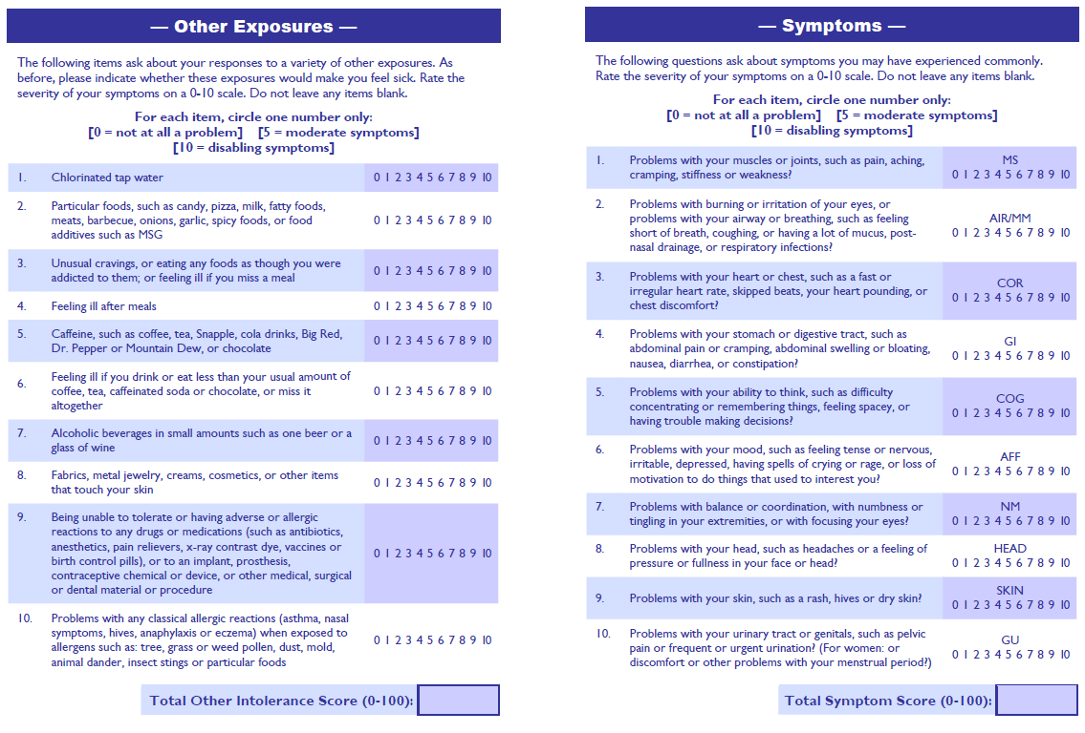

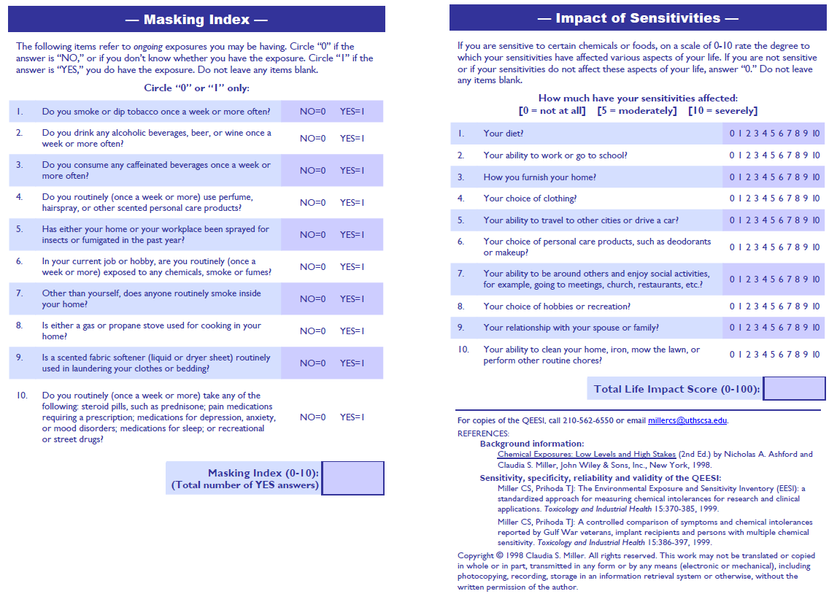

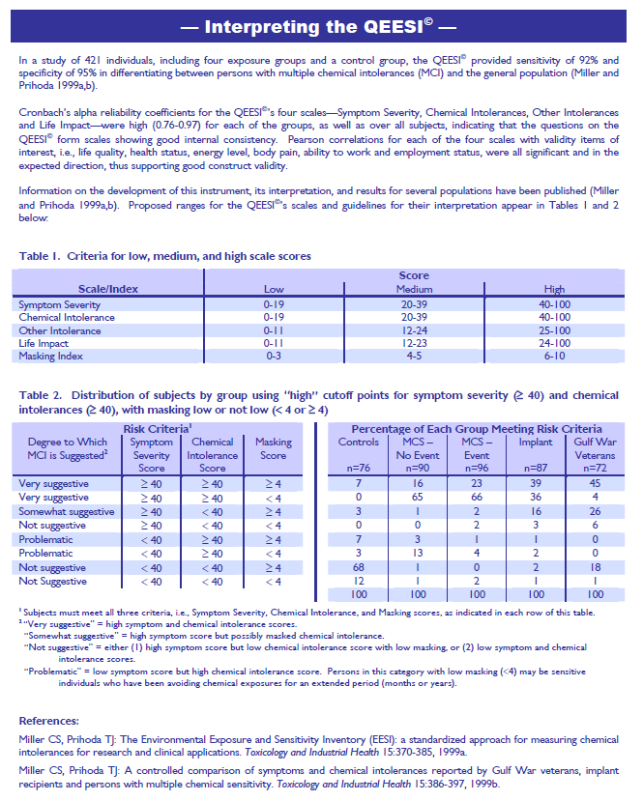

**Appendix III.** Sample PRISM Report showing VOC sources and reduction recommendations

**Appendix IV.** Environmental House Calls (EHC) Schedule & Timeline

|  |  |  |  |  |  |  |
| --- | --- | --- | --- | --- | --- | --- |
| **1ST VISIT** | | | Activity | | | Estimated Time (min) |
| Consent | | | 20 |
| QEESI | | | 20 |
| Survey (Exposure history) | | | 15 |
| Blood Collection | | | 15 |
| Buccal Swab Collection | | | 10 |
| Walk-thru assessment & Photos | | | 40 |
| **TOTAL ESTIMATED TIME = 2:00 HR** | | | |
| **2nd VISIT** 2-4 weeks later or upon availability of blood results |  | | | Activity | | Estimated Time (min) |
| EHC SAMPLING | | | Prism VOC / IAQ (Air sample) | | 120 |
| Vacuum Allergy/ERMI mold (Dust) | | 30 |
| CO2/O2/Temp/Humidity | | 30 |
| Ultrafine PMs | | 30 |
| Multiple size PMs | | 30 |
| VOC PPB RAE | | 30 |
| Buck air sampler (mold) | | 45 |
| Trace Air OV/IAQ Badge* | | *8 hours |
| *Provided 1 day before | | | | **TOTAL ESTIMATED TIME = 2:00 HR** | | |
| **3rd VISIT** One month after 2nd visit or upon availability of IAQ results | | | | Activity | | Estimated Time (min) |
| Provide & Discuss EHC/TILT Action Plan | | 30 |
| Alternative Cleaning Supplies & Education | | 30 |
| **TOTAL ESTIMATED TIME = 1:00 HR** | | | | | | |
| **4th VISIT** 6-8 months after 3rd visit | |  | | | Activity | Estimated Time (min) |
|  | | | Follow up QEESI | 20 |
| TILT Post Questionnaire | 30 |
| Walk-thru assessment & Photos | 30 |
| EHC SAMPLING | | | Prism VOC / IAQ (Air sample) | 120 |
| Vacuum Allergy/ERMI mold (Dust) | 30 |
| CO2/O2/Temp/Humidity | 30 |
| Ultrafine PMs | 30 |
| Multiple size PMs | 30 |
| VOC PPB RAE | 30 |
| Buck air sampler (mold) | 45 |
| Trace Air OV/IAQ Badge * | 8 hours |
| *Provided 1 day before | | | | | **TOTAL ESTIMATED TIME = 2:00 HR** | |
| **5th VISIT (FINAL)** Approx. 1 month after 4th visit | | | Activity | | | Estimated Time (min) |
| Provide overall evaluation of TILT home intervention | | | 20 |
| Provide results of genetic testing | | | 20 |
| Participant Q&A session | | | 20 |
| **TOTAL ESTIMATED TIME = 1:00 HR** | | | |

**Appendix V.** Home Walk-Through Assessment used during EHCs

|  |  |  |  |  |  |  |  |  |  |  |  |  |  |  |  |  |  |  |  |  |
| --- | --- | --- | --- | --- | --- | --- | --- | --- | --- | --- | --- | --- | --- | --- | --- | --- | --- | --- | --- | --- |
| **Home Walk-Through Assessment** | | | | | | | | | | | | | | | | | | | | |
| 1. **General Characteristics** | | | | | | | | | | | | | | | | | | | | |
| 1. | | Year Built: ___________________ | | | | | | | Age of property: ___________________ | | | | | | | | | | | |
| 2. | | House Type | | | Single family  Detached (1 story) | | | | Single family  Detached (2-3 stories) | | | Other | | | | | Multi-family  (End or inside unit) | | | |
| 3. | | Floors lived in | | | Basement | | | | 1st floor | | | 2nd floor | | | | | 3rd or higher | | | |
| 4. | | No. of rooms in residence__________ | | | | | | | No. of bedrooms _____ | | | Approximate living area _________________ | | | | | | | | |
| 5. | | Is home connected to municipal services? | | | | Water_______________ | | | Sewer_________________ | | | Water well __________ | | | | Septic tank _________ | | | | |
| 1. **Demographic Information** | | | | | | | | | | | | | | | | | | | | |
|  | | Type of ownership | | | | | Own house | | | Rent | | | Other  __________________________________________________ | | | | | | | |
|  | | How long have you lived in this residence? ___________________ Years __________________ Months | | | | | | | | | | | | | | | | | | |
|  | | How many people live in the house as their primary residence? ___________________________________________ | | | | | | | | | | | | | | | | | | |
| **C. Indoor Pollutants** | | | | | | | | | | | | | | | | | | | | |
| ***1. Mold/Moisture*** | | | | | | | | | | | | | | | | | | | | |
|  | a | | | Have there been any water leaks during the past year? Indicate where: _________________________ | | | | | | | | | | | | | | Y  N | | |
|  | b | | | Is there a dehumidifier in the home? | | | | | | | | | | | | | | Y  N | | |
| ***2. Pets*** | | | | | | | | | | | | | | | | | | | | |
|  | a | | | Are pets present in your home? If so, how many? __________________ | | | | | | | | | | | | | | Y  N | | |
|  | b | | | Type of pets? | | | | Cats? | | | Dogs? | | | Other? | | | | | | |
|  | c | | | Where are your pets kept? | | | | Full access to house  Inside, but not in bedroom(s) | | | | | | | Outside only  N/A | | | | | |
|  | d | | | Is there pet waste (i.e., Kitty litter box, etc.) inside the residence? | | | | | | | | | | | | | | Y  N | | |
| ***3. Pests*** | | | | | | | | | | | | | | | | | | | | |
|  | a | | | Have you had a problem with pests (cockroaches, water-bugs, mice, rats, bedbugs) inside the home? | | | | | | | | | | | | | | Y  N | | |
| ***4. Dust Mite Control*** | | | | | | | | | | | | | | | | | | | | |
|  | a | | | In bedroom areas, do you:   * Have carpeting, stuffed toys, or fleecy materials? * Use portable air cleaners? | | | | | | | | | | | | | | | Y  N  N/A  Y  N  N/A | |
| **D. Sanitary Conditions** | | | | | | | | | | | | | | | | | | | | |
| 1. | | | Is food, including pet food, stored appropriately in closed containers to avoid unwanted pests? | | | | | | | | | | | | | | | | | Y  N  N/A |

|  |  |  |  |  |  |  |  |  |  |  |  |  |  |  |  |  |
| --- | --- | --- | --- | --- | --- | --- | --- | --- | --- | --- | --- | --- | --- | --- | --- | --- |
| **Home Health Hazards** | | | **Exterior** | **Entry Way** | **Living Room** | **Dining Room** | **Kitchen** | **Hallway/Stairs** | **Bathroom 1** | **Master Bedroom** | **Bedroom 2** | **Bedroom 3** | **Bedroom 4** | **Bathroom 2** | **Garage/Storage** | **Other: ___________________** |
| **Fragrances** | **Cleaning products** | |  |  |  |  |  |  |  |  |  |  |  |  |  |  |
| **Air fresheners**  **Automatic _____** | |  |  |  |  |  |  |  |  |  |  |  |  |  |  |
| **Plug-ins** | |  |  |  |  |  |  |  |  |  |  |  |  |  |  |
| **Scented personal care products** | |  |  |  |  |  |  |  |  |  |  |  |  |  |  |
| **Pesticides/ Herbicides** | **Spray** | |  |  |  |  |  |  |  |  |  |  |  |  |  |  |
| **Dust/Powder** | |  |  |  |  |  |  |  |  |  |  |  |  |  |  |
| **Foggers** | |  |  |  |  |  |  |  |  |  |  |  |  |  |  |
| **Mothballs** | |  |  |  |  |  |  |  |  |  |  |  |  |  |  |
| **Chemicals** | **Paint** | |  |  |  |  |  |  |  |  |  |  |  |  |  |  |
| **Adhesives** | |  |  |  |  |  |  |  |  |  |  |  |  |  |  |
| **Solvents** | |  |  |  |  |  |  |  |  |  |  |  |  |  |  |
| **Gasoline** | |  |  |  |  |  |  |  |  |  |  |  |  |  |  |
| **Fertilizer** | |  |  |  |  |  |  |  |  |  |  |  |  |  |  |
| **Smoking** | **Active smoking** | |  |  |  |  |  |  |  |  |  |  |  |  |  |  |
| **Smoking odor** | |  |  |  |  |  |  |  |  |  |  |  |  |  |  |
| **Ashtrays** | |  |  |  |  |  |  |  |  |  |  |  |  |  |  |
| **Matches/lighters** | |  |  |  |  |  |  |  |  |  |  |  |  |  |  |
| **e-Cigarettes** | |  |  |  |  |  |  |  |  |  |  |  |  |  |  |
| **Chewing tobacco** | |  |  |  |  |  |  |  |  |  |  |  |  |  |  |
| **Other_______________** | |  |  |  |  |  |  |  |  |  |  |  |  |  |  |
| **Combustion products** | **Candles** | |  |  |  |  |  |  |  |  |  |  |  |  |  |  |
| **Incense** | |  |  |  |  |  |  |  |  |  |  |  |  |  |  |
| **Fireplace** | |  |  |  |  |  |  |  |  |  |  |  |  |  |  |
| **Cooking** | |  |  |  |  |  |  |  |  |  |  |  |  |  |  |
| **Other ____________** | |  |  |  |  |  |  |  |  |  |  |  |  |  |  |
| **Home Health Hazards** | | | **Exterior** | **Entry Way** | **Living Room** | **Dining Room** | **Kitchen** | **Hallway/Stairs** | **Bathroom 1** | **Master Bedroom** | **Bedroom 2** | **Bedroom 3** | **Bedroom 4** | **Bathroom 2** | **Garage/Storage** | **Other: ___________________** |
| **Moisture, Mold, Mildew** | **Mold/**  **Mildew** | |  |  |  |  |  |  |  |  |  |  |  |  |  |  |
| **Water Leaks** | |  |  |  |  |  |  |  |  |  |  |  |  |  |  |
| **Condensation** | |  |  |  |  |  |  |  |  |  |  |  |  |  |  |
| **Water Damage** | |  |  |  |  |  |  |  |  |  |  |  |  |  |  |
| **Flooring** | **Carpet** | |  |  |  |  |  |  |  |  |  |  |  |  |  |  |
| **Tile** | |  |  |  |  |  |  |  |  |  |  |  |  |  |  |
| **Wood** | |  |  |  |  |  |  |  |  |  |  |  |  |  |  |
| **Area Rug** | |  |  |  |  |  |  |  |  |  |  |  |  |  |  |
| **Other ____________** | |  |  |  |  |  |  |  |  |  |  |  |  |  |  |
| **Holes, Entry Points, and/or Damage?** | **Floors** | |  |  |  |  |  |  |  |  |  |  |  |  |  |  |
| **Walls** | |  |  |  |  |  |  |  |  |  |  |  |  |  |  |
| **Ceilings** | |  |  |  |  |  |  |  |  |  |  |  |  |  |  |
| **Around pipes** | |  |  |  |  |  |  |  |  |  |  |  |  |  |  |
| **Other ____________** | |  |  |  |  |  |  |  |  |  |  |  |  |  |  |
| **Are windows operable?** | | |  |  |  |  |  |  |  |  |  |  |  |  |  |  |
| **Exhaust fan present and operable?** | | |  |  |  |  |  |  |  |  |  |  |  |  |  |  |
| **Signs or presence of pests** | **Cockroaches** | |  |  |  |  |  |  |  |  |  |  |  |  |  |  |
| **Rodents** | **Mice** |  |  |  |  |  |  |  |  |  |  |  |  |  |  |
| **Rats** |  |  |  |  |  |  |  |  |  |  |  |  |  |  |
| **Bedbugs** | |  |  |  |  |  |  |  |  |  |  |  |  |  |  |
| **Unvented appliances** | **Gas stove** | |  |  |  |  |  |  |  |  |  |  |  |  |  |  |
| **Gas dryer** | |  |  |  |  |  |  |  |  |  |  |  |  |  |  |
| **Gas heater** | |  |  |  |  |  |  |  |  |  |  |  |  |  |  |
| **Space heater** | |  |  |  |  |  |  |  |  |  |  |  |  |  |  |
| **Alternative fuel heater** | |  |  |  |  |  |  |  |  |  |  |  |  |  |  |
| **Home Health Hazards** | | | **Exterior** | **Entry Way** | **Living Room** | **Dining Room** | **Kitchen** | **Hallway/Stairs** | **Bathroom 1** | **Master Bedroom** | **Bedroom 2** | **Bedroom 3** | **Bedroom 4** | **Bathroom 2** | **Garage/Storage** | **Other: ___________________** |
| **Pets** | **Dog(s)** | |  |  |  |  |  |  |  |  |  |  |  |  |  |  |
| **Cat(s)** | |  |  |  |  |  |  |  |  |  |  |  |  |  |  |
| **Other pet(s): ______________________** | |  |  |  |  |  |  |  |  |  |  |  |  |  |  |
| **Smell** | **Natural gas** | |  |  |  |  |  |  |  |  |  |  |  |  |  |  |
| **Sewer gas** | |  |  |  |  |  |  |  |  |  |  |  |  |  |  |
| **Musty smell** | |  |  |  |  |  |  |  |  |  |  |  |  |  |  |
| **Clutter/Hoarding** | | |  |  |  |  |  |  |  |  |  |  |  |  |  |  |
| **Sanitation: Garbage** | | |  |  |  |  |  |  |  |  |  |  |  |  |  |  |
| **Furnishings that off-gas: ____________________________________**  **____________________________________** | | |  |  |  |  |  |  |  |  |  |  |  |  |  |  |

**Notes:** ___________________________________________________________________________________________________________________________________________________________________________________________________________________________________________________________________________________________________________________________________________________________________________________________________________________________________________________________________________________________________________________________________________________________________________________________________________________________________________________________________________________________________________________________________________________________________________________________________________________________________________________________________________________________________________________________________________________________________________________________________________________________________________________________________________________________________________________________________________________________________________________________________________________________________________________________________________________________________________________________

**Appendix V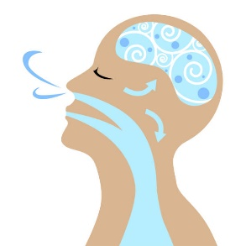I-A.** 7 Steps to Creating a Clean Air Oasis

***We spend 90% of our day indoors where the air often is more polluted than the air outside.***

Research suggests that a “clean room” may help people who suffer from breathing difficulties, allergies, headaches, brain fog/confusion, fatigue, and other health problems. You can create a clean air oasis in your home, or in one room, where the air is as free as possible of chemicals, smoke, fragrances, and allergy triggers.

1. **Pick a room**

Choose the room where you spend most of your time, usually your bedroom. Bring in clean outside air whenever possible, but avoid opening windows when pollen or pollution levels are high.

1. **Eliminate indoor air pollutants**

Remove all products that have strong odors including cleaning and laundry products, pesticides, perfume/cologne, scented lotions, deodorants, cosmetics, candles, air fresheners (including plug-ins and diffusers). Avoid any aerosol sprays (such as hair spray) because their tiny droplets are easily inhaled.

1. **Ask your primary care doctor about allergy testing.**

Dander (dead skin cells) from pets, dust mites, mold, and seasonal pollens can trigger asthma, allergies, and other problems.

1. **Clean safely**

Use only fragrance-free products for cleaning and doing laundry. Cleaning and vacuuming are best done when sensitive individuals are not in the immediate area. Ventilate during and after cleaning. See list of cleaning supplies and instructions on the back of this page.

1. **Avoid burning anything indoors**

Smoke and combustion gases irritate the lungs. Do not permit smoking, vaping, or the burning of candles or incense. Do not use fireplaces, open-flame gas heaters, or unvented water heaters. Prevent carbon monoxide poisoning—never heat your home using a gas stove, gas oven, or Hibachi. If you move or purchase new appliances, electric stoves and other electric appliances are the better health option.

1. **Go the extra mile**

An air purifier with HEPA and charcoal filters can remove some pollutants. Keep the purifier running while the room is occupied, including overnight. Bring in clean outside air whenever possible.

1. **Learn more**

****Many of our choices affect the quality of air we breathe. Learn how to remove fragrances from fabrics, stop pests without using pesticides, control humidity and mold, and find safer products for home repair/remodeling.

Visit <https://tiltresearch.org/> for more information.

This work was generously supported by the Marilyn Brachman Hoffman Foundation.

**Appendix VI-B.**  Alternative Cleaning Recipes

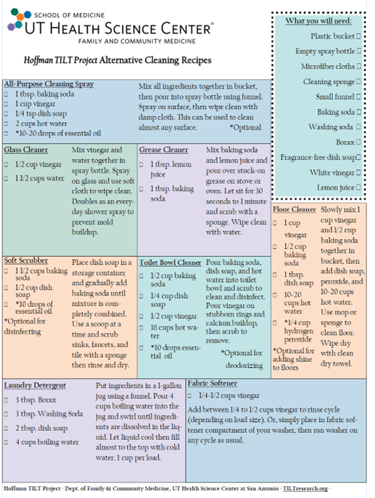

**Appendix VII.** Brief Exposure History

If you developed symptoms after a specific exposure event, complete the following questions:

1. Did you become ill after a particular exposure event?

Yes____ No____ (If you answered “No” the next questions will not be relevant.)

2. If yes, what was the exposure(s)?

______________________________________________________________________

______________________________________________________________________

3. When did the exposure occur?

______________________________________________________________________

______________________________________________________________________

4. What symptoms did you experience at that time?

______________________________________________________________________

______________________________________________________________________

5. Were any other people or animals exposed?

i. If so, who?

______________________________________________________________________

______________________________________________________________________

ii. What symptoms, if any, did they experience?

______________________________________________________________________

______________________________________________________________________

6. Describe how your symptoms have changed since the exposure (if at all).

______________________________________________________________________

______________________________________________________________________

7. Are there other details you think are important? (Complete on additional page, if necessary.)

______________________________________________________________________

______________________________________________________________________