Supplementary materials
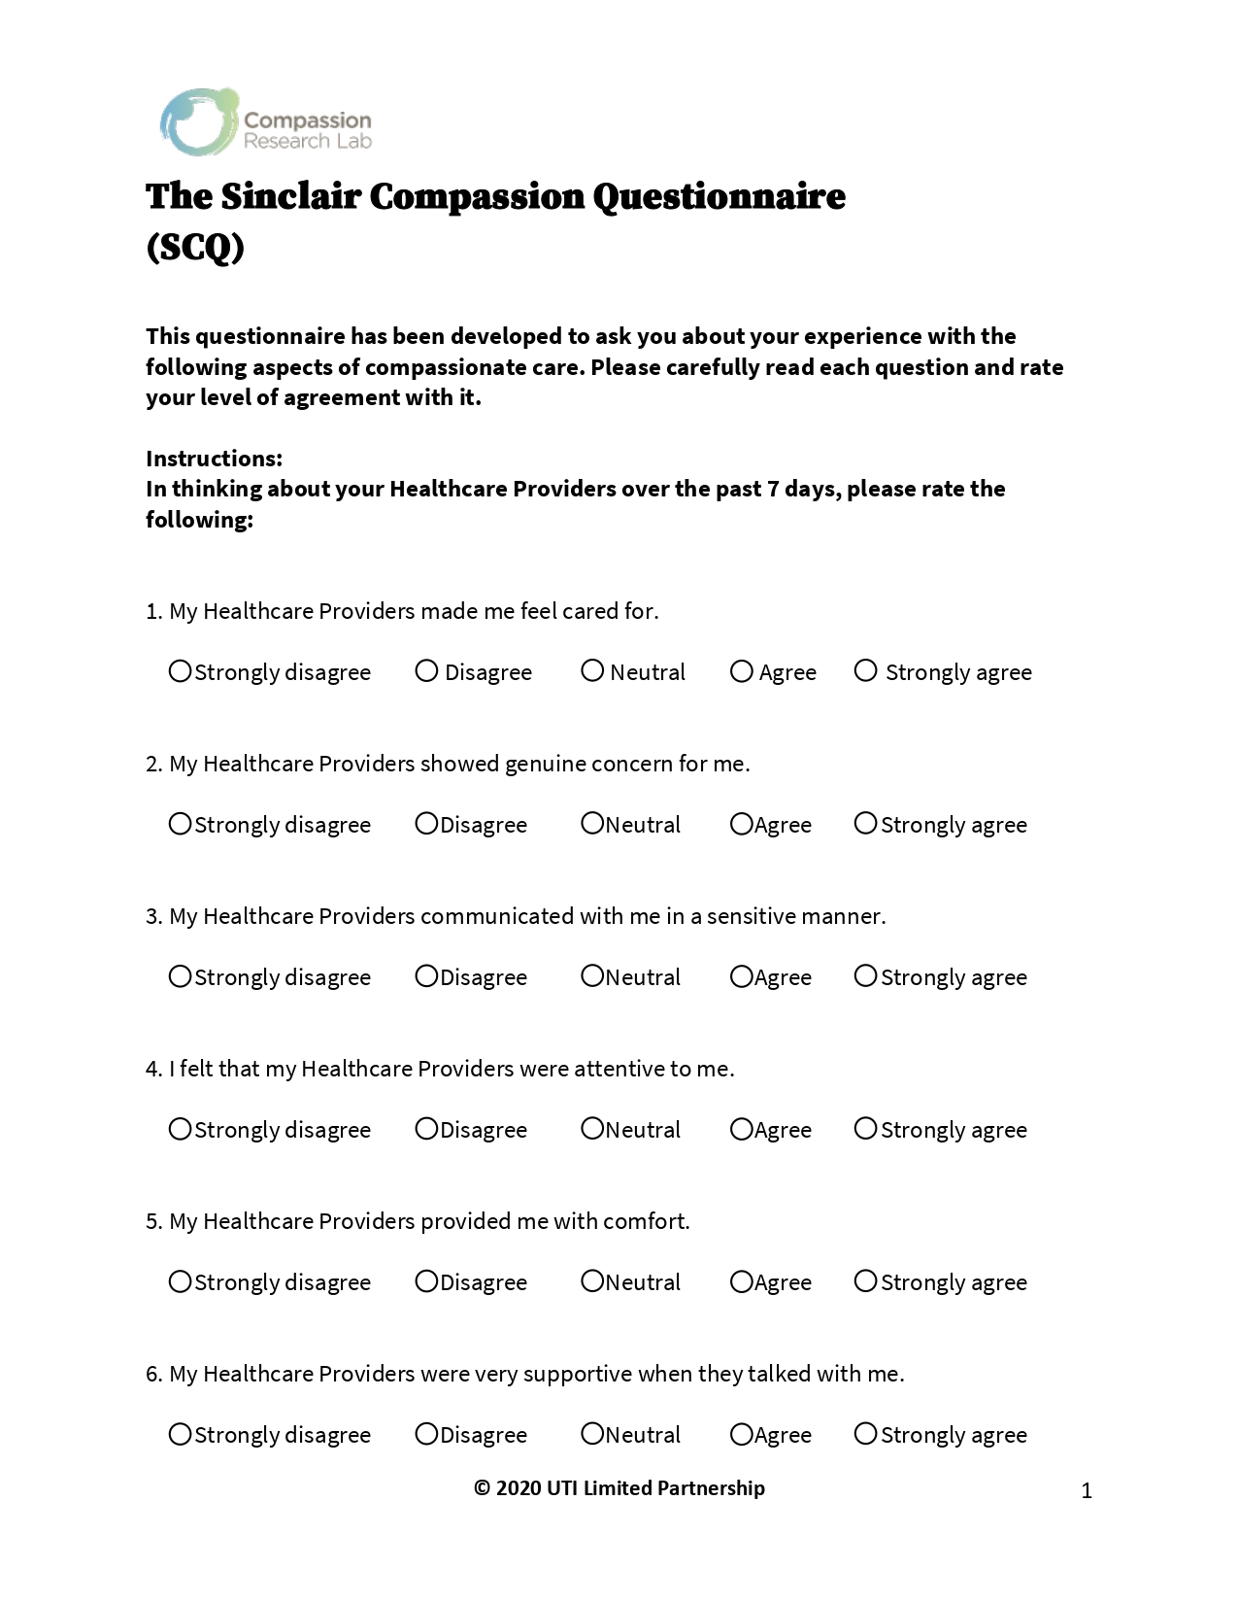
The Original English Version of Sinclair Compassion Questionnaire (SCQ).
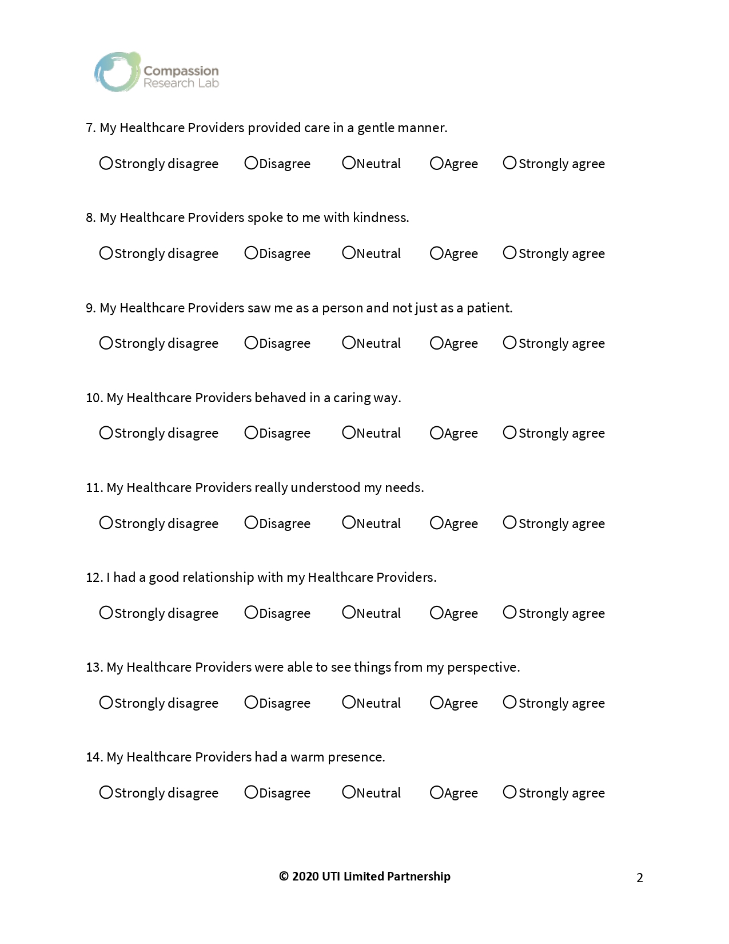

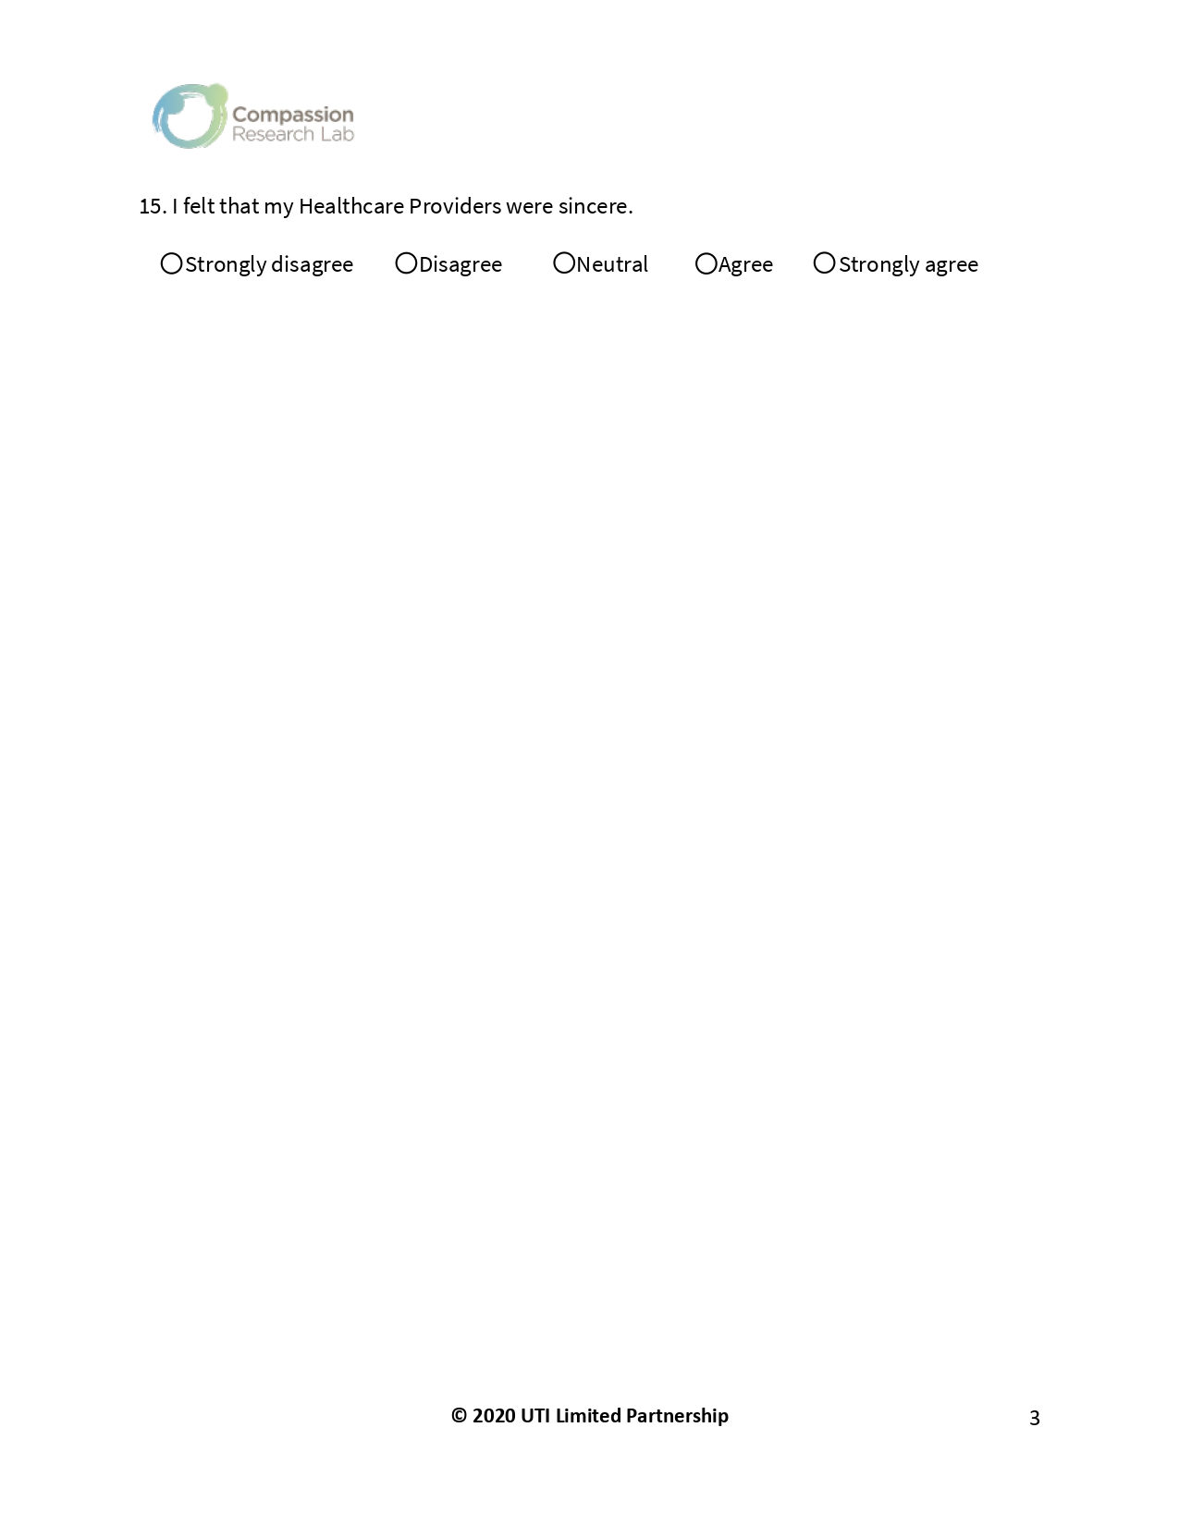

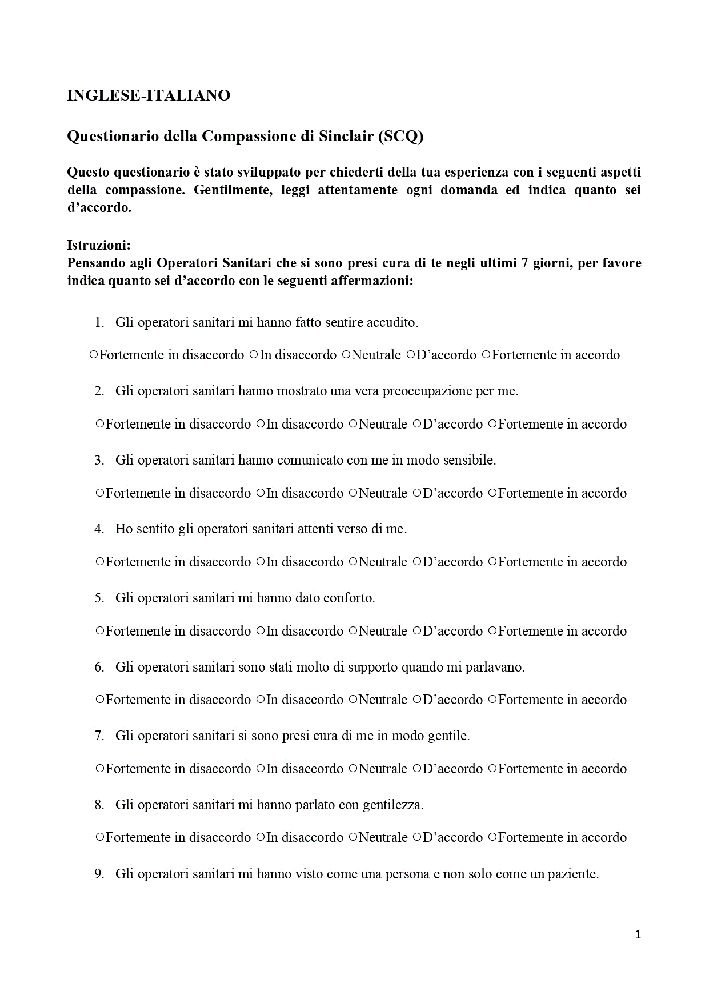
The Italian Version of Sinclair Compassion Questionnaire (SCQ).
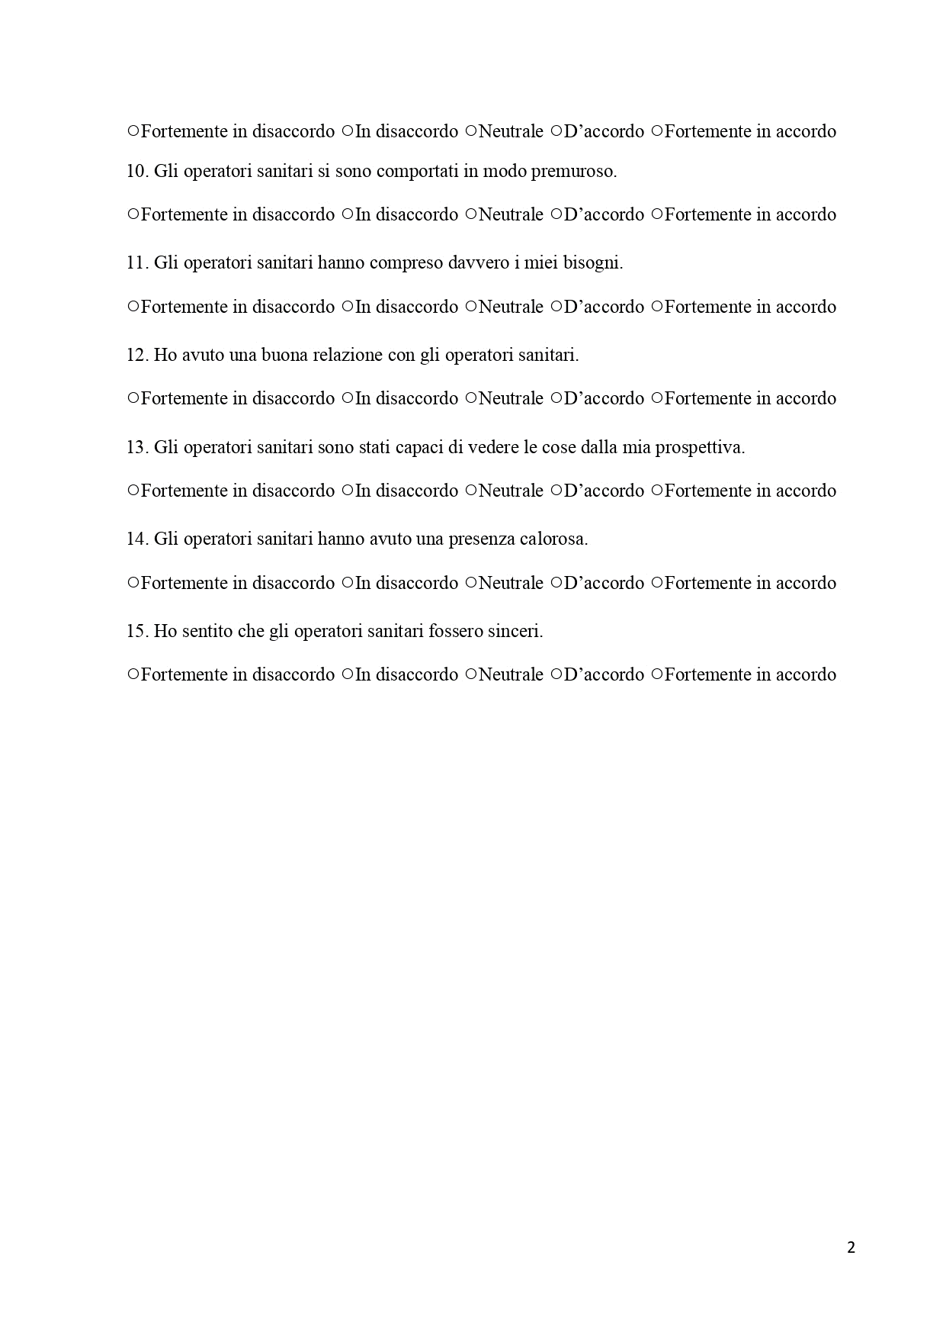
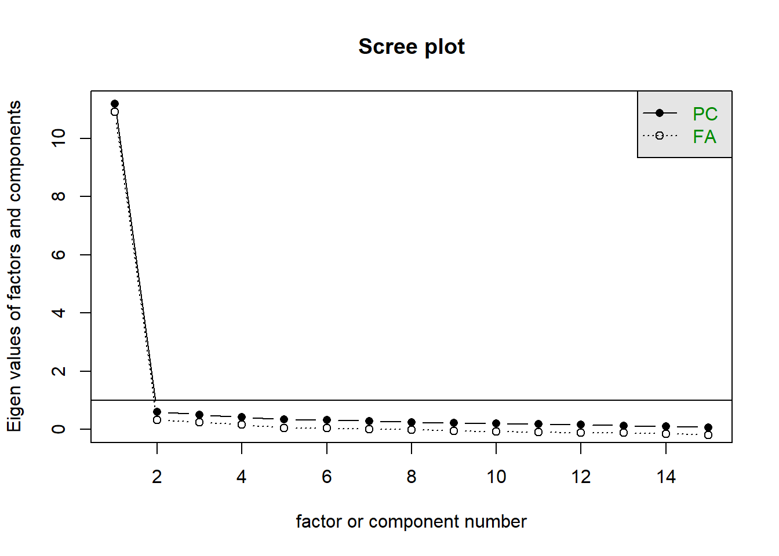

Figure S1. Scree plot for the choice of the number of factors.

Item Response Theory (IRT) model was generated to evaluate association between items and latent dimension theta (compassion). It uses the responsive pattern and responsive probability of items to measure their ability to discriminate different levels of compassion (Figure S2).
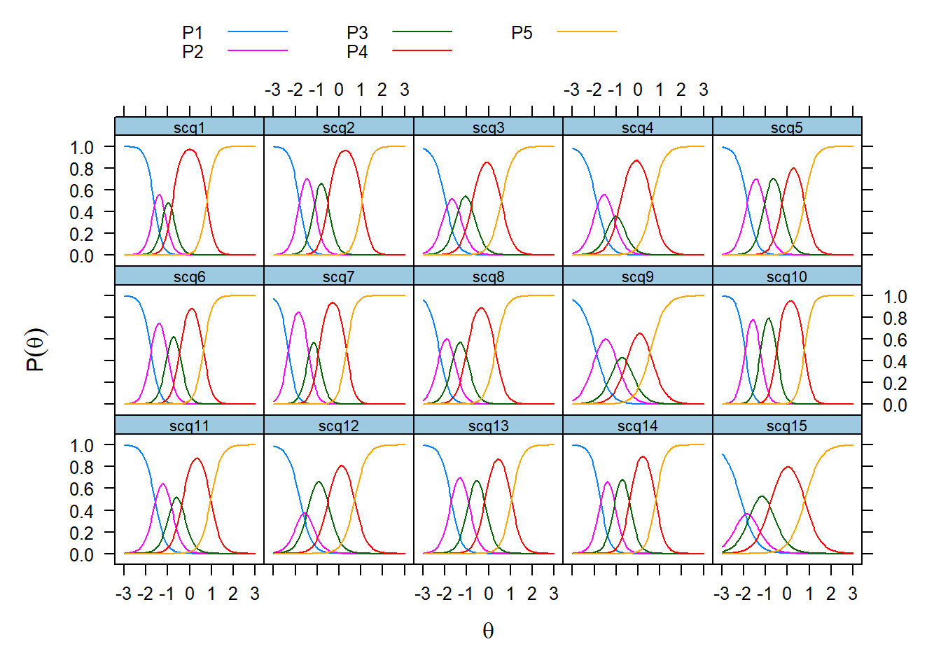
Figure S2. Probability of latent dimension for each item response

A Fisher information matrix was calculated from the correlation matrix of the items to evaluate how much information each item gives about compassion. From Figure S3 we can see that items 9 and 15 are the least informative, thus Cronbach’s alpha was computed excluding them and its value was still 0.98.
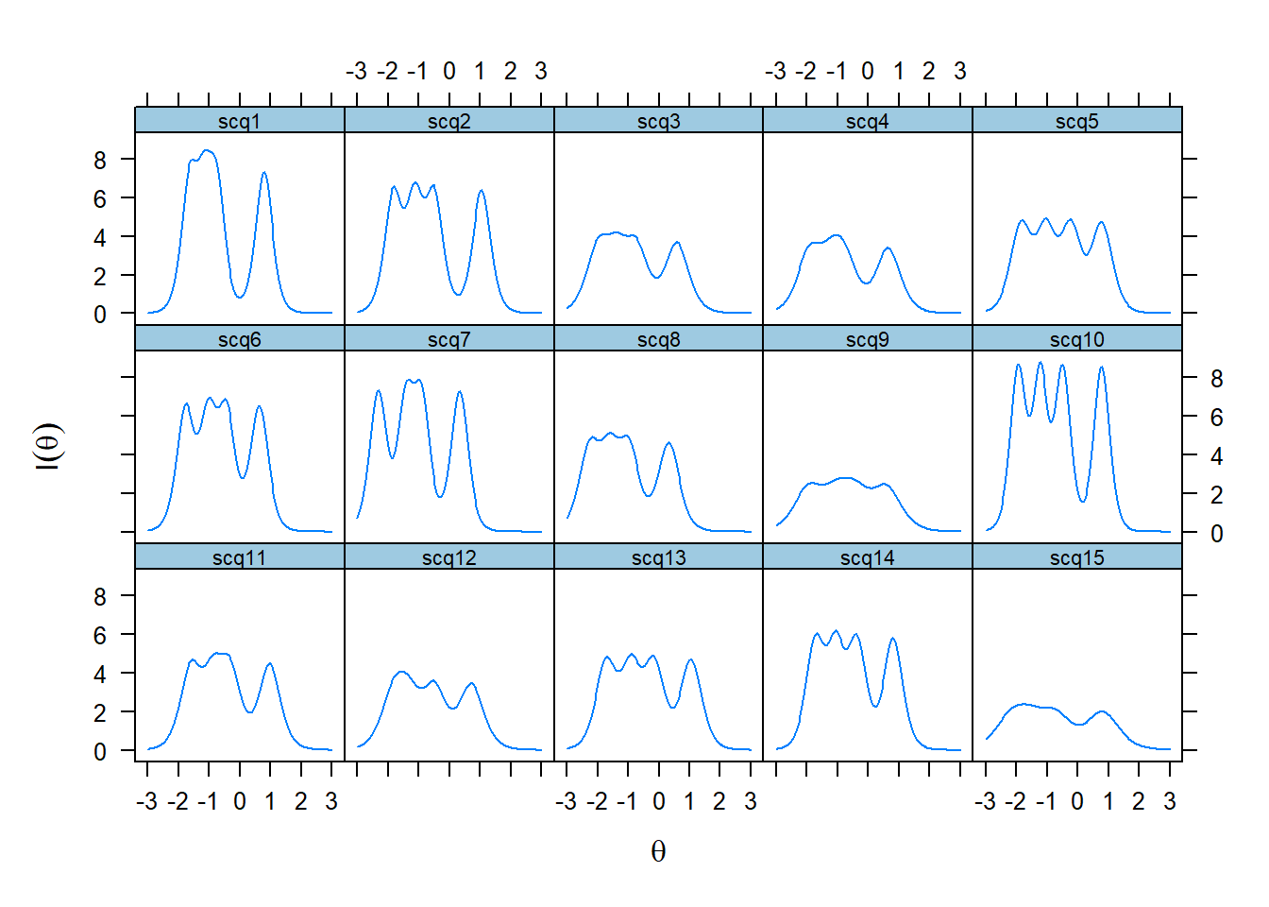
Figure S3. Fisher Information curve for each item

