|  |  |  |  |  |  |
| --- | --- | --- | --- | --- | --- |
| **Table S1**. The information of ISSR primers used in this study. | | | | | |
| Polymorphic Information Content (PIC) | Polymorphic percent | No. of polymorphic fragment | Total No. of fragments | Primer sequence | Primer No. |
| 0.41 | 75.00 | 6 | 8 | AGAGAGAGAGAGAGAGYA | P1 |
| 0.48 | 100.00 | 6 | 6 | AGAGAGAGAGAGAGAGYC | P2 |
| 0.47 | 87.50 | 7 | 8 | CTCTCTCTCTCTCTCTRG | P3 |
| 0.44 | 72.73 | 8 | 11 | CAGCAGCAGCAGCAGCAGT | P4 |
| 0.44 | 87.50 | 7 | 8 | GGAGAGGAGAGGAGAGGAGA | P5 |
| 0.44 | 62.50 | 5 | 8 | TGTGTGTGTGTGTGTGG | P6 |
| 0.44 | 100.00 | 8 | 8 | CTCTCTCTCTCTCTCTRA | P7 |
| 0.47 | 75.00 | 9 | 12 | TCTCTCTCTCTCTCTCC | P8 |
| 0.45 | 68.75 | 11 | 16 | ACACACACACACACACYC | P9 |
| 0.41 | 100.00 | 10 | 10 | ACACACACACACACACYG | P10 |
| 0.47 | 100.00 | 6 | 6 | GATAGATAGATAGATA | P11 |
| 0.46 | 80.00 | 8 | 10 | CTCTCTCTCTCTCTCTRG | P12 |
| 0.45 | 81.98 | 91 | 111 | - | total |
|  |  | 7.58 | 9.25 | - | av |

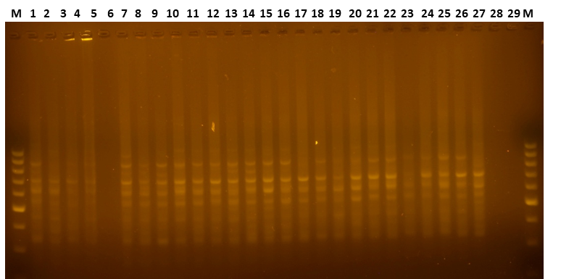

**Figure S1.** Some amplified fragments with the use of ISSR4 in some tea genotypes.

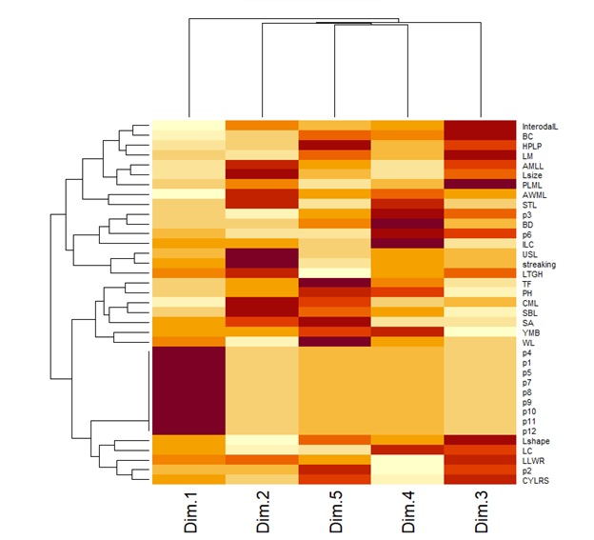

**Figure S2**. Heatmap analysis of tea genotypes based on morphological traits and ISSR markers.