Supplementary information file
Table S1. Analysis of molecular variance (AMOVA) among 20 studied accessions of common bean using Gene Alex 6.5 software
Source | df | Sum of Square | Estimated Variance | % Variance
Among Pops | 19 | 98.045 | 0.031 | 1%
Within Pops | 99 | 492.644 | 4.976 | 99%
Total | 118 | 590.689 | 5.007 | 100%
Table S2. Pairwise genetic distance (Nei’s 1978) among 20 common bean accessionscollected from Uttarakhand
Accessions | 1 | 2 | 3 | 4 | 5 | 6 | 7 | 8 | 9 | 10 | 11 | 12 | 13 | 14 | 15 | 16 | 17 | 18 | 19 | 20
1 | 0
2 | 0.1977 | 0
3 | 0.1236 | 0.1172 | 0
4 | 0.098 | 0.0356 | 0.0559 | 0
5 | 0.1221 | 0.1064 | 0.1203 | 0.0225 | 0
6 | 0.2459 | 0.072 | 0.1931 | 0.1094 | 0.1264 | 0
7 | 0.0963 | 0.0757 | 0.1201 | 0.0783 | 0.1495 | 0.1246 | 0
8 | 0.1117 | 0.0439 | 0.1414 | 0.0042 | 0.0732 | 0.0913 | 0.041 | 0
9 | 0.1136 | 0.0689 | 0.1728 | 0.0289 | 0.1013 | 0.0992 | 0.0349 | -0.0105 | 0
10 | 0.0803 | 0.0811 | 0.1111 | 0.0349 | 0.1125 | 0.1006 | 0.0529 | 0.0314 | 0.0335 | 0
11 | 0.0985 | 0.0794 | 0.1741 | 0.0378 | 0.1115 | 0.1082 | 0.0796 | 0.008 | 0.0097 | 0.0132 | 0
12 | 0.0854 | 0.0613 | 0.1543 | 0.0273 | 0.0986 | 0.0998 | 0.0313 | -0.0062 | -0.002 | 0.0286 | 0.0105 | 0
13 | 0.0889 | 0.0732 | 0.1404 | 0.0304 | 0.1211 | 0.1039 | 0.0228 | -0.0061 | -0.004 | 0.035 | 0.0217 | -0.0095 | 0
14 | 0.079 | 0.0843 | 0.093 | 0.0399 | 0.1457 | 0.1545 | 0.0219 | 0.0171 | 0.0222 | 0.0697 | 0.0554 | 0.0231 | -0.0009 | 0
15 | 0.0562 | 0.11 | 0.1217 | 0.0251 | 0.108 | 0.1461 | 0.0801 | 0.0312 | 0.0271 | -0.0116 | 0.0044 | 0.0346 | 0.0277 | 0.0484 | 0
16 | 0.1319 | 0.0627 | 0.1047 | -0.0073 | 0.0567 | 0.0832 | 0.1175 | 0.0157 | 0.0438 | 0.0536 | 0.0493 | 0.0415 | 0.0364 | 0.0617 | 0.045 | 0
17 | 0.1766 | 0.0642 | 0.1442 | 0.0199 | 0.1295 | 0.1122 | 0.1117 | 0.0149 | 0.0316 | 0.0792 | 0.0432 | 0.0373 | 0.021 | 0.0419 | 0.0573 | 0.002 | 0
18 | 0.1332 | 0.1856 | 0.1988 | 0.1277 | 0.228 | 0.1908 | 0.1875 | 0.0934 | 0.1107 | 0.0934 | 0.0555 | 0.1213 | 0.105 | 0.1057 | 0.0746 | 0.1309 | 0.1149 | 0
19 | 0.1826 | 0.1696 | 0.1135 | 0.0946 | 0.1302 | 0.057 | 0.1912 | 0.1148 | 0.1329 | 0.108 | 0.1218 | 0.1303 | 0.1219 | 0.1284 | 0.1139 | 0.0689 | 0.1173 | 0.1162 | 0
20 | 0.1797 | 0.1202 | 0.1414 | 0.0698 | 0.1283 | 0.0626 | 0.1502 | 0.0508 | 0.0731 | 0.0782 | 0.0533 | 0.0671 | 0.0663 | 0.0894 | 0.0883 | 0.0568 | 0.069 | 0.05 | 0.0173 | 0

Table S3. Characteristics of cpSSR markers showing cross transferability in 4 pulse species of fabaceae family
S. No. | Locus | N | Na | Ne | I | He
1 | Locus1 | 4 | 2.000 | 1.882 | 0.662 | 0.469
2 | Locus2 | 4 | 2.000 | 1.941 | 0.677 | 0.484
3 | Locus3 | 4 | 2.000 | 1.800 | 0.628 | 0.438
4 | Locus4 | 4 | 2.000 | 1.600 | 0.562 | 0.375
5 | Locus5 | 4 | 2.000 | 1.941 | 0.677 | 0.484
6 | Locus6 | 4 | 2.000 | 1.741 | 0.612 | 0.422
7 | Locus7 | 4 | 2.000 | 1.581 | 0.519 | 0.344
8 | Locus8 | 4 | 2.000 | 1.941 | 0.677 | 0.484
9 | Locus9 | 4 | 2.000 | 1.882 | 0.662 | 0.469
10 | Locus10 | 4 | 2.000 | 1.741 | 0.612 | 0.422
11 | Locus11 | 4 | 2.000 | 1.581 | 0.519 | 0.344
 | Mean | 4 | 2.000 | 1.785 | 0.619 | 0.430
N= sample sizes; N_{a} = number of alleles, N_{e}= effective number of alleles; I = Shannon’s information index; He= expected heterozygosity

Fig. S1a Variations in seed weight of 20 studied accessions of common bean
Fig. S1b Variations in seed length, width and thickness of 20 studied accessions of common bean
Fig. S2 Representative gel image illustrating PCR amplification using cpSSR markers: (a) PV_cpSSR11 & PV_cpSSR 3 in 20 accessions of common bean (b) Transferability of SSR markers in different species of Fabaceae family

Fig. S3 Distribution of 20 common bean accessions from Uttarakhand based on selected SSR loci recorded by the neighbor joining method using PHYLIP Program

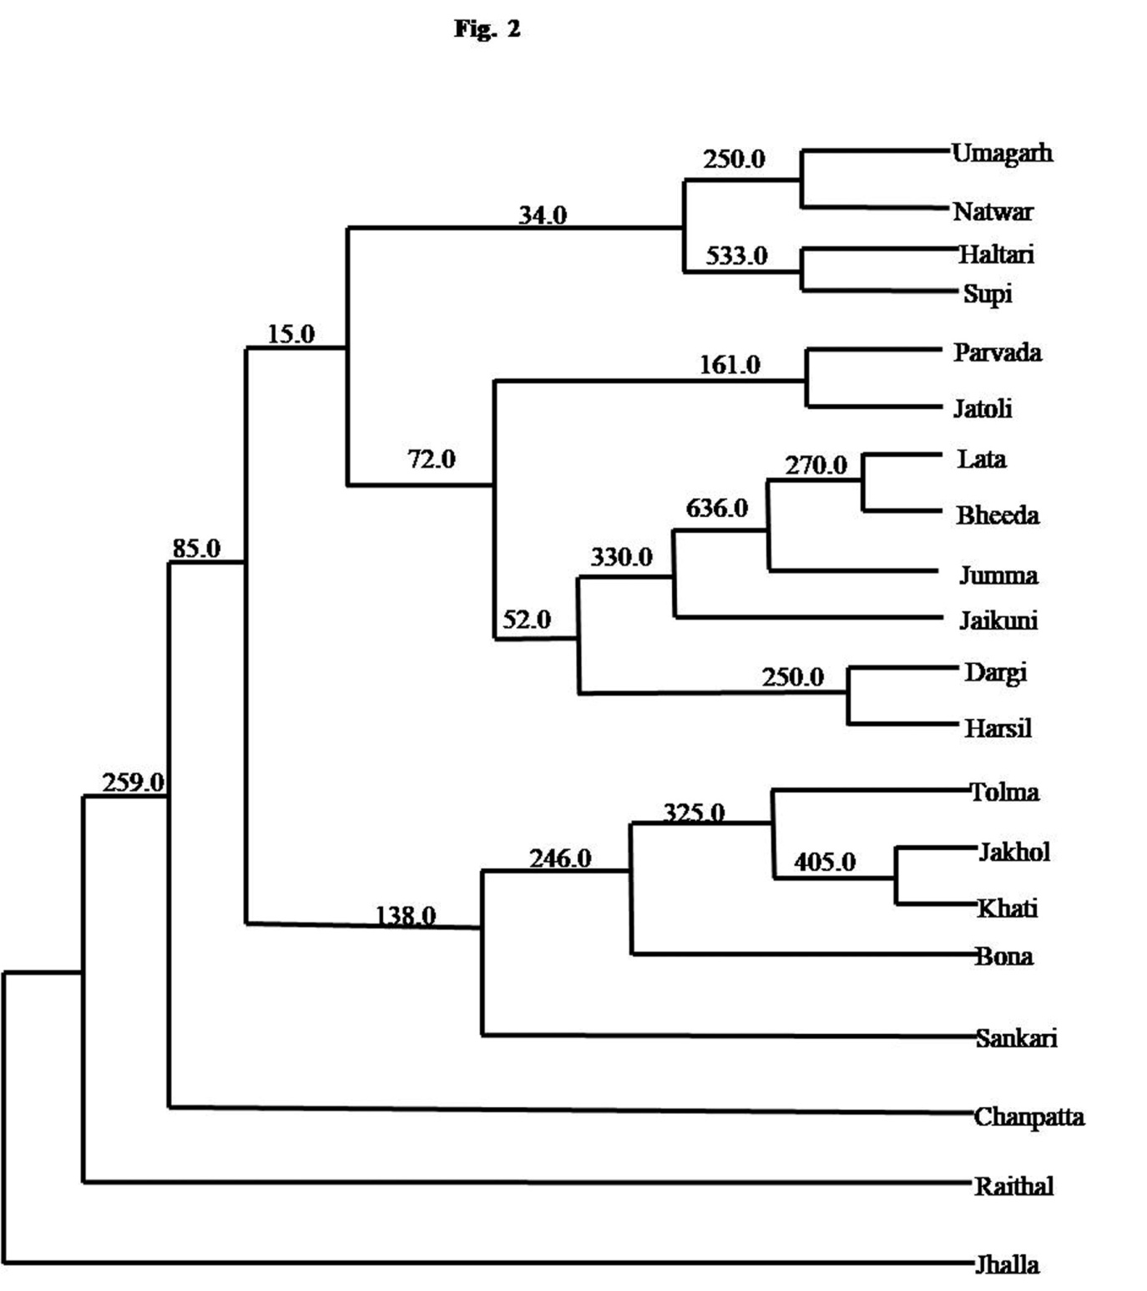

Fig. S4 PCoA plot of common bean accessions based on cpSSR marker data. Coordinate 1 and coordinate 2 comprised about 8.57 and 16.73% variations respectively
