**Fig. S1. Weather data (standard week) representing maximum and minimum temperatures and precipitation during summer season 2021 and 2022**

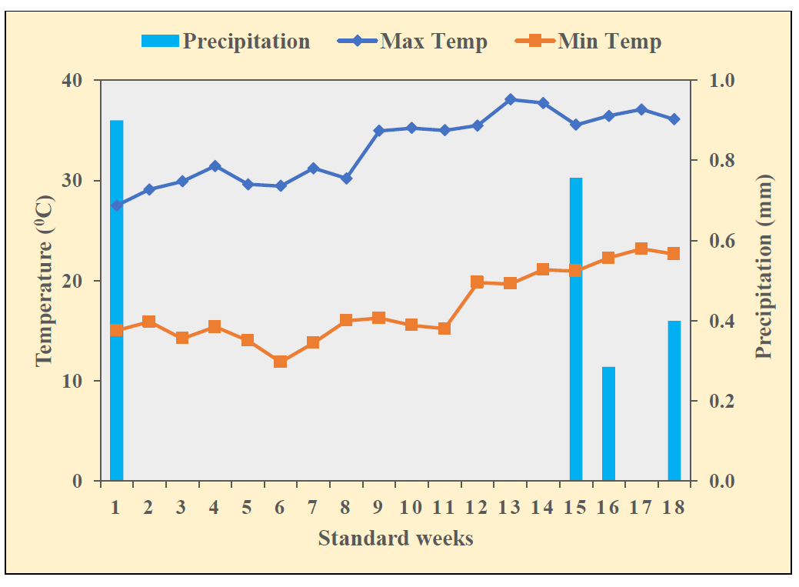

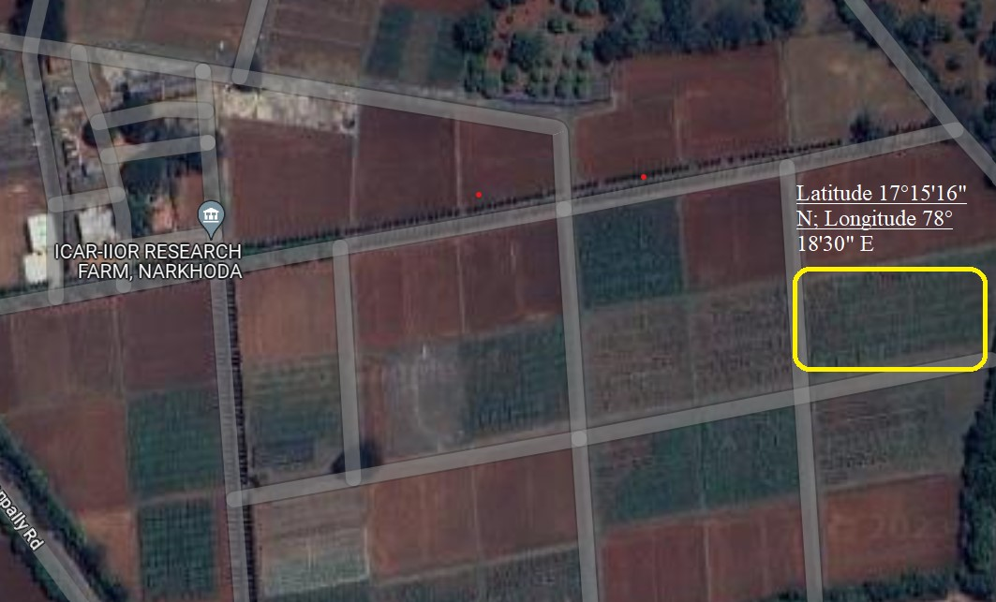**Fig. S2.** **Test location map of the experimental field i.e., ICAR-IIOR research farm, Narkhoda, Hyderabad, India. (Source: Google maps)**

**Fig. S3. Phenotypic (a) and genotypic (b) correlation matrix of morpho physiological, yield and quality traits under WW conditions.**

**(a)**

pai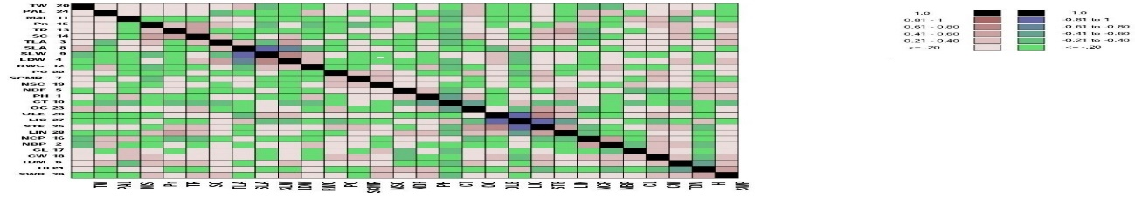

**b)**

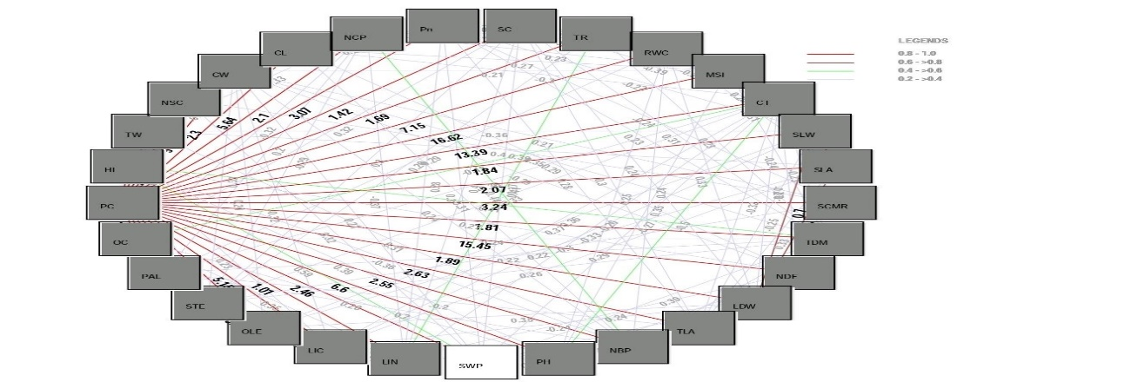

**Fig. S4. Phenotypic (a) and genotypic (b) correlation matrix of morpho-physiological, yield and quality traits under WS conditions.**

**(a)**

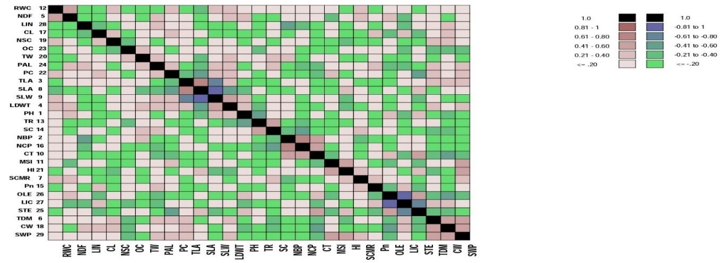

**(b)**

