Microplot 1 | 21 | 21 | 21 | 63 | 63 | 63 | 57 | 57 | 57 | 101 | 101 | 101 |  | Microplot 6 | 8 | 8 | 8 | 97 | 97 | 97 | 54 | 54 | 54 | 98 | 98 | 98
Microplot 1 | 77 | 77 | 77 | 1 | 1 | 1 | 33 | 33 | 33 | 15 | 15 | 15 |  | Microplot 6 | 36 | 36 | 36 | 20 | 20 | 20 | 100 | 100 | 100 | 2 | 2 | 2
Microplot 1 | 34 | 34 | 34 | 96 | 96 | 96 | 59 | 59 | 59 | 29 | 29 | 29 |  | Microplot 6 | 51 | 51 | 51 | 94 | 94 | 94 | 24 | 24 | 24 | 122 | 122 | 122
Microplot 1 | 113 | 113 | 113 | 47 | 47 | 47 | 103 | 103 | 103 | 75 | 75 | 75 |  | Microplot 6 | 99 | 99 | 99 | 69 | 69 | 69 | 80 | 80 | 80 | 58 | 58 | 58
Microplot 1 | 3 | 3 | 3 | 61 | 61 | 61 | 26 | 26 | 26 | 97 | 97 | 97 |  | Microplot 6 | 22 | 22 | 22 | 14 | 14 | 14 | 40 | 40 | 40 | 9 | 9 | 9
Microplot 1 | 104 | 104 | 104 | 36 | 36 | 36 | 106 | 106 | 106 | 2 | 2 | 2 |  | Microplot 6 | 101 | 101 | 101 | 23 | 23 | 23 | 64 | 64 | 64 | 11 | 11 | 11
Microplot 1 | 41 | 41 | 41 | 44 | 44 | 44 | 8 | 8 | 8 | 125 | 125 | 125 |  | Microplot 6 | 78 | 78 | 78 | 52 | 52 | 52 | 73 | 73 | 73 | 37 | 37 | 37
Microplot 1 | 115 | 115 | 115 | 51 | 51 | 51 | 85 | 85 | 85 | 53 | 53 | 53 |  | Microplot 6 | 17 | 17 | 17 | 30 | 30 | 30 | 117 | 117 | 117 | 65 | 65 | 65
Microplot 1 | 5 | 5 | 5 | 79 | 79 | 79 | 118 | 118 | 118 | 83 | 83 | 83 |  | Microplot 6 | 92 | 92 | 92 | 67 | 67 | 67 | 48 | 48 | 48 | 104 | 104 | 104
Microplot 1 | 22 | 22 | 22 | 110 | 110 | 110 | 67 | 67 | 67 | C | C | C |  | Microplot 6 | 41 | 41 | 41 | 109 | 109 | 109 | 90 | 90 | 90 | C | C | C
Microplot 2 | 70 | 70 | 70 | 18 | 18 | 18 | 102 | 102 | 102 | 72 | 72 | 72 |  | Microplot 7 | 77 | 77 | 77 | 1 | 1 | 1 | 61 | 61 | 61 | 118 | 118 | 118
Microplot 2 | 122 | 122 | 122 | 46 | 46 | 46 | 4 | 4 | 4 | 108 | 108 | 108 |  | Microplot 7 | 63 | 63 | 63 | 39 | 39 | 39 | 70 | 70 | 70 | 53 | 53 | 53
Microplot 2 | 100 | 100 | 100 | 35 | 35 | 35 | 91 | 91 | 91 | 80 | 80 | 80 |  | Microplot 7 | 10 | 10 | 10 | 103 | 103 | 103 | 123 | 123 | 123 | 96 | 96 | 96
Microplot 2 | 55 | 55 | 55 | 120 | 120 | 120 | 76 | 76 | 76 | 7 | 7 | 7 |  | Microplot 7 | 84 | 84 | 84 | 34 | 34 | 34 | 21 | 21 | 21 | 3 | 3 | 3
Microplot 2 | 78 | 78 | 78 | 87 | 87 | 87 | 23 | 23 | 23 | 45 | 45 | 45 |  | Microplot 7 | 72 | 72 | 72 | 120 | 120 | 120 | 87 | 87 | 87 | 119 | 119 | 119
Microplot 2 | 82 | 82 | 82 | 65 | 65 | 65 | 16 | 16 | 16 | 98 | 98 | 98 |  | Microplot 7 | 18 | 18 | 18 | 57 | 57 | 57 | 111 | 111 | 111 | 43 | 43 | 43
Microplot 2 | 6 | 6 | 6 | 95 | 95 | 95 | 89 | 89 | 89 | 74 | 74 | 74 |  | Microplot 7 | 112 | 112 | 112 | 68 | 68 | 68 | 50 | 50 | 50 | 124 | 124 | 124
Microplot 2 | 84 | 84 | 84 | 93 | 93 | 93 | 50 | 50 | 50 | 58 | 58 | 58 |  | Microplot 7 | 81 | 81 | 81 | 5 | 5 | 5 | 121 | 121 | 121 | 26 | 26 | 26
Microplot 2 | 30 | 30 | 30 | 123 | 123 | 123 | 71 | 71 | 71 | 27 | 27 | 27 |  | Microplot 7 | 32 | 32 | 32 | 102 | 102 | 102 | 71 | 71 | 71 | 125 | 125 | 125
Microplot 2 | 111 | 111 | 111 | 42 | 42 | 42 | 19 | 19 | 19 | C | C | C |  | Microplot 7 | 114 | 114 | 114 | 27 | 27 | 27 | 42 | 42 | 42 | C | C | C
Microplot 3 | 9 | 9 | 9 | 107 | 107 | 107 | 88 | 88 | 88 | 38 | 38 | 38 |  | Microplot 8 | 75 | 75 | 75 | 46 | 46 | 46 | 85 | 85 | 85 | 76 | 76 | 76
Microplot 3 | 60 | 60 | 60 | 39 | 39 | 39 | 28 | 28 | 28 | 114 | 114 | 114 |  | Microplot 8 | 4 | 4 | 4 | 106 | 106 | 106 | 60 | 60 | 60 | 115 | 115 | 115
Microplot 3 | 37 | 37 | 37 | 11 | 11 | 11 | 86 | 86 | 86 | 69 | 69 | 69 |  | Microplot 8 | 108 | 108 | 108 | 12 | 12 | 12 | 55 | 55 | 55 | 15 | 15 | 15
Microplot 3 | 90 | 90 | 90 | 119 | 119 | 119 | 56 | 56 | 56 | 10 | 10 | 10 |  | Microplot 8 | 66 | 66 | 66 | 83 | 83 | 83 | 28 | 28 | 28 | 107 | 107 | 107
Microplot 3 | 24 | 24 | 24 | 40 | 40 | 40 | 62 | 62 | 62 | 112 | 112 | 112 |  | Microplot 8 | 59 | 59 | 59 | 116 | 116 | 116 | 89 | 89 | 89 | 33 | 33 | 33
Microplot 3 | 116 | 116 | 116 | 43 | 43 | 43 | 14 | 14 | 14 | 73 | 73 | 73 |  | Microplot 8 | 29 | 29 | 29 | 38 | 38 | 38 | 16 | 16 | 16 | 113 | 113 | 113
Microplot 3 | 48 | 48 | 48 | 31 | 31 | 31 | 109 | 109 | 109 | 52 | 52 | 52 |  | Microplot 8 | 95 | 95 | 95 | 62 | 62 | 62 | 93 | 93 | 93 | 82 | 82 | 82
Microplot 3 | 64 | 64 | 64 | 105 | 105 | 105 | 92 | 92 | 92 | 121 | 121 | 121 |  | Microplot 8 | 7 | 7 | 7 | 86 | 86 | 86 | 44 | 44 | 44 | 6 | 6 | 6
Microplot 3 | 13 | 13 | 13 | 81 | 81 | 81 | 32 | 32 | 32 | 20 | 20 | 20 |  | Microplot 8 | 105 | 105 | 105 | 25 | 25 | 25 | 91 | 91 | 91 | 79 | 79 | 79
Microplot 3 | 99 | 99 | 99 | 54 | 54 | 54 | 117 | 117 | 117 | C | C | C |  | Microplot 8 | 13 | 13 | 13 | 47 | 47 | 47 | 31 | 31 | 31 | 45 | 45 | 45
Microplot 4 | 66 | 66 | 66 | 17 | 17 | 17 | 94 | 94 | 94 | 49 | 49 | 49 |  | Microplot 9 | 49 | 49 | 49 | 88 | 88 | 88 | 56 | 56 | 56 | 110 | 110 | 110
Microplot 4 | 124 | 124 | 124 | 68 | 68 | 68 | 25 | 25 | 25 | 12 | 12 | 12 |  | Microplot 9 | 35 | 35 | 35 | 19 | 19 | 19 | 74 | 74 | 74 | C | C | C
Microplot 4 | 23 | 23 | 23 | 6 | 6 | 6 | 75 | 75 | 75 | 32 | 32 | 32 |  | Microplot 9 | 13 | 13 | 13 | 111 | 111 | 111 | 73 | 73 | 73 | 34 | 34 | 34
Microplot 4 | 60 | 60 | 60 | 11 | 11 | 11 | 8 | 8 | 8 | 33 | 33 | 33 |  | Microplot 9 | 68 | 68 | 68 | 47 | 47 | 47 | 26 | 26 | 26 | 83 | 83 | 83
Microplot 4 | 29 | 29 | 29 | 66 | 66 | 66 | 78 | 78 | 78 | 91 | 91 | 91 |  | Microplot 9 | 54 | 54 | 54 | 119 | 119 | 119 | 79 | 79 | 79 | 104 | 104 | 104
Microplot 4 | 36 | 36 | 36 | 53 | 53 | 53 | 102 | 102 | 102 | 48 | 48 | 48 |  | Microplot 9 | 30 | 30 | 30 | 15 | 15 | 15 | 90 | 90 | 90 | 69 | 69 | 69
Microplot 4 | 94 | 94 | 94 | 49 | 49 | 49 | 82 | 82 | 82 | 77 | 77 | 77 |  | Microplot 9 | 67 | 67 | 67 | 28 | 28 | 28 | 5 | 5 | 5 | 44 | 44 | 44
Microplot 4 | 10 | 10 | 10 | 37 | 37 | 37 | 99 | 99 | 99 | 86 | 86 | 86 |  | Microplot 9 | 19 | 19 | 19 | 45 | 45 | 45 | 108 | 108 | 108 | C | C | C
Microplot 4 | 113 | 113 | 113 | 42 | 42 | 42 | 98 | 98 | 98 | 85 | 85 | 85 |  | Microplot 9 | 2 | 2 | 2 | 57 | 57 | 57 | 71 | 71 | 71 | 24 | 24 | 24
Microplot 5 | 81 | 81 | 81 | 17 | 17 | 17 | 62 | 62 | 62 | 92 | 92 | 92 |  | Microplot 10 | 21 | 21 | 21 | 110 | 110 | 110 | 116 | 116 | 116 | 38 | 38 | 38
Microplot 5 | 27 | 27 | 27 | 61 | 61 | 61 | 105 | 105 | 105 | 43 | 43 | 43 |  | Microplot 10 | 106 | 106 | 106 | 55 | 55 | 55 | 124 | 124 | 124 | 14 | 14 | 14
Microplot 5 | 50 | 50 | 50 | 97 | 97 | 97 | 80 | 80 | 80 | 109 | 109 | 109 |  | Microplot 10 | 112 | 112 | 112 | 70 | 70 | 70 | 123 | 123 | 123 | 16 | 16 | 16
Microplot 5 | 89 | 89 | 89 | 46 | 46 | 46 | 120 | 120 | 120 | 72 | 72 | 72 |  | Microplot 10 | 74 | 74 | 74 | 122 | 122 | 122 | 4 | 4 | 4 | 65 | 65 | 65
Microplot 5 | 58 | 58 | 58 | 100 | 100 | 100 | 76 | 76 | 76 | 35 | 35 | 35 |  | Microplot 10 | 101 | 101 | 101 | 87 | 87 | 87 | 118 | 118 | 118 | 20 | 20 | 20
Microplot 5 | 56 | 56 | 56 | 93 | 93 | 93 | 88 | 88 | 88 | 41 | 41 | 41 |  | Microplot 10 | 51 | 51 | 51 | 7 | 7 | 7 | 59 | 59 | 59 | 125 | 125 | 125
Microplot 5 | 39 | 39 | 39 | 52 | 52 | 52 | 117 | 117 | 117 | 84 | 84 | 84 |  | Microplot 10 | 115 | 115 | 115 | 63 | 63 | 63 | 95 | 95 | 95 | 25 | 25 | 25
Microplot 5 | 96 | 96 | 96 | 64 | 64 | 64 | 22 | 22 | 22 | 3 | 3 | 3 |  | Microplot 10 | 114 | 114 | 114 | 1 | 1 | 1 | 103 | 103 | 103 | 12 | 12 | 12
Microplot 5 | 31 | 31 | 31 | 107 | 107 | 107 | 40 | 40 | 40 | C | C | C |  | Microplot 10 | 18 | 18 | 18 | 121 | 121 | 121 | 9 | 9 | 9 | C | C | C
3 m
3 m
Replication I
Replication II
1 m
Replication III
1 m

5 m

30 m

8 m

Supplementary Fig. S1. Experimental layout for evaluation of O. sativa genotypes and O. glaberrima accessions against Meloidogyne graminicola in the nematode-infested sick plot. The number in square indicates the ‘genotype id’. ‘C’ indicates the check varieties.

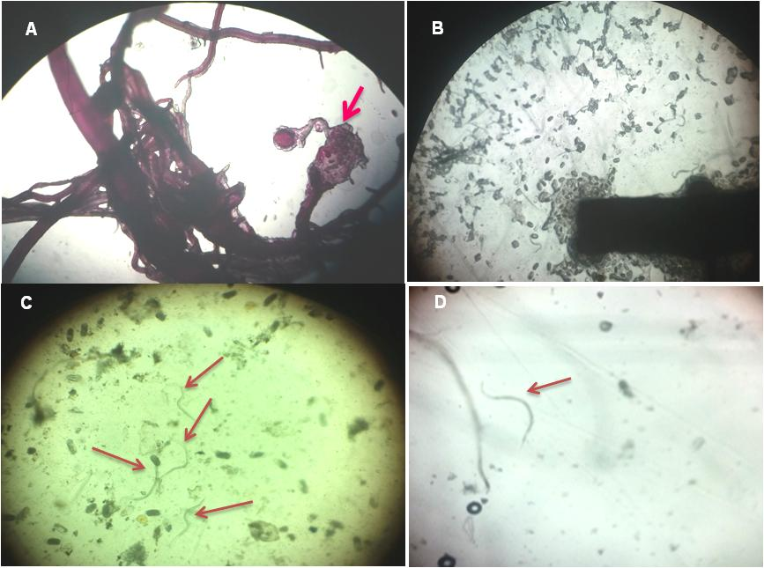

Supplementary Fig. S2. Stained roots of O. sativa cv. PR121 and O. glaberrima acc. IRGC102196. A-Adult female and egg masses in gall of PR121; B-Egg masses released from galls of PR121; C-Number of Juveniles seen in PR121; D-few (1-2) juveniles present in O. glaberrima acc. IRGC102196.

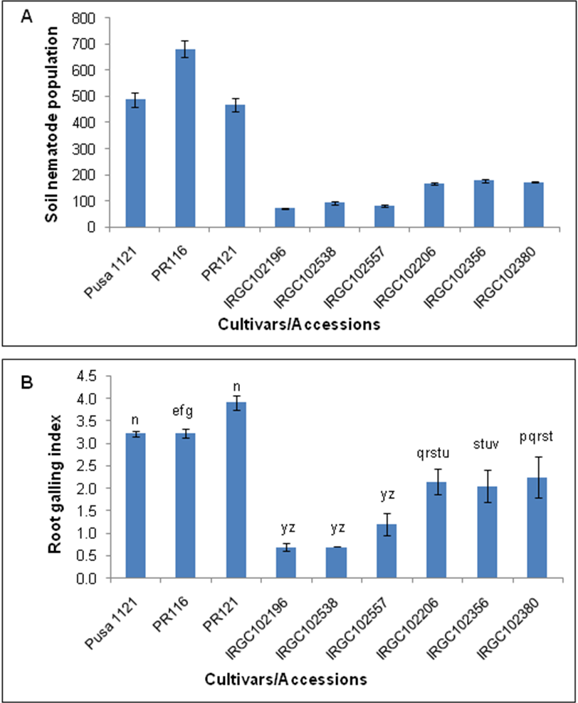

Supplementary Fig. S3. Soil nematode population/250 cc soil (a) and root galling index (b) among O. sativa cultivars (check varieties: Pusa1121, PR116, PR121) and O. glaberrima accessions (IRGC102196, IRGC102538, IRGC102557, IRGC102206, IRGC102356, IRGC102380). Data are means of three replicates for two years.

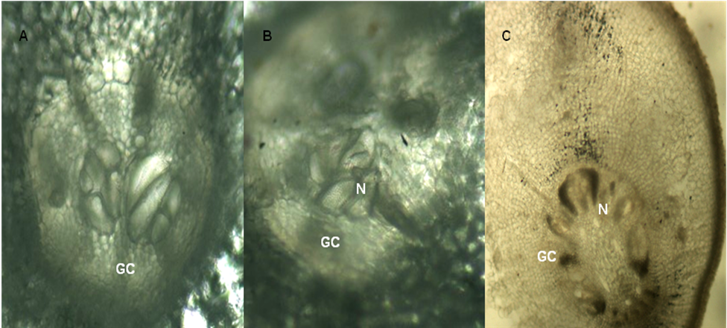

Supplementary Fig. S4. Comparative anatomy of susceptible O. sativa cv. PR121 (a and b) and resistant O. glaberrima acc. IRGC102196 (c). Giant cells formation (a) presence of juveniles inside of giant cells of roots (b) and diminished giant cell with dead juveniles (c) GC=giant cell, N=J2 juvenile.

