**Table S1. List of germplasm (bush/determinate growth habit) of French bean used in the present study**

|  |  |  |  |  |  |  |  |
| --- | --- | --- | --- | --- | --- | --- | --- |
| **Genotypes** | **Accessions** |  | **Genotypes** | **Accessions** |  | **Genotypes** | **Accessions** |
| G1 | IIHR-7 |  | G36 | IIHR-112 |  | G71 | Widusa |
| G2 | IIHR-8-1 |  | G37 | IIHR-113 |  | G72 | Perry Marrow |
| G3 | IIHR-8-2 |  | G38 | IIHR-117 |  | G73 | Mork |
| G4 | IIHR-9 |  | G39 | IIHR-121 |  | G74 | Bio-98 |
| G5 | IIHR-10 |  | G40 | IIHR-123 |  | G75 | Uday |
| G6 | IIHR-11 |  | G41 | IIHR-130 |  | G76 | Triloki |
| G7 | IIHR-13 |  | G42 | IIHR-131 |  | G77 | Kanchan |
| G8 | IIHR-21 |  | G43 | IIHR-150 |  | G78 | Amber |
| G9 | IIHR-24 |  | G44 | IIHR-155/156 |  | G79 | Yathiraj |
| G10 | IIHR-26 |  | G45 | IIHR-170 |  | G80 | Zede 5058 |
| G11 | IIHR-27 |  | G46 | IIHR-185 |  | G81 | BOLD |
| G12 | IIHR-32 |  | G47 | IIHR-188 |  | G82 | Suvidha |
| G13 | IIHR-34-1 |  | G48 | IIHR-223 |  | G83 | Anoop |
| G14 | IIHR-35 |  | G49 | IIHR-228 |  | G84 | Sharath |
| G15 | IIHR-36 |  | G50 | IIHR-229 |  | G85 | Komal |
| G16 | IIHR-37 |  | G51 | IIHR-244 |  | G86 | Arjun |
| G17 | IIHR-44 |  | G52 | IIHR-245 |  |  |  |
| G18 | IIHR-48 |  | G53 | IIHR-255 |  |  |  |
| G19 | IIHR-50 |  | G54 | IIHR-274-1 |  |  |  |
| G20 | IIHR51-2 |  | G55 | IIHR-287 |  |  |  |
| G21 | IIHR-56 |  | G56 | GC773/EC931873 |  |  |  |
| G22 | IIHR-66-1 |  | G57 | GC775/EC931875 |  |  |  |
| G23 | IIHR-67 |  | G58 | GC930/EC932010 |  |  |  |
| G24 | IIHR-76 |  | G59 | GC776/EC931876 |  |  |  |
| G25 | IIHR-79 |  | G60 | GC781/EC931887 |  |  |  |
| G26 | IIHR-79-1 |  | G61 | GC787/EC931857 |  |  |  |
| G27 | IIHR-84 |  | G62 | GC896/EC931896 |  |  |  |
| G28 | IIHR-94-2 |  | G63 | GC918/EC932018 |  |  |  |
| G29 | IIHR94-3 |  | G64 | GC927/EC932027 |  |  |  |
| G30 | IIHR-96 |  | G65 | GC930/EC932030 |  |  |  |
| G31 | IIHR-101 |  | G66 | GC960/EC932060 |  |  |  |
| G32 | IIHR-101-2 |  | G67 | GC960-1 |  |  |  |
| G33 | IIHR-103 |  | G68 | GC1072/EC932018 |  |  |  |
| G34 | IIHR-107 |  | G69 | Kaboon |  |  |  |
| G35 | IIHR-111 |  | G70 | Michilite |  |  |  |

**Table S2. Effect of seasons and their interaction on estimates of BLUP and genetic variability parameters green pod yield and attributing traits in determinate germplasm accessions of French bean.**

|  |  |  |  |  |  |  |  |  |
| --- | --- | --- | --- | --- | --- | --- | --- | --- |
| **Statistics** | **Seasons** | **h2(bs)** | **Genotype**  **Variance** | **SGI** | **Residual Variance** | **Grand Mean** | **LSD** | **CV** |
| BLUP_DFL | Rabi | 0.58 | 4.85** |  | 7.15 | 35.02 | 4.03 | 7.64 |
| Summer | 0.58 | 3.11** |  | 4.48 | 37.05 | 3.21 | 5.71 |
| Kharif | 0.96 | 16.54** |  | 1.45 | 28.99 | 2.35 | 4.16 |
| Overall | 0.50 | 2.56** | 5.62** | 4.33 | 33.69 | 3.17 | 6.17 |
| BLUP_TPW | Rabi | 0.89 | 175.18** |  | 44.14 | 67.13 | 12.45 | 9.90 |
| Summer | 0.90 | 88.68** |  | 19.62 | 39.89 | 8.36 | 11.10 |
| Kharif | 0.93 | 182.54** |  | 26.61 | 60.91 | 9.90 | 8.47 |
| Overall | 0.67 | 66.34** | 82.59** | 29.86 | 55.98 | 13.04 | 9.76 |
| BLUP_PL | Rabi | 0.71 | 3.27** |  | 2.72 | 14.14 | 2.76 | 11.67 |
| Summer | 0.93 | 2.59** |  | 0.42 | 11.06 | 1.24 | 5.85 |
| Kharif | 0.93 | 3.99** |  | 0.59 | 12.71 | 1.47 | 6.04 |
| Overall | 0.87 | 2.73** | 0.56** | 1.23 | 12.64 | 1.64 | 8.79 |
| BLUP_PW | Rabi | 0.56 | 1.58** |  | 2.52 | 11.18 | 2.35 | 14.20 |
| Summer | 0.90 | 2.51** |  | 0.54 | 11.18 | 1.38 | 6.55 |
| Kharif | 0.94 | 2.75** |  | 0.36 | 10.26 | 1.16 | 5.86 |
| Overall | 0.86 | 1.94** | 0.34** | 1.14 | 10.88 | 1.44 | 9.81 |
| BLUP_PN | Rabi | 0.90 | 43.94** |  | 9.54 | 25.60 | 5.83 | 12.07 |
| Summer | 0.88 | 7.95** |  | 2.21 | 11.66 | 2.77 | 12.75 |
| Kharif | 0.94 | 38.18** |  | 5.20 | 19.74 | 4.39 | 11.55 |
| Overall | 0.17 | 2.07ns | 27.98 ns | 5.60 | 19.00 | 3.66 | 12.46 |
| BLUP_PY | Rabi | 0.89 | 1902.28** |  | 448.23 | 169.32 | 39.81 | 12.50 |
| Summer | 0.90 | 242.90** |  | 54.82 | 46.60 | 13.95 | 15.89 |
| Kharif | 0.94 | 2211.78** |  | 302.18 | 120.17 | 33.44 | 14.47 |
| Overall | 0.30 | 196.01 ns | 1257.81 ns | 265.40 | 112.03 | 32.77 | 14.54 |

** Significant at 5% level, ns non-significant, h2(bs): heritability (broad-sense),GSV: Genotype x season variance, LSD: least significant difference, CV: coefficient of variation (%), BLUP: best linear unbiased prediction, DFL: days to flowering, PWT: pod weight (grams), PL: pod length (cm), PW: pod width (mm), PN: pod number per plant, PY: green tender pod yield per plant (grams)

**Table S3. Genotypic (below diagonal) and phenotypic (above diagonal) correlation of green pod yield and attributing traitsfor different and across seasons in determinate growth habit type germplasm accessions of French bean**

|  |  |  |  |  |  |  |
| --- | --- | --- | --- | --- | --- | --- |
| **Traits** | **DFL** | **TPW** | **PL** | **PW** | **PN** | **PY** |
| **Rabi Season, 2023** | | | | | | |
| DFL | 1.000 | -0.145 | -0.097 | -0.235* | -0.093 | -0.176 |
| TPW | -0.145 | 1.000 | 0.678** | 0.296** | -0.234* | 0.587** |
| PL | -0.002 | 0.744** | 1.000 | -0.09 | -0.270* | 0.327** |
| PW | -0.279** | 0.363** | -0.074 | 1.000 | -0.066 | 0.157 |
| PN | -0.16 | -0.231* | -0.296** | -0.045 | 1.000 | 0.610** |
| PY | -0.243* | 0.603** | 0.373** | 0.229* | 0.600** | 1.000 |
| **Summer Season, 2023** | | | | | | |
| TPW | 1.000 | 0.085 | 0.188 | -0.239* | 0.402** | 0.347** |
| PWT | 0.087 | 1.000 | 0.667** | 0.123 | 0.049 | 0.727** |
| PL | 0.253* | 0.688** | 1.000 | -0.207 | 0.067 | 0.537** |
| PW | -0.360** | 0.108 | -0.233* | 1.000 | -0.228* | -0.091 |
| PN | 0.555** | 0.072 | 0.099 | -0.256* | 1.000 | 0.701** |
| PY | 0.454** | 0.739** | 0.573** | -0.123 | 0.705** | 1.000 |
| **Kharif Season, 2023** | | | | | | |
| TPW | 1.000 | -0.151 | -0.239* | -0.13 | 0.251* | 0.064 |
| PWT | -0.165 | 1.000 | 0.727** | 0.173 | -0.009 | 0.588** |
| PL | -0.254* | 0.755** | 1.000 | -0.229* | 0.025 | 0.466** |
| PW | -0.131 | 0.164 | -0.272* | 1.000 | -0.102 | 0.003 |
| PN | 0.271* | -0.025 | 0.005 | -0.113 | 1.000 | 0.789** |
| PY | 0.076 | 0.575** | 0.460** | -0.014 | 0.791** | 1.000 |
| **Across Seasons, 2023** | | | | | | |
| TPW | 1.000 | -0.123 | -0.089 | -0.254* | 0.494** | 0.192 |
| PWT | -0.163 | 1.000 | 0.741** | 0.16 | -0.188 | 0.669** |
| PL | -0.094 | 0.802** | 1.000 | -0.239* | -0.156 | 0.506** |
| PW | -0.345** | 0.118 | -0.290** | 1.000 | -0.214* | -0.029 |
| PN | 0.999** | -0.532** | -0.379** | -0.575** | 1.000 | 0.558** |
| PY | 0.757** | 0.924** | 0.806** | -0.166 | -0.173 | 1.000 |

** Significant at 5% level, ns non-significant, h2(bs): heritability (broad-sense),GSV: Genotype x season variance, LSD: least significant difference, CV: coefficient of variation (%), BLUP: best linear unbiased prediction, DFL: days to flowering, PWT: pod weight (grams), PL: pod length (cm), PW: pod width (mm), PN: pod number per plant, PY: green tender pod yield per plant (grams)

**Table S4. Seasonal correlation for green pod yield and attributing traits in determinate germplasm accessions of French bean**

|  |  |  |  |  |  |
| --- | --- | --- | --- | --- | --- |
| **Traits** | **Seasons** | **Effect of seasons on genotypic correlation** | | **Effect of seasons on phenotypic correlation** | |
| **Rabi** | **Summer** | **Rabi** | **Summer** |
| DFL | Summer | 0.488 |  | 0.284** |  |
| Kharif | 0.243 | 0.487 | 0.181 | 0.364** |
| TPW (g) | Summer | 0.215 |  | 0.193 |  |
| Kharif | 0.599 | 0.508 | 0.545** | 0.465** |
| PL (cm) | Summer | 0.766 |  | 0.620** |  |
| Kharif | 0.927 | 0.817 | 0.753** | 0.758** |
| PW (mm) | Summer | 0.882 |  | 0.625** |  |
| Kharif | 0.857 | 0.866 | 0.619** | 0.798** |
| PN | Summer | 0.022 |  | 0.020 |  |
| Kharif | -0.002 | 0.326 | -0.002 | 0.296** |
| PY (g) | Summer | 0.004 |  | 0.003 |  |
| Kharif | 0.222 | 0.188 | 0.203 | 0.172 |

DFL: days to flowering, PWT: pod weight (grams), PL: pod length (cm), PW: pod width (mm), PN: pod number per plant, PY: green tender pod yield per plant (grams)

**Table S5. Mean performances for green pod yield in the top ten best-performing determinate germplasm accessions in French bean**

|  |  |  |  |  |  |  |  |
| --- | --- | --- | --- | --- | --- | --- | --- |
| **Sl No** | **Accession No** | **DFL** | **PL** | **PW** | **TPW** | **PN** | **PY** |
| 1 | IIHR-11 | 38.50 | 11.34 | 10.61 | 59.17 | 26.95 | 165.66 |
| 2 | IIHR-229 | 35.33 | 14.92 | 8.73 | 70.83 | 21.68 | 163.71 |
| 3 | IIHR-101-2 | 35.17 | 14.52 | 8.29 | 63.50 | 25.48 | 161.75 |
| 4 | IIHR-170 | 35.00 | 16.28 | 10.51 | 79.72 | 19.23 | 161.18 |
| 5 | IIHR-27 | 33.00 | 13.70 | 11.07 | 60.10 | 24.67 | 159.48 |
| 6 | Zede 5058 | 34.17 | 14.61 | 9.33 | 70.98 | 18.52 | 150.82 |
| 7 | IIHR-76 | 33.67 | 14.30 | 10.61 | 69.17 | 20.32 | 149.21 |
| 8 | IIHR-48 | 33.83 | 13.74 | 11.33 | 59.17 | 24.29 | 147.60 |
| 9 | IIHR-66-1 | 34.83 | 13.74 | 9.96 | 74.67 | 17.92 | 147.50 |
| 10 | IIHR-56 | 33.17 | 15.86 | 10.91 | 60.17 | 21.77 | 146.82 |
| **Best Performing Standards** | | | | | | | |
| 1 | Amber | 35.33 | 9.40 | 11.56 | 48.17 | 26.64 | 141.88 |
| 2 | Arka Bold | 34.00 | 12.11 | 15.41 | 68.67 | 18.93 | 141.65 |
| 3 | Arka Suvidha | 31.67 | 13.22 | 9.90 | 65.00 | 17.93 | 126.09 |

DFL: days to flowering, PWT: pod weight (grams), PL: pod length (cm), PW: pod width (mm), PN: pod number per plant, PY: green tender pod yield per plant (grams)

**Table S6. Estimates of AMMI Stability Value (ASV) across seasons for green pod yield and attributing traits in determinate growth type French bean germplasm**

|  |  |  |  |  |  |  |  |
| --- | --- | --- | --- | --- | --- | --- | --- |
| **Sl**  **No** | **Accessions** | **AMMI Stability Value (ASV)** | | | | | |
| **DFL** | **PL** | **PW** | **TPW** | **PN** | **PY** |
| 1 | IIHR-50 | 0.699 | 0.839 | 0.531 | 1.247 | 0.588 | 0.058 |
| 2 | IIHR-101 | 0.187 | 0.166 | 0.292 | 0.127 | 0.081 | 0.061 |
| 3 | IIHR-223 | 0.105 | 0.905 | 0.308 | 0.176 | 0.016 | 0.098 |
| 4 | IIHR-107 | 0.089 | 0.200 | 0.562 | 0.503 | 0.142 | 0.121 |
| 5 | IIHR-155 | 0.125 | 0.569 | 0.290 | 0.204 | 0.072 | 0.123 |
| 6 | IIHR-8-2 | 0.059 | 0.396 | 0.357 | 0.240 | 0.101 | 0.133 |
| 7 | IIHR-121 | 0.243 | 0.205 | 0.130 | 0.194 | 0.266 | 0.163 |
| 8 | IIHR-274-1 | 0.208 | 0.333 | 0.371 | 0.235 | 0.349 | 0.168 |
| 9 | IIHR-228 | 0.097 | 0.272 | 0.131 | 0.530 | 0.304 | 0.176 |
| 10 | GC918 | 0.131 | 0.431 | 0.755 | 0.211 | 0.114 | 0.178 |
| **Best Performing Standards** | | | | | | | |
| 1 | Kanchan | 0.069 | 0.265 | 0.170 | 0.242 | 0.131 | 0.121 |
| 2 | Suvidha | 0.097 | 0.287 | 0.362 | 0.538 | 0.158 | 0.269 |
| 3 | Sharath | 0.138 | 0.979 | 0.297 | 0.901 | 0.207 | 0.270 |
| **ASV for seasons** | | | | | | | |
|  | Kharif | 1.579 | 0.946 | 1.049 | 0.980 | 1.467 | 1.425 |
|  | Rabi | 1.293 | 1.376 | 1.467 | 1.347 | 1.718 | 1.434 |
|  | Summer | 0.901 | 1.267 | 1.002 | 1.289 | 0.865 | 0.988 |

DFL: days to flowering, PWT: pod weight (grams), PL: pod length (cm), PW: pod width (mm), PN: pod number per plant, PY: green tender pod yield per plant (grams)

**Table S7. Estimates of Genotypic Selection Indices (GSI) across seasons for green pod yield and attributing traits in determinate growth type French bean germplasm**

|  |  |  |  |  |  |  |  |  |  |  |  |  |  |
| --- | --- | --- | --- | --- | --- | --- | --- | --- | --- | --- | --- | --- | --- |
| **Sl No** | **Accessions** | **DFL** | | **PL** | | **PN** | | **PW** | | **TPW** | | **PY** | |
| **Mean** | **GSI** | **Mean** | **GSI** | **Mean** | **GSI** | **Mean** | **GSI** | **Mean** | **GSI** | **Mean** | **GSI** |
| 1 | IIHR-155 | 33.17 | 81 | 14.43 | 71 | 19.91 | 30 | 10.76 | 85 | 56.33 | 56 | 143.63 | 18 |
| 2 | IIHR-228 | 36.67 | 109 | 15.14 | 29 | 19.75 | 72 | 10.91 | 58 | 55.00 | 96 | 137.59 | 28 |
| 3 | IIHR-76 | 33.67 | 114 | 14.30 | 74 | 20.32 | 33 | 10.09 | 43 | 62.00 | 81 | 149.21 | 33 |
| 4 | IIHR-223 | 35.00 | 107 | 14.77 | 88 | 18.25 | 42 | 10.86 | 94 | 55.17 | 55 | 121.75 | 35 |
| 5 | IIHR-150 | 34.83 | 77 | 15.35 | 39 | 19.71 | 76 | 10.74 | 96 | 56.50 | 86 | 136.07 | 36 |
| 6 | IIHR-11 | 38.50 | 129 | 11.34 | 77 | 26.95 | 47 | 8.73 | 65 | 69.17 | 72 | 165.66 | 39 |
| 7 | IIHR-131 | 34.67 | 67 | 14.35 | 57 | 19.68 | 46 | 10.65 | 66 | 56.83 | 74 | 139.92 | 41 |
| 8 | IIHR-170 | 35.00 | 137 | 16.28 | 40 | 19.23 | 57 | 10.76 | 73 | 56.17 | 113 | 161.18 | 47 |
| 9 | IIHR-9 | 31.50 | 24 | 14.67 | 56 | 17.66 | 61 | 8.38 | 55 | 70.98 | 56 | 121.56 | 49 |
| 10 | IIHR-79-1 | 32.17 | 102 | 10.12 | 128 | 21.40 | 97 | 10.14 | 107 | 61.17 | 107 | 120.17 | 51 |
| **Best Performing Standards** | | | | | | | | | | | | | |
| 1 | Arka Suvidha | 31.67 | 48 | 13.22 | 66 | 17.93 | 62 | 13.25 | 142 | 40.92 | 130 | 126.09 | 55 |
| 2 | Kanchan | 32.00 | 44 | 12.24 | 79 | 16.54 | 81 | 12.87 | 94 | 45.67 | 95 | 100.62 | 60 |
| 3 | Arka Anoop | 35.67 | 154 | 13.48 | 75 | 19.35 | 36 | 13.50 | 126 | 36.47 | 128 | 122.93 | 61 |

GSI: Genotypic selectin index, DFL: days to flowering, PWT: pod weight (grams), PL: pod length (cm), PW: pod width (mm), PN: pod number per plant, PY: green tender pod yield per plant (grams)

**Table S8. Estimates of BLUP across seasons for green pod yield and attributing traits in determinate growth type French bean germplasm**

|  |  |  |  |  |  |  |  |
| --- | --- | --- | --- | --- | --- | --- | --- |
| **Sl No** | **Accessions** | **BLUP_DFL**  **(days)** | **BLUP_TPW**  **(g)** | **BLUP_PL**  **(cm)** | **BLUP_PW**  **(mm)** | **BLUP_PN** | **BLUP_PY**  **(g)** |
| 1 | IIHR-11 | 36.08 | 58.12 | 11.50 | 10.65 | 20.33 | 127.97 |
| 2 | IIHR-229 | 34.50 | 65.95 | 14.64 | 9.02 | 19.45 | 127.39 |
| 3 | IIHR-101-2 | 34.42 | 61.03 | 14.28 | 8.64 | 20.09 | 126.81 |
| 4 | IIHR-170 | 34.34 | 71.91 | 15.83 | 10.56 | 19.04 | 126.64 |
| 5 | IIHR-27 | 33.35 | 58.74 | 13.57 | 11.05 | 19.95 | 126.13 |
| 6 | Zede 5058 | 33.92 | 66.04 | 14.36 | 9.54 | 18.92 | 123.56 |
| 7 | IIHR-76 | 33.68 | 64.83 | 14.09 | 10.65 | 19.22 | 123.08 |
| 8 | IIHR-48 | 33.76 | 58.12 | 13.60 | 11.27 | 19.89 | 122.60 |
| 9 | IIHR-66-1 | 34.26 | 68.52 | 13.60 | 10.09 | 18.82 | 122.57 |
| 10 | IIHR-56 | 33.43 | 58.79 | 15.46 | 10.90 | 19.47 | 122.37 |
| **Best Performing Standards** | | | | | | | |
| 1 | Amber | 34.50 | 50.73 | 9.81 | 11.47 | 20.28 | 120.90 |
| 2 | Arka Bold | 33.84 | 64.49 | 12.17 | 14.79 | 18.99 | 120.83 |
| 3 | Arka Suvidha | 32.68 | 62.03 | 13.14 | 10.03 | 18.82 | 116.21 |
| **BLUP estimates for Seasons** | | | | | | | |
|  | Kharif | 28.99 | 60.91 | 12.71 | 10.26 | 19.74 | 120.17 |
|  | Rabi | 35.02 | 67.13 | 14.14 | 11.18 | 25.60 | 169.32 |
|  | Summer | 37.05 | 39.89 | 11.06 | 11.18 | 11.66 | 46.60 |

BLUP: best linear unbiased prediction, DFL: days to flowering, PWT: pod weight (grams), PL: pod length (cm), PW: pod width (mm), PN: pod number per plant, PY: green tender pod yield per plant (grams)

**Table S9. Estimates of Yield Related Environmental Maximum (YREM) across seasons for green pod yield and attributing traits in French bean germplasm**

|  |  |  |  |  |  |  |  |
| --- | --- | --- | --- | --- | --- | --- | --- |
| **Sl No** | **Accessions** | **TPW** | | **PN** | | **PY** | |
| **Mean** | **YREM** | **Mean** | **YREM** | **Mean** | **YREM** |
| 1 | IIHR-101-2 | 63.50 | 0.7304 | 25.48 | 0.6795 | 161.75 | 0.7775 |
| 2 | IIHR-11 | 59.17 | 0.6473 | 26.95 | 0.7385 | 165.66 | 0.7553 |
| 3 | IIHR-170 | 79.72 | 0.8907 | 19.23 | 0.4971 | 161.18 | 0.7327 |
| 4 | IIHR-229 | 70.83 | 0.7845 | 21.68 | 0.5486 | 163.70 | 0.7068 |
| 5 | IIHR-27 | 60.10 | 0.6869 | 24.67 | 0.6377 | 159.48 | 0.6959 |
| 6 | IIHR-76 | 69.17 | 0.7653 | 20.32 | 0.5332 | 149.21 | 0.6707 |
| 7 | IIHR-48 | 59.17 | 0.6646 | 24.29 | 0.6322 | 147.60 | 0.6630 |
| 8 | IIHR-228 | 69.00 | 0.7855 | 19.74 | 0.5076 | 137.59 | 0.6621 |
| 9 | IIHR-155 | 69.17 | 0.7794 | 19.91 | 0.5125 | 143.63 | 0.6574 |
| 10 | IIHR-44 | 69.17 | 0.7940 | 17.85 | 0.4738 | 122.43 | 0.6385 |
| **Best Performing Standards** | | | | | | | |
| 1 | Amber | 48.17 | 0.5257 | 26.64 | 0.6671 | 141.88 | 0.5934 |
| 2 | Arka Bold | 68.67 | 0.7656 | 18.93 | 0.4595 | 141.65 | 0.5820 |
| 3 | Arka Komal | 57.37 | 0.6477 | 20.52 | 0.4793 | 124.98 | 0.5624 |

DFL: days to flowering, PWT: pod weight (grams), PL: pod length (cm), PW: pod width (mm), PN: pod number per plant, PY: green tender pod yield per plant (grams)

**Figure S1. Meteorological data during *rabi* season (November 2022 to January 2023)**

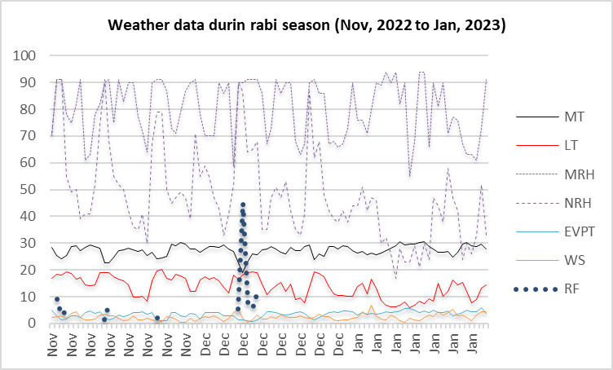

MT: Maximum temperature (0C), LT: Lowest/Minimum temperature (0C), MRH: Morning relative humidity (%) at 8.30 am, NRH: Noon Relative Humidity (%) at 1.30 pm, EVPT: Evaporation (mm), WS: wind speed (km/h), RF: Rainfall (mm)

**Figure S2. Meteorological data during summer season (March 2023 to May 2023)**

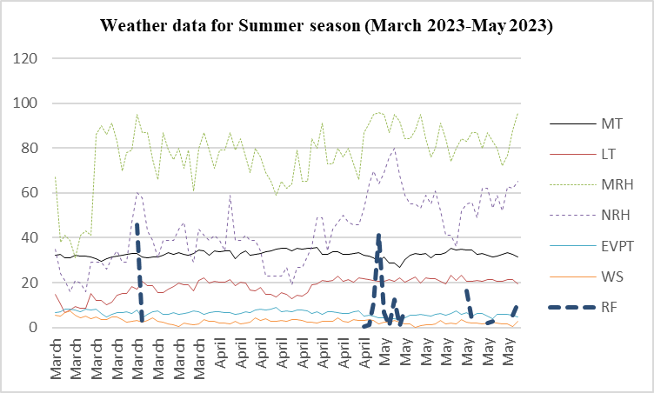

MT: Maximum temperature (0C), LT: Lowest/Minimum temperature (0C), MRH: Morning relative humidity (%) at 8.30 am, NRH: Noon Relative Humidity (%) at 1.30 pm, EVPT: Evaporation (mm), WS: wind speed (km/h), RF: Rainfall (mm)

**Figure S3. Meteorological data during *kharif* season (July 2023 to September 2023)**

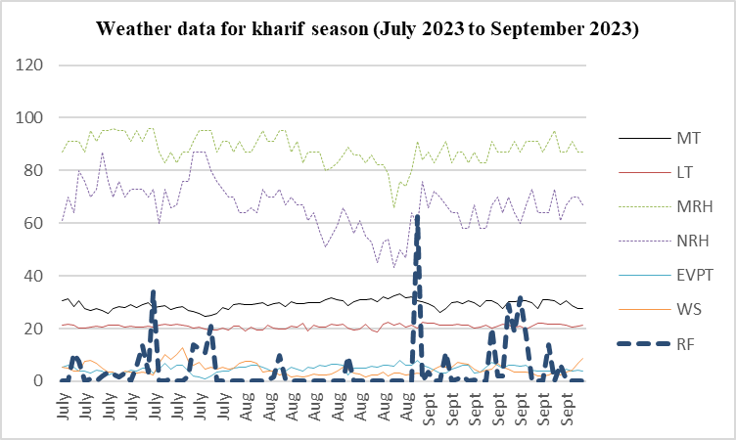

MT: Maximum temperature (0C), LT: Lowest/Minimum temperature (0C), MRH: Morning relative humidity (%) at 8.30 am, NRH: Noon Relative Humidity (%) at 1.30 pm, EVPT: Evaporation (mm), WS: wind speed (km/h), RF: Rainfall (mm)

|  |  |
| --- | --- |
| a) AMMI Biplot for PC1 vs PC2 for PY | b) AMMI Biplot for PC1 vs Mean for PY |
| c) AMMI Biplot for PC1 vs PC2 for PN | d) AMMI Biplot for PC1 vs Mean for PN |
| e) AMMI Biplot for PC1 vs PC2 for TPW | f) AMMI Biplot for PC1 vs Mean for TPW |

**Figure S4. AMMI Biplots showing the position of different germplasm accessions on PC1 vs. PC2 and PC1*vs* Train Mean for different traits. Figures a, c & e are AMMI Biplots of PC1 vs PC2 and Figures b, d & f are AMMI Biplots of PC1 vs trait mean for PY, PN and TPW respectively. Genotypes marked in yellow are having the lowest ASV values combined with the highest PY and respective trait mean.**