# Modern arable and diverse ley farming systems increase soil organic matter faster than global targets

# **Supplementary Information**

1. Soil organic matter
2. Labile carbon
3. Bulk density
4. Water infiltration
5. Penetrometer point pressure
6. Organic ley species mix

### **Soil Organic Matter**

**Figure S1** Soil Organic Matter (g.kg-1), by treatment, soil depth and year (in pairs: left 2014; right 2019), measured using the loss on ignition method. Boxplots indicate medians, interquartile ranges and extreme values beyond 95%.

**Table S1** Change in SOM content (g.kg-1), between 2014 and 2019, predicted means by treatment and depth, with 95% confidence intervals and p-values representing probability predicted mean change in SOM is zero (Ho)

|  |  |  |  |  |  |  |  |
| --- | --- | --- | --- | --- | --- | --- | --- |
| treatment | emmean | SE | df | lower CI | upper CI | t-ratio | p-value |
| depth = 0-100mm: |  |  |  |  |  |  |  |
| Positive reference | 8.223 | 1.119 | 33.4 | 5.948 | 10.497 | 7.35 | *<0.001 |
| Enhanced | 3.666 | 0.923 | 15.9 | 1.707 | 5.625 | 3.97 | *0.001 |
| Standard | 2.826 | 0.923 | 15.9 | 0.867 | 4.784 | 3.06 | *0.008 |
| Negative reference | -0.583 | 1.119 | 33.4 | -2.858 | 1.692 | -0.521 | 0.606 |
| depth = 100-300mm: |  | |  |  |  |  |  |
| Positive reference | 2.951 | 1.119 | 33.4 | 0.676 | 5.226 | 2.638 | *0.013 |
| Enhanced | 0.3 | 0.923 | 15.9 | -1.659 | 2.259 | 0.325 | 0.750 |
| Standard | -0.289 | 0.923 | 15.9 | -2.248 | 1.67 | -0.313 | 0.758 |
| Negative reference | -1.44 | 1.119 | 33.4 | -3.715 | 0.835 | -1.287 | 0.207 |

* denotes p-value <0.05

**Table S2** Change in SOM content (g.kg-1), between 2014 to 2019, contrast of treatment pairs at the two depths, 95% confidence intervals

|  |  |  |  |  |  |  |  |
| --- | --- | --- | --- | --- | --- | --- | --- |
| Contrast of treatment pairs | estimate | SE | df | lower CI | upper CI | t-ratio | p-value |
| depth = 0-100mm: |  |  |  |  |  |  |  |
| Positive reference - Enhanced | 4.56 | 1.29 | 83.1 | 1.19 | 7.93 | 3.545 | *0.004 |
| Positive reference - Standard | 5.40 | 1.29 | 83.1 | 2.03 | 8.77 | 4.199 | *<0.001 |
| Positive reference - Negative r. | 8.81 | 1.43 | 117.8 | 5.07 | 2.54 | 6.148 | *<0.001 |
| Enhanced - Standard | 0.84 | 1.12 | 50.2 | -2.13 | 3.82 | 0.75 | 0.88 |
| Enhanced - Negative reference | 4.25 | 1.29 | 83.1 | 0.88 | 7.62 | 3.305 | *0.008 |
| Standard - Negative reference | 3.41 | 1.29 | 83.1 | 0.04 | 6.78 | 2.652 | *0.046 |
| depth = 100-300mm: |  |  |  |  |  |  |  |
| Positive reference - Enhanced | 2.65 | 1.29 | 83.1 | -0.72 | 6.02 | 2.062 | 0.174 |
| Positive reference - Standard | 3.24 | 1.29 | 83.1 | -0.13 | 6.61 | 2.521 | 0.064 |
| Positive reference - Negative r. | 4.39 | 1.43 | 117.8 | 0.66 | 8.12 | 3.066 | *0.014 |
| Enhanced - Standard | 0.59 | 1.12 | 50.2 | -2.39 | 3.56 | 0.526 | 0.952 |
| Enhanced - Negative reference | 1.74 | 1.29 | 83.1 | -1.63 | 5.11 | 1.354 | 0.532 |
| Standard - Negative reference | 1.15 | 1.29 | 83.1 | -2.22 | 4.52 | 0.895 | 0.807 |

* denotes p-value <0.05

**Table S3** Relative change (%) in SOM between 2014 to 2019 with 95% confidence intervals. Calculated as % annual relative change in SOM = (((((SOM2019 - SOM2014) / SOM2014) + 1) ^(1/5)) - 1) * 100

|  |  |  |  |  |  |  |  |
| --- | --- | --- | --- | --- | --- | --- | --- |
| treatment | emmean | SE | df | lower CI | upper CI | t-ratio | p-value |
| depth = 0-100mm: |  |  |  |  |  |  |  |
| Positive reference | 3.15 | 0.50 | 21.4 | 2.12 | 4.18 | 6.359 | *<0.001 |
| Enhanced | 1.59 | 0.41 | 10.1 | 0.69 | 2.51 | 3.9 | *0.003 |
| Standard | 1.21 | 0.41 | 10.1 | 0.30 | 2.12 | 2.953 | *0.014 |
| Negative reference | -0.30 | 0.50 | 21.4 | -1.33 | 0.73 | -0.609 | 0.549 |
| depth = 100-300mm: |  |  |  |  |  |  |  |
| Positive reference | 1.57 | 0.66 | 7.92 | 0.06 | 3.09 | 2.399 | *0.044 |
| Enhanced | 0.22 | 0.59 | 5.15 | -1.28 | 1.72 | 0.375 | 0.723 |
| Standard | 0.00 | 0.59 | 5.15 | -1.50 | 1.50 | -0.007 | 0.995 |
| Negative reference | -0.67 | 0.66 | 7.92 | -2.18 | 0.85 | -1.022 | 0.337 |

* denotes p-value <0.05

### **Labile Carbon**

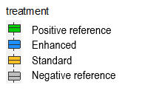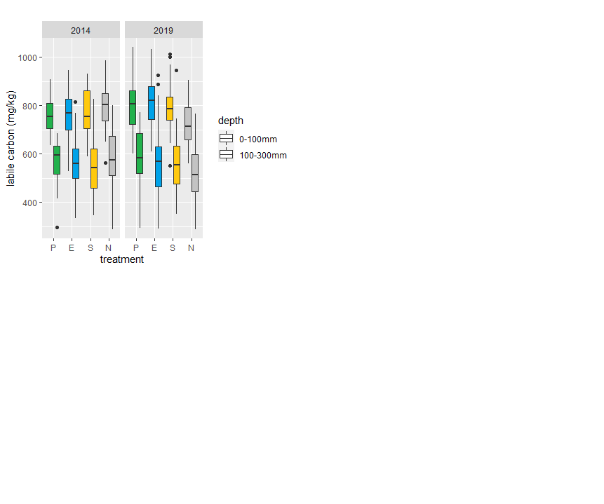

**Figure S2** Labile carbon (mg.kg-1), in 2014 and 2019 by treatment, by year and by depth (in pairs: left 0-100 mm; right 100-300 mm), Boxplots indicate medians, interquartile ranges and extreme values beyond 95%.

**Table S4** Labile carbon (mg.kg-1), predicted means 95% confidence intervals, by treatment and depth

|  |  |  |  |  |  |  |
| --- | --- | --- | --- | --- | --- | --- |
| treatment | emmean | SE | df | lower CI | upper CI | t-ratio |
| depth = 0-100 mm |  |  |  |  |  |  |
| Positive reference | 799 | 25.5 | 7.41 | 739 | 858 | 31.271 |
| Enhanced | 817 | 23.4 | 5.21 | 758 | 876 | 34.94 |
| Standard | 787 | 23.4 | 5.21 | 727 | 846 | 33.656 |
| Negative reference | 724 | 25.5 | 7.41 | 665 | 784 | 28.367 |
| depth = 100-300 mm |  |  |  |  |  |  |
| Positive reference | 590 | 31.7 | 6.71 | 515 | 666 | 18.633 |
| Enhanced | 559 | 29.1 | 4.8 | 484 | 635 | 19.209 |
| Standard | 562 | 29.1 | 4.8 | 486 | 637 | 19.284 |
| Negative reference | 517 | 31.7 | 6.71 | 442 | 593 | 16.325 |

**Table S5** Labile carbon (mg.kg-1) in 2019, contrasts of treatment pairs of Labile carbon 95% confidence intervals

|  |  |  |  |  |  |  |  |
| --- | --- | --- | --- | --- | --- | --- | --- |
| contrast | estimate | SE | df | lower CI | upper CI | t-ratio | p-value |
| depth = 0-100mm: |  |  |  |  |  |  |  |
| Positive reference - Enhanced | -18.4 | 22.2 | 36.4 | -78.16 | 41.4 | -0.826 | 0.842 |
| Positive reference - Standard | 11.7 | 22.2 | 36.4 | -48.14 | 71.5 | 0.525 | 0.953 |
| Positive reference - Negative r. | 74.2 | 24.5 | 52.1 | 9.22 | 139.1 | 3.03 | *0.019 |
| Enhanced - Standard | 30 | 19.7 | 22.3 | -24.62 | 84.7 | 1.524 | 0.441 |
| Enhanced - Negative reference | 92.5 | 22.2 | 36.4 | 32.72 | 152.3 | 4.165 | *0.001 |
| Standard - Negative reference | 62.5 | 22.2 | 36.4 | 2.7 | 122.3 | 2.813 | *0.038 |
| depth = 100-300mm: |  |  |  |  |  |  |  |
| Positive reference - Enhanced | 30.75 | 26 | 36.8 | -39.33 | 100.8 | 1.181 | 0.643 |
| Positive reference - Standard | 28.56 | 26 | 36.8 | -41.51 | 98.6 | 1.097 | 0.694 |
| Positive reference - Negative r. | 73.12 | 28.9 | 53.9 | -3.41 | 149.7 | 2.533 | 0.066 |
| Enhanced - Standard | -2.19 | 22.9 | 21.8 | -65.77 | 61.4 | -0.096 | 0.999 |
| Enhanced - Negative reference | 42.38 | 26 | 36.8 | -27.7 | 112.5 | 1.627 | 0.377 |
| Standard - Negative reference | 44.56 | 26 | 36.8 | -25.51 | 114.6 | 1.711 | 0.333 |

* denotes p-value <0.05

### **Bulk Density**

**Figure S3** Bulk density (g.cm-3), boxplot by depth and by treatment, showing medians, interquartile ranges and 95% data limits with extreme points. The data for bulk density is shown in the boxplots below for 2018, after 4 years of experimentation and at the three sample depths (0-100 mm, 100-300 mm, 300-500 mm).

**Table S6** Bulk density (g.cm-3), predicted means and 95% confidence intervals, in 2018 by treatment and by depth

|  |  |  |  |  |  |  |
| --- | --- | --- | --- | --- | --- | --- |
| treatment | emmean | SE | df | lower CI | upper CI | t-ratio |
| depth = 0-100mm: |  |  |  |  |  |  |
| Positive reference | 0.86 | 0.04 | 18.03 | 0.77 | 0.95 | 20.105 |
| Enhanced | 0.83 | 0.04 | 9.22 | 0.75 | 0.91 | 22.896 |
| Standard | 0.84 | 0.04 | 9.22 | 0.76 | 0.92 | 23.223 |
| Negative reference | 0.95 | 0.04 | 18.03 | 0.86 | 1.04 | 22.11 |
| depth = 100-300mm: |  |  |  |  |  |  |
| Positive reference | 0.87 | 0.04 | 18.03 | 0.78 | 0.96 | 20.28 |
| Enhanced | 1.00 | 0.04 | 9.22 | 0.91 | 1.08 | 27.457 |
| Standard | 0.94 | 0.04 | 9.22 | 0.86 | 1.02 | 25.981 |
| Negative reference | 1.03 | 0.04 | 18.03 | 0.94 | 1.12 | 23.948 |
| depth = 300-500mm: |  |  |  |  |  |  |
| Positive reference | 0.77 | 0.05 | 24.22 | 0.67 | 0.86 | 16.508 |
| Enhanced | 0.90 | 0.04 | 9.74 | 0.82 | 0.98 | 24.411 |
| Standard | 0.90 | 0.04 | 9.22 | 0.82 | 0.99 | 24.943 |
| Negative reference | 0.93 | 0.04 | 18.03 | 0.84 | 1.02 | 21.566 |

**Table S7** Bulk density (g/cm3), contrasts of treatment pairs at three depths, in 2018 estimate, 95% confidence intervals (* denotes p-value <0.05)

|  |  |  |  |  |  |  |  |
| --- | --- | --- | --- | --- | --- | --- | --- |
| contrast | estimate | SE | df | lower CI | upper CI | t-ratio | p-value |
| depth = 0-100mm: |  |  |  |  |  |  |  |
| Positive reference - Enhanced | 0.034 | 0.043 | 164.7 | -0.078 | 0.146 | 0.78 | 0.864 |
| Positive reference - Standard | 0.022 | 0.043 | 164.7 | -0.090 | 0.134 | 0.506 | 0.958 |
| Positive reference - Negative r. | -0.086 | 0.049 | 228.7 | -0.213 | 0.041 | -1.76 | 0.296 |
| Enhanced - Standard | -0.012 | 0.037 | 95.4 | -0.107 | 0.084 | -0.324 | 0.988 |
| Enhanced - Negative reference | -0.120 | 0.043 | 164.7 | -0.232 | -0.008 | -2.775 | *0.031 |
| Standard - Negative reference | -0.108 | 0.043 | 164.7 | -0.220 | 0.004 | -2.501 | 0.064 |
| depth = 100-300mm: |  |  |  |  |  |  |  |
| Positive reference - Enhanced | -0.124 | 0.043 | 164.7 | -0.236 | -0.012 | -2.874 | *0.024 |
| Positive reference - Standard | -0.071 | 0.043 | 164.7 | -0.183 | 0.041 | -1.636 | 0.362 |
| Positive reference - Negative r. | -0.158 | 0.049 | 228.7 | -0.284 | -0.031 | -3.219 | *0.008 |
| Enhanced - Standard | 0.054 | 0.037 | 95.4 | -0.042 | 0.149 | 1.465 | 0.463 |
| Enhanced - Negative reference | -0.034 | 0.043 | 164.7 | -0.146 | 0.079 | -0.775 | 0.866 |
| Standard - Negative reference | -0.087 | 0.043 | 164.7 | -0.199 | 0.025 | -2.014 | 0.187 |
| depth = 300-500mm: |  |  |  |  |  |  |  |
| Positive reference - Enhanced | -0.130 | 0.047 | 193.3 | -0.252 | -0.008 | -2.756 | *0.032 |
| Positive reference - Standard | -0.137 | 0.047 | 189.8 | -0.257 | -0.016 | -2.926 | *0.02 |
| Positive reference - Negative r. | -0.159 | 0.052 | 247.1 | -0.294 | -0.024 | -3.052 | *0.013 |
| Enhanced - Standard | -0.007 | 0.037 | 99.8 | -0.104 | 0.090 | -0.186 | 0.999 |
| Enhanced - Negative reference | -0.029 | 0.044 | 169.1 | -0.142 | 0.084 | -0.669 | 0.909 |
| Standard - Negative reference | -0.022 | 0.043 | 164.7 | -0.134 | 0.090 | -0.516 | 0.955 |

### **Water Infiltration**

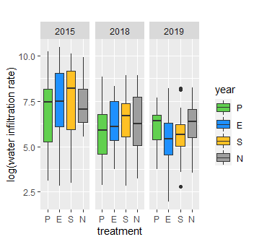

**Figure S4** Water infiltration log(rate), boxplots, top: by year and treatment, bottom: by treatment, year and crop. Medians, interquartile ranges and data limits shown. P-positive, E-enhanced, S-standard, N-negative

Water infiltration readings were taken in three separate years 2015, 2018 and 2019 (Figure S4). The model produced non-estimable means for crops which were confounded by years. No significant effect of overall treatments was found (p-value =0.24).

### **Penetrometer point pressure**

The penetrometer point pressure dataset of measurement below 200mm did not allow for a meaningful analysis due to a large proportion of missing values, mostly resulting from high stone content at this depth. At 250mm, 1 in 4 readings and at 325mm, 1 in 3 readings were unobtainable. The observations from 100mm and 200mm soil depths were much more complete and are shown in Figure S5.

Only data for 2018 was modelled as the most recent and most impacted by the treatments. Comparison between years was not possible due to variations in soil conditions between years. Table S8 and Figure S6 plot, shows the predicted means by treatment and depth, together with 95% confidence intervals. Soil compaction was higher in the positive reference treatment at the shallow depth (0-100mm) compared to all other treatments, while positive was higher than enhanced at the 200mm depth, see Table S9. A model of bulk density with penetrometer at the 0-100mm depth failed to converge.

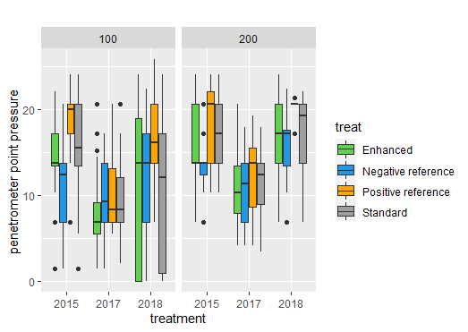

B

A

**Figure S5** Penetrometer point pressure (105 Nm-2), boxplot, plot A: depth = 100 mm and plot B: depth = 200 mm, by treatment, showing interquartile range and >95% extreme values.

**Table S8** Penetrometer 2018 (105N/m2), predicted means and 95% confidence intervals, by treatment and depth

|  |  |  |  |  |  |  |
| --- | --- | --- | --- | --- | --- | --- |
| treatment | emmean | SE | df | lower CI | upper CI | t-ratio |
| depth = 100 mm |  |  |  |  |  |  |
| Positive reference | 16.7 | 3.26 | 4.21 | 7.79 | 25.5 | 5.115 |
| Enhanced | 11.5 | 3.12 | 3.56 | 2.35 | 20.6 | 3.673 |
| Standard | 10.7 | 3.13 | 3.59 | 1.58 | 19.7 | 3.41 |
| Negative reference | 13.4 | 3.22 | 4.04 | 4.5 | 22.3 | 4.163 |
| depth = 200 mm |  |  |  |  |  |  |
| Positive reference | 20.2 | 1.51 | 50.8 | 17.2 | 23.2 | 13.423 |
| Enhanced | 16.7 | 0.87 | 10.2 | 14.8 | 18.6 | 19.284 |
| Standard | 17 | 0.91 | 12.7 | 15.1 | 19 | 18.817 |
| Negative reference | 15.5 | 1.03 | 21.7 | 13.4 | 17.7 | 15.067 |

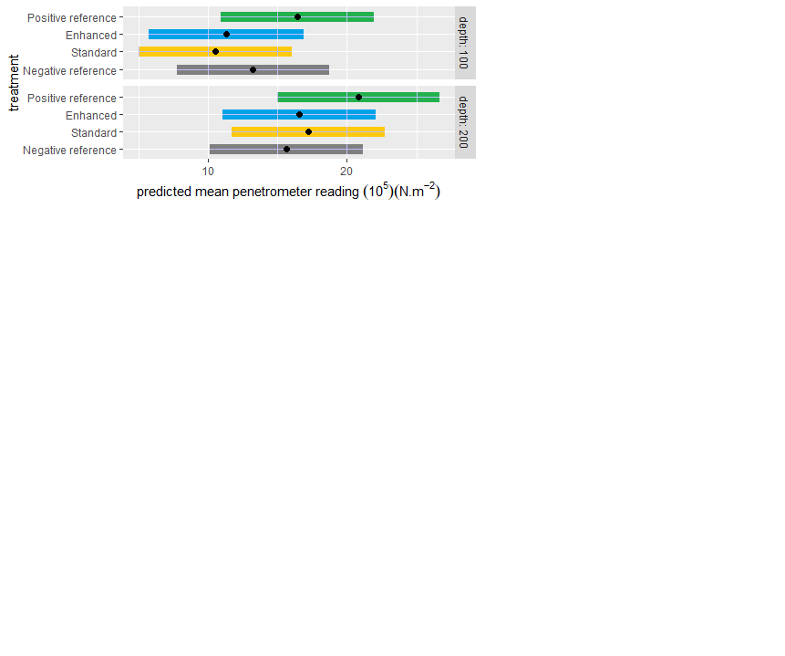

**Figure S6** Penetrometer point pressure 2018 (105 N/m2), plot of predicted means and 95% confidence intervals at 100 mm and 200 mm depth,

**Table S9** Penetrometer point pressure 2018 (105N/m2), contrast of treatment pairs by depth,

|  |  |  |  |  |  |  |  |
| --- | --- | --- | --- | --- | --- | --- | --- |
| contrast | estimate | SE | df | lower CI | upper CI | t-ratio | p-value |
| depth = 100 mm |  |  |  |  |  |  |  |
| Positive reference - Enhanced | 5.21 | 1.79 | 36.8 | 0.38 | 10.03 | 2.9 | *0.031 |
| Positive reference - Standard | 6.00 | 1.81 | 37.5 | 1.14 | 10.85 | 3.32 | *0.010 |
| Positive reference - Negative r. | 3.24 | 1.96 | 46.9 | -1.98 | 8.47 | 1.653 | 0.360 |
| Enhanced - Standard | 0.79 | 1.54 | 22.6 | -3.49 | 5.07 | 0.513 | 0.955 |
| Enhanced - Negative reference | -1.96 | 1.73 | 32.8 | -6.65 | 2.72 | -1.133 | 0.672 |
| Standard - Negative reference | -2.75 | 1.74 | 33.6 | -7.47 | 1.96 | -1.579 | 0.403 |
| depth = 200 mm |  |  |  |  |  |  |  |
| Positive reference - Enhanced | 3.49 | 1.66 | 42.6 | -0.94 | 7.92 | 2.104 | 0.168 |
| Positive reference - Standard | 3.13 | 1.67 | 45.7 | -1.33 | 7.59 | 1.869 | 0.256 |
| Positive reference - Negative r. | 4.66 | 1.75 | 51.3 | 0.02 | 9.29 | 2.667 | *0.049 |
| Enhanced - Standard | -0.36 | 1.15 | 18.2 | -3.62 | 2.9 | -0.313 | 0.989 |
| Enhanced - Negative reference | 1.17 | 1.24 | 24.2 | -2.25 | 4.58 | 0.943 | 0.782 |
| Standard - Negative reference | 1.53 | 1.28 | 28.8 | -1.95 | 5.01 | 1.197 | 0.634 |

* denotes p-value <0.05

### **Organic ley species mix**

**Table S10** Commercially available 23 species mixture drilled as the ley phase of the 7 year rotation applied in this study.

|  |  |
| --- | --- |
| **Scientific name** | **Common name** |
| *Cichorium intybus* | Chicory |
| *Dactylis glomerata* | Cocksfoot grass |
| *Festuca arundinacea* | Tall fescue |
| *Festuca pratensis* | Meadow fescue |
| *Leucanthemum vulgare* | Oxeye daisy |
| *Lolium multiflorum* | Italian ryegrass |
| *Lolium perenne* | Perennial ryegrass |
| *Lotus corniculatus* | Birdsfoot trefoil |
| *Lotus pedunculatus* | Large birdsfoot trefoil |
| *Medicago lupulina* | Black medic |
| *Medicago sativa* | Lucerne |
| *Melilotus officinalis* | Yellow sweet clover |
| *Onobrychis viciifolia* | Sainfoin |
| *Phacelia tanacetifolia* | Lacy phacelia |
| *Phleum pratense* | Timothy |
| *Plantago lanceolata* | Ribworth plantain |
| *Sanguisorba minor* | Burnet forage herb |
| *Silene dioica* | Red campion |
| *Trifolium hybridum* | Alsike clover |
| *Trifolium incarnatum* | Crimson clover |
| *Trifolium pratense* | Red clover |
| *Trifolium repens* | White clover |
| *Vicia sativa* | Winter vetch |