Appendix A.
Experimental stimuli for acceptability judgment tasks in Experiments 1 and 2
(Instruction: Now, let’s begin the acceptability judgment task. In this survey, you will read English sentences and rate how natural they sound. First, let's practice. Please read the following sentence. (Practice 1): Paul is hated dogs. The sentence above is not grammatically correct, so you should mark it as 1 (very unnatural) or 2 (unnatural). (Practice 2): Alice loves cats. The sentence above is grammatically correct, so you should mark it as 3 (natural) or 4 (very natural). Now, we will begin the task. There are a total of 60 sentences, with one sentence per page. Once you start answering a question, please do not go back to previous questions.)

Amber explained the answer to Zach. / *Amber explained Zach the answer.

Amy carried the luggage for Beth. / *Amy carried Beth the luggage.

Angela whispered the password to Amy. / *Angela whispered Amy the password.

Charles described the problem to Dean. / *Charles described Dean the problem.

Edward donated his clothes to charity. / *Edward donated charity his clothes.

Emily returned the books to Jane. / *Emily returned Jane the books.

Ethan whispered the secret to Paul. / *Ethan whispered Paul the secret.

Gary returned his paintings to the museum. / *Gary returned the museum his paintings.

Jennifer said hello to Nancy. / *Jennifer said Nancy hello.

Jenny explained the difference to Tom. / *Jenny explained Tom the difference.

Kevin displayed the result to Bruce. / *Kevin displayed Bruce the result.

Laura said no to Hellen. / *Laura said Hellen no.

Lucas described the apartment to Mike. / *Lucas described Mike the apartment.

Nancy displayed the picture to James. / *Nancy displayed James the picture.

Nick shouted the message to Bill. / *Nick shouted Bill the message.

Peter donated some money to Jack. / *Peter donated Jack some money.

Susan carried some bags for Lisa. / *Susan carried Lisa some bags.

Tony shouted the news to Jim. / *Tony shouted Jim the news.

Appendix B.
Experimental stimuli for self-paced reading tasks in Experiments 1 and 2
(Instruction: You will now have 5 practice items. Each item starts with lines. When you press the space bar, the first word will appear. With the second space bar pressing, the first word disappears, and the next word appears. In this way, you will keep pressing the bar until you read a whole sentence.)

Amber explained the answer to Zach after they finished the test.
/ *Amber explained Zach the answer after they finished the test.
Q) Did they finish the test?

Amy carried the luggage for Beth when they entered the hotel.
/ *Amy carried Beth the luggage when they entered the hotel.
Q) Did they enter the restaurant?

Angela whispered the password to Amy as they entered the secure building.
/ * Angela whispered Amy the password as they entered the secure building.
Q) Did Angela enter the secure building?

Charles described the problem to Dean as they fixed the computer.
/ *Charles described Dean the problem as they fixed the computer.
Q) Did they fix the car?

Edward donated his clothes to charity before he left the country.
/ *Edward donated charity his clothes before he left the country.
Q) Did Edward left the country?

Emily returned the books to Jane after they finished the project.
/ *Emily returned Jane the books after they finished the project.
Q) Did they finish the project?

Ethan whispered the secret to Paul when they met at the cafe.
/ *Ethan whispered Paul the secret when they met at the cafe.
Q) Did they meet at the library?

Gary returned his paintings to the museum after he retired from his job.
/ *Gary returned the museum his paintings after he retired from his job.
Q) Did Gary retire from his job?

Jennifer said hello to Nancy when they walked in the park.
/ *Jennifer said Nancy hello when they walked in the park.
Q) Did they walk in the market?

Jenny explained the difference to Tom as they saw the twins.
/ *Jenny explained Tom the difference as they saw the twins.
Q) Did they see the twins?

Kevin displayed the result to Bruce after they finished the experiment.
/ *Kevin displayed Bruce the result after they finished the experiment.
Q) Did they finish the lunch?

Laura said no to Hellen when she asked for help.
/ *Laura said Hellen no when she asked for help.
Q) Did Hellen ask for help?

Lucas described the apartment to Mike as they watched the monitor.
/ *Lucas described Mike the apartment as they watched the monitor.
Q) Did they watched the news?

Nancy displayed the picture to James when they met at the restaurant.
/ *Nancy displayed James the picture when they met at the restaurant.
Q) Did they meet at the restaurant?

Nick shouted the message to Bill when they climbed the mountain.
/ *Nick shouted Bill the message when they climbed the mountain.
Q) Did they climb the mountain?

Peter donated some money to Jack when he won the lottery.
/ *Peter donated Jack some money when he won the lottery.
Q) Did Peter win the lottery?

Susan carried some bags for Lisa as they moved up the stairs.
/ *Susan carried Lisa some bags as they moved up the stairs.
Q) Did Susan move up the stairs?

Tony shouted the news to Jim as they ran through the park.
/ *Tony shouted Jim the news as they ran through the park.
Q) Did they run through the campus?

Appendix C.
Results of acceptability judgments among the EFL, ESL, and Control groups focusing on licit double-object dative sentences (fillers) and unconventional dative sentences (experimental items)

(1) Descriptive statistics
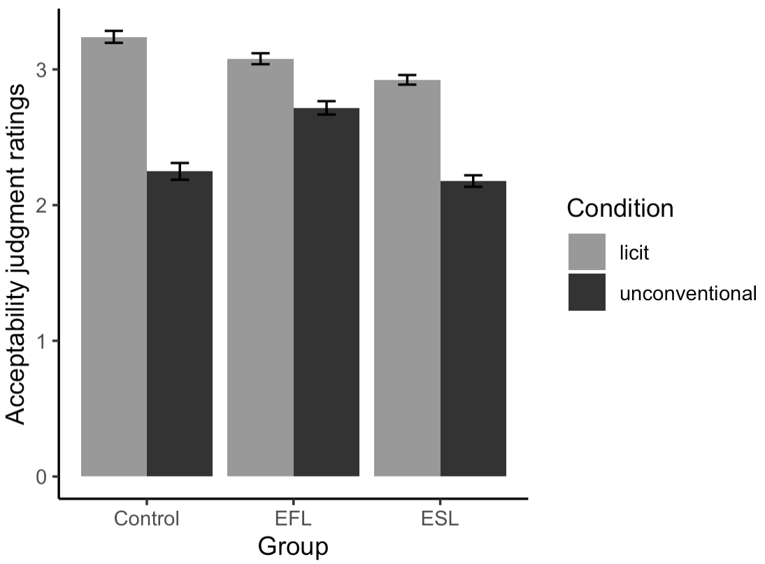
Group | Condition | Mean | SD
Control | licit | 3.24 | 0.73
 | unconventional | 2.25 | 0.93
EFL | licit | 3.08 | 0.81
 | unconventional | 2.72 | 0.90
ESL | licit | 2.92 | 0.94
 | unconventional | 2.18 | 1.02

(2) Results of cumulative link mixed-effects regression combining all three groups
Model formula: Judgment ~ condition*group + (1+condition|participant) + (1+group|item)
Factor | ß | SE | p
Group (ESL vs. Control) | 0.350 | 0.367 | .341
Group (ESL vs. EFL) | –0.777 | 0.252 | .002**
Condition | –2.028 | 0.371 | < .001***
Group (ESL vs. Control) × Condition | 1.824 | 0.496 | < .001***
Group (ESL vs. EFL) × Condition | –0.270 | 0.333 | .419
***: p < .001; **: p < .01

(3) Results of cumulative link mixed-effects regression conducted for each group
Model formula: Judgment ~ condition + (1+condition|participant) + (1|item)
Group | Factor | ß | SE | p
Control | Condition | –3.098 | 0.547 | < .001***
EFL | Condition | –1.060 | 0.377 | .005**
ESL | Condition | –2.090 | 0.438 | < .001***
***: p < .001; **: p < .01

Appendix D.
Results of acceptability judgments testing the modulating effects of Group (EFL, ESL), Conventionality (Conventional, Unconventional), and Proficiency (LexTALE scores) on L2 learners’ judgment patterns.

Model formula: Judgment ~ condition*group*proficiency + (1+condition|participant) + (1+group*proficiency|item)
Factor | ß | SE | p
Group | –0.623 | 0.325 | .055
Condition | –3.540 | 0.275 | < .001***
Proficiency | 0.003 | 0.012 | .827
Group × Condition | –1.176 | 0.519 | .023*
Group × Proficiency | –0.014 | 0.024 | .560
Condition × Proficiency | –0.081 | 0.020 | < .001***
Group × Condition × Proficiency | –0.063 | 0.040 | .112
***: p < .001; *: p < .05

