Supplementary material for: If long-term suppression is not possible, how do we minimize mortality for infectious disease outbreaks?

# 1 Authors

Andreas Handel , Department of Epidemiology and Biostatistics, The University of Georgia, Athens, GA, USA, <http://orcid.org/0000-0002-4622-1146>

Joel C. Miller, School of Engineering and Mathematical Sciences, La Trobe University, Bundoora, VIC, Australia, <https://orcid.org/0000-0003-4426-0405>

Yang Ge, School of Health Professions, The University of Southern Mississippi, Hattiesburg, MS, USA, <https://orcid.org/0000-0001-5100-0703>

Isaac Chun-Hai Fung , Department of Biostatistics, Epidemiology, and Environmental Health Sciences, Jiann-Ping Hsu College of Public Health, Georgia Southern University, Statesboro, GA, USA, <https://orcid.org/0000-0001-5496-2529>

Corresponding authors: ,

# 2 Overview

This document describes the technical details of the model.

Also, part of the supplement are 3 R scripts which allow an interested reader to explore our model and fully reproduce the figures shown in the manuscript.

A version of the model is also freely available in the DSAIDE R package (1). By using this package, the user can access and explore the model through a graphical interface. The simulation is called *Control of different populations*. For more on the DSAIDE package, including how to install it and how to access an online version that does not require installing R and only needs a browser, see this website: <https://ahgroup.github.io/DSAIDE/>

# 3 The model

We use a simple simulation model (a compartmental SIR-type model). The model tracks individuals who are uninfected and susceptible, , individuals who are infected and infectious, , recovered, and dead, individuals. Individuals are divided into 3 populations, namely children, adults and elderly (). Thus, our model with 3 age groups and 4 compartments per age group leads to a 12-compartment differential equation model. The model is implemented as a set of ordinary differential equations, which are given by

The main text shows a schematic drawing of the model, figure 3.1 shows another model schematic that more directly indicates how different model components map to the equations and interact with each other.

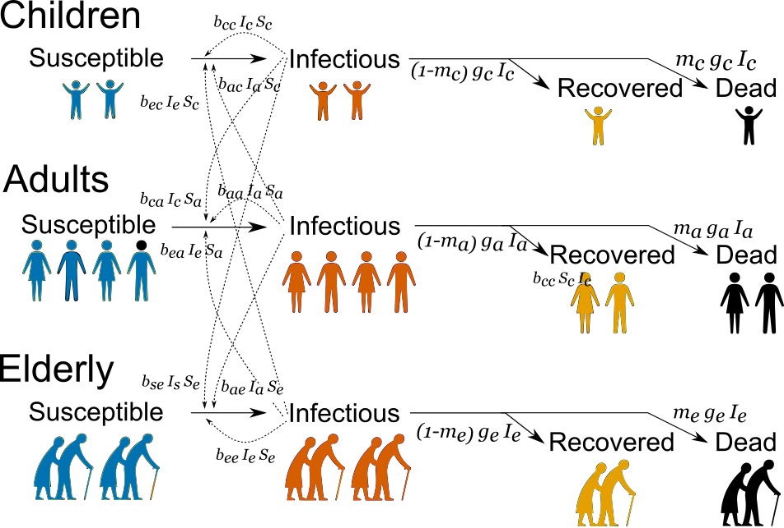

Figure 3.1: Schematic of model.

# 4 Model Parameters

The following table provides values and sources for all parameter values used in the model. The overall model results do not depend on the exact model settings.

|  |  |  |  |
| --- | --- | --- | --- |
| Parameter | Meaning | Value | Notes |
|  | total population size |  | adjusting this number only scales the model and does not affect results |
|  | Population size of children |  | in line with many European countries |
|  | Population size of adults |  | in line with many European countries |
|  | Population size of elderly |  | in line with many European countries |
|  | Fraction dying among children | 0.001 | (2,3) |
|  | Fraction dying among adults | 0.01 | (2,3) |
|  | Fraction dying among elderly | 0.1 | (2,3) |
|  | Recover rate of children | 0.1 / day | (4) |
|  | Recover rate of adults | 0.1 / day | (4) |
|  | Recover rate of elderly | 0.1 / day | (4) |
|  | Basic reproductive number | 2 | (5) |
|  | relative transmission coefficient from children to children | 1 | approximating results in (6–8) |
|  | relative transmission coefficient from adults to children |  | see above |
|  | relative transmission coefficient from elderly to children |  | see above |
|  | relative transmission coefficient from children to adults |  | see above |
|  | relative transmission coefficient from adults to adults | 1 | see above |
|  | relative transmission coefficient from elderly to adults |  | see above |
|  | relative transmission coefficient from children to elderly |  | see above |
|  | relative transmission coefficient from adults to elderly |  | see above |
|  | relative transmission coefficient from elderly to elderly | 0.75 | see above |
|  | scaling factor to adjust relative transmission rates to achieve desired | 3E-7 | see description below |

# 5 Reproductive number

The size of an outbreak is largely determined by the reproductive number. The reproductive number is the average new infectious infections generated by one infectious individual. If this number is larger than 1, the outbreak grows, if it is less than 1, the outbreak declines. Intervention measures try to reduce the reproductive number, ideally as close to 0 as possible, though this is often not feasible. Any reduction will lead to a reduction in the outbreak size.

To ensure we implement control strategies that are comparable in overall strength while targeting different age groups, we can compute the reproductive number for our model, both in the absence and presence of control. One can compute the reproductive number for compartmental models using a next generation matrix approach (10). One starts by specifying transmission and transition matrices (9). For our model in the presence of control measures, these matrices are:

and

The reproductive number, , is then given by the largest eigenvalue of the matrix , which can be computed easily numerically. We use this equation to determine the value of such that we achieve the desired of 2 in the absence of control. Similarly, we use this equation to adjust the adult interventions strength for different scenarios such that the effective reproductive numbers for scenarios 3-5 are comparable.

# 6 Modeling Interventions

To model some type of – unspecified – non-pharmaceutical intervention, we reduce the rates at which individuals in any one of the age groups get infected. This is done by reducing the infection rates by some factor, e.g. targeting children would lead to , and . The superscript indicates the transmission rates reduced by intervention, and the intervention strength is given by , which can vary from 0 (no intervention) to 1 (perfect intervention). In the model, interventions can be applied to each group independently at strengths , and targeting children, adults and elderly respectively. Each intervention is started at some time after the outbreak has started, and is ended at some later time .

For the simulations shown in the main text, scenario 1 has not control. For scenario 2, with strong control applied to all groups, we have and . This leads to an effective reproductive number of around 0.18. For scenario 3, we have maximum control applied to children () and no control applied to elderly (). For scenario 5, the inverse applies. For scenario 4, control is only applied to adults (, ). For each scenario, there is some control applied to adults to get comparable effective reproductive numbers across the 3 scenarios. We chose a scenario where the effective reproductive number was approximately for each scenario while the intervention is applied. This can be achieved by setting to 0.339 and 0.318 for scenarios 3 and 5 respectively.

# 7 Years of life lost (YLL)

To illustrate the impact of considering years of life lost instead of mortality, we assume that the average life-expectancy in the population is 80 years, and that the average ages of death for children, adults and elderly are 10, 40 and 70 years respectively. That means that every death among children contributes to 70 years of life lost (YLL), for adults this is 40 YLL and 10 YLL for elderly.

# References

1. Dynamical Systems Approach to Infectious Disease Epidemiology (Ecology/Evolution). https://ahgroup.github.io/DSAIDE/;

2. Mizumoto K, Chowell G. Estimating risk for death from 2019 novel coronavirus disease, China, January-February 2020. Emerging Infectious Diseases. 2020 Jun; 26(6):1251-1256.

3. Verity R, Okell LC, Dorigatti I, Winskill P, Whittaker C, Imai N, et al. Estimates of the severity of coronavirus disease 2019: A model-based analysis. The Lancet Infectious Diseases. 2020 Jun;20(6):669–77.

4. Wölfel R, Corman VM, Guggemos W, Seilmaier M, Zange S, Müller MA, et al. Virological assessment of hospitalized patients with COVID-2019. Nature. 2020 May;581(7809):465–9.

5. Li Q, Guan X, Wu P, Wang X, Zhou L, Tong Y, et al. Early transmission dynamics in wuhan, china, of novel coronavirus-infected pneumonia. The New England journal of medicine. 2020 Mar 26; 382(13):1199-1207.

6. Mossong J, Hens N, Jit M, Beutels P, Auranen K, Mikolajczyk R, et al. Social contacts and mixing patterns relevant to the spread of infectious diseases. PLoS medicine. 2008 Mar;5(3):e74.

7. Klepac P, Kucharski AJ, Conlan AJ, Kissler S, Tang M, Fry H, et al. Contacts in context: Large-scale setting-specific social mixing matrices from the BBC Pandemic project. medRxiv. 2020; doi: https://doi.org/10.1101/2020.02.16.20023754

8. Steele MK, Remais JV, Gambhir M, Glasser JW, Handel A, Parashar UD, et al. Targeting pediatric versus elderly populations for norovirus vaccines: A model-based analysis of mass vaccination options. Epidemics. 2016 Dec;17:42–9.

9. Diekmann O, Heesterbeek JAP, Roberts MG. The construction of next-generation matrices for compartmental epidemic models. Journal of the Royal Society Interface. 2010 Jun;7(47):873–85.

10. van den Driessche P, Watmough J. Reproduction numbers and sub-threshold endemic equilibria for compartmental models of disease transmission. Mathematical Biosciences. 2002 Dec;180:29–48.