Supplemental Table S1a. Number of subjects who had microbiome samples available, by assessment
 | Microbiome samples from Day 14 | Microbiome samples from Day 30 | Microbiome samples from Day 180
Emotional responsivity | 18 | 19
Visual orientation | 18 | 19
Motor maturity | 18 | 19
Reward association |  |  | 18
Cognitive flexibility |  |  | 15
Impulsivity |  |  | 20

Supplementary Table S1b. Availability of fecal swabs and neuro-/cognitive development measures by subject (n=33)¹
Subject ID | Day 14 / emotional responsivity measure | Day 14/visual orientation measure | Day 14/motor maturity measure | Day 30 / emotional responsivity measure | Day 30 / visual orientation measure | Day 30 / motor maturity measure | Day 180 / reward association measure | Day 180 / cognitive flexibility measure | Day 180 / impulsivity measure
ZP01 | NA | NA | NA | X | X | X | X | NA | X
ZP02 | X | X | X | X | X | X | X | X | X
ZP03 | X | X | X | NA | NA | NA | X | X | X
ZP04 | X | X | X | X | X | X | NA | NA | NA
ZP05 | X | X | X | X | X | X | NA | NA | NA
ZP06 | X | X | X | X | X | X | NA | NA | NA
ZP07 | X | X | X | X | X | X | X | X | X
ZP08 | X | X | X | X | X | X | NA | NA | NA
ZP09 | X | X | X | X | X | X | NA | NA | NA
ZP11 | X | X | X | X | X | X | NA | NA | NA
ZP12 | X | X | X | X | X | X | NA | NA | NA
ZP13 | X | X | X | X | X | X | NA | NA | NA
ZP14 | X | X | X | X | X | X | NA | NA | X
ZP15 | X | X | X | X | X | X | NA | NA | NA
ZP16 | X | X | X | X | X | X | NA | NA | NA
ZP17 | X | X | X | X | X | X | NA | NA | NA
ZP18 | X | X | X | NA | NA | NA | NA | NA | NA
ZP19 | X | X | X | X | X | X | X | X | X
ZP20 | X | X | X | X | X | X | X | NA | X
ZP21 | NA | NA | NA | X | X | X | X | NA | X
ZP22 | NA | NA | NA | X | X | X | NA | NA | NA
ZN02 | NA | NA | NA | NA | NA | NA | NA | NA | X
ZN04 | NA | NA | NA | NA | NA | NA | X | X | X
ZN07 | NA | NA | NA | NA | NA | NA | X | X | X
ZN32 | NA | NA | NA | NA | NA | NA | X | X | X
ZN36 | NA | NA | NA | NA | NA | NA | X | X | X
ZN37 | NA | NA | NA | NA | NA | NA | X | X | X
ZN39 | NA | NA | NA | NA | NA | NA | X | X | X
ZN41 | NA | NA | NA | NA | NA | NA | X | X | X
ZN42 | NA | NA | NA | NA | NA | NA | X | X | X
ZN43 | NA | NA | NA | NA | NA | NA | X | X | X
ZN44 | NA | NA | NA | NA | NA | NA | X | X | X
ZN45 | NA | NA | NA | NA | NA | NA | X | X | X
Total Available | 18 | 18 | 18 | 19 | 19 | 19 | 18 | 15 | 20
- X = data available; NA = data not available

Supplemental Tables S2a-c. Coabundance factor loadings for the top 10 most abundant gut microbes, by age group
Genus | Factor 1 | Factor 2 | Factor 3
Table 2A. Day 14
Catenibacterium | 0.90
Lactobacillus | 0.74 | 0.44
Eubacterium | -0.72
Roseburia | -0.67 | 0.63
Faecalibacterium | -0.6 |  | 0.52
Bifidobacterium |  | -0.92
Blautia | -0.33 | 0.89
[Prevotella] | 0.31 | 0.67
Prevotella |  |  | -0.85
Collinsella | 0.36 |  | 0.79
% variance explained | 40% | 36% | 24%
Table 2B. Day 30
[Prevotella] | 0.90
Lactobacillus | 0.75 | -0.31
Faecalibacterium | -0.70 | 0.51 | -0.30
Bifidobacterium | -0.64 | -0.45 | -0.49
Prevotella | 0.41
Catenibacterium |  | -0.84
Eubacterium |  | 0.80
Blautia | 0.39 | 0.67
Collinsella |  |  | 0.74
Ruminococcus |  |  | 0.60
% variance explained | 41% | 37% | 22%
Table 2C. Day 180
Bifidobacterium |  | -0.87
Catenibacterium |  | 0.60
Ruminococcus | -0.64 |  | 0.53
Faecalibacterium |  |  | 0.59
S24-7_unclassified |  | 0.79 | -0.36
Oscillospira |  |  | -0.69
Roseburia | 0.80
Prevotella | -0.56 | -0.33 | -0.44
Lactobacillus |  |  | -0.64
Blautia | 0.88 |  | -0.63
% variance explained | 36% | 32% | 32%
1. Loadings < 0.30 are not shown 2. [Prevotella] refers to Prevotella of Paraprevotellaceae family.

Supplemental Tables S3a-b. AIC model selection of multiple linear regression models comparing the predictive power of the gut microbiome (Co-Abundance Factors, Shannon diversity) and rearing environment-driven models

Supplemental Table S3a. AIC model selection of multiple linear regression models: Co-abundance factors and rearing environment-driven models
 | AICc | Delta_AICc | AICcWt | Log Likelihood
Emotional responsivity, Day 14, Factor 1
Rearing | 71.47 | 0.00 | 0.89 | -28.24
Rearing & Microbiome | 75.73 | 4.25 | 0.11 | -28.05
Microbiome | 81.97 | 10.50 | 0.00 | -33.49
Emotional responsivity, Day 14, Factor 2
Rearing | 71.47 | 0.00 | 0.87 | -28.24
Rearing & Microbiome | 75.65 | 4.18 | 0.11 | -28.01
Microbiome | 78.36 | 6.88 | 0.03 | -31.68
Emotional responsivity, Day 14, Factor 3
Rearing | 71.47 | 0.00 | 0.63 | -28.24
Rearing & Microbiome | 72.64 | 1.16 | 0.35 | -26.50
Microbiome | 79.27 | 7.80 | 0.01 | -32.13
Visual orientation, Day 14, Factor 1
Rearing | 96.21 | 0.00 | 0.85 | -40.61
Rearing & Microbiome | 100.53 | 4.31 | 0.10 | -40.44
Microbiome | 101.98 | 5.77 | 0.05 | -43.49
Visual orientation, Day 14, Factor 2
Rearing | 96.21 | 0.00 | 0.75 | -40.61
Microbiome | 99.28 | 3.06 | 0.16 | -42.14
Rearing & Microbiome | 100.43 | 4.22 | 0.09 | -40.40
Visual orientation, Day 14, Factor 3
Rearing | 96.21 | 0.00 | 0.85 | -40.61
Rearing & Microbiome | 100.66 | 4.44 | 0.09 | -40.51
Microbiome | 101.67 | 5.45 | 0.06 | -43.33
Motor maturity, Day 14, Factor 1
Rearing | 33.85 | 0.00 | 0.78 | -9.43
Rearing & Microbiome | 37.60 | 3.75 | 0.12 | -8.98
Microbiome | 37.87 | 4.02 | 0.10 | -11.43
Motor maturity, Day 14, Factor 2
Rearing | 33.85 | 0.00 | 0.50 | -9.43
Microbiome | 34.23 | 0.38 | 0.41 | -9.62
Rearing & Microbiome | 37.25 | 3.40 | 0.09 | -8.81
Motor maturity, Day 14, Factor 3
Rearing | 33.85 | 0.00 | 0.71 | -9.43
Rearing & Microbiome | 36.92 | 3.07 | 0.15 | -8.64
Microbiome | 37.17 | 3.32 | 0.14 | -11.09
Emotional responsivity, Day 30, Factor 1
Rearing & Microbiome | 71.54 | 0.00 | 0.68 | -26.27
Rearing | 73.03 | 1.49 | 0.32 | -29.21
Microbiome | 83.44 | 11.90 | 0.00 | -34.41
Emotional responsivity, Day 30, Factor 2
Rearing | 73.03 | 0.00 | 0.76 | -29.21
Rearing & Microbiome | 75.37 | 2.34 | 0.24 | -28.19
Microbiome | 83.17 | 10.14 | 0.00 | -34.28
Emotional responsivity, Day 30, Factor 3
Rearing | 73.03 | 0.00 | 0.72 | -29.21
Rearing & Microbiome | 75.05 | 2.01 | 0.26 | -28.02
Microbiome | 81.00 | 7.96 | 0.01 | -33.19
Visual orientation, Day 30, Factor 1
Rearing | 97.14 | 0.00 | 0.66 | -41.26
Microbiome | 99.01 | 1.87 | 0.26 | -42.20
Rearing & Microbiome | 101.44 | 4.30 | 0.08 | -41.22
Visual orientation, Day 30, Factor 2
Rearing | 97.14 | 0.00 | 0.76 | -41.26
Rearing & Microbiome | 100.69 | 3.55 | 0.13 | -40.84
Microbiome | 100.99 | 3.86 | 0.11 | -43.19
Visual orientation, Day 30, Factor 3
Rearing | 97.14 | 0.00 | 0.77 | -41.26
Rearing & Microbiome | 100.61 | 3.48 | 0.13 | -40.81
Microbiome | 101.26 | 4.11 | 0.10 | -43.32
Motor maturity, Day 30, Factor 1
Microbiome | 35.96 | 0.00 | 0.47 | -10.67
Rearing | 36.07 | 0.12 | 0.44 | -10.73
Rearing & Microbiome | 39.42 | 3.46 | 0.08 | -10.21
Motor maturity, Day 30, Factor 2
Rearing | 36.07 | 0.00 | 0.46 | -10.73
Rearing & Microbiome | 37.02 | 0.94 | 0.29 | -9.01
Microbiome | 37.25 | 1.18 | 0.25 | -11.32
Motor maturity, Day 30, Factor 3
Rearing | 36.07 | 0.00 | 0.80 | -10.73
Rearing & Microbiome | 40.16 | 4.09 | 0.10 | -10.58
Microbiome | 40.38 | 4.31 | 0.09 | -12.88
Reward association, Day 180, Factor 1
Microbiome | 129.98 | 0.00 | 0.78 | -57.49
Rearing | 133.35 | 3.38 | 0.14 | -59.18
Rearing & Microbiome | 134.50 | 4.53 | 0.08 | -57.43
Reward association, Day 180, Factor 2
Microbiome | 133.06 | 0.00 | 0.51 | -59.03
Rearing | 133.35 | 0.29 | 0.44 | -59.18
Rearing & Microbiome | 137.62 | 4.56 | 0.05 | -58.99
Reward association, Day 180, Factor 3
Microbiome | 131.21 | 0.00 | 0.69 | -58.10
Rearing | 133.35 | 2.14 | 0.24 | -59.18
Rearing & Microbiome | 135.57 | 4.36 | 0.08 | -57.97
Cognitive flexibility, Day 180, Factor 1
Microbiome | 112.88 | 0.00 | 0.70 | -48.11
Rearing | 114.82 | 1.94 | 0.26 | -49.08
Rearing & Microbiome | 118.66 | 5.78 | 0.04 | -48.08
Cognitive flexibility, Day 180, Factor 2
Microbiome | 113.15 | 0.00 | 0.66 | -48.24
Rearing | 114.82 | 1.67 | 0.29 | -49.08
Rearing & Microbiome | 118.02 | 4.87 | 0.06 | -47.76
Cognitive flexibility, Day 180, Factor 3
Microbiome | 111.18 | 0.00 | 0.81 | -47.26
Rearing | 114.82 | 3.64 | 0.13 | -49.08
Rearing & Microbiome | 116.31 | 5.14 | 0.06 | -46.91
Impulsivity (composite), Day 180, Factor 1
Microbiome | 95.08 | 0.00 | 0.50 | -40.40
Rearing | 95.33 | 0.25 | 0.44 | -40.52
Rearing & Microbiome | 99.17 | 4.09 | 0.06 | -40.36
Impulsivity (composite), Day 180, Factor 2
Microbiome | 95.24 | 0.00 | 0.48 | -40.48
Rearing | 95.33 | 0.09 | 0.46 | -40.52
Rearing & Microbiome | 99.31 | 4.07 | 0.06 | -40.43
Impulsivity (composite), Day 180, Factor 3
Microbiome | 94.95 | 0.00 | 0.51 | -40.33
Rearing | 95.33 | 0.38 | 0.42 | -40.52
Rearing & Microbiome | 99.05 | 4.10 | 0.07 | -40.29

Supplemental Table S3b. AIC model selection of multiple linear regression models: Shannon diversity and rearing environment-driven models
 | AICc | Delta_AICc | AICcWt | Log Likelihood
Emotional responsivity, Day 14
Rearing | 71.47 | 0.00 | 0.89 | -28.24
Rearing & Microbiome | 76.00 | 4.53 | 0.09 | -28.18
Microbiome | 79.79 | 8.31 | 0.01 | -32.39
Visual orientation, Day 14
Rearing | 96.21 | 0.00 | 0.81 | -40.61
Microbiome | 100.36 | 4.15 | 0.10 | -42.68
Rearing & Microbiome | 100.74 | 4.53 | 0.08 | -40.55
Motor maturity, Day 14
Rearing | 33.85 | 0.00 | 0.73 | -9.43
Microbiome | 36.46 | 2.61 | 0.20 | -10.73
Rearing & Microbiome | 38.36 | 4.51 | 0.08 | -9.36
Emotional responsivity, Day 30
Rearing & Microbiome | 70.23 | 0.00 | 0.80 | -25.61
Rearing | 73.03 | 2.80 | 0.20 | -29.21
Microbiome | 83.94 | 13.71 | 0.0 | -34.66
Visual orientation, Day 30
Rearing | 97.14 | 0.00 | 0.76 | -41.26
Rearing & Microbiome | 100.33 | 3.20 | 0.15 | -40.67
Microbiome | 101.41 | 4.28 | 0.09 | -43.40
Motor maturity, Day 30
Rearing | 36.07 | 0.00 | 0.70 | -10.73
Microbiome | 38.45 | 2.38 | 0.21 | -11.92
Rearing & Microbiome | 40.27 | 4.20 | 0.09 | -10.64
Reward association, Day 180
Microbiome | 132.55 | 0.00 | 0.56 | -58.77
Rearing | 133.35 | 0.80 | 0.37 | -59.18
Rearing & Microbiome | 136.64 | 4.09 | 0.07 | -58.50
Cognitive flexibility, Day 180
Microbiome | 114.69 | 0.00 | 0.50 | -49.01
Rearing | 114.82 | 0.13 | 0.47 | -49.08
Rearing & Microbiome | 120.42 | 5.73 | 0.03 | -48.96
Impulsivity (composite), Day 180
Microbiome | 94.69 | 0.00 | 0.54 | -40.20
Rearing | 95.33 | 0.39 | 0.39 | -40.52
Rearing & Microbiome | 98.86 | 0.07 | 0.07 | -40.20

Supplemental Table S4. Multiple linear regression models predicting average % correct responses on ODR (proxy of impulsivity)
Microbiome co-abundance factors predicting average % correct responses on ODR
 | β (95% CI) | p
Factor 1 | -0.24 (-2.56-2.07) | 0.82
Factor 2 | -0.003 (-2.13-2.13) | 0.99
Factor 3 | -0.88 (-2.94-1.19) | 0.38
Infant sex (female) | 0.02 (-4.01-4.04) | 0.93
Growth rate (g/Day) | -1.68 (-1.85-0.87) | 0.45
Rearing environment (NR) | 5.97 (1.28-10.64) | 0.02
Shannon diversity predicting average % correct responses on ODR
 | β (95% CI) | p
Shannon diversity | -1.93 (-5.74-1.88) | 0.30
Infant sex (female) | -0.27 (-3.89-3.35) | 0.88
Growth rate (g/Day) | -0.36 (-1.69-0.98) | 0.58
Rearing environment (NR) | 5.02 (0.09-9.94) | 0.05

Supplemental Table S5. AIC model selection of multiple linear regression models predicting average % correct responses on ODR
Impulsivity, Day 180, Factor 1
Rearing | 119.20 | 0.00 | 0.87 | -52.46
Rearing & Microbiome | 123.31 | 4.11 | 0.11 | -52.43
Microbiome | 127.10 | 7.89 | 0.02 | -56.40
Impulsivity, Day 180, Factor 2
Rearing | 119.20 | 0.00 | 0.87 | -52.46
Rearing & Microbiome | 123.38 | 4.18 | 0.11 | -52.46
Microbiome | 127.11 | 7.91 | 0.02 | -56.41
Impulsivity, Day 180, Factor 3
Rearing | 119.20 | 0.00 | 0.81 | -52.46
Rearing & Microbiome | 122.31 | 3.11 | 0.17 | -51.93
Microbiome | 126.33 | 7.12 | 0.02 | -56.02
Impulsivity, Day 180, Shannon diversity
Rearing | 119.20 | 0.00 | 0.71 | -52.46
Rearing & Microbiome | 121.89 | 2.68 | 0.19 | -51.71
Microbiome | 123.18 | 3.97 | 0.10 | -54.45

Supplemental Table S6. Neurodevelopmental/cognitive development measures and Shannon diversity across surrogate-reared and peer-reared infants (Mann-Whitney U Tests)
 | Cliff’s Delta | p
Day 14
Emotional responsivity | 0.14 | 0.77
Visual Orientation | -0.64 | 0.11
Motor Maturity | -0.29 | 0.49
Shannon diversity | 0.29 | 0.53
Day 30
Emotional responsivity | 0.19
Visual Orientation | -1.0 | 0.02
Motor Maturity | -0.33 | 0.47
Shannon diversity | -0.24 | 0.67
Day 180
Reward association | -0.20 | 0.64
Cognitive flexibility | 0.77 | 0.03
Impulsivity (composite) | 0.03 | 1.0
Shannon diversity | -0.43 | 0.27

Supplemental Figures S1a-c. Alpha diversity (Shannon diversity index) by rearing environment and infant age
Caption: Mann-Whitney U Test:
1a. Cliff's Delta: 0.79, p-value < 0.01; 1b. Cliff’s Delta: 0.60, p-value = 0.02; 1c. Cliff’s Delta: 0.29, p-value = 0.30
1b.
1a.
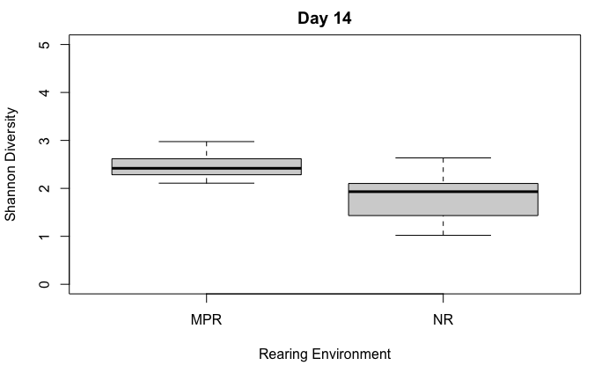
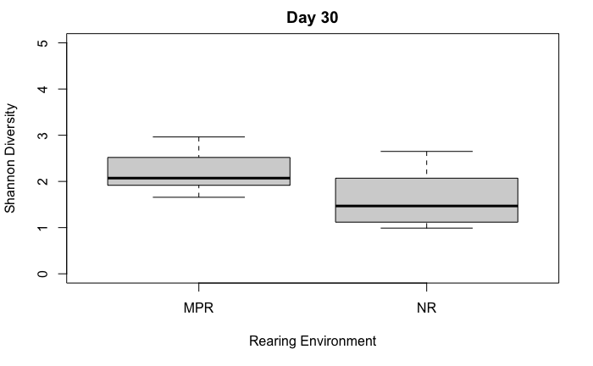

1c.
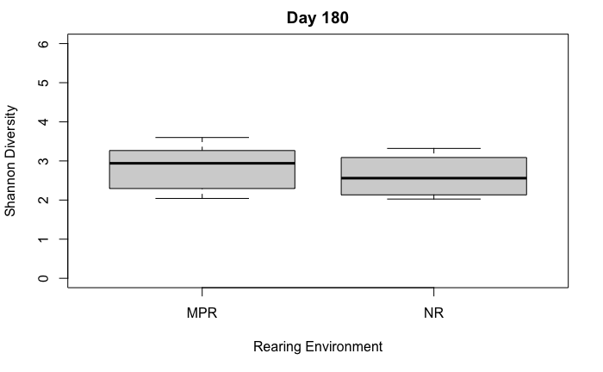

Supplemental Figures S2a-i. Microbiome co-abundance factors by rearing environment and infant age
Supplemental Figures S2a-c. Microbiome co-abundance factors by rearing environment at Day 14
Caption: 2a. Co-abundance factor 1 (high Catenbacterium and Lactobacillus): Cliff’s Delta = 0.69, p-value = 0.01; 2b. Co-abundance factor 2 (low Bifidobacterium and high Blautia): Cliff's Delta = 0.58, p-value = 0.04; 2c. Co-abundance factor 3 (low Prevotella): Cliff's Delta: 0.06, p-value = 0.86.
2b.
2a.
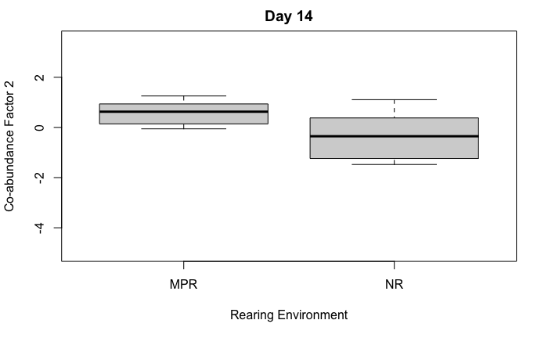
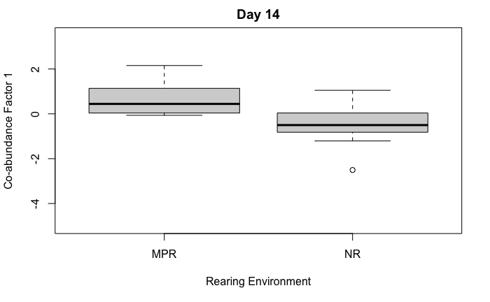

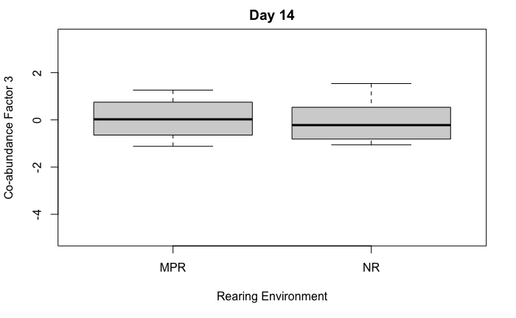
2c.

Supplemental Figures S2d-f. Microbiome co-abundance factors by rearing environment at Day 30
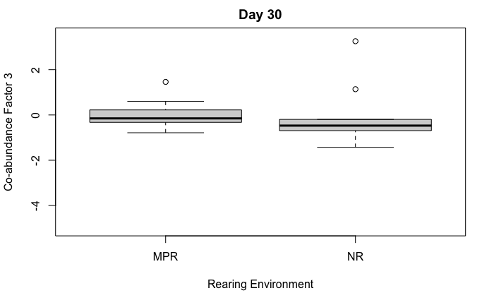
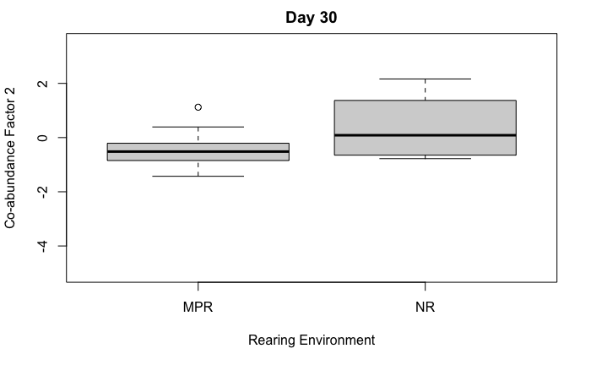
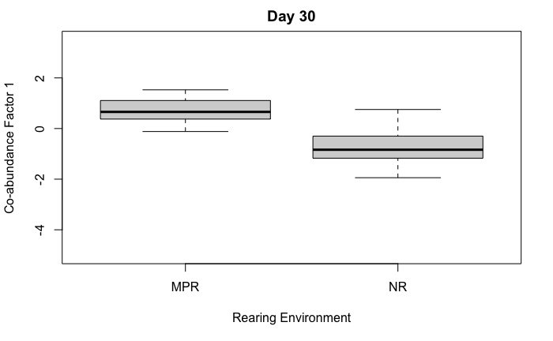
Caption: 2d. Co-abundance Factor 1 (high Prevotella [Paraprevotellaceae family] and Lactobacillus, and low Faecalibacterium): Cliff's Delta = 0.80, p-value < 0.01; 2e. Co-abundance Factor 2 (high Eubacterium, Blautia and low Catenibacterium): Cliff's Delta: -0.38, p-value = 0.09; 2f. Co-abundance Factor 3 (high Collinsella, Ruminococcus, and low Bifidobacterium) Delta: 0.56, p-value = 0.24
2f.
2e.
2d.
S2g-i. Microbiome co-abundance factors by rearing environment at Day 180
Caption: 2g. Co-abundance Factor 1 (high Roseburia, Blautia, and low Ruminococcus and Prevotella): Cliff's Delta = -0.19, p-value = 0.20; 2h. Co-abundance Factor 2 (low abundance of Bifidobacterium and of an unclassified genus): Cliff's Delta = 0.00, p-value = 1.00; 2i. Co-abundance Factor 3 (high Prevotella and low Lactobacillus): Cliff's Delta = -0.22, p-value = 0.18
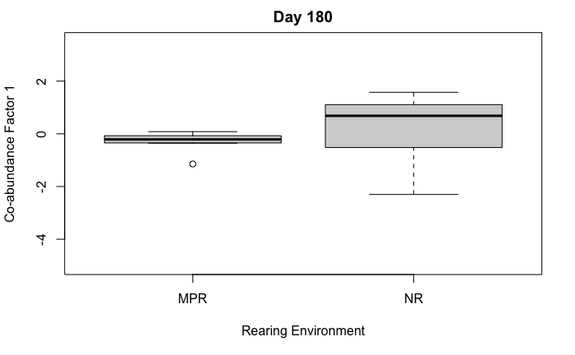
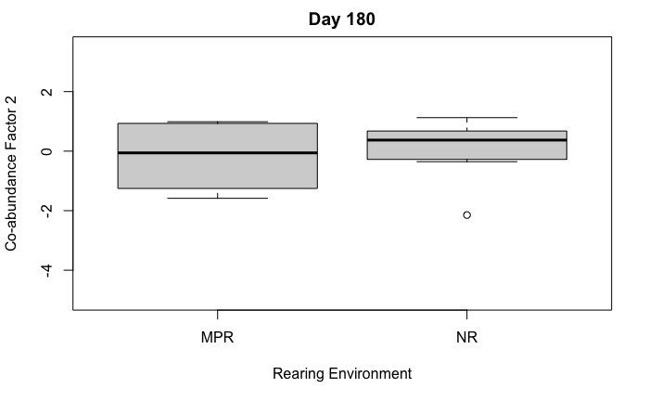
2h.
2g.

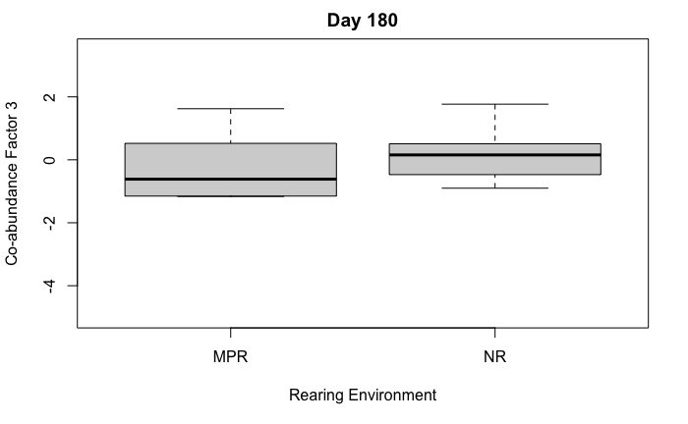
2i.

