Supplementary Materials
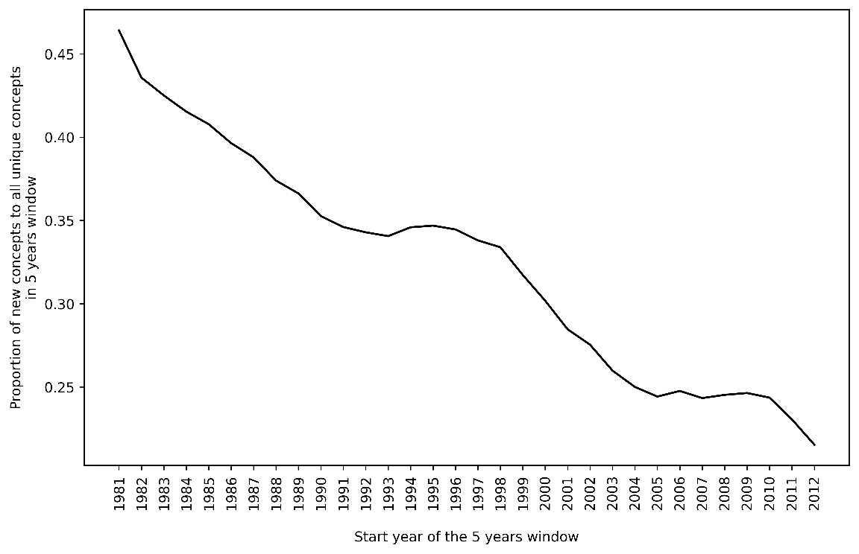
Fig. S1. The proportion of new concepts to all unique concepts in moving 5 years.

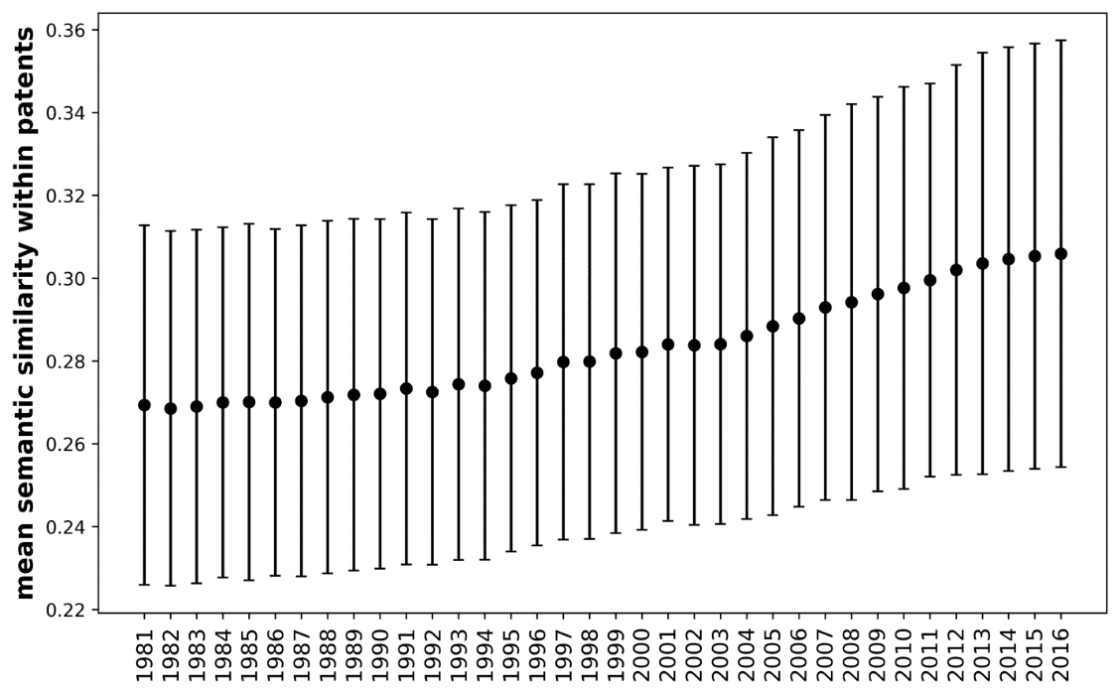
Fig. S2. Mean semantic similarity within 10,000 randomly chosen patents. We randomly chose 10,000 patents every year, calculated the pairwise semantic similarity between the unique terms within each patent title and abstracts, and took the mean of the distribution for each patent.
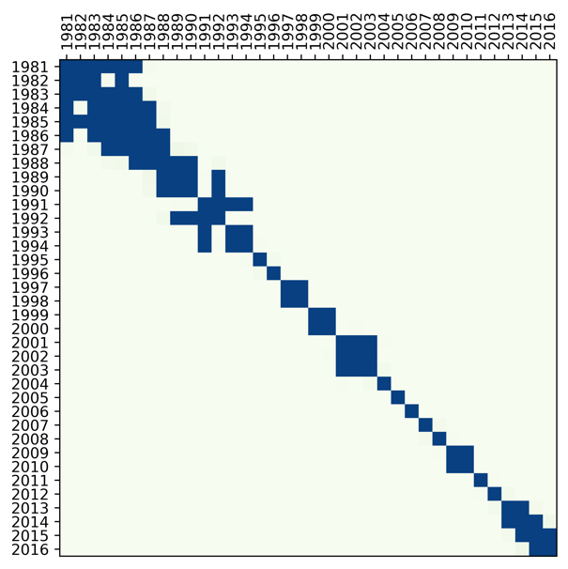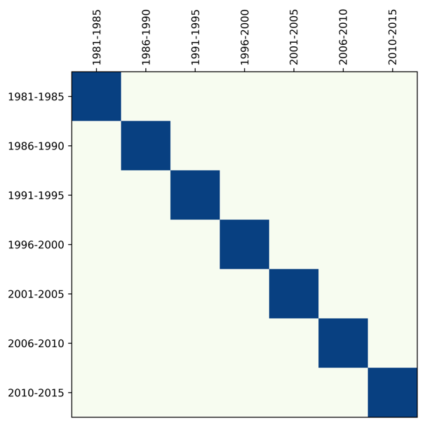
- Yearly bin B) Bins of 5 years
Fig. S3. Kolmogorow-Smirnov tests of the null hypothesis that two samples are drawn from the same distribution for mean semantic similarity distributions over time. The dark cells indicate that the distributions are not significantly different so that we cannot reject the null hypothesis. Plot A) shows that the difference is significant for years that have long periods of time in between, although several pairs of consecutive years seem to have similar distributions. Plot B) shows that the differences are significant across 5-year periods.
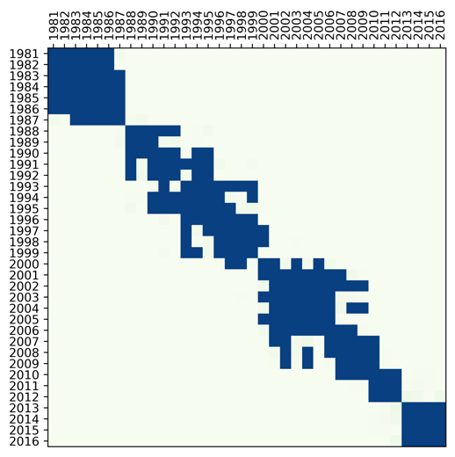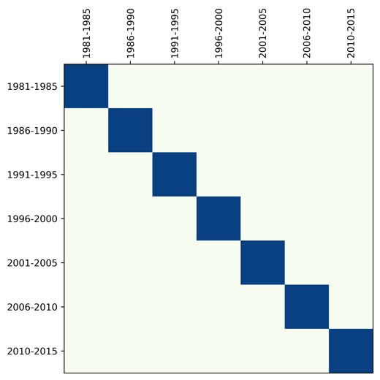
- Yearly bin B) Bins of 5 years
Fig. S4. Kolmogorow-Smirnov tests of the null hypothesis that two samples are drawn from the same distribution for delta information content distributions over time. The dark cells indicate that the distributions are not significantly different so that we cannot reject the null hypothesis. Plot A) shows that the difference is significant for years that have long periods of time in between, although several pairs of consecutive years seem to have similar distributions. Plot B) shows that the differences are significant across 5-year periods.

