SUPPLEMENTARY MATERIALS
Supplementary Figure 1. Brief Description of the 10 Research Studies Utilizing MyChart Recruitment
Research Study | Study Type | Main Criteria | Criteria Complexity | ~# of Invites Sent
1 | Observational | HI 50-75 y/o | Simple | 5600
2 |  | NMNC |  | 2700
3 |  | Females ≥ 45 y/o with coronary artery disease | Moderate | 1700
4 |  | Postpartum and RSV vaccinated |  | 1700
5 |  | NMNC |  | 700
6 | Interventional | Peripheral Artery Disease and on statins | Complex | 2000
7 |  | Coronary Artery Disease with a bypass procedure, and see explicit providers |  | 2600
8 |  | Long Covid Diagnosis | Moderate | 750
9 |  | Black individuals ≤ 65 y/o with PTSD |  | 2600
10 |  | HI not on statins |  | 1000
Note: HI = Healthy Individuals with no major conditions; NMNC = no major neurological conditions

Supplementary Figure 2. Demographics of Individuals in Healthcare System and Those Further Identified for Research
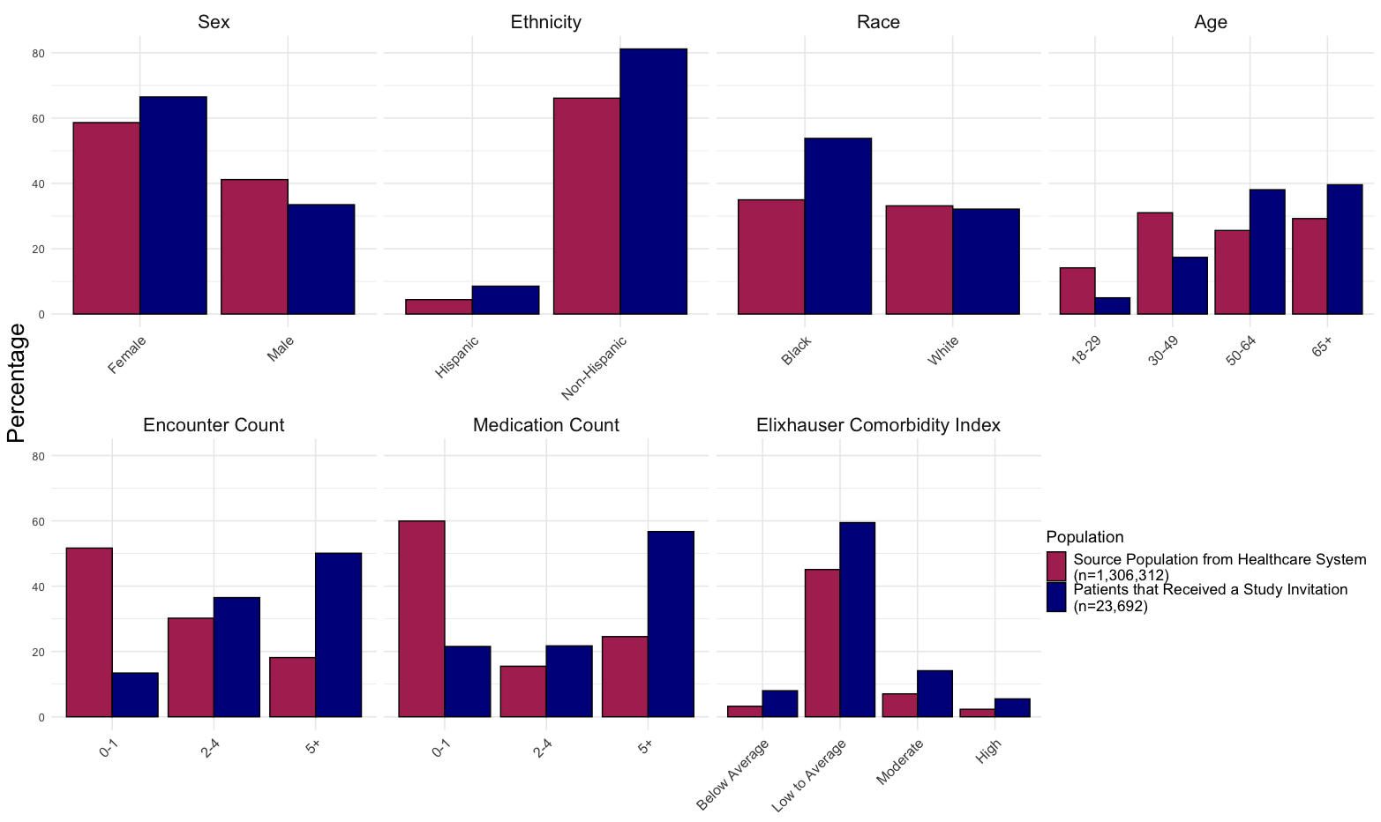Note: All individuals identified for research come from the healthcare system. Sex, ethnicity, and race demographics have missing data, especially in the healthcare system population. Percentages represent the proportion of individuals in the demographic group out of the total number of individuals in the population (healthcare system or those who were identified to be potentially eligible for a research study and were then sent a research invitation

