**9. Supplementary Material**

## 9.1. Literature Review

This literature review explores existing research to understand compliance theories, identify their limitations, and inform the theoretical framework of this study. Etienne (2010) defines compliance as the "acquiescence to expectations that can take a range of forms: rules, standards, proposals, entreaties, orders, [and] suggestions." Most notably, Kagan and Scholz (1980) present three basic typologies of compliance: 1) The amoral calculator, 2) The political citizen, and 3) The incompetent. The amoral calculator, driven by economic utility, weighs the benefits of illegal actions against their costs. Political citizens, motivated by social norms and duty, adhere to laws they perceive as morally right. Incompetent inspectees lack the capacity to recognize legal violations due to organizational ineptitude or conflicting goals within their organizations.

The essence of these three typologies is cited and discussed extensively in other research. To illustrate, Becker (1968) examines a utilitarian, economically-driven theory of inspectees’ motivation, proposing that economically driven inspectees choose illegal action over other alternatives if the economic utility of committing a crime is greater than its costs. Amoral calculators are economical, self-interested actors, driven by what May (2005) and Mitchell (2007) refer to as the *logic of consequence*. With this logic, inspectees make decisions based on explicit calculations of how the consequences of the decision will affect their interests. This typology has been widely used in later studies to model inspectees’ behavior (see examples in Stigler, 1970; Becker and Stigler, 1974; and May, 2005).

The political citizen, as described by Mitchell (2007), embodies what he terms the *logic of appropriateness*. Such inspectees are guided by internalized social norms, asking themselves, "What is the *right* thing to do in this situation for someone like me?" (Mitchell, 2007). They feel a duty to adhere to norms and may be motivated by a belief in the legitimacy of authority or by personal ethical standards (Tyler, 1990). Essentially, political citizens obey laws because they perceive them as morally upright social norms.

The incompetent typology of compliance refers to inspectees whose actions stem from a lack of capacity or competence to recognize legal violations. Van Snellenberg and Van de Peppel (2002) argue that organizational ineptitude can contribute to law violations, citing examples such as poor management, insufficient procedures, and lack of coordination. Additionally, conflicting goals across different organizational levels can create confusion and misalignment, complicating the assessment of compliance (Van Snellenberg and Van de Peppel, 2002; Bruijn et al., 2007).

The Tafel van Elf, another theoretical complicance framework by Ruimschotel (1996), further delineates inspectees’ motivations behind why they break laws (Table 7).

These behavioral theories attempt to explain how inspectees make decisions with a multitude of choices, often assuming perfect rationality. The perfect rationality model assumes a traditional, economically-driven characterization of human behavior (Beinhocker, 2006). However, this assumption overlooks aspects of real-world behavior. Firstly, it assumes that inspectees prioritize one goal, neglecting the fact that they are typically driven by multiple motivations (Alm et al., 1995; Scholz, 1997; May, 2005; Beinhocker, 2006; Marin et al., 2020). Secondly, it expects inspectees to make complex calculations based on vast amounts of data, which may not be feasible in practice (Beinhocker, 2006). Lastly, perfect rationality restricts inspectees to acting in predetermined ways, disregarding their ability to evolve over time. This oversimplification limits the breadth of real-world behavioral phenomena that can be studied, as it fails to account for unexpected and idiosyncratic behaviors. Consequently, models based solely on perfect rationality run the risk of portraying behavior unrealistically and may overlook crucial aspects of inspectees’ actual behavior.

Existing literature suggests tailored enforcement strategies for each typology of compliance. Lodge and Wegrich (2012) define enforcement as the coercion of inspected parties to comply with laws without which there is no obligation for inspectees to act in a compliant way. For amoral calculators, economic strategies such as deterrence or financial incentives are recommended to alter behavior by influencing economic utility (Becker, 1968; Burby and Paterson, 1993; Gray and Scholz, 1993; Van Snellenberg and Van de Peppel, 2002). However, studies indicate heavier fines may not necessarily lead to increased compliance and, in some cases, could even decrease it (Grasmick and Green, n.d.; Paternoster et al., 1982; Langbein and Kerwin, 1985; Tsebelis, 1990; Tsebelis, 1991; Tsebelis, 1993; Sherman, 1993). For political citizens and incompetent actors, Kagan and Scholz (1980) suggest a cooperative and educational strategy, respectively. A cooperative strategy maintains a balanced relationship of negotiation and collaboration between inspectees and inspectors, while an educational strategy aims to build the capacity of inspected parties to cultivate the processes needed for compliance (Kagan and Scholz, 1980).

***Table 7.*** *Tafel van Elf (adapted from Ministerie van Justitie, 2006).*

|  |  |  |
| --- | --- | --- |
| **MOTIVATION** | **DESCRIPTION** | **PROPOSED INTERVENTION** |
| **Spontaneous, Intrinsic Behavior** |  |  |
| 1. Knowledge of the rules | An unfamiliarity of regulations and/or a lack of clarity | Target communications and training |
|  | of regulations leads to inadvertent non-compliance. | about regulations. |
| 2. Costs and benefits | Financial and intangible costs and benefits influence | Subsize compliant actors, price regulations, |
|  | non-compliance. This includes the financial costs and benefits of compliance versus non-compliance and the intangible costs and benefits to public reputation. | certification of good conduct. |
| 3. Degree of acceptance | Individual acceptance of the reasonableness of the regulation. | Encourage self-regulation by placing responsibility for the policy’s success on the inspectees themselves. |
| 4. Adherence to standards | The degree of willingness of the inspectee to conform to the authority of the government. | Education on the policy’s purpose. |
| 5. Social control | The inspectees’ perceived probability of positive or negative sanctions and/or backlash for their behavior by other actors in their social network, such as competitors, other companies, other nongovernmental monitoring organizations, and customers. | Provide information to the social network on quality standards and how they can better identify non-compliance. |

### Enforcement-driven Behavior

|  |  |  |
| --- | --- | --- |
| 6. Perceived likelihood of being reported to the government | Perceived probability that a violation will be detection by parties other than the government who then report it to the government. | Set up click lines and improve the accessibility of inspectorates, stimulate willingness to report. |
| 7. Perceived likelihood of | Perceived probability of inspection by the government. | Publicize information about inspection |
| administrative or physical control |  | probabilities, increase inspection capacity. |
| 8. Perceived likelihood of detection | Perceived probability of detection of violation | Publicize information about the likelihood of |
|  | by the government. | discovery and increase resources to increase enforcement capacity. |
| 9. Perceived likelihood of being | Perceived probability of increasing inspections in the | Investigate those with increased risk of |
| inspected in the future | future in the event of a violation today. | violation, namely, those who have violated in the past. |
| 10. Perceived likelihood of | Perceived probability of a sanction if a violation is | Increase capacity of the Public Prosecution |
| being sanctioned | found after inspection. | Service and public administration. |
| 11. Severity of sanctions | The amount and type of sanction linked to the violation and its associated disadvantages. | Increase sanctions with more violations. |

Because of the limitations of the compliance typologies, Scholz (1984) argues for an integrative enforcement strategy which he posits yields better compliance outcomes than singular, rigid strategies like deterrence through fines or fear of detection. Consequently, numerous researchers have endeavored to meld diverse typologies into a flexible enforcement paradigm, offering regulatory agencies dynamic means of determining appropriate interventions. In the book, "Responsive Regulation: Transcending the Deregulation Debate," Ayres and Braithwaite (1992) propose a hierarchy of enforcement strategies designed to provide a flexible set of intervention strategies tailored to the nature and gravity of the offense. Called responsive regulation, this framework advocates aligning the severity of enforcement measures with the severity of the offense (Figure 28). As the behavior of the inspected party improves, the enforcement severity can diminish over time. This responsive regulatory framework laid the groundwork for subsequent studies on regulatory policy and the emergence of the theory of risk-based regulation (see Baldwin and Black, 2008; Black and Baldwin, 2010; and Lodge and Wegrich, 2012).

Responsive regulation empowers inspectors to craft targeted interventions suited to the specific offense, eschewing a one-size-fits-all approach. This approach led to various intervention strategies such as tit-for-tat, tripartism, self-regulation, and partial-industry intervention (Van der Heijden, 2020; see Table8).While some studies demonstrate that responsive regulation increases compliance (see Islam and McPhail, 2011; Christian, 2017; Zhu and Chertow, 2019), there are several criticisms of this approach.

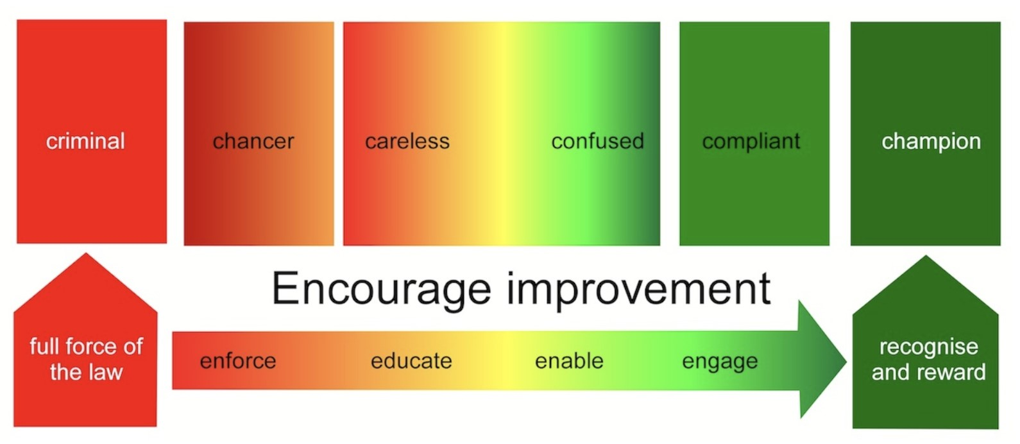

***Figure 28.*** *The responsive regulatory strategy as summarized by Braithwaite (2016) from the South Australian Environmental Protection Agency.*

*Inspectees on the left side of the spectrum should be subject to severe enforcement measures. Conversely, as one moves towards the right side of the spectrum, the enforcement strategy should transition to less coercive, reward-oriented approaches.*

***Table 8.*** *Intervention strategies of responsive regulation (adapted from Van der Heijden, 2020).*

|  |  |
| --- | --- |
| **Intervention** | **Strategy Description** |
| Tit-for-tat | The severity of the enforcement is aligned with the severity of the offense. |
| Tripartism | Empower other third-party organizations like industry corporations or citizen associations to create an environment of cooperation. |
| Self-regulation | Encourage firms to set their own regulations that are publicly approved so that enforcement of the rules can also be done publicly. |
| Partial-industry | Target specific, competitive firms for inspection, with the idea that the natural competition of the market will also impact the portion of the market that is not inspected. |

The primary critique is that responsive regulation is effective only when inspectors and inspectees engage in multiple interactions over time (Short and Toffel, 2010; Van Duin et al., 2018). Given its responsive nature, the effectiveness of enforcement strategies can only be assessed if there is adequate capacity and resources for follow-up inspections to evaluate the intervention’s impact. Additionally, if inspectors refrain from escalating enforcement after repeated offenses, overall compliance tends to suffer (Van Erp, 2011).

## 9.2. Sensitivity Analysis and Structural Validation

A global sensitivity analysis was conducted on the model using NetLogo’s BehaviorSpace and Python 3.8 to assess the influence of input parameters systematically. Sensitivity analyses help to “[identify]...important thresholds," thereby “[disciplining] the dialogue about options and make unavoidable judgments more considered" (Epstein, 2008). This analysis reveals the impact of each parameter on the model output, aiming to understand the model’s dynamics and its practical boundaries. The sensitivity analysis sheds light on the model’s complexities by combining empirical and theoretical parameters.

***Table 9.*** *Varied parameters for the model sensitivity analysis.*

|  |  |  |  |
| --- | --- | --- | --- |
| Parameter | Min Value | Max Value | Varied by |
| Initial share of compliant inspectees (%*𝑖𝑛𝑖𝑡,𝑐𝑜𝑚𝑝*) | 10% | 70% | 10% |
| % of random inspections (%*𝑟𝑎𝑛𝑑*) | 10 | 90 | 10 |
| Logit mu (*𝜇*) | 0.1 | 1.0 | 0.1 |
| Logit sigma (*𝜎*) | 0.1 | 1.0 | 0.1 |
| Radius of peers (*𝑟𝑝𝑒𝑒𝑟𝑠*) | 5 | 50 | 5 |

***Table 10.*** *Structurally valid ranges of varied parameters in the sensitivity analysis.*

|  |  |  |
| --- | --- | --- |
|  | Structurally Valid Ranges | |
| Parameter | Standard Enforcement | Responsive Enforcement |
| Initial share of compliant inspectees (%init,comp)  *AR inspection strategy & 𝑟peers=10* | 42.5% - 47.5% | 38% - 40% |
| Percent of Random Inspections (%rand)  *MRRbNC inspection strategy* | 10% - 90%*𝑎* | 10% - 90% |
| Percent of Random Inspections (%rand)  *MRRbNC inspection strategy* | 10% - 90%*𝑎* | 10% - 90% |
| Logit Normal Parameters (*𝜇* and *𝜎*)  *AR inspection strategy & 𝑟peers=10* | See Table 11 | |
| Radius of Peers (*𝑟*peers)  *AR inspection strategy* | 5*𝑏* 5 - 15 | |

*𝑎* This range of %rand produces an inspectee population with more than 50% of non-compliant inspectees. Though this is not in alignment with definition of structural validity as described in the beginning of Section 9.2, the model still behaves as expected and does not converge unrealistically towards either zero or 100% compliance.

*𝑏* Similarly, a radius of five with SE produces an inspectee population with more than 50% of non-compliant inspectees. However, this is the only viable value for the radius, as increasing it further only decreases the compliance rate.

Structural validation determines the boundaries of model parameters where the output ceases to be reasonable. According to ILT experts, a non-compliant proportion greater than 50% of the population is unrealistic for any sector. Such high non-compliance suggests regulations may be too costly or misaligned with real-life circumstances. When compliance falls below 50%, regulations are typically revised to improve adherence rather than enforcing penalties. Therefore, a compliance threshold of 50% is used for structural validation.

***Table 11.*** *Structurally valid values of 𝜇 and 𝜎.*

|  |  |  |
| --- | --- | --- |
|  | Valid range of Logit *𝜎* Values | |
| *𝜇* | Standard Enforcement | Responsive Enforcement |
| 0.1 | 0.11 - 0.2 | None |
| 0.2 | 0.22 - 0.3 | None |
| 0.3 | 0.31 - 0.4 | None |
| 0.4 | 0.42 - 0.6 | None |
| 0.5 | 0.54 - 0.8 | None |
| 0.6 | 0.66 - 1.0 | None |
| 0.7 | 0.73 - 1.0 | None |
| 0.8 | 0.85 - 1.0 | 0.14 - 0.3 |
| 0.9 | 0.94 - 1.0 | 0.24 - 0.4 |
| 1 | None | 0.37 - 0.6 |

Five parameters, as shown in Table 9, were varied, while default values for others were kept constant. Each parameter was simulated 50 times over 1,000 time steps.

The parameters logit mu (*𝜇*) and sigma (*𝜎*) determine the mean and standard deviation of a logit normal distribution used to characterize inspectees’ capacity to absorb an enforcement intervention. This variable, called the absorbance capacity, ranges from zero to one. A high absorbance capacity, close to one, suggests that the inspectee can sustain their business despite the enforcement intervention.

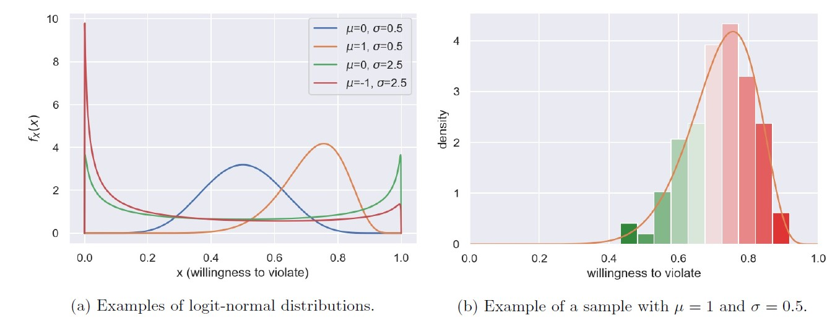

***Figure 29.*** *Logit-normal distributions with different values of 𝜇 and 𝜎 (Knol, 2021).*

Conversely, a low absorbance capacity, closer to zero, indicates that the inspectee cannot withstand the consequences of the intervention and becomes compliant. The logit-normal distribution was selected because it always yields a value between zero and one, allowing users to shape the distribution by adjusting the mean (*𝜇*) and standard deviation (*𝜎*). Equations 9.1a and 9.1b provide the logit-normal probability density function and the variable’s logit, respectively. It is important to note that this indicator is not a phenomenological parameter, as there is no empirical data on how inspectees respond to enforcement. Figure 29 shows various logit-normal probability density functions given different values of *𝜇* and *𝜎*.

$f\left(x;μ,σ\right)= \frac{1}{σ\sqrt{2π}}e^{\frac{{(logit\left(x\right)-μ)}^{2}}{2σ^{3}}}\frac{1}{x(1-x)}$ (9.1a)

$logit\left(x\right)=log\left(\frac{1}{x(1-x)}\right)$ (9.1b)

Ultimately, the sensitivity analysis and structural validation highlight the importance of initial conditions, enforcement strategies, and peer pressure effects in influencing compliance rates. Responsive enforcement (RE) consistently achieves higher compliance rates compared to structural enforcement (SE) in all variations of the tested parameters. A wider distribution of absorbance capacities (*𝜎*) leads to better compliance outcomes than a smaller spread. The radius of peers significantly impacts the effectiveness of enforcement strategies, with RE being less sensitive to variations in the radius compared to SE. Based on the results, the optimal radius for RE is 10. Table 10 summarizes the results of the sensitivity analysis and structural validation.