**Supporting Information**

**Adaptive Decision-Making: Bayesian Network Modeling for Blue-Green Infrastructure Selection in Dynamic Climate and Land Use Context**

1. **The development of Conditional Probability Tables**
2. Meteorological parameters nodes CPT

The CPT of the climate parameters in the BN were constructed using data collected from local sources in Istanbul's districts. This data was uploaded to GeNIe and discretized into three categories: low, medium, and high. The ranges defining these states were established based on climate parameter data spanning 2020-2022, using the dataset's minimum and maximum values to determine the range boundaries. The dataset incorporated measurements from 24 out of Istanbul's 39 districts. After discretizing the data, the parameters were learned for the model, and each dataset was matched with its correspondent node of the three parameters; the temperature variable is aligned with the average temperature dataset, precipitation is paired with the maximum precipitation dataset, and humidity is associated with the average humidity dataset. Meanwhile, the LCZ and cost and maintenance variables are designated as fixed nodes.

1. Blue-green infrastructure node CPT

The CPT of the BGI node is calculated using data obtained from literature and expert knowledge via multistep method. The first step is to score the BGI solutions in terms of their efficiency. The chosen BGI solutions were evaluated based on their effectiveness in mitigating extreme meteorological events caused by climate change, specifically high temperature, relative humidity, and precipitation. Each solution's efficiency in reducing temperature, relative humidity, and managing stormwater was scored on a scale from 0 to 10, with urban gardens and parks identified as the most effective in temperature reduction due to their shading from trees. However, considerations such as tree type, density, and wind factors impact their effectiveness. Rainwater harvesting ranked as the least effective due to its limited application scale. Regarding relative humidity, solutions were assessed against Istanbul's high humidity levels, aiming to reduce it to a comfort level. Blue infrastructure solutions like rainwater harvesting scored low as they lacked the capacity to decrease humidity, while roadside green infrastructure and urban parks scored higher due to their cooling effects and their influence on human perception of humidity. In terms of stormwater management, green roofs were deemed the most effective BGI solution, capturing rainwater before it becomes runoff, while green walls and rainwater harvesting were considered less efficient due to their design limitations and capacity constraints.

The second step is calculating the probabilities of each solution based on the scores given. To be able to calculate the probabilities, the scores are normalized first using the minimum-maximum method as the below equation.

$N\left(x_{i}\right)=\frac{x_{i}- min}{max - min}$ (1)

where 'xi' represents the BGI solution, 'N(xi)' stands for the normalized value of that BGI solution, with the minimum value denoting the lower limit on the scale (set at 0), and 'max' indicating the upper limit of the scale, which is 10.

Then the probabilities were computed by dividing each individual score by the total sum of scores within the corresponding category. It's essential that the collective sum of these probabilities equals 1.

The BGI node has three parent nodes, with each has three states defined as low, medium, and high, which results in 27 probabilities computed for each solution in the conditional probability table of the BGI. Weights were allocated to the three states that characterize the influence of the parameter on the BGI node. Specifically, the weights for the low, medium, and high states were set at 0.1, 0.3, and 0.6, respectively. This distribution reflects the increasing significance of NbS in climate change adaptation as temperature, humidity, or precipitation levels rise.

The probability of the solution in different conditional states is calculated as the formula below (Das, 2008).

(2)

Based on the equation above, the adapted equation for this study is:

$P\left({BGI}^{i} | T^{s_{j}},H^{s_{j}},R^{s_{j}}\right)=\sum_{i=1}^{X}{w_{j}}P({BGI}^{i}|\left\{Comp\left(T^{s_{j}}\right)\right\},\left\{Comp\left(H^{s_{j}}\right)\right\},\left\{Comp\left(R^{s_{j}}\right)\right\})$ (3)

where I is the BGI, I = 1,2,3…,X and sj is the state sj = l,m,h; wj is the weight for each state; T is temperature, H is humidity, and R is rainfall (precipitation).

Table 2. The scores of Blue-Green infrastructures

|  |  |  |  |
| --- | --- | --- | --- |
| **BGI** | **Temperature Reduction** | **Humidity Reduction** | **Stormwater Management** |
| Detention Basins | 4 | 4 | 5 |
| Green Roofs | 9 | 8 | 10 |
| Green Walls | 8 | 6 | 1 |
| Infiltration Basins | 6 | 4 | 8 |
| Infiltration Trenches | 3 | 5 | 3 |
| Pervious Surfaces | 2 | 3 | 7 |
| Rain Gardens | 6 | 7 | 9 |
| Rainwater Harvesting | 1 | 1 | 2 |
| Retention Ponds | 4 | 2 | 4 |
| Roadside Green Infrastructure | 7 | 10 | 2 |
| Swales | 5 | 5 | 6 |
| Urban Gardens and Parks | 10 | 9 | 4 |

1. Local climate zones node’s CPT

The CPT of the LCZ node consists of the data that comprises percentages representing each class, obtained from the LCZ map created, essentially presenting the probabilities of each class existing in Istanbul.

1. Cost and maintenance node’s CPT

The cost range for each solution is determined through a combination of literature review and expert input, as detailed in the NbS Characteristics’ table in the supplementary material. The probabilities of a solution falling into low, medium, or high cost and maintenance levels are then estimated based on this range. The CPT for the Cost and Maintenance node is established based on the cost ranges of the solutions. Six out of twelve solutions fall into the low-cost range, justifying a weight of 0.5. Four out of twelve are within the medium range, resulting in a weight of 0.333. Finally, two out of twelve have a high-cost range, corresponding to a weight of 0.167.

1. Applicability node’s CPT

The applicability node is dependent on its three parent nodes; BGI, LCZ, cost & maintenance, which resulted in a complex CPT, where the relationships between the four nodes needed to be quantified.

* *Probabilities of BGI conditional to cost and maintenance*

The probabilities of BGI solutions in term of the cost and maintenance states were predicted following the below method, because they will be used in calculating the conditional probability table of the applicability node.

Referring to Table ‎3, for a solution with a low cost, the predicted probability distribution over the three states (low, medium, and high) is 0.8, 0.1, and 0.1, respectively. In the case of a cost range from low to medium, the distribution becomes 0.7, 0.2, and 0.1. A solution with a medium cost has a probability distribution of 0.5 for the medium state, and 0.25 each for low and high states. For solutions with a medium to high-cost range, the probabilities are assumed to be 0.2 for low, 0.5 for medium, and 0.3 for high. This is rationalized by the idea that if a medium-budget application is feasible, a high-budget one is less likely to be implemented.

Table 3. Blue-Green infrastructure solutions probabilities in terms of cost and maintenance

|  |  |  |  |  |
| --- | --- | --- | --- | --- |
| **BGI** | **Cost range** | **BGI Probabilities per C&M range** | | |
| **low** | **medium** | **high** |
| Detention Basins | low-med | 0.7 | 0.2 | 0.1 |
| Green roofs | med-high | 0.2 | 0.5 | 0.3 |
| Green walls | med-high | 0.2 | 0.5 | 0.3 |
| Infiltrations basins | low | 0.8 | 0.1 | 0.1 |
| Infiltrations trenches | low | 0.8 | 0.1 | 0.1 |
| Pervious surfaces | low | 0.8 | 0.1 | 0.1 |
| Rain gardens | med | 0.25 | 0.5 | 0.25 |
| Rainwater harvesting | low | 0.8 | 0.1 | 0.1 |
| Retention ponds | low | 0.8 | 0.1 | 0.1 |
| Roadside green infrastructure | low-med | 0.7 | 0.2 | 0.1 |
| Swales | low | 0.8 | 0.1 | 0.1 |
| Urban gardens/parks | low-med | 0.7 | 0.2 | 0.1 |

* *Probabilities of BGI conditional to LCZ*

The evaluation process for BGI involves three steps. Firstly, BGIs are scored on a scale from 0 to 10 based on their applicability to each LCZ class, with 0 indicating inapplicability and 10 signifying high applicability. This scoring is informed by literature and expert opinions, as outlined in the NbS characteristics table. Secondly, the scores undergo normalization using the minimum-maximum method. LCZ classes A, F, and G (representing dense trees, bare soil or sand, and water) are deemed unsuitable for any of the selected NbS solutions, receiving a score of 0 for all solutions. The final step involves calculating probabilities for BGI applicability in each LCZ class by dividing each score by the total scores for the respective class.

* *Weights of the parent nodes*

The effectiveness of BGI solutions hinges on their performance concerning climate parameters, cost, maintenance needs, and LCZ classes. As a result, each preceding node holds a certain weight on the target node, with these weights determined through expert knowledge and understanding of these interconnected factors.

For each one of the three states of applicability have an assigned weight in terms of the parent nodes. LCZ weights are 0.1, 0.2, and 0.7, C&M have weights of 0.1, 0.6, and 0.9, while BGI have 0.05, 0.15, and 0.8 for each state respectively.

* *Probabilities of applicability node*

The CPT for the applicability node is a substantial table containing 540 probabilities. This is derived from the multiplication of the variables involved: 12 for BGI, 15 for LCZ, and 3 for C&M, resulting in 12 * 15 * 3 = 540 probabilities in total. The same equation used for calculating the CPT of BGI was applied in this step.

$P\left(A^{e} | {BGI}_{c}^{i},{CM}_{i}^{d},{LCZ}^{c}\right)=\sum_{e=1}^{k}{w_{j_{e}}}P(A^{e}|\left\{Comp\left({BGI}_{c}^{i}\right)\right\},\left\{Comp\left({CM}_{i}^{d}\right)\right\},\left\{Comp\left({LCZ}^{c}\right)\right\})$ (4)

where A represents applicability and e denotes its state (e = l, m, h); i represents BGI variables (i = 1, 2, 3, ..., 12); d represents the state of cost and maintenance (d = l, m, h); wj represents the weight of the parameters for each state, and c represents the class of LCZ (c = 1, 2, 3, ..., 9, A, B..G).

This equation was used to calculate 540 probabilities under different conditions.

1. **Local Climate Zones**

Table B1. Local climate zones’ areas and percentages in Istanbul

|  |  |  |  |
| --- | --- | --- | --- |
| **Class No.** | **Class** | **Area Class (km2)** | **Percentage** |
| 1 | Compact High-rise | 15.13 | 0.28% |
| 2 | Compact Mid-rise | 281.57 | 5.27% |
| 3 | Compact Low-rise | 10.76 | 0.20% |
| 4 | Open High-rise | 103.51 | 1.94% |
| 5 | Open Mid-rise | 73.73 | 1.38% |
| 6 | Open Low-rise | 153.83 | 2.88% |
| 8 | Large Low-rise | 167.93 | 3.14% |
| 9 | Sparsely Built | 780.40 | 14.61% |
| A | Dense Trees | 2,006.60 | 37.56% |
| B | Scattered Trees | 162.23 | 3.04% |
| C | Bush, Scrub | 45.06 | 0.84% |
| D | Low Plants | 1,240.28 | 23.21% |
| E | Bare Rock or Paved | 139.09 | 2.60% |
| F | Bare Soil or Sand | 54.99 | 1.03% |
| G | Water (inland) | 118.15 | 2.21% |

1. **The Bayesian Belief Network Model**

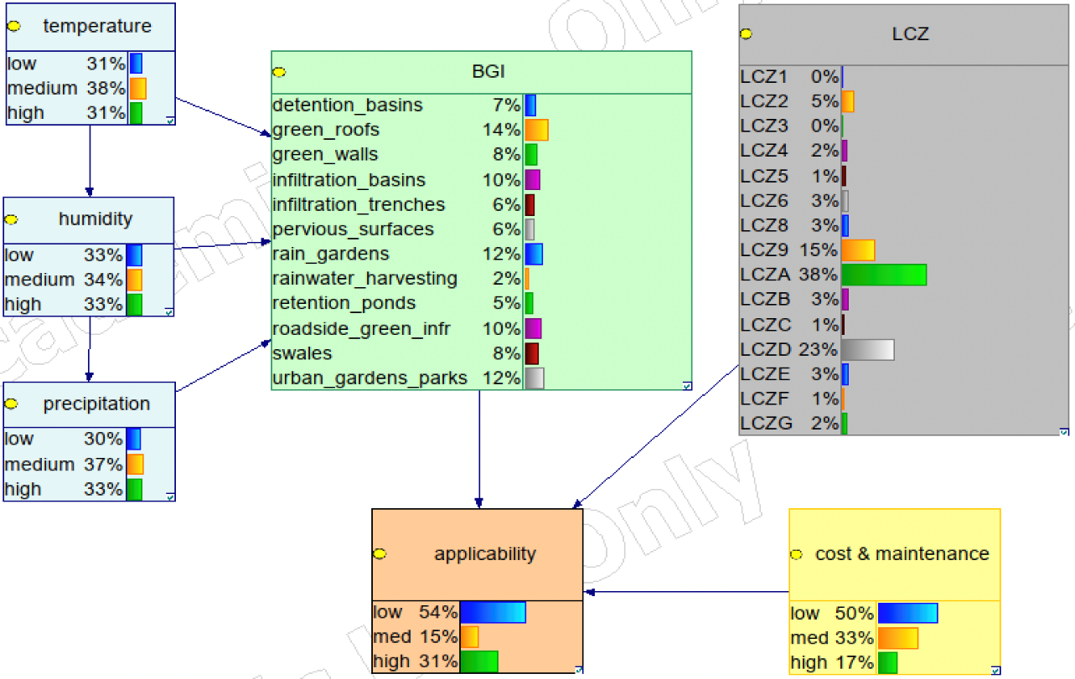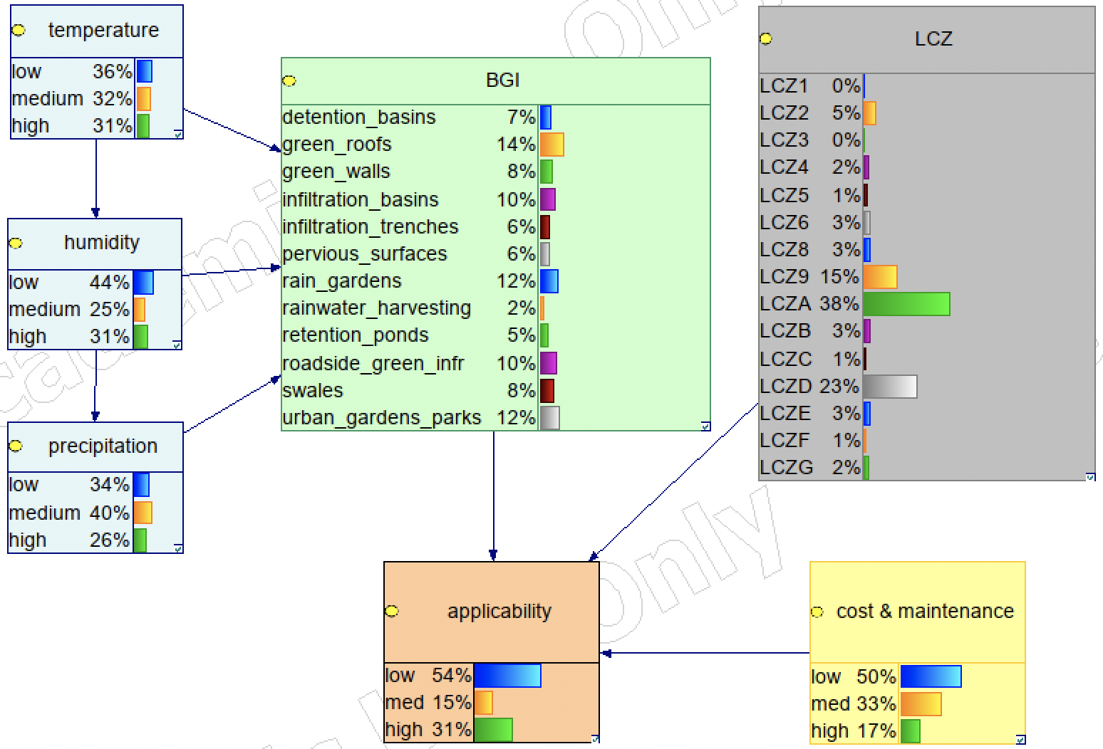

a)

b)

Figure 3. a) The trained Bayesian Network model, b) sensitivity analysis: altering parrameters’ bins.

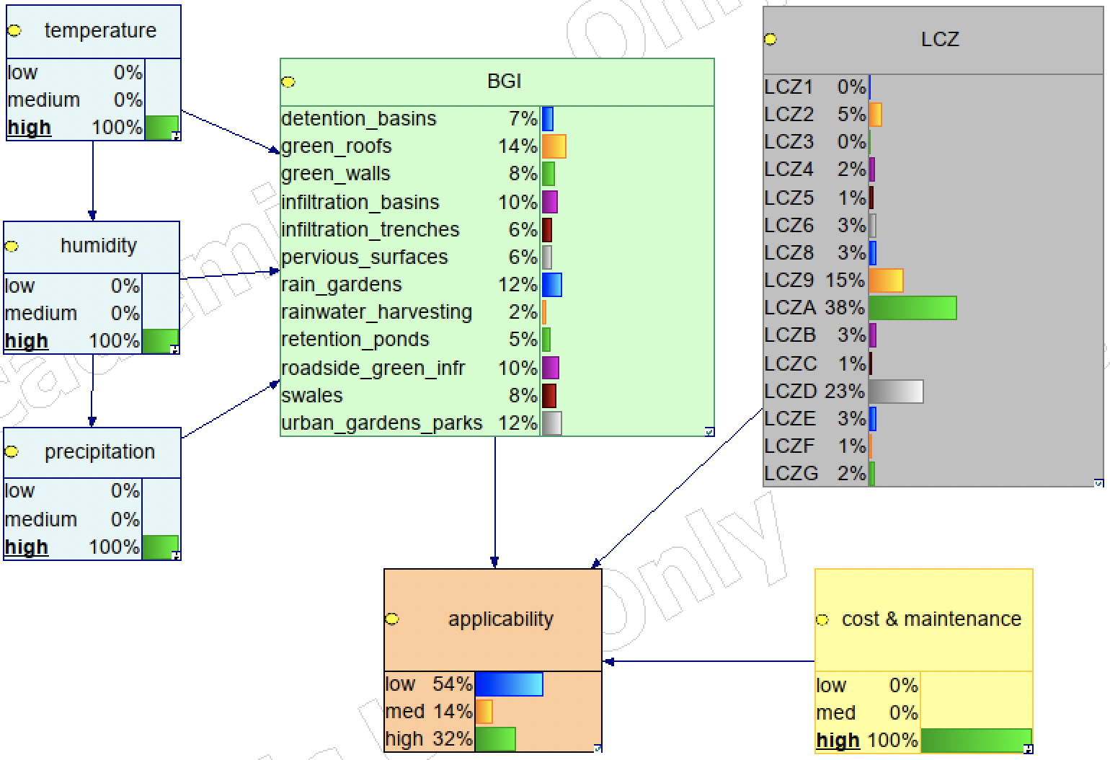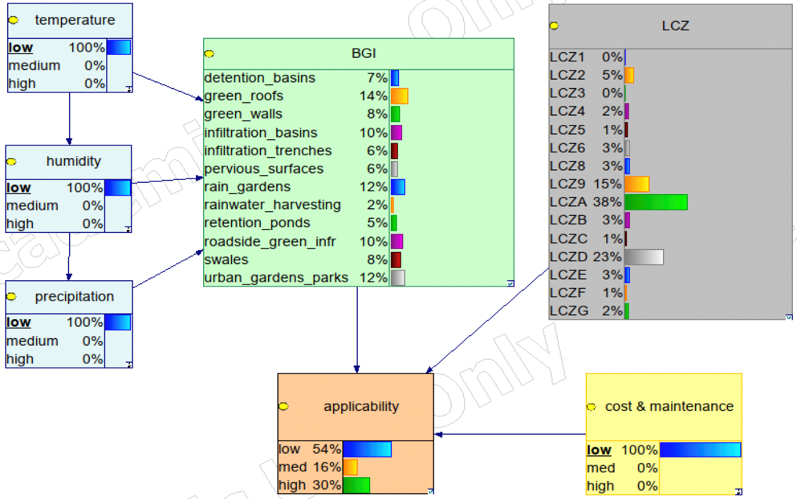

a)

b)

Figure 4. Sensitivity analysis through stress testing under a) low conditions, and b) high conditions