**Figure S1.** Days between same patient first and last isolates, November 2016-August 2019

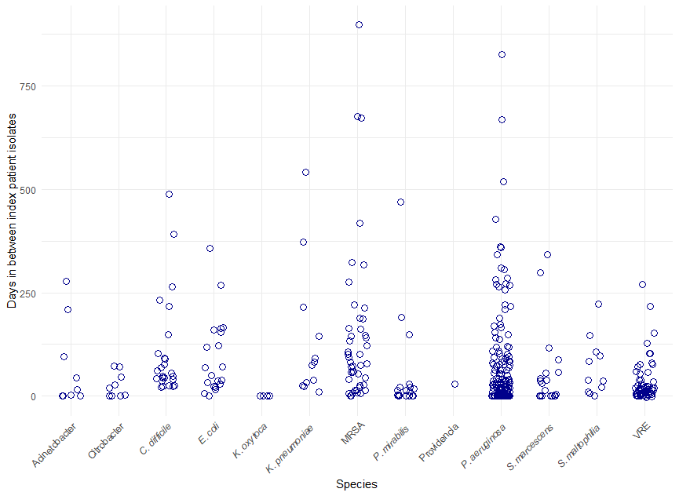

*MRSA: Methicillin-resistant *Staphylococcus* *aureus*; VRE: vancomycin-resistant *Enterococcus*