SUPPLEMENTS
Supplement 1. Timeline of key events and study interventions during the COVID-19 pandemic response

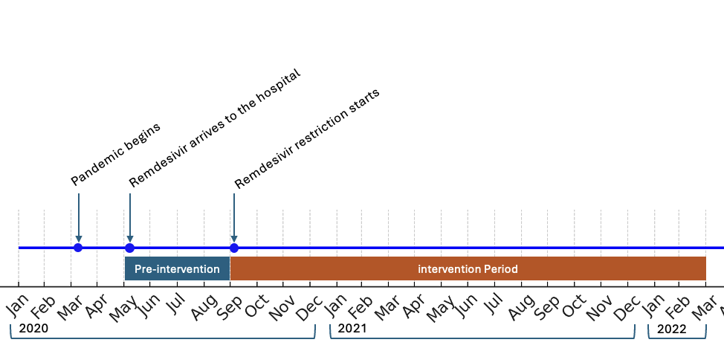
Supplement 2. Institutional guidelines at our hospital throughout the pandemic

Date | Guideline
May 14 | FDA  Exclusion criteria: eGFR ≤ 30 ml/min/1.72 m2, ALT/AST > 5 x the upper limit of normal, full term neonates (= day to = 28 days old) with a serum creatinine greater than or equal to 1 mg/dL unless the potential benefits outweighs the potential risks.  Inclusion criteria: Per U.S. FDA emergency use authorization for hospitalized children and adults with confirmed or suspected severe COVID-19 Sa02 less than or equal to 94 percent on room air, requiring supplemental oxygen, patients expected to survive the next 48 hours.  Remdesivir is recommended for those with severe COVID-19 on supplemental oxygen rather than in patients on high-flow oxygen, noninvasive ventilation, mechanical ventilation, or ECMO and with shorter onset of symptoms.  Institutional guideline  Remdesivir is optimal within the first 10 days of symptom onset
July 24 | Institutional guideline  Remdesivir is optimal within the first 10 days of symptom onset  Remdesivir is recommended for those with severe COVID-19 on supplemental oxygen rather than in patients on high-flow oxygen, noninvasive ventilation, mechanical ventilation, or ECMO and with shorter onset of symptoms.  NIH Guidelines  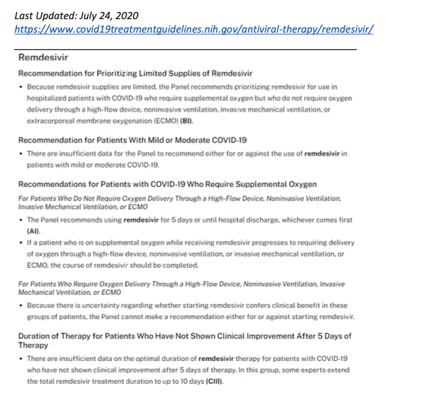
September 1 | Institutional Guidelines  Remdesivir is recommended for those with severe COVID-19 on supplemental oxygen rather than in patients on high-flow oxygen, noninvasive ventilation, mechanical ventilation, or ECMO and with shorter onset of symptoms.  Remdesivir formulary restrictions now implemented.  NIH Guideline  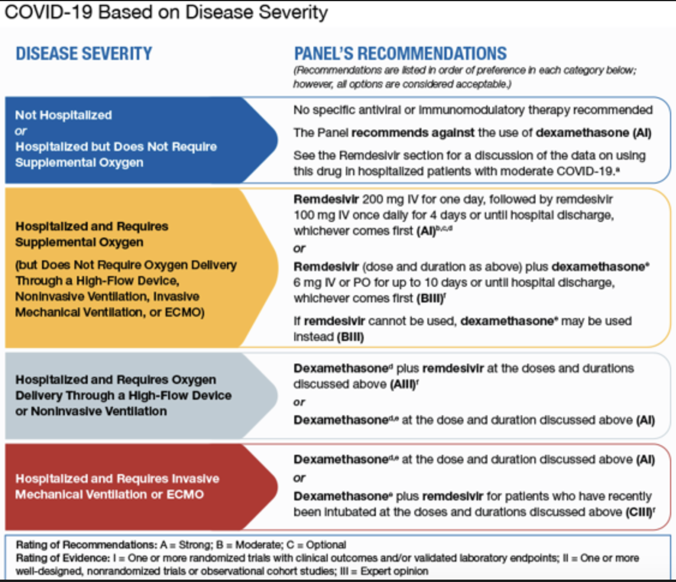

Supplement 3. Formula for estimated DOT/1000 for RDV without formulary restrictions

Estimated DOT/1000 = ( $\frac{Average Monthly DOT/1000 for RDV}{Patients approved to receive RDV}) x Total RDV Requests$

48.02= ( $\frac{25.64}{236}) x 442$

Supplement 4. Average monthly and peak DOT/1000 for RDV during each COVID-19 wave
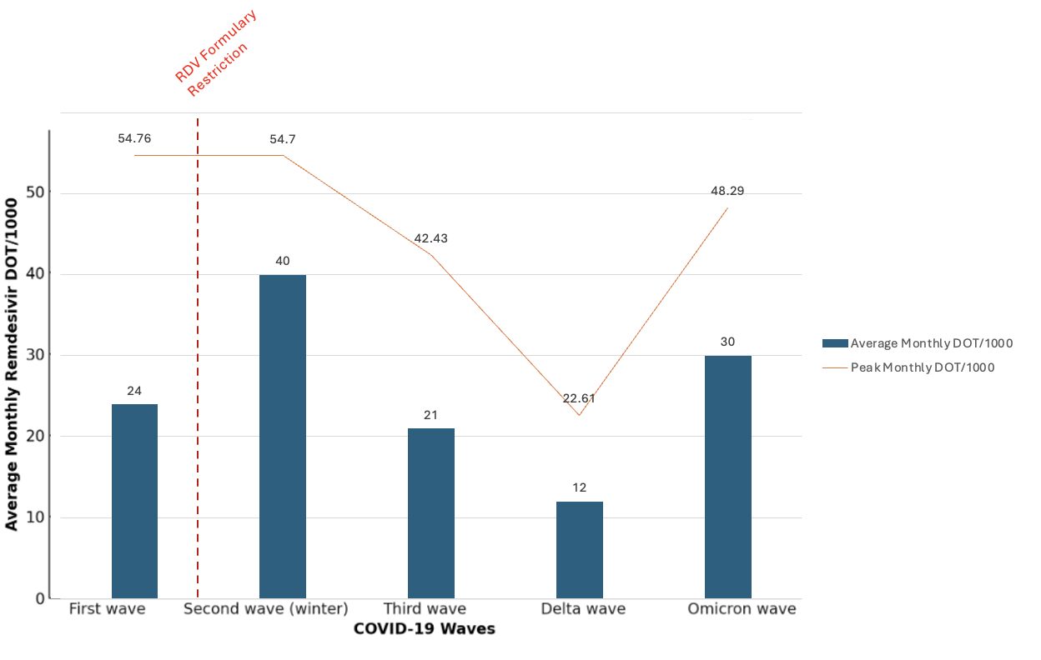

Supplement 5. Average monthly DOT/1000 with restrictions and expected monthly DOT/1000 without restrictions each COVID-19 wave.
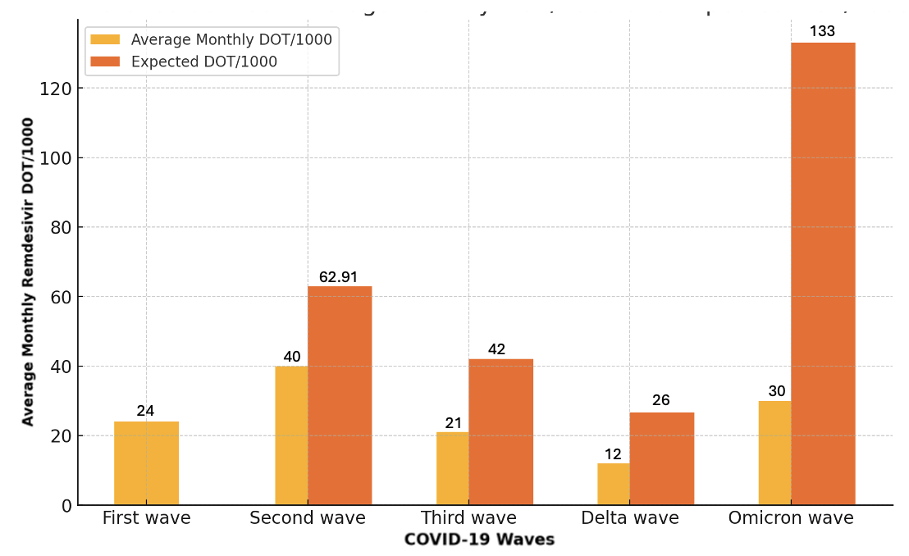

Supplement 6. Delta between average monthly DOT/1000 with restrictions and expected monthly DOT/1000 without restrictions each COVID-19 wave.
