**Supplementary Information**

**Uncertainties about waste using a global online survey and review approach: Environmentalist perceptions, waste compositions and views from media and science**

**Laura Markley1*, Maja Grünzner2 and Tony R. Walker 3**

1 Syracuse University, College of Engineering and Computer Science, Civil and Environmental Engineering, 223 Link Hall, Syracuse NY 13244, United States; lamarkle@syr.edu

2 University of Vienna, Faculty of Psychology, Department of Cognition, Emotion and Methods, Environmental Psychology Group, Wächtergasse 1, 1010 Vienna, Austria; maja.gruenzner@univie.ac.at

3 School for Resource and Environmental Studies, Dalhousie University, Halifax, Canada; trwalker@dal.ca

*Correspondence: lamarkle@syr.edu;

**Supplementary Information**

Additional Tables:

**Table S1.** Ecological Worldview (NEP Scores) among Futuristic February Participants (n=50).

| **Do you Agree or Disagree that…** | **Mean** | **SD** |
| --- | --- | --- |
| **1.** We are approaching the limit of the number of people the earth can support. | 4.26 | 1.14 |
| **2.** Humans have the right to modify the natural environment to suit their needs. | 4.20 | 0.96 |
| **3.** When humans interfere with nature it often produces disastrous consequences. | 4.70 | 0.53 |
| **4.** Human ingenuity will ensure that we do NOT make the earth unlivable. | 3.28 | 1.20 |
| **5.** Humans are severely abusing the environment. | 4.97 | 0.33 |
| **6.** The earth has plenty of natural resources if we just learn how to develop them. | 2.48 | 1.47 |
| **7.** Plants and animals have as much rights as humans to exist. | 4.88 | 0.71 |
| **8.** The balance of nature is strong enough to cope with the impacts of modern industrial nations. | 4.47 | 0.93 |
| **9.** Despite our special abilities humans are still subject to the laws of nature. | 4.85 | 0.48 |
| **10.** The so called ecological crisis facing humankind has been greatly exaggerated. | 4.68 | 0.93 |
| **11.** The earth is like a spaceship with very limited room and resources. | 4.25 | 0.85 |
| **12.** Humans were meant to rule over the rest of nature.* | 4.78 | 0.93 |
| **13.** The balance of nature is very delicate and easily upset. | 4.03 | 1.13 |
| **14.** Humans will eventually learn enough about how nature works to be able to  control it. | 4.05 | 1.14 |
| **15.** If things continue on their present course we will soon experience a major ecological catastrophe. | 4.88 | 0.46 |
| **Total** | **4.32** | **0.88** |

*Note*. Agreement with the odd numbered items and disagreement with the even numbered items display a proecological worldview response. Strongly disagree = 1, Mildly disagree = 2, Unsure = 3, Mildly agree = 4, Strongly agree = 5. The scale is reversed for even numbered questions. SD = Standard Deviation.

|  |  |
| --- | --- |
| **Table S2:** Trash summary categories assigned to write-in answers provided by survey participants. | |
| **Trash Summary Category** | **Describe the most common type of trash found in the category selected above (for example: plastic water bottles or food containers, aluminum cans, glass juice bottles):** |
| Beverage Container | Beer and Seltzer cans; Orange juice; Sparkling water cans; Water bottle; Aluminum cans, glass bottles |
| Bottles | Glass bottles; Plastic bottles/containrs; Wine bottles |
| Boxes | Amazon boxes; Cardboard boxes; Boxes; Mostly boxes |
| Cans | Aluminum cans; Aluminum cans |
| Cardboard | Cardboard |
| Disposable paper products | Napkins/paper towel; Tissues |
| Food packaging | Cardboard boxes/containers from "canned" beans; Cardboard food boxes; Pasta boxes; Paperboard food packaging; Plastic bags from pantry food; Food-related packaging; Cans from food; Tea bags; Plastic food packaging; Food/tea cartons; Plastic food packaging; Food cardboard packages; Cheese it boxes; Food packaging in general; Cardboard boxes for packaged goods like granola bars; Plastic food containers; Boxes that held food/drinks |
| Mail | Junk mail; Mail; Junk mail; Junk mail; Ads from local businesses; Mail (I don't receive junk mail); Paper/Mail; Junk mail |
| Packaging | Packaging |
| Paper | Scrap paper |
| Receipts | Receipts |
| Stickers | Stickers |
| Takeout Boxes | Takeaway food containers; Pizza boxes; Take out |
| *Note:* Only the first listed item provided by participants was considered to determine the most common type of trash found. The complete answers can be found in the Survey Excel doc. | |

Internal Review Board Status:

This work received Institutional Review Board exemption (#20-054) on February 28, 2020.

Survey:

**Individual Non-Perishable Waste Generation and Perceptions of Waste and the Environment following the Futuristic February Social Media Campaign**

Charles Driscoll and Laura Markley, Civil and Environmental Engineering

Informed consent statement and survey will be administered through Qualtrics.

**Informed Consent Statement:**

My name is Laura Markley, and I am a PhD student at Syracuse University in the Department of Civil and Environmental Engineering. I am inviting you to participate in a research study. Involvement in the study is voluntary, so you may choose to participate or not. This sheet will explain the study to you and please feel free to ask questions about the research if you have any. I will be happy to explain anything in detail if you wish.

I am interested in learning more about (1) factors influencing individual waste generation (2) components of non-perishable waste and (3) perceptions of waste and the environment. You are being asked to participate in this study by providing weights and descriptions of your waste collected during Futuristic February. Afterward, you’ll be asked questions about your perception of the waste issue and the relationship between humans and the environment. These questions do not have right or wrong answers, but are designed with your experience and your perceptions in mind. We ask only for candid, open responses that provide us with information about your personal views and correct data on the weight and type of non-perishable trash collected during February. This survey will take an estimated 10-15 minutes of your time.

Your information will be kept confidential to the best of our ability. This survey will not ask for any private identifying information that could be linked to you. Whenever one works with email or the internet there is always the risk of compromising privacy, confidentiality, and/or anonymity. Your confidentiality will be maintained to the degree permitted by the technology being used. It is important for you to understand that no guarantees can be made regarding the interception of data sent via the internet by third parties.

The benefits of this research are that you will be helping us to better understand how you feel about waste production and sustainability. By being involved you are allowing your thoughts to be heard. This study will better inform future research and provide background knowledge on the components and factors influencing individual waste generation. You will also be providing valuable information on perceptions of waste, plastic pollution, and the environment. This information is vital to securing a more sustainable future.

The risks to you of participating in this study are minimal, and are not greater than risks ordinarily encountered in daily life. All information will be kept confidential, and you will remain anonymous. No identifying information will be included in papers or presentations resulting from this research. If you do not want to take part, you have the right to refuse to take part, without penalty. If you decide to take part and later no longer wish to continue, you have the right to withdraw from the study at any time, without penalty.

If you have any questions, concerns, or complaints about the research, contact Laura Markley at [lamarkle@syr.edu](mailto:lamarkle@syr.edu).

**All of my questions have been answered if I have them, I am 18 years of age or older, and I wish to participate in this research study.**

Multiple Choice: Yes or No

**Survey:**

Thank you for taking the time to fill out this survey after participating in Futuristic February.

These questions will gather information that will be used to further understand the factors contributing to waste generation and the most prominent forms of waste. Your answers are for study purposes only. Please answer openly and honestly.

If you collected your waste for Futuristic February with a group (household, school, family, etc) and your waste can be categorized SEPARATELY (they are not mixed together and you know your waste from the other persons'), you may fill out 1 survey per person, otherwise denote the number of people who participated in the group waste collection.

**What country do you live in?**

Fill in blank

**What city/town do you live in?**

Fill in blank

**I collected my waste....**

Separately: the non-perishable waste is from me alone.

As a group: the non-perishable waste is from multiple people and I would not be able to weigh each person's trash separately.

*If “separately”: skip to demographic information*

*If “as a group”: display questions below:*

**What type of group?**

Household (Family/Roommates)

Classroom

School

Other

*If “Other”:*

*Fill in Blank*

*Groups skip to end of demographic information.*

**Demographic Information:**

**Age:**

18-20

21-29

30-39

40-49

50-59

60 or older

**Gender:**

Female

Male

Non-binary/third gender

Prefer to self-describe

Prefer not to say

Other

**I identify my ethnicity as (select all that apply):**

Asian

Black/African

Caucasian

Hispanic/Latinx

Native American

Pacific Islander

Prefer not to answer

Other

*If Other:*

**Type in the ethnicity with which you identify here:**

Fill in blank

**Which of the categories best describes your employment status?**

Undergraduate student

Graduate student

Employed, working 1-39 hours per week

Employed, working 40 or more hours per week

Not employed, looking for work

Not employed, not looking for work

Retired

Disabled, not able to work

**Please select your income range before taxes:**

Under $20,000

$20,001 – $40,000

$40,001 – $60,000

$60,001 – $80,000

$80,001 – $100,000

$100,001 or over

**What is the highest level of education you have completed or degree you have received?**

Secondary education without graduation (K-11 or 12, but did not graduate)

High school degree or equivalent (e.g. GED)

Vocational training

Some college but no degree

Associate degree

Bachelor Degree

Master’s Degree

Specialist Degree

Doctorate

**Please select the category that best describes the degree of urbanization of the neighborhood in which you live:**

Highly urbanized, I live in a busy city where the buildings are close to each other.

Urbanized, I live in a city where the buildings are close, but there is still some breathing room.

Suburban, I live in a neighborhood with spacing out of houses and apartments with occasional noise.

Exurban – large lots but still in a neighborhood with a kind of sub-urban feel. I have to commute a relatively long distance to work

Rural, I live in an area where houses are much further apart and it is very quiet.

*Groups skip to here.*

**Futuristic February Non-perishable Waste Information:**

**For how many days did you collect your non-perishable waste (the entire month of February is 29 days)?**

29 days

Other

*If Other:*

**Input the amount of days you collected your waste for:**

Fill in blank.

**After participating in Futuristic February, I consider my waste stream (including the amount of trash and recycling I produce):**

Very sustainable – in my opinion, I produce very little waste in comparison to most people.

Sustainable -  I try to reduce, reuse, recycle and have a low waste output, and feel that my efforts result in more sustainable practices and less waste than most people.

Average - I produce an amount of waste that I consider to be roughly equivalent to the amount of waste that most people produce.

Excessive - I produce more waste than the average person.

**Weighing your non-perishable waste:**

To weigh your waste, we suggest placing it all in a **garbage bag** or in a **large box or secondary container**.

If the secondary container is **NOT** part of your trash, record the weight of the container (box or otherwise) below.   
If the secondary container **IS** part of your trash, record the total weight.

A regular kitchen or bathroom scale is suitable for weighing. Make sure the bag or box is balanced and is being fully weighed on the scale.

**What is the weight of your collected non-perishable waste?**

Fill in blank

**Weight of secondary container (if NOT part of your trash), otherwise skip:**

Fill in blank

**Of your collected waste materials, what is the most commonly occurring?**

**(by number of objects, a visual estimate of the most abundant material is okay - no need to count them all)**

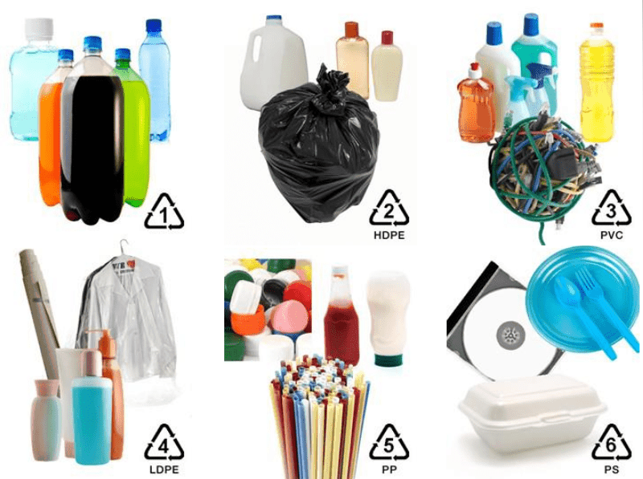

Plastic (Films, bags, bottles, food containers, Styrofoam)

Cardboard and paper (shipping boxes, pizza boxes, cereal boxes, shoe boxes, pasta boxes, cardboard egg cartons, sheets of paper, junk mail, tissue)

Aluminum / Steel (Cans, foil)

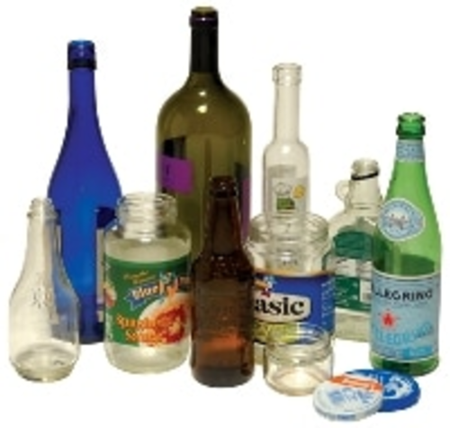

Glass (Bottles, salsa jars, pickle jars, wine bottles, seltzer bottles)

Other

Images above from:

Crystal Crees. Slide 3441453 [digital image]. <http://slideplayer.com/slide/3441453/>

Department of Environmental Protection, Montgomery County Maryland. <https://www2.montgomerycountymd.gov/DepHowDoI/material.aspx?tag=paper&material_key=24>

South Central Solid Waste Authority. <https://scswa.net/why-recycle-aluminum-and-tin-steel-cans/>

Denver Recycling Directory. https://www.denvergov.org/content/denvergov/en/trash-and-recycling/recycling/recycling-directory-dropoff-locations.html#!rc-cpage=41190

**If other, describe here:**

Fill in blank

**Describe the most common type of trash found in the category selected above (for example: plastic water bottles or food containers, aluminum cans, glass juice bottles):**

Fill in blank

**Perceptions of Waste & Plastic Pollution Issues:**

**Listed below are statements about waste and plastic pollution. For each one, please indicate whether you STRONGLY AGREE, MILDLY AGREE, are UNSURE, MILDLY DISAGREE or STRONGLY DISAGREE with it.**

**If you are completing this survey as a group, you may discuss the statements together.**

Waste (in the form of trash / garbage) is the greatest threat to our oceans.

Plastic pollution is the greatest threat to our environment.

Microplastic particles (broken up pieces of larger plastic or smaller plastics like microbeads) are toxic to humans and animals.

Bioplastics are all biodegradable.

Biodegradable plastics are able to break down in the environment.

Ocean trash gyres, locations in the ocean where large quantities of trash are concentrated by currents, have trash islands that can be seen from space.

Reducing our trash / garbage generation is the best way to reduce our overall environmental footprint.

Single-use items are better if they can be composted.

Glass is infinitely recycled in recycling facilities.

Glass or paper are better alternatives to plastic.

All plastics are equally recyclable.

**Perception of the Relationship between Humans and the Environment:**

**Listed below are statements about the relationship between humans and the environment. For each one, please indicate whether you STRONGLY AGREE, MILDLY AGREE, are UNSURE, MILDLY DISAGREE or STRONGLY DISAGREE with it.**

**If you are completing this survey as a group, you may discuss the statements together.**

We are approaching the limit of the number of people the earth can support.

Humans have the right to modify the natural environment to suit their needs.

When humans interfere with nature it often produces disastrous consequences.

Human ingenuity will ensure that we do NOT make the earth unlivable.

Humans are severely abusing the environment.

The earth has plenty of natural resources if we just learn how to develop them.

Plants and animals have as much rights as humans to exist.

The balance of nature is strong enough to cope with the impacts of modern industrial nations.

Despite our special abilities humans are still subject to the laws of nature.

The so-called “ecological crisis” facing humankind has been greatly exaggerated.

The earth is like a spaceship with very limited room and resources.

Humans were meant to rule over the rest of nature.

The balance of nature is very delicate and easily upset.

Humans will eventually learn enough about how nature works to be able to control it.

If things continue on their present course, we will soon experience a major ecological catastrophe.

**Thank you for completing this survey!**

**If you have any outstanding questions, please feel free to contact us at lamarkle@syr.edu.**