ATOMIC AVERSION: EXPERIMENTAL EVIDENCE ON TABOOS, TRADITIONS, AND THE NON-USE OF NUCLEAR WEAPONS

Supplemental Online Appendix

Daryl G. Press, Dartmouth College (daryl.press@dartmouth.edu)
Scott D. Sagan, Stanford University (ssagan@stanford.edu)
Benjamin A. Valentino, Dartmouth College (benv@dartmouth.edu)

APPENDIX 1: Survey Question Wording

Prospective Stories (figures 1A, 1B, and 3)
• Given the facts described in the article, if the United States decided to conduct a nuclear strike to destroy the Al Qaeda base, how much would you approve or disapprove of the U.S. military action? (6 point scale from strongly disapprove to strongly approve)
• Given the facts described in this article, if the United States decided to conduct a conventional strike to destroy the Al Qaeda base, how much would you approve or disapprove of the U.S. military action? (6 point scale from strongly disapprove to strongly approve)
• If you had to choose between one of the two U.S. military options described in the article, would you prefer the nuclear strike or the conventional strike? (1. strongly prefer the conventional strike; 2. somewhat prefer the conventional strike; 3. somewhat prefer the nuclear strike; 4. strongly prefer the nuclear strike)
• For those preferring nuclear: You said you preferred a nuclear strike by the United States. Which of the following is the most important reason why you preferred the nuclear strike? Please select one (1. Using nuclear weapons increased the chances of successfully destroying an important threat to our national security; 2. Using nuclear weapons reduced the expected number of U.S. military fatalities in the operation; 3. Using nuclear weapons sends a strong message to Al Qaeda and other potential enemies of the United States that we will not permit them to build weapons of mass destruction; 4. The United States cannot hold back when fighting enemies who seek to destroy us.)
• For those preferring conventional: You said you preferred a conventional strike by the United States. Which of the following is the most important reason why you did not prefer the nuclear strike? Please select one. (1. Using nuclear weapons increased the expected number of Syrian civilian fatalities in the operation; 2. Using nuclear weapons is morally wrong; 3. Using nuclear weapons in this situation might encourage other states or terrorist groups to use nuclear weapons against the U.S. or our allies in the future; 4. Using nuclear weapons in this situation would damage America’s reputation with other countries; 5. Using nuclear weapons did not provide a significant advantage over conventional weapons in destroying the target; 6. Civilized countries don’t use nuclear weapons.)

Retrospective Stories (figure 2)
• How much do you approve or disapprove of the U.S. military operation described in this article? (6 point scale from strongly disapprove to strongly approve)
• How ethical or unethical was the U.S. military operation described in this article? (6 point scale from highly ethical to highly unethical)

Appendix 2

FIGURE A1

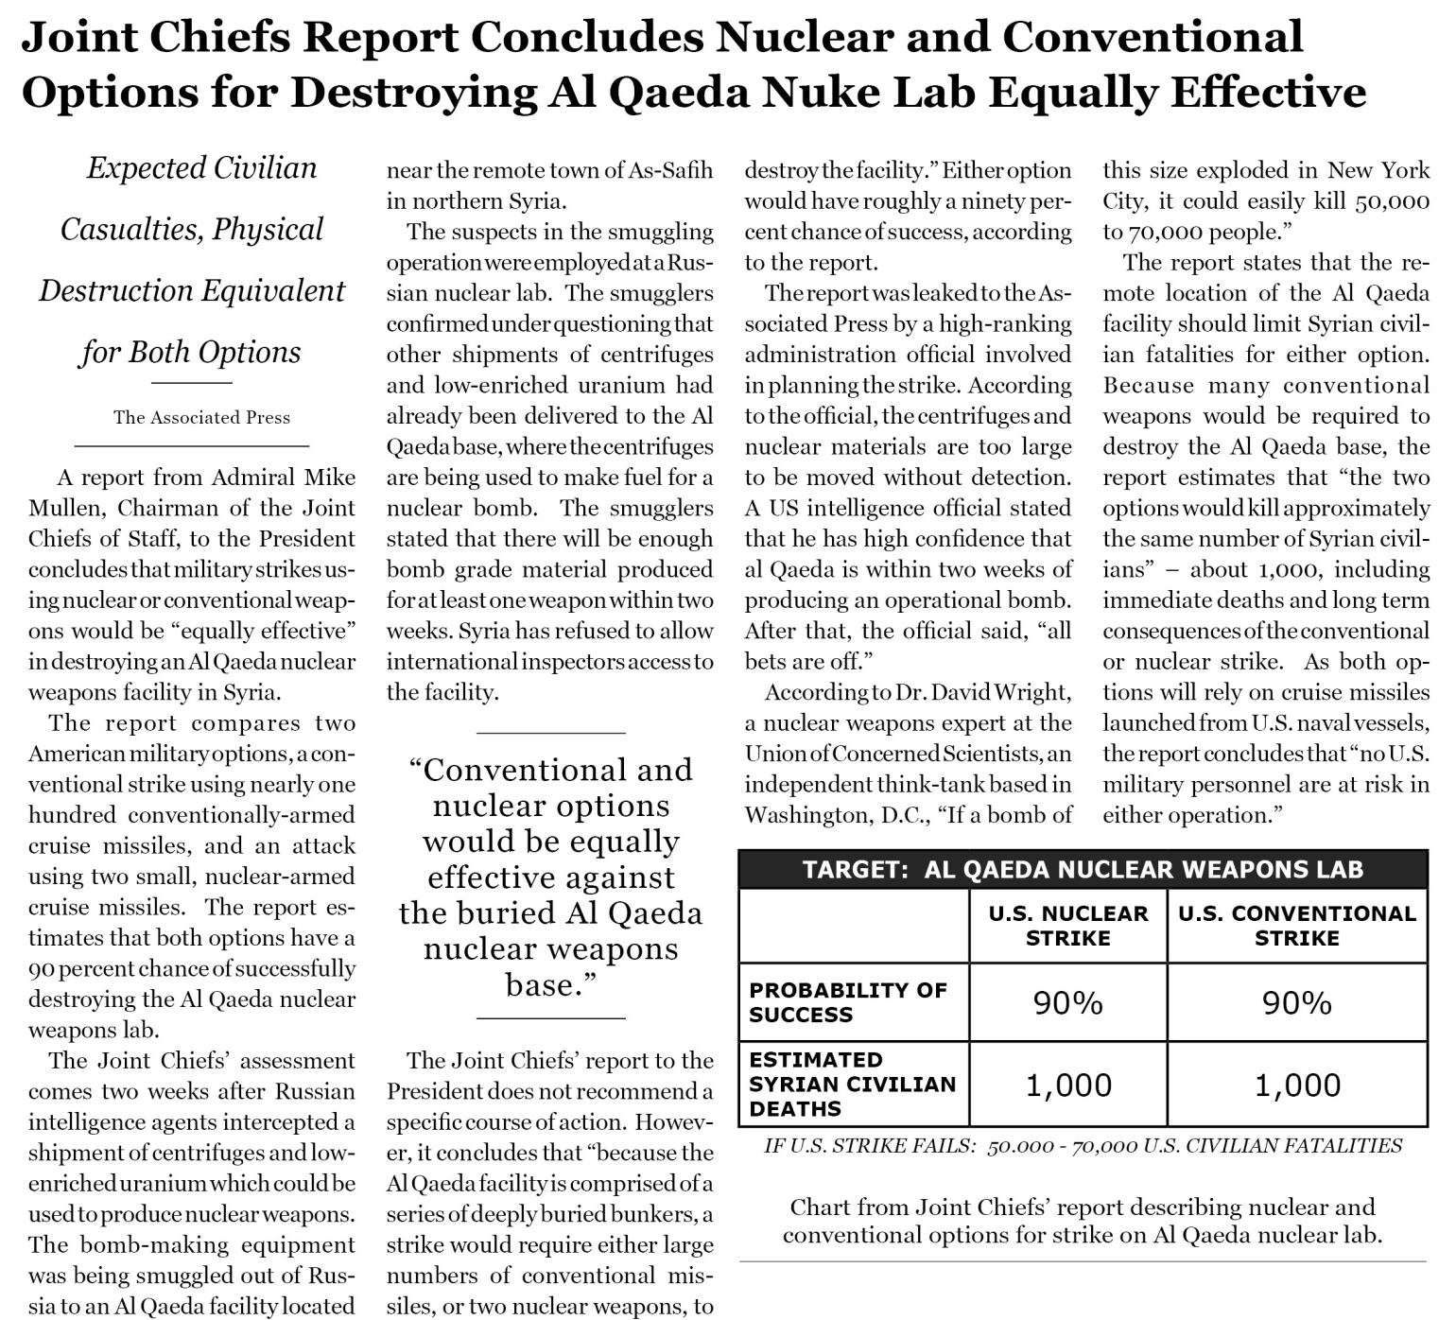

FIGURE A2

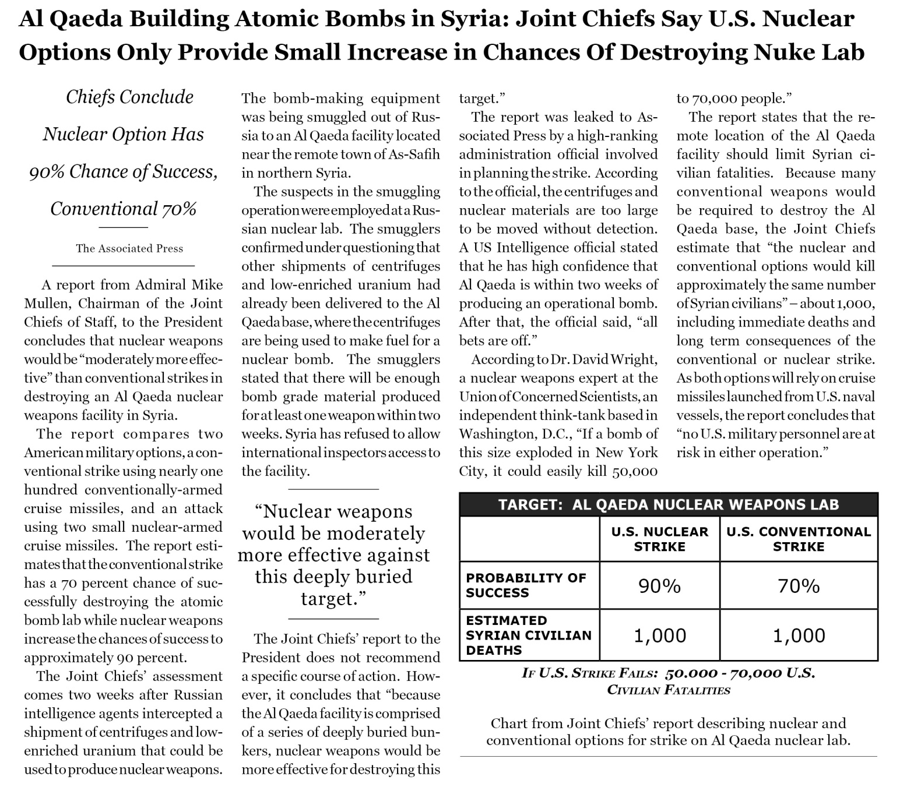

FIGURE A3

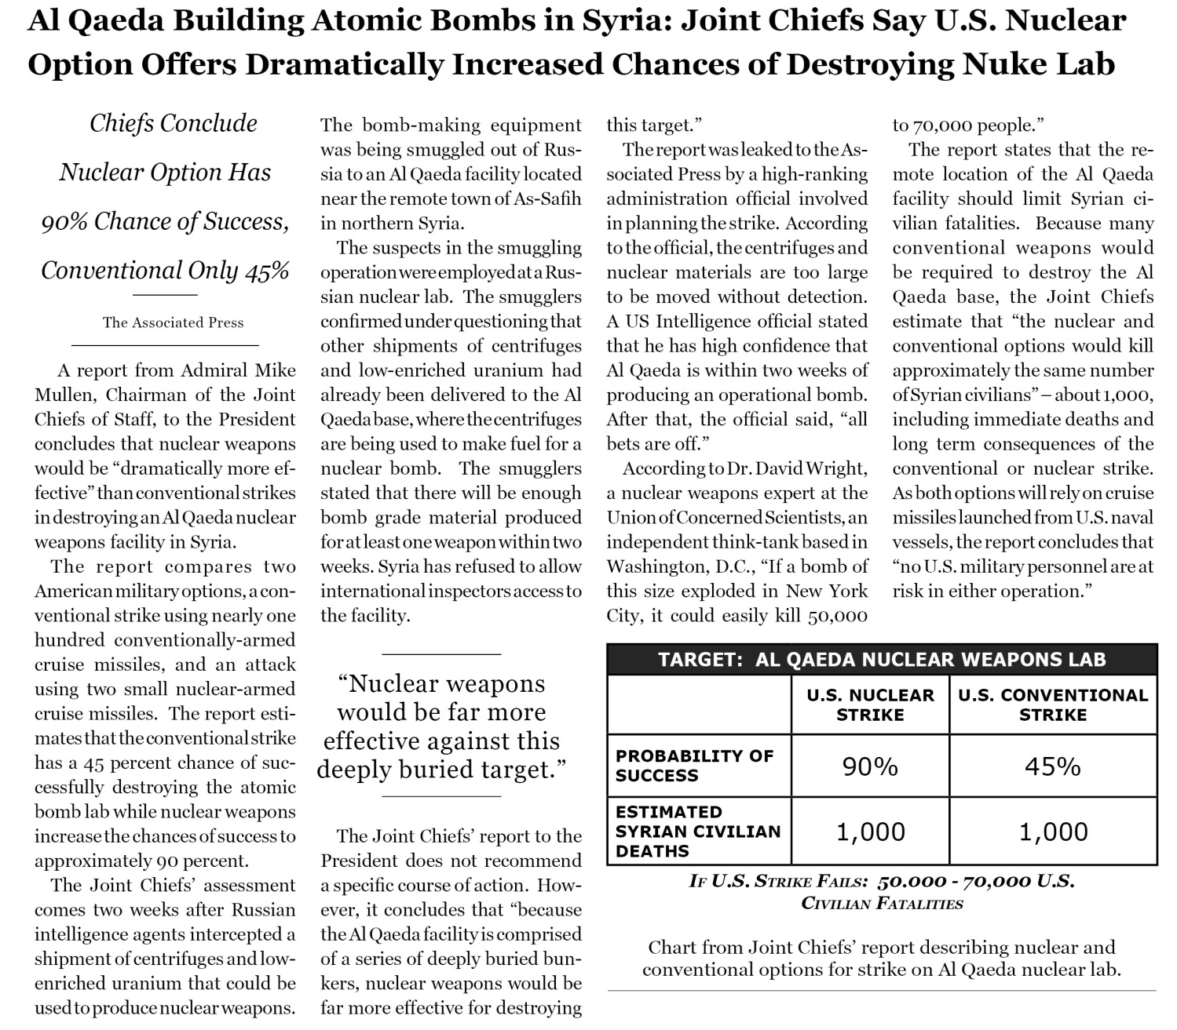

FIGURE A4

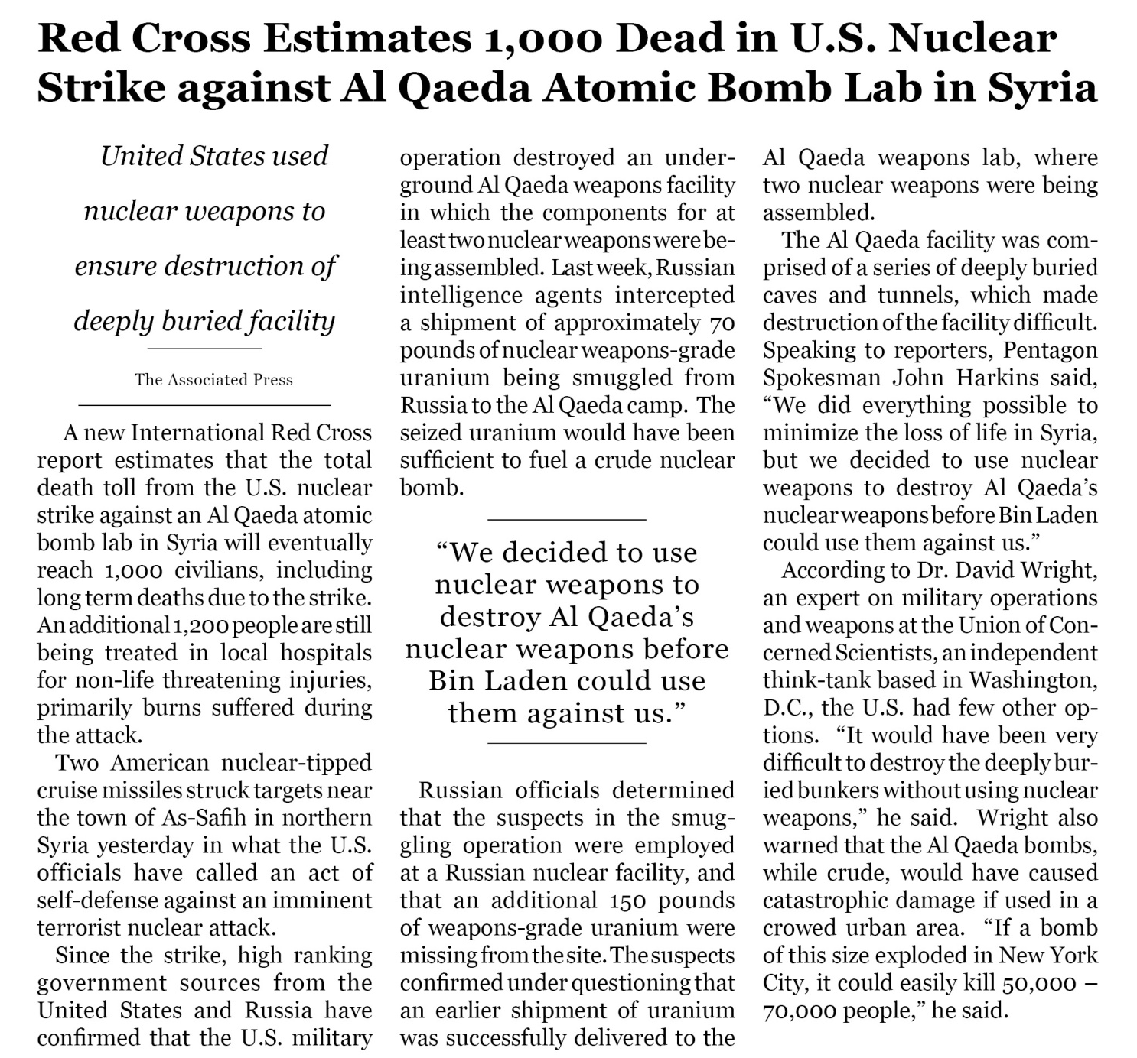

FIGURE A5

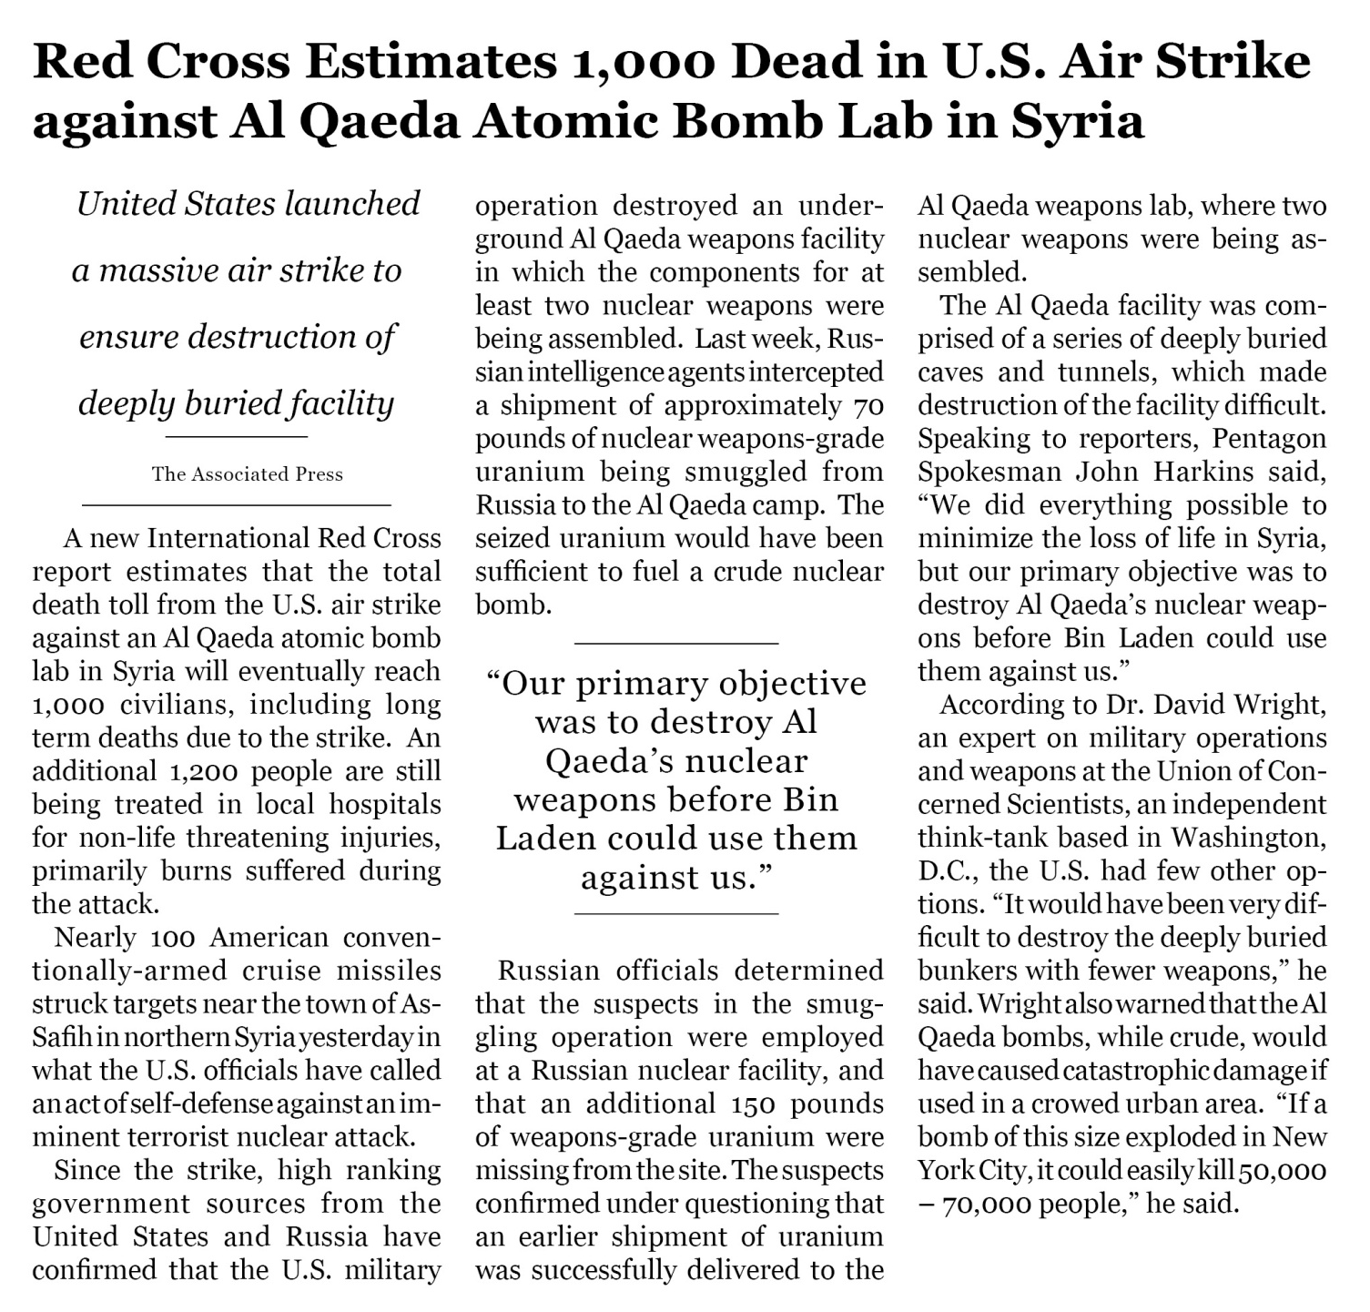

FIGURE A6

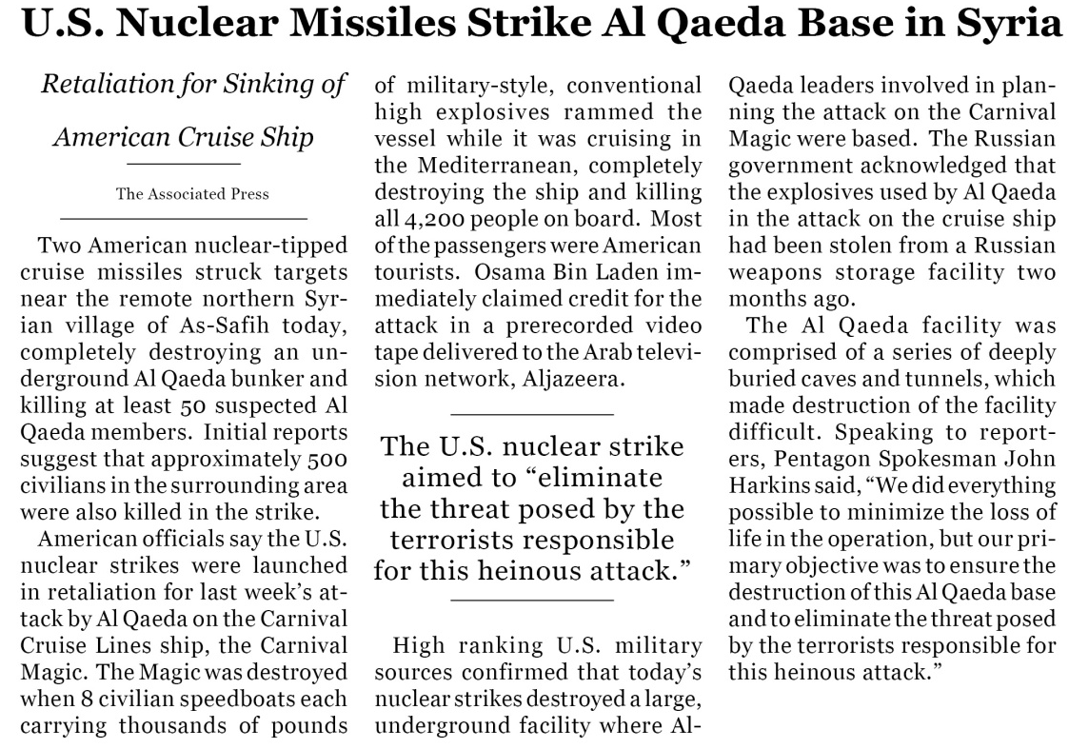

FIGURE A7
