Supplemental Table 1. Primer sequences used for qPCR.
Identifier | Forward |  | Reverse
1367836_at | ATGACGGCTATGGTGTCTCC |  | GGCTTGTCTCAAGTGCTTCC
1368797_at | GGAGGACCAGATCTCCCTTC |  | GACCGCATCTTCCATCTTGT
1369840_at | TGGAGACCCTGCGTTTTATC |  | CTGTTGCCCTTAACGTGGTT
1367667_at | TCTTCCAGATCCAGGACGAC |  | CTCTAAGATCTGGCGCTGCT
1370870_at | AAAGTCAGCCTTTCCCAGGT |  | AAGCGACTTCAAAACCAGGA
1367854_at | ACCCTTAGCCATCGTCACAC |  | GACACGAGACGTTTCACAGC
1367707_at | AGTCACCCTGAAGGCATCAC |  | TCTCACAGTGGCCACACACT
1387312_a_at | TGCACTTTCACGATTCTTGC |  | GCCGAACTGCTGAAGTTACC

Supplemental Table 2. Eight selected genes quantified by qPCR.
Identifier | Gene Symbol | Gene Title | Function
1369840_at | UST4r | Integral membrane transport protein UST4r | Unknown
1367667_at | Fdps | Farnesyl diphosphate synthase | Enzyme
1367707_at | Fasn | Fatty acid synthase | Enzyme
1387312_a_at | Gck | Glucokinase | Enzyme
1370870_at | Me1 | Malic enzyme 1, NADP(+)-dependent, cytosolic | Enzyme
1367854_at | Acly | ATP citrate lyase | Enzyme
1367836_at | Cpt1a | Carnitine palmitoyltransferase 1a, liver | Enzyme
1368797_at | Nr1i3 | Nuclear receptor subfamily 1, group I, member 3 | Nuclear receptor

Supplemental Figure 1. Correlation of expression data between microarray and qPCR.
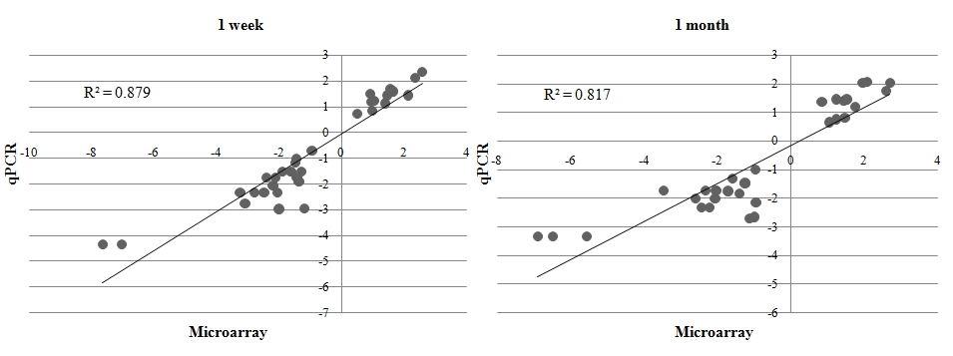
Log-transformed fold-changes of transcripts measured by quantitative real-time PCR were plotted against the corresponding log-transformed values obtained by microarray analysis. Results of qPCR are presented as means of five rats.

