Effect of chitooligosaccharide on the viability of mouse 3T3-L1 pre-adipocytes. Absorbance measure reflects binding of the 3-(4,5- dimethyl-2-yl)-2,5-diphenyltetrazolium bromide (also known as MTT reagent) by the viable cells after 24 hrs and 48 hrs

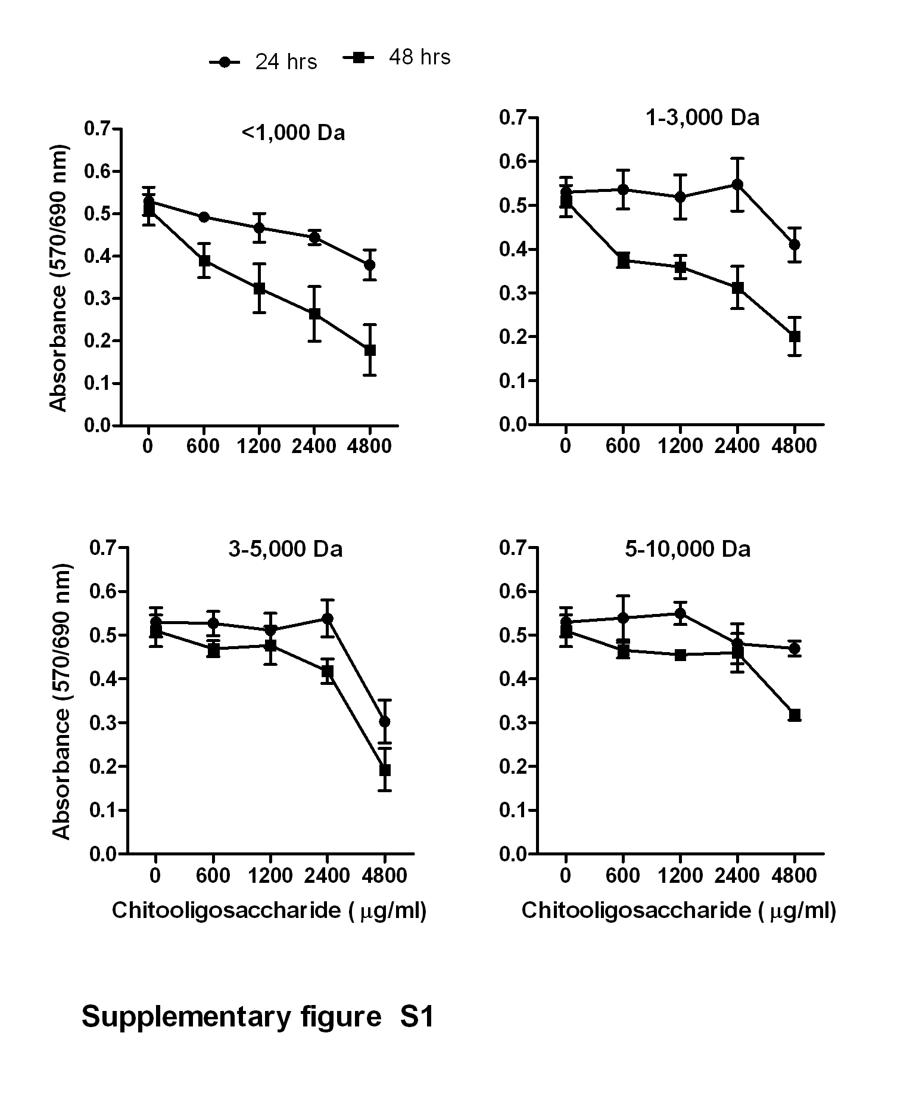
Effect of chitooligosaccharide on the cytotoxicity of mouse 3T3-L1 pre-adipocytes. Absorbance measure reflects the activity of lactate dehydrogenase in the cells after 24 hrs and 48 hrs of incubation with chitooligosaccharides.

