Appendix 1 Effects of SWH fractions on body weight gain, uteri index and serum, biochemical makers in OVX mice.

Group | Body weight  (g change) |  |  | Uteri indexª  (mg/g) |  |  | Serum Ca  (mg/dl) |  |  | Serum P  (mg/dl)
Group | Mean | SEM |  | Mean | SEM |  | Mean | SEM |  | Mean | SEM
Sham | 2⋅11 | 0⋅12 |  | 1⋅17 | 0⋅11 |  | 8⋅05 | 0⋅35 |  | 6⋅05 | 0⋅26
OVX | 3⋅10† | 0⋅12 |  | 0⋅48† | 0⋅02 |  | 8⋅81 | 0⋅12 |  | 5⋅85 | 0⋅15
E₂ | 0⋅43*** | 0⋅24 |  | 6⋅06*** | 0⋅58 |  | 9⋅22 | 0⋅07 |  | 5⋅90 | 0⋅24
SWH | 1⋅57*** | 0⋅29 |  | 1⋅12* | 0⋅18 |  | 8⋅55 | 0⋅34 |  | 5⋅86 | 0⋅27
SWA | 2⋅33 | 0⋅24 |  | 0⋅96 | 0⋅14 |  | 8⋅82 | 0⋅22 |  | 5⋅82 | 0⋅20
SWB | 2⋅34 | 0⋅28 |  | 0⋅78 | 0⋅07 |  | 8⋅72 | 0⋅10 |  | 5⋅23 | 0⋅32
SWC | 1⋅14*** | 0⋅23 |  | 0⋅93 | 0⋅12 |  | 8⋅92 | 0⋅14 |  | 5⋅92 | 0⋅32
Sham and OVX mice were subjected to the following treatment for 12 weeks: Sham, sham-operated vehicle-treated; OVX, ovariectomy, vehicle-treated; E₂, 17β-estradiol (3⋅2 μg/g body weight/d); SWH, SWH ethanol extract (1⋅0 mg/g body weight/d); SWA, SWH water eluate (0⋅570 mg/g body weight/d), SWB, SWH 30% ethanol eluate (0⋅128 mg/g body weight/d); SWC, SWH 50% and 95% ethanol eluate group (0⋅189 mg/g body weight/d). Mean value was significantly different from that of the OVX group: * P < 0⋅05, ** P < 0⋅01, *** P < 0⋅001. Mean value was significantly different from that of the Sham group: †P < 0⋅05.
ª Uterus index was represented as uterine weight divide by body weight.
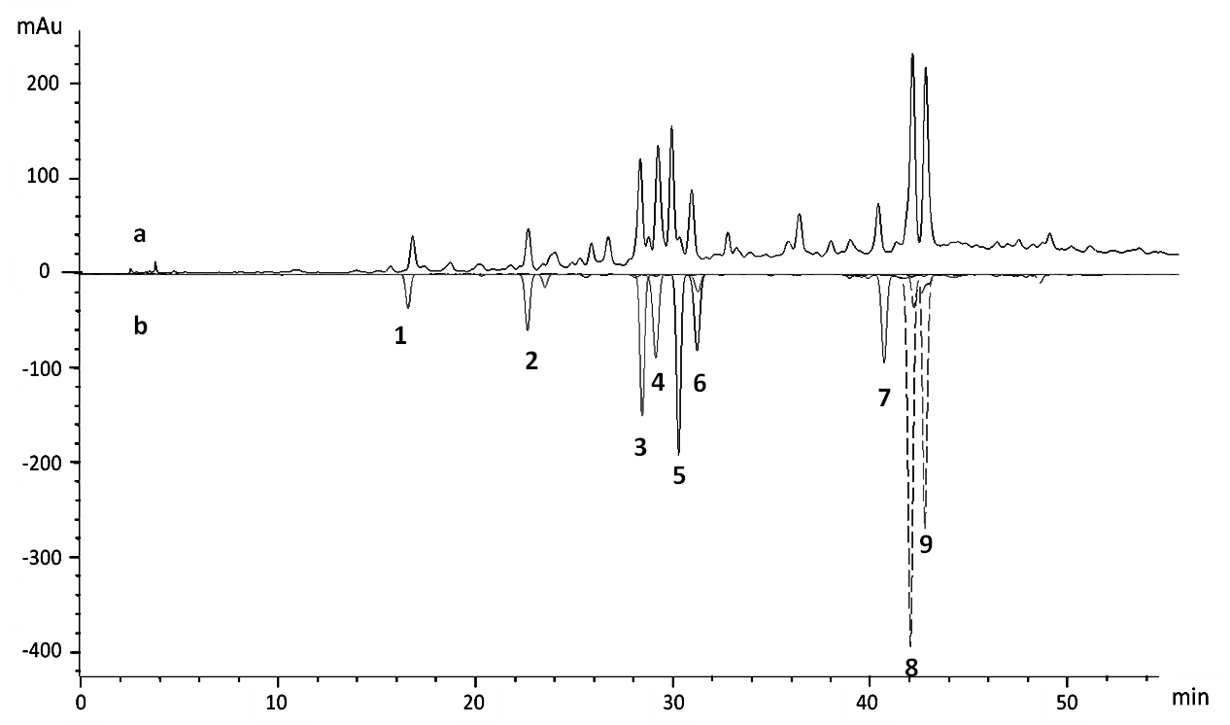
Appendix 2 HPLC fingerprint of bioactive fraction (SWC) and its main components.
The upper line (a) is the HPLC profile of SWC, while the lower one (b) is the mixture line of nine compounds. peak 1 (16⋅8 min, vanillic acid), peak 2 (22⋅7 min, coniferyl alcohol), peak 3 (28⋅3 min, (+)-erythro-1-(4-hydroxy-3- methoxyphenyl)-2-[4-(3-hydroxypropanyl)-2-methoxy-phenoxy]-1,3-propanediol), peak 4 (29⋅3 min, (+)-thero-1-(4-hydroxy-3-methoxyphenyl)-2-[4-(3 -hydroxypropanyl)-2-hydro-phenoxy]-1,3-propanediol), peak 5 (29⋅9 min, (+)-thero-guaiacylglycerol-β-O-4'-conifery ether), peak 6 (31⋅0 min, (+)-erythro -1-(4-hydroxy-3-methoxyphenyl)-2-[-4-(3-hydroxypropanyl)-2-methoxy-phenoxy]-1, 3-propanediol), peak 7 (40⋅4 min, (+)-lariciresinol), peak 8 (42⋅1 min, dehydrodiconiferylalcohol), peak 9 (42⋅8 min, dihydrodehydrodiconiferyl alcohol).

