Supplementary Tables
Table S1: Gas chromatography quantification of fatty acids in the frontal cortex.
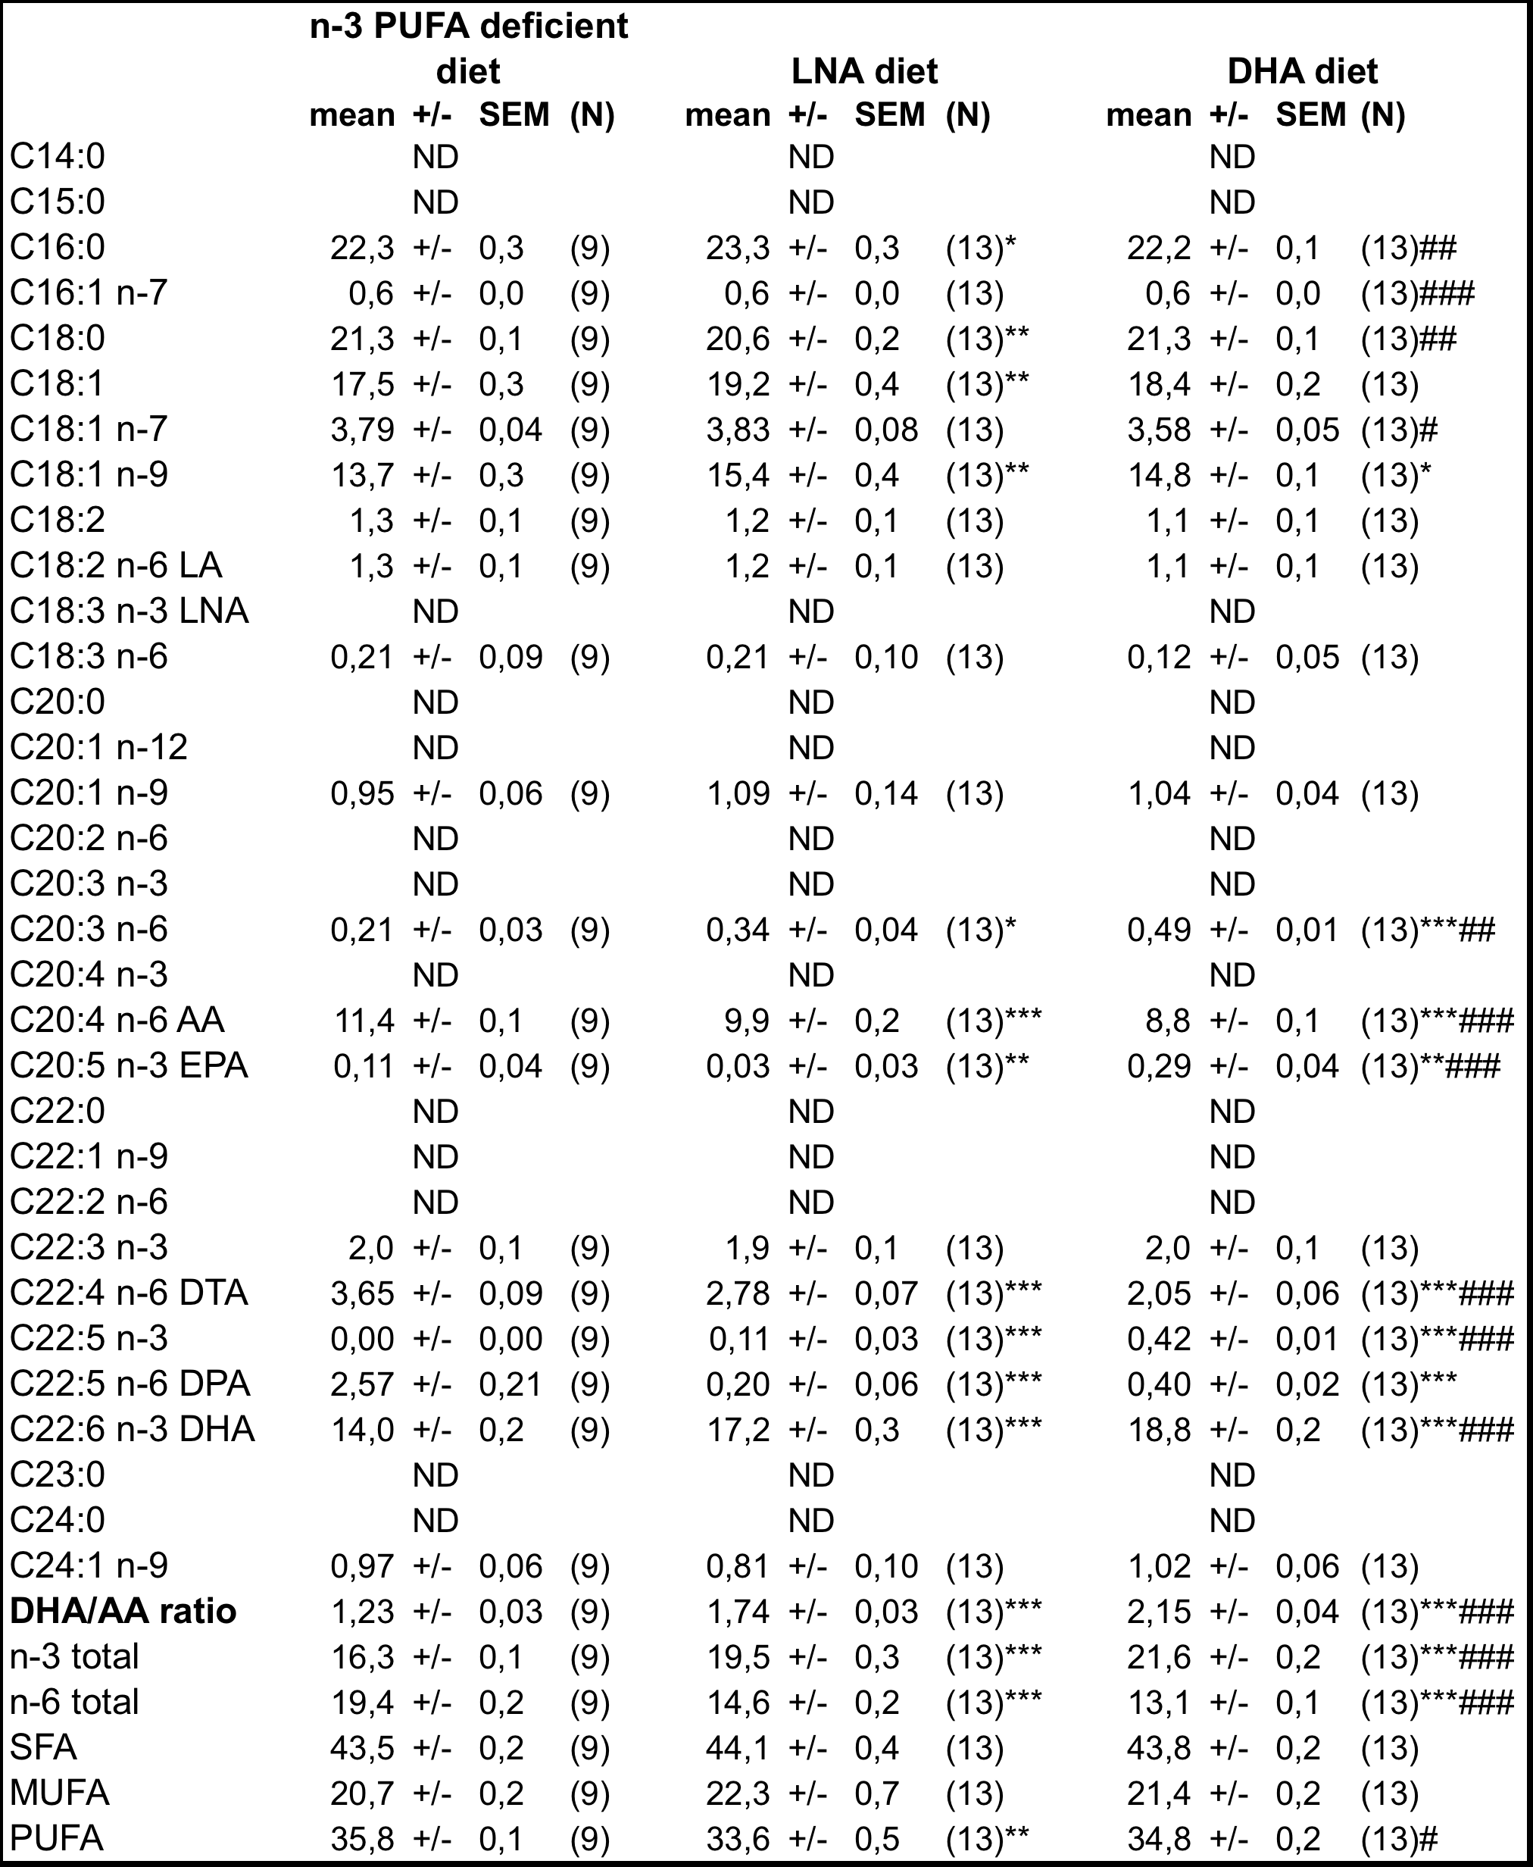

Values are expressed as mean ± SEM in percentage of total fatty acids. Statistical comparisons were performed using a one-way ANOVA followed by a Tukey-Kramer post-hoc test. Abbreviations: ND: not detected, SFA: saturated fatty acid, MUFA: monosaturated fatty acid, PUFA: polyunsaturated fatty acid, n-3 PUFA: omega-3, n-6 PUFA: omega-6, n-7: omega-7, n-9: omega-9, LA: linoleic acid, LNA: linolenic acid, AA: arachidonic acid, EPA:eicosapentaenoic acid, DHA: docosahexaenoic acid, DPA: docosapentanoic acid, DTA: docosatetranoic acid, N: number of animals.
*Pvalue<0.05; ** Pvalue<0.01; *** Pvalue<0.001 versus n-3 PUFA deficient diet
# Pvalue<0.05; ## Pvalue<0.01; ### Pvalue<0.001 versus LNA diet
Table S2: Summary of electrophysiological parameters recorded.
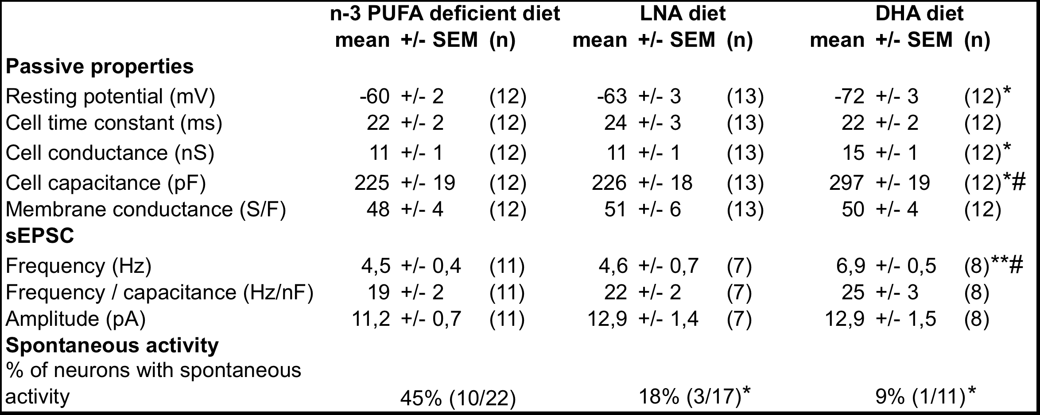
Values are expressed as mean ± SEM. Statistical comparisons were performed using a one-way ANOVA followed by a Tukey-Kramer post-hoc test and a Pearson’s chi-square test (% of neurons with spontaneous activity). Abbreviations: DHA: docosahexaenoic acid, LNA: linolenic acid, PUFA: polyunsaturated fatty acid, sEPSC: spontaneous excitatory post-synaptic current, n: number of recorded neurons.
*P<0.05, ** P<0.01, *** P<0.001 versus n-3 PUFA deficient diet
# P<0.05 versus LNA diet; ## P<0.01 versus LNA diet; ### P<0.001 versus LNA diet

